**Xiang Pan 潘翔**

**1900941520**

[**hover@hust.edu.cn**](mailto:hover@hust.edu.cn)

# Part 1: Why the update rule is doing gradient descent?

## 1 Proof

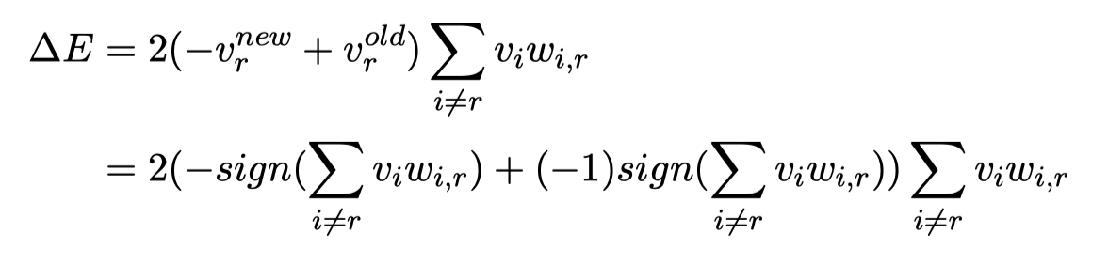

<0

=0

<=0

## 2 Pattern

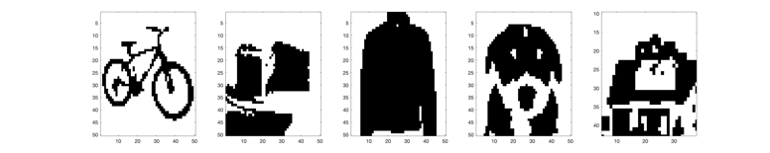

**­­­Image 1.1 Pattern from original Image**

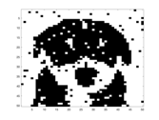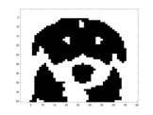

**Image 1.2 Corrupt and the Image Pattern after Hopnet**

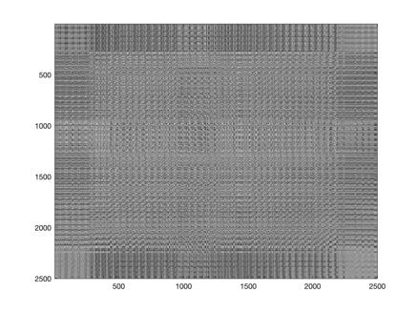

**Image 1.3 Connection Map of Neuron**

### Does the network always settle down to the global minimum?

There are three situations

X(m) is the state of Neuron, because Hopfield neural network is a finite neural network

1. Stable(A)
2. Loop(B)

When the iteration end, the final state will be one of the loop states, but it is usually not the global minimum

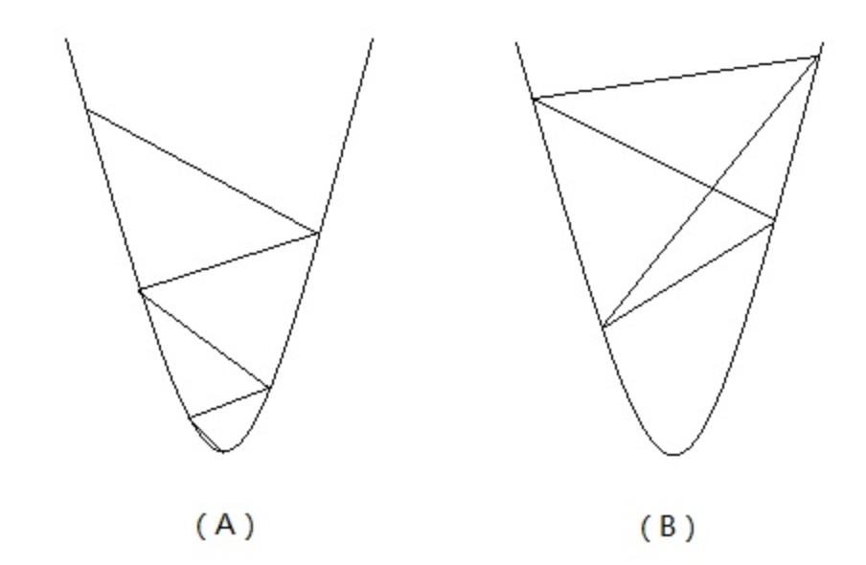

**Image 1.4 The Energy Space of Hopfield NN**

# Part 2: How many patterns can be stored and retrieved?



**Image 2.1 Pattern Learning By Hebbian rule,** **Corrupted**



**Image 2.2 Pattern Learning By oja rule, Corrupted**

**With enough iteration numbers, the result of oja rule and Hebbian rule is almost no difference.**

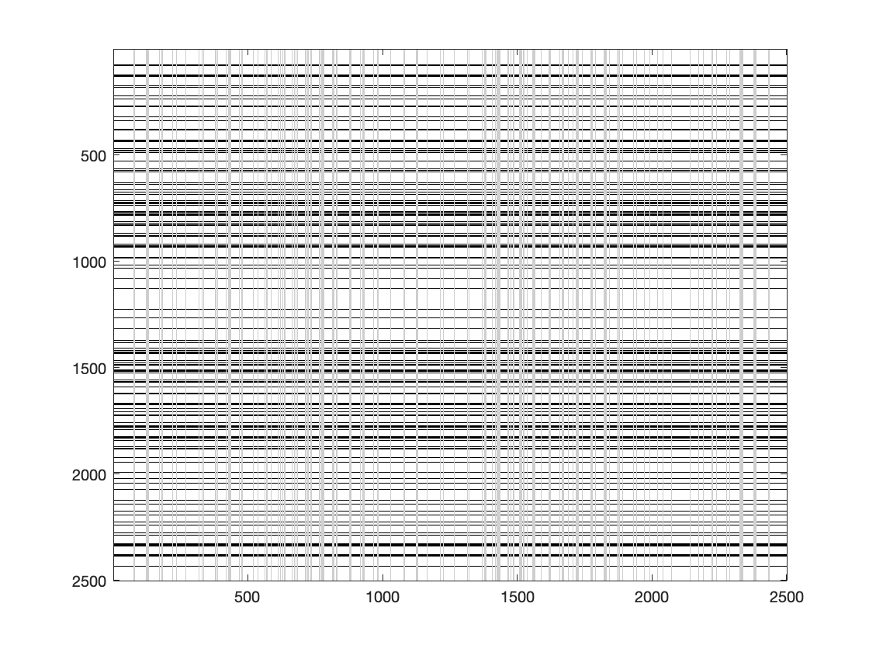

**Image 2.4 Connection Map of Neuron(pattern=1)**

We can notice that the connection is more sparse than more pattern numbers. Hence, we can use the connection map to measure the capacity of the NN which means that if the connection map is dense, then we add more patterns, the network may miss some information of other pattern.

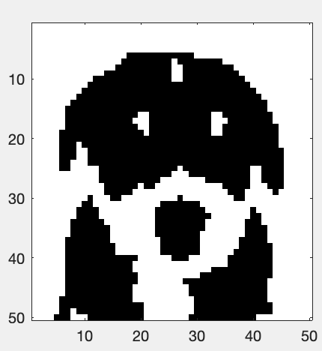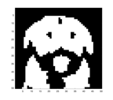

**Image 2.5 Connection Map of Neuron(Noise=10000)**

Noise is add randomly, so it may cover the blank area of the picture, the network may memory the pattern outline, but with the reverse of point distribution.

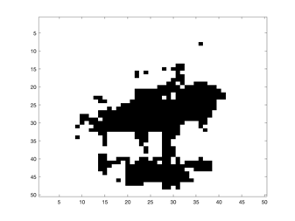

**Image 2.5 Pattern not in Network Memory**

# Part 3: What is the algorithm implemented and why it helps?

**Code 3.1 Learning Alternately**

for epoch=1:100

for iter=1:numPatterns

xcur = mypatterns(:,:,1:iter);

xcur = reshape(xcur,2500,iter);

ycur = xcur'*T';

deltaT = lr*(xcur - T*ycur')*ycur;

T=T+deltaT;

end

end

The method implemented is just like batch train. Comparing to use one sample at one training step, the batch method provides more stable and can make the NN memory more share pattern and will not overfit 1 pattern.