Modeling hw2

10170437 Mark Taylor

Contents

# Table of Contents

Modeling hw2 1

Table of Contents 1

Problems 1

Model Establishing 2

Drawing the Graph 2

Solve by Lingo 3

Result & Analysis 4

Problems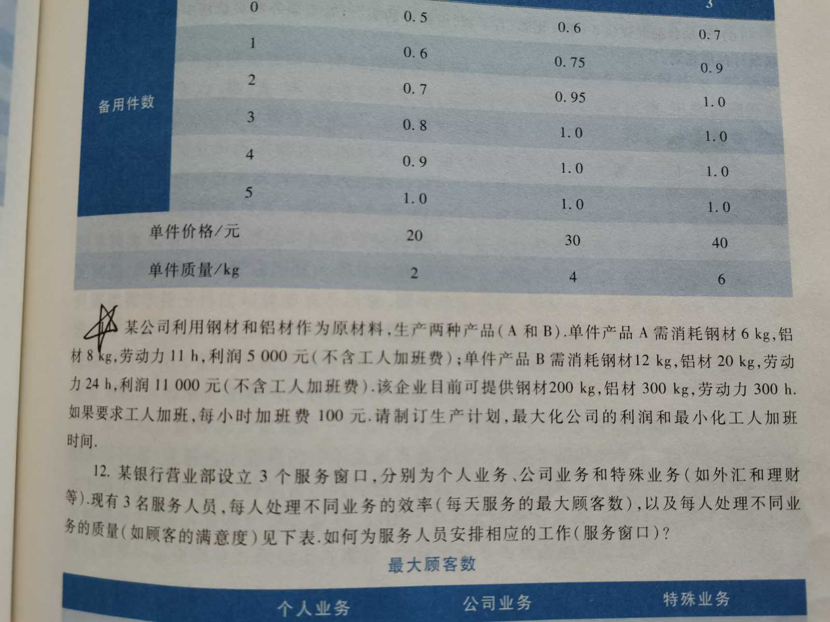

# **Model Establishing**

Let x: = the No. of product A, and y: = the No. of product B.

It’s not difficult to obtain following model by observing the problem.

Max(*profit*) & Min(*overtime*);

*profit* = 5000\**x* + 11000\**y* - 100\**overtime*,

6\**x* + 12\**y* <= 200,

8\**x* + 20\**y* <= 300,

11\**x* + 24\**y* - 300 = *overtime*.

(Of course, *x*, *y*, & *overtime* >= 0.

Moreover, *x* & *y* are integers, which results

in *overtime* also being an integer.)

# Drawing the Graph

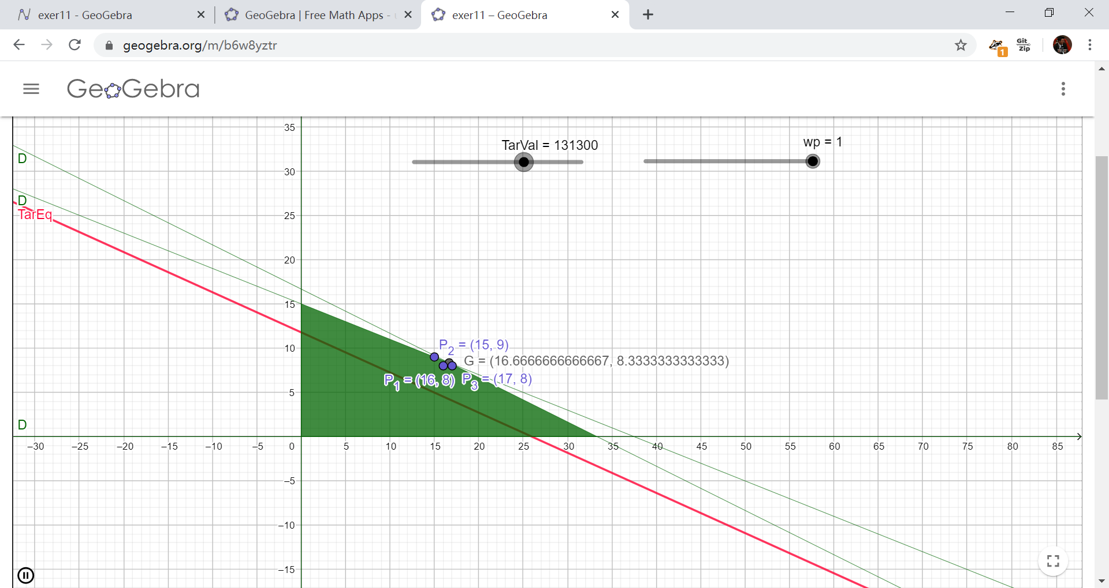 See & play around it online at <https://www.geogebra.org/m/b6w8yztr>.

# Solve by Lingo

* See Lingo code as follows

model:

! A greedy boss wants maximum profit & minimum overtime for employees;

max = z;

!@param x: the No. of product A

@param y: the No. of product B;

wp = 0.9; ! weight of profit. This is decided by the boss;

wt = 1 - wp; ! weight of overtime;

z = profit * wp + (-overtime) * wt; ! Target optimal (maximum) value;

profit = 5000*x + 11000*y - 100*overtime;

[Steel] 6*x + 12*y <= 200;

[Aluminum] 8*x + 20*y <= 300;

[TotalHours] 11*x + 24*y <= 300 + overtime;

! declare variable x & y as integer only;

@gin(x); @gin(y);

end

* 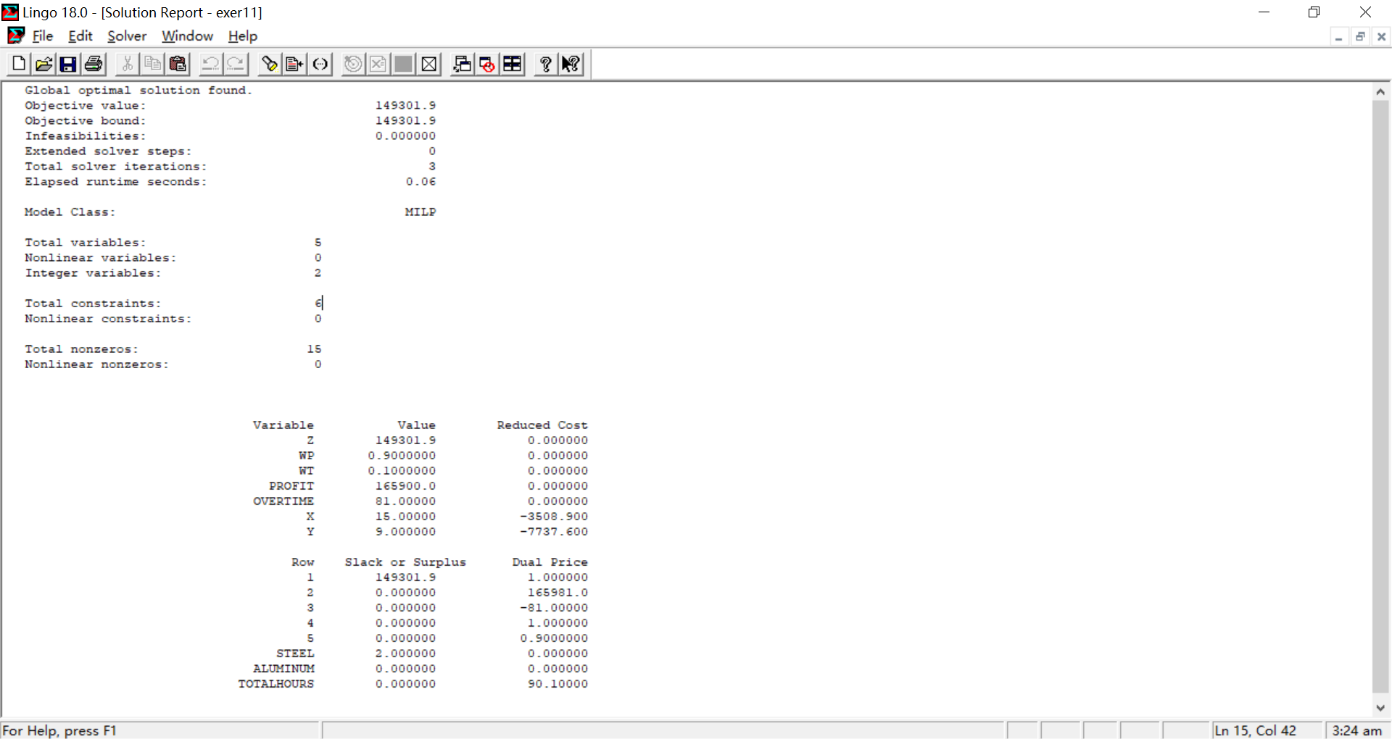Output

# Result & Analysis

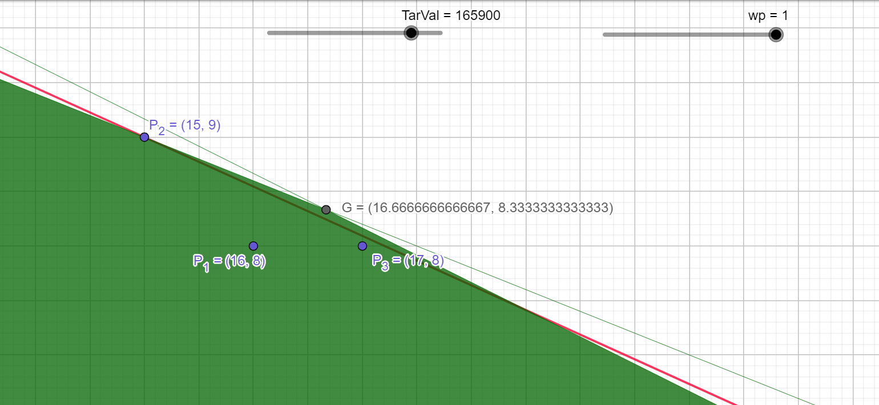

Zooming in we shall find when $wp=1$, Target Equation (red line) will cross point $P_{2}(15,9)$ as the last integer point in domain $D$ (green area). Moreover, if we try to change $wp$ (simple to do, just to drag $wp$ in the slider), and the result remains unchanged. Let’s delve a little bit into the details about why this happens.

By the model,

$$profit=5000x+11000y-100*overtime$$

$=5000x+11000y-100\left(11x+24y-300\right)$

$=3900x+8600y+30000$,

$$z=profit*wp+\left(-overtime\right)*\left(1-wp\right)$$

$=\left(3900x+8600y+30000\right)*wp-\left(11x+24y-300\right)*\left(1-wp\right)$. (TarEq)

weight of profit weight of overtime

Obviously, even when $wp=0.1, 1-wp=0.9$, the slope of equation (TarEq) changes little, since the profit weight part has a magnitude of 102 ~103 and the overtime weight part has a magnitude of at most 101, concerning the coefficients of $x \& y$.

Furthermore, if we try to change the $wp$ in the Lingo program, we can get the same result as that of $wp=1$.

So, the final solution is to **produce 15 pieces of product A, and 9 pieces of product B, with 81 hours of overtime, generating maximum profit ¥165900, and leaving 2kg of rolled steel, regardless of the wight of profit given by the boss.**

(see also the Lingo solution report as follows)

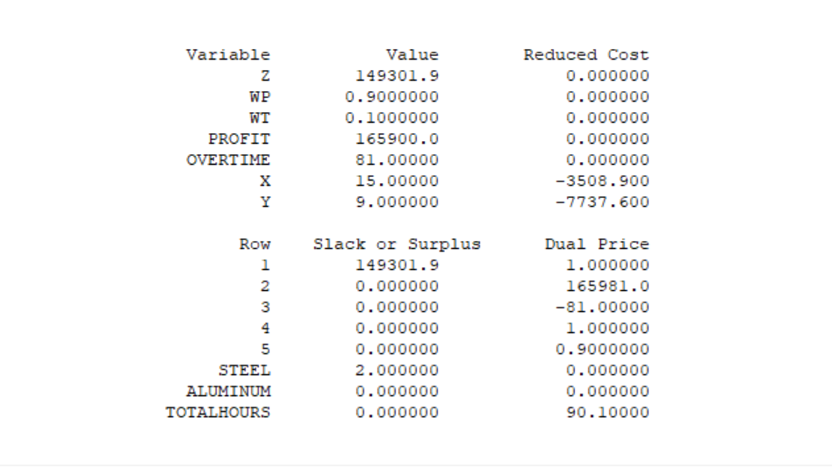

Lingo solution report