Table of Contents

# Abstract

The minimum set of genes of an organism refers to the smallest set of genes that can support a free living organism. In this study the minimum set of genes was described using three machine learning models are used (Naive Bayes Classifier, Random Forest Classifier, and Artificial Neural Network), each trained with data annotated using the COG (Clusters of Orthologous Groups) framework. The models show promising predictive power (Naive Bayes Classifier=0.80, Random Forest Classifier=0.78, and Artificial Neural Network=0.87). Each model is then subjected to feature extraction to describe a its own interpretation of the minimum set of genes. Each of the models' set of genes are compared the CEG databases set of essential genes. The results show that even though the Naive Bayes Classifier does not have the most predictive power, it is able to perform best in the set comparisons between the CEG database. In particular it was the best model in classifying which genes are non-essential (Jaccard index of 0.0058 when compared to CEG set of nonessential genes). These findings show that machine learning algorithms can provide good modelling tools for the minimum set of genes. The methods discussed in this paper can be applied to improve our understanding of the concepts behind gene essentiality and the requirements of creating life.

# Introduction

The first free living genome was sequenced in 1995 (R. Fleischmann et al., 1995). It was the genome of the bacterium *H. influenzae*, containing 1,830,137 base pairs. Eight years after the publishing of *H. influenzae* genome, in 2002, the Human Genome Project was completed (Tripp & Grueber, 2011). Started in 1990, the project was a product of contributions from multiple universities and laboratories around the world. The project involved a laborious process of experimentally obtaining segments of DNA and a more laborious process of reassembling the segments. After 12 years, the whole project completely sequenced the 3.3 billion base pair long human genome. The Human Genome Project inspired the emergence of research about genomes and sequencing tools and processes. The project also inspired the emergence of many genomics related researches in the field of bioinformatics, like sequence analysis, genome annotation and sequence databases.

## There is an abundance of genomic data

Currently, the field genomics is on the background of the big data and machine learning age. The emergence of big data and the advancements in bio-informatics brought upon the abundance of high quality genetic data (Mushegian & Koonin, 1996; Thanassi, 2002; Tonder et al., 2014). This is facilitated by public databases like GenBank, the Sequence Read Archive and European Nucleotide Archive (ENA) (Benson et al., 2000; Leinonen et al., 2011; Leinonen, Sugawara, & Shumway, 2011). These databases store sequences derived from innovations from next generation sequencing. Next generation sequencing is a group of modern genome sequencing technologies that are reportedly powerful enough to sequence the whole human genome in a single day. Computationally powerful machines combined with computationally powerful techniques like next generation sequencing, give the field of genomics better tools as it revisits some of biology's difficult questions.

## The fewest parts to construct a cell.

One of difficult open questions in biology right now is the study on the search for the minimal set of genes. Finding the minimal gene set is the attempt to identify the smallest set of genes that can support life (**???**). There have been many attempts to answer this question through theory and small scale experimentation (Glass et al., 2006). Identifying minimal gene set can provide basis for synthetic biology (Lluch-Senar et al., 2015), which is an emerging interdisciplinary field of biology and engineering. This field studies the synthesis and application of artificial biological systems. Although there are many attempts in creating artificial life that are relatively successful, none of these attempts have gone as close as creating free living cells (Ferber, 2004). By finding the minimal set of genes that can support life the current understanding of simple biological systems will improve making the road to the first free living artificial life one step closer.

## Effective ways to kill cells

Another application of determining the minimal set of genes is in differentiating essential and non-essential genes in bacterial genomes. This will give antibiotics better techniques in killing pathogenic bacteria by disabling essential genes (Akerley et al., 1998). Gene targeting with the knowledge of gene essentiality can be a very effective means of killing pathogenic bacteria (R. Zhang & Lin, 2009). Knowledge of gene essentiality will provide pharmaceutical research advanced antibiotic techniques like general bacteria killers and species specific bacteria killers.

## The goals of this study

This study aims to model the minimum set of genes using machine learning algorithms. This study also aims to document the applicability of machine learning methods as modelling tools for the minimum set of genes. The ultimate goal of this study is to contribute to the understanding of the minimum set of genes by proposing its methodology.

In the following chapter this study will discuss, the biological concepts relating to the minimal set of genes. The following chapter will also contain previous work that contribute to the study on the minimal set of genes along with the accomplished milestones and gaps in knowledge. The next chapter will discuss on which methods this study has chosen to contribute to the current gaps in knowledge. After that there will be a chapter comparing the results between the findings from this and the findings from previous studies. Finally, the last chapter will include a summary of the whole paper, some recommendations and the impact of this study.

# Related Work

## Theoretical Perspectives

### Genes, Proteins and Function Expressions

The central dogma of molecular biology explains the how genetic information flows within a biological system (Crick, 1958). This idea was first stated by one of the co-discoverers the structure of a the DNA, Francis Crick. The most simplistic description of the central dogma states that "DNA makes RNA and RNA makes protein" (Leavitt, 2010). The dogma is a framework that describes three general processes of biological sequential information transfers.

#### Replication

DNA replication is simply the processes that facilitate the reproduction of DNA sequences. This process is essential since DNA information must be reproduced when the cell itself reproduces (Leavitt, 2010).

#### Transcription

This is the process in which DNA information in a particular section is replicated into another type of biological sequence information, the RNA. There many biological process that facilitate the transcription of DNA to RNA but RNA is basically a copy of the information found in the DNA. RNA serves as a middle man/messenger sequence between DNA and protein sequences. This extra middle step is essential in the whole process as it protects the information located in the DNA. Instead of subjecting DNA to the dangers of the process of translation, the RNA copy is used instead (Leavitt, 2010).

#### Translation

This process takes place after an RNA is transcripted from DNA. An RNA makes its way to a ribosome, a cellular organelle that facilitates translation. Using multiple enzymatic processes within the ribosome, RNA sequences of nucleoases (A,U,G,C) are translated into protein sequences of amino acids. Every three nucleobases in the RNA has a corresponding translation to one of the 20 amino acids. Starting from RNA, the translation process yields a protein sequence of amino acids. These proteins are responsible for various biological functions that are expressed in organisms (Leavitt, 2010).

### Essential and Non-essential Genes

Genes range from as few as 480 base pairs ,as shown by the bacterium *Mycoplasma genitalium*, to 100,000 to 150,000, as shown by multi-cellular eukaryotes like humans (E. V. Koonin, 2000). Not all of these genes are completely essential for the survival of an organism. Some of these genes are functionally redundant. Functionally redundant genes are two or more genes that share the same function when expressed. This means that only one of these genes is needed for surviva. (E. V. Koonin, 2000; Nowak, Boerlijst, Cooke, & Maynard Smith, 1997). The concept of essential genes refer to the smallest set of genes which produces a fully functioning organism under the best conditions of living, that is, nutrients are abundant and stress is absent (E. V. Koonin, 2000). Researchers have considered the upper bound of the minimum set of genes to be 480 genes. This number is chosen as it is the number of genes of the bacterium *Mycoplasma genitalium*. *M. genitalium* is the organism with the smallest known genome (C. M. Fraser et al., 1995 ).

### Core genome

One of the approaches for the determination of the minimal set of genes uses the concept of the core genome. The core genome of a group of organisms refer to the set of genes shared by all organisms under said group of organisms. This set of genes doesn't include genes that vary for other organisms in the same group (genes that only contribute to the diversity of said group of organisms) (Tettelin et al., 2005; Tettelin, Riley, Cattuto, & Medini, 2008 ). Since the core genome of a group of organisms consists of genes shared by multiple genomes, said core genome could be a good candidate for the minimal gene set.

## State of the Art

### Using the *Mycoplasma genitalium* bacteria

For many researchers, *Mycoplasma genitalium's* genome has been the primary candidate for the core bacterial gene set. It is widely accepted that the length of this bacterium's gene set is the upper bound for the bacterial genome (C. M. Fraser et al., 1995). Global transposon mutagenesis on *M. genitalium* is a well studied approach on the study of the minimal gene set.

Trasposon mutagenesis is a process that allows gene segments to be transferred to another organism. Because of the insertion of the introduced gene during transposon, the host organism (the owner of the interupted gene) experiences a mutation. By deliberately interrupting the host's chromosomes, researchers can infer information on the function of the hosts genes (L. Hamer, DeZwaan, Montenegro-Chamorro, Frank, & Hamer, 2001). Hutchison III et. al. (1996) used transposon mutagenesis on *M. genitalium's* genome along with its closest relative *M. pneumoniae* to identify which gene locations are essential and which are nonessential (Hutchison III, 1999). The researchers did this by deliberately inserting extant genes to introduce mutations to *M. genitalium* and *M. pneumoniae* and studying the effects of these mutations to their survivability (1999). Their analysis suggests that 265 to 350 of the 480 protein-coding genes of *M. genitalium* are considered essential.

*M. genitalium's* gene sequence has also been used in the comparative genomics approach of the search for the minimal bacterial gene set. Using protein sequence analysis, a bioinformatics approach of comparing sequences described by Koonin (1996), Musheigian and Koonin (1996) compared *M. genitalium* with *Haemophilus influenzae* and found 240 orthologs (genes with the same functions but not necessarily same sequences) (1996 ). This means that the two bacteria share a set of 256 gene functions. Genes outside of the 256 orthologs can be considered non-essential genes since either bacterium can survive without them.

### Experimentally determined essential genes

DEG 5.0 is a database of genes where their essentiality to survival is experimentally determined (R. Zhang & Lin, 2009 ). This database is an improved version of DEG 1.0, created 5 years. It contains information about the essential genes, the experimental method used to determine their essentiality, and their associated references. The most common experimental methods of confirming gene essentiality are direct gene deletions or random mutagenesis (R. Zhang & Lin, 2009 ).

##### Direct deletions

Mori et. al. (2015) identified 328 essential gene candidates for the bacterium *Escherichia coli* using direct gene deletions (2015). Their method involves experimentally "knocking out" gene segments and studying the effect of the gene's abscence to the survivability of *E. coli*. Kobayashi et. al. (2003) and de Berardinis et. al. (2008) also used single gene deletions to determine essential genes for *Bacillus subtilis* and *Acinetobacter baylyi* respectively (2008; 2003).

##### Transposon mutagenesis

Transposon mutagenesis, just as discussed previously, is an approach using transposons which insert in extant genes in random positions in the genome. At publication of Zhang's (2009) paper, 7 prokaryote genomes' essential genes were studied.The number of essential genes for each specific prokaryote ranges between 300-650 (R. Zhang & Lin, 2009).

### Use of machine learning and statistical methods

The current trend of research in this study is starting to shift from experimental methods to qualitative analyses due to the emergence of statistical and machine learning tools. Van Tonder et. al. (2014) used this approach to determine bacterial core genomes to specific populations (Tonder et al., 2014 ). The researchers developed Bayesian decision models to estimate the number of core genes for each population. The researchers built the Bayesian prior of the model using the probabilities of gene occurrences as posterior. Said Bayesian prior rule is then used to determine if a gene is present in the core genes.

### Clusters of Orthologous Groups (COGs)

Koonin started his work on the minimum set of genes in 1996 with Musheigan in a time when completely sequenced genomes were scarce. In fact it was only 1995 when the first bacteral genome (*H. influenzae*) was completely sequnced. During this time he was able to suggest the first iterations of the minimum gene set concept by comparing two relatively distant bacteria (*M. genitalium* and *H. influenzae*) (Mushegian & Koonin, 1996 ). A year later Koonin, along with Tatusova and Lipman (1997) proposed a new perspective in protein classification (1997). This was the first conceptions of Cluster's of Orthologous Genes (COG). The study created families of gene encoded proteins according to their orthology (having same functions). At the time of the study's publishing, 720 COG's were identified, each with individual orthologous proteins or orthologous set of proteins. The COG classification was used as a framework to predict gene functions of poorly sequenced genome. Using this new COG tool in hand, in the year 2000, Koonin revisited the minimal gene set concept (E. V. Koonin, 2000 ). The COG approach along with more sequenced genomes, allowed Koonin to compare more genes. Koonin found a smaller set of conserved gene functions (about 30% of the 1996 minimum gene set size) across 25 sequenced genomes which oppose his previous finding in 1996.

## Gaps in knowledge

### Comparative methods fail on highly diverse group of organisms

The most common methods of comparative genomics usually involve studying the intersection of gene sets. Examples of this approach are Koonin and Musheigian's (1996) comparison between *M. genitalium** and *H. influenzae* and Tettelin et. al's (2005) *Streptococcus agalactiae* pangenome (1996; 2005 ). This approach worked very well on these papers because these studies involve comparing two closely related genes or comparing a group of genes belonging in a population of organisms. A problem arises when the collection of genes compared is in a diverse group. The intersection of gene sets on a collection of diverse group will yield a very small set (Tonder et al., 2014). The reason for this limitation is because the conservativeness of this comparative approach fails to take into account the complex relationships of genes and metabolic functions like synthetic lethality (e.g. genes A and B are only lethal if both are present in the same genome) (Mori et al., 2015; Pál et al., 2006) and conditionally essential genes (e.g. gene A is essential given C) (Gerdes et al., 2006).

### Bacteria's resilience to transposon mutagenesis' disruption and single gene deletions

Hutchison (1999) discussed some of the limitations of transposon mutagenesis in his paper. Hutchison's paper reported unexpectedly low results of 12 essential genes out of 1354 (less than 1%). According to his discussion this may be because his experiment failed to disrupt some of the genes providing incorrect results. Hutchison also suggests that erroneous results may be due to some cells keeping a functional duplicate copy of the otherwise disrupted gene.

### Previous methodologies don't make use of current state of the art gene annotations

As discussed in the previous sections, knowledge about the minimum set of genes evolve as new bioinformatics and genomic tools evolve. As an example, Koonin's body of work in the concept of minimum set of gene's has undergone multiple revisions as new tools emerge (E. V. Koonin, 2000 ; Mushegian & Koonin, 1996). Koonin's 2000 meta study on the concept of the minimum gene set make use of the early version of the COG database tool (Tatusov, 1997). At the time of the paper's publishing, Koonin worked with 25 completely sequenced genomes and the COG the database contained 2112 unique COGs. On the other hand, at the time of this paper writing the most recent version (2014 update) of the COG database contains 5665 unique COG's (Galperin, Makarova, Wolf, & Koonin, 2015). The emergence of more completely sequenced genomes and better annotation tools prompt a revisit of the minimum gene set concept. This time around we have access to robust machine learning techniques to study this abundant gene data.

# Research questions

Based on these gaps in knowledge this research question is formulated:

#### Are these machine learning classifiers a valid tool for determining the minimal set of genes?

Although, there have been few studies that use machine learning tools in the study of the minimum set of genes, there have been no studies that document the applicability of various machine learning methods (Tonder et al., 2014). Basing on these few promising machine learning studies this study hypothesizes that machine learning classifiers will be a useful tool to be used in determining the minimal set of genes.

# Methodology

## Data Collection

### Genes as features

To find the minimum set of bacteria genes to sustain a valid bacteria, a machine learning classification model was to be created built on features based on the genomic data. By building a model that can recognize valid and free living bacteria, this study can also propose on what features characterize a valid bacteria. These features used to build the model should represent genes of said bacteria. By studying on how the machine learning algorithms built the model we can infer which genes are the best determinants for characterizing a valid and free living bacteria and by consequence which genes are required to create a bacteria. But instead of focusing on the predictive and classification abilities of the model, the focus of this study was to analyse which features (genes) are strongest determinants. Of course the classification model built must also be a competent classifier, but this is only to ensure that the model built is correct and unbiased.

### Positive and Negative data

The data used in this study are genes with functions annotated according to COG's (cluster of orthologous genes). The data is divided into 2 groups, positive group (valid free living bacteria) and negative group (unculturable and non free living bacteria). Both sets are comprised of multiple samples of fully sequenced bacterium preprocessed by the Philippine Genome Center. Each column in the data (feature) represents a COG profile. For each instance of bacteria, the values for each cell represents the frequency of the COG's found in said bacterium’s genome. The model requires a negative set of data so that the models have a way to differentiate valid bacteria to non valid bacteria. Without the opposite groups the model built would be unable to make unbiased generalizations of the the characteristics of the bacterial core genome.

## Training and Testing

The process for model creation for the three models are identical. The data is split into two partitions, training and testing. The training partition is used to fit the model to the data and the testing partition is used to calculate the model's validation score. It is important that data is not shared by the two partitions. This rule is kept so that the model's tests can detect if the classifier is able to generalize on the data or it merely overfits on the data.

Overfitting occurs when the model describes the data's noise instead of the underlying relationship of genes and genome validity of bacteria. A model's overfitting is manifested by having exceptional scores on its training while having poor scores on its testing. This will happen if the model is too biased on the training partition and its noise and specificities instead of generalizing the relationships (M. K. Smith, 2014). The precautions to avoid overfitting is different for each model and these precautions will be discussed in their own sections later. The ratio of splitting into partitions should also be an informed choice. Leaving too little data instances for the training partition will negatively affect the model's accuracy. While leaving too little data instances for the testing partition will create unreliable tests. The two partitions of data must be large enough to be equivalent representations of each other (Steinberg, 2014).

## Model Choices

### Naive Bayes

Naive Bayes is suitable for classifiers with features that represent frequency or set elements. This applies to the data set used in this study where frequency is the frequency of a particular COG in a bacterium's genome. Each data instance can also be represented as a set of COG's that fully comprises the bacterium's genome (H. Zhang, 2004).

#### Model Fitting

The Naive Bayes family of classifiers are created based on Bayesian theorem. This algorithm is naive in the sense that it makes a naive assumption that all of the features in the model are mutually independent of each other. Applying Bayes theorem in bacterium data gives this relationship:

Where $P(y|x_{1},...,x_{n})$ is the posterior probability of a bacterium being valid or invalid ($y$) given that the probabilities of gene occurences ($x_{i}$) are $x_{1},...,x_{n}|y$ (H. Zhang, 2004).

$P(y)$ refers to the prior probability, or the general probability of the occurences of valid and invalid bacteria. There are no papers that describe the actual probability distribution of valid and invalid bacterium in the wild therefore the value used for the prior probability is the probability distribution of the data provided. $P(x_{1},...,x_{n}|y)$ refers to the likelihood probability or the likelihood of gene occurences to be $x_{1},...,x_{n}$ for each type of data ($y$, valid or invalid bacteria). The values $x_{1},...,x_{n}$ are frequency distributions of each gene (n=4347) in a given bacterium over the total number of gene occurrences in the whole dataset.

Naive Bayes family of classifiers are relatively immune to overfitting. This is because the rules that the algorithm builds are simple probability rules that erase noise and outliers. As long as the data is an accurate representation of the actual relationships, these models will not overfit (H. Zhang, 2004).

#### Model representation of minimum set of genes

The model’s representation of the minimum set of genes will be derived from a set of each feature's coefficient of likelihood. This set will be a set of probabilities, where each probability represents a corresponding gene. Each feature's coefficient represents the likelihood that its corresponding gene is describes a valid bacterium. If that value is close to one, then it is likely that this gene is part of the minimum set.

### Random Forest Classifier

This model is also suitable for classifiers that can be represented as frequency values or set elements. The advantage of this model over Naive Bayes is that it is able to build more complex conditional relationships between features. This is suitable for this study since bacteria metabolism is governed by complex relationships (as previously discussed) (Dietterich, 2000).

#### Model Fitting

Random forest classifier is an ensemble classifier of decision trees. This means that this classifier is a model that classifies according to a frequency distribution of opinions from a set of independently trained decision trees. Each decision tree is trained in its own independent subset of the data. Decision trees are models which are also built from frequency distributions of data. Instead of making posterior probability rules like the Naive Bayes family of algorithms, decision tree algorithms build a tree of if-then-else decision rules (Dietterich, 2000).

image of dtree

image of dtree

Each node of a tree is a feature in the dataset and each leaf is an output class. Therefore, the model in this case is a tree where each node is a gene and each leaf represent either a valid bacterium or an invalid bacterium. Given a set of genes S that represent a bacteria, the classifier follows the decision tree, checking on each tree node if the gene is present in S and follows the described tree path until it ends up on the leaves as either valid or invalid. The model does this for each tree in the Forest and yields a frequency distribution of opinions. The predicted class will be whichever output class that has a higher frequency of opinions.

Decision trees are prone to overfitting that is why this study uses a random forest classifier.Instead of using only one decision tree to describe relationships in the data, a forest of decision trees is used, each tree with independent models of relationships built from disjoint partitions of the data. This isolates noise and outliers to a specific tree in the forest. Erroneous opinions will be hidden in the set of opinions, preventing it from affecting the model's predictions (Díaz-Uriarte & Alvarez de Andrés, 2006).

#### Model Representation of the minimum set of genes

Random Forest Classifier creates a tree for each decision tree specified. Each of these trees describes the relationships within the data. Decision tree algorithms only create nodes for features that are good determinants of data. Because of this behaviour, trees created from the genome data will only contain genes which are good determinants of bacteria validity. The trees created from the data will also describe complex conditional relationships of genes like, synthetic lethality and conditional essentiality.

### Artificial Neural Network

Artificial Neural Networks are a powerful classification tool and are suitable for data with highly complex relationships. Models created using a multi-layer perceptron can generalize into high order mappings that represent high order relationships which may be the case for this data. Although the problem with multi-layer perceptron is that it produces a "black box" model which is difficult to analyse.

#### Model Fitting

An artificial neural network is defined by (1) the interconnection of neurons according to their layers, (2) the weights of the interconnections (3) an activation function that converts a neuron’s input into a meaningful output (Hagan, Demuch, & Beale, 1996).

neural network image

neural network image

The leftmost layer of a network is a set of input neurons representing the set of features. In this case it is a set of genes and their frequency distributions. The value passed into each neuron is a the weighted sum $g(w_{1}x_{1}+w_{2}x_{2}+...+w_{n}x_{n})$ where $w_{i}$ is the interconnection weight, x is the node value and $g$ is an activation function. The activation function in this case is the sigmoid function

Neural networks model's intuition is based on the universal approximation theorem. According to this theorem, any continuous function can be approximated by a single hidden layer containing a finite amount of neurons given mild assumptions under an activation function (Hagan et al., 1996). This just means that if the relationship of gene sets to bacterial validity can be represented as a continuous function, then there exists a neural network model that represents this relationship.

Neural Networks can easily overfit to the training data. But there are regularization precautions that are embedded into the training of neural networks that can avoid overfitting. Before training the model an alpha parameter can be set, along with other parameters like, number of layers and number of neurons per layer. This alpha parameter represents the regularization term, also known as a penalty term. It penalizes extremely large weights ($w$) therefore promoting smaller weight values. Thus, the resulting function representation of a highly regularized neural network has softer curves. Softer curves means that the model is more forgiving to the effects of data noise thus mitigating overfitting (Hagan et al., 1996).

#### Model representation of minimum set of genes

The model representation of a neural network model is less intuitive than the Bayesian model and the Random Forest model. Instead of a set of probabilities or trees, the neural network model yields a matrix of weights with size $m×n$ where m is the number of neurons per layer and n is the number of layers. Since this study's interest is finding the minimum set of genes, this study will examine which weight values are consistently high for each node. Weights with higher values means that its corresponding feature (gene) contribute more in the classification decision of valid vs invalid bacteria.

## Algorithm Parameter Tuning

### Random Forest Classifier

#### Forest Size

The number of trees in a forest can affect the model's behaviour. Having too little trees in the forest will make the model prone to overfitting while having too many trees will make the subsets of data assigned for each tree too small to represent the whole data. Therefore the amount of trees in the forest should be chosen carefully. This study did this by fitting the data into models with different forest sizes, from size=1 to size=20. When the forest is of size 1 (one decision tree) the sole tree is assigned with 195 samples. While a forest with size 20 assigns about 10 samples for each tree.

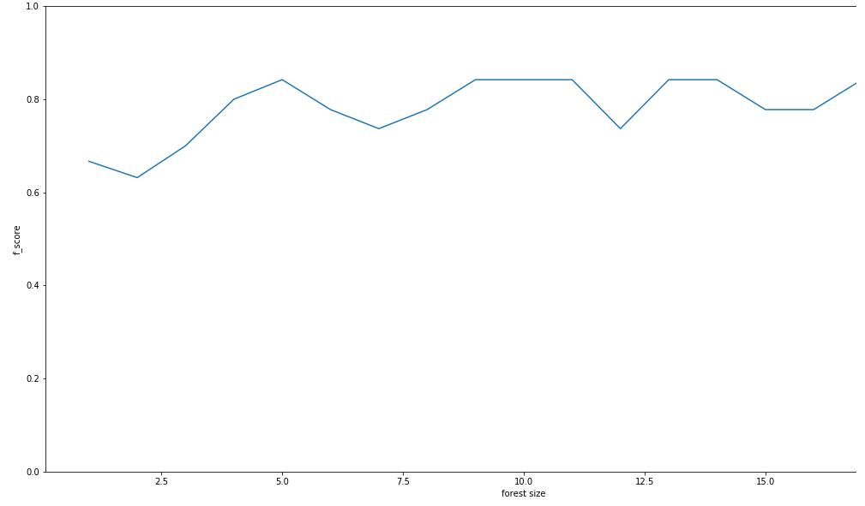

According to the graph in Figure 4.1, the model performs the best at about forest sizes greater than 5. Beyond this value, the graph shows that there is no meaningful increase in the model's performance as the forest size increases.

#### Minimum Impurity Split

The model's minimum impurity parameter was also tuned. Minimum impurity refers to the value in which the algorithm decides to split the tree into subtrees. A conservative approach in building each tree in the forest is making a tree split only when both subtrees are purely valid bacteria and purely invalid bacteria. This approach is prone to overfitting since it doesn't forgive impurities from outlier samples. By setting the minimum impurity to a higher value, the algorithm becomes more lenient in its tree splits, forgiving noise and outliers. Although, if minimum impurity is set too high, the algorithm may be too lenient that it may forgive even incorrect tree splits that do not actually represent relationships in the data. Finding the best amount of impurity is similar to finding the best forest size. The model is fit with varying minimum impurities from impurity=0 to impurity=1.

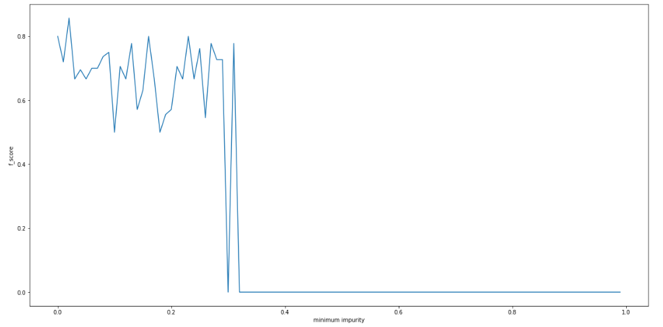

The best performing minimum values of impurity are found between 0 to 0.1. According to the graph in Figure 4.2, the best performing minimum values of impurity were found between 0 to 0.1. The model's performance experiences higher variance beyond this value. As soon as impurity exceeds 0.3, the performance drops to zero because splits become too forgiving that the tree becomes meaningless.

### Artificial Neural Network

#### Number of Nodes in 1 Hidden Layer

The number of nodes in the hidden layer of a neural network also affects the model's performance. Just like hidden layer sizes, having too few neurons may affect the ability of the network to model the relationships of the data while having too much neurons may slow down training and promote overfitting (Hagan et al., 1996). There are also architectural rules of thumb for choosing the number of neurons per layer. According to Hagan et. al, (2014) one should begin with more than enough neurons from the start (somwhere between $N_{i}$ and $N_{o}$. In this study different neuron sizes were tested, between n=10 until n=300.

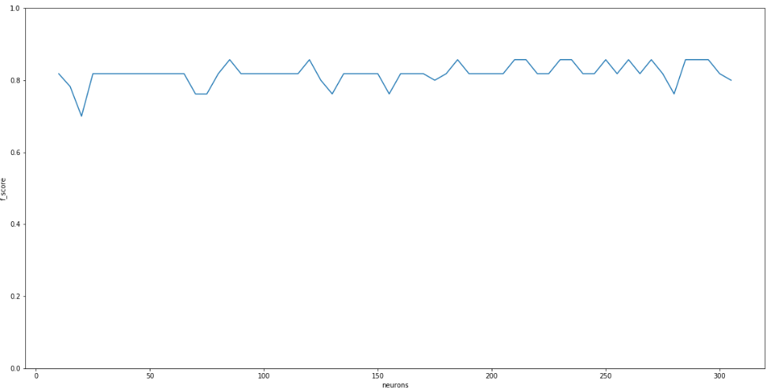

According to the graph in figure 4.3, the performance of the model is fluctuates between 0.75 to 0.85 between n=10 and n=60. At about n>60 the performance of the model stabilizes to a narrower range, between 0.75 and 0.85. Increasing the number of neurons where 60 1$. Despite knowing this, the model was still fit into different sizes of hidden layers from n=1 to n=20 just for the purposes of testing.

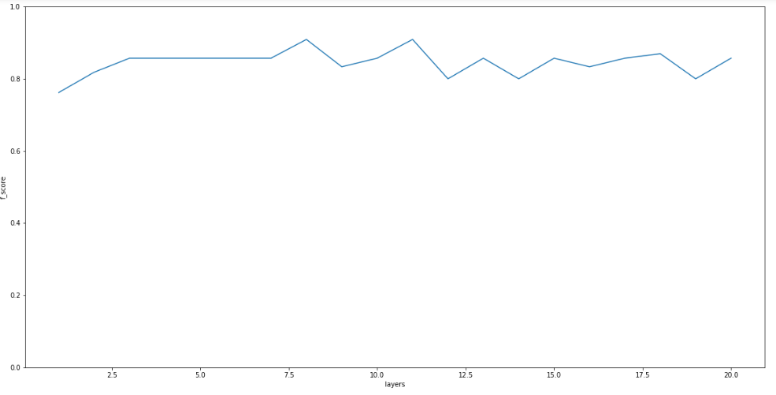

According to the graph in Figure 4.4, neural networks’ performaces fluctuate between 0.8 and 0.85. The size of the hidden layer does not meaningfully affect this model's performance. After testing all this, it was decided that the number of layers be set as small as possible (n=1) to follow the architectural rule of thumb.

## Cross Validation

### F1 score as Performance Measure

The amount of positive (valid bacteria; n=195) and negative (invalid bacteria;n=66) samples are unequal in this dataset. This means that using the measure of accuracy:

where $tP$ is the number of true positives (predicted positive and actually positive); $tN$ is the number of true negatives (predicted negative and actually positive); and $N$ is the total size of the test partition.

Accuracy will not be a good measure of model performance. This is because having more positive data will reward higher accuracy to models that have high frequencies of positive predictions. Using accuracy as a measure of performance will favor models that "cheat" by simply predicting positive for any sample. To avoid models cheating, the measure f-1 score is used instead of accuracy. $F_{1}$ score is defined as:

where precision is defined as

and recall is defined as

$fN$ stands for false negatives (predicted negative but actually positive) and $fP$ stands for false positives (predicted positive but actually negative) $F_{1}$ score is a more robust performance measure since it takes into account both precision and recall. Despite having unequal amounts of positive and negative data, $F_{1}$ score can accurately measure model performance.

### Measuring overfitting

It was discussed in the previous sections how unreliable it is to measure a model’s performance using the same data it was trained on. Having high performance on the training partition does not necessarily mean that the model has successfully described the relationships of data. High performance on the training partition could also mean that the model is highly overfit to the training data. This is why in this section, training performance and testing performance for each model is compared. The following graphs show the effect of changing the proportion of the two partitions to each model's performance. Each model performance is tested from training proportion of 0.1 (train_samples=26) to training proportion 0.75 (train_samples=196). Whatever is left in the whole dataset is used as the test proportion.

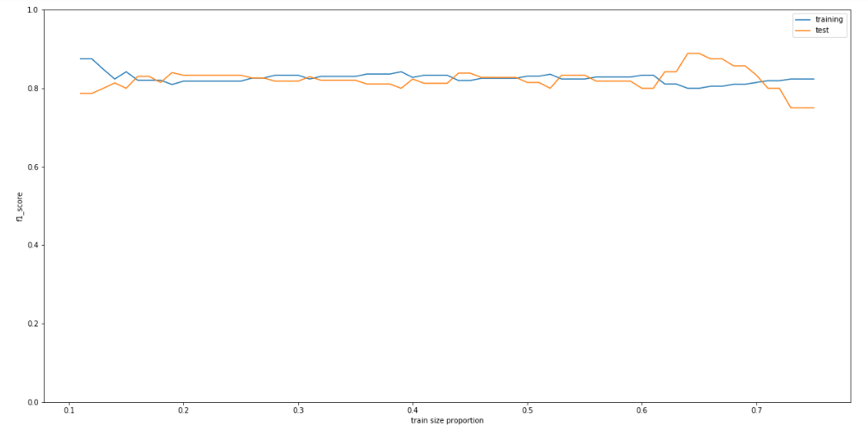

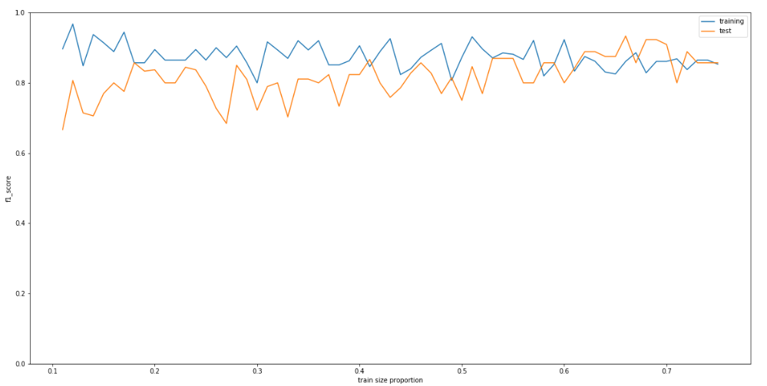

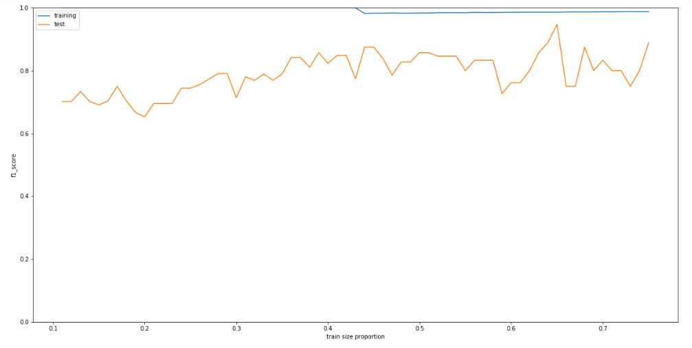

All of the models show typical model behaviors. While the training partition increases in size, training score decreases. This is because more samples mean that noise and outliers are outscaled by the number of samples, therefore, overfitting becomes less likely, decreasing the performance on its own training data. On the other hand, while the training partition increases in size, test score increases. This is because the increase of training samples means that the model is able to generalize the relationships easier. Good generalization is manifested by a higher score in its test partition since this partition does not share the noise and outlier samples of the training partition.

# Results

## Binarization of data

One of the observations this study makes is how the models perform better when data is binarized. Instead of using each frequency value for each gene (Cluster of Orthologous Genes), the model yielded higher cross validation values when data was transformed through a binarization function:

This approach may work better because same COG's serve similar functions (as discussed in a previous section in Chapter 2: Clusters of Orthologous Genes). Using frequency distribution as data values may obscure the relationships from the models due to the extra complexity. It may also introduce more noise for the data making it highly prone to overfitting.

## Minimum Set of Genes

### Coefficient of likelihood for each gene

Using the Naive Bayes Classifier each a coefficient of likelihood for each gene was obtained. The higher the coefficient of likelihood, the higher the probability that this gene is part of the minimum set of genes. The following graph in Figure 5.1 shows the frequency distribution of gene likelihoods:

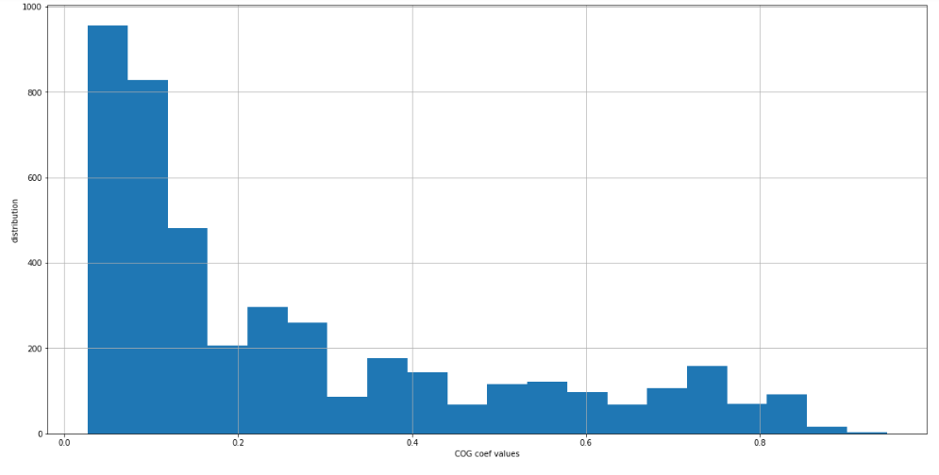

Figure 5.1 shows that the frequency of genes decreases as the coefficient of likelihood increases. In fact there are only 3 genes with coefficient of likelihood greater than or equal to 0.9. As we decrease our coefficient of likelihood threshold, we can include more genes, as seen in Table 5.1.

Threshold of coefficient of likelihood and the corresponding number of genes included in the set

|  |  |
| --- | --- |
|  | Number of genes in the set |
| bayesian findings t=0.9 | 3 |
| bayesian findings t=0.8 | 110 |
| bayesian findings t=0.7 | 393 |
| bayesian findings t=0.6 | 566 |

### Decision trees of important genes

Using the Random forest classifier, 5 decision trees were obtained. These trees model the relationship of genes to bacterial validity.

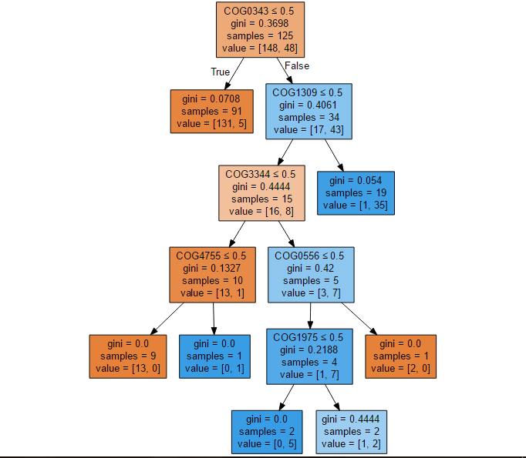

Genes which are closer to the root nodes are genes which are more likely part of the minimum set of genes since these genes are the primary splitters between valid and invalid bacteria. This means that the presence or absence of these genes describe the difference between each valid and invalid bacteria. Genes located farther from the root node are genes that may exhibit conditional essentiality from its parent genes.

### Matrix of network weights

Using the artificial neural network 2 matrices of interconnection weights were obtained. Since the architecture of the neural network is 4346-75-1 (4356 features/input neurons, 75 hidden layer neurons, 1 output class) the two matrices are o sizes $W_{1}:4346×75$ and $W_{2}:75×1$. We can infer which neurons in the hidden layers classify for valid bacteria by looking at matrix $W_{2}$. Highly positive values in $W_{2}$ indicate neurons that are strong determinants of bacterial validity. Each of these hidden layer neurons have a corresponding column in matrix $W_{1}$.

Therefore the gene weights (weights of interconnections between input and hidden layer) of highly positive hidden neurons with higher values will correspond genes which are more likely part of the minimum set of genes.

# Discussions

Each of the models were able to model the relationships with relatively high performance (Naive Bayes f1_score=0.80; Random Forest Classifier f1_score=0.78; Artificial Neural Network f1_score=0.87) but the main focus of the study was each of the model's representation of the minimum set of genes. In the representation aspect, each of the model's show its own respective advantages and disadvantages. The Random Forest Classifier was able to show complex conditional relationships of genes with each other but this models feature's cannot be represented as a set of genes. It was the Naive Bayes Classifier which was able to represent its features as coefficient of likelihoods that correspond to each gene's likelihood of being an element of the minimum set of genes.

## Comparing findings to an existing database

By obtaining the important features on each model, this study was able to propose its own findings on the concept of minimum gene set. Using the CEG database as a point of comparison, the following results were obtained:

Jaccard index values of each model and their corresponding feature importance threshold (t)

|  |  |  |
| --- | --- | --- |
|  | CEG essential genes | non essential genes |
| bayesian findings t=0.9 | 0.00149775 | 0 |
| bayesian findings t=0.8 | 0.0549176 | 0 |
| bayesian findings t=0.7 | 0.191447 | 0.00245776 |
| bayesian findings t=0.6 | 0.269896 | 0.0058548 |
| nn findings t=0.9 | 0.0684466 | 0.0189306 |
| nn findings t=0.8 | 0.130047 | 0.0403559 |
| nn findings t=0.7 | 0.189569 | 0.0614355 |
| nn findings t=0.6 | 0.23507 | 0.104526 |

Note that only the non-tree based models are in this table since the random forest model's representation of the minimum set of genes cannot be perfectly represented by feature importances. Random Forest classifier represents feature importances as if-else conditional relationships instead of individual weighted coefficients for each gene. Table 5.2 shows the Jaccard index of each model's obtained gene set and the CEG databases gene set. Jaccard index $J(A,B)$ is a measure used to compare similarity over two sets. Jaccard index is defined by:

Table 5.2 shows that the gene sets obtained by this study are smaller than the gene set in the CEG database. There could be two reasons behind this disparity in gene sets.

1. CEG database contain functionally redundant genes. The gene set obtained from the CEG database doesn't necessarily represent the minimum gene set itself, this gene set is merely the set of genes that have been defined as essential. There may be redundant functions in the CEG database itself which means that constructing a valid bacterium doesn't require exactly one of each gene defined in the database.
2. The model is unable to represent the minimum set of genes. Although the models yield high scores in classifying between valid and invalid bacteria, this doesn't mean that models are able to perfectly represent the minimum set of genes. This could be the consequence if the data used in training isn't enough to represent the whole population of valid and invalid bacteria. There may be samples of bacteria that are not represented in any of the samples in the data. If this is truly the case the model would be unaware of relationships of genes and validity of these underrepresented bacteria. Although all of the models genes sets are similar in the sense that all are smaller than the CEG database, the two models differ in their ability to determine nonessential genes. The Bayesian classifier's Jaccard index when compared to the non-essential gene set is smaller than the neural network classifiers Jaccard Index. This means that the neural network classifier has more genes misidentified as essential. This is a surprising result given that the neural network slightly outperforms the Bayesian classifier. The neural network's classifier's poor performance in identifying non-essential genes could be attributed to its own model representation of the minimum set of genes. It was discussed earlier how neural network classifiers are black box models. Even though these type of models perform well in classification, they are not widely used in feature analyses of data because of their complex and black boxed structure.

# Conclusion

The advent of big data and machine learning has contributed to the growth of many fields. In this study, machine learning was used in the field of genomics and bioinformatics, particularly on the concept of the minimum set of genes. Multiple machine learning algorithms (Naive Bayes, Random Forest, Artificial Neural Network) were used to model the relationship between bacterial validity and genes. Training using data from COG annotated gene sequences, the models were able to classify the validity of a given bacterium based only on its genes. The models show promising predictive power (Naive Bayes Classifier=0.80, Random Forest Classifier=0.78, and Artificial Neural Network=0.87). Each model is then subjected to feature extraction to describe a its own interpretation of the minimum set of genes. Each of the models' set of genes are compared the CEG databases set of essential genes. The results show that even though the Naive Bayes Classifier does not have the most predictive power, it is able to perform best in the set comparisons between the CEG database. In particular it was the best model in classifying which genes are non-essential (Jaccard index of 0.0058 when compared to CEG set of nonessential genes)

As a recommendation, future studies could focus on selecting more robust methods in extracting feature importance. This especially applies to the extraction of feature importance in a neural network model. At the time of writing this paper, there is still no widespread consensus as to which feature extraction method is best in neural network models. In the future when there is one, the study of minimum set of genes will surely benefit from it. It is also advisable for future studies to include other families of classifiers like SVM, KNN or maybe unsupervised algorithms like K means clustering.

In conclusion, this study answers the research question formulated in chapter 3: “Are these machine learning classifiers a valid tool for determining the minimal set of genes?”. After considering the results of each machine learning algorithm, the hypothesis discussed from chapter 3 is accepted. The study shows that there is good promise in the application of machine learning in the study of the minimum set of genes. The study on the minimum set of genes has been an open problem ever since the emergence of the field of genomics. This study is the first of kind in the sense that this was the first attempt in applying machine learning algorithms to model the minimum set of genes. Research on the field of bio-informatics and machine learning are still emerging, in the future when data is more abundant and tools are more advanced, this study would be a good framework for more large-scale and in depth studies.

# References

Akerley, B. J., Rubin, E. J., Camilli, A., Lampe, D. J., Robertson, H. M., & Mekalanos, J. J. (1998). Systematic identification of essential genes by in vitro mariner mutagenesis. *Proceedings of the National Academy of Sciences*, *95*(15), 8927–8932. <http://doi.org/10.1073/pnas.95.15.8927>

Benson, D. A., Karsch-Mizrachi, I., Lipman, D. J., Ostell, J., Rapp, B. A., & Wheeler, D. L. (2000). GenBank. *Nucleic Acids Research*, *28*(1), 15–8. <http://doi.org/10.1093/nar/28.1.15>

Berardinis, V. de, Vallenet, D., Castelli, V., Besnard, M., Pinet, A., Cruaud, C., … Weissenbach, J. (2008). A complete collection of single-gene deletion mutants of Acinetobacter baylyi ADP1. *Molecular Systems Biology*, *4*, 174. <http://doi.org/10.1038/msb.2008.10>

Crick, F. H. (1958). On protein synthesis. *Symposia of the Society for Experimental Biology*, *12*, 138–163. <http://doi.org/10.1038/227561a0>

Dietterich, T. G. (2000). An Experimental Comparison of Three Methods for Constructing Ensembles of Decision Trees. *Machine Learning*, *40*(2), 139–157. <http://doi.org/10.1023/A:1007607513941>

Díaz-Uriarte, R., & Alvarez de Andrés, S. (2006). Gene selection and classification of microarray data using random forest. *BMC Bioinformatics*, *7*(6), 3. <http://doi.org/10.1186/1471-2105-7-3>

Ferber, D. (2004). SYNTHETIC BIOLOGY: Microbes Made to Order. *Science*, *303*(5655), 158–161. <http://doi.org/10.1126/science.303.5655.158>

Fleischmann, R., Adams, M., White, O., Clayton, R., Kirkness, E., Kerlavage, A., … Al., E. (1995). Whole-genome random sequencing and assembly of Haemophilus influenzae Rd. *Science*, *269*(5223), 496–512. <http://doi.org/10.1126/science.7542800>

Fraser, C. M., Gocayne, J. D., White, O., Adams, M. D., Clayton, R. A., Fleischmann, R. D., … Venter, J. C. (1995). The Minimal Gene Complement of Mycoplasma genitalium. *Science*, *270*(5235), 397–403. <http://doi.org/10.1126/science.270.5235.397>

Galperin, M. Y., Makarova, K. S., Wolf, Y. I., & Koonin, E. V. (2015). Expanded Microbial genome coverage and improved protein family annotation in the COG database. *Nucleic Acids Research*, *43*(D1), D261–D269. <http://doi.org/10.1093/nar/gku1223>

Gerdes, S., Edwards, R., Kubal, M., Fonstein, M., Stevens, R., & Osterman, A. (2006). Essential genes on metabolic maps. *Current Opinion in Biotechnology*, *17*(5), 448–456. <http://doi.org/10.1016/j.copbio.2006.08.006>

Glass, J. I., Assad-Garcia, N., Alperovich, N., Yooseph, S., Lewis, M. R., Maruf, M., … Venter, J. C. (2006). Essential genes of a minimal bacterium. *Proceedings of the National Academy of Sciences of the United States of America*, *103*(2), 425–30. <http://doi.org/10.1073/pnas.0510013103>

Hagan, M. T., Demuch, H. B., & Beale, M. (1996). *Neural Network Design* (p. 732). [publisher not identified]. Retrieved from <http://hagan.okstate.edu/nnd.html>

Hamer, L., DeZwaan, T. M., Montenegro-Chamorro, M. V., Frank, S. A., & Hamer, J. E. (2001). Recent advances in large-scale transposon mutagenesis. *Current Opinion in Chemical Biology*, *5*(1), 67–73. <http://doi.org/10.1016/S1367-5931(00)00162-9>

Hutchison III, C. A. (1999). Global transposon mutagenesis and a minimal Mycoplasma genome. *Science*, *286*(5447), 2165–2169. <http://doi.org/10.1126/science.286.5447.2165>

Kobayashi, K., Ehrlich, S. D., Albertini, A., Amati, G., Andersen, K. K., Arnaud, M., … Ogasawara, N. (2003). Essential Bacillus subtilis genes. *Proceedings of the National Academy of Sciences*, *100*(8), 4678–4683. <http://doi.org/10.1073/pnas.0730515100>

Koonin, E. V. (2000). How many genes can make a cell: The Minimal-Gene Set Concept. *Annual Review of Genomics Human Genetics*, *1*(1), 99–116. <http://doi.org/10.1146/annurev.genom.1.1.99>

Leavitt, S. A. (2010). Deciphering the Genetic Code: Marshall Nirenberg. *Office of NIH History*. Retrieved from <https://history.nih.gov/exhibits/nirenberg/glossary.htm>

Leinonen, R., Akhtar, R., Birney, E., Bower, L., Cerdeno-T??rraga, A., Cheng, Y., … Cochrane, G. (2011). The European nucleotide archive. *Nucleic Acids Research*, *39*(SUPPL. 1), D28–D31. <http://doi.org/10.1093/nar/gkq967>

Leinonen, R., Sugawara, H., & Shumway, M. (2011). The sequence read archive. *Nucleic Acids Research*, *39*(SUPPL. 1), D19–D21. <http://doi.org/10.1093/nar/gkq1019>

Lluch-Senar, M., Delgado, J., Chen, W.-H., Llorens-Rico, V., O’Reilly, F. J., Wodke, J. A., … Serrano, L. (2015). Defining a minimal cell: essentiality of small ORFs and ncRNAs in a genome-reduced bacterium. *Molecular Systems Biology*, *11*(1), 780–780. <http://doi.org/10.15252/msb.20145558>

Mori, H., Baba, T., Yokoyama, K., Takeuchi, R., Nomura, W., Makishi, K., … Wanner, B. L. (2015). *Identification of essential genes and synthetic lethal gene combinations in Escherichia coli K-12.* (Vol. 1279, pp. 45–65). <http://doi.org/10.1007/978-1-4939-2398-4_4>

Mushegian, A. R., & Koonin, E. V. (1996). A minimal gene set for cellular life derived by comparison of complete bacterial genomes. *Proceedings of the National Academy of Sciences*, *93*(19), 10268–10273. <http://doi.org/10.1073/pnas.93.19.10268>

Nowak, M. A., Boerlijst, M. C., Cooke, J., & Maynard Smith, J. (1997). Evolution of genetic redundancy. *Nature*, *388*(6638), 167–71. <http://doi.org/10.1038/40618>

Pál, C., Papp, B., Lercher, M. J., Csermely, P., Oliver, S. G., & Hurst, L. D. (2006). Chance and necessity in the evolution of minimal metabolic networks. *Nature*, *440*(7084), 667–670. <http://doi.org/10.1038/nature04568>

Smith, M. K. (2014). Overfitting. Retrieved from <http://www.ma.utexas.edu/users/mks/statmistakes/ovefitting.html>

Steinberg, D. (2014). Why Data Scientists Split Data into Train and Test. Retrieved from <http://info.salford-systems.com/blog/bid/337783/Why-Data-Scientists-Split-Data-into-Train-and-Test>

Tatusov, R. L. (1997). A Genomic Perspective on Protein Families. *Science*, *278*(5338), 631–637. <http://doi.org/10.1126/science.278.5338.631>

Tettelin, H., Masignani, V., Cieslewicz, M. J., Donati, C., Medini, D., Ward, N. L., … Fraser, C. M. (2005). Genome analysis of multiple pathogenic isolates of Streptococcus agalactiae: Implications for the microbial “pan-genome”. *Proceedings of the National Academy of Sciences*, *102*(39), 13950–13955. <http://doi.org/10.1073/pnas.0506758102>

Tettelin, H., Riley, D., Cattuto, C., & Medini, D. (2008). Comparative genomics: the bacterial pan-genome. <http://doi.org/10.1016/j.mib.2008.09.006>

Thanassi, J. A. (2002). Identification of 113 conserved essential genes using a high-throughput gene disruption system in Streptococcus pneumoniae. *Nucleic Acids Research*, *30*(14), 3152–3162. <http://doi.org/10.1093/nar/gkf418>

Tonder, A. J. van, Mistry, S., Bray, J. E., Hill, D. M. C., Cody, A. J., Farmer, C. L., … Brueggemann, A. B. (2014). Defining the Estimated Core Genome of Bacterial Populations Using a Bayesian Decision Model. *PLoS Computational Biology*, *10*(8), e1003788. <http://doi.org/10.1371/journal.pcbi.1003788>

Tripp, S., & Grueber, M. (2011). Economic Impact of the Human Genome Project. <http://doi.org/10.1017/CBO9781107415324.004>

Zhang, H. (2004). The Optimality of Naive Bayes. *Proceedings of the Seventeenth International Florida Artificial Intelligence Research Society Conference FLAIRS 2004*, *1*(2), 1–6. <http://doi.org/10.1016/j.patrec.2005.12.001>

Zhang, R., & Lin, Y. (2009). DEG 5.0, a database of essential genes in both prokaryotes and eukaryotes. *Nucleic Acids Research*, *37*(SUPPL. 1), D455–8. <http://doi.org/10.1093/nar/gkn858>