# Practice 3

## Номер 1

### Вопрос 1

Отношения в реляционных схемах имеют смысл связей, значит им нужно содержать информацию, необходимую для понимания, какие конкретно объекты связываются. В случае, если у нас нет ключей (уникальных), мы не можем быть уверены, с каким именно объектом имеем связь. Также при наличии противоречащих дубликатов невозможно понять, какая именно запись верная, поэтому в целом мы не хотим иметь дубликаты уникальных ключей. Для этого необходимо требование уникальности ключа, оно позволяет однозначно идентифицировать объекты в связи.

### Вопрос 2

Если попробовать составить схему без отдельных записей о сущностях и отношениях, будут возникать повторения из-за связей многие ко многим, что представляет собой проблему, так как мы избегаем повторений.

## Номер 2

### Библиотека

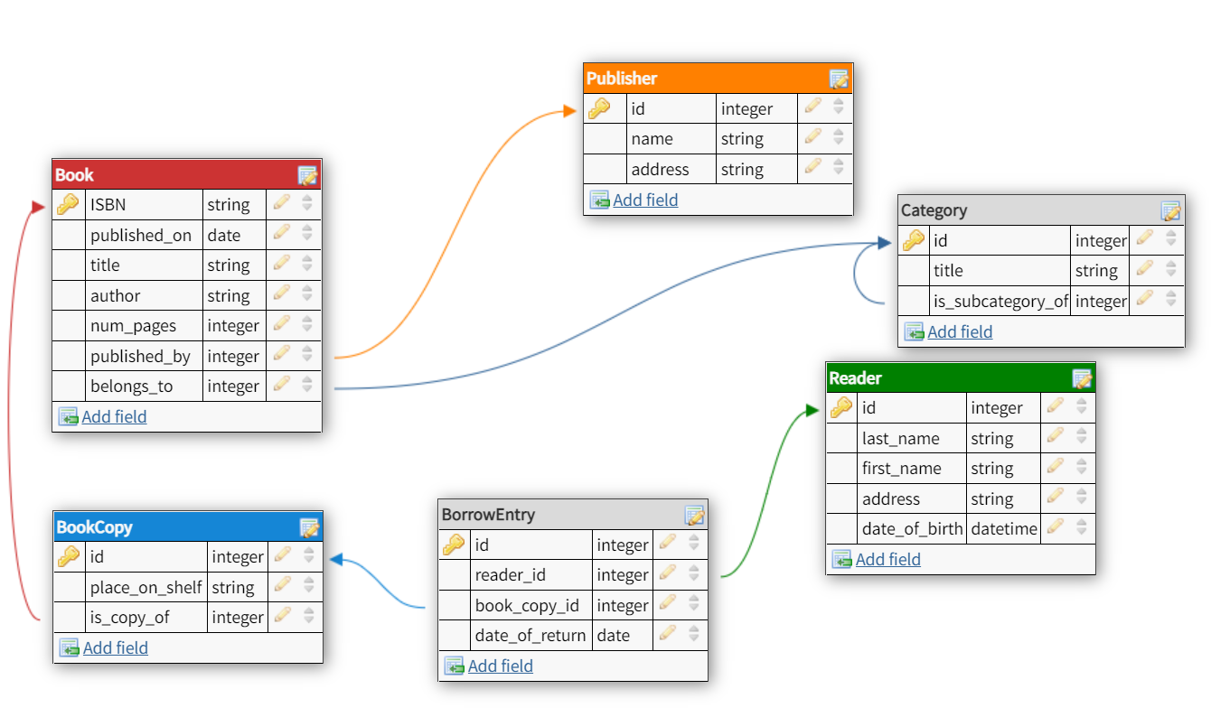

Пример

Books

|  |  |  |  |  |
| --- | --- | --- | --- | --- |
| ISBN | Title | Author | Published on | Number of pages |
| 9780345342966 | Fahrenheit 451 | [Ray Bradbury](https://www.amazon.com/Ray-Bradbury/e/B000AQ1HW4/ref=dp_byline_cont_book_1) | 01/01/1987 | 179 |
| 9780670240173 | Dialogues with Marcel Duchamp | Pierre Cabanne | 01/01/2019 | 224 |
| 9780321563842 | The C++ Programming Language | Bjarne Stroustrup | 01/05/2013 | 240 |
| 9781840227864 | The Little Prince | Antoine de Saint-Exupery | 01/01/2018 | 144 |

Categories

|  |  |
| --- | --- |
| Id | Title |
| 1 | Detective |
| 2 | True crime |
| 3 | Fantasy |
| 4 | Science fiction |
| 5 | Space |
| 6 | Adventures |
| 7 | Poetry |

Publishers

|  |  |  |
| --- | --- | --- |
| Id | Name | Address |
| 239 | Del Rey | 1745 Broadway New York New York 10019 USA |
| 240 | GarageMCA | 9/32 Krymsky Val st., 119049, Moscow, Russia |
| 241 | Ad Marginem Press | Perevedenovksy per., 18, b. 9 |

Book Copies

|  |  |
| --- | --- |
| Id | Place on shelf |
| 2 | 12 |
| 3 | 54 |
| 4 | 6 |
| 5 | 23 |
| 6 | 2 |
| 7 | 1 |

Readers

|  |  |  |  |  |
| --- | --- | --- | --- | --- |
| Id | First Name | Last Name | Date of birth | Address |
| 2 | Nataliia | Zubareva | 04/05/2001 | Ulitsa Miklukho-Maklaya, 6, Moscow, 117198 |
| 3 | Alexandra | Koneva | 26/12/2000 | Lomonosovskiy Prospekt, 27 корпус 4, Moscow, 119234 |
| 4 | Vitaliy | Sergeev | 09/08/1989 | Pokrovsky Blvd, 11, Moscow, 109028 |
| 5 | Anna | Andreeva | 18/11/2004 | Leninskiy Prospekt, дом 65, Moscow, 119991 |

Borrow Entries

|  |  |
| --- | --- |
| Id | Date of return |
| 1 | 25/09/2021 |
| 2 | 12/12/2021 |
| 3 | 01/03/2021 |
| 4 | 03/04/2021 |
| 5 | 04/05/2021 |
| 6 | 01/06/2021 |

Borrowed by

|  |  |
| --- | --- |
| Borrow entry id | Reader id |
| 4 | 4 |
| 6 | 4 |
| 1 | 2 |

Is borrowed

|  |  |
| --- | --- |
| Book copy id | Borrow entry id |
| 7 | 4 |
| 4 | 6 |
| 2 | 1 |

Is subcategory of

|  |  |
| --- | --- |
| Subcategory id | Category id |
| 2 | 1 |
| 6 | 5 |

Is copy of

|  |  |
| --- | --- |
| Copy id | Book isbn |
| 3 | 9781840227864 |
| 6 | 9780345342966 |
| 2 | 9780321563842 |

Is published by

|  |  |
| --- | --- |
| Book isbn | Publisher id |
| 9780345342966 | 239 |
| 9780670240173 | 240 |

Belongs to categories

|  |  |
| --- | --- |
| Book isbn | Category id |
| 9780345342966 | 4 |
| 9780345342966 | 6 |
| 9780321563842 | 1 |
| 9780321563842 | 2 |
| 9781840227864 | 5 |
| 9781840227864 | 6 |
| 9781840227864 | 3 |

Адрес

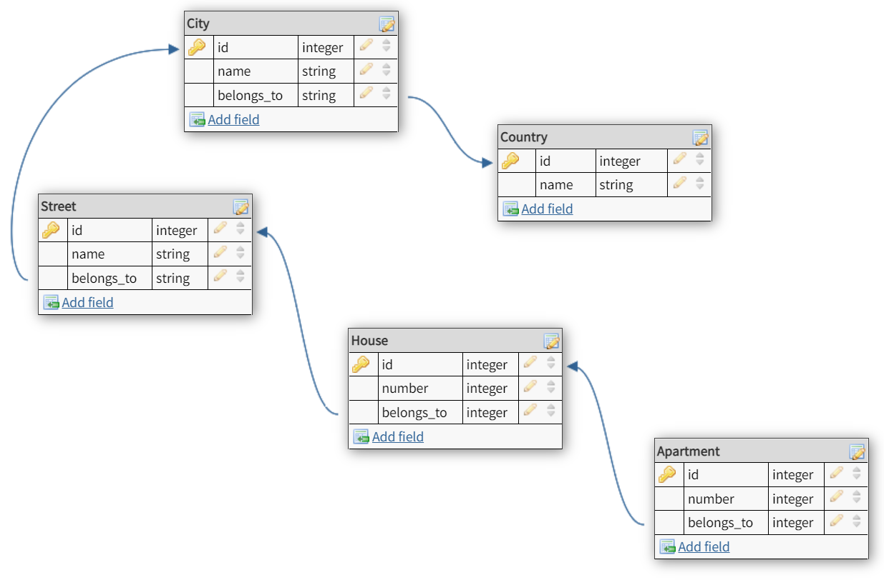

Пример

Apartments

|  |  |
| --- | --- |
| Id | Number |
| 12 | 1026 |
| 13 | 3 |
| 14 | 2 |
| 15 | 54 |

Houses

|  |  |
| --- | --- |
| Id | Number |
| 56 | 7 |
| 57 | 2 |
| 58 | 1 |
| 59 | 119 |

Streets

|  |  |
| --- | --- |
| Id | Name |
| 5 | 5 Avenue |
| 6 | Prospekt Mira |
| 7 | Nevsky Prospect |
| 8 | De Leeuw van Vlaanderenstraat |

Cities

|  |  |
| --- | --- |
| Id | Name |
| 3 | Moscow |
| 4 | Saint Petersburg |
| 5 | Amsterdam |
| 6 | New York |

Countries

|  |  |
| --- | --- |
| Id | Name |
| 1 | Russia |
| 2 | USA |
| 3 | Canada |
| 4 | Netherlands |

Apartment belongs to

|  |  |
| --- | --- |
| Apartment id | House id |
| 15 | 58 |
| 12 | 56 |
| 14 | 59 |

House belongs to

|  |  |
| --- | --- |
| House id | Street id |
| 59 | 7 |
| 57 | 5 |
| 56 | 8 |

Street belongs to

|  |  |
| --- | --- |
| Street id | City id |
| 8 | 5 |
| 6 | 3 |
| 5 | 6 |

City belongs to

|  |  |
| --- | --- |
| City id | Country id |
| 5 | 4 |
| 3 | 1 |
| 3 | 2 |

Соревнование

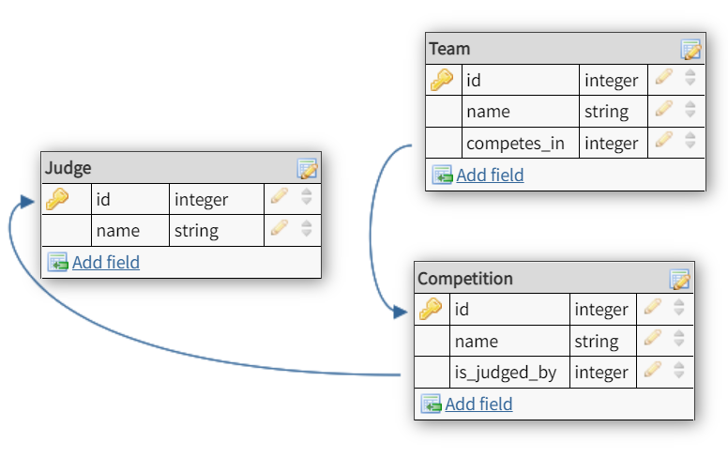

Пример

Teams

|  |  |
| --- | --- |
| Id | Name |
| 4 | Aliceband |
| 5 | Best team |
| 6 | Who |

Competitions

|  |  |
| --- | --- |
| Id | Name |
| 1 | ICPC |
| 2 | Olympic Games |

Judges

|  |  |
| --- | --- |
| Id | Name |
| 7 | Ruth Bader Ginsburg |
| 8 | Judy Sheindlin |
| 9 | Alex Summers |

Is judged by

|  |  |
| --- | --- |
| Competition id | Judge id |
| 2 | 9 |
| 1 | 8 |

Is competing in

|  |  |
| --- | --- |
| Team id | Competition id |
| 6 | 1 |
| 5 | 1 |
| 4 | 2 |

### Родители и дети

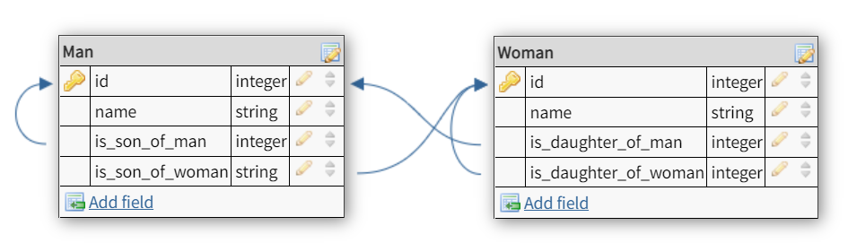

Пример

Men

|  |  |
| --- | --- |
| Id | Name |
| 1 | Paul |
| 2 | Evgeniy |
| 3 | James |
| 4 | Petr |

Women

|  |  |
| --- | --- |
| Id | Name |
| 1 | Anna |
| 2 | Maria |
| 3 | Katherina |
| 4 | Ella |

Is son of woman

|  |  |
| --- | --- |
| Id of son | Id of mother |
| 1 | 1 |
| 2 | 4 |
|  |  |

Is son of man

|  |  |
| --- | --- |
| Id of son | Id of father |
| 1 | 3 |
| 2 | 4 |

Is daughter of woman

|  |  |
| --- | --- |
| Id of daughter | Id of mother |
| 3 | 1 |
| 2 | 4 |

Is daughter of man

|  |  |
| --- | --- |
| Id of daughter | Id of father |
| 3 | 3 |
| 2 | 3 |

### ER

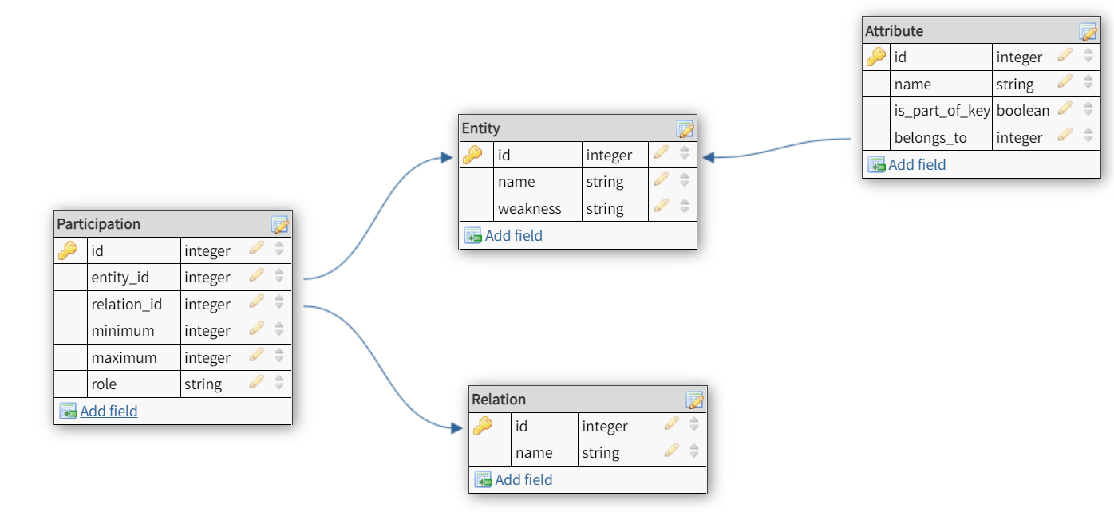

Пример

Entities

|  |  |  |
| --- | --- | --- |
| Id | Name | Weakness |
| 1 | People | Strong |
| 2 | Food | Strong |

Attributes

|  |  |  |
| --- | --- | --- |
| Id | Name | Is part of key |
| 1 | id_person | Yes |
| 2 | id_food | Yes |
| 3 | name | No |
| 4 | foodType | No |

Relations

|  |  |
| --- | --- |
| Id | Name |
| 1 | Person likes food |
| 2 | Person dislikes food |

Attributes belong to

|  |  |
| --- | --- |
| Attribute_id | Entity_id |
| 1 | 1 |
| 2 | 2 |
| 3 | 1 |
| 4 | 2 |

Participations

|  |  |  |
| --- | --- | --- |
| Id | Minimum | Maximum |
| 1 | 1 | Inf |
| 2 | 1 | Inf |
| 3 | 1 | Inf |
| 4 | 1 | Inf |

Entity in participation

|  |  |
| --- | --- |
| Participation id | Entity id |
| 1 | 1 |
| 2 | 2 |
| 3 | 1 |
| 4 | 2 |

Relationship in participation

|  |  |
| --- | --- |
| Participation id | Relation id |
| 1 | 1 |
| 2 | 1 |
| 3 | 2 |
| 4 | 2 |

## Номер 3

### Поезда

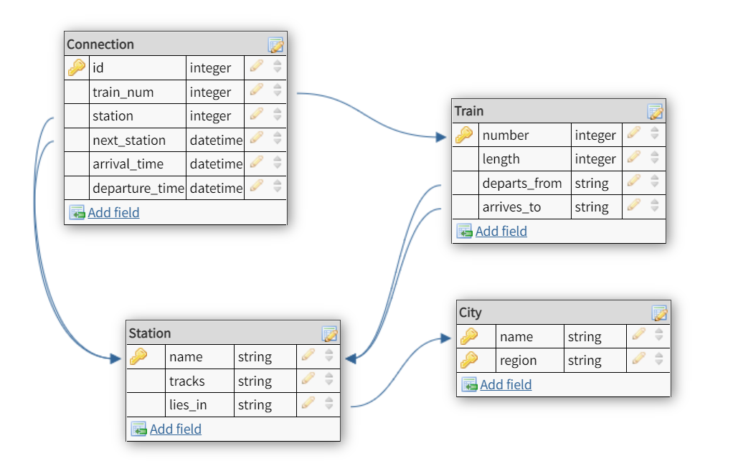

Пример

Trains

|  |  |
| --- | --- |
| Number | Length |
| 056А | 15 |
| 118Н | 10 |
| 012Я | 16 |

Stations

|  |  |
| --- | --- |
| Name | Tracks |
| Oktyabrskaya | 1,2,3,4 |
| Malaya Vishera | 1,2 |
| Glavny Vokzal | 1,2,3,4,5,6,7,8,9,10 |
| Kazansky Vokzal | 1,2,3,4,5,6,7,8,9,10,11,12,13,14,15 |
| Yaroslavsky Vokzal | 1,2,3,4,5,6,7,8,9,10,11,12,13,14,15 |
| Kazan | 1,2,3,4,5,6,7,8,9,10 |
| Vladimir | 1,2,3,4,5,6 |

Cities

|  |  |
| --- | --- |
| Name | Region |
| Moscow | Moscow |
| Saint Petersburg | Saint Petersburg |
| Malaya Vishera | Malovisherskiy |
| Vladimir | Vladimirskaya oblast |
| Kazan | Kazanskaya oblast |

Connections

|  |  |  |
| --- | --- | --- |
| Id | Arrival time | Departure time |
| 2 | 23:31 | 23:35 |
| 3 | 00:47 | 00:50 |
| 4 | 01:17 | 01:20 |
| 5 | 02:58 | 03:00 |

Train departs from station

|  |  |
| --- | --- |
| Train id | Station id |
| 056А | Oktyabrskaya |
| 118Н | Kazansky Vokzal |
| 012Я | Yaroslavsky Vokzal |

Train arrives to station

|  |  |
| --- | --- |
| Train id | Station id |
| 056А | Glavny Vokzal |
| 118Н | Kazan |
| 012Я | Vladimir |

Station lies in city

|  |  |
| --- | --- |
| Station id | City id |
| Oktyabrskaya | Moscow |
| Malaya Vishera | Malaya Vishera |
| Glavny Vokzal | Saint Petersburg |
| Kazansky Vokzal | Moscow |
| Yaroslavsky Vokzal | Moscow |
| Kazan | Kazan |
| Vladimir | Vladimir |

Connection by train

|  |  |
| --- | --- |
| Connection id | Train id |
| 2 | 056А |
| 3 | 056А |
| 4 | 056А |

Connection to station

|  |  |
| --- | --- |
| Connection id | Station id |
| 3 | Vyshniy Volochek |
| 4 | Bologoye Moskovskoye |
| 5 | Malaya Vishera |

Connection to next station

|  |  |
| --- | --- |
| Connection id | Station id |
| 3 | Bologoye Moskovskoye |
| 4 | Malaya Vishera |
| 5 | Saint Petersburg |

### Больница

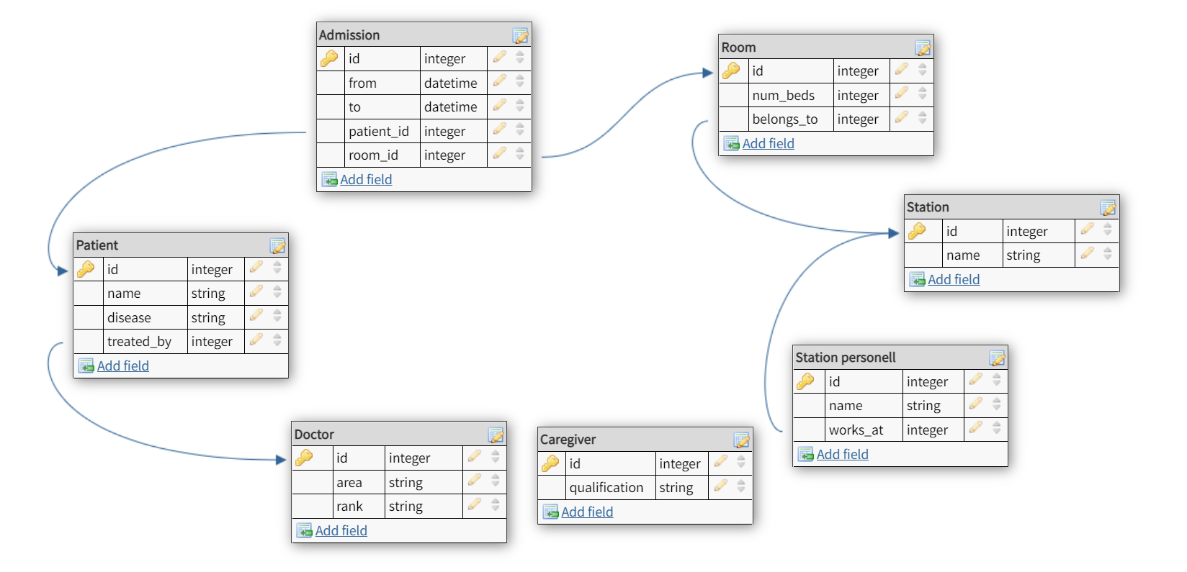

Пример

Station personnel

|  |  |
| --- | --- |
| Id | Name |
| 1 | Leonard McCoy |
| 2 | Rose Lalonde |
| 3 | Christine Chapel |
| 4 | Steven Jones |

Doctors

|  |  |  |
| --- | --- | --- |
| Id (from personnel id) | Area | Rank |
| 1 | Stomatology | Regular doctor |
| 2 | Therapist | Regular doctor |

Caregivers

|  |  |
| --- | --- |
| Id (from personnel id) | Qualification |
| 3 | Head nurse |
| 4 | Nurse |

Patients

|  |  |  |
| --- | --- | --- |
| Id | Name | Disease |
| 1 | Adam Lane | Influenza |
| 2 | Jeff Braun | Stomatitis |

Stations

|  |  |
| --- | --- |
| Id | Name |
| 1 | Dental |
| 2 | Viral |

Rooms

|  |  |
| --- | --- |
| Id | Number of beds |
| 1 | 4 |
| 2 | 5 |
| 3 | 4 |

Admissions

|  |  |  |
| --- | --- | --- |
| Id | From | To |
| 1 | 01/10/2021 | 08/10/2021 |
| 2 | 28/09/2021 | 10/10/2021 |

Patient is treated by doctor

|  |  |
| --- | --- |
| Patient id | Doctor id |
| 1 | 2 |
| 2 | 1 |

Admission of patient

|  |  |
| --- | --- |
| Admission id | Patient id |
| 1 | 1 |
| 2 | 2 |

Admission to room

|  |  |
| --- | --- |
| Admission id | Room id |
| 1 | 2 |
| 2 | 1 |

Room belongs to a station

|  |  |
| --- | --- |
| Room id | Station id |
| 1 | 1 |
| 2 | 2 |
| 3 | 1 |

Personnel belongs to a station

|  |  |
| --- | --- |
| Personnel id | Station id |
| 1 | 1 |
| 2 | 2 |
| 3 | 1 |
| 4 | 2 |