**First version**

image_size = (1716, 942) -> 1.0

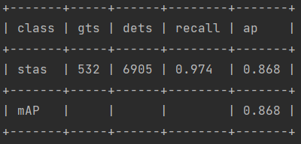

new_image_size = (1372, 753) -> 0.8

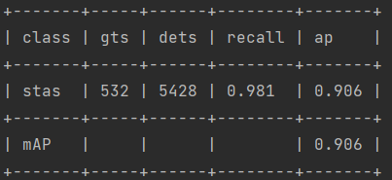

new_image_size = (1000, 565) -> 0.6

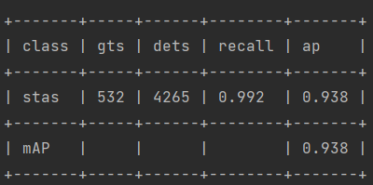

new_image_size = (858, 471) -> 0.5

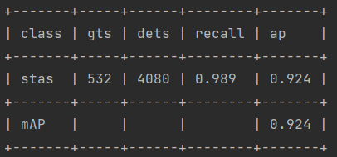

new_image_size = (1200, 660) -> 0.7

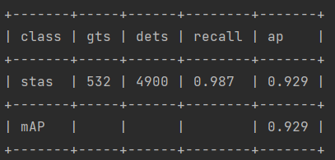

0.6 without flip

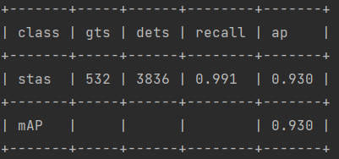

Multiscale

test_mutli_scale_image_size = [(858, 471), (850, 520), (1000, 565), (1000, 610), (1200, 660), (1200, 720)]

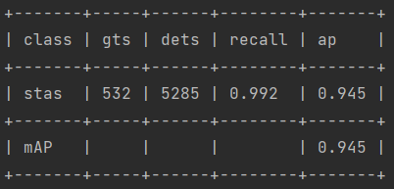

test_mutli_scale_image_size = [(686, 376), (686, 420), (850, 471), (850, 520), (1000, 565), (1000, 610), (1200, 660), (1200, 710), (1372, 753), (1372, 800)]

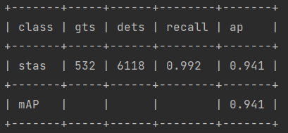

test_mutli_scale_image_size = [(858, 471), (858, 660), (1000, 565), (1000, 760)]

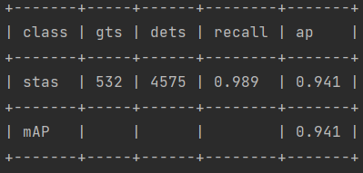

new_image_size = (943, 518) -> 0.55

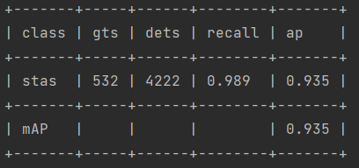

new_image_size = (1115, 612) -> 0.65

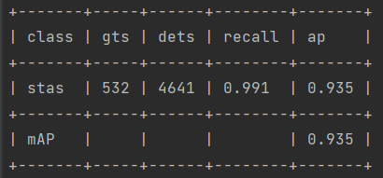

test_mutli_scale_image_size = [(858, 471), (943, 518), (1000, 565), (1115, 612), (1200, 660)]

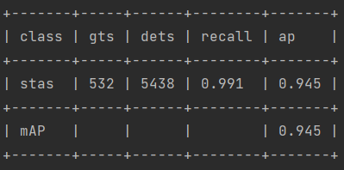

Model epoch_5

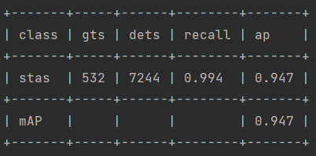

???????

mutli_scale_image_size = [(850, 471), (850, 500), (900, 500), (900, 520)]

new_image_size = (1000, 565)

沒有fix seed

又重新get validation

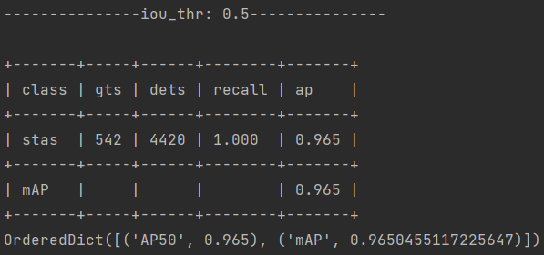

Max per image -> 200

Best v3

Score_threshold 0.001

**OHEMSampler**

**Albu augmentation**

**Cdiouloss**

**Range next**

**Cosine annealing**

**Loss weight 5**

**[10, 20, 30, 40, 50, 60, 70, 80, 90, 100, 110, 120, 130, 140, 150, 160, 170, 180, 190, 200, 210, 220, 230, 240, 250, 260, 270, 280, 290, 300, 310, 320, 330, 340, 350, 360, 370, 380, 390, 400, 410, 420, 430, 440, 450, 460, 470, 480, 490, 500, 510, 520, 530, 540, 550, 560, 570, 580, 590, 600]**

**[0, 0, 19, 96, 202, 294, 278, 295, 239, 195, 154, 152, 114, 102, 93, 69, 61, 54, 26, 32, 28, 37, 20, 30, 21, 12, 14, 17, 9, 9, 14, 4, 5, 6, 7, 11, 8, 6, 5, 2, 1, 0, 3, 2, 2, 0, 1, 1, 3, 1, 2, 4, 1, 3, 2, 0, 1, 2, 1, 15]**

**0.6 0.8 10. 1.5**

**1.6 1.25 1.0 0.6**

**5e-5 > 2e-5**

**V11-2 best 4 scale**

**V11 -> value**

**V12 -> range without albu**

**V12-1 -> scale 4, random sample 0.927**

**V12-2 -> scale 4, oehm sample 0.930 \***

**V12-3 -> scale 6, oehm sample 0.921**

**V12-4 -> scale 8, oehm sample 0.927**

**V12-5 -> scale 2, oehm sample 0.925**

**V12-6 -> scale 3, oehm sample 0.927**

**V13 different train scale**

**V13-1 -> [(686, 376), (950, 520)] -> value**

**V13-2 -> [(686, 376), (950, 520)] -> range**

**Epoch 10 [5, 8]**

**V13-3 -> [(686, 376), (950, 520)] -> value 0.932**

**[0.5, 1.0, 2.0]**

**V13-4 -> [(686, 376), (950, 520)] -> 0.929**

**[0.6, 1.1, 1.6]**

**V13-5 -> [(686, 376), (950, 520)]**

**range**

**[0.6, 0.95, 1.1, 1.3, 1.6]**

**Albu**

**Loss 5.0**

**V13-5 -> [(686, 376), (950, 520)] 0.931**

**range**

**[0.6, 0.95, 1.1, 1.3, 1.6]**

**Albu - colorjitter**

**0.85 1.0 1.28**

**0.8 1.0 1.1 1.35**

**0.78 0.92 1.0 1.2 1.41**

**V14-1**

**0.78 0.92 1.0 1.2 1.41**

**dict(**

**type='OneOf',**

**transforms=[**

**dict(**

**type='RGBShift',**

**r_shift_limit=10,**

**g_shift_limit=10,**

**b_shift_limit=10,**

**p=1.0),**

**dict(**

**type='HueSaturationValue',**

**hue_shift_limit=20,**

**sat_shift_limit=30,**

**val_shift_limit=20,**

**p=1.0),**

**dict(type='FancyPCA', alpha=0.1, always_apply=False, p=1.0), #trick**

**],**

**p=0.1),**

**0.933 good**

**Epoch10 best**

**V5 finetune on V14-1**

**Very bad**

**V14-2**

**Base on v14-1**

**0.8 1.0 1.1 1.35**

**0.929**

**V14-3**

**Base on V14-1**

**0.85 1.0 1.28**

**V14-4**

**Base on V14-1**

**dict(**

**type='OneOf',**

**transforms=[**

**dict(type='Blur', blur_limit=3, p=1.0),**

**dict(type='MedianBlur', blur_limit=3, p=1.0),**

**dict(type='MotionBlur', blur_limit=6, always_apply=False, p=1.0)#trick**

**],**

**p=0.1),**

**0.932**

**V14-5 0.929**

**Base on v14-4**

**Loss 2**

**V14-6 0.934**

**Base on v14-4**

**CioULoss**

**V14-7**

**Base on v14-6**

**Loss 5 10 20**

**Bad**

**V14-8**

**Base on v14-6**

**Mosaic0.2 + mixup0.2**

**0.935**

**Mixup0.94**

**0.928 bad**

**V14-9**

**Base on v14-8**

**Focal_ciou_loss**

**0.930**

**Base on v14-4 0.928**

**FocalCIoULoss**

**Bad**

**0.5 bad**

**0.25 bad**

**2 bad**

**FocalCIoULoss**

**2**

**0.934**

**FoCalCIoULoss**

**(1 - IoU)**gamma**

**Gamma = 0.5**

**V14-10(Gone)**

**FocalEIoULoss - old**

**0.933**

**V14-11**

**FocalCIoULoss 000000000**

**5**

**FoCalCIoULoss**

**(1 - IoU)**gamma**

**Gamma = 2**

**Eval loss**

**V14-6 origin**

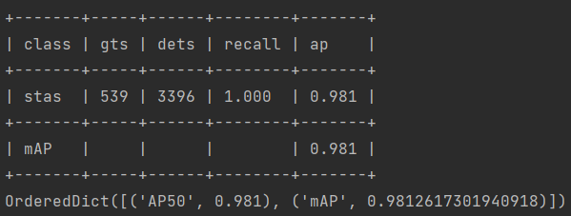

**Nms**

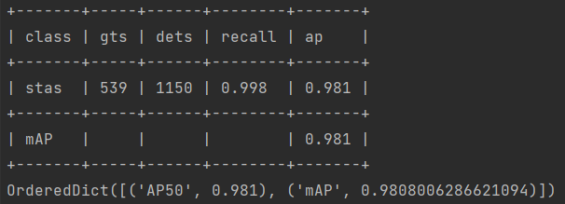

**Soft_Nms0.4**

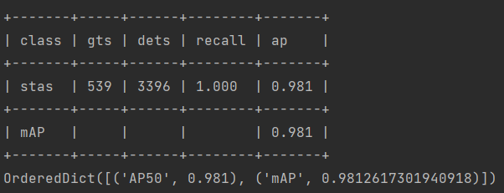

**Soft_nms 0.6**

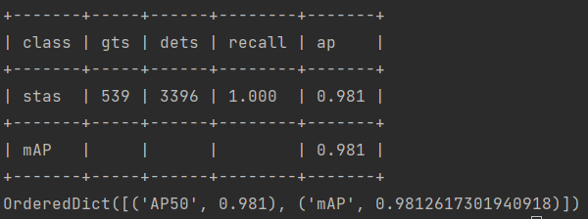

**Softnms1.0**

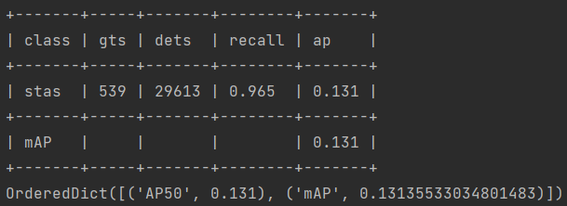

**Softnms 0.8**

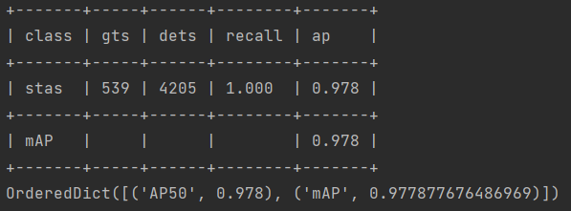

**Softnms 0.7**

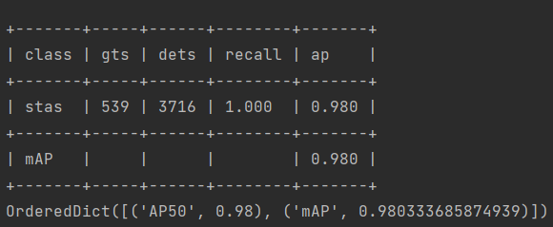

**Softmax0.6**

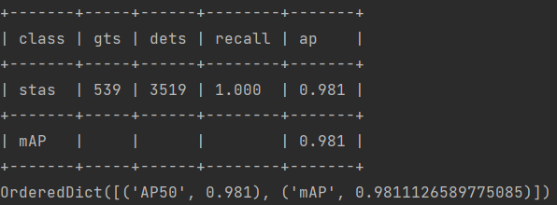

**Softmax0.5**

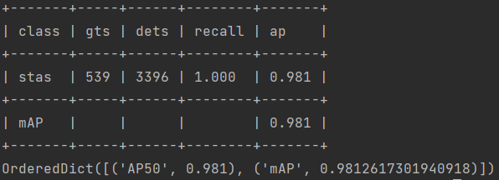

**Softnms0.4**

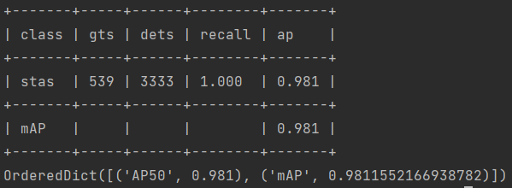

**Softnms0.3**

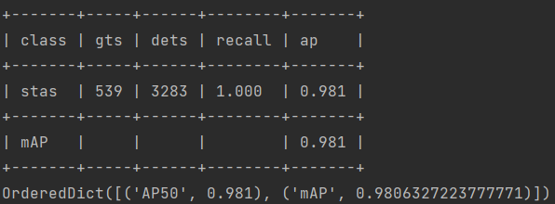

**WBF 1.0**

**0.55**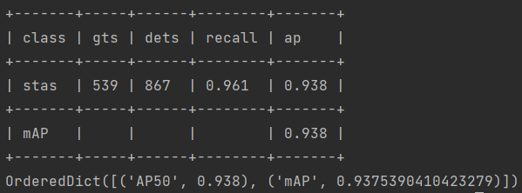

**0.75**

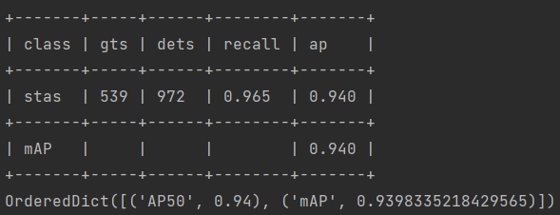

**0.95**

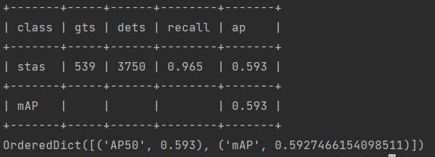

**Mixup 0.4**

**0.928**