The Run Time Table

Implementation | N = 128 | N = 256 | N = 512 | N = 1024 | N = 2048
CPU(C) | 1.555 ms | 16.223 ms | 148.151 ms | 1.295 sec | 20.713 sec
Naive CUDA | 0.452 ms | 0.576 ms | 1.392 ms | 9.457 ms | 52.582 ms
Optimized CUDA | 0.372 ms | 0.741 ms | 2.120 ms | 9.700 ms | 47.754 ms
cuBLAS | 20.301 ms | 1.703 ms | 1.052 ms | 1.482 ms | 6.804 ms

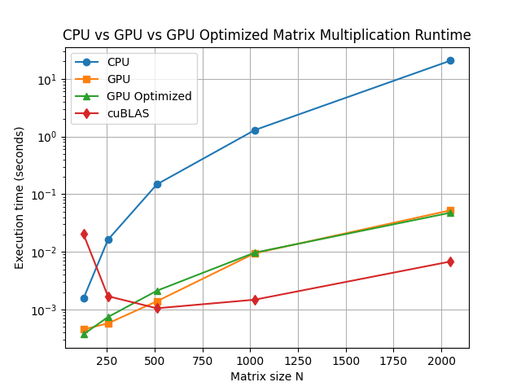

Analysis questions
- How does performance change as matrix size increases?
    - CPU: Runtime grows very fast (roughly O(N^3)), as expected for standard matrix multiplication.
    - Naive CUDA: Very fast for small matrices but increases slower than CPU.
    - Optimized CUDA: Slightly slower than naive for small N, but better than naive at larger N.
    - cuBLAS: Extremely optimized. Runtime sometimes smaller than both naive and optimized CUDA, especially for mid-sized matrices.
- At what point does the GPU significantly outperform the CPU?
When N >= 256, GPU starts dominating the performance. But for small matrices (N=128), GPU speedup is minimal because kernel launch overhead and memory transfer dominate.

- How much speedup is gained by tiling optimization vs. naïve CUDA?
N | Naive | Optimized | Speedup
128 | 0.452 | 0.372 | 1.22×
256 | 0.576 | 0.741 | 0.78× (slower!)
512 | 1.392 | 2.120 | 0.66× (slower!)
1024 | 9.457 | 9.700 | 0.97×
2048 | 52.582 | 47.754 | 1.10×

Tiling optimization only pays off for very large matrices; for small/medium matrices, naive GPU can be faster.

- How close is your optimized kernel to cuBLAS performance?
    - Small N (<= 256 ): Optimized kernel can beat cuBLAS because cuBLAS has a minimum startup overhead (library initialization, tuning).
    - Large N (>= 512): cuBLAS is much faster (up to 7×).

- Why might cuBLAS still outperform hand-written kernels?
    - Highly tuned kernels: cuBLAS is optimized per GPU architecture (warp-level, instruction-level parallelism, memory coalescing).
    - Memory optimization: Uses shared memory, register tiling, prefetching, and avoids bank conflicts.
    - Vectorization: Takes advantage of GPU vector units (SIMD instructions).
    - Auto-tuning & blocking: Dynamically chooses best block size, tile size, and loop unrolling.
    - Pipeline optimization: Overlaps memory transfer and compute efficiently.

- Why cuBLAS works faster when N increases from 128 to 256:
    - The “fixed overhead” isn’t truly constant in runtime measurements
For very small matrices (N=128), cuBLAS may choose a general, safe, but inefficient algorithm because it thinks the matrices are “too small to optimize aggressively;” For slightly larger matrices (N=256), it switches to a faster path—using vectorized instructions, optimized tiling, or shared memory blocks—so the runtime drops instead of increasing.

    - Memory alignment & kernel choice quirks
N=128 may not be “aligned” well for certain SIMD/vector operations, so the library falls back to a simple, slower kernel. N=256 is better aligned and triggers a high-performance kernel, giving faster runtime than for N=128.

