**Problem A:**

**The Suspects**

Time Limit: 3 seconds

**Problem Description**

Severe acute respiratory syndrome (SARS), an atypical pneumonia of unknown aetiology, was recognized as a global threat in mid-March 2003. To minimize transmission to others, the best strategy is to separate the suspects from others.

In the Not-Spreading-Your-Sickness University (NSYSU), there are many student groups. Students in the same group intercommunicate with each other frequently, and a student may join several groups. To prevent the possible transmissions of SARS, the NSYSU collects the member lists of all student groups, and makes the following rule in their standard operation procedure (SOP).

Once a member in a group is a suspect, all members in the group are suspects.

However, they find that it is not easy to identify all the suspects when a student is recognized as a suspect. Your job is to write a program which finds all the suspects.

**Input Format**

The input file contains several cases. Each test case begins with two integers $n$ and $m$ on a line, in which $n$ is the number of students, and $m$ is the number of groups. You may assume that $0<n≤30000$ and $0≤m≤500$. Every student is numbered by a unique integer between 0 and $n-1$, and initially student 0 is recognized as a suspect in all the cases. This line is followed by $m$ member lists of the groups, one line per group. Each line begins with an integer $k$ by itself representing the number of members in the group. Followed the

number of members, there are $k$ integers representing the students in this group. All the integers in a line are separated by a space.

A case with $n=0$ and $m=0$ indicates the end of the input, and need not be processed.

**Output Format**

For each case, output the number of suspects in one line.

**Example**

|  |  |
| --- | --- |
| **Sample Input:** | **Sample Output:** |
| 100 4  2 1 2  5 10 13 11 12 14  2 0 1  2 99 2  200 2  1 5  5 1 2 3 4 5  1 0  0 0 | 4  1  1 |

**Problem B:**

**Area of rectangles**

Time Limit: 1 second

**Problem Description**

Given $n$ rectangles in the plane, find the area of the union of all rectangles.

**Input Format**

The first line is the number of test cases. The first line of each test case is $n$, $n≤20000$, and each of the following $n$ lines is the data of a rectangle. Each rectangle is given by four nonnegative integers $x_{1}$, $y_{1}$, $x_{2}$, $y_{2}$, where $\left(x_{1},y_{1}\right)$ and $\left(x_{2},y_{2}\right)$ are two opposite corners of the rectangle. The coordinates are at most 120000, and separated by a space.

**Output Format**

For each test case, output the area of the union of all rectangles.

**Problem C:**

**Cross Shot**

Time Limit: 2 seconds

**Problem Description**

平面上有N個矩形目標，每個矩形有一個價值W[i]。現在想選擇一點P，通過此點發射出一條水平與一條垂直的射擊線，這兩條線所經過所有矩形價值總和就是本次射擊的得分，本題要計算出一次射擊的最高得分。所謂直線通過矩形是指兩者至少交集一點。

**Input Format**

第一行有一正整數T代表共有T筆測資，T≤ 9，以下依序有T筆測資。每筆測資的第一行是一個大於1的整數N，接下來有N行，每行五個整數表示一個矩形，依序是x1, y1,x2,y2與w，其中0 ≤ x1 < x2 <M，0 ≤ y1 < y2 <M代表矩形的水平與垂直座標範圍，而w是不超過100的非負整數代表此矩形的價值。

**Output Format**

依序每一行輸出每一筆測資所求的最大得分。

**Example**

|  |  |
| --- | --- |
| **Sample Input** | **Sample Output** |
| 2  3  0 2 5 4 1  5 4 7 6 2  8 7 9 9 3  4  1 1 2 2 2  3 1 4 2 3  1 3 2 4 4  3 3 4 4 5 | 6  12 |

**Problem D:**

**Helicopter**

Time Limit: 2 seconds

**Problem Description**

小智的學校在天空之城，他每天開直升機上學，現在他想要規劃一條路徑以便在從家裡到學校的路上可以抓到最多的寶貝，請你寫個程式幫助他。

我們將學校與他家之間所有的位置劃分成N*N的格子，每個格子以坐標(x,y)表示，其中x代表水平距離，y代表高度，而小智家的坐標在(0,0)的位置，學校在(N-1,N-1)的位置，由於他的父母不准他上學途中貪玩繞路，直升機被設定成每次只能向前或向上一格，也就是說，如果從(x,y)到(x+1,y)或(x,y+1)，當然，他也不可以超過x<N且y<N範圍，否則會無法到達學校。

小智到學校的路途上一共有N隻寶貝，每隻寶貝可以補獲的範圍是某特定高度而水平座標在某連續區間的格子。明確的說，對於寶貝P(i), 0≦ i <N，要捕抓到P(i)，小智必須經過下列座標之一：{(x,y)| S(i)≦x≦T(i) and y=i}，其中所有的S(i)與T(i)都已經透過抓寶雷達得到資料了。

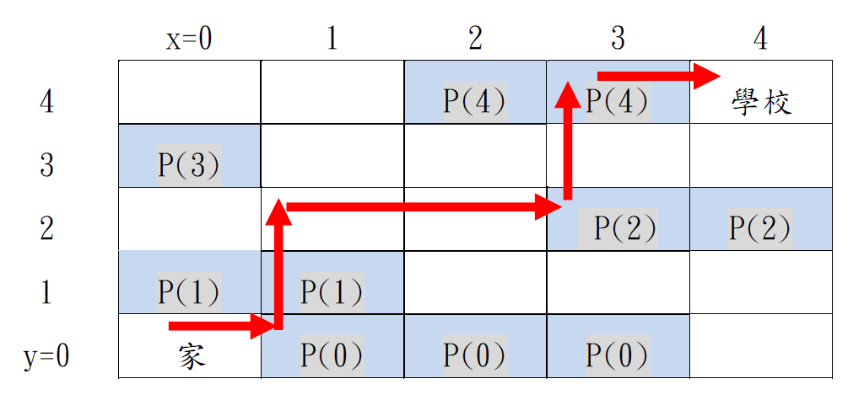

上圖是一個N=5的例子，藍色區塊顯示可以捕抓到寶貝的地方，請注意，每一個寶貝都是在一個水平連續區間。紅線所顯示的路徑是一條合乎規定的路徑，因為他每一步都只有向右或向上，沿這一條路徑可以捕抓到四隻寶貝，是所有可能路徑中可以捕抓到寶貝數最多的。

**Input Format**

輸入包含多個測試案例。每個測試案例的第一行是座標範圍的N且N≦250000，接下來N行，每一行有兩個整數S(i)與T(i)，依序是i=0,1,…N-1，其中0≦S(i)≦T(i)<N。一筆測試案例結束後是下一筆測試案例，若N=0代表輸入資料結束，不須處理這筆資料。

**Output Format**

針對每個測試案例的每個計算要求，以一行輸出小智最多可以抓到幾隻寶貝。

**Example**

|  |  |
| --- | --- |
| **Sample Input** | **Sample Output** |
| 5  2 2  1 1  0 0  2 2  4 4  2  1 1  0 0  0 | 3  1 |

**Problem E:**

**Shooting rectangles**

Time Limit: 2 seconds

**Problem Description**

There are $N$ targets on the plane, and we want to shoot all the targets by minimum number of shoots. Each target is a rectangle which can be specified by a 4-tuple $\left(x_{1},y_{1},x_{2},y_{2}\right)$ such that the rectangle contains all points in the set

$$\left\{\left(x,y\right) | x_{1}≤x≤x_{2} and y_{1}≤y≤y_{2}\right\}$$

Any shoot must be a straight line passing through the origin (0,0), and a target is shot if the line intersects the target, i.e., the line and the rectangle share at least one point. The goal of this problem is to determine the minimum number of shoots such that every target will be shot at least once.

**Technical Specification**

* The number of test cases is at most 9.
* For each test case, the number of rectangles $N$, $1≤N≤100000$.
* All X-coordinates are integers between 0 and 30000. All Y-coordinates are integers between -30000 and 30000.

**Input Format**

The first line of the input file contains an integer indicating the number of test cases. Then, the test cases are given one by one. Each test case starts with a line containing the number N of rectangles in the case. Each of the next $N$ lines specifies a rectangle. A rectangle is given by four integers $x_{1}$, $y_{1}$, $x_{2}$, $y_{2}$, and there is a space between two integers.

**Output Format**

For each test case, output the minimum number of shoots in one line.

**Example**

|  |  |
| --- | --- |
| **Sample Input** | **Sample Output** |
| 2  4  0 -20 10 -10  10 -9 20 10  5 10 10 20  0 20 4 30  5  0 -20 10 -10  10 -10 20 10  5 10 10 20  4 20 5 21  0 21 50 25 | 2  2 |

**Problem F:**

**Three Points of Time**

Time Limit: 2 seconds

**Problem Description**

There are $N$ time intervals. The $i$-th time interval is represented by $[s(i),t(i)]$, where $s(i)$ and $t(i)$ are the starting and the finishing time. In addition, there is a weight $w(i)$ associated with the interval. You are asked to choose three points of time to maximize the total weight of intervals containing at least one of your choices. An interval $[s(i),t(i)]$ contains a point of time x if and only if $s(i)≤x≤t(i)$.

**Technical Specification**

$N≤70000$

* All $s(i)$, $t(i)$, $w(i)$ are integers

$0≤s\left(i\right)≤t\left(i\right)≤2^{30}$

$1≤w\left(i\right)≤1000$

**Input Format**

The first line is an integer indicating the number of test cases. There are at most 8 test cases. Each test case starts with a line containing $N$, and the following $N$ lines are the data for the intervals, one line for one interval. Each line contains three numbers, *i.e.*, $s(i)$, $t(i)$, and then $w(i)$, separated by a space.

**Output Format**

For each test case, output the maximum total weight in one line.

**Example**

|  |  |
| --- | --- |
| **Sample Input:** | **Sample Output:** |
| 1  7  0 1 1  1 3 2  2 5 4  4 10 1  4 6 2  7 8 2  10 11 1 | 12 |