Integrating the Healthcare Enterprise



IHE IT Infrastructure

Technical Framework Supplement

Mobile Alert Communication Management

(mACM)

HL7® FHIR® Release 4

Using Resources at FMM Level 2

Rev. 2.3 – Trial Implementation

Date: July 24, 2018

Author: IHE ITI Technical Committee

Email: iti@ihe.net

**Please verify you have the most recent version of this document.** See [here](http://ihe.net/Technical_Frameworks/) for Trial Implementation and Final Text versions and [here](http://ihe.net/Public_Comment/) for Public Comment versions.

**Foreword**

This is a supplement to the IHE IT Infrastructure Technical Framework V15.0. Each supplement undergoes a process of public comment and trial implementation before being incorporated into the volumes of the Technical Frameworks.

This supplement is published on July 24, 2018 for trial implementation and may be available for testing at subsequent IHE Connectathons. The supplement may be amended based on the results of testing. Following successful testing it will be incorporated into the IT Infrastructure Technical Framework. Comments are invited and may be submitted at [http://www.ihe.net/ITI_Public_Comments](http://www.ihe.net/ITI_Public_Comments/).

This supplement describes changes to the existing technical framework documents.

“Boxed” instructions like the sample below indicate to the Volume Editor how to integrate the relevant section(s) into the relevant Technical Framework volume.

Amend Section X.X by the following:

Where the amendment adds text, make the added text bold underline. Where the amendment removes text, make the removed text bold strikethrough. When entire new sections are added, introduce with editor’s instructions to “add new text” or similar, which for readability are not bolded or underlined.

General information about IHE can be found at [http://ihe.net](http://ihe.net/).

Information about the IHE IT Infrastructure domain can be found at [http://ihe.net/IHE_Domains](http://ihe.net/IHE_Domains/).

Information about the organization of IHE Technical Frameworks and Supplements and the process used to create them can be found at [http://ihe.net/IHE_Process](http://ihe.net/IHE_Process/) and [http://ihe.net/Profiles](http://ihe.net/Profiles/).

The current version of the IHE IT Infrastructure Technical Framework can be found at [http://ihe.net/Technical_Frameworks](http://ihe.net/Technical_Frameworks/).

CONTENTS

Introduction to this Supplement 5

Open Issues and Questions 6

Closed Issues 6

General Introduction 10

Appendix A – Actor Summary Definitions 10

Appendix B – Transaction Summary Definitions 10

Glossary 10

**Volume 1 – Profiles 11**

Copyright Licenses 11

Domain-specific additions 11

42 Mobile Alert Communication Management (mACM) Profile 12

42.1 Mobile Alert Communication Management (mACM) Actors, Transactions, and Content Modules 12

42.1.1 Actor Descriptions and Actor Profile Requirements 13

42.1.1.1 Alert Reporter 13

42.1.1.2 Alert Aggregator 14

42.2 mACM Actor Options 14

42.2.1 Query for Alert Status Option 14

42.2.2 Disseminate and Report Alert Status Option 15

42.3 mACM Required Actor Groupings 15

42.4 mACM Overview 15

42.4.1 Concepts 16

42.4.2 Use Cases 16

42.4.2.1 Use Case #1: Crisis Response 18

42.4.2.1.1 Crisis Response Use Case Description 19

42.4.2.1.2 Crisis Response Process Flow 19

42.4.2.2 Use Case #2: Care Reminders 20

42.4.2.2.1 Care Reminder Use Case Description 20

42.4.2.2.2 Care Reminder Process Flow 21

42.5 mACM Security Considerations 21

42.5.1 Patient Safety Considerations 22

42.6 mACM Cross Profile Considerations 22

42.6.1 Health Worker Registry Services 22

42.6.2 Client Registry Services 25

**Volume 2 – Transactions 29**

3.84 Mobile Report Alert [ITI-84] 29

3.84.1 Scope 29

3.84.2 Actor Roles 29

3.84.3 Referenced Standards 29

3.84.4 Interaction Diagram 30

3.84.4.1 Mobile Report Alert Request 30

3.84.4.1.1 Trigger Events 31

3.84.4.1.2 Message Semantics 31

3.84.4.1.2.1 FHIR CommunicationRequest Resource Constraints 31

3.84.4.1.2.1.1 FHIR CommunicationRequest Resource Constraints – Disseminate and Report Alert Status Option 32

3.84.4.1.3 Expected Actions 33

3.84.4.1.3.1 FHIR Communication Constraints 34

3.84.4.1.3.2 Expected Actions – Disseminate and Report Alert Status Option 35

3.84.4.2 Mobile Report Alert Response 37

3.84.4.2.1 Trigger Events 37

3.84.4.2.2 Message Semantics 37

3.84.4.2.3 Expected Actions 37

3.84.5 Alert Terminologies and Mappings 37

3.84.5.1 Defined Terminologies 37

3.84.5.2 Mappings Between Terminologies 39

3.84.6 Security Considerations 42

3.85 Query for Alert Status [ITI-85] 42

3.85.1 Scope 42

3.85.2 Actor Roles 42

3.85.3 Referenced Standards 42

3.85.4 Interaction Diagram 43

3.85.4.1 Query for Alert Status Request Message 43

3.85.4.1.1 Trigger Events 44

3.85.4.1.2 Message Semantics 44

3.85.4.1.3 Expected Actions 44

3.85.4.2 Query for Alert Status Response Message 44

3.85.4.2.1 Trigger Events 44

3.85.4.2.2 Message Semantics 44

3.85.4.2.3 Expected Actions 45

3.85.5 Alert Terminologies and Mappings 45

3.85.6 Security Considerations 45

Volume 2 Namespace Additions 46

# Introduction to this Supplement

|  |  |  |  |  |  |  |
| --- | --- | --- | --- | --- | --- | --- |
| Whenever possible, IHE profiles are based on established and stable underlying standards. However, if an IHE domain determines that an emerging standard has high likelihood of industry adoption, and the standard offers significant benefits for the use cases it is attempting to address, the domain may develop IHE profiles based on such a standard. During Trial Implementation, the IHE domain will update and republish the IHE profile as the underlying standard evolves.  Product implementations and site deployments may need to be updated in order for them to remain interoperable and conformant with an updated IHE profile.  This mCSD Profile is based on Release 4 of the emerging HL7®[1] FHIR®[2] specification. HL7 describes FHIR Change Management and Versioning at <https://www.hl7.org/fhir/versions.html>.  HL7 provides a rating of the maturity of FHIR content based on the FHIR Maturity Model (FMM): level 0 (draft) through N (Normative). See [http://hl7.org/fhir/versions.html#maturity](http://hl7.org/fhir/versions.html" \l "maturity).  The FMM levels for FHIR content used in this profile are:   |  |  | | --- | --- | | FHIR Resource Name | FMM Level | | Communication | 2 | | CommunicationRequest | 2 | |

The mACM Profile provides the infrastructural components needed to send short, unstructured text alerts to human recipients and can record the outcomes of any human interactions upon receipt of the alert. The mACM Profile additionally allows for a feedback mechanism to determine the status of an alert through the use of alert statuses.

## Open Issues and Questions

*#6) MEMLS has location notion of physical offset (e.g., within building). How should this be represented for the dissemination event location field? See Appendix A of PCD MEM-LS Supplement.*

*#11) Open Issue: mACM definition of “alert” is not same as general definition:  
http://ihe.net/uploadedFiles/Documents/Templates/IHE_TF_GenIntro_AppD_Glossary_Rev1.0_2014-07-01.pdf*

*It is not clear how to resolve: For example, PCD’s term could be broadened or we could rewrite this profile to not use the term alert.*

*#19) Opened CPs with FHIR (10390 and 10391) to enable searching on CommunicationRequest.reason and Communication.reason.*

*#21) In Table 3.84.5.2-3: Alert Status Value Set Mapping there are many values from PCD that are combined into one value from FHIR. We will open a CP to add failed, but are there others that should be requested and is this a problem? The CommunicationRequest and Communication statuses are more directly related to that particular communication and request and not really of the alert itself. Responses would be handled as a second Communication resource. notDone and notDoneReason can also be used to track the reason one Communication failed or wasn’t sent. Does there need to be a field in CommunicationRequest to track the current alert status? Is there a better mapping of these values in the table?*

## Closed Issues

*#0) Should a codeset be defined to capture the priority of an alert in the flag.priority resource. .*

*#1) Would we be prescriptive about the way to set PCD abnormality flags in the flag.characteristics data field? Table 8.3 is referenced, but no uri or oid is specified.*

*#2) mACM defines FHIR extensions which require profiles in 3.84.41.2.1and 3.85.41.2.1. FHIR requires that these profiles are published. Currently the text states that the profiles are available at, for example:*

*http://www.ihe.net/fake_url_for_trial_implementation/mACM/Profile/flag.recipient*

*these URLs are examples only. Upon publication, a permanent home for any needed extension points should be defined as an IHE resource.*

We have removed all extensions and just have constraints.

*#3) Do not have a way to identity a device which is a non-medical device (e.g., not subject to FDA regulation) A clarification issue on FHIR was raised:*

<http://gforge.hl7.org/gf/project/fhir/tracker/?action=TrackerItemEdit&tracker_item_id=6209&start=0>

*#4) Should we have Device as a recipient in transactions 84 and 85. This is not specifically required for the uses cases described in Vol 1, but may be useful for PCD.*

*#5) For the flag.author data field, it would be useful to have the author of an alert be an Organization resource (e.g., CDC). A FHIR issue was filed:*

[*http://gforge.hl7.org/gf/project/fhir/tracker/?action=TrackerItemEdit&tracker_item_id=6208&start=0*](http://gforge.hl7.org/gf/project/fhir/tracker/?action=TrackerItemEdit&tracker_item_id=6208&start=0)

*If this Issue is not approved, an extension point should be added to the flag resource to allow an Organizational author of the alert. For example, the following could be added to Table 3.84.4.2.2.1-1:*

|  |  |  |
| --- | --- | --- |
| extension  [0..1] | This data field identifies the originator of the alert.  This data field is defined as an extension with URL flag.author and with value in valueReference and whose value is an organization represented by a reference to an Organization resource.  This data field should only be populated if a subject of care was not identified. | Reference(  Organization  ) |

*#7) The use of the flag.category is unclear – it could either be flag/alert content or could be used for alert filtering/routing. A FHIR issue was filed:*

<http://gforge.hl7.org/gf/project/fhir/tracker/?action=TrackerItemEdit&tracker_item_id=6170&start=0>

*to clarify its use. A FHIR Skype conversation indicated that the later sense of flag.category is what is intended, and this is the way that is used in this profile.*

*#8) Use Case #1 in Vol 1 requires that an alert be issued without an identified subject of care. The flag resource has a flag.patient field that is [1..1] which would preclude the use of the flag resource for this use case. A FHIR issue has been filed:*

<http://gforge.hl7.org/gf/project/fhir/tracker/?action=TrackerItemEdit&tracker_item_id=6171&start=0>

*to change to [0..1]. If this CP is approved, then Section 3.84.4.1.2.1 should be updated.*

*#9) A concern brought up by PCD is that the use of flag.patient is limiting scope of the alert. What about location or equipment source=medical device, a use cased highlighted in Vol 1 of PCD? Example of a location would be a cord pull in bathroom in a hallway. A FHIR issue was raised:*

<http://gforge.hl7.org/gf/project/fhir/tracker/?action=TrackerItemEdit&tracker_item_id=6271&start=0>

CP was rejected by FHIR and not relevant now because we’re using the Communication resource.

*#10) Multiple extension points have been define by this profile on the FHIR flag resource. Some of those may be useful to be part of the core resource. A FHIR issue to this effect was raised here:*

[*http://gforge.hl7.org/gf/project/fhir/tracker/?action=TrackerItemEdit&tracker_item_id=6272&start=0*](http://gforge.hl7.org/gf/project/fhir/tracker/?action=TrackerItemEdit&tracker_item_id=6272&start=0)

Extension points have been removed.

*#12) The PCD referenced WCTP standard is not a formally published standard and that maintenance of WCTP is within the PCD Technical Committee.*

*#13) Would be good to have Group as an allowed recipient for an alert. FHIR issue filed:*

*http://gforge.hl7.org/gf/project/fhir/tracker/?action=TrackerItemEdit&tracker_item_id=8466*

*This was accepted, but it looks like it should also be added to CommunicationRequest resources:*

[*http://gforge.hl7.org/gf/project/fhir/tracker/?action=TrackerItemEdit&tracker_item_id=9773*](http://gforge.hl7.org/gf/project/fhir/tracker/?action=TrackerItemEdit&tracker_item_id=9773)

These have both been approved.

*#14) Would be useful to have Period in the core Communication resource rather than as an extension http://gforge.hl7.org/gf/project/fhir/tracker/?action=TrackerItemEdit&tracker_item_id=8467*

*This was rejected by FHIR: “Communication represents a piece of information that *was* conveyed to a recipient. Validity period isn't relevant. (Flag on the other hand represents a piece of data that should be continuously exposed to a category of recipients over a period of time.)”*

*This raises the issue of whether mACM should use CommunicationRequest resources as the trigger.*

We have decided to use CommunicationRequest as the primary FHIR Resource for sending alerts.

*#15) Figure 3.84.4.1.3.1-1 probably should live in Volume 1.*

We decided against this.

*#16) Should there be a FHIR CP for other extensions? This will depend on open issue #14 resolution.*

There are currently no extensions, just constraints so this is no longer necessary.

#17) *Should the dissemination extension be replaced by multiple Communication resources sharing the same original CommunicationRequest resource?*

We have made this change.

#18) *FHIR CP #10387 asks for a way to describe the location a CommunicationRequest refers to. The current Table 3.85.4.2-1 uses sender.location (when sender is a Device). Is sender.location suitable?*

This CP wanted more reason which we didn’t have. We have left it using the Device.location when the sender is a device.

*#20) Should the basedOn field be constrained to only allow a maximum of one entry that must be the CommunicationRequest that started the process. This should meet the needs of this profile since the Communication is only created by the server and isn’t created from any other outside means.*

We decided to constrain this for this profile as that is what is required. Communications created by this profile shouldn’t have other needs, but we can take another look if it is needed to include multiples.

*#22) Should Table 3.84.5.21-52: Mobile Report Alert Priority Code System have a different mapping, there aren’t the same number as in FHIR: routine, urgent, asap, stat.*

We made a mapping of the 4 values even though they didn’t seem to exactly match in context.

# General Introduction

Update the following Appendices to the General Introduction as indicated below. Note that these are not appendices to Volume 1.

# Appendix A – Actor Summary Definitions

Add the following actors to the IHE Technical Frameworks General Introduction list of actors:

|  |  |
| --- | --- |
| Actor | Definition |
| Alert Reporter | This actor originates the alert (an alarm, either physiological or technical, or an advisory). May also query the Alert Aggregator for the status of the alert. |
| Alert Aggregator | This actor receives alerts from an Alert Reporter and collects status events related to the dissemination of the alert. |
| Alert Manager | This actor receives alerts from an Alert Reporter, manages them according to business context, and disseminates them to an Alert Communicator. |

Note: The Alert Communicator is defined in PCD TF-1: 6.3.4 of the IHE Patient Care Device (PCD) Technical Framework (<http://www.ihe.net/uploadedFiles/Documents/PCD/IHE_PCD_TF_Vol1.pdf>).

# Appendix B – Transaction Summary Definitions

Add the following transactions to the IHE Technical Frameworks General Introduction list of Transactions:

|  |  |
| --- | --- |
| Transaction | Definition |
| Mobile Report Alert [ITI-84] | This transaction is used by the Alert Reporter to report alerts to the Alert Aggregator. The Alert Reporter sends alerts to the Alert Aggregator in an unsolicited manner. |
| Query for Alert Status [ITI-85] | This transaction is used by the Alert Reporter to query an Alert Aggregator for alert status information as communicated to an Alert Aggregator for a particular alert. |

Glossary

Add the following glossary terms to the IHE Technical Frameworks General Introduction Glossary:

No new glossary terms.

Volume 1 – Profiles

## Copyright Licenses

Add the following to the IHE Technical Frameworks General Introduction Copyright section:

None

## Domain-specific additions

None

# 42 Mobile Alert Communication Management (mACM) Profile

The mACM Profile provides the infrastructural components needed to send short, unstructured text alerts to human recipients and can record the outcomes of any human interactions upon receipt of the alert. The mACM Profile additionally allows for a feedback mechanism to determine the status of an alert through the use of alert statuses. Additional characteristics of alerts are discussed in Section 42.1.4.1.

Recognizing that there are many health care workflows that could leverage a notification mechanism, it is not the aim of this profile to describe all of these workflows. Instead, this profile will limit considerations to two use cases:

* *Crisis Response,* defined in Section 42.4.2.1, covers the distribution of notifications to health workers defined by the Common Alerting Protocol version 1.2.
* *Care Reminders,* defined in Section 42.4.2.2, covers the distribution of notifications to care givers and subjects of care based on upcoming or missed appointments as defined, medication reminders and other similar patient care reminders.

It is the expectation that the infrastructural components of the mACM Profile will be reusable beyond the use cases described in Section 42.4.2 and will support extensions to support domain specific workflows.

The mACM Profile:

* defines a transaction, Mobile Report Alert [ITI-84], which is suitable for mobile devices and non-clinical contexts and provides alternative message semantics for the Report Alert [PCD-04] transaction;
* defines a transaction, Query for Alert Status [ITI-85], which allows an originator of an alert to receive all status updates on alert that it reported;
* supports alerting in national deployment and cross-enterprise contexts in addition to a controlled health delivery network;
* supports interaction with the public, such as appointment reminders, on a broad a variety of devices, interaction timings and platforms.

## 42.1 Mobile Alert Communication Management (mACM) Actors, Transactions, and Content Modules

Figure 42.1-1 shows the actors directly involved in the mACM Profile and the relevant transactions between them.

No content modules are defined by the mACM Profile.

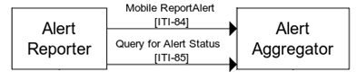

Figure 42.1-1: mACM Actor and Transaction Diagram

Table 42.1-1 lists the transactions for each actor directly involved in the mACM Profile. To claim compliance with this profile, an actor shall support all required transactions (labeled “R”) and may support the optional transactions (labeled “O”).

Table 42.1-1: mACM Profile - Actors and Transactions

| Actors | Transactions | Optionality | Reference |
| --- | --- | --- | --- |
| Alert Reporter | Mobile Report Alert [ITI-84] | R | ITI TF-2c: 3.84 |
| Query for Alert Status [ITI-85] | O | ITI TF-2c: 3.85 |
| Alert Aggregator | Mobile Report Alert [ITI-84] | R | ITI TF-2c: 3.84 |
| Query for Alert Status [ITI-85] | R | ITI TF-2c: 3.85 |

### 42.1.1 Actor Descriptions and Actor Profile Requirements

Most requirements are documented in the Volume 2 Transactions and the Volume 3 Content Modules. This section documents any additional requirements on profile actors.

#### 42.1.1.1 Alert Reporter

An Alert Reporter shall originate or relay alerts (an alarm, either physiological or technical, or an advisory) to the Alert Aggregator using the Mobile Report Alert [ITI-84] transaction.

Under the Query for Alert Status Option, this actor can query an Alert Aggregator for details related to the dissemination of this alert to the intended recipient(s).

The Alert Reporter may receive alerts from multiple sources and translate these alerts as needed to make them interoperable with the Alert Aggregator. It does not need to be the original source of the alert data. The means by which an Alert Reporter may receive alerts from other sources is out of scope of this profile.

The Response message of the Mobile Report Alert [ITI-84] and Query for Alert Status [ITI-85] transactions may additionally reference Fast Healthcare Interoperability Resources (FHIR®[3]). An Alert Aggregator’s response in these transactions may include URL references to FHIR Resources. Such referenced resources could include, but are not limited to Practitioner, Patient, Group, Organization, Device and Location. In such an instance, an Alert Reporter may need to resolve the URL reference to obtain any needed data. See ITI TF-2x: Appendix Z.5 for details.

#### 42.1.1.2 Alert Aggregator

The Alert Aggregator receives alerts from the Alert Reporter via the Mobile Report Alert [ITI-84] transaction. The Alert Aggregator uses recipient information from the alert reporter to determine the contact information for that recipient. The Alert Aggregator may then manage these alerts according to the required jurisdiction-defined business context, for example dispatching them onto a communications platform for delivery to an intended recipient.

The Alert Aggregator may optionally collect details related to the dissemination of the alert, for example under the Disseminate and Report Alert Status Option. The Alert Aggregator makes queries against these dissemination details available via the Query for Alert Status [ITI-85] transaction.

The Response message of the Mobile Report Alert [ITI-84] and Query for Alert Status [ITI-85] transactions may utilize FHIR Resources.

When the Alert Aggregator includes a reference, the Alert Aggregator ensures that the reference resolves to the intended FHIR Resource. Such referenced resources could include, but are not limited to Practitioner, Patient, Group, Organization, Device and Location.

## 42.2 mACM Actor Options

Options that may be selected for each actor in this profile, if any, are listed in the Table 42.2-1. Dependencies between options when applicable are specified in notes.

Table 42.2-1: mACM - Actors and Options

| Actor | Option Name | Reference |
| --- | --- | --- |
| Alert Reporter | Query for Alert Status | Section 42.2.1 |
| Alert Aggregator | Disseminate and Report Alert Status | Section 42.2.2 |

### 42.2.1 Query for Alert Status Option

The Query for Alert Status Option enables an Alert Reporter to retrieve feedback on the current status of the alert. This option supports analytics on the delivery status and provides feedback capabilities for other business processes that an Alert Reporter implements.

An Alert Aggregator may collect and make available for querying the information related to the dissemination of an alert, either through the Disseminate and Report Alert Status Option, or through other means, which are out of scope of this profile.

An Alert Reporter that supports the Query for Alert Status Option shall initiate the Query for Alert Status [ITI-85] transaction.

### 42.2.2 Disseminate and Report Alert Status Option

This option enables mACM actors to operate in an environment that is also using the IHE PCD ACM Profile.

An Alert Aggregator that claims the Disseminate and Report Alert Status Option shall be grouped with an ACM Alert Manager. This grouping enables the mACM Alert Aggregator to collect feedback on the current status of an alert disseminated in an ACM environment.

* When the mACM Alert Aggregator receives a valid Mobile Report Alert [ITI-84] transaction, the grouped ACM Alert Manager initiates the Disseminate Alert [PCD-06] transaction to an ACM Alert Communicator, using the translation tables in ITI TF-2c: 3.84.5.2
* When the ACM Alert Manager receives a response to Report Dissemination Alert Status [PCD-07] about the corresponding alert, then the grouped mACM Alert Aggregator shall represent the dissemination data in a Query for Alert Status [ITI-85] response, using the translation tables in ITI TF-2c: 3.84.5.2.

See ITI TF-2c: Figure 3.84.4.1.3.2-2 and ITI TF-2c: 3.84.4.1.3.2 “Expected Actions - Disseminate and Report Alert Status Option”.

## 42.3 mACM Required Actor Groupings

An actor from this profile (Column 1) shall implement all of the required transactions and/or content modules in this profile ***in addition to*** all of the transactions required for the grouped actor (Column 2).

Table 42.3-1: mACM - Required Actor Groupings

| mACM Actor | Actor to be grouped with | Reference | Content Bindings Reference |
| --- | --- | --- | --- |
| Alert Aggregator with the Disseminate Status and Report Alert Option | PCD ACM Alert Manager | PCD TF-1: 6.1 | -- |
| Alert Reporter | None |  |  |

## 42.4 mACM Overview

The mACM Profile supports the delivery of a variety of alerts to both Health Workers and Clients (Subjects of Care) with a feedback mechanism to record delivery status and human responses.

### 42.4.1 Concepts

In Figure 42.4.1-1, the sequencing of the transactions in Figure 42.1-1 is illustrated.

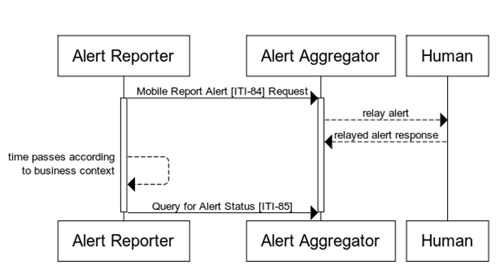

Figure 42.4-1: Process Flow Diagram

The text in Figure 42.4-2 was used to generate the diagram in Figure 42.4-1. Readers will generally find the diagram more informative. The text is included here to facilitate editing.

title

participant Alert Reporter

participant Alert Aggregator

Alert Reporter->Alert Aggregator: Mobile Report Alert [ITI-84] Request

activate Alert Reporter

activate Alert Aggregator

Alert Aggregator-->Human: relay alert

Human-->Alert Aggregator: relayed alert response

Alert Reporter-->Alert Reporter: time passes according\n to business context

Alert Reporter->Alert Aggregator: Query for Alert Status [ITI-85]

deactivate Alert Aggregator

deactivate Alert Reporter

Figure 42.4-2: Pseudocode for Process Flow Diagram

### 42.4.2 Use Cases

The mACM Profile takes into consideration uses cases that span clinical, health systems management and public health domains.

A critical requirement of the mACM Profile is the ability to provide basic alerting services within resource-constrained environments with a low barrier to entry. Such communities may exist at national context for Low and Middle Income Countries (LMICs[4]), as well as underserved communities in high-income countries (e.g., the population targeted by Detroit’s Beacon Project[5]). A proliferation of alerting services exists in national health networks of resource-constrained countries (see Figure 42.4.2-1 for an illustrative example) and the mACM Profile fulfills an important need of the ministries of health to provide a central messaging infrastructure. Such a centralized infrastructure provides the ministry the ability to:

* Assert and enforce governance policies on the utilization of alerting services on mobile platforms
* Define and enforce cost control measures across various mobile alerting platforms

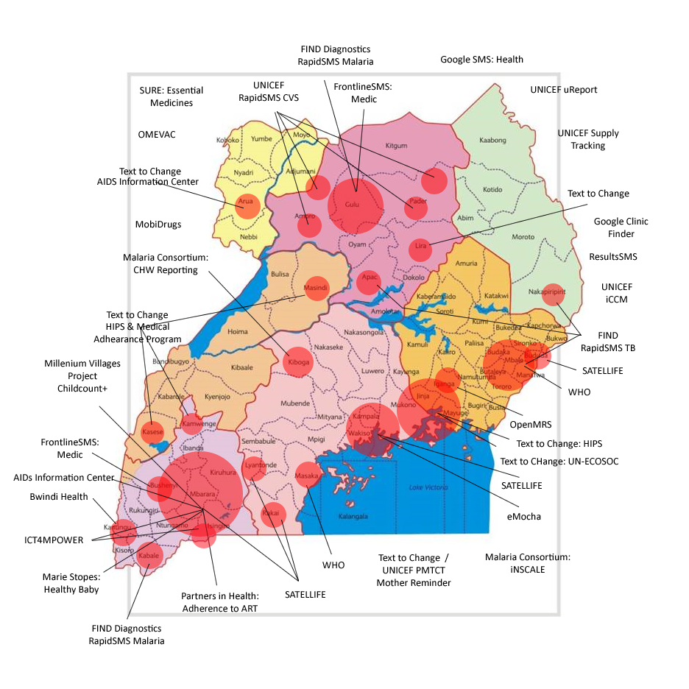

(Courtesy UNICEF/Blaschke/2011)

Figure 42.4.2-1 Extant mobile-based mHealth Services in Uganda

#### 42.4.2.1 Use Case #1: Crisis Response

In response to a crisis or emergency situation, such as the 2014 and 2015 outbreaks of Ebola in western Africa, it is critical to communicate to health workers across organizational and national boundaries, and to verify receipt of such alerts. Such alerts are commonly issued in the OASIS Common Alerting Protocol (CAP) format:

* <http://docs.oasis-open.org/emergency/cap/v1.2/CAP-v1.2-os.html>

There is a desire to assure human acknowledgment of receipt of these CAP messages.

##### 42.4.2.1.1 Crisis Response Use Case Description

The Crisis Response use case describes the mechanism for delivering alerts in the CAP format to health workers within a particular health care network*.* The nature of this network is not prescribed in this profile and may consist, for example, of a network of hospitals or a national health care network.

The manner of production and publication of the CAP message is not prescribed in this profile.

There are several existing profiles and specifications related to CAP messages that detail values of and requirements on particular data fields*.* Such specifications include:

* OASIS Integrated Public Alert and Warning System (IPAWS)
* HITSP T 63 - Emergency Message Distribution Element Transaction
* NIEM Emergency Management

This profile can be used to relay CAP messages issued by an appropriate authority to an appropriate set of health workers on last-mile devices. In addition, this profile describes a mechanism for recording human acknowledgment of receipt of information contained in the CAP messages. These responses can it turn be used for analytical and monitoring purposes.[6]

##### 42.4.2.1.2 Crisis Response Process Flow

The workflow for delivery and acknowledgment of a CAP message is illustrated in Figure 42.4.2.1.2-1.

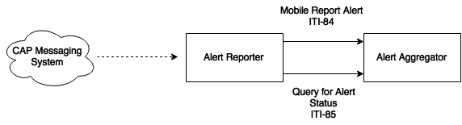

Figure 42.4.2.1.2-1: CAP Delivery and Acknowledge

Figure 42.4.2.1.2-1 illustrates the distribution of a CAP message from an external system to an Alert Reporter. Though the method for receiving a CAP message is not specified by the profile, the Alert Reporter should:

* Identify a cohort of health workers for receiving the text of the CAP message
* Translate the CAP message into the message semantics defined in ITI TF-2c: 3.84 and transmit to the Alert Aggregator

The Alert Aggregator distributes the alert and collects alert dissemination statuses from Alert Communicators and makes status information available to the Alert Reporter via the Query for Alert Status.

#### 42.4.2.2 Use Case #2: Care Reminders

A subject of care may receive care from multiple providers across multiple health care networks, and coordination of care across providers and networks is difficult. If an Electronic Medical Record or Longitudinal/Shared Health Record is present, Care Reminder alerts can be triggered through the examination of clinical records about the subject of care. Care Reminder alerts are sent either to the subject of care or a designated health worker.

##### 42.4.2.2.1 Care Reminder Use Case Description

The following are illustrative examples of Care Reminder alerts:

* (Rwanda) When patients are referred to the district hospital by a Community Health Worker (CHW), the CHW can choose an immediate, urgent or routine referral. In urgent cases, they must visit the hospital within three days and for routine referrals, they must visit the hospital within seven days. The Health Information Exchange (HIE) is able to detect if the patient has missed her referral by checking if an encounter has been received at the Longitudinal Health Record within the time frame. If an encounter has not been received the HIE sends out an out an alert of the missed appointment to inform the CHW that originally interfaced with that patient.
* (Tanzania) An examination of an Electronic Medical or Health Record indicates that a child has missed a vaccination according to an established protocol of care. An SMS reminder is generated and sent to the mother or other designated guardian. In the case when a mother does not have access to a cell phone or other electronic device, an alert should be generated and sent to the child’s caregiver. This caregiver could be a Community Health Worker, a village elder, or a sub-village chairman.

##### 42.4.2.2.2 Care Reminder Process Flow

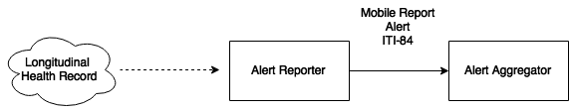

Figure 42.4.2.2.2-1: Care Reminders

## 42.5 mACM Security Considerations

The implementer of this profile is advised that many risks cannot be mitigated by the IHE profile and instead the responsibility for mitigation is transferred to the vendor, and occasionally to the operational environment.

To address identified security risks for the transactions defined in this profile, implementers should ensure that:

* All actors in mACM are grouped with a Consistent Time (CT) Profile - Time Client. This grouping will assure that all systems have a consistent time clock to assure a consistent timestamp for audit logging and alert dissemination.
* All actors in mACM are grouped with an Audit Trail and Node Authentication (ATNA) Profile - Secure Node or Secure Application Actor. This grouping will assure that only highly trusted systems can communicate and that all changes are recorded in the audit log.
* The Alert Reporter is grouped with an Authorization Client in the Internet User Authorization (IUA) Profile. The Alert Aggregator should be grouped with an IUA Resource Server. This grouping will enable service side access control and more detailed audit logging if ATNA is also used.
* All actors in mACM are grouped with the appropriate actor from the Enterprise User Authentication (EUA) Profile to enable single sign-on inside an enterprise by facilitating one name per user for participating devices and software.

In particular, appropriate care should be taken when a subject of care is identified in the alert as the content may contain PHI. There are many security and privacy concerns with mobile devices, including lack of physical control. Many common information technology uses of HTTP, including REST, are accessing far less sensitive information than health documents. These factors present an especially difficult challenge for the security model. It is recommended that application developers perform a Risk Assessment in the design of the applications, and that operational environment using mACM perform Risk Assessments in the design and deployment of the operational environment.

An Alert Aggregator should not return any patient information in transaction Mobile Report Alert [ITI-84] or Query for Alert Status [ITI-85] unless proper authentication and communications security have been proven.

There are many reasonable methods of securing transactions. These security models can be layered in at the HTTP transport layer and do not modify the interoperability characteristics defined in the mACM Profile.

### 42.5.1 Patient Safety Considerations

If used beyond original use cases, patient safety risks may need to be assessed.

## 42.6 mACM Cross Profile Considerations

### 42.6.1 Health Worker Registry Services

The Alert Reporter would receive great benefit from operating in a health care network that has a registry of health worker. These registries can be used to create a list of enterprise IDs for health workers. Such a service for health workers could be provided, for example, by the:

* Care Services InfoManager in the Care Services Discovery (CSD) Profile
* Provider Information Directory in the Healthcare Provider Directory (HPD) Profile
* Personnel White Pages Directory in the Personnel White Pages (PWP) Profile

The utility of such providing such services is illustrated in Figure 42.6.1-1, which shows in interaction diagram, and Figure 42.6.1-2, which shows a sequencing of these interactions.

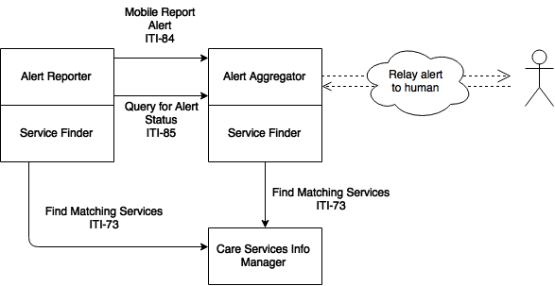

Figure 42.6.1-1: mACM Actor Interactions with a Health Worker Registry

In Figure 42.6.1-1, the CSD InfoManager acts as a registry of health workers in the health system. The Alert Reporter, grouped with a Service Finder, executes an appropriate Find Matching Services [ITI-73] transaction to determine a list of enterprise IDs for targeted health workers according to internal business requirements. The Alert Reporter then sends the alert on to the Alert Aggregator using the Mobile Report Alert [ITI-84] transaction. The Alert Aggregator, grouped with a Service Finder, may also execute an appropriate Find Matching Services [ITI-73] transaction in order to determine the contact points (e.g., cell phone number) of the referenced health worker.

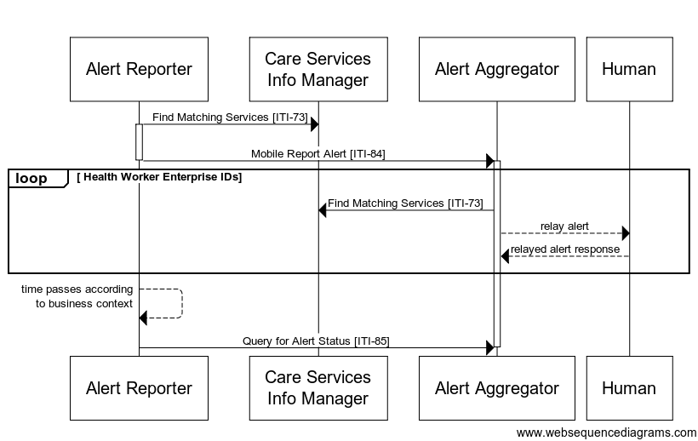

Figure 42.6.1-2: Sequencing of mACM Actor Interactions with a Health Worker Registry

The text in Figure 42.6.2.1-3 was used to generate the diagram in Figure 42.6.2.1-2. Readers will generally find the diagram more informative. The text is included here to facilitate editing.

title

Alert Reporter->Care Services\nInfo Manager:Find Matching Services [ITI-73]

activate Alert Reporter

Alert Reporter->Alert Aggregator: \nMobile Report Alert [ITI-84]

deactivate Alert Reporter

activate Alert Aggregator

loop Health Worker Enterprise IDs

Alert Aggregator->Care Services\nInfo Manager: Find Matching Services [ITI-73]

Alert Aggregator-->Human: relay alert

Human-->Alert Aggregator: relayed alert response

end

Alert Reporter-->Alert Reporter: time passes according\n to business context

Alert Reporter->Alert Aggregator: Query for Alert Status [ITI-85]

Figure 42.6.1-3: Pseudocode for Sequencing of mACM Actor Interactions  
 with a Health Worker Registry

In Figure 42.6.1-2, a potential sequencing of the transactions in Figure 42.6.1-1 is illustrated. These steps may be described as follows:

1. The Alert Reporter, grouped with a Care Services Finder, executes the Find Matching Services [ITI-73] transaction against a Care Services InfoManager to determine the enterprise IDs for a list of Health Workers matching a set of criteria. The specific criteria used are dependent on the business context under which the alert is intended to be communicated.
2. Using the resultant list of Health Worker enterprise IDs, the Alert Report executes Mobile Report Alert [ITI-84] to report the given alert to an Alert Aggregator.
3. For each Health Worker identified in the alert, the Alert Aggregator, grouped with a Service Finder, determines available contact points (e.g., telephone number, email address) by executing Find Matching Services [ITI-73] against a Care Services InfoManager.

### 42.6.2 Client Registry Services

The Alert Reporter would receive great benefit from operating in a health care network that has a health client registry. These registries can be used to create a list of enterprise IDs for subjects of care. Such a service for a client registry could be provided, for example, by the:

* The Patient Demographics Supplier in the Patient Demographics Query (PDQ) Profile
* The Patient Demographics Supplier in the Patient Demographics Query for Mobile (PDQm) Profile

The utility of such providing such services is illustrated in Figure 42.6.2-1, which shows in interaction diagram, and Figure 42.6.2-2, which shows a sequencing of these interactions.

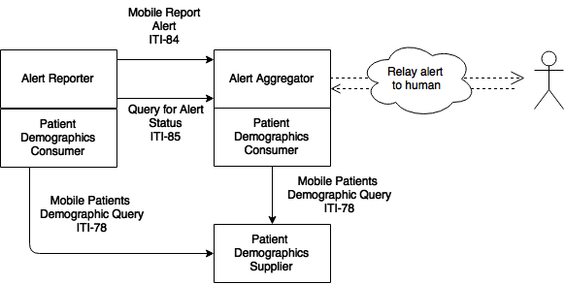

Figure 42.6.2-1: mACM Actor Interactions with a Client Registry using the PDQm Profile

In Figure 42.6.2-2, the PDQm Patient Demographics Supplier acts as a registry of subjects of care in the health system. The Alert Reporter, grouped with a Patient Demographics Consumer, executes an appropriate Mobile Patients Demographic Query [ITI-78] transaction to determine a list of enterprise IDs for targeted subjects of care according to internal business requirements. The Alert Reporter then sends the alert on to the Alert Aggregator using the Mobile Report Alert [ITI-84] transaction. The Alert Aggregator, grouped with a Patient Demographics Consumer, may also execute an appropriate Mobile Patients Demographic Query [ITI-78] transaction in order to determine the contact points (e.g., cell phone number) of the referenced subject of care.

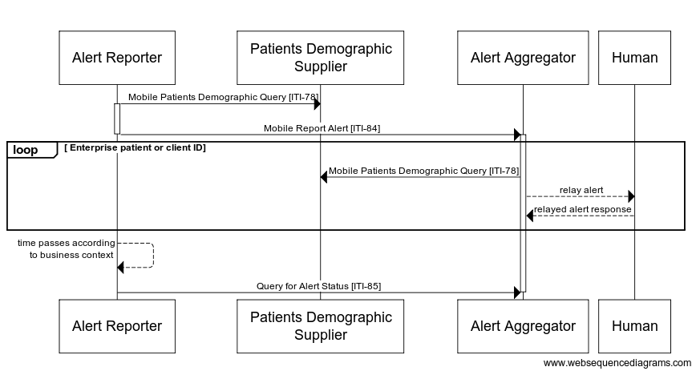

Figure 42.6.2-2: Sequencing of mACM Actor Interactions with a Client Registry

The text in Figure 42.6.2.2-3 was used to generate the diagram in Figure 42.6.2.2-2. Readers will generally find the diagram more informative. The text is included here to facilitate editing.

title

Alert Reporter->Patients Demographic\nSupplier: Mobile Patients Demographic Query [ITI-78]

activate Alert Reporter

Alert Reporter->Alert Aggregator: \nMobile Report Alert [ITI-84]

deactivate Alert Reporter

activate Alert Aggregator

loop Enterprise patient or client ID

Alert Aggregator->Patients Demographic\nSupplier: Mobile Patients Demographic Query [ITI-78]

Alert Aggregator-->Human: relay alert

Human-->Alert Aggregator: relayed alert response

end

Alert Reporter-->Alert Reporter: time passes according\n to business context

Alert Reporter->Alert Aggregator: Query for Alert Status [ITI-85]

Figure 42.6.2-3: Pseudocode for Sequencing of mACM Actor Interactions   
with a Client Registry

In Figure 42.6.2-2, a potential sequencing of the transactions in Figure 42.6.2-1 is illustrated. These steps may be described as follows:

1. The Alert Reporter, grouped with a Patient Demographics Consumer, executes the Mobile Patient Demographics Query [ITI-78] transaction against a Patient Demographics Supplier to determine the enterprise IDs for a list of Subjects of Care matching a set of criteria. The specific criteria used are dependent on the business context under which the alert is intended to be communicated.
2. Using the resultant list of Subject of Care enterprise IDs, the Alert Report executes Mobile Report Alert [ITI-84] to report the given alert to an Alert Aggregator.
3. For each Subject of Care identified in the alert, the Alert Aggregator, grouped with a Patient Demographics Consumer, determines available contact points (e.g., telephone number, email address) by executing Mobile Patient Demographics Query [ITI-78] against a Patient Demographics Supplier.

Volume 2 – Transactions

## 3.84 Mobile Report Alert [ITI-84]

### 3.84.1 Scope

The Mobile Report Alert transaction is used to issue alerts to health workers and subjects of care.

An Alert Reporter initiates a Mobile Report Alert transaction against an Alert Aggregator.

### 3.84.2 Actor Roles

Alert Reporter

Alert Aggregator

Figure 3.84.2-1: Use Case Diagram

Table 3.84.2-1: Actor Roles

|  |  |
| --- | --- |
| **Actor:** | Alert Reporter |
| **Role:** | Sends an alert to an Alert Aggregator for dissemination to a health worker or subject of care. |
| **Actor:** | Alert Aggregator |
| **Role:** | Accepts an alert from an Alert Reporter for dissemination to subjects of care and health workers |

### 3.84.3 Referenced Standards

* HL7 FHIR standard R4 <http://hl7.org/fhir/R4/index.html>
* HL7 - Health Level 7 Version 2.6 Ch7 Observation Reporting
* ISO/IEEE 11073-10201 Domain Information Model
* ISO/IEEE 11073-10101 Nomenclature
* IETF RFC7159 - JSON
* XML
* HTTP 1.1
* XML Schema 1.1
* IETF RFC5646 - Tags for Identifying Languages

### 3.84.4 Interaction Diagram

The following interaction diagram illustrates an Alert Reporter sending a Mobile Report Alert to an Alert Aggregator via the message semantics as defined for a CommunicationRequest resource.

Alert Reporter

Alert Aggregator

Mobile Report Alert [ITI-84] Request

FHIR CREATE CommunicationRequest REQUEST

Mobile Report Alert [ITI-84] Response

FHIR CREATE CommunicationRequest RESPONSE

Figure 3.84.4-1: Interaction Diagram

#### 3.84.4.1 Mobile Report Alert Request

The Alert Aggregator shall support the message semantics for create as defined at [http://hl7.org/fhir/R4/http.html#create](http://hl7.org/fhir/R4/http.html" \l "create) as applicable to a CommunicationRequest Resource defined at <http://hl7.org/fhir/R4/communicationrequest.html>.

The CommunicationRequest Resource is further constrained as defined in Section 3.84.4.1.2.1.

##### 3.84.4.1.1 Trigger Events

An Alert Reporter triggers a Mobile Report Alert Request according to the business rules for the alert being issued. These business rules are out of scope of this transaction.

##### 3.84.4.1.2 Message Semantics

An Alert Reporter initiates a create request as defined at [http://hl7.org/fhir/R4/http.html#create](http://hl7.org/fhir/R4/http.html" \l "create) on the CommunicationRequest Resource in order to report a new alert.

An Alert Reporter shall use either the XML or the JSON messaging formats as defined in FHIR. An Alert Aggregator shall support receiving a request in both the JSON and the XML messaging formats as defined in FHIR. See ITI TF-2x: Appendix Z.6 for more details.

###### 3.84.4.1.2.1 FHIR CommunicationRequest Resource Constraints

An Alert Aggregator and an Alert Reporter shall use a FHIR CommunicationRequest Resource. The FHIR CommunicationRequest Resource shall be further constrained as described in Table 3.84.4.1.2.1-1. The Data Field column in Table 3.84.4.1.2.1-1 references the object model defined at <http://hl7.org/fhir/R4/communicationrequest.html>.

Table 3.84.4.1.2.1-1: CommunicationRequest Resource Constraints

| Data Field  & Cardinality | Description  &  Constraints | FHIR Data Type |
| --- | --- | --- |
| category  [1..*] | This cardinality differs from the cardinality required in the FHIR CommunicationRequest Resource.  Signifies that this communication shall be disseminated by the Alert Aggregator according to the expected actions defined in Section 3.84.4.1.3.  One of the entries of this data field shall contain:   * The coding.code attribute value is defined in the “Code” column of Table 3.84.5.1-1 * The value coding.system attribute value shall be “1.3.6.1.4.1.19376.1.2.5.1” | CodeableConcept |
| payload  [1..*] | This data field contains the content of the alert.  This cardinality differs from the cardinality required in the FHIR CommunicationRequest Resource. The Alert Aggregator shall include at least one payload element with the unstructured text content of the alert. Additional payload elements may be present, for example for compliance with jurisdictional accessibility requirements, literacy issues, or translations of the unstructured text content in other languages.  This payload element shall have a contentAttachment element that meets the following requirements:   * The payload shall contain the language of the unstructured plain text content in the contentAttachment.language attribute * The payload shall contain the unstructured plain text content of the alert to be communicated in the contentAttachment.title attribute * The payload shall have the value “text/plain” in the contentAttachment.contentType attribute | Attachment |
| priority  [1..1] | This cardinality differs from the cardinality required in the FHIR CommunicationRequest Resource.   * The value for priority shall be taken from FHIR code system RequestPriority. See http://hl7.org/fhir/request-priority. | code |

3.84.4.1.2.1.1 FHIR CommunicationRequest Resource Constraints – Disseminate and Report Alert Status Option

For Alert Reporter and Alert Aggregator Actors that support the Disseminate and Report Alert Status Option, the additional constraints in Table 3.84.4.1.2.1-1 apply to the CommunicationRequest Resource.

Table 3.84.4.1.2.1.1-1: Additional Resource Constraints For the Disseminate and Report Alert Status Option

| Data Field  & Cardinality | Description  &  Constraints | FHIR Data Type |
| --- | --- | --- |
| reasonCode  [0..*] | This data field identifies secondary characteristics of the alert.   * The coding.code attribute value is defined in the “Code” column of Table 3.84.5.1-3, as appropriate to the business context * The value coding.system attribute value is defined in the “Code System” column of Table 3.84.5.1-3 | CodeableConcept |

##### 3.84.4.1.3 Expected Actions

The Alert Aggregator shall issue a Mobile Report Alert Response upon validation of a received Mobile Report Alert Request. See Section 3.84.4.2.

The Alert Aggregator shall respond with appropriate HTTP error codes as described at [http://hl7.org/fhir/R4/http.html#create](http://hl7.org/fhir/R4/http.html" \l "create) if any of the following conditions are met:

* Return 400 if the Mobile Report Alert Request was invalid
* Return 422 with an OperationOutcome Resource if the alert CommunicationRequest.category.code has value “pcd-alert” and the Alert Aggregator does not support the Disseminate and Report Alert Status Option

If the Mobile Alert Request is valid, the Alert Aggregator shall create a CommunicationRequest Resource as described at <http://hl7.org/fhir/R4/communicationrequest.html> and constrained in Section 3.84.4.1.2.1.

The Alert Aggregator shall create a Communication Resource as described at <http://hl7.org/fhir/R4/communication.html> and constrained in Section 3.84.4.1.3.1 for each alert that it sends.

For each alert response received, the Alert Aggregator shall create a Communication Resource as constrained in Section 3.84.4.1.3.1 and in Section 3.84.4.1.3.2 and update the CommunicationRequest.status field according to the translation tables in Section 3.84.5.2.

The jurisdiction should determine the retention policy for response status events.

Figure 3.84.4.1.3-1 shows the sequencing of the FHIR Resource creation.

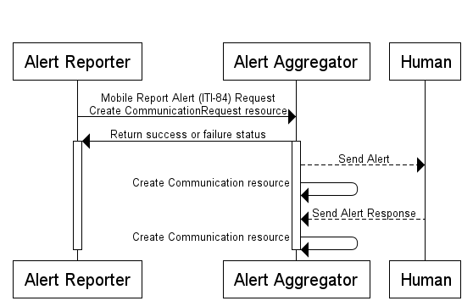

Figure 3.84.4.1.3-1: Process flow diagram for FHIR Resource creation

The text in Figure 3.84.4.1.3-2 was used to generate the diagram in Figure 3.84.4.1.3-1. Readers will generally find the diagram more informative. The text is included here to facilitate editing.

title

participant Alert Reporter

participant Alert Aggregator

Alert Reporter->Alert Aggregator: Mobile Report Alert (ITI-84) Request\nCreate CommunicationRequest resource

Alert Aggregator->Alert Reporter: Return success or failure status

activate Alert Reporter

activate Alert Aggregator

Alert Aggregator-->Human: Send Alert

Alert Aggregator->Alert Aggregator: Create Communication resource

Human-->Alert Aggregator: Send Alert Response

Alert Aggregator->Alert Aggregator: Create Communication resource

deactivate Alert Reporter

deactivate Alert Aggregator

Figure 3.84.4.1.3-2: Pseudocode for Process flow diagram for FHIR Resource creation

###### 3.84.4.1.3.1 FHIR Communication Constraints

The FHIR Communication Resource shall be constrained as described in Table 3.84.4.1.3.1-1*.*

Table 3.84.4.1.3.1-1: Communication Resource Constraints

| Data Field  &  Cardinality | Description  & Constraints | FHIR Data Type |
| --- | --- | --- |
| meta.lastUpdated [1..1] | This cardinality differs from the cardinality required in the FHIR Communication Resource.  The last time that the Communication Resource was updated or an associated alert dissemination status was updated. | instant |
| basedOn  [1..*] | This cardinality differs from the cardinality required in the FHIR Communication Resource.  A reference to the CommunicationRequest Resource that triggered the creation of this Communication Resource. | Reference (CommunicationRequest) |
| reasonCode  [0..*] | This data field identifies secondary characteristics of the alert.  In the case of an Alert Aggregator which is exercising the Disseminate and Report Alert Status Option, the CodeableConcept shall further be constrained so that:   * The coding.code attribute value is defined in the “Code” column of Table 3.84.5.1-3, as appropriate to the business context * The value coding.system attribute value is defined in the “Code System” column of Table 3.84.5.1-3 | CodeableConcept |

###### 3.84.4.1.3.2 FHIR Communication Constraints For Responses

When the FHIR Communication Resource is a response, it shall also be constrained as described in Table 3.84.4.1.3.2-1*.*

Table 3.84.4.1.3.2-1: Communication Resource Constraints for Reponses

| Data Field  &  Cardinality | Description  & Constraints | FHIR Data Type |
| --- | --- | --- |
| inResponseTo  [1..*] | This cardinality differs from the cardinality required in the FHIR Communication Resource.  A reference to the Communication Resource that this is in response to. | Reference (Communication) |

###### 3.84.4.1.3.3 Expected Actions – Disseminate and Report Alert Status Option

Under the Disseminate and Report Alert Status Option, if the Mobile Report Alert Request contains a value of “pcd-alert” in CommunicationRequest.category.code then the Alert Aggregator grouped with the ACM Alert Manager shall disseminate the alert to designated recipients using the Disseminate Alert [PCD-06] transaction. The grouped actor shall record dissemination status updates related to the dissemination of the alert according to the translation tables in Section 3.84.5.2. Additional constraints on the CommunicationRequest.category and CommunicationRequest.reasonCode data fields are defined in Table 3.84.5.1-1 and Table 3.84.5.1-3 respectively.

For each valid Report Dissemination Alert Status [PCD-07] request the Alert Aggregator receives, it shall create a Communication Resource as described in Section 3.84.4.1.3.1 and update the CommunicationRequest.status field according to the translation tables in Section 3.84.5.2.

Figure 3.84.4.1.3.3-1 shows the sequencing of the transactions for the Disseminate and Report Alert Status Option.

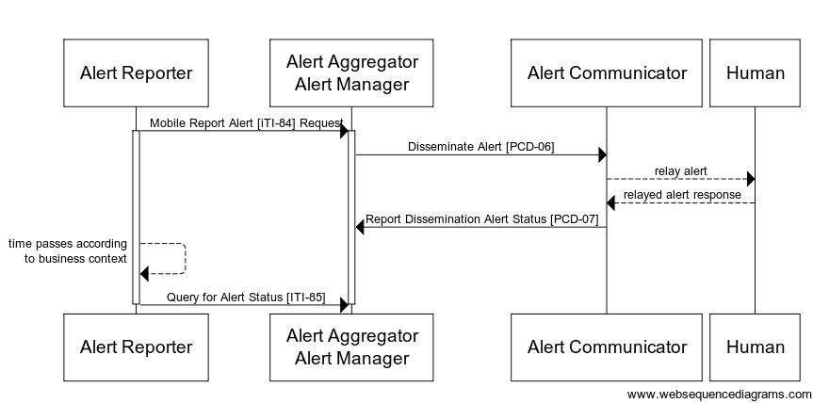

Figure 3.84.4.1.3.3-1: Process Flow Diagram for   
Disseminate and Report Alert Status

The text in Figure 3.84.4.1.3.3-2 was used to generate the diagram in Figure 3.84.4.1.3.3-1. Readers will generally find the diagram more informative. The text is included here to facilitate editing.

title

participant Alert Reporter

participant Alert Aggregator\nAlert Manager

Alert Reporter->Alert Aggregator\nAlert Manager: Mobile Report Alert (ITI-84) Request

activate Alert Reporter

activate Alert Aggregator\nAlert Manager

Alert Aggregator\nAlert Manager->Alert Communicator: Disseminate Alert (PCD-06)

Alert Communicator-->Human: relay alert

Human-->Alert Communicator: relayed alert response

Alert Communicator->Alert Aggregator\nAlert Manager: Report Dissemination Alert Status (PCD-07)

Alert Reporter-->Alert Reporter: time passes according\n to business context

Alert Reporter->Alert Aggregator\nAlert Manager: Query for Alert Status [ITI-85]

deactivate Alert Reporter

deactivate Alert Aggregator\nAlert Manager

Figure 3.84.4.1.3.3-2: Pseudocode for Process Flow Diagram for Alert Disseminate and Report Alert Status

#### 3.84.4.2 Mobile Report Alert Response

The Mobile Report Alert transaction uses the response semantics as appropriate according to the FHIR operation initiated by the Alert Reporter.

##### 3.84.4.2.1 Trigger Events

An Alert Aggregator sends a Mobile Report Alert Response to the Alert Reporter upon validation of a received Mobile Report Alert Request.

##### 3.84.4.2.2 Message Semantics

The Alert Aggregator shall respond with the appropriate response codes as defined at [http://hl7.org/fhir/R4/http.html#create](http://hl7.org/fhir/R4/http.html" \l "create).

##### 3.84.4.2.3 Expected Actions

There are no additional actions required on the Alert Reporter upon receipt of the Mobile Report Alert Response.

If an Alert Reporter does not receive a valid Mobile Report Alert Response, it may reinitiate the transaction.

### 3.84.5 Alert Terminologies and Mappings

This section contains tables of terminologies referenced as well as mappings between referenced terminologies for the Mobile Report Alert [ITI-84] transaction.

#### 3.84.5.1 Defined Terminologies

This section contains tables of terminologies referenced in the Mobile Report Alert [ITI-84] transaction.

The following table contains values, which shall be used by the Alert Reporter in the Mobile Alert Request message for CommunicationRequest.category.

Table 3.84.5.1-1: Mobile Report Alert Category Code System - 1.3.6.1.4.1.19376.1.2.5.1

| Code | Meaning |
| --- | --- |
| alert | Signifies that this communication is intended to be disseminated by the Alert Aggregator according to the expected actions defined in Section 3.84.4.1.3. |
| pcd-alert | Signifies that this communication is intended to be disseminated by the Alert Aggregator according to the expected actions defined in Section 3.84.4.1.3 and disseminated according to the Disseminate and Report Alert Status Option. For example, when the Alert Reporter wants the message disseminated by the in-house PCD system rather than the general contact method. |

The following table contains values which shall be used by the Alert Reporter in the Mobile Alert Request message for CommunicationRequest.reasonCode. These are secondary characteristics that apply to an alert that is intended for dissemination under the Disseminate and Report Alert Status Option.

Table 3.84.5.1-3: Mobile Report Characteristics Value Set OID - 1.3.6.1.4.1.19376.1.2.5.3

| Codes | Code System | List of codes |
| --- | --- | --- |
| All Codes from | 1.3.6.1.4.1.19376.1.2.5.3.1 | See Table 3.84.5.1-4 |
| All Codes from | 1.3.6.1.4.1.19376.1.2.5.3.2 |
| All Codes from | 1.3.6.1.4.1.19376.1.2.5.3.3 |
| All Codes from | 1.3.6.1.4.1.19376.1.2.5.3.4 |
| All Codes from | 1.3.6.1.4.1.19376.1.2.5.3.5 |

The code systems defined for this transaction are found in Table 3.84.5.1-4. This table is adapted from PCD TF-2: Table 8-3.

Table 3.84.5.1-4: Mobile Report Characteristics Code System

| Code | Code System | Meaning |
| --- | --- | --- |
| N | 1.3.6.1.4.1.19376.1.2.5.3.1 | Abnormal Type: Normal, not abnormal |
| L | 1.3.6.1.4.1.19376.1.2.5.3.1 | Abnormal Type: Below low normal |
| LL | 1.3.6.1.4.1.19376.1.2.5.3.1 | Abnormal Type: Below lower panic limits |
| H | 1.3.6.1.4.1.19376.1.2.5.3.1 | Abnormal Type: Above high normal |
| HH | 1.3.6.1.4.1.19376.1.2.5.3.1 | Abnormal Type: Above higher panic limits |
| A | 1.3.6.1.4.1.19376.1.2.5.3.1 | Abnormal Type: Abnormal (for non-numeric results) |
| tpoint | 1.3.6.1.4.1.19376.1.2.5.3.2 | Event Phase: time point |
| start | 1.3.6.1.4.1.19376.1.2.5.3.2 | Event Phase: start (of an interval event/alert) – an end is expected |
| start_only | 1.3.6.1.4.1.19376.1.2.5.3.2 | Event Phase: start – continue and end are not to be expected |
| continue | 1.3.6.1.4.1.19376.1.2.5.3.2 | Event Phase: continuation (of an ongoing interval event/alert) |
| end | 1.3.6.1.4.1.19376.1.2.5.3.2 | Event Phase: end (of an interval event/alert) |
| present | 1.3.6.1.4.1.19376.1.2.5.3.2 | Event Phase: event/alert is active at this time |
| update | 1.3.6.1.4.1.19376.1.2.5.3.2 | Event Phase: Update |
| escalate | 1.3.6.1.4.1.19376.1.2.5.3.2 | Event Phase: escalation of an ongoing alert/alarm |
| inactivate | 1.3.6.1.4.1.19376.1.2.5.3.2 | Event Phase: Inactivation (e.g., silence) |
| deescalate | 1.3.6.1.4.1.19376.1.2.5.3.2 | Event Phase: de-escalation of an ongoing alert/alarm |
| reset | 1.3.6.1.4.1.19376.1.2.5.3.2 | Event Phase: clear latched alarm |
| stop | 1.3.6.1.4.1.19376.1.2.5.3.2 | Event Phase: pause an event/alert; could restart with same ID later |
| change | 1.3.6.1.4.1.19376.1.2.5.3.2 | Event Phase: change |
| SP | 1.3.6.1.4.1.19376.1.2.5.3.3 | Alert Source: alarm – physiological |
| ST | 1.3.6.1.4.1.19376.1.2.5.3.3 | Alert Source: alarm – technical |
| SA | 1.3.6.1.4.1.19376.1.2.5.3.3 | Alert Source: alarm – advisory |
| alarm-paused | 1.3.6.1.4.1.19376.1.2.5.3.4 | Inactivation State: Alarm is paused |
| alarm-off | 1.3.6.1.4.1.19376.1.2.5.3.4 | Inactivation State: Alarm is off |
| audio-paused | 1.3.6.1.4.1.19376.1.2.5.3.4 | Inactivation State: Audio is paused |
| audio-off | 1.3.6.1.4.1.19376.1.2.5.3.4 | Inactivation State: Audio is off |
| inactive | 1.3.6.1.4.1.19376.1.2.5.3.5 | Alert State: inactive |
| active | 1.3.6.1.4.1.19376.1.2.5.3.5 | Alert State: active |
| latched | 1.3.6.1.4.1.19376.1.2.5.3.5 | Alert State: latched |

#### 3.84.5.2 Mappings Between Terminologies

This section contains mappings of terminologies referenced in the Mobile Report Alert [ITI-84] transaction for use in the Disseminate and Report Alert Status Option. The translation tables provide a mapping from the FHIR CommunicationRequest Resource to the data fields in the Disseminate Alert [PCD-06] and Report Dissemination Alert Status [PCD-07] transactions.

Table 3.84.5.2-1: Disseminate Alert Field Translation

| PCD-06 Data Field | CommunicationRequest Resource Data Field | Comments |
| --- | --- | --- |
| Alert_Location | CommunicationRequest.sender(Device).location | Examples in PCD-06 refer to Devices. If sender refers to a Device Resource, then you can get the Location from that. |
| Alert_Patient | CommunicationRequest.subject |  |
| Alert_Identifier | CommunicationRequest.id |  |
| Alert_Callback |  | Not mapped |
| Alert_Reference | URL of CommunicationRequest Resource |  |
| Alert_Comment | CommunicationRequest.payload.contentAttachment.title | The appropriate choice of language of the contentAttachment should be made if more than one is provided |
| Alert_Evidentiary_Data |  | Not mapped |

Table 3.84.5.2-2: Disseminate Alert Status Field Translation

| PCD-06 Data Field | Communication or CommunicationRequest Resource Data Field | Comments |
| --- | --- | --- |
| Alert_Identifier | CommunicationRequest.id |  |
| Alert_Status | CommunicationRequest.status  and  Communication.status | The value in the FHIR RequestStatus or EventStatus value set shall be encoded according to Table 3.84.5.2-3 |
| Communication.reasonCode | This value shall be encoded according to Table 3.84.5.1-3 |

Table 3.84.5.2-3 contains the mapping from the Alert_Status codes used in the Report Dissemination Alert Status [PCD-07] transaction to the RequestStatus value set defined at <http://hl7.org/fhir/R4/codesystem-request-status.html>.

Table 3.84.5.2-3: Alert Status Value Set Mapping

| Alert_Status code from [PCD-07] | Code from FHIR RequestStatus value set | Code from FHIR EventStatus value set |
| --- | --- | --- |
| Received | active | in-progress |
| Undeliverable | revoked | stopped |
| Delivered | active | in-progress |
| Read | completed | completed |
| Accepted | completed | completed |
| AcceptedPositive | completed | completed |
| AcceptedNotRelevant | completed | completed |
| AcceptedFalse | completed | completed |
| Rejected | revoked | stopped |
| Cancelled | revoked | stopped |
| CancelledOther | revoked | stopped |
| CallBackStart | active | in-progress |
| CallBackEnd | active | in-progress |

Table 3.84.5.2-4 contains a mapping from the facets for the Report Alert [PCD-04], Disseminate Alert [PCD-06], and Disseminate Alert Status Report [PCD-07] transactions to the FHIR CommunicationRequest Resource data fields as extended by this transaction.

Table 3.84.5.2-4: Disseminate Alert Facet Translation

| PCD-04, PCD-06 and PCD-07 Facet | CommunicationRequest Resource Data Field | Comments |
| --- | --- | --- |
| Event identification | CommunicationRequest.id |  |
| Source identification | CommunicationRequest.sender.id | Applicable only in the case that the sender was a device |
| Event phase | CommunicationRequest.reasonCode  for the code system 1.3.6.1.4.1.19376.1.2.5.3.2 |  |
| Alert state | CommunicationRequest.reasonCode  for the code system 1.3.6.1.4.1.19376.1.2.5.3.5 |  |
| Inactivation state | CommunicationRequest.reasonCode  for the code system 1.3.6.1.4.1.19376.1.2.5.3.4 |  |
| Alarm priority | CommunicationRequest.priority.code |  |
| Alert type | CommunicationRequest.reasonCode for the code system 1.3.6.1.4.1.19376.1.2.5.3.3 |  |

The following table contains a mapping which shall be used by the Alert Reporter in the Mobile Alert Request message for CommunicationRequest.priority. This table is adapted from PCD TF-2: Table 8-4 and maps to the RequestPriority value set at http://hl7.org/fhir/request-priority.

Table 3.84.5.2-5: Mobile Report Alert Priority Code System

| Code | Code from RequestPriority value set | Comments |
| --- | --- | --- |
| PN | routine | Since this field is required, there is no option to not have a priority, so default to routine. |
| PL | urgent |  |
| PM | asap |  |
| PH | stat |  |

### 3.84.6 Security Considerations

See ITI TF-2x: Appendix Z.8 for common mobile security considerations.

## 3.85 Query for Alert Status [ITI-85]

### 3.85.1 Scope

This transaction is used by an Alert Reporter to determine from the Alert Aggregator the status and any acknowledgements of one or more alerts by the recipient.

### 3.85.2 Actor Roles

Alert Reporter

Alert Aggregator

Figure 3.85.2-1: Use Case Diagram

Table 3.85.2-1: Actor Roles

|  |  |
| --- | --- |
| **Actor:** | Alert Reporter |
| **Role:** | Queries an Alert Aggregator for the status of one or more alerts that it issued. |
| **Actor:** | Alert Aggregator |
| **Role:** | Sends any status messages and human recipient acknowledgments for the indicated alerts |

### 3.85.3 Referenced Standards

* HL7 FHIR standard R4 <http://hl7.org/fhir/R4/index.html>
* HL7 - Health Level 7 Version 2.6 Ch7 Observation Reporting
* ISO/IEEE 11073-10201 Domain Information Model
* ISO/IEEE 11073-10101 Nomenclature
* World Geodetic System WGS-84
* IETF RFC7159 - JSON
* XML
* HTTP 1.1
* XML Schema 1.1

### 3.85.4 Interaction Diagram

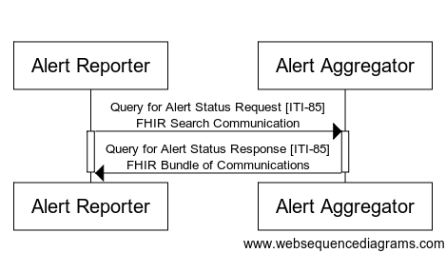

Figure 3.85.4-1: Query for Alert Status Sequence Diagram

The text in Figure 3.85.4-2 was used to generate the diagram in Figure 3.85.4-1. Readers will generally find the diagram more informative. The text is included here to facilitate editing.

title

Alert Reporter->Alert Aggregator: Query for Alert Status Request [ITI-85]\nFHIR Search Communication

activate Alert Reporter

activate Alert Aggregator

Alert Aggregator->Alert Reporter: Query for Alert Status Response [ITI-85]\nFHIR Bundle of Communications

Figure 3.85.4-2: Pseudocode for Query for Alert Status Sequence Diagram

#### 3.85.4.1 Query for Alert Status Request Message

The Query for Alert Status Request message is a FHIR search operation on the CommunicationRequest and Communication Resources.

##### 3.85.4.1.1 Trigger Events

An Alert Reporter triggers a Query for Alert Status Request to an Alert Aggregator according to the business rules for the alert(s) being investigated. These business rules are out of scope of this profile.

##### 3.85.4.1.2 Message Semantics

An Alert Reporter initiates a search request using HTTP GET as defined at [http://hl7.org/fhir/R4/http.html#search](http://hl7.org/fhir/R4/http.html" \l "search) on the CommunicationRequest Resource or the Communication Resource.

An Alert Aggregator shall support combinations of search parameters as defined at [http://hl7.org/fhir/R4/search.html#combining](http://hl7.org/fhir/R4/search.html" \l "combining), “Composite Search Parameters.”

The Alert Aggregator shall support all search parameters at [http://hl7.org/fhir/R4/communicationrequest.html#search](http://hl7.org/fhir/R4/communicationrequest.html" \l "search) and [http://hl7.org/fhir/R4/communication.html#search](http://hl7.org/fhir/R4/communication.html" \l "search).An Alert Aggregator shall support receiving a request for both the JSON and the XML messaging formats as defined in FHIR.An Alert Reporter shall use either the XML or the JSON messaging formats as defined in FHIR. See ITI TF-2x: Appendix Z.6 for more details.

##### 3.85.4.1.3 Expected Actions

The Alert Aggregator shall return matching Communication or CommunicationRequest Resources in a Query for Alert Status.

#### 3.85.4.2 Query for Alert Status Response Message

The Query for Alert Status [ITI-85] transaction uses the response semantics as defined at [http://hl7.org/fhir/R4/http.html#search](http://hl7.org/fhir/R4/http.html" \l "search) as applicable for the CommunicationRequest Resource, as defined at <http://hl7.org/fhir/R4/communicationrequest.html>, or the Communication Resource, as defined at <http://hl7.org/fhir/R4/communication.html>.

##### 3.85.4.2.1 Trigger Events

The Alert Aggregator sends the Query for Alert Status Response to the Alert Reporter upon when results to the query are ready.

##### 3.85.4.2.2 Message Semantics

The Alert Aggregator shall support the search response message as defined at [http://hl7.org/fhir/R4/http.html#search](http://hl7.org/fhir/R4/http.html" \l "search) on the CommunicationRequest Resource, defined at <http://hl7.org/fhir/R4/communicationrequest.html> or the Communication Resource, defined at <http://hl7.org/fhir/R4/communication.html>.

##### 3.85.4.2.3 Expected Actions

This behavior is not further defined or constrained by IHE.

### 3.85.5 Alert Terminologies and Mappings

The alert terminologies and their mappings are described in Section 3.84.5.

### 3.85.6 Security Considerations

See ITI TF-2x: Appendix Z.8 for common mobile security considerations.

# Volume 2 Namespace Additions

Add the following terms to the IHE General Introduction Appendix G:

The mACM Profile defines following OIDs:

* 1.3.6.1.4.1.19376.1.2.5 the root OID for the mACM Profile
* 1.3.6.1.4.1.19376.1.2.5.1 the OID for the code set used by mACM for specifying the category of a FHIR CommunicationRequest or Communication Resource
* 1.3.6.1.4.1.19376.1.2.5.3 the OID for the value set used by mACM for specifying the reasonCode of a FHIR CommunicationRequest or Communication Resource
* 1.3.6.1.4.1.19376.1.2.5.3.1 the OID for the code set used by mACM for PCD abnormal type
* 1.3.6.1.4.1.19376.1.2.5.3.2 the OID for the code set used by mACM for PCD event phase
* 1.3.6.1.4.1.19376.1.2.5.3.3 the OID for the code set used by mACM for PC alert type
* 1.3.6.1.4.1.19376.1.2.5.3.4 the OID for the code set used by mACM for PCD inactivation state
* 1.3.6.1.4.1.19376.1.2.5.3.5 the OID for the code set used by mACM for PCD alert state

1. HL7 is the registered trademark of Health Level Seven International.
2. FHIR is the registered trademark of Health Level Seven International.
3. Fast Healthcare Interoperability Resources and FHIR are the registered trademarks of Health Level Seven.
4. http://data.worldbank.org/about/country-and-lending-groups
5. http://www.healthit.gov/sites/default/files/beacon-factsheet-semi.pdf
6. Waidyanatha, Nuwan and Gow, Gordon and Anderson, Peter, Common Alerting Protocol Message Broker for Last-Mile Hazard Warning System in Sri Lanka: An Essential Component (May 2007). Available at SSRN: <http://ssrn.com/abstract=1568001> or <http://dx.doi.org/10.2139/ssrn.1568001>