Name: Hao Liu,

Student #: 218703991,

EECS2210: Electronic Circuits & Devices

Lab #1

# Introduction to Circuit Simulation using LTSpice

Objectives

The main objectives of this lab are:

1. To get familiar with the LTSpice environment through running simulations on a few simple circuits.
2. To learn about the concept of “frequency bandwidth” in electrical circuits.

Preparation

Consider the circuit shown below. Assume that the circuit is in the steady-state condition, that is, no changes has happened to it since a long time ago.

1. Write the input-output transfer function (Vout/Vin) expression for this circuit as a function of frequency (ω). To do this, you should use the impedance values for both resistor and capacitor.

$Impedance for Resistor=Z_{R}=R$ $Impedance For Capacitor Z_{C}=\frac{1}{jωC}$

$\frac{V_{out}}{V_{in}}=\frac{1}{1+jωRC}$ j is the imaginary unit, and omega is the angular frequency

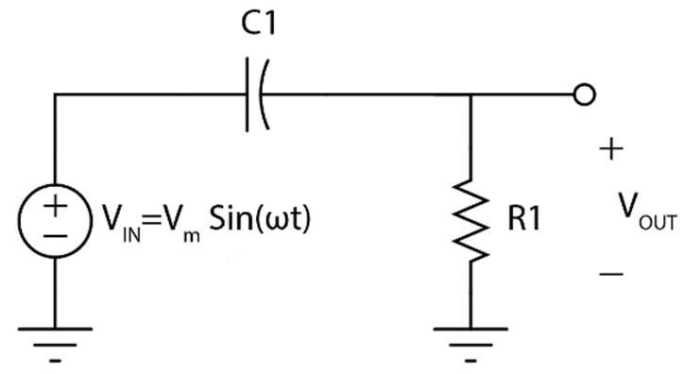

Figure 1

1. For R1=100Ω and C1=1µF, calculate the magnitude of the transfer function at the following frequencies: 1Hz, 100Hz, 10 kHz, and 100 kHz.

$$By using the Function \left|\frac{V_{out}}{V_{in}}\right|=\frac{1}{\sqrt{{1+(ωRC)}^{2}}}$$

$$ω=2πf, where f=1Hz, 100Hz, 10kHz, 100kHz$$

$$Given R=100ohms, C=1e10-6F$$

|  |  |  |
| --- | --- | --- |
|  | Frequency (Hz) | Magnitude Vout/Vin |
| 1 | 1 | 0.9999 |
| 2 | 100 | 0.9980 |
| 3 | 10K | 0.1572 |
| 4 | 100K | 0.0159 |

1. Based on the above calculations, try to hand-draw an approximate plot of |Vout/Vin| versus frequency.

1. What is the functionality of this circuit? Bring an example where such a transfer function could become useful.

This circuit is like a low passing filter, it filters the frequency signal, and the values are determined by the values of the resistor and capacitor.

For example, most commonly used in electronics to filter high frequency noises such as audio signals, it let the sounds pass through and filter out the noises.

1. Let’s assume that we are interested in the power transfer function (i.e., Pout/Pin). Since power has a quadratic relationship with voltage, we can find the power transfer function by looking at |Vout/Vin|2 values. Use the expression you found in step 1 to calculate the frequency (f3dB) at which |Pout/Pin|=0.5.
$$\left|P_{out}/P_{in}\right|={\left(\frac{V_{out}}{V_{in}}\right)}^{2}$$

$$\frac{P_{out}}{P_{in}}=\frac{1}{\sqrt{{1+\left(ωRC\right)}^{2}}}, 0.5=\frac{1}{{1+\left(ωRC\right)}^{2}}, \left(f_{3dB}\right)=\frac{1}{2πRC}=\frac{1}{2π(100ohm)(1E-6F)}=1591Hz$$

2. In engineering, quite often we express magnitudes in decibels. Voltage transfer functions in decibels are calculated as 20log|Vout/Vin| and power transfer functions in decibels are calculated as 10log|Pout/Pin|. Find the approximate decibel (dB) value of the |Pout/Pin| at 1Hz, 100,000Hz, and the frequency (f3dB) you found in step 5.

$$P_{dB}=10\log_{10}\left(\frac{P_{out}}{P_{in}}\right)=10\log_{10}\left({\left(\frac{V_{out}}{V_{in}}\right)}^{2}\right)=20\log_{10}\left(\frac{V_{out}}{V_{in}}\right)$$

Decibel value and magnitude of 1Hz 1591Hz 100,000Hz

|  |  |  |
| --- | --- | --- |
|  | Magnitude |Vout/Vin| | Power Transfer (dB) |
| 1Hz | 0.999 | -1.714E-6 |
| 1591Hz | 0.707 | -3.0103 |
| 100,000Hz | 0.016 | -35.964 |

1. In your words, try to describe why this frequency is named “the -3dB frequency”.

Is because at this point the filter begins to weaken the frequency/signal. Basically, it means that the output power is dropping.

1. Repeat steps 1 to 6 for the circuit shown below

Should this be the same at the first circuit?

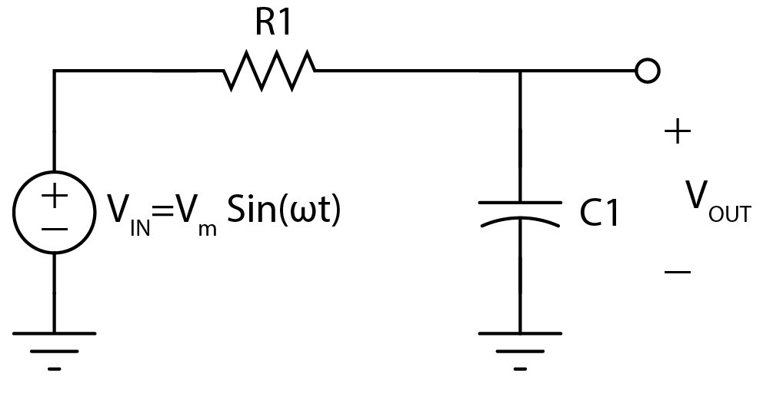

Figure 2

1. In this course, we will be making use of LTSpice for circuit simulations. LTSpice is a

schematic editor and circuit simulator. Once a schematic is created and the type of simulation is chosen, the circuit can be simulated. Next, by clicking on nodes or elements in the schematic, signals (voltage or current) can be displayed and analyzed. Download and install LTspice from the links provided at the end of this document. It is a free software with both Windows and MAC versions available. Try to familiarize yourself with the software environment using the many different online tutorials and starting guides. We have provided some example links of such online resources at the end of this document as well. In lab 1, you will make and simulate some simple circuits using this software.

Lab Experiment:

1. Draw the circuit shown in Figure 1 in LTspice. Set the input to be a sine wave with 0 offset, 1V amplitude, and frequency of 1 kHz.
2. Under simulation menu, choose simulation cmd and setup a transient simulation with stop time of 100ms, “Time to start saving data” set to 0 and maximum timestep of 0.01ms.
3. You circuit should look like below:

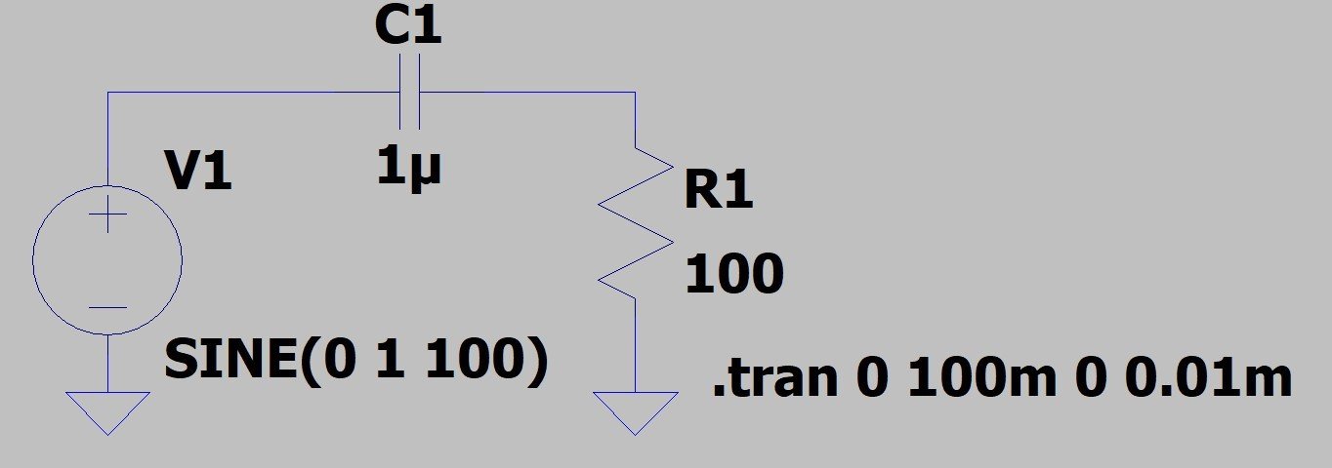

1. Click on the little running fellow () to run the simulation.
2. Use the mouse pointer to prove the voltage at the input and output nodes.
3. Try to change the frequency from 1 to 100,000Hz (same numbers as in step 2 of the preparation) and see how the output waveform changes. Describe your results in your report.

1. Right-click on the voltage source and edit the AC magnitude as shown in the figure below

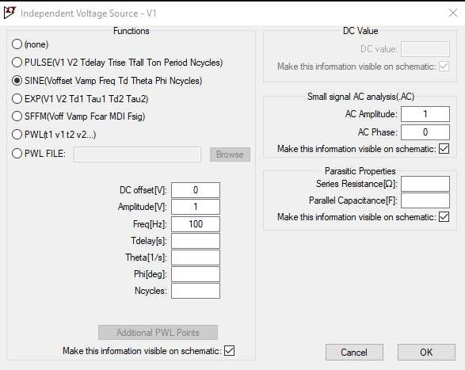

1. Next, open the simulation cmd window and choose the second tab “AC Analysis”. Edit it as shown below

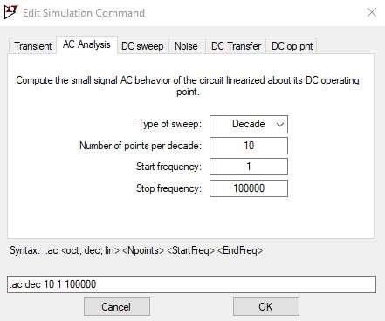

1. Run the simulation and probe the output node only. What is the solid trace representing? Use the graph tools to find the exact 3dB frequency and confirm that it is equal to what you found in the preparations. Show your result in your report.
2. Repeat steps 1 to 9 for the circuit shown in figure 2.

Download and Install:

Both Windows and Mac OS X versions of LTSpice are available here for download: https://www.analog.com/en/design-center/design-tools-and-calculators/ltspice-simulator.html

Quick tips:

* Right click (not double click) on an item to edit its property.
* You can choose the type of simulation (transcient, ac analysis, dc sweep, etc) under "simulate" - "edit simulation cmd" (For OSX users, use shortcut "s" to add a spice directive then right click in text box and choose "Help me edit")
* After a simulation, click on a net or device terminal of interest to plot the voltage or current, respectively.
* A single voltage source can be used as different kinds voltage sources by changing its property.
* Label important nets such as input and output (using the “label net” tool located two icons to the right of the yellow pencil icon.

Useful shortcuts:

* F2: add a component
* F3: draw a line
* F4: label a wire net
* F5: delete
* F6: duplicate
* F7: move (Ctrl+R: rotate, Ctrl+E: mirror)
* F8: drag
* F9: undo
* ESC: cancel

Online Resources:

Some examples of online resources for LTSpice

1. http://denethor.wlu.ca/ltspice/
2. http://ltwiki.org/index.php5?title=SPICE_and_LTspice_Courseware_and_Tuto rials