EECS2210: Electronic Devices and Circuits

Name: Hao Liu

Student#: 218703991

Lab #*2*

# Diode Circuits

# Introduction

The diode is a two-terminal, nonlinear device which behaves like a valve, allowing current to flow from the anode to the cathode, but not vice versa. The objective of this lab is to study a collection of basic diode circuits.

# Background knowledge

1. Diode Logic Gates: Diodes together with resistors can be used to implement digital logic functions. Figure 2.1 shows two diode logic gates, each with three inputs, VA, VB, and VC. It is easy to see that diodes connected to +5V inputs will conduct, thus clamping the output VY to a value equal to +5 V. This positive voltage at the output will keep the diodes whose inputs are low (around 0 V) cut off. Thus, the output will be high if one or more of the inputs are high. The circuit therefore implements the logic OR function. Similarly, you are encouraged to show that using the same logic system mentioned above, the circuit of Fig. 2.1(b) implements the logic AND function, in which, the output VY is high (i.e., +5V) if ALL inputs are high (i.e., 5V).

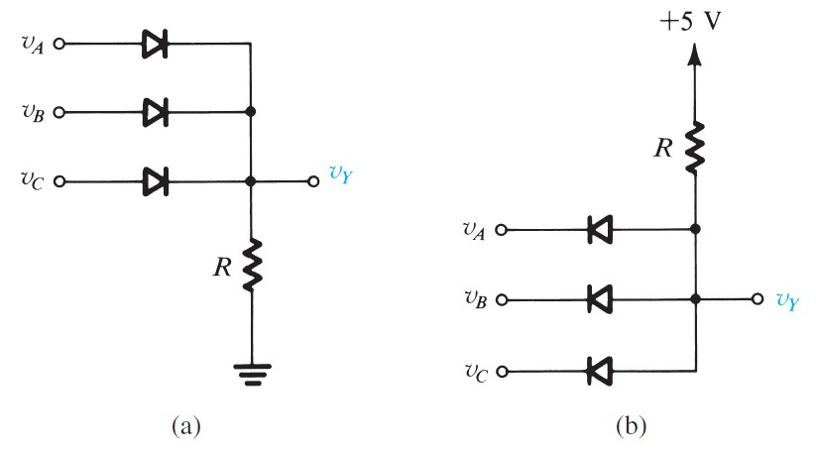

Fig. 2.1. Diode logic gates: (a) OR gate; (b) AND gate

1. Half-Wave Rectifier: Electronic devices (e.g., cellphones, computers) require a constant voltage supply. However, electricity is distributed to homes as sinusoidal alternating current (AC). Thus, circuits are required to convert the line voltage from a sinusoidal input to a constant output voltage (DC). The circuit shown in Figure 2.2. ensures that the output voltage is never negative, which is the first step in the conversion process.

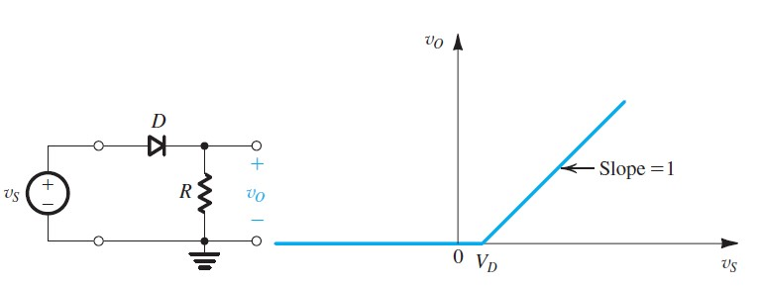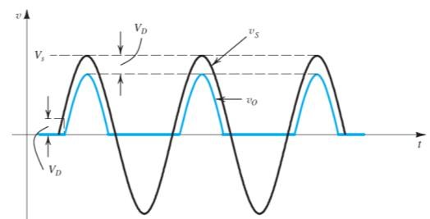

Fig. 2.2. Half-wave Rectifier

1. Precision Half-Wave Rectifier: The rectifier circuit shown in Fig. 2.2. suffers from having a diode turn-on voltage drop (e.g., 0.7 V) in the signal paths. Thus, these circuits work well only when the signal to be rectified is much larger than the voltage drop of a conducting diode (e.g., 0.7 V).

Figure 2.3. shows a precision half-wave rectifier circuit consisting of a diode placed in the negative-feedback path of an op amp, with R being the rectifier load resistance. The opamp, of course, needs power supplies for its operation. For simplicity, these are not shown in the circuit diagram. The circuit works as follows: If VI  goes positive, the output voltage VA of the op amp will go positive and the diode will conduct, thus establishing a closed feedback path between the op amp’s output terminal and the negative input terminal. This negative-feedback path will cause a virtual short circuit to appear between the two input terminals of the opamp. Thus the voltage at the negative input terminal, which is also the output voltage VO, will equal (to within a few millivolts) that at the positive input terminal, which is the input voltage VI (VO = VI for VI ≥ 0).

Note that the offset voltage ( 0.7 V) exhibited in the simple half-wave rectifier circuit of Fig. 2.2 is no longer present. For the op-amp circuit to start operation, VI must exceed only a negligibly small voltage equal to the diode drop (0.7V) divided by the op amp’s open-loop gain (e.g., >1000). In other words, the straight-line transfer characteristic VO-VI almost passes through the origin. This makes this circuit suitable for applications involving very small signals.

Consider now the case when vI goes negative. The op amp’s output voltage vA will tend to follow and go negative. This will reverse-bias the diode, and no current will flow through resistance R, causing vO to remain equal to 0 V. Thus, for vI < 0, vO = 0. Since in this case the diode is off, the op amp will be operating in an openloop fashion, and its output will be at its negative saturation level.

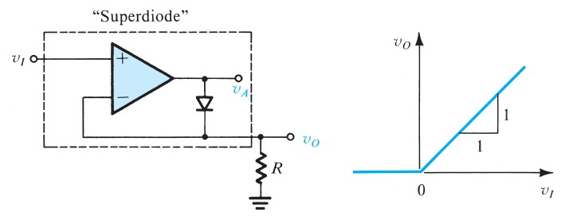

Fig. 2.3. Precision Half-wave Rectifier

1. Peak Detector: By adding a capacitor to the output of either halfwave rectifier in Figures 2.2 and 2.3, a circuit called a peak detector is formed which ‘remembers’ the peak value of the input signal. Figure 2.4 shows the modification for Figure 2.2. The length of time which the circuit ‘remembers’ peak values is determined by the time constant of the circuit. If the value of the capacitor is very large, a near-constant output voltage is produced, yielding a reasonable approximation of a DC power supply. For more information about how this circuit works, you can watch this Lecture video: *“Week3 - HWR - RC load”*

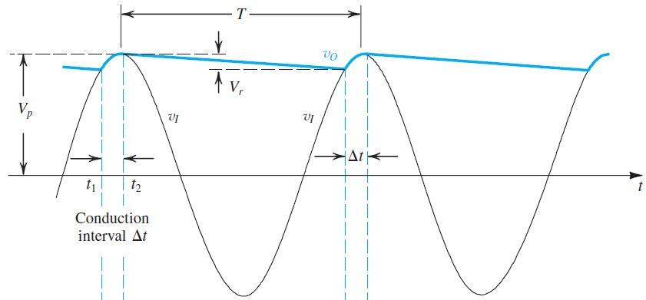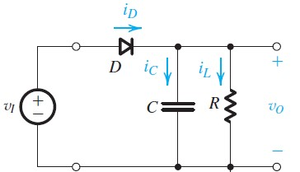

Fig. 2.4. Peak Detector

1. Charge Pumps for Voltage Multiplication: Charge pump circuits are commonly used to generate high voltages beyond the supply voltage (VDD). The Dickson charge pump is shown in Figure 2.5. It operates by transferring charge from left to right along the diode chain, from capacitor to capacitor. When Vclk is high (Vdd), diode D1 conducts until the voltage across capacitor C1 is charged to Vdd. When Vclk is low (negative Vdd), diode D2 conducts and transfers charge from C1 over to C2. Eventually, the voltage across capacitor C2 becomes 2Vdd. When Vclk goes high (Vdd) again, the voltage at node 2 now becomes 3Vdd. This process repeats itself at each stage, with the voltages at each node as shown in Fig. 2.5.

NOTE: The circuit theoretically produces a voltage of 5Vdd. In practice, however, there is a diode voltage drop of VD at each stage and the final output voltage is 5(Vdd - VD). For Vdd = 5 V and VD = 0.7 V, the output voltage is about 5 × (5-0.7) = 21.5 V.

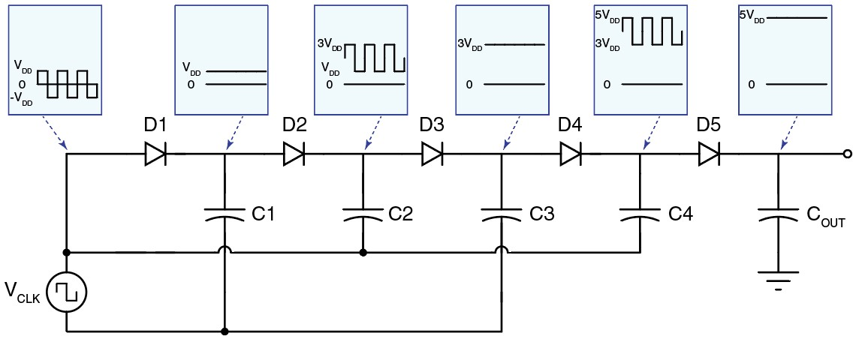

Fig. 2.5. Dickson charge pump

1. Diode as a small-signal resistor: While the diode is intrinsically nonlinear, when forward-biased with a constant current, the diode can be *approximated* as a linear resistor for *small* *variations* in current and voltage. This linear approximation of nonlinear devices about a dc operating point is called small-signal modeling.

Application: A Voltage-Controlled Variable Attenuator

The model of a diode as a resistor for small signals can be exploited to implement a voltage controlled variable attenuator as shown in Figure 2.6. At frequencies well above DC, the capacitors in Figure 2.6 can be considered as short circuits. Thus, the amplitude of VIN is attenuated by a voltage divider consisting of RIN and the small-signal resistance of the two diodes D1 and D2, rd1 and rd2:

𝑉𝑜𝑢𝑡 = 𝑟𝑑1𝑟+𝑑1𝑟+𝑑2𝑟+𝑑2𝑅𝑖𝑛 𝑉𝑖𝑛 𝐸𝑞𝑢𝑎𝑡𝑖𝑜𝑛 (2.1)

If the resistance RCTRL is chosen to be far greater than the small-signal resistance of the diodes, RCTRL can be ignored when analyzing the voltage divider. The small-signal resistance of diodes D1 and D2 is given by rd = VT/ID where VT is the thermal voltage and is about 25 mV at room temperature, and ID is the dc current flowing through the diode, which is adjusted using the control voltage, VCTRL.

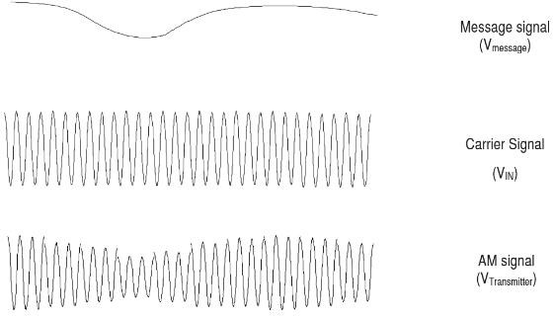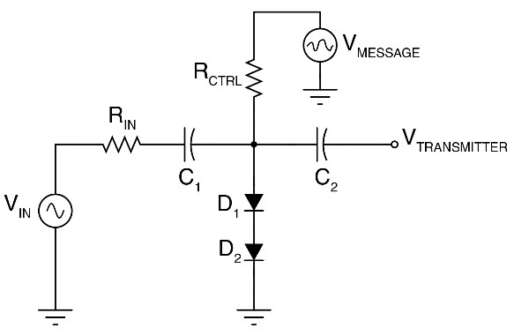

Fig. 2.6. voltage controlled variable attenuator

# Lab Preparation

There is an Appendix section at the end of this lab manual that might help you with setting up the LTSpice simulations below. Please read that before starting the prelab simulations.

1. Simulate the variable diode attenuator circuit using LTspice. For simulations, use the ‘1N4148’ model in diode list (right-click on diode). Perform a transient (time domain) simulation of the variable attenuator in Fig. 2.6 using the following value: Rin =45kΩ, Rctrl = 45kΩ, C1=1μF, C2 = 1μF.

Tips: For your simulation, place an additional 100MΩ resistor between the output node, Vtransmitter, and ground. For vin, use a 100 kHz sine wave of 0.5 Vpeak-peak.

* 1. Include a plot of the output waveform, Vtransmitter, for the control voltage Vmessage of 1V and 2.2V in your report. Run the simulations from 0 to 100 μs.

* 1. A screen shot of a computer

     Description automatically generatedUsing Equation 2.1, calculate the expected peak-to-peak voltage of output signal Vtransmitter, for a control voltage Vmessage of 2.2 V. To calculate the diode current, you can assume that the voltage across each diode is about 0.35 V. How do your calculated results compare with the simulation results above?

* 1. With Vmessage at 2.2 V, change the amplitude of the sine wave of Vin, increasing its value until the output waveform is visibly distorted. Include a plot of the distorted output waveform in your report.

I increased the amplitude in steps from 1V and stopped at 5V and the distortion had clearly shown up, and as I went higher with the voltage it seems to have different levels of distortion.

* 1. Measure the peak-to-peak amplitude of both Vin and Vtransmitter for this distorted case.

Measured peak to peak amplitude of $V_{transmitter}≈1.8V$ Measured peak to peak amplitude of Vin is 10V

1. Implement two half-wave rectifier circuits: build Figure 2.2 using the ‘1N4148’ diode and R = 100 kΩ, and the precision half-wave rectifier in Figure 2.3. For using op-amp model refer to the appendix. Apply a 5V(peak-topeak), 5kHz sine wave, and plot the input and output waveforms for both circuits. What are the peak output voltages of each circuit? How do the two waveforms differ?

ASK TA ABOUT THIS

1. Implement the positive peak detector in Fig. 2.4 by placing a 100 nF capacitor at the output of the positive halfwave rectifier built in the previous step. Apply a 5 V(peak-to-peak), 1 kHz sine wave to the circuit and plot the resulting input and output waveforms. Add amplitude modulation (AM) and turn the sine wave into an AM signal. A sample AM signal is shown in Figure 2.7. To create AM signal choose bv from components and refer to the appendix to set the parameters.

1. A screenshot of a computer

   Description automatically generatedAdd a 10 kΩ resistor in parallel with the 100 nF capacitor and plot the new output waveform. How has the output waveform changed with the additional resistor?

By adding a 10k resistor the peak decays faster than before and that’s the reason it leads to this waveform. The time constant as been shorten it because of the parallel resistor and which will lead to a faster discharge between the cycles.

# Lab Experiments

Before you begin, read the Background section, making sure you understand the operation of all the circuits.

E1. Build the diode logic gate of Fig. 2.7 using red LEDs for the diodes and a resistor value in the range of 10 - 20 kΩ. The longer pin is the anode of the LED. Draw the truth table of the logic gate using +4 V as TRUE and 0 V as

FALSE. Set the current limit of the power supply to be 150 mA. What Boolean function does this logic gate implement? (If the LEDs are not bright enough, slowly increase the voltage up to 5 V.)

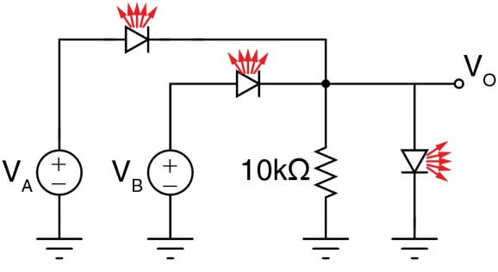

Fig. 2.7. Diode-based Logic Gate

NOTE: for the rest of the lab, you will use the 1N4148 silicon diodes (NOT the LEDs).

E2. Build two half-wave rectifier circuits: build Figure 2.2 using a silicon (Si) diode and R = 100 kΩ, and the precision half-wave rectifier in Figure 2.3. Use standard ±15 V supply voltages for the 741 op-amp. Apply a 5 V(peak-to-peak), 1 kHz sine wave, and sketch the input and output waveforms for both circuits. What are the peak output voltages of each circuit? How do the two waveforms differ?

E3. Build the positive peak detector in Fig. 2.4 by placing a 100nF capacitor at the output of the positive half-wave rectifier built in the previous step. Apply a 1 kHz sine wave to the circuit and sketch the resulting input and output waveforms. Add amplitude modulation (AM) and turn the sine wave into an AM signal. A sample AM signal is shown in Figure 2.6. On the function generator, in the Modulation section, select ‘AM’ and a particular waveform button and adjust the modulation dial. Sketch both the AM input signal and output of the circuit and notice how the peak detector ‘rides’ the top of the waves of the AM signal. (You should use 100Hz or lower to avoid signal aliasing.)

E4. Add a 5.1 kΩ resistor in parallel with the 100 nF capacitor and sketch the new output waveform. How has the output waveform changed with the additional resistor? (use 2×10 kΩ in parallel if you cannot find 5.1 kΩ)

E5. Build the variable attenuator of Fig. 2.6 using silicon diodes, Rin = Rctrl = 100 kΩ, C1=100 nF, C2 = 100 nF. Set Vctrl initially to 1.0 V, and gradually increase it to 2.5 V, while applying a 100 kHz, 0.5 Vp-p sine wave for Vin. What effect does increasing Vctrl have on the output signal?

# Appendix

In this lab for op-amp model you need to select components => [opamps] => opamp. This is an ideal model for opamp. To run the simulation you need to click on .op and add the below command:

.lib opamp.sub

As shown in the figure below for AM signal choose sine wave of 5Vpeak-peak and frequency of 1kHz. Label the output as va. Similar to AM signal, use sine wave of 4Vpeak-peak and frequency of 20Hz for carrier signal. Label this as vb. Next you need select bv from components and set value to V=V(va)*V(vb).

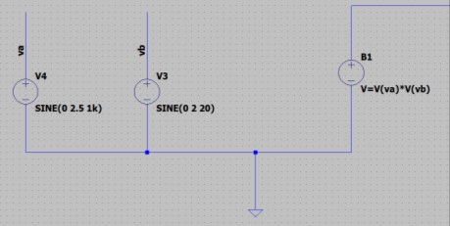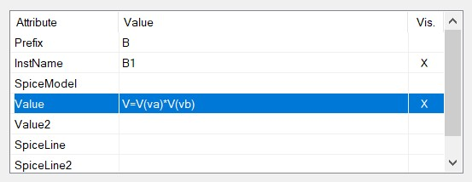

The output of the bv should be like below.

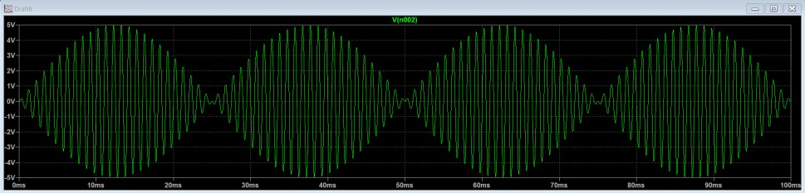

Finally, you need connect the output of bv to the peak detector:

