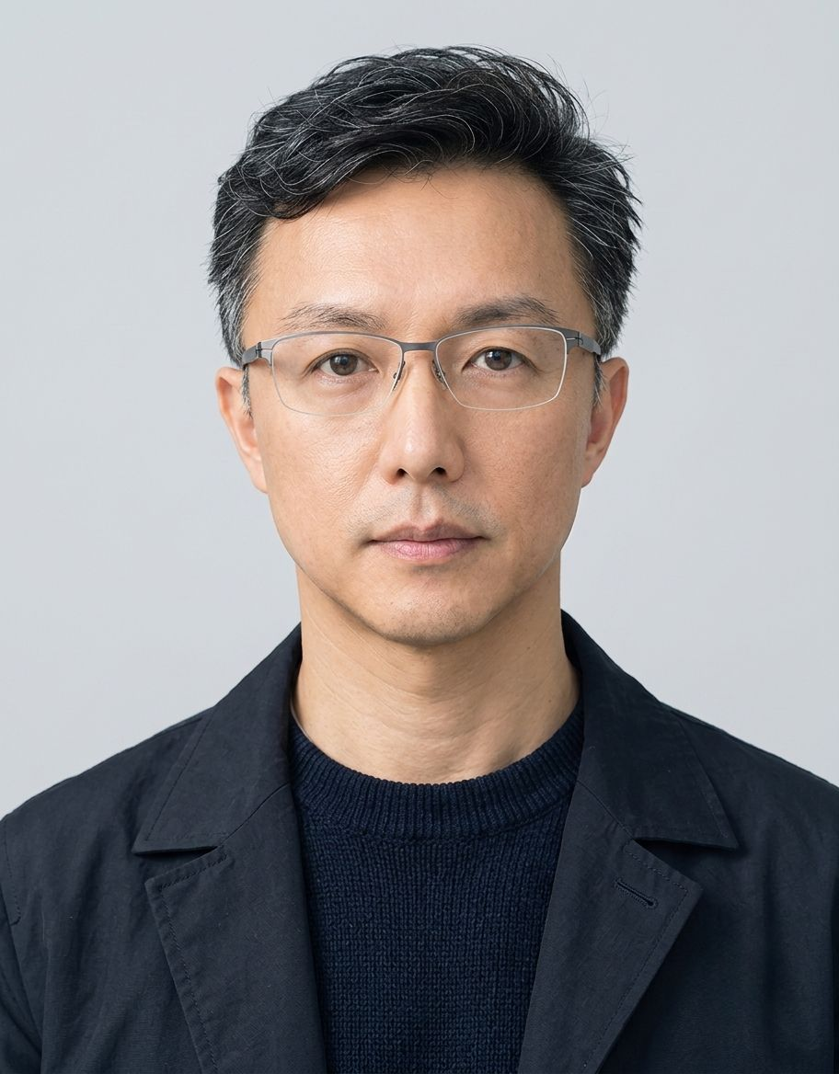 | Presenter: Howard Liao, Ph.D.  Howard Liao, Ph.D.  Group Chief Information Security Officer (CISO)  Global Cybersecurity, Digital Trust & Resilience (For Board, President & CEO)  Taiwan (Open to Global Sites) | Mobile: +886-975-323161 | Email: Liao.Howard@gmail.com  LinkedIn: linkedin.com/in/howardliao78 | Portfolio: https://howardliao.github.io/Howard_CISO/

$14M+  IT & Security Capital  Global Budget Governance | 100%  Zero Outage SLA  Multi-Cloud GKE Resilience | -30%  Cloud Annual TCO  FinOps Cross-Cloud Optimization | -30%  Major Incidents / MTTR  Centralized SOC/SIEM Defense

Executive Summary
Dr. Howard Liao (Howard Liao, Ph.D.) is Group Chief Information Security Officer (CISO) and Vice President of Technology across multinational internet technology and digital platforms. Executive technology leader with 24 years of enterprise IT leadership (career initiated in 2002), including 8+ years at the IT Director level across publicly listed and multinational platforms, serving as Group CISO since 2025.
Combines board-level cybersecurity leadership with hands-on technical depth in Zero Trust, identity and access management, multi-cloud security, SOC/SIEM/EDR, incident response, DevSecOps, data protection, third-party risk management, and AI governance.
Experienced in securing business-critical systems, sensitive records, intellectual property, enterprise applications, cloud/SaaS platforms, and cross-border data flows. Applies a pragmatic, risk-based approach to improving security maturity, operational resilience, audit readiness, recoverability, and digital trust.
Proven record of translating cybersecurity risks and technical priorities into measurable business, financial, operational, and compliance outcomes for boards and executive leadership. Builds scalable security operating models that enable international growth while protecting critical assets and improving business continuity.
Prior experience in IT/OT convergence and multi-site industrial environments provides additional capability for complex infrastructure, operational resilience, supply-chain integration, and partner ecosystem security.
Leadership Value Proposition
- CISO and board leadership: Translates security posture, risk exposure, incidents, investment priorities, and control gaps into business impact through risk matrices, RTO/RPO, SLA, ROI/TCO, and maturity roadmaps.
- Group security governance: Establishes group-wide security operating models across headquarters, international sites, cloud environments, SaaS platforms, managed-service providers, and business partners.
- Digital trust and resilience: Protects critical enterprise systems, confidential records, intellectual property, and sensitive information through identity governance, security monitoring, encryption, auditability, backup, recovery, and incident readiness.
- Cloud-native technical depth: Combines executive strategy with practical experience across AWS, Azure, GCP, Kubernetes/GKE, Zero Trust, API security, WAF/WAAP, SIEM/SOC, EDR/XDR, DevSecOps, and infrastructure automation.
- AI governance: Implements ISO/IEC 42001-based AI governance to enable responsible AI adoption while controlling shadow AI, data leakage, IP exposure, third-party model risk, and operational risk.
- Business-enabling mindset: Works closely with business, finance, legal, HR, engineering, operations, product, and IT leaders to embed cybersecurity into growth, transformation, and customer trust.
Core Competencies
Cybersecurity Strategy, Governance & Risk
- Group cybersecurity strategy, operating model, policy architecture, risk appetite, maturity assessments, KPI/KRI design, executive reporting, and multi-year security roadmaps.
- ISO 27001/27002, NIST Cybersecurity Framework, Zero Trust architecture, risk management, vendor risk, security due diligence, audit readiness, and security control assessment.
- Security investment governance through risk reduction, ROI/TCO, RTO/RPO, SLA, business continuity, and measurable value realization.
- Board reporting, audit engagement, customer security reviews, crisis governance, and executive stakeholder management.
Digital Trust, Data Governance & Auditability
- Security governance for critical business systems, confidential records, sensitive data, intellectual property, enterprise workflows, and digital platforms.
- System inventory, business-criticality classification, risk assessment, security control baselines, evidence management, and security operating procedures.
- Least privilege, segregation of duties, access recertification, logging, audit-trail protection, encryption, backup, recovery, and change-control governance.
- Data lifecycle controls covering classification, access, retention, archival, deletion, integrity, traceability, availability, and recoverability.
- Security architecture and supplier assurance for ERP, CRM, HRIS, finance, document management, workflow, data platforms, collaboration tools, and SaaS ecosystems.
Identity, Zero Trust & Data Protection
- Enterprise IAM, SSO, MFA, conditional access, privileged-access governance, PAM concepts, least privilege, joiner-mover-leaver lifecycle controls, and third-party identity management.
- Data classification, DLP, encryption, key management, endpoint protection, secure collaboration, CASB/SSE concepts, and cross-border data governance.
- Protection of IP, confidential R&D information, customer and partner data, financial records, commercial information, and internal corporate assets.
Cloud, SaaS & Enterprise Application Security
- AWS, Azure, and GCP security governance, landing zones, centralized logging, configuration assurance, CSPM/CNAPP-aligned controls, segmentation, WAF/WAAP, API security, backup, and disaster recovery.
- Secure governance of ERP/SAP, CRM, HRIS, finance applications, data platforms, collaboration tools, workflow systems, and business-critical SaaS services.
- Cloud and SaaS vendor due diligence, shared-responsibility assessments, architecture review, contractual security controls, continuous assurance, and exit/continuity planning.
- Multi-region and multi-zone architecture design for critical services and cross-region disaster recovery.
Security Operations, Resilience & Incident Response
- SOC/MDR operating model, SIEM, EDR/XDR, centralized logging, detection engineering, threat intelligence, vulnerability management, incident response, and executive incident reporting.
- Ransomware readiness, immutable backup, disaster recovery, business continuity, crisis communication, tabletop exercises, adversary simulation, and recovery governance.
- Security observability using ELK Stack, Graylog, Prometheus, LibreNMS, Spiceworks, cloud-native monitoring, and application/system telemetry.
- Security metrics covering MTTR, detection coverage, incident severity, response effectiveness, recovery capability, and control effectiveness.
DevSecOps, Application & Supply-Chain Security
- Secure SDLC, threat modeling, SAST, DAST, SCA, secrets management, API security, secure CI/CD, policy-as-code, Terraform/IaC governance, Kubernetes/GKE security, and SBOM.
- Software-supply-chain security, open-source component governance, secure code review, vulnerability remediation, and application security requirements.
- Security governance for internal engineering teams, outsourced development partners, system integrations, APIs, data pipelines, and third-party platforms.
AI Governance & Secure Innovation
- ISO/IEC 42001-based AI governance, Responsible AI policies, approved use-case governance, model and vendor risk assessments, data classification, and AI lifecycle management.
- GenAI data-leakage prevention, shadow-AI control, secure RAG knowledge-base governance, access control, prompt/data protection, monitoring, auditability, and human oversight.
- AI-assisted risk scoring, anomaly detection, threat correlation, and security analytics.
Leadership & Stakeholder Management
- Cross-functional and cross-border leadership across Taiwan, China, Asia-Pacific, Europe, and global managed-service partners.
- Leadership of cybersecurity, IT operations, cloud operations, infrastructure, SRE, DevOps, applications, service desk, and external service-provider teams.
- Multi-million-dollar annual IT and cybersecurity budget responsibility.
- Chinese and English executive communication; board reporting; audit facilitation; customer due diligence; vendor governance; and incident crisis leadership.
Professional Experience
Group Vice President & Group CISO (Information Security & Digital Transformation)
Multinational Digital Tech & Entertainment Platform Group (Encompassing Shengxin, Shengji & Global Affiliates)
Multinational Digital Platform Conglomerate | Taiwan & Global Operations
May 2025 – Present
Acting in a CISO-level capacity, leading group cybersecurity strategy, cloud and infrastructure governance, enterprise resilience, and AI governance across multiple business units.
Leadership Scope
- Group-wide IT and cybersecurity governance across multiple business units and operating sites.
- Leadership of approximately 35–40 professionals across cybersecurity, infrastructure, applications, operations, and external service partners.
- Annual IT and cybersecurity budget responsibility of approximately USD 10–12 million.
Selected Achievements & Impact
- Established group-wide cybersecurity governance based on ISO 27001 and NIST CSF, elevating risk, investment prioritization, resilience metrics, and accountability to board-level oversight.
- Built an enterprise cybersecurity risk-management system covering asset criticality, threats, vulnerabilities, control maturity, third-party exposure, and quantified risk matrices.
- Developed multi-year cybersecurity roadmaps linked to annual budgets, OGSM objectives, business priorities, and measurable risk-reduction outcomes.
- Designed Zero Trust-aligned identity, endpoint, network, cloud, and access-control architecture for critical enterprise applications, data platforms, and partner collaboration.
- Implemented centralized SOC/SIEM, EDR, log aggregation, security monitoring, and incident-response procedures, reducing major security incidents by approximately 30% and improving detection and response performance.
- Established multi-cloud security observability and configuration-assurance dashboards, improving executive visibility, audit evidence, customer due-diligence response, and remediation governance.
- Introduced ISO/IEC 42001-based AI governance, including AI-use policies, risk assessment, data-protection requirements, model lifecycle controls, and third-party AI-service governance.
- Secured executive sponsorship and investment for Zero Trust, SOC/SIEM, disaster recovery, and cloud-security initiatives through ROI/TCO, RTO/RPO, SLA, risk-reduction, and audit-readiness analysis.
- Coordinated security and digital-transformation initiatives among IT, finance, legal, HR, engineering, business operations, and external service partners.
IT Director
GameSparcs Co., Ltd. (TPEx: 6542.TWO / XSGames Group) Publicly Listed Company
Publicly Listed Global Gaming Platform Operator | Taichung, Taiwan
September 2022 – April 2025
Led global cloud architecture, cybersecurity governance, digital-platform resilience, DevOps productivity, and high-availability operations for a publicly listed online platform serving millions of users.
Leadership Scope
- Led approximately 30–35 professionals across cloud operations, DevOps, SRE, cybersecurity, infrastructure, and application-support functions.
- Accountable for multi-cloud infrastructure and cybersecurity budgets of approximately USD 12–14 million annually.
- Supported high-traffic, customer-facing digital platforms requiring 24/7 availability, large-scale transaction processing, and resilient cross-region operations.
Selected Achievements & Impact
- Designed and delivered a GKE-centered, multi-zone, multi-region architecture with cross-region disaster recovery, enabling 24/7 service availability and a zero-downtime record for critical services.
- Built centralized observability, APM, SIEM, cloud logging, monitoring, and incident-response processes, reducing MTTR by approximately 30% through real-time event correlation and improved operational visibility.
- Implemented ISO 27001- and NIST CSF-aligned cybersecurity policies and controls for IAM, asset management, secure development, cloud operations, incident response, vendor governance, and audit evidence.
- Introduced Zero Trust principles through IAM, SSO, MFA, least privilege, and controlled remote access, strengthening protection for distributed teams, privileged users, and external partners.
- Strengthened the external attack surface through API security, WAF/WAAP, DDoS protection, anti-bot controls, rate limiting, API authorization, and network-security governance.
- Established incident-response playbooks, security exercises, adversary simulations, crisis communication procedures, and recovery governance, improving organizational readiness and reducing breach impact.
- Embedded SAST, DAST, secrets management, CI/CD controls, IaC governance, container-security practices, and software-supply-chain controls into engineering and deployment workflows.
- Built FinOps practices across multi-cloud environments, achieving approximately 30% cloud-cost optimization while maintaining performance, resilience, and customer experience during traffic spikes.
- Received a Cloud Architecture Excellence Award for a GKE-based multi-cloud platform combining high availability, operational resilience, and cost optimization.
IT Director
Hongen Technology (Headquartered in Shenzhen with offices in Hsinchu, Hangzhou, Chengdu / 泓晏科技)
Electronics Manufacturing & Technology Services | Taiwan and China
March 2018 – August 2022
Led enterprise IT, cybersecurity, data governance, digital transformation, and multi-site technology operations across Taiwan and China.
Leadership Scope
- Managed approximately 30–40 professionals across IT, cybersecurity, applications, infrastructure, operations, and technology services.
- Held annual IT and cybersecurity budget responsibility of approximately USD 5–7 million.
- Supported multi-site business operations, R&D, supply-chain, engineering, finance, procurement, and external-partner environments.
Selected Achievements & Impact
- Established ISO 27001-aligned cybersecurity governance, risk assessment, asset management, identity and access controls, segmentation, vulnerability management, and auditability for enterprise and operational environments.
- Designed secure architecture for ERP, PLM, supply-chain, workflow, analytics, and enterprise systems, improving availability, traceability, data protection, and continuity.
- Led secure integration of ERP, MES, PLM, APS, HR, and analytics platforms, enabling controlled information flow, authentication, encryption, audit logging, and management visibility across business functions.
- Built data-governance and BI capabilities supporting inventory management, anomaly analysis, operational decision-making, and post-merger data integration.
- Developed risk-based vulnerability, patch-management, incident-response, backup, and continuity processes that balanced cybersecurity improvement with operational requirements.
- Coordinated cybersecurity and resilience initiatives across IT, engineering, operations, procurement, finance, and external service partners in Taiwan and China.
- Supported organizational integration and data-asset due diligence during acquisition by a major Chinese manufacturing group.
Additional Context
Prior IT/OT convergence experience provides practical capability for complex infrastructure, supply-chain, partner, and operational integration needs.
IT Manager
HyWeb Technology Co., Ltd. (Headquartered in Hsinchu with offices in Taipei, Taichung, Kaohsiung, Thailand, Beijing / 凌網科技、凌網知識) Publicly Listed Company
Publicly Listed IT Services Company | Taiwan, China and Thailand
May 2014 – February 2018
Led regional IT operations, service management, data-center strategy, infrastructure governance, and cross-border technology support for offices in Taipei, Hsinchu, Taichung, Beijing, and Thailand.
Leadership Scope
- Managed approximately 34–45 professionals across infrastructure, enterprise applications, service desk, support, and operations.
- Led regional IT budgets, data-center operations, backup architecture, disaster-recovery planning, and service-management improvement.
Selected Achievements & Impact
- Implemented ITSM and cross-regional service-management processes, improving service consistency, accountability, incident response, and operational transparency across Asia-Pacific offices.
- Established regional data-center strategy, high-availability architecture, backup governance, and disaster-recovery plans to support critical business services.
- Introduced PMP and agile delivery practices, improving cross-border project governance, delivery predictability, and stakeholder collaboration.
- Strengthened infrastructure standards, security operations, and technology-service governance for geographically distributed operations.
IT Manager / Digital Transformation Lead
Kuang Nan Group / Fengchen Group – Aiju Computer (Headquartered in Taichung with offices in Taipei, Shenzhen, Shanghai, Zhangjiagang ) Publicly Listed Company
Retail, Distribution & Technology Services Group | Taiwan and China
July 2011 – April 2014
Led enterprise-system integration, business-data governance, and digital transformation during merger-and-acquisition activities for a retail and distribution group.
Leadership Scope
- Managed approximately 15–20 IT professionals.
- Responsible for ERP, POS, CRM, enterprise data integration, business continuity, application governance, and transformation budgets.
Selected Achievements & Impact
- Consolidated ERP, POS, CRM, and analytics platforms to improve group-level visibility into sales, inventory, customer behavior, and operational performance.
- Led data cleansing, master-data governance, migration, and business-system consolidation to maintain continuity during cross-border M&A.
- Enabled management reporting and decision support through integrated enterprise-data architecture.
IT Manager
Borland (美商 寶藍) Multinational Company
Multinational Software Company | Taiwan and China
March 2008 – June 2011
Built cross-border IT collaboration platforms, high-availability enterprise systems, infrastructure services, and data-protection capabilities for Taiwan and China R&D and operations teams.
Selected Achievements & Impact
- Designed high-availability database, application, backup, and recovery architecture for enterprise applications and mission-critical transaction environments.
- Supported deployment of software-lifecycle-management platforms, engineering collaboration systems, and regional IT services.
- Maintained operational stability, data protection, and cross-border collaboration capability in multinational operating environments.
IT Manager
Sybase (美商 賽貝斯) Multinational Company
Multinational Database and Enterprise Software Vendor | Asia-Pacific
August 2002 – February 2008
Led Asia-Pacific data-center consolidation, infrastructure standardization, database availability, regional IT operations, and mission-critical support for telecommunications and financial-services customers.
Leadership Scope
- Managed regional infrastructure teams of approximately 10–15 professionals.
- Supported enterprise database, high-availability, failover, backup, and data-center environments.
Selected Achievements & Impact
- Implemented unified Active Directory, data-center consolidation, high-availability database, and failover strategies across Asia-Pacific operations.
- Delivered carrier-grade database tuning, availability, recovery, and performance solutions for business-critical customer environments.
- Ensured operational continuity and audit compliance during regional consolidation and global customer projects.
Professional Certifications
- ISO 27001 Information Security Management System — Lead Auditor / Internal Auditor
- ISO/IEC 42001 AI Management System — AI Governance
- Project Management Professional — PMP
- Certified ScrumMaster — CSM
- Oracle Certified Professional — OCP
- Oracle Certified Associate — OCA
- ESG Sustainability Planner
Academic Education
Ph.D. in Information Technology Management
Chaoyang University of Technology, College of Informatics
September 2009 – June 2013
Research interests: Cybersecurity governance, cloud security, AI governance, data governance, software engineering, DevSecOps, and digital transformation strategy.
Master of Science in Information Science
National Chung Hsing University, Institute of Computer Science
September 2004 – June 2006
Focus areas: Modern cryptography, data mining, data governance, software engineering, systems analysis, and enterprise information systems.
Awards, Keynotes, Publications & Speaking
1. Keynote Addresses & Professional Speaking
MongoDB.local Taipei Keynote Speaker
MongoDB Inc. | September 2024
Delivered Keynote on global multi-region high-availability data architecture, sharing how MongoDB Atlas fully managed cloud database supported global cross-region low-latency gaming with 99.995% availability.
🔗 Verified Source / DOI / URL: https://www.ithome.com.tw/pr/163534
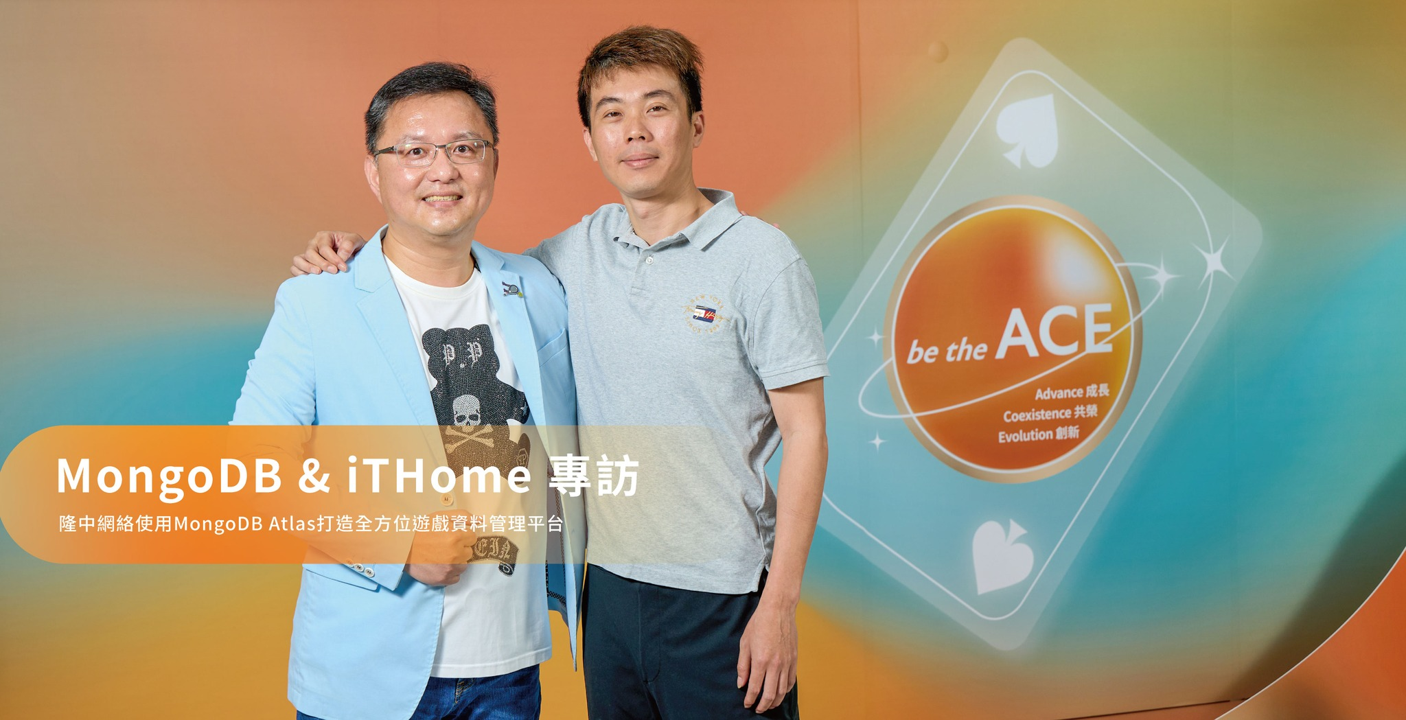
CIO Taiwan Value Academy 17th Keynote Speaker
CIO Taiwan Value Academy | May 2024
Keynote presentation to enterprise CIOs/CISOs on multi-cloud resource governance, cybersecurity compliance, FinOps TCO optimization, and architecture resilience.
🔗 Verified Source / DOI / URL: https://www.cio.com.tw/events/value-index-2/

Executive Yuan DGPA Master Lecture Series
Directorate-General of Personnel Administration | June 2024
Invited master instructor for civil servants, promoting cloud modernization, Zero Trust architecture, and resilient IT governance.
🔗 Verified Source / DOI / URL: https://elearn.hrd.gov.tw/info/10042804
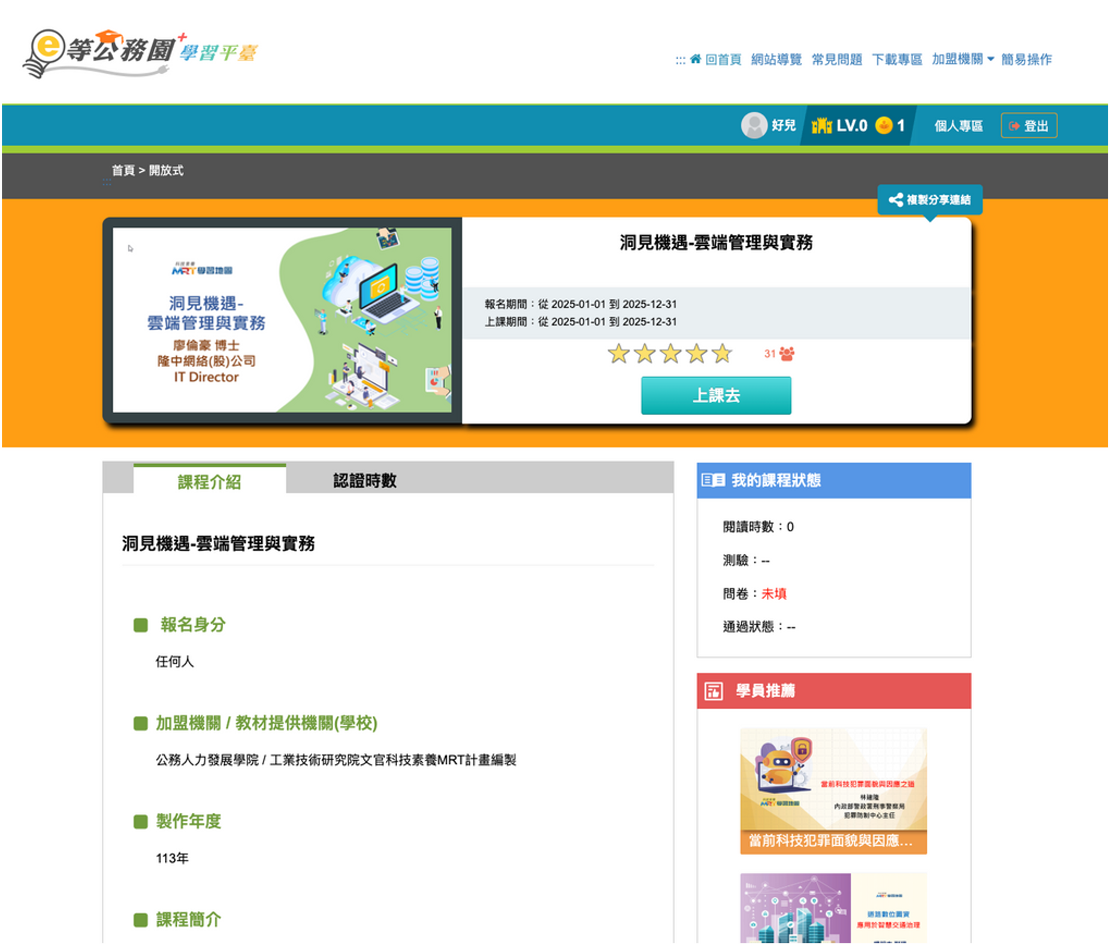
Google Cloud Official Global Customer Success Story
Google Cloud APAC Video | March 2024
Featured in official video case study on deploying Kubernetes/GKE multi-zone architecture achieving 100% Zero Outage during peak traffic spikes.
🔗 Verified Source / DOI / URL: https://youtu.be/_kTZSZ_0lNE?si=CT2lo8c4IF0zI1Ki
2. Academic Publications & Research
Springer SCI Journal Paper Publication: Reversible secret-image sharing with high visual quality
Multimedia Tools and Applications (Springer Nature, Vol. 74) | June 2014
Authors: Ching-Chiuan Lin, Lun-Hao Liao (Howard Liao), Kuo-Feng Hwang, Shih-Chieh Chen. Proposes a high visual quality reversible secret-image sharing scheme in cryptographic image security.
🔗 Verified Source / DOI / URL: https://link.springer.com/article/10.1007/s11042-012-1190-1
International Journal Publication: Utilizing GIS and GPS in Designing a Trilingual Tourist APP
Applied Science and Management Research (Vol. 2) | May 2015
Research on location-based mobile systems integrating GIS and GPS technologies for multilingual travel platforms.
National Central Library Legal Archive & Academic Advising
National Central Library (Advising Archive ID: 106IKTC0183002) | October 2014
Ph.D. dissertation on ITIL V3 and SOA framework governance. Archived in National Central Library under ID 106IKTC0183002.
🔗 Verified Source / DOI / URL: https://ndltd.ncl.edu.tw/
3. Media Coverage & Technical Features
CIO Taiwan Magazine Cover Feature Interview
CIO Taiwan Magazine (Issue 2024.05) | May 2024
In-depth interview by Editor-in-Chief on Multi-Cloud Networking (MCN), Kubernetes native architecture, and FinOps cost optimization.
🔗 Verified Source / DOI / URL: https://www.cio.com.tw/interview-howard-liao-online-gamesparcs-it-director/
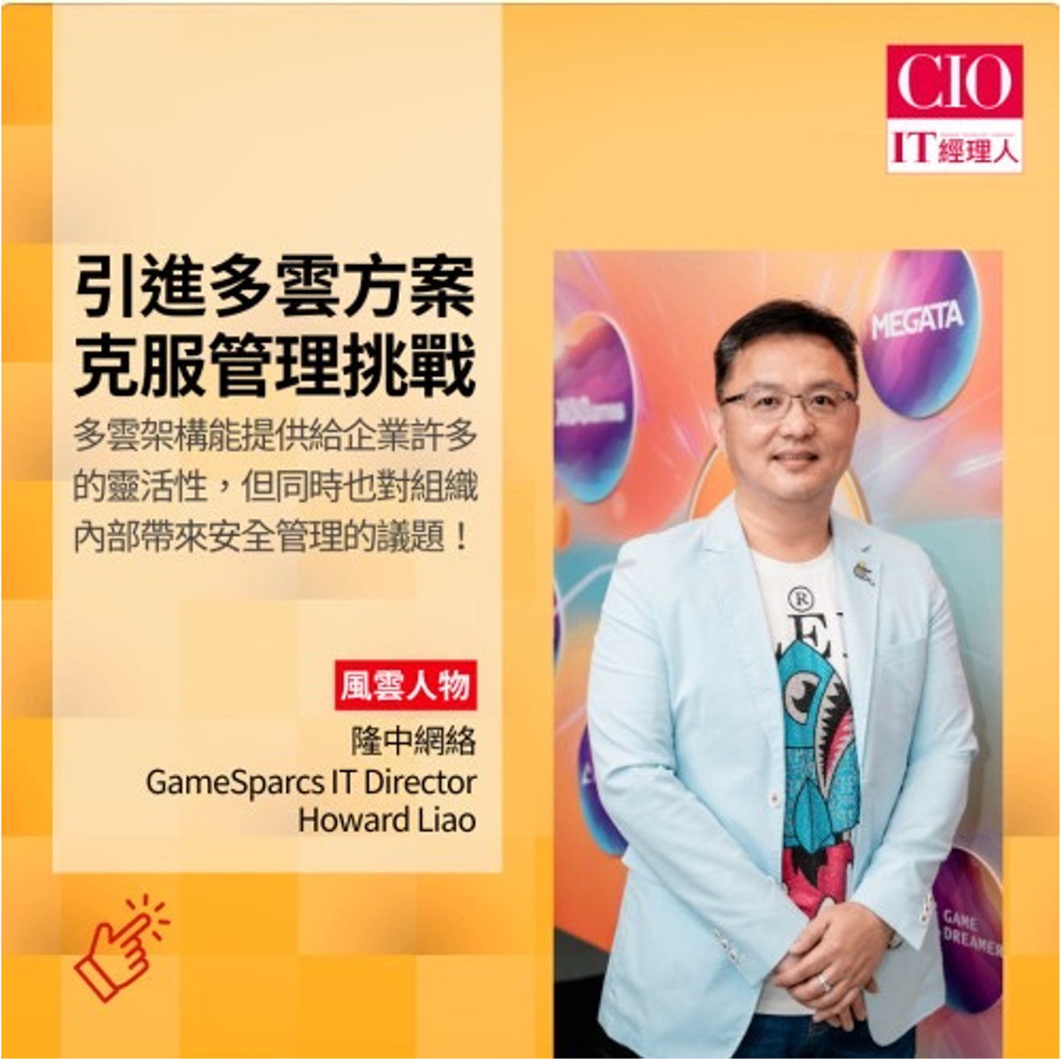
iThome Tech Feature Report
iThome Computer Daily | September 2024
Full-page technology feature highlighting Howard Liao's data platform architecture delivering 99.995% availability for global operations.
🔗 Verified Source / DOI / URL: https://www.ithome.com.tw/pr/163534
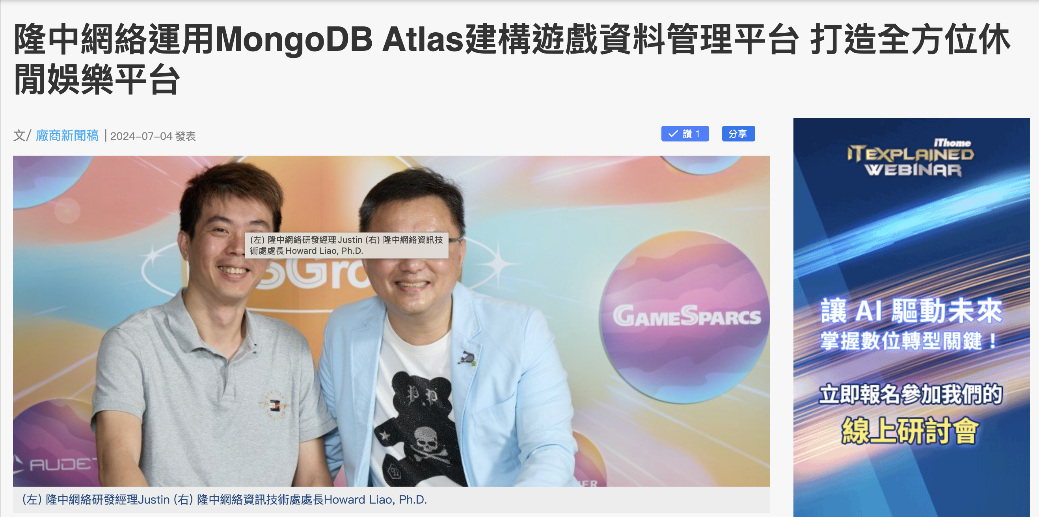
DIGITIMES Tech News Feature: MongoDB 8.0 Launch
DIGITIMES Tech News | September 2024
News coverage citing GameSparcs architecture cases in generative AI and real-time database workloads.
🔗 Verified Source / DOI / URL: https://www.digitimes.com.tw/tech/dt/n/shwnws.asp?id=0000704377_KI14VVDK6CQ8TB8OXC3GJ
4. Awards & Community Leadership
- Cloud Architecture Excellence Award — Recognized for a GKE-based multi-cloud architecture delivering high availability, operational resilience, and approximately 30% cloud-cost optimization.
- Keynote speaker at cybersecurity summits, sharing practical experience in hybrid-cloud security, Zero Trust implementation, ISO 27001, ISO/IEC 42001, cybersecurity governance, and digital resilience.
- Invited speaker at CIO academies and technology communities on multi-cloud governance, AI governance, enterprise digital transformation, and cybersecurity strategy.
Cancer NoNo Foundation Board Member & CIO
Cancer NoNo Foundation (CSR) | 2022 – Present
Serving as Board Director and CIO, leading CSR digital initiatives, children dietary education, and secure medical IT platforms.
🔗 Verified Source / DOI / URL: https://www.cancer-nono.org.tw/web/about/page.php?lang=zh_tw&scid=7&sid=5

