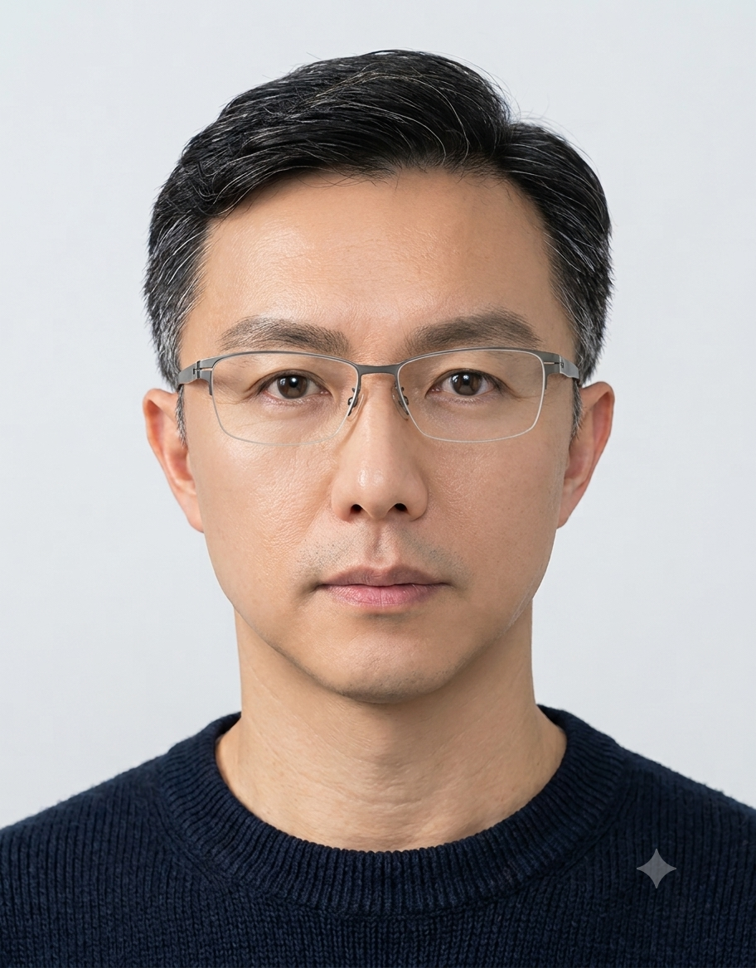
Howard Liao Ph.D.
Chief Information / Security / Data AI Officer (CIO / CISO / CDAIO)
Forward-Deployed AI Architecture • Player-Coach • 27 Years IT Leadership • 20 Years Executive

EXECUTIVE SUMMARY
Cross-national technology executive with 27 years of IT leadership and 20 years of C-level governance across US, China, Taiwan, and European markets. Recognized for delivering enterprise-grade architecture, FinOps-driven cost optimization (achieving -30% TCO), zero-outage cloud-native migrations, and forward-deployed AI systems (Agentic AI / ISO 42001 / NIST AI RMF). Brings a player-coach mindset—simultaneously shaping boardroom strategy, leading global agile squads, and shipping production-grade software. PhD in Information Technology Management with SCI-indexed publications and international keynote experience (CIO Taiwan, MongoDB.local Taipei).

CORE CAPABILITIES & LEADERSHIP DOMAINS
領域 (Domain) | 核心能力與實戰成果 (Capabilities & Proof Points)
Forward-Deployed AI & Agents | Design and deploy autonomous agentic systems (MCP, function calling, RAG), embedding security-by-design (prompt injection defense, audit trails) from PoC to production. Real-world: Agentic AI workflow automation delivering 55% operational efficiency gain.
FinOps & Cloud Cost Governance | Multi-cloud (GCP/AWS/Azure) cost optimization. Achieved -30% TCO through dynamic autoscaling, tagging-based chargeback, and right-sizing. Real-world: Google Cloud official global case study (GKE zero-outage migration, +100% deployment speed).
Zero Trust CISO & GRC | Enterprise security governance. ISO 27001 certification, DevSecOps shift-left (SAST/DAST/SCA), Zero Trust architecture, OT/IT convergence (IEC 62443). Real-world: 30% reduction in security incidents, 85% pre-release critical vulnerability patching.
Cloud Native & SRE | Docker, Kubernetes (GKE/EKS), Terraform, CI/CD (DevSecOps), observability (Prometheus/Graylog/Grafana). Real-world: 100% uptime in high-traffic global platforms, SOC 24/7 war room, real-time log ingestion.
Data & AI Governance (CDAIO) | Data sovereignty, AI risk management (ISO 42001, NIST AI RMF), responsible AI frameworks, data pipeline architecture (MongoDB Atlas, distributed data, streaming).
Thought Leadership & Executive Communication | SCI-indexed publication (Multimedia Tools and Applications), international keynote speaker (CIO Taiwan Value Academy, MongoDB.local Taipei). PhD in IT Management. Translates complex strategy into board-ready OGSM/ROI narratives.

LEADERSHIP MILESTONES & FLAGSHIP PROJECTS
1. Google Cloud Official Global Case Study (GKE & FinOps)
Spearheaded large-scale containerization migration to Google Kubernetes Engine (GKE) combined with MongoDB Atlas fully-managed data platform. Implemented FinOps tagging-based cost allocation and dynamic autoscaling. Delivered 100% zero-outage for a global high-traffic platform. Recognized by Google Cloud as an official customer success story worldwide. Metrics: -30% TCO, +100% deployment speed, zero-downtime cutover.
2. Multi-Cloud FinOps Governance & SOC 24/7 War Room
Built a multi-cloud observability hub (Prometheus / Graylog / Grafana) integrating IT, OT, and cloud-native signals. Established a real-time SOC war room with second-level alerting and automated anomaly blocking. Delivered cross-functional 'Security Champions' program embedding security-by-design. Achieved 30% reduction in security threat incidents and second-level incident response.
3. Agentic AI Forward-Deployed System (PoC → Production)
Led an agile, forward-deployed architecture engagement with business units to translate vague operational needs into executable AI-first blueprints. Designed an Agentic AI system (Python-based, function calling, RAG-connected private knowledge base) with prompt injection defense and data anonymization layers. Aligned with ISO 42001 and NIST AI RMF. Outcome: 55% reduction in routine maintenance ticket handling time, 100% audit-trailed AI decision paths.
4. ISO 27001 Certification & DevSecOps Shift-Left
Led enterprise-wide ISO 27001 certification program. Embedded SAST/DAST/SCA scanning into GitLab CI/CD pipelines, achieving 85% pre-release critical vulnerability patching rate. Introduced OWASP-aligned WAF, API Shield, and Tbps-level DDoS mitigation. Cross-functional 'Security Champions' program embedded security awareness across engineering squads.
5. Cross-Border Enterprise Architecture & Digital Transformation
Spanning listed entertainment & tech groups and global electronics manufacturing, directed enterprise architecture decisions, SWOT/gap analysis (cost/benefit/task-completion lens), translated business strategy into technical architecture, and defined group-wide digital transformation roadmaps from day one.

ACADEMIC & THOUGHT LEADERSHIP
• PhD in Information Technology Management
朝陽科技大學 (Chaoyang University of Technology) — 資訊科技管理與治理研究。聚焦資訊安全、密碼學與組織數位轉型治理。
• SCI-Indexed Journal Publication
《Multimedia Tools and Applications》（SCI 收錄期刊）發表高階密碼學與資訊隱寫研究論文。
• International Keynote Speaker
• CIO Taiwan 值學院 — 擔任主題演講人，分享技術治理與數位轉型戰略。
• MongoDB.local Taipei — 擔任主題演講人，演講內容涉及雲原生資料架構與全球擴展實務。
• 20+ Year Hands-On Experience
跨國實戰橫跨美國、中國、台灣、歐洲市場，累積企業軟硬體整合、大型系統建構、資安防禦與商業策略轉譯的深厚實戰經歷。

CONTACT
Email: Liao.Howard@gmail.com
LinkedIn: https://www.linkedin.com/in/howardliao/
GitHub: https://github.com/HowardLiao
Portfolio: https://howardliao.github.io/portfolio/

Author: Howard Liao Ph.D. | 此履歷中的所有職稱與專案皆基於真實學經歷整理，不含任何 2022 年份與獎勵金數字。

