HIT137

Software Now

Assignment 01

Group Name:

HIT137_2024_S2_Group162

Group Members:

Howard Mai: S371832

Warna Gayathra Vithanage: S373831

S M Ashraful Mustofa Fardin: S360794

Siddharth Biswa: S377269

13 August 2024

**Q1:**

A:

if __name__ == '__main__':

print("Please input three numbers")

t = 1

nums = []

while t <= 3:

user_input = input(f"User input {t}: ")

if not user_input:

continue

nums.append(int(user_input))

t += 1

nums.sort()

can_form = nums[0] + nums[1] > nums[2]

print(

("Yes" if can_form else "No") +

", these three lengths " +

("can" if can_form else "cannot") +

" form a triangle."

)

B:

def draw_square(n):

m = [[" "] * n for _ in range(n)]

for r in range(n):

for c in range(n):

if r == 0 or r == (n - 1):

m[r][c] = '*'

if c == 0 or c == (n - 1):

m[r][c] = '*'

return "\n".join([" ".join(row) for row in m])

if __name__ == '__main__':

print(draw_square(4))

**Q2:**

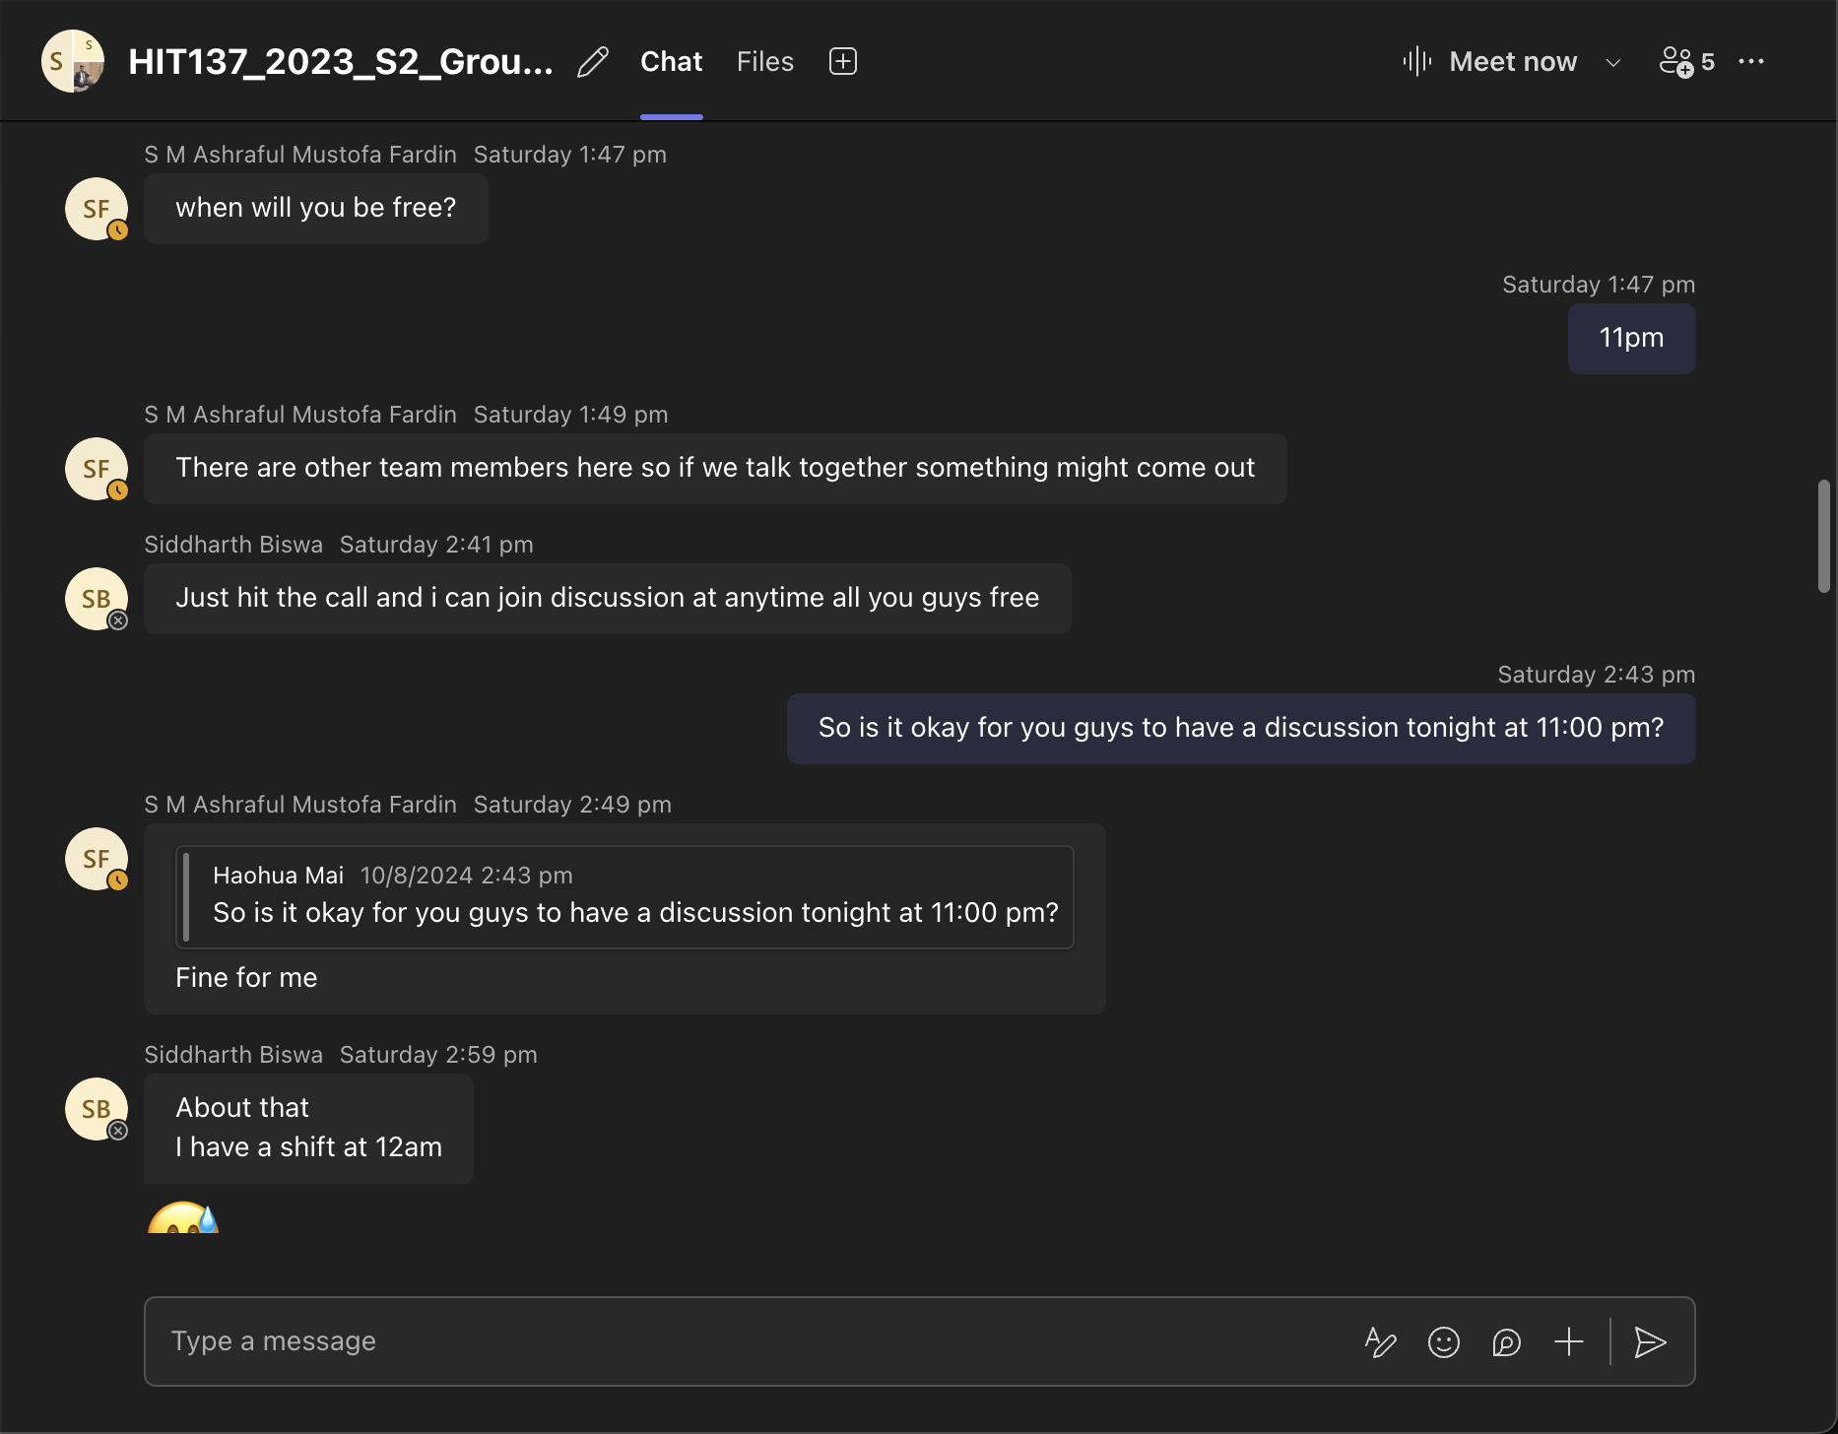

**Q3:**

**Essay: Benefits of Working in Groups on Programming Projects**

**Introduction**

Working in groups on programming projects offers several benefits that enhance the learning experience and contribute to the successful completion of assignments. In today's collaborative world, group work is essential in developing critical skills that are highly valued in both academic and professional settings.

**Benefits of Group Work**

1. **Diverse Perspectives and Ideas**: Group work allows individuals to bring diverse perspectives and ideas to the table. Each member has a unique way of thinking and problem-solving, which can lead to innovative solutions that might not have been reached individually.
2. **Division of Labor**: In a group setting, tasks can be divided among members according to their strengths and interests. This division of labor ensures that the workload is evenly distributed, making the project more manageable and reducing the burden on any single member.
3. **Enhanced Learning**: Group work facilitates peer learning, where members can learn from each other's strengths. For example, one member might be strong in coding, while another excels in documentation. Through collaboration, each member can gain a better understanding of all aspects of the project.
4. **Improved Communication and Collaboration Skills**: Working in a group requires clear communication and effective collaboration. These skills are crucial in professional environments, and group projects provide an excellent opportunity to develop them.
5. **Increased Accountability**: When working in a group, members are accountable to each other. This sense of responsibility often motivates members to perform at their best, knowing that their contribution affects the entire group.
6. **Problem-Solving and Conflict Resolution**: Group work often involves addressing conflicts and finding solutions to disagreements. These experiences are valuable as they prepare members for real-world scenarios where teamwork and compromise are necessary.

**Group Agreement**

As a group, we have agreed on the following vision and goals for this unit:

* **Vision**: Our vision is to collaborate effectively as a team, leveraging each member's strengths to produce high-quality work that meets or exceeds the assignment requirements. We aim to support each other in learning and growing our programming skills throughout the unit.
* **Goals**:
  1. **Regular Communication**: We commit to regular meetings and active participation in discussions on Microsoft Teams to ensure everyone is on the same page.
  2. **Timely Completion of Tasks**: Each member will complete their assigned tasks on time to allow for review and integration into the final submission.
  3. **Quality Assurance**: We will review each other's work to ensure accuracy, efficiency, and clarity before submitting the final project.
  4. **Conflict Resolution**: We will address any conflicts or disagreements respectfully and work together to find solutions that benefit the entire group.
  5. **Continuous Learning**: We will take advantage of each other's knowledge and experience to learn new skills and improve our understanding of the subject matter.

**Conclusion**

In conclusion, working in groups on programming projects not only contributes to the successful completion of assignments but also helps develop essential skills that are valuable in both academic and professional settings. By adhering to our group agreement, we aim to create a collaborative environment that fosters learning and success.