ADALM-Pluto Dashboard Plot Guide
ENGR 078 Final Project 1 live signal displays
This guide explains the plots in the Pluto dashboard using only the class-connected signal ideas shown in the app: spectrum/PSD, I/Q constellation, eye diagram, SNR/noise, and throughput.
Screenshots were captured from the running ADALM-Pluto dashboard in BPSK, QPSK, and 16-QAM modes. Because these are live Pluto captures, the exact point clouds and rates can change each time the app runs.
Quick Map
Mode | Bits/symbol | What to expect
BPSK | 1 bit/symbol | Two possible symbol decisions, mainly separated along the I axis.
QPSK | 2 bits/symbol | Four possible phase states, one in each I/Q quadrant.
16-QAM | 4 bits/symbol | Sixteen amplitude-and-phase states arranged as a grid in I/Q.

General Reading Order
- First check the status and modulation mode, so the expected number of symbol points makes sense.
- Then check the spectrum to confirm signal energy is present near baseband.
- Use the constellation and eye diagram to judge signal quality and timing.
- Use the throughput counter to confirm that decoded bits are accumulating over time.

Power Spectrum / PSD
What It Means
This plot shows where the received signal power sits in frequency. It is the same idea as the power spectral density and spectrum plots from class: the x-axis is frequency in hertz and the y-axis is power in dB.
How To Read It
- Look for the raised center band: that is the transmitted signal energy around baseband.
- The blue trace is the raw received Pluto samples; the red trace includes the software impairments selected in the dashboard.
- If frequency offset is added, the signal energy shifts left or right. If noise is added, the floor around the signal rises.
Quick check: A healthy display has one clear occupied band near the center and a lower surrounding noise floor.
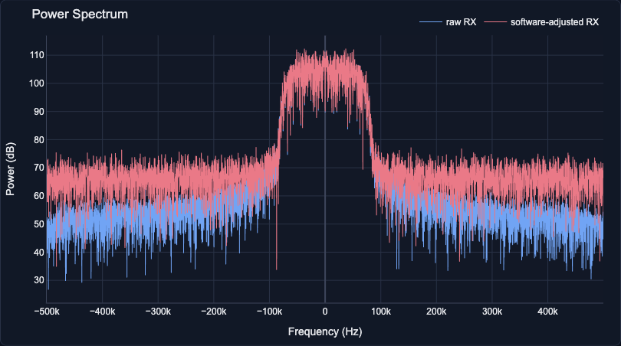
Figure 1. Power Spectrum / PSD in BPSK mode.
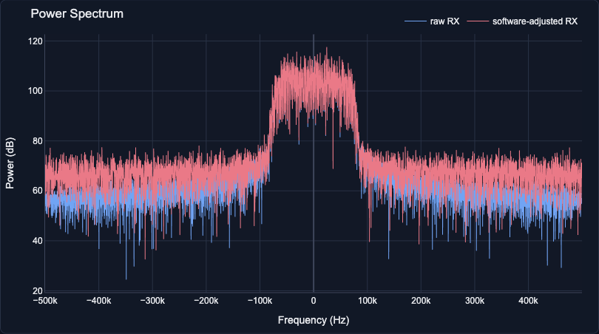
Figure 2. Power Spectrum / PSD in QPSK mode.
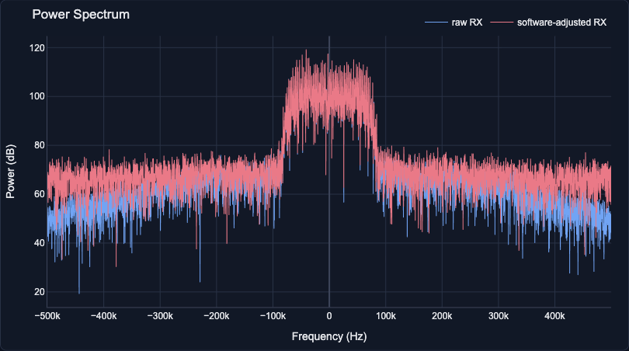
Figure 3. Power Spectrum / PSD in 16-QAM mode.

I/Q Constellation
What It Means
This plot shows the received symbols after the receiver has converted the signal into in-phase and quadrature components. The horizontal axis is I and the vertical axis is Q.
How To Read It
- Yellow x marks show ideal decision locations; green dots show received symbol estimates from the Pluto signal.
- Tight clusters near the ideal points mean cleaner reception. Wider clouds mean more noise, timing error, or synchronization error.
- Rotation usually points to phase offset. A stretched or smeared pattern can come from frequency offset, filtering, or a noisy channel.
Quick check: The expected pattern changes with modulation: BPSK has two decisions, QPSK has four, and 16-QAM has a denser grid.
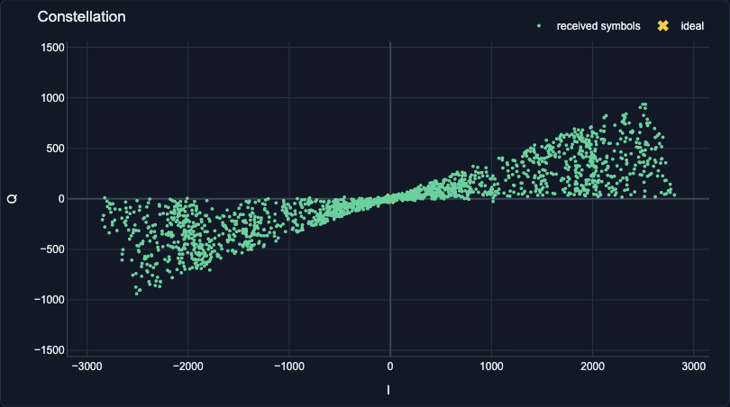
Figure 4. I/Q Constellation in BPSK mode.
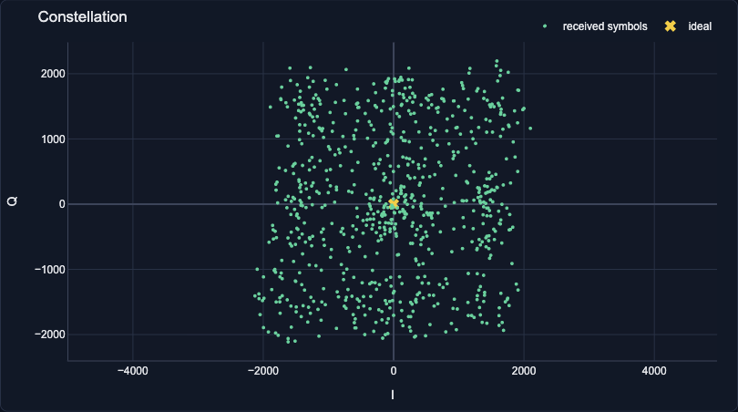
Figure 5. I/Q Constellation in QPSK mode.
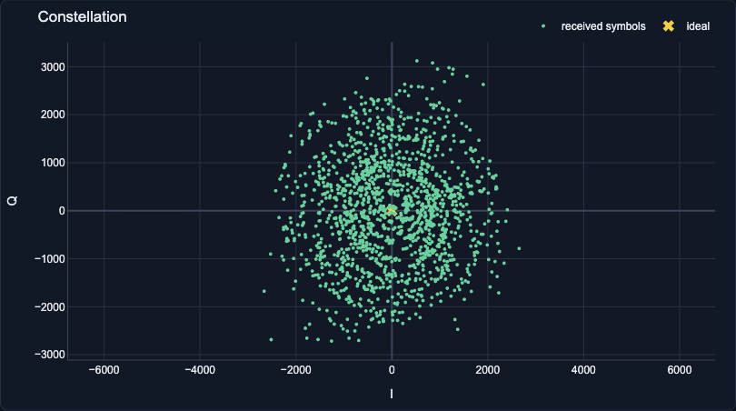
Figure 6. I/Q Constellation in 16-QAM mode.

Eye Diagram
What It Means
This plot overlays many short windows of the matched-filter output. It is a class tool for seeing symbol timing, noise margin, and intersymbol interference.
How To Read It
- The dashed yellow line marks the nominal sampling instant, one symbol period into the two-symbol window.
- A more open eye means the receiver has a safer time and amplitude margin for deciding symbols.
- A closed, fuzzy, or crossing-heavy eye means noise, timing error, bandwidth limitation, or ISI is making decisions harder.
Quick check: Use the eye diagram as a timing-quality view, not as a direct bit counter.
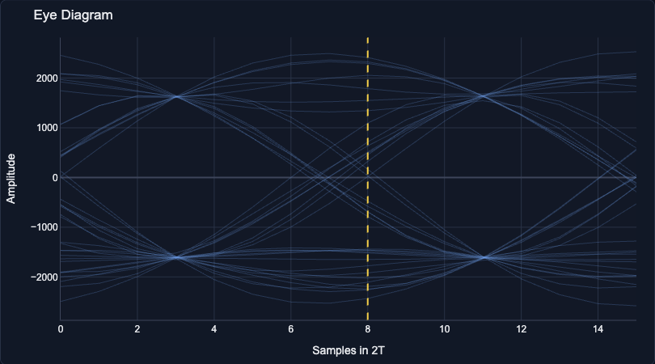
Figure 7. Eye Diagram in BPSK mode.
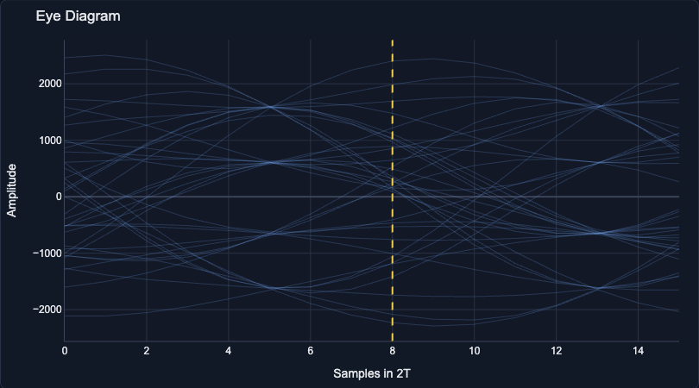
Figure 8. Eye Diagram in QPSK mode.
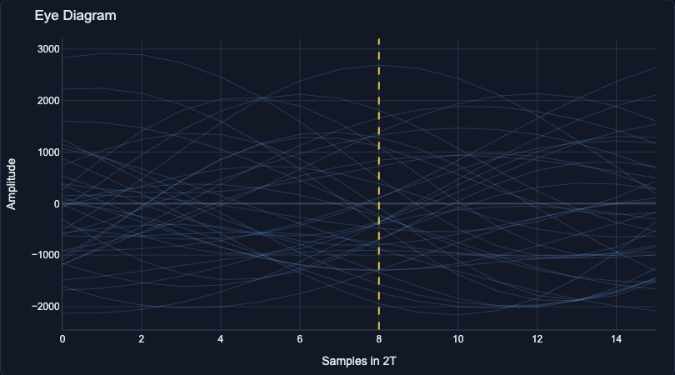
Figure 9. Eye Diagram in 16-QAM mode.

Throughput Counter
What It Means
This plot is the live data-rate view. It keeps the useful counter you liked: yellow shows the instantaneous decoded rate in kb/s and purple shows the cumulative number of decoded bits.
How To Read It
- The yellow line jumps because each Pluto receive/update cycle produces a different short-term rate.
- The purple line should generally climb over time while the dashboard is streaming.
- Higher bits per symbol can raise the possible bit rate, but the actual live value also depends on synchronization and buffer timing.
Quick check: This plot is the best place to answer: is the receiver still decoding data and how quickly is the bit count growing?
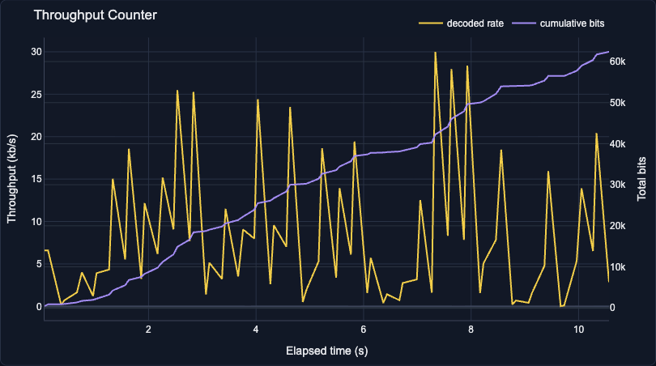
Figure 10. Throughput Counter in BPSK mode.
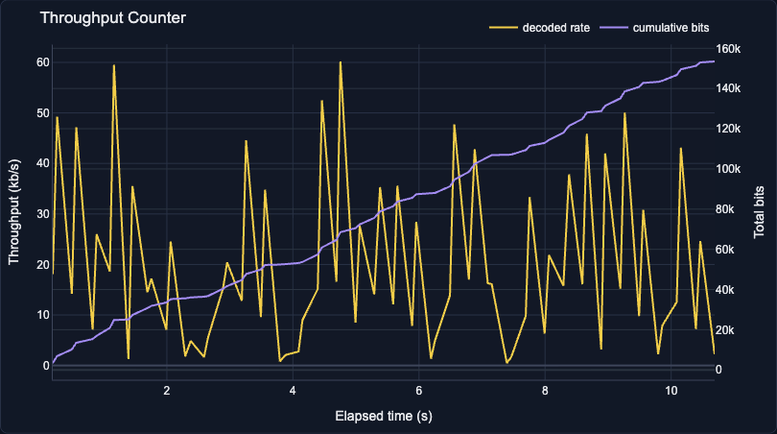
Figure 11. Throughput Counter in QPSK mode.
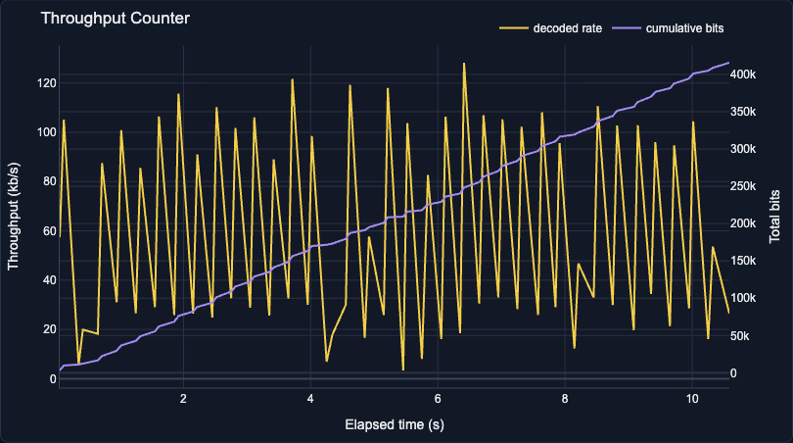
Figure 12. Throughput Counter in 16-QAM mode.

Control Effects
Software AWGN SNR
Lowering this slider adds more noise in software. In the spectrum, the floor rises. In the constellation, the green dots spread. In the eye diagram, the opening becomes less clean.
Carrier Phase Offset
Changing phase rotates the I/Q constellation. This is easiest to see on PSK modes because their information is carried strongly by phase.
Carrier Frequency Offset
Changing frequency offset shifts or smears the received signal over time. In the spectrum, the signal band moves away from center; in the constellation, points can rotate or blur.
Throughput
Throughput is a live rate counter, so it is expected to jump. The important sign is that the cumulative-bit curve keeps increasing while streaming.

