Howard Hardnett

05/04/2022

Assignment: WhatABook: Database and Table Creation

GitHub Link: <https://github.com/Howardlee23/csd-310/blob/main/module_10/hhardnett-WhatABook-Database-and-Table-Creation.py>

Create a new MySQL database and name it **whatabook**

Take a screenshot of the command running in the terminal window

Using the examples I provided in previous assignments, create a new database user and name it **whatabook_user** and assign it the password **MySQL8IsGreat!**

* + Follow the code I used to create the **pysports_user**
  + Take a screenshot of the command running in the terminal window





Create the appropriate tables to match the ORD you defined in Module 10.2 Assignment

* + Take a screenshot of the commands running in the terminal window

CREATING THE USER TABLE

CREATING THE BOOKS TABLE

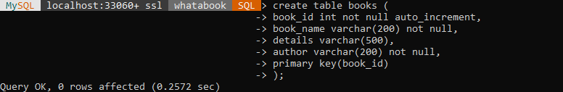

CREATING THE WISHLIST TABLE

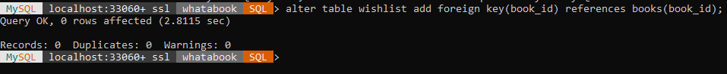

CREATING THE STORE TABLE

Insert new records to fill each table

* + 1 store
  + 9 books
  + 3 users
  + 1 wishlist item for each user (total of 3 wishlist records)
  + Take a screenshot of the insert statements

INSERT INTO STORE

INSERT INTO BOOKS

INSERT INTO USERS

INSERT INTO WISHLIST

