Rocillo, Howard E. 2ECE-B 12/3/19

1. Problem 1

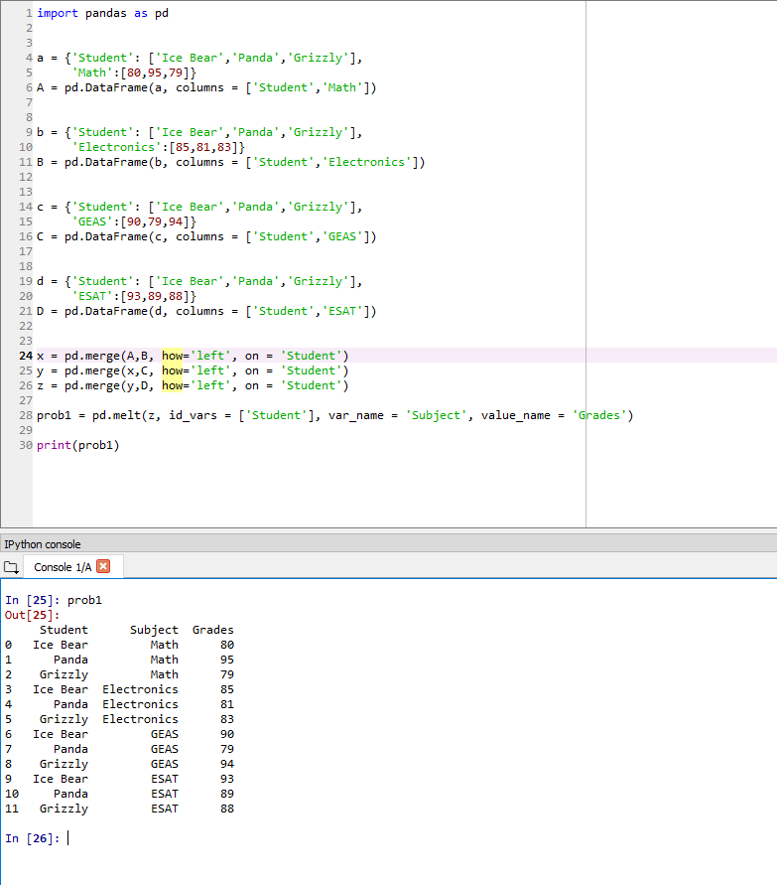

1. Problem 2

