**Report**

**Execute flow:**

**Server Working Flow**

1. When we execute the server first,then the server will waiting for the clients which listen to the same port and host(ip) to send request to the server.
2. After getting the request from the clients,server will store them in a queue.

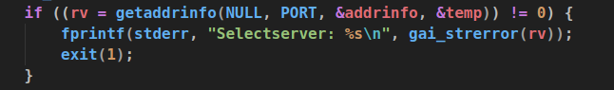

1. Then use a for loop to go through available request to socket and bind them.

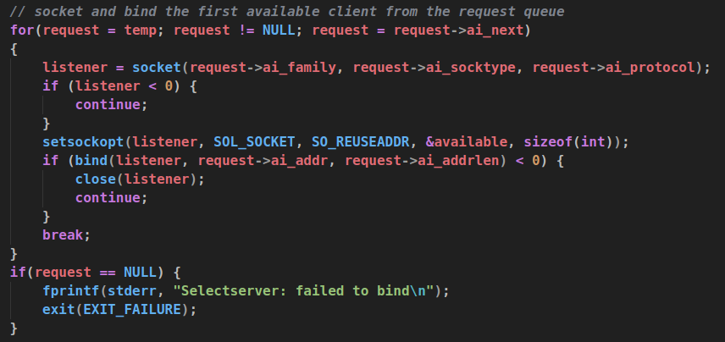

1. Server listen to clients to send data.
2. Go through all request in the queue and accept them one by one for recv or send data



1. Use FD_SET to add the accept socketFD to master set



1. Recv and Send data, and remember to use FD_CLR remove the sockFD from the master set after recv data, or FD_ISSET to check sending

**Client Working Flow**

1. Getaddrinfo.
2. Run through all the request and socket and connect.
3. Create a pthread and execute handler function

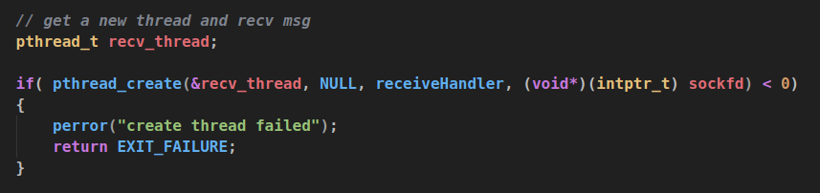

1. Pthread handler function, this function is used to let the thread listening to the server and recv the data the is sent from the server and print it out.

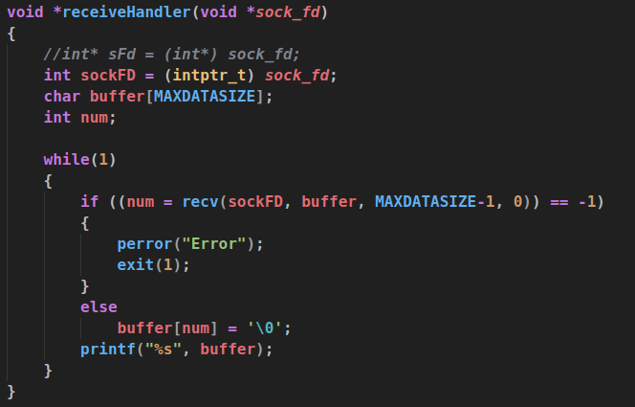

1. Check quitting command



1. String Processing, add ‘;’

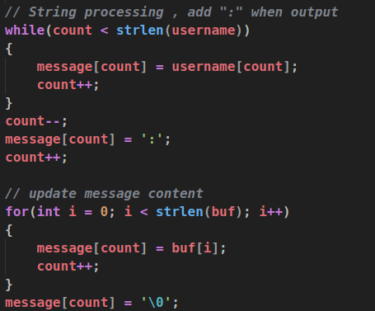

1. Sending data

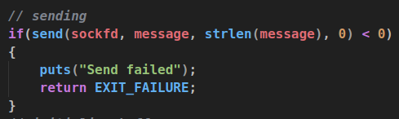

1. Close socket

**Output**

