**Artificial Intelligence In Medical Applications and Services**

**Homework3 Report**

**1. Score Result**

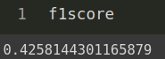

**2. Process**

As the TA mentioned, we can seperate the whole project into 2 parts which are

**Preprocessing** and **Model_Training.**

1. **Preprocessing**

First we use **loadInputFile** function toload the data given by TA (SampleData_deid.txt).

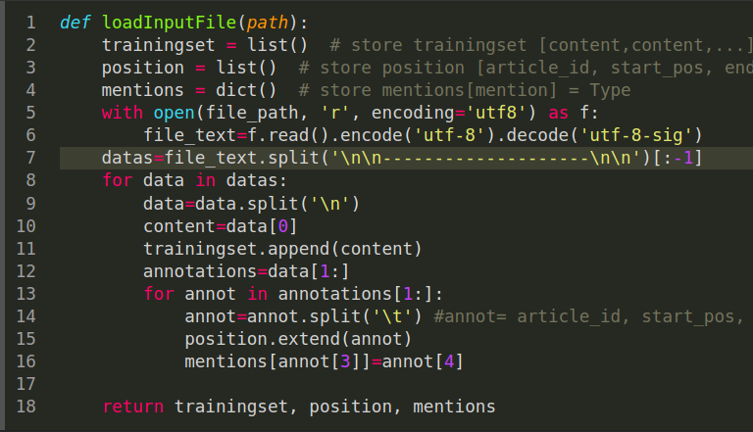

Then use CRFFormatData to change the input data into a corresponding format (clear the space, adding 'B' 'O' 'I' label)

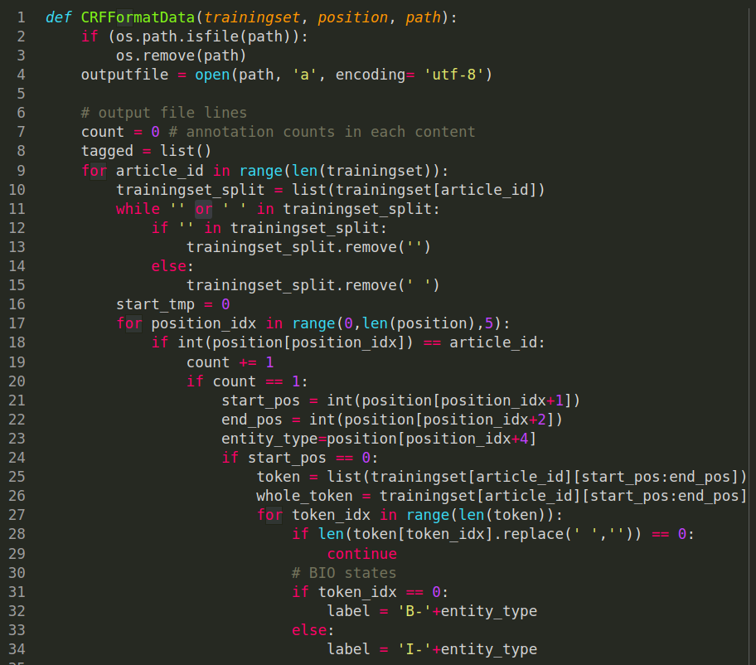

1. **Model_Training**

Create a model to fit and predict, and don’t forget to flatten to get final f1score and print the prediction result

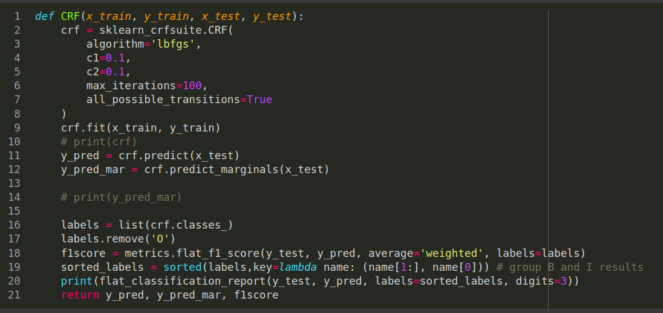

This part is very important. We need to prepare a pretrained word vector file to let it find corresponding key value of the token that get from input data.

The first two tokens are the parameters which are vocabulary_size and it’s dimension. And keep the rest tokens into **vec** array in float type, and return word_vecs dictionary.

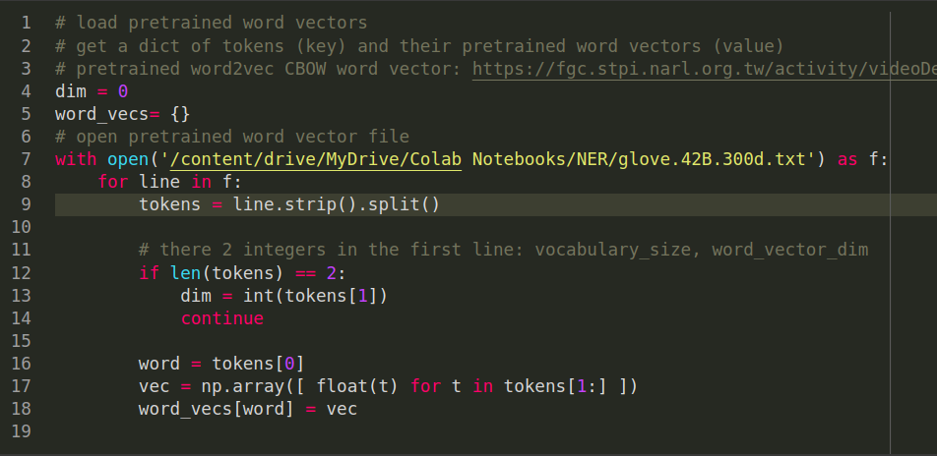

Prepare dataset and split them into training_set and testing_set with test_size = 0.33

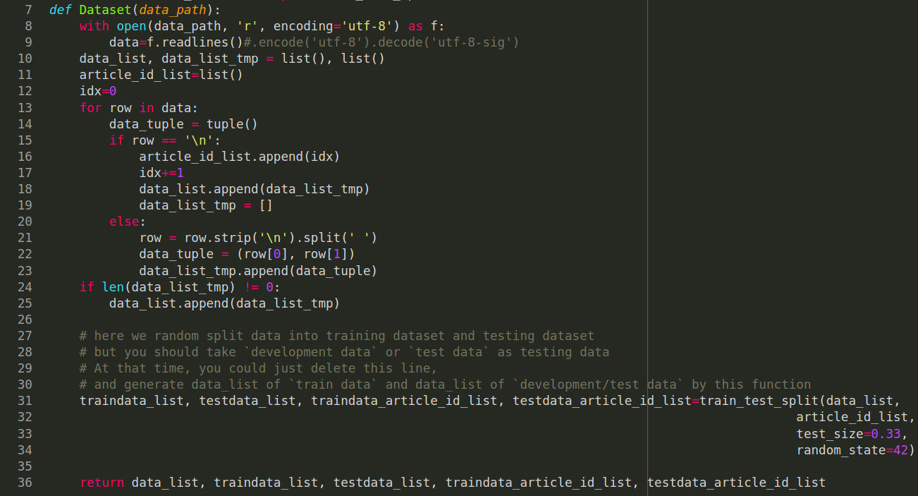

Use the pretrained word vector that we just imported as embedding_dict to find the input data_list’s corresponding value with three for loops and keep them as a list.

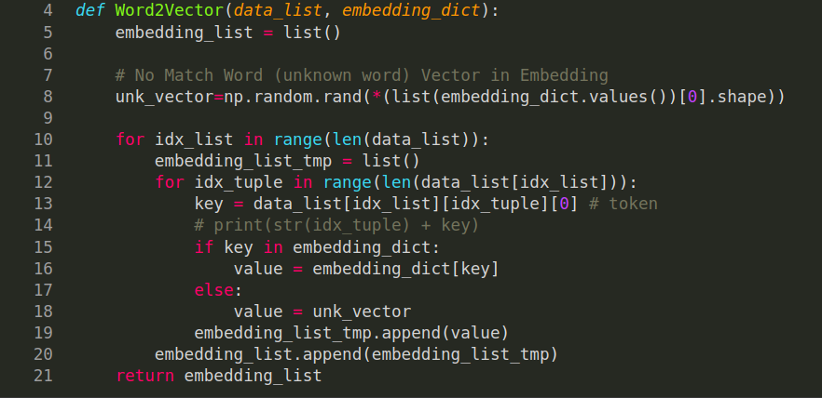

Extract all the features of embedding_list and keep also(three loops go through 3 dimension of embed_list)

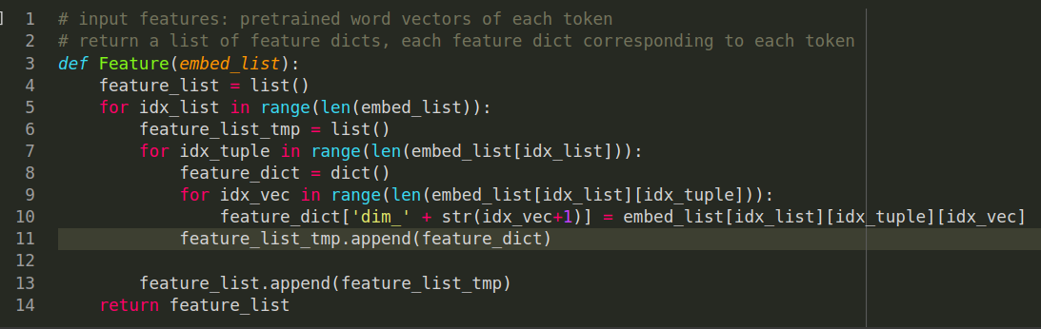

This is how embed_list[idx_list][idx_tuple][idx_vec] looks like:

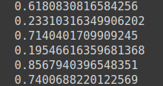

Prepare a Label list by set the third dimension of data_list to **1**

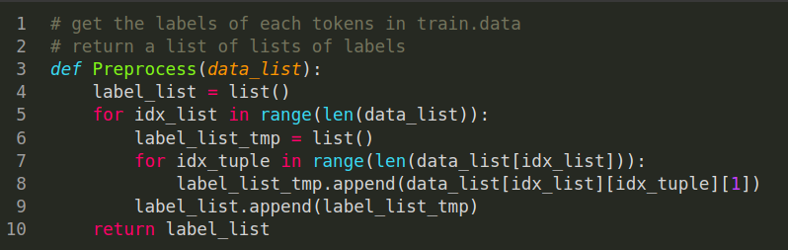

Call the functions

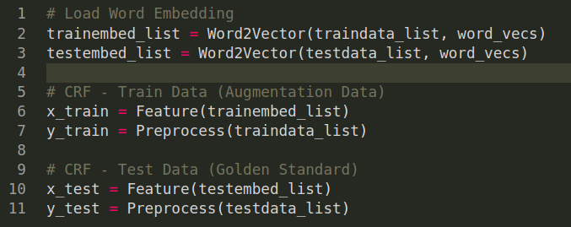

Fit and predict



Result

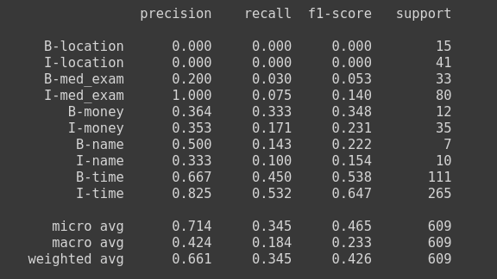

F1Score



Change the output format and save into output.tsv file

Here we show the entity text’s id, start_position, ending_position, content and type.

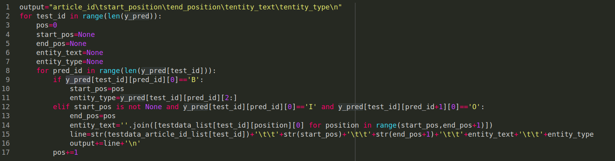

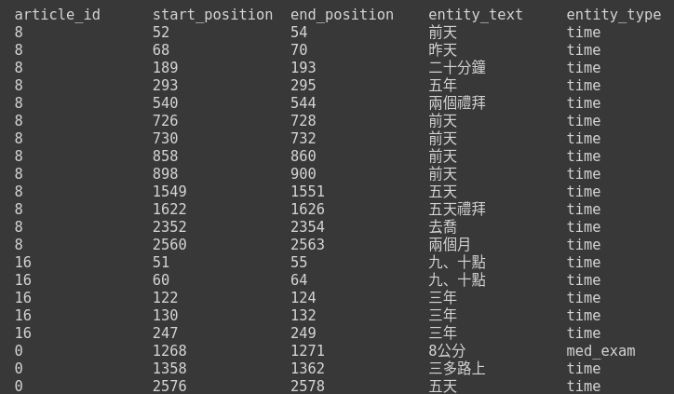

**3. Features**

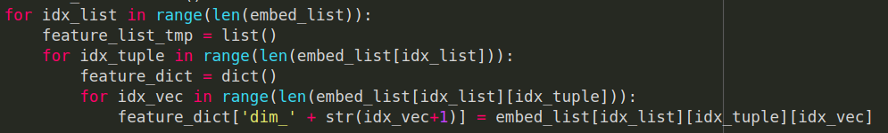

This is how embed_list[idx_list][idx_tuple][idx_vec] looks like:



**4. Experience**

* From this homework, I had learned what are **NER** and **CRF model**,and how computer learn a high-level human language.
* As we know, **f1score** show our model performance, but the point is how to get higher score! This is definitely different to the typical ML model, because it is not only the input_data but also how we processing the input_data into tokens and label is decisively important !
* There is no so much parameters to let you adjust to get better model performance, so a great processing_data and completely pretrained word vector file will help your model to become better!
* Interesting topic for us to explore how great ML is in this generation.
* Thanks for Prof and TA! :)