# Paper Prototyping: Just two friends

**Name:** Steven van den Hoven

**Class:** 1DAE16

## Introduction and target experience

<A short introduction of your game and the target experience e.g. “I made a multi-player survival game about (not) being part of a cult. The goal is to survive as long as possible, either until everyone is part of the final cult or you are the lone survivor. At the start everyone is equal, so you are parts of the same cult (those who have nothing). As time progresses new items spawn and people can pick these up. You are part of the same cult if you have the same items equipped. Picking up items may give a boost or edge over other players, but doing so too early may prove risky as others who are not part of your cult may gang up on you. Let the games begin.”>

I made a co-op game where you and your friend are being fired at by attacks while being tied to together by the rope of friendship. And because all good things come to an end the game doesn’t end until you and your rope of friendship snaps. Every time you get hit by an attack your rope gets shrinks leaving you and your friend less room to roam around without the other. But if your rope has been at least shrunk once, There are little friendship healing points you can pickup to regain length in your rope.

## Screenshot(s)

<Insert recognizable screenshot(s) here.>

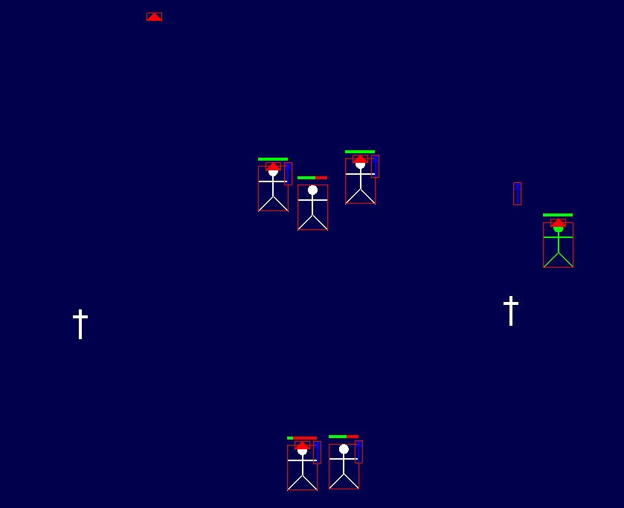

## Feedback from playtesting

<Copy and paste your target question(s), gathered feedback, analysis and changes (in chronological order) here.>

Playtest Session 1:

Target questions

*What will the players natural instinct do without me giving any info about the game. Do they reacts appropriate to the attacks. And do they notice the game mechanics by themselves?*

*Is there anything that you didn’t expect in the loop of the game?*

*What do you think about the difficulty?*

FeedbackAnalysis

*Example:*

***Game 1 with Esteban, Casper***

*Esteban + Casper: “The attacks are to random, sometimes it’s to easy but then suddenly the attacks are generated in such a way there isn’t even a chance to dodge them”*

*Question “Is there anything that you didn’t expect in the loop of the game?”*

*Esteban: “For so many balls to come at me at once.”*

*Casper: “No it all seemed fine”*

*Question “Was the controls clear?”*

*Esteban: “Like he said basically yeah.”*

*Casper: “Yeah, the WASD was obvious and then after a second we knew it was the arrow keys.”*

***Game 2 Nand, Steven***

*Nand: “The random generation gives a unfair advantage towards the game, I can barely dodge some of the attacks”*

*Nand: “Also once you lose length in your rope there is no way to get it back, maybe at some pickups to get some your length back”*

*Question: “So would you say it was difficult or not really?”*

*Nand: “Sometimes yeah because of the random generation”*

***Game 3 with Berra, Yifan***

*Berra: “The game is fun, but gets boring after a while with only the balls coming at you, maybe makes some other attacks so there is more variety in the game”*

*Yifan: “I don’t feel I have a lot of options as a player, just move to dodge, but maybe adding a dash or a ghost ability would be cool”*

*Question: “What would you see as other attacks?”*

*Berra: “Maybe some bombs?”*

*Yifan: “Lasers? Or maybe balls that spawn other balls?”*

*Example:*

*<The complete lack on feedback about lag or stutter indicates that, even thought there was some* ***lag*** *(I checked), it* ***did not impede on the gameplay*** *so there is no need to improve the networking code for the time being (phew).*

*It is clear that we should let the player know which* ***inputs*** *exist in the game and what they do. A* ***start screen*** *likely suffices to get started properly.*

* *It was unclear what was happening and what you could do. What meaning does it have to wear a hat? Does it give immunity or a bonus? Can you only attack when wielding the blue club or earlier than that? How do I even attack?*

*It is indeed unclear what is going on at the start of the game. Later on I will discuss combat, but the* ***figuring******out*** *what being part of a cult is and why you should, or should not, become part of a different cult by picking up, or dropping, items is* ***part of the learning experience and its emergent dynamics****.*

*There was a lot of feedback on the combat: how it boiled down to mashing spacebar as much as possible. Even though there was a* ***timer******between******attacks****, players did not notice this and just mashed as fast and hard as possible. Perhaps* ***animations*** *could help to let the player know they cannot attack infinitely fast, and should time their attacks.*

*There was also a lot of feedback that in 1v1* ***combat*** *essentially the one with highest hp left is bound to win. There is no way to escape fast enough, or to outsmart the opponent. Suggestions made include adding* ***dashing****,* ***sprinting****,* ***slowing******down******when******attacking*** *and/or adding an* ***energy******bar****. All of these are interesting and I would like to move forward testing out these in the next playtest because they are the core of survival in this game and would provide more* ***risk****-****reward*** *and* ***thought*** *when playing.*

***Items******spawn*** *rather quickly currently, this is a balancing issue and definitely needs addressing at some point. Same goes for adding* ***powerups*** *to items, should be more of an incentive to pick up items. But at the time players pick up items anyway, because it allows to attack others, so their primary goal currently suffices.*

***Respawning*** *is definitely an interesting option. Currently players already figured out that if they reconnect, they spawn again with a new stick figure. >*

Implemented change

*I changed the base spawn system so that attacks don’t random generate but have a hard coded pattern. The only thing that is random generate is the order they are played. Now it’s a wave system with a hard coded pattern.*

*I implemented recover balls. Where if the players now lose length in their rope they can regain the length till it hits its original size.*

*Added ray attacks to the game. The rays give a prior warning so that the players can reacts in a timely matter.*

Playtest Session 2:

Target questions

*What do people think of the new attack patterns? Is it too easy to difficult*

*Is it clear that the recover ball is friendly? And what it does without me explaining it?*

*Are the lasers fair? Do you understand it’s a laser?*

*Example:*

***Game 1 with Nand, Steven***

*Nand: “Much better then last time, But it’s kinda easy right now”*

*Question “Are the lasers fair? Do you understand it’s a laser?”*

*Nand: “Owh yeah it seeing a yellow block took me by surprised but then after the short time it made sense, maybe at some sfx of a laser shooting so it’s more clear.”*

***Game 2 with Leoanrdo, Steven***

*Leoandro: “The game is nice, but I would like to see more different wave and attacks”*

*Question “Is it clear that the recover ball is friendly? And what it does without me explaining it?”*

*Leoandro: “At first I didn’t really knew it was doing, but it was green so I assumed it was good?. But when I had barely and length left and picked a couple up I started to see rope get longer again so that’s when I understood it.”*

…

## Feedback given to others

Feedback for Nand

*Example:*

*<Arrow/WASD key inputs are straightforwad but picking up, dropping and how to attack take some time to figure out. It is also unclear when you can attack someone, apparently only when you have different items.*

*Spacebar spam: Grace or invincibility period so you don't die all at once.*

*… >*

…