**词法分析器设计**

**1. 实验目的**

通过本实验的编程实践，了解词法分析的任务，掌握词法分析程序设计的原理和构造方法，对编译的基本概念、原理和方法有完整的和清楚的理解，并能正确地、熟练地运用。

**2. 实验内容**

用C++语言实现对C++语言子集的源程序进行词法分析。通过输入C++源程序从左到右对字符串进行扫描和分解，依次输出各个单词所属类别及单词本身的值；若遇到无法识别的单词则显示“Unknown”，然后跳过错误部分继续显示；同时进行标识符登记符号表的管理。

**3. 实验原理**

本次实验采用NFA->DFA->minimise DFA的过程:

对待分析的简单的词法（关键词/id/num/运算符/空白符等）先分别建立自己的NFA，然后将他们用产生式连接起来并设置一个唯一的开始符，终结符不合并。

词法可以分为以下几个基本部分

（1）关键字(keyword)：

"include","define","auto","bool","break","case","catch","char","class",

"const","const_cast","continue","default","delete","do","double",

"dynamic_cast","else","enum","explicit","extern","false","float","for",

"friend","goto","if","inline","int","long","mutable","namespace","new",

"operator","private","protected","public","register","reinterpret_cast",

"return","short","signed","sizeof","static","static_cast","struct",

"switch","template","this","throw","true","try","typedef","typeid",

"typename","union","unsigned","using","virtual","void","volatile","while"

（2）分隔符（separator）

",",";",".","\'","\"","(",")","[","]","{","}","//","/*","*/","#"

（3）运算符(operator)

"+","-","*","/","%","=","==","!=","<","<=",">",">="

（4）标识符（identifier）

（5）数字（number）

（6）注释（note）

（7）字符串常量（constant）

（8）空格有空白、制表符和换行符组成。空格一般用来分隔ID、SUM、运算符、界符和关键字，词法分析阶段通常被忽略。

若无法按照以上自动机读取，则认为是未知符号。

**4. 相关自动机描述**

NFA:

Minimize DFA：

1. **流程图**

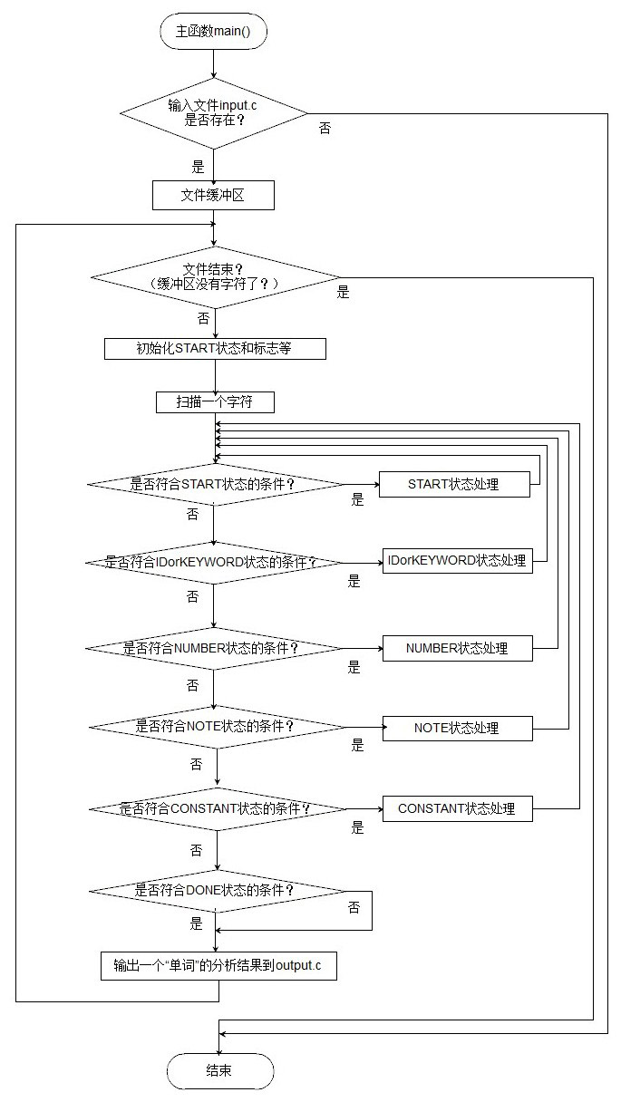

**测试用例**

输入代码：

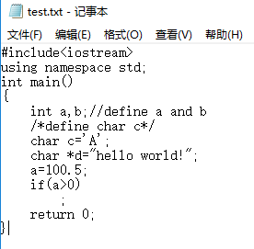

输出结果：

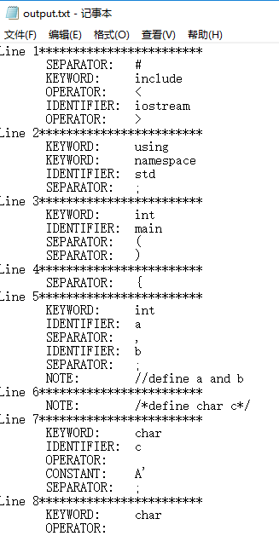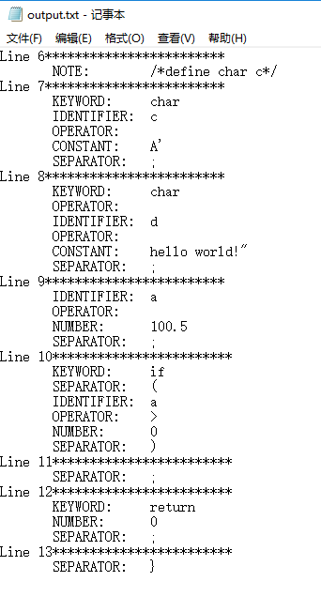

**8. 出现的问题与解决方案**

本实验的难点就是进行有效地进行状态如转换，先对每一个简单部分，如空白符、id、digit等画出自动机状态，然后由NFA->DFA，添加一个唯一的初始状态，产生式连接。再将DFA中等价的状态合并最后变成DFA0。这样便大大简化了代码量，也使得逻辑思维更加清晰。

**9. 自我体会**

将理论运用到实际，不仅可以帮我们更好地复习理论知识，还可以让我们发发掘到一些更深刻层面上的东西。通过本次实验，我深入了解了词法分析的过程，对NFA,DFA,DFA0之间的转换也更能更加熟练地运用。这次实验还有许多需要加强的地方，比如还可以对id的类型进行明确分类，是函数还是变量，是什么类型的，返回类型是什么等等。之后有机会的话，我一定会更加深入的研究，将这个实验更加完善。

完整代码：

#include "stdio.h"

#include "string.h"

#include<stdlib.h>

#include<iostream>

using namespace std;

#define MAX_STR 256

#define MAX_KEYWORDS 62

#define MAX_OPERATORS 12

#define MAX_SEPARATORS 15

#define STA_START 1 /* START: 开始符号 */

#define STA_IDorKEYWORD 2 /* IDENTIFIER： 标识符 */

#define STA_NUMBER 3 /* NUMBER： 数字 */

#define STA_NOTE 4 /* NOTE: 注释 */

#define STA_CONSTANT 5 /* CONSTANT: 常量 */

#define STA_DONE 6 /* DONE： 完成 */

#define TYPE_KEYWORD 1 /* KEYWORD： 保留字 */

#define TYPE_IDENTIFIER 2 /* IDENTIFIER： 标识符 */

#define TYPE_NUMBER 3 /* NUMBER： 数字 */

#define TYPE_NOTE 4 /* NOTE: 注释 */

#define TYPE_CONSTANT 5 /* CONSTANT: 常量 */

#define TYPE_OPERATOR 6 /* OPERATOR: 运算符 */

#define TYPE_SEPARATOR 7 /* SEPARATOR: 分隔符 */

#define TYPE_ERROR 8 /* ERROR: 错误 */

#define TYPE_UNKNOWN 9 /* UNKNOWN: 未知 */

#define TYPE_ENDFILE 10 /* ENDFILE: 文件结束 */

char *Operators[MAX_OPERATORS] = { "+","-","*","/","%","=","==","!=","<","<=",">",">=" };

char *Separators[MAX_SEPARATORS] = { ",",";",".","\'","\"","(",")","[","]","{","}","//","/*","*/","#" };

char *Keywords[MAX_KEYWORDS] = { "include","define","auto","bool","break","case","catch","char","class",

"const","const_cast","continue","default","delete","do","double",

"dynamic_cast","else","enum","explicit","extern","false","float","for",

"friend","goto","if","inline","int","long","mutable","namespace","new",

"operator","private","protected","public","register","reinterpret_cast",

"return","short","signed","sizeof","static","static_cast","struct",

"switch","template","this","throw","true","try","typedef","typeid",

"typename","union","unsigned","using","virtual","void","volatile","while" };

bool IsOperator(char c);

bool IsSeparator(char c);

bool IsKeyWord(char *str);

bool IsAlpha(char c);

bool IsNum(char c);

void OutputOneDone(FILE*outf, int type, char * str);

void LexAnalyse(FILE *inf, FILE *outf);

int main()

{

FILE * inputfile, *outputfile;

if ((inputfile = fopen("test.txt", "r")) == NULL){

cout << "File doesn't exist!" << endl;

system("pause");

return 0;

}

else{

outputfile = fopen("output.txt", "w");

LexAnalyse(inputfile, outputfile);

fclose(inputfile);

fclose(outputfile);

cout << "Finish lexis analysis" << endl;

}

system("pause");

return 0;

}

bool IsOperator(char c)

{

for (int i = 0; i < MAX_OPERATORS; i++)

if (Operators[i][0] == c)

return true;

return false;

}

bool IsSeparator(char c)

{

for (int i = 0; i < MAX_SEPARATORS; i++)

if (Separators[i][0] == c)

return true;

return false;

}

bool IsKeyWord(char * str)

{

for (int i = 0; i < MAX_KEYWORDS; i++){

if (strcmp(Keywords[i], str) == 0)

return true;

}

return false;

}

bool IsAlpha(char c)

{

if ((c >= 'a'&&c <= 'z') || (c >= 'A'&&c <= 'Z'))

return true;

return false;

}

bool IsNum(char c)

{

if (c >= '0'&&c <= '9')

return true;

return false;

}

void OutputOneDone(FILE * outf, int type, char * str)

{

if (IsKeyWord(str))

type = TYPE_KEYWORD;

switch (type){

case TYPE_KEYWORD: fprintf(outf, " KEYWORD: "); break;

case TYPE_IDENTIFIER: fprintf(outf, " IDENTIFIER: "); break;

case TYPE_NUMBER: fprintf(outf, " NUMBER: "); break;

case TYPE_NOTE: fprintf(outf, " NOTE: "); break;

case TYPE_CONSTANT: fprintf(outf, " CONSTANT: "); break;

case TYPE_OPERATOR: fprintf(outf, " OPERATOR: "); break;

case TYPE_SEPARATOR: fprintf(outf, " SEPARATOR: "); break;

case TYPE_ERROR: fprintf(outf, " ERROR: "); break;

case TYPE_UNKNOWN: fprintf(outf, " UNKNOWN: "); break;

default:break;

}

fprintf(outf, "%s\n", str);

}

void LexAnalyse(FILE * inf, FILE * outf)

{

char ch;

char str[MAX_STR] = "";

int i, line_num = 1;

int state, type;

char flag_noteline_one = 0;

char flag_dot = 0;

fprintf(outf, "Line %d************************\n", line_num);

while (!feof(inf))

{

i = 0;

state = STA_START; //innitially state

flag_noteline_one = 0;

flag_dot = 0;

while (state != STA_DONE) //still search

{

ch = fgetc(inf); //get current char

switch (state)

{

case STA_START:

if (ch == ' ' || ch == '\t')

{}

else if (ch == '\n'){

line_num++;

fprintf(outf, "Line %d************************\n", line_num);

}

else if (IsAlpha(ch)){

state = STA_IDorKEYWORD;

type = TYPE_IDENTIFIER;

str[i] = ch;

++i;

}

else if (IsNum(ch)){

state = STA_NUMBER;

type = TYPE_NUMBER;

str[i] = ch;

++i;

}

else if (ch == '/'){

str[i] = ch;

i++;

ch = fgetc(inf);

if (ch == '/') { //note //

flag_noteline_one = 1;

state = STA_NOTE;

type = TYPE_NOTE;

str[i] = ch;

i++;

}

else if (ch == '*') { // note /*

state = STA_NOTE;

type = TYPE_NOTE;

str[i] = ch;

i++;

}

else //divide operator like / in 1/3

{

state = STA_DONE;

type = TYPE_OPERATOR;

fseek(inf, -1, SEEK_CUR);

i = 1;

str[1] = '\0';

}

}

else if (ch == '<' || ch == '>'){

state = STA_DONE;

type = TYPE_OPERATOR;

str[0] = ch;

ch = fgetc(inf);

if (ch == '='){

str[1] = ch;

str[2] = '\0';

i = 2;

}

else{

fseek(inf, -1, SEEK_CUR);

i = 1;

}

}

else if (ch == '!'){

state = STA_DONE;

str[0] = ch;

ch = fgetc(inf);

if (ch == '=')

{

type = TYPE_OPERATOR; // recognize !=

str[1] = '=';

str[2] = '\0';

i = 2;

}

else{

type = TYPE_UNKNOWN;

fseek(inf, -1, SEEK_CUR);

i = 1;

}

}

else if (ch == '\"' || ch == '\''){

state = STA_CONSTANT;

type = TYPE_CONSTANT;

}

else if (IsOperator(ch)){

state = STA_DONE;

type = TYPE_OPERATOR;

str[0] = 0;

i = 1;

}

else if (IsSeparator(ch)){

state = STA_DONE;

type = TYPE_SEPARATOR;

str[0] = ch;

i = 1;

}

else if (ch == EOF){

state = STA_DONE;

type = TYPE_ENDFILE;

}

else{

state = STA_DONE;

type = TYPE_UNKNOWN;

}

break; //end of case state STA_START

case STA_IDorKEYWORD:

if (IsAlpha(ch)) { //start with aplha

str[i] = ch;

i++;

}

else if (ch == '.'){//such as a.b

str[i] = ch;

i++;

ch = fgetc(inf);

if (IsAlpha(ch)){

str[i] == ch;

i++;

}

else if (ch == ' ' || ch == '\t' || ch == '\n' || IsOperator(ch) || IsSeparator(ch)){

fseek(inf, -1, SEEK_CUR);

state = STA_DONE;

type = TYPE_ERROR; //like a. a.1

}

else{

str[i] = ch;

i++;

type = TYPE_ERROR;

}

} //end of ch=='.'

else if (ch == ' ' || ch == '\t' || ch == '\n' || IsOperator(ch) || IsSeparator(ch)){

state = STA_DONE;

fseek(inf, -1, SEEK_CUR);

}

else{

state = STA_DONE;

type = TYPE_ERROR;

}

break;

case STA_NUMBER:

if (IsNum(ch)){

str[i] = ch;

i++;

}

else if (ch == '.'){

str[i] = ch;

i++;

ch = fgetc(inf); //next char

if (flag_dot == 0){

if (IsNum(ch)){

str[i] = ch;

i++;

flag_dot = 1;

}

else{

fseek(inf, -1, SEEK_CUR);

state = STA_DONE;

type = TYPE_ERROR;

}

}

else{

type = TYPE_ERROR;

str[i] = ch;

i++;

}

}//end of ch=='.'

else if (ch == ' ' || ch == '\t' || ch == '\n' || IsOperator(ch) || IsSeparator(ch)){

state = STA_DONE;

fseek(inf, -1, SEEK_CUR);

}

else{

type = TYPE_ERROR;

str[i] = ch;

i++;

}

break;

case STA_NOTE:

if (flag_noteline_one == 1) { // note //

if (ch == '\n'){

state = STA_DONE;

fseek(inf, -1, SEEK_CUR);

}

else{

str[i] = ch;

i++;

}

}//end of flag==1

else {// note /*

if (feof(inf)){

state = STA_DONE;

type = TYPE_ERROR;

}

else if (ch == '\n'){

line_num++;

str[i] = ch;

i++;

}

else if (ch == '*'){

str[i] = ch;

i++;

ch = fgetc(inf);

if (ch == '/') {

state = STA_DONE;

str[i] = ch;

i++;

}

else{

if (feof(inf)){

state = STA_DONE;

type = TYPE_ERROR;

}

fseek(inf, -1, SEEK_CUR);

}

} //end of ch==*

else{

str[i] = ch;

i++;

}

}

break;

case STA_CONSTANT:

if (feof(inf)){

state = STA_DONE;

type = TYPE_ERROR;

}

else if (ch == '\n'){

line_num++;

str[i] = ch;

i++;

}

else if (ch == '\"' || ch == '\''){

state = STA_DONE;

str[i] = ch;

i++;

}

else if (ch == '\\'){

str[i] = ch;

i++;

ch = fgetc(inf);

str[i] = ch;

i++;

}

else{

str[i] = ch;

i++;

}

break;

case STA_DONE:

break;

default:

break;

}//END OF switch

}//end of inner while

str[i] = '\0';//end of string

OutputOneDone(outf, type, str);

}//end of out while

}//end of function