操作系统实验报告
- 基本信息

- 实验内容
- 在Windows和Linux(或者Mac) 操作系统上，利用各自操作系统提供的Mutex和信号量机制（Win32 API或Pthreads），实现生产者/消费者问题。
- 在Linux或者Mac操作系统上，利用POSIX condition variable和Mutex机制，实现生产者/消费者问题。

- 实验目的
通过实验，理解Win32 API、Pthreads中mutex locks、semaphores、condition variables等使用方法，并掌握如何利用它们实现进程（线程）间的同步和互斥。

- 设计思路
实验一：
- 利用Mutex和信号量机制实现生产者/消费者问题：首先创建数据结构buffer用于存放生产出的产品，producer线程对buffer做加操作，consumer线程对buffer做减操作；为了防止多个producer与consumer同时对buffer进行修改，设置互斥锁mutex对buffer进行保护；设置信号量empty与full用于保存buffer的内存空间剩余状态；最终利用课本“Operating System Concepts(Seventh Edition)” Chapter 6后的Project的实验要求和代码框架，实现具体代码。

- 利用condition variable和Mutex机制实现生产者/消费者问题：利用网站提供的代码中实现的数据结构queue用于存放产出的产品，在生产者进线程中在更改产品数量total_produced之前利用pthread_mutex_lock()函数进行上锁，在产品数量达到最大值或者生产结束利用pthread_mutex_unlock()对Mutex解锁；若生产者队列已满，利用pthread_cond_wait()函数进行阻塞，在mutex解锁之前唤醒所有consumer,让其可以消费生产出的产品；对于消费者线程，在更改产品数量total_produced之前利用pthread_mutex_lock()函数进行上锁，在产品消费数量达到最大值或者生产结束利用pthread_mutex_unlock()对Mutex解锁；若生产者队列为空，利用pthread_cond_wait()函数进行阻塞，在mutex解锁之前唤醒所有producer,让其进行生产。
实验二：
利用网站提供的代码，可以实现哲学家进餐问题。根据题目要求，需要解决Dining-Philosopher的死锁问题。死锁发生的原因是所有的哲学家同时拿起左边的筷子，并且均没有拿起右边的筷子。为了避免死锁，提出了两种方法：
1 asymmetric Solution（非对称解决方案）：非对称的解决方案是让偶数号的哲学家先拿起左筷子，再拿起右筷子。让奇数号的哲学家先拿起右筷子，再拿起左筷子。具体实现可根据哲学家的id，若为奇数，则利用pthread_mutex_lock()先锁住右边筷子，再锁住左边筷子。

2 waiter solution（服务员解决方案）：使用condition variable 模拟服务员的原子操作：利用mutex代表一个服务员（waiter），服务员会为哲学家同时提供两根筷子。因为对多个临界资源，要么全部分配，要么都不分配，故不会出现死锁的情形。具体实现可先构建condition variable，waiter，在哲学家thinking结束后，利用pthread_mutex_lock()先锁定waiter，再判断当前哲学家可否拿起左右筷子。并且进餐后，也需要先锁定waiter，再释放筷子。

- 主要数据结构及其说明
实验一：
- buffer_item buffer[BUFFER_SIZE];
sem_t empty;
sem_t full;
sem_t mutex;
buffer用于存放生产出的产品，提供insert_item()函数与remove_item()函数对buffer内容进行修改;信号量empty与full表示buffer中空位数量与产品数量，mutex用于保护buffer进行互斥访问。

2.typedef struct {
int buf[QUEUESIZE]; /* Array for Queue contents, managed as circular queue */
int head; /* Index of the queue head */
int tail; /* Index of the queue tail, the next empty slot */
int full; /* Flag set when queue is full */
int empty; /* Flag set when queue is empty */
pthread_mutex_t *mutex; /* Mutex protecting this Queue's data */
pthread_cond_t *notFull; /* Used by producers to await room to produce*/
pthread_cond_t *notEmpty; /* Used by consumers to await something to consume*/
} queue;

typedef struct {
queue *q;
int *count;
int tid;
} pcdata;
queue用于表示产品队列，提供queueInit()函数、queueDelete()函数、queueAdd()函数、queueRemove()函数对queue进行操作；pcdata为producer与consumer的数据区。

实验二：
1）对整个dp问题，均有以下数据结构
哲学家结构体。记录哲学家的id 等信息
typedef struct {
int id; /* Int ID number assigned by
set_table() */
pthread_cond_t can_eat; /* Condition var used in a WAITER SOLUTION */
int prog; /* Progress during current main()
accounting period */
int prog_total; /* Total progress across all
sessions */
pthread_t thread; /* Thread structure for this
philosopher */
} philosopher;

5根筷子的互斥变量
pthread_mutex_t chopstick[NUM_CHOPS];

2）对waiter solution，增加以下数据结构
服务员，互斥变量
static pthread_mutex_t waiter;
记录每个筷子是否available
static int available_chopsticks[NUM_CHOPS];

- 源程序
- 利用Mutex和信号量机制实现生产者/消费者问题：

实验一：
Buffer.h
用于实现生产出的产品，提供insert_item()函数与remove_item()函数对buffer内容进行修改

typedef int buffer_item; //buffer中item的数据类型
#define BUFFER_SIZE 5
buffer_item buffer[BUFFER_SIZE]; //建立Buffer
int count=0;

//往buffer队列中添加item
int insert_item(buffer_item item){
//找到第一个为空的位置
int i=0;
for(i=0;i<BUFFER_SIZE;i++)
{
if(buffer[i]==0)
{
buffer[i]=item;
count++;
if(count== BUFFER_SIZE ) // Buffer满
printf("prod: FULL\n");
return 0;
}
}
return -1;
}

//从buffer中删除item
int remove_item(buffer_item *item){
//找到rand所在位置
int i=0;
for(i=0;i<BUFFER_SIZE;i++)
{
if(buffer[i]==*item)
{
buffer[i]=0;
count--;
if(count==0)
printf("cons: EMPTY\n"); // Buffer空
return 0;
}
}
return -1;
}

pc.h
功能：实现生产者/消费者的问题
#include<stdlib.h>
#include<unistd.h>
#include<pthread.h>
#include<semaphore.h>
//导入信号量
#include "buffer.h"
//导入buffer

sem_t empty; // 表示buffer中空位数量
sem_t full; //表示buffer中产品数量
sem_t mutex; //保护对buffer的互斥访问

int p_count=1; //生产者数量
int c_count=1; //消费者数量

//生产者线程
void *producer(void *param)
{
buffer_item rands; //构建新的item
//死循环，永远执行
while(1)
{
srand(time(0));
sleep(rand()%7+1); //sleep模仿IO调度

rands=p_count; //当前生产者数量
printf("prod: %d\n",rands);
p_count++; //生产者数量+1
sem_wait(&empty); //空槽数-1 若无空槽，则等待
sem_wait(&mutex); //对mutex上锁，若mutex被抢占，则等待

insert_item(rands); //关键代码段

sem_post(&mutex); //对mutex解锁
sem_post(&full); //产品数量+1
}
}

//消费者线程
void *consumer(void *param)
{
buffer_item rands; //构建新的item
//死循环，永远执行
while(1)
{
srand(time(0)+1);
sleep(rand()%9+1);
rands=c_count; //当前消费者数量
c_count++; //消费者数量
sem_wait(&full); // 产品数量-1，若无产品，则等待
sem_wait(&mutex); //对mutex上锁，若mutex被抢占，则等待
//关键代码段
printf("cons: %d\n",rands);
remove_item(&rands);

sem_post(&mutex); //对mutex解锁
sem_post(&empty); //空槽数+1
}
}

Main.cpp
功能：实现对生产者消费者代码的测试。
#include<iostream>
#include<stdlib.h>
#include "pc.h"
#include<pthread.h>
#include<assert.h>
using namespace std;

int main()
{
//初始化semaphore
//空槽数empty= BUFFER_SIZE 产品数full=0 互斥锁mutex=1
sem_init(&empty,0,BUFFER_SIZE);
sem_init(&full,0,0);
sem_init(&mutex,0,1);

//创建两个线程
pthread_t p1,p2;
int rc;
printf("main:begin\n");
rc=pthread_create(&p1,NULL,producer,NULL); //创建线程p1 生产者
assert(rc==0);
rc=pthread_create(&p2,NULL,consumer,NULL); //创建线程p2 消费者
assert(rc==0);
rc=pthread_join(p1,NULL); //等待线程p1结束
assert(rc==0);
rc=pthread_join(p2,NULL); //等待线程p2结束
assert(rc==0);
printf("main:end\n");
return 0;
}

- 利用condition variable和Mutex机制实现生产者/消费者问题：

producer_consumer.c
注：为网站提供样例代码。在此仅复制修改的部分代码。加粗代码为添加代码。
void *producer (void *parg)
{
queue *fifo; //队列指针
int item_produced;
pcdata *mydata;
int my_tid;
int *total_produced;

mydata = (pcdata *) parg;

fifo = mydata->q;
total_produced = mydata->count;
my_tid = mydata->tid;

/*
* Continue producing until the total produced reaches the
* configured maximum
*/
while (1) {
/*
* Do work to produce an item. Tthe get a slot in the queue for
* it. Finally, at the end of the loop, outside the critical
* section, announce that we produced it.
*/
do_work(PRODUCER_CPU, PRODUCER_BLOCK);
/*
* If the queue is full, we have no place to put anything we
* produce, so wait until it is not full.
*/

pthread_mutex_lock(fifo->mutex); //对mutex上锁，确保互斥访问

while (fifo->full && *total_produced != WORK_MAX) {
printf ("prod %d: FULL.\n", my_tid);

pthread_cond_wait(fifo->notFull,fifo->mutex); //若队列满则阻塞

}

/*
* Check to see if the total produced by all producers has reached
* the configured maximum, if so, we can quit.
*/

if (*total_produced >= WORK_MAX) {

pthread_mutex_unlock(fifo->mutex); //mutex解锁
break;
}

/*
* OK, so we produce an item. Increment the counter of total
* widgets produced, and add the new widget ID, its number, to the
* queue.
*/

item_produced = (*total_produced)++;

queueAdd (fifo, item_produced);
/////////////////////////////////////////////////////////////////////////////////////
/////////////////////////////////////////////////////////////////////////////////////
pthread_cond_broadcast(fifo->notEmpty); //唤醒所有consumer
pthread_mutex_unlock(fifo->mutex);
/////////////////////////////////////////////////////////////////////////////////////
/////////////////////////////////////////////////////////////////////////////////////

/*
* Announce the production outside the critical section
*/
printf("prod %d: %d.\n", my_tid, item_produced);
pthread_mutex_unlock(fifo->mutex);
}

printf("prod %d: exited\n", my_tid);
return (NULL);
}

void *consumer (void *carg)
{
queue *fifo;
int item_consumed;
pcdata *mydata;
int my_tid;
int *total_consumed;

mydata = (pcdata *) carg;

fifo = mydata->q;
total_consumed = mydata->count;
my_tid = mydata->tid;

/*
* Continue producing until the total consumed by all consumers
* reaches the configured maximum
*/

while (1) {
/*
* If the queue is empty, there is nothing to do, so wait until it
* si not empty.
*/
/////////////////////////////////////////////////////////////////////////////////////
/////////////////////////////////////////////////////////////////////////////////////
pthread_mutex_lock(fifo->mutex); //对mutex上锁，确保互斥访问
/////////////////////////////////////////////////////////////////////////////////////
/////////////////////////////////////////////////////////////////////////////////////
while (fifo->empty && *total_consumed != WORK_MAX) {
printf ("con %d: EMPTY.\n", my_tid);
/////////////////////////////////////////////////////////////////////////////////////
/////////////////////////////////////////////////////////////////////////////////////
pthread_cond_wait(fifo->notEmpty,fifo->mutex); //若队列空则阻塞
/////////////////////////////////////////////////////////////////////////////////////
/////////////////////////////////////////////////////////////////////////////////////
}
/*
* If total consumption has reached the configured limit, we can
* stop
*/
if (*total_consumed >= WORK_MAX) {
pthread_mutex_unlock(fifo->mutex);
break;
}
/*
* Remove the next item from the queue. Increment the count of the
* total consumed. Note that item_consumed is a local copy so this
* thread can retain a memory of which item it consumed even if
* others are busy consuming them.
*/
queueRemove (fifo, &item_consumed);
/////////////////////////////////////////////////////////////////////////////////////
/////////////////////////////////////////////////////////////////////////////////////
pthread_cond_broadcast(fifo->notFull);//唤醒所有producer
pthread_mutex_unlock(fifo->mutex);
/////////////////////////////////////////////////////////////////////////////////////
/////////////////////////////////////////////////////////////////////////////////////
(*total_consumed)++;
/*
* Do work outside the critical region to consume the item
* obtained from the queue and then announce its consumption.
*/
do_work(CONSUMER_CPU,CONSUMER_CPU);

printf ("con %d: %d.\n", my_tid, item_consumed);

}

printf("con %d: exited\n", my_tid);
return (NULL);
}

实验二：
dining_philosophers.c
直接运行源代码即可，无修改成分，在此省略

dp_waiter.c
在此仅复制修改的部分代码。加粗代码为添加代码
static void *dp_thread(void *arg)
{
int eat_rnd;
int i;
int id;
philosopher *me;
int think_rnd;

me = (philosopher *) arg;
id = me->id;

/*
* While the gobal Stop flag is not set, keep thinking and eating
* like a good Philosopher.
*/
while (!Stop) {
/*
* Determine how long to think and eat in this cycle. Limit the
* values to defined maximum values.
*/
think_rnd = (rand() % MAX_PHIL_THINK_PERIOD);
eat_rnd = (rand() % MAX_PHIL_EAT_PERIOD);

/*
* Think a random number of thoughts before getting hungry. this
* is a loop with a lot of overhead, since we call a subroutine
* for each thought. That is a feature, not a bug, in this case as
* we want each thought to be several machine instructions.
*/
for (i = 0; i < think_rnd; i++){
think_one_thought();
}
/*//////////////////////////////////////////////////////////////////////////////////////////
* Waiter Solution Amendation
*//////////////////////////////////////////////////////////////////////////////////////////
//注在此根据available_chopsticks 判断即可，不需要再lock right和 left
pthread_mutex_lock(&waiter);//锁定 waiter
while(!(available_chopsticks[id])){ //判断当前哲学家可否拿起左右的筷子
pthread_cond_wait(&(me->can_eat), &waiter);
}

available_chopsticks[id] = 0;
pthread_mutex_unlock(&waiter);
////////////////////////////////////////////////////////////////////////////////////////////
/*
* Eat some random amount of food. Again, this involves a
* subroutine call for each mouthful, which is a feature, not a
* bug.
*/

for (i = 0; i < eat_rnd; i++){
eat_one_mouthful();
}
////////////////////////////////////////////////////////////////////////////////////////////
pthread_mutex_lock(&waiter);//锁定waiter，此时当前哲学家将进行放下筷子的操作
available_chopsticks[id] = 1;
////////////////////////////////////////////////////////////////////////////////////////////
/*
* Release both chopsticks: WAITER SOLUTION
*/
pthread_mutex_unlock(&waiter);//解锁waiter，允许其他哲学家去判断筷子的available属性以及是否可以进入eating状态

/*
* Update my progress in current session and for all time.
*/
me->prog++;
me->prog_total++;
}

dp_asymmetric.c
在此仅复制修改的部分代码。加粗代码为添加代码
static void *dp_thread(void *arg)
{
int eat_rnd;
int i;
int id;
philosopher *me;
int think_rnd;

me = (philosopher *) arg;
id = me->id;

/*
* While the gobal Stop flag is not set, keep thinking and eating
* like a good Philosopher.
*/
while (!Stop) {
/*
* Determine how long to think and eat in this cycle. Limit the
* values to defined maximum values.
*/
think_rnd = (rand() % MAX_PHIL_THINK_PERIOD);
eat_rnd = (rand() % MAX_PHIL_EAT_PERIOD);

/*
* Think a random number of thoughts before getting hungry. this
* is a loop with a lot of overhead, since we call a subroutine
* for each thought. That is a feature, not a bug, in this case as
* we want each thought to be several machine instructions.
*/
for (i = 0; i < think_rnd; i++){
think_one_thought();
}

/*//////////////////////////////////////////////////////////////////////////////////////////
* Asymmetric Solution Amendation
*//////////////////////////////////////////////////////////////////////////////////////////
//如果是奇数号哲学家，先拿右边筷子
if (id % 2 ){
pthread_mutex_lock(right_chop(me));
}
pthread_mutex_lock(left_chop(me));//拿左边筷子
if (id % 2 == 0){
pthread_mutex_lock(right_chop(me));//偶数哲学家，后拿右筷子
}
/////////////////////////////////////////////////////////////////////////////////////////////
/*
* Eat some random amount of food. Again, this involves a
* subroutine call for each mouthful, which is a feature, not a
* bug.
*/
for (i = 0; i < eat_rnd; i++){
eat_one_mouthful();
}

/*
* Release both chopsticks: WAITER SOLUTION
*/
pthread_mutex_unlock(right_chop(me));
pthread_mutex_unlock(left_chop(me));

/*
* Update my progress in current session and for all time.
*/
me->prog++;
me->prog_total++;
}

/*
* Philosopher thread finished, so rejoin parent
*/
return NULL;
}

- 程序运行时的初值和运行结果
实验一：
- 利用Mutex和信号量机制实现生产者/消费者问题：
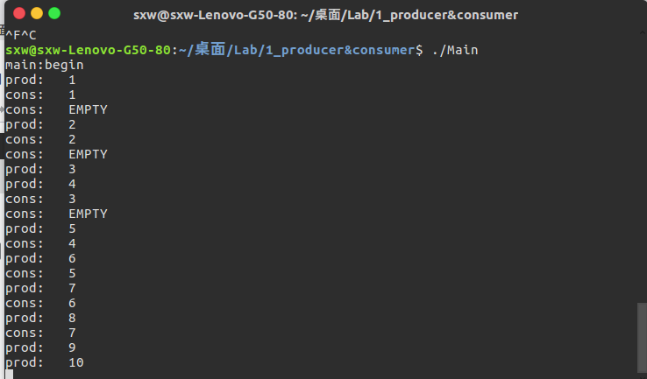

- 利用condition variable和Mutex机制实现生产者/消费者问题：
（由于结果较长，此处仅截取第一种情况，具体结果见附件）
P-1 C-1
************
RAW

************
con 0: EMPTY.
prod 0: 0.
prod 0: 1.
prod 0: 2.
con 0: 0.
prod 0: 3.
prod 0: 4.
con 0: 1.
prod 0: 5.
prod 0: 6.
prod 0: 7.
con 0: 2.
prod 0: 8.
prod 0: FULL.
con 0: 3.
prod 0: 9.
prod 0: FULL.
con 0: 4.
prod 0: 10.
prod 0: FULL.
con 0: 5.
prod 0: 11.
prod 0: FULL.
con 0: 6.
prod 0: 12.
prod 0: FULL.
con 0: 7.
prod 0: 13.
prod 0: FULL.
con 0: 8.
prod 0: 14.
prod 0: FULL.
con 0: 9.
prod 0: 15.
prod 0: FULL.
con 0: 10.
prod 0: 16.
prod 0: FULL.
con 0: 11.
prod 0: 17.
prod 0: FULL.
con 0: 12.
prod 0: 18.
prod 0: FULL.
con 0: 13.
prod 0: 19.
prod 0: FULL.
con 0: 14.
prod 0: 20.
prod 0: FULL.
con 0: 15.
prod 0: 21.
prod 0: FULL.
con 0: 16.
prod 0: 22.
prod 0: FULL.
con 0: 17.
prod 0: 23.
prod 0: FULL.
con 0: 18.
prod 0: 24.
prod 0: FULL.
con 0: 19.
prod 0: 25.
prod 0: FULL.
con 0: 20.
prod 0: 26.
prod 0: FULL.
con 0: 21.
prod 0: 27.
prod 0: FULL.
con 0: 22.
prod 0: 28.
prod 0: FULL.
con 0: 23.
prod 0: 29.
prod 0: exited
con 0: 24.
con 0: 25.
con 0: 26.
con 0: 27.
con 0: 28.
con 0: 29.
con 0: exited

实验二：

Dining_philosophy
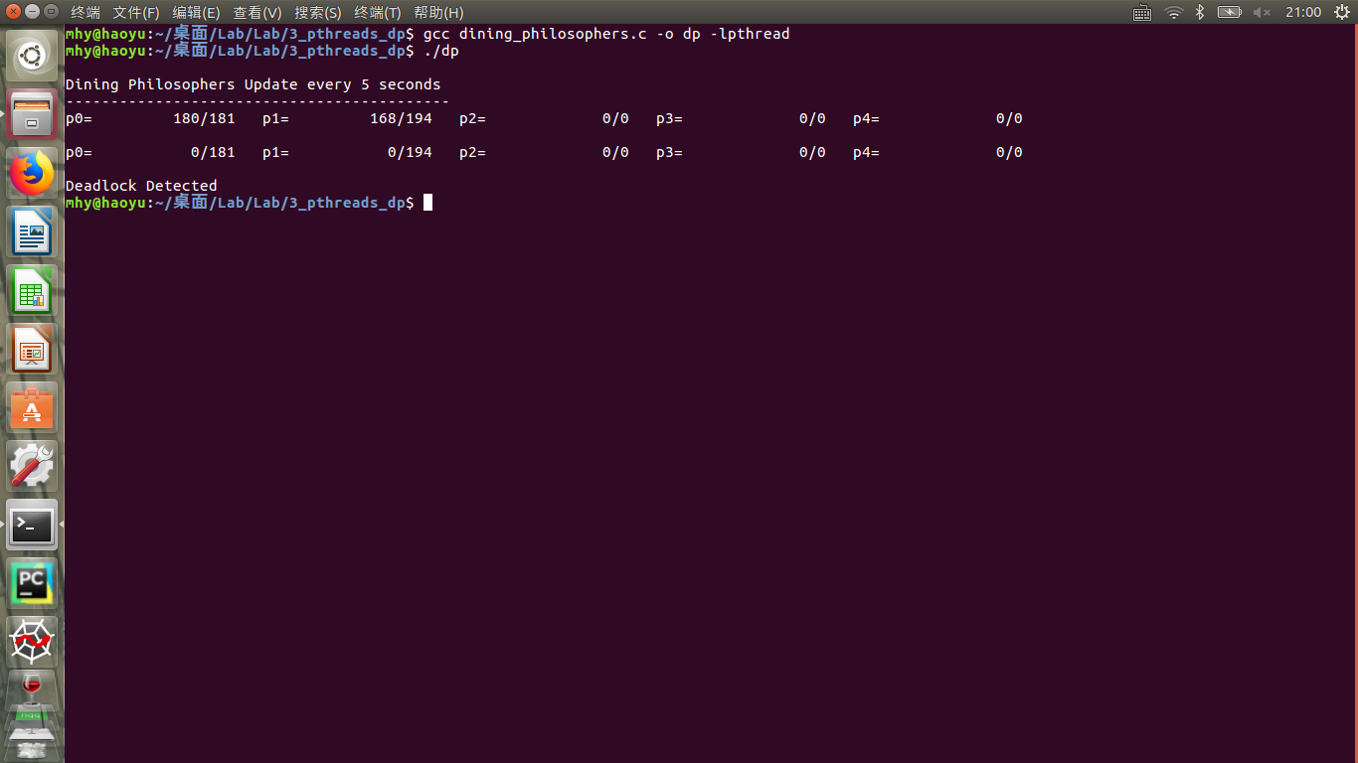

Dining Philosophers Update every 5 seconds
-------------------------------------------
p0= 180/181 p1= 168/194 p2= 0/0 p3= 0/0 p4= 0/0

p0= 0/181 p1= 0/194 p2= 0/0 p3= 0/0 p4= 0/0

Deadlock Detected

可以发现，很快产生了死锁。

Dp_assymmetric
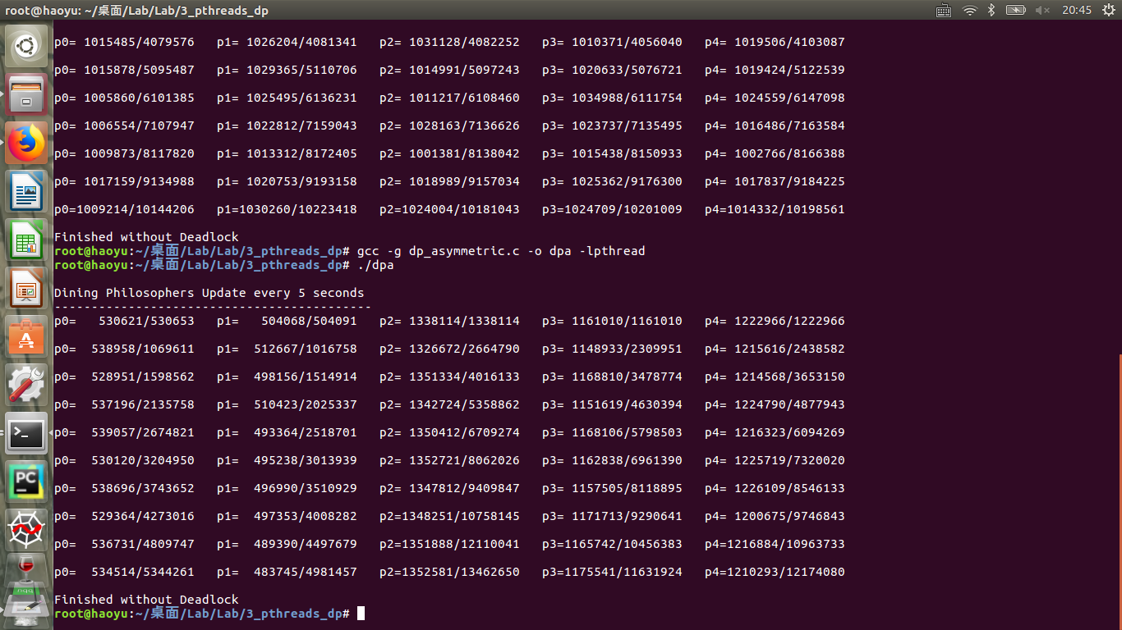
Dining Philosophers Update every 5 seconds
-------------------------------------------
p0= 1001582/1001612 p1= 998943/998964 p2= 1015932/1015932 p3= 980648/980648 p4= 1017942/1017942

p0= 1007196/2008817 p1= 998017/1996983 p2= 1006990/2022922 p3= 968817/1949473 p4= 1012454/2030396

p0= 1009611/3018484 p1= 996334/2993317 p2= 1011208/3034130 p3= 988784/2938287 p4= 1009817/3040244

p0= 1002145/4020629 p1= 1018535/4011855 p2= 1006857/4041030 p3= 998144/3936492 p4= 968314/4008599

p0= 974935/4995573 p1= 1030901/5042756 p2= 1030187/5071219 p3= 1011448/4947940 p4= 967334/4975937

p0= 1028951/6024524 p1= 982958/6025719 p2= 1029199/6100418 p3= 986074/5934016 p4= 990924/5966867

p0= 1001220/7025744 p1= 1005979/7031698 p2= 1019573/7119999 p3= 1013895/6947913 p4= 977831/6944704

p0= 1014957/8040731 p1= 987748/8019492 p2= 986440/8106439 p3= 1023890/7971837 p4= 997430/7942134

p0= 1005717/9046448 p1= 998761/9018303 p2= 1007341/9113829 p3= 965940/8937777 p4= 1015304/8957438

p0=1006390/10052838 p1=1003750/10022053 p2=1008154/10122012 p3= 996980/9934808 p4= 998588/9956056

Finished without Deadlock

Dp_waiter
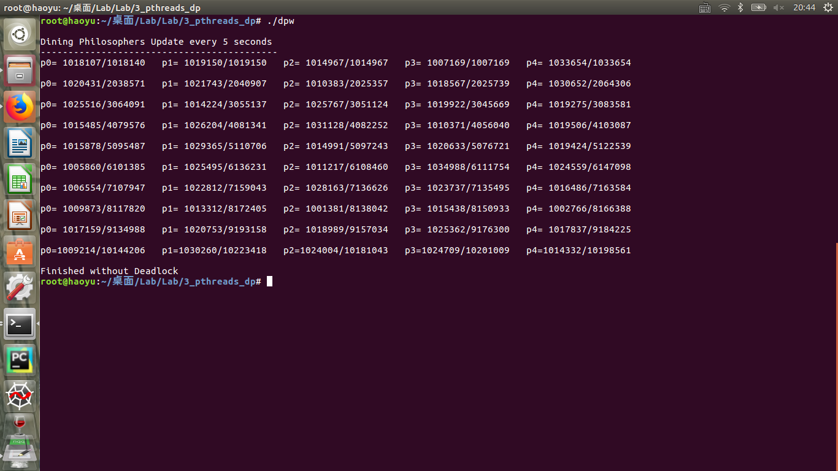

Dining Philosophers Update every 5 seconds
-------------------------------------------
p0= 547367/547391 p1= 472304/472304 p2= 1350461/1350461 p3= 1168572/1168572 p4= 1220669/1220669

p0= 539132/1086523 p1= 486846/959150 p2= 1360017/2710481 p3= 1162752/2331326 p4= 1228681/2449352

p0= 536810/1623333 p1= 490747/1449897 p2= 1346992/4057481 p3= 1166312/3497642 p4= 1233852/3683206

p0= 543180/2166513 p1= 501894/1951791 p2= 1346432/5403919 p3= 1162244/4659889 p4= 1219830/4903037

p0= 536741/2703265 p1= 490796/2442593 p2= 1331198/6735117 p3= 1153811/5813700 p4= 1219859/6122896

p0= 552592/3255857 p1= 486694/2929291 p2= 1333605/8068726 p3= 1153476/6967177 p4= 1246174/7369070

p0= 545754/3801611 p1= 495669/3424960 p2= 1334200/9402930 p3= 1155285/8122468 p4= 1205729/8574802

p0= 541496/4343107 p1= 497221/3922181 p2=1332471/10735462 p3= 1156345/9278852 p4= 1221597/9796399

p0= 541235/4884342 p1= 489958/4412139 p2=1351102/12086568 p3=1161911/10440767 p4=1230964/11027364

p0= 543441/5427783 p1= 490476/4902643 p2=1340728/13427328 p3=1160355/11601122 p4=1234236/12261645

Finished without Deadlock

- 实验体会
- 在此次实验中我们小组通过团队分工协作完成所有任务，在进行生产者消费者实验时遇到了对信号量与条件变量的概念和使用不清楚的问题，通过小组讨论与查阅资料掌握了他们的用法。
- 在生产者消费者代码运行中出现了死锁的现象，经过检查发现是由于mutex信号量所处的位置不正确，经过修改之后完成了生产者消费者实验。
- 在哲学家进餐问题中通过不同的方法成功避免或减少了死锁现象的发生，对条件变量和Mutex的使用有了更深的理解。
- 通过此次实验，我们了解到了团队协作的重要性，并了解了pthread中信号量、条件变量和mutex的使用方法，成功用其实现了进程间的同步与互斥。

- 思考题
实验一：
- Briefly describe the problem you are trying to solve and describe the design of your solution.
利用网站提供的代码中实现的数据结构queue用于存放产出的产品，在生产者进线程中在更改产品数量total_produced之前利用pthread_mutex_lock()函数进行上锁，在产品数量达到最大值或者生产结束利用pthread_mutex_unlock()对Mutex解锁；若生产者队列已满，利用pthread_cond_wait()函数进行阻塞，在mutex解锁之前唤醒所有consumer,让其可以消费生产出的产品；对于消费者线程，在更改产品数量total_produced之前利用pthread_mutex_lock()函数进行上锁，在产品消费数量达到最大值或者生产结束利用pthread_mutex_unlock()对Mutex解锁；若生产者队列为空，利用pthread_cond_wait()函数进行阻塞，在mutex解锁之前唤醒所有producer,让其进行生产。

2) Discuss why the busy-wait solution is inefficient for threads running on the same CPU, even though it produces the "desired behavior".
(a)性能差：busy-wait线程会消耗等待的周期；
(b)优先级倒置：如果采用busy-wait，一个线程持有锁那么优先级更高的线程肯呢个无法进行。

3) Why are you confident your solution is correct? You will need to argue from your narrated output as to why your solution is correct. Note, your output will likely not match the output listed here exactly. Two successive runs of your application will probably not match even vaguely, due to random variations in how threads are scheduled. However, your report should discuss each of the following points and discuss how your output supports your discussion of each:
Are each producer and consumer operating on a unique item? Is each item both produced and consumed?
从上文中程序运行结果可以看出每一个生产者和消费者都在独立的元素上进行操作，每一个元素也被生产出来后被消费。
Do the producers produce the correct number of items and the consumers consume the correct number of items?
从上文程序运行结果可以看出消费者正确的消费了成产出的产品。
Does each thread exit appropriately?
prod 0: FULL.
con 0: 23.
prod 0: 29.
prod 0: exited
con 0: 24.
con 0: 25.
con 0: 26.
con 0: 27.
con 0: 28.
con 0: 29.
con 0: exited
通过截取了部分运行结果，可以看出在producer达到WORK_MAX(30)之后producer退出，consumer在消费完WORK_MAX(30)之后退出。
Does your solution pass the above tests with the different numbers of producer and consumer threads in the Makfile tests?
是的

实验二：
- Describe the asymmetric solution. How does the asymmetric solution guarantee the philosophers never enter a deadlocked state?
Asymmetric solution是让偶数号的哲学家先拿起左筷子，再拿起右筷子。让奇数号的哲学家先拿起右筷子，再拿起左筷子。本方法破坏了同方向的环路。一个哲学家拿到一只筷子后，就阻止了他邻坐的哲学家吃饭。按照下图，1 2 号竞争2号筷子，3 4号竞争4号筷子，5号不需要竞争。最后总有一个哲学家能获得两支筷子进餐。
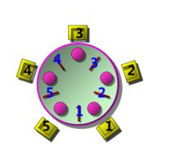
- Does the asymmetric solution prevent starvation? Explain.
不能避免饥饿。如上图，假设每次1号哲学家抢2号筷子的手速都很快，由于2号哲学家和1号竞争2号筷子，则可能2号哲学家永远无法抢到2号筷子，进而导致starvation

3) Describe the waiter's solution. How does the waiter's solution guarantee the philosophers never enter a deadlocked state?
Waiter solution 把拿左右两只筷子绑定成原子操作。设定一个waiter mutex，只有当左右筷子都拿到时，才释放waiter。本方法破坏了”任一哲学家在未拿到两只筷子吃饭前，绝不放下手中的筷子”这一条件，进而破坏了死锁的条件。

4) Does the waiter's solution prevent starvation? Explain.
不能。若2号哲学家抢waiter的速度非常快且频繁。则和他竞争的1号3号哲学家则永远抢不到waiter。进而导致starvation

5) Consider a scenario under a condition variable based solution where a philosopher determines at the time it frees its chopsticks that both chopsticks of another philosopher (Phil) it shares with are free, and so it sends the (possibly) waiting Phil a signal. Under what circumstances may Phil find that both of its chopsticks are NOT free when it checks?

当一个哲学家释放了mutex，因此另一个哲学家check了资源并且能够进入mutex。这个哲学家有能力在另一个哲学家被唤醒并且check筷子之前check并获得mutex。

