NON-DISCLOSURE AGREEMENT (NDA)
The Identity Vault Project

This Non-Disclosure Agreement (“Agreement”) is entered into as of 3/17/2026, by and between:
Disclosing Party: KJ Business Growth LLC (“Company”)
Receiving Party: Patrick Simpson (“Contractor”)

1. Purpose
The Contractor agrees to receive and evaluate confidential information related to the development of a software platform known as “The Identity Vault”.

2. Definition of Confidential Information
Confidential Information includes business plans, product ideas, technical systems, code, databases, marketing strategies, and any non-public information shared verbally or in writing.

3. Obligations of the Contractor
The Contractor agrees to keep all information confidential, not share it, and not use it outside the scope of this project.

4. Ownership of Work & Intellectual Property
All work created by the Contractor related to The Identity Vault shall be the sole property of KJ Business Growth LLC.

5. Non-Use & Non-Compete
The Contractor agrees not to recreate or build a competing platform using this information.

6. Term
This Agreement remains in effect for 3 years from signing.

7. Exclusions
Confidential Information does not include publicly available or independently developed information.

8. Governing Law
This Agreement shall be governed by the laws of the State of Iowa.

9. Signatures

KJ Business Growth LLC
By: __________________________
Name: Kathryn Jones
Date: ________________________

Contractor
By: ___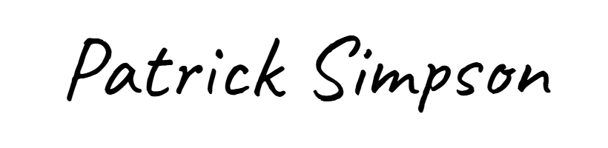 ___
Name: ___Patrick Simpson_______
Date: _____03/17/2026__________

