Brand Safety in Toxic Feeds: A Registered Report

Abstract
Online toxicity is abundant and captures attention. Yet brands overwhelmingly treat it as a reputational threat and withdraw advertising. Prior research on toxicity and unsafe advertising contexts supports both responses, yet studied them only in isolation: brand safety research documents negative spillover from unsafe content, while platform research documents engagement advantages of negative and toxic content. We will integrate these perspectives in a single empirical framework proposed in this Stage 1 registered report protocol. Using a dose-response design with stimulus sampling, we will manipulate the proportion of toxic content in simulated but naturalistic social media feeds presented to 5,000 participants and measure ad effectiveness and brand safety. First, we predict an inverted-U relationship between feed-level toxicity and ad effectiveness: from low to moderate toxicity effectiveness measured as attention is elevated. High toxicity, however, results in reduced effectiveness as attention is withdrawn. For brand safety, we test for a linearly decreasing effect predicted by prior research. We further translate the attentional mechanism to brand safety to propose that brand safety is increasingly harmed when toxicity is rising up to moderate thresholds where attention is strongest. At high toxicity the withdrawal of attention results in attenuated harm to the brand. The findings aim to inform brand safety strategy by providing evidence on whether the attentional and reputational consequences of toxicity indeed warrant withdrawal from toxic environments.
Keywords: toxicity, brand safety, advertising, platforms

“If it bleeds, it leads” - Pooley (1989)

Online platforms have increasingly become home to toxic discourses. Harassment, hate speech, cyberbullying, identity attacks, and deliberately insulting language pervade feeds across topics and languages, driven by recommendation algorithms and virality mechanisms amplifying such content (Rathje and Van Bavel 2025). This toxicity poses a challenge for the multi-billion dollar advertising industry operating on these platforms. When toxicity on X (formerly Twitter) escalated following changes in ownership and content moderation in late 2022, major advertisers including Apple, Disney, and IBM suspended their campaigns and the platform’s ad revenue declined by more than half within a year (Dempsey 2023). This was not an isolated case. The World Bank pulled advertising from X in 2024 after a paid placement appeared alongside content from a white supremacist organization (Lyons and Stocker 2024). These incidents, which recur across major platforms including Meta and YouTube (Madio and Quinn 2024), highlight a tension brands advertising online face: the same platforms that reach billions of consumers also expose branded content to environments brands cannot fully control. With global social media advertising projected to hit nearly $340 billion in 2026 (Statista 2026) and social channels attracting the largest share of incremental ad dollars worldwide (WARC 2026), the reputational and financial risk to brands can be substantial.
Marketing research examines this risk to brands through the lens of brand safety. Recent work on brand safety documents that the proximity of branded content to “unsafe” material can contaminate brand perceptions, even when no explicit link between the brand and the adjacent content exists (Grewal, Vana, and Stephen 2025). The general recommendation, followed by both theory and practice, is that any association with this type of content should be avoided (for a recent exception, Simonov, Valletti, and Veiga 2025). Accordingly, brand safety strategies in the form of detection algorithms, blocklists, and moderation have become a major point of concern for both brands and platforms. Among the unsafe content circulating online, toxicity represents a particularly prevalent and challenging source of contamination, given its harmful and targeted nature. Different from broader characterizations of unsafe content based on topics (e.g., war, smoking, sex), toxicity originates in discussion style and can thus challenge safety in any topical context.
A separate stream of platform research studies the notion that toxicity can have positive implications (Beknazar-Yuzbashev et al. 2022). Here, toxicity has been shown to drive attention and generate engagement. The platform-level implication seems different to the advice given to brands: instead of avoiding toxicity, it can retain and engage users. From this perspective, feeds containing toxicity might expose embedded advertisements to larger and more engaged audiences. More attention is generally considered positive for an ad’s effectiveness, but does that hold if this attention stems from a toxic context that might harm the brand?
These two streams generate an interesting context for the same managerial question: Should a brand withdraw from toxic discourse or is there a more nuanced approach warranted? Brand safety research advises general withdrawal from toxic environments to avoid reputational damage due to potential spillovers. Platform research implies that those same environments could increase exposure, attention, and engagement. We argue that existing work cannot resolve this seeming contradiction because each stream examines only one perspective in isolation. Brand safety studies typically measure ad and brand outcomes without accounting for the attention environment that toxicity creates. Platform studies often measure platform-level outcomes without tracking whether certain spillovers on brand safety might offset attentional or engagement gains. Marketing research has yet to examine both in combination and within the same feed exposure.
We address this gap by integrating ad effectiveness and brand safety within a single empirical framework. Focusing on digital advertising on social media, where toxicity is widespread and brands exercise little control over surrounding content, we examine whether the relationship between toxicity, advertising effectiveness, and brand safety is more complex than either stream in isolation suggests. We manipulate the proportion of toxic content in simulated but naturalistic social media feeds using a Digital In-Context Experiment (Roggenkamp, Boegershausen, and Hildebrand 2025) combined with a dose-response design with stimulus sampling (Simonsohn, Montealegre, and Evangelidis 2025; Tomaino et al. 2025) and measure ad effectiveness as well as brand safety across toxicity doses.
Our central argument is that toxicity affects both ad effectiveness and brand safety outcomes through attention allocation in a non-monotonic form. Progressing from low to moderate toxicity doses, we expect attention to increase in toxicity. Elevated attention should affect ad effectiveness positively but brand safety negatively. A heightened emphasis on the brand in an increasingly toxic context causes harm. As toxicity is increasing to extreme levels, attention is withdrawn from the branded ad, yielding decreased effectiveness but attenuated safety compared to moderate toxicity doses.
With this research, we intend to contribute to theory and practice in online advertising and brand safety specifically. First, we combine previously separate research programs on brand safety and online toxicity. Extending recent work on toxic behavior in gaming (Bernritter et al. 2025), we show that toxicity is an operationalizable construct with nuanced and unexpected effects for attention, ad effectiveness, and brand safety. Contrary to prior theorizing and practice, toxicity is not generally negative but might come with advantages conditional on the doses. Second, adding to brand and platform research, we demonstrate that both actors face a trade-off wherein toxicity is driving attention and advertising effectiveness, but at the potential expense of brand safety. Solving this tradeoff will depend on monitoring and moderating toxicity doses for their effect on multiple metrics across stakeholders. Third, we apply recent advances in behavioral research combining traditional survey responses with unobtrusive measures to show that online research on advertising and platform dynamics can benefit from a more naturalistic and systematic empirical approach. While static vignette experiments can be helpful to isolate single variables and mechanisms, they may come at the cost of missing the varied effects of more natural interactions.
We proceed by presenting our theorizing around toxicity in online discourse and its effect on brand’s advertising and safety, culminating in three hypotheses. After that, we provide motivating evidence for toxicity’s effect on engagement from pilot data spanning 12,473 A/B tests in the context of a news platform. Then, we lay out the envisioned experimental paradigm. This includes the design, procedure and stimuli, outcomes, along with an analysis plan and sample size justification. Further, we discuss pilot data that informs our empirical strategy and confirms its feasibility.

THEORY

Toxicity in Online Discourse
Toxicity describes intentionally inflammatory communication directed at a target to provoke unproductive conflict. It subsumes harassment, hate speech, cyberbullying, identity attacks, profanity, and threats, unified by a common function of inflicting harm on a target (Hanscom et al. 2024; Lees et al. 2022; Shahi and Majchrzak 2025). Crucially, toxicity is a property of communicative style rather than subject matter as it characterizes how a message is deployed irrespective of the topic it addresses. Toxicity’s purpose is to damage rather than to evaluate, criticize, or persuade per se. Whereas constructive criticism, passionate disagreement, and even harsh evaluative language can be productive, toxicity has no regard for productive disagreement or advancing an argument.
Toxic discourse is pervasive across platforms, languages, and subjects (Avalle et al. 2024; Shahi and Majchrzak 2025). It emerges wherever users interact, not only around highly controversial subjects, such as politics, but also in entertainment, sports, and consumer contexts (Salminen et al. 2020; Tufa, Markov, and Vossen 2024). Platform architectures amplify the prevalence of toxicity through recommendation algorithms, virality features, and network effects (Recuero 2024; Hanscom et al. 2024). The consequences of toxicity extend beyond the immediate online interaction and can translate to offline violence. For instance, recent evidence suggests that social media can act as a propagation mechanism for violent crimes by enabling the spread of extreme viewpoints (Müller and Schwarz 2020; Müller and Schwarz 2023). Toxicity therefore generates regulatory pressure for platforms as legislation in the EU and elsewhere mandates moderation of toxic content (European Parliament and Council of the European Union 2022; United Kingdom 2023).
To meet these moderation demands, platforms can readily operationalize toxicity via automated classifiers (see e.g., Horta Ribeiro, Cheng, and West 2023; Singhal et al. 2023). These assign continuous toxicity scores to individual posts, enabling moderation decisions that human manual review cannot produce at the volume of contemporary platforms (Jhaver et al. 2019). The most widely deployed toxicity classifier, Google’s Perspective API, is trained on millions of human-annotated comments and runs on Reddit threads, The New York Times’ comment sections, and Wikipedia, among other platforms (Lees et al. 2022).
For brand safety practice, toxicity offers a complementary perspective. Because toxicity describes communicative style rather than subject matter, it differs from the content category-driven approaches that govern programmatic brand safety. Established industry standards and individual company solutions implement blocklists that classify content by subject matter: violence, adult material, hate speech, and similar categories (e.g., “Content Exclusion Categories Brand Suitability Control” n.d.; GARM 2026; Shehu, Abou Nabout, and Clement 2021). These operationalizations are coarse and produce both type-1 and type-2 errors. Keyword blocklists over-block safe inventory by flagging topical terms regardless of communicative intent: during the Euro 2024 final, keywords such as “shoot” or “attack” caused nearly half of a UK publisher’s output to be excluded from advertising (Benjamin 2024), and as one advertising executive noted, the approach “frequently results in inventory that is contextually relevant, and safe, being blocked.” Conversely, the same blocklists fail to detect unsafe content whenever a nominally harmless topic turns toxic through communicative style. Because toxicity is topic-independent, it addresses both failure modes simultaneously: it can flag unsafe contexts that topic-based filters miss while reducing exclusion of safe inventory. This captured dimension of communicative style is also what produces the attentional, attitudinal, and arousal effects relevant to advertising outcomes (see “Motivating Evidence” section).

Toxicity and Advertising
Toxicity is consequential for advertising along two dimensions. The first is ad effectiveness (i.e., whether the toxic context alters the attentional and mnemonic processing of the ad itself). The second is brand safety (i.e., whether the toxic context contaminates evaluations of the advertised brand). These dimensions are distinct yet interrelated. They capture different stages of the advertising process (see also Shankar et al. 2022), attention and encoding on one hand and brand evaluation on the other, yet naturally brand harm requires prior exposure: an ad that wasn’t noticed shouldn’t harm or benefit the brand it carries. We develop hypotheses for each outcome in turn, before examining how attention connects them.

Attention
Evidence on toxicity in advertising is mixed (Banerjee et al. 2026). On the one hand, scholars find evidence for the claim from the infamous adage: “if it bleeds, it leads” (Pooley 1989). Toxic content generates larger, wider, and deeper reply threads than civil counterparts on Twitter (Saveski, Roy, and Roy 2021) and across other platforms (Avalle et al. 2024), and reducing toxicity via a browser extension decreased user attention, time spent, impressions, and clicks (Beknazar-Yuzbashev, Jiménez-Durán, and Stalinski 2024). More generally, research on negative content demonstrated that it captures disproportionate attention (Pratto and John 1991; Rozin and Royzman 2001), receives higher engagement rates, greater sharing, and stronger recall than neutral and positive content (for an overview, see Robertson et al. 2023). Further, any threat-relevant stimuli, such as toxic communication (e.g., personal insult), activate automatic detection processes that elevate attention (Öhman and Mineka 2001).
On the other hand, sustained exposure to severely toxic content produces aversion and withdrawal: users report avoiding participation for fear of harassment or shutting down accounts entirely, and self-censorship and silencing are among the observed reactions (Lenhart et al. 2016). Moderation studies find that reducing toxicity can increase participation (Wise, Hamman, and Thorson 2006), and widely applied classifiers define toxicity explicitly as a heightened propensity to leave a discussion (Lees et al. 2022; Aridor et al. 2024).
We argue that both effects may exist and that the level of toxicity represents the moderating variable, implying a non-monotonic relationship where attention is increasing first and decreasing later. The cue-utilization hypothesis provides a potential unifying mechanism (Easterbrook 1959). At low to moderate toxicity, the provocative and targeted nature of toxic communication raises overall attention and pulls in users who engage by replying, retaliating, defending, or spectating. Importantly, the widened attentional window encompasses adjacent stimuli including the ad. At extreme toxicity, attention is focused more on threat-relevant cues at the expense of peripheral stimuli (Harmon-Jones, Gable, and Price 2013; Van Steenbergen, Band, and Hommel 2011), and the ad — a commercially oriented, non-threatening element — loses attentional resources. Evidence from specific high-severity contexts is consistent with this: misogynistic hate speech reduces women’s participation in political discourse (Carlson 2019), and toxicity decreases player engagement in gaming (Liu, Tang, and Williams 2025). The mixed evidence is thus not contradictory but might reflect sampling across different positions on the toxicity continuum.
We expect that attention therefore depends on the toxicity dose in the feed. At low-to-moderate doses, the attentional pull from toxicity exceeds aversion. At high doses, the relationship reverses. We hypothesize an inverted U (see Figure 1 A): attention allocation increases with toxicity dose up to a threshold and declines beyond it.
H1: Toxicity and attention follow an inverted-U relationship, such that attention increases with toxicity dose up to a point, beyond which it decreases.

Brand Safety
Prior literature suggests a negative relationship between toxicity and brand safety, where attitudinal or behavioral responses toward the brand are harmed as toxicity is increasing. Spillover contamination from adjacent unsafe content is a central mechanism explaining this pattern (Shehu, Abou Nabout, and Clement 2021; Bernritter et al. 2025; Grewal, Vana, and Stephen 2025): consumers transfer negative associations from that content to the co-located brand, even absent any causal or semantic link between them. That is, when a brand is presented alongside unsafe content online, there is a spillover of the adjacent negativity that harms said brand. This spillover of contextual factors on co-located brands presented in the same context has also been demonstrated in settings beyond digital media, such as print and television (Bushman 2005; De Pelsmacker, Geuens, and Anckaert 2002; Nian, Hu, and Chen 2021; Fossen, Mallapragada, and De 2020). Toxicity presents such an unsafe context as it is defined by harm inflicted on others. Based on the presented research, toxicity doses should affect brand safety negatively (see also Figure 1 B).
H2: Toxicity and brand attitudes follow a monotonically negative relationship, such that brand attitudes decrease as toxicity dose increases.
An ad that was not noticed should not harm or benefit the brand it carries. Hence, only when attention is allocated to the ad in its toxic context, we would expect harm to spillover. For instance, Roggenkamp, Boegershausen, and Hildebrand (2025) found that there is no effect of unsafe content on brands among inattentive consumers. The core question then becomes how toxic content affects brand safety depending on attention.
Naturally scrolling through a social media feed distributes attention across dozens of competing stimuli. In prior research, participants regularly evaluate a curated and isolated pairing of an ad and unsafe content presented via static vignettes with minimal (attentional competition, e.g., from a surrounding feed or earlier content exposure) – a condition that likely overstates the attention granted to any single adjacency in natural browsing. For example, Lee, Kim, and Lim (2021) presented participants with a vignette containing a single offensive social media post on animal abuse with a pet shop brand ad presented above, alongside, and below the post.
Work on advertising has pointed out the relevance of testing advertisement effects in naturalistic settings (Eisend 2009) and highlighted the need to account for cluttered media environments with attention competition and dilution (Ha and McCann 2008). Translated to our context, brand safety should be threatened only when the brand-unsafe context “cuts through the clutter” (e.g., Pieters, Warlop, and Wedel 2002; Ordenes et al. 2019) and the pairing is processed as such. To test this we apply a more realistic environment, that is, a feed in which the content competes for attention. We vary toxicity doses while naturally scrolling through the feed and mirror the attention allocation in realistic contexts.
We propose that under these conditions, the inverted U-shape hypothesized for the effect of toxicity on attention under H1 will qualify the linear negative relationship under H2. Specifically, we expect that the relationship of toxicity on brand safety is itself non-monotonic. For brand safety, low toxicity generates little attention and therefore little harm – the brand should stay safe. As toxicity is increasing to moderate levels, where attention is maximized, safety should be harmed the strongest. For extreme toxicity doses attention is partially withdrawn and even in the presence of high toxicity, the lack of attention attenuates damage to brand safety (see also Figure 1 C). Formally:
H3: Toxicity and brand attitudes follow a non-linear relationship, such that brand attitudes decrease with toxicity dose up to a point, beyond which it partially recovers as attention withdraws.
The relationship between these three variables (attention, brand attitudes, and the resulting non-linear safety effect) is stylized in Figure 1.
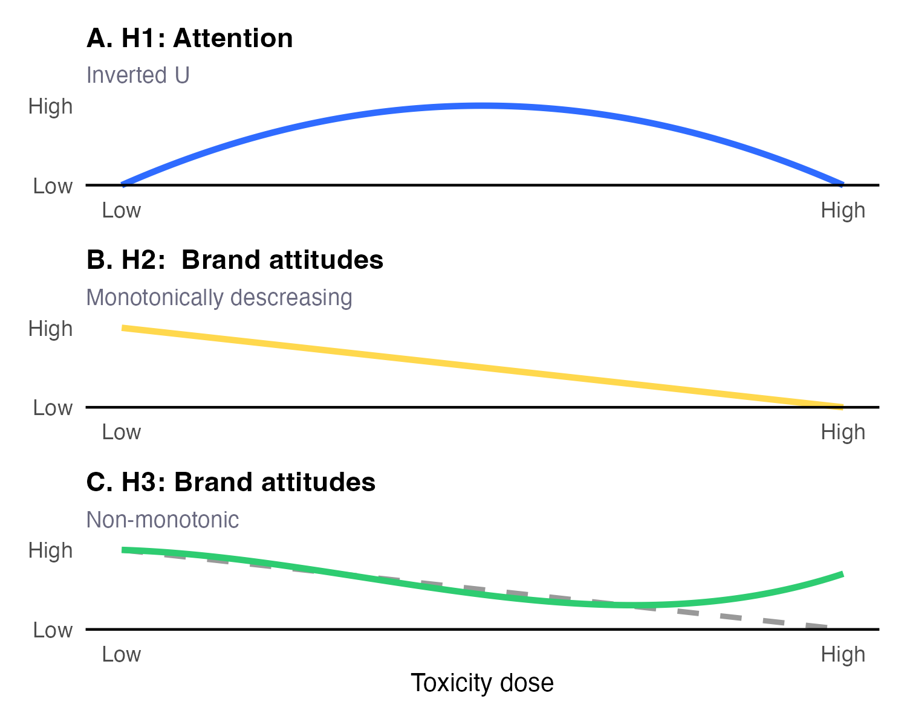
Figure 1: Stylized Hypothesized Relationships between Toxicity Doce, Attention Allocation, and Brand Attitudes
Note that null findings on H2 and H3 might still be partly informative to theory and practice. While these results would not necessarily establish the absence of an effect of toxicity on brand attitudes, they indicate that for the toxicity doses tested, neither a monotonic decline predicted by prior work nor the rebound predicted by our theorizing characterizes the data. For brands and platforms, this pattern weakens the empirical case for treating toxicity as uniformly harmful and thus to avoid. Depending on H1, this could even suggest that moderate levels of toxicity can be beneficial for advertisers and platforms alike.

MOTIVATING EVIDENCE
Before designing an experiment, we sought observational data that complements previous findings (Beknazar-Yuzbashev et al. 2022; Beknazar-Yuzbashev, Jiménez-Durán, and Stalinski 2024; Aridor et al. 2024) and speaks to the relationship between toxicity and attention. We draw on the Upworthy Research Archive (Matias et al. 2021)^[We use the pre-processed data provided in Reiss and Roggenkamp (2025) as they also include variables on the news headline’s valence (see also Robertson et al. 2023), and data from a viral news platform that systematically tested headline variants to maximize reader engagement. Here, a click can be interpreted as a variant of a news headline cutting through the clutter and capturing interest in the underlying article – broadly consistent with H1.
In this large-scale data, which accounts for more than 205.8M impressions, the company recorded 12,473 A/B tests each randomly assigning website visitors to one of approximately 4 headline variants for an average article (53,755 variants in total). The recorded click-through rates (CTRs) range from .000% to 14.891% with an average of 1.394% and median CTR at 1.067%.
We first predicted the probability that people would perceive a headline as toxic using the Perspective API. Following prior research, we then classified headlines as toxic (vs. civil) if they exceed a predicted probability score of 60% (Avalle et al. 2024, see also our Stimuli Generation section). This allowed us to compare toxic news headlines ($Median_{CTR}^{Toxic}=$ 1.401%) with civil alternatives ($Median_{CTR}^{Civil}=$ 1.061%), suggesting that toxic headlines performed better on average. Figure 2 provides model-free support for this comparison: the distribution of CTRs is shifted rightward for toxic headlines across the full range of observed values. A fixed-effects regression that compares headlines which refer to the same article further quantifies the difference: the estimated uplift in CTR due to toxicity for any single article corresponds to 6.408% (95% CI: [2.637%, 10.179%]) of the median CTR, a modest but robust effect that holds after controlling for headline length, readability, and negative emotional valence. This provides large-scale evidence that toxic communicative style, independent of topic or sentiment, can elevate individual interest in digital content, in line with our expectation that toxicity can increase attention.
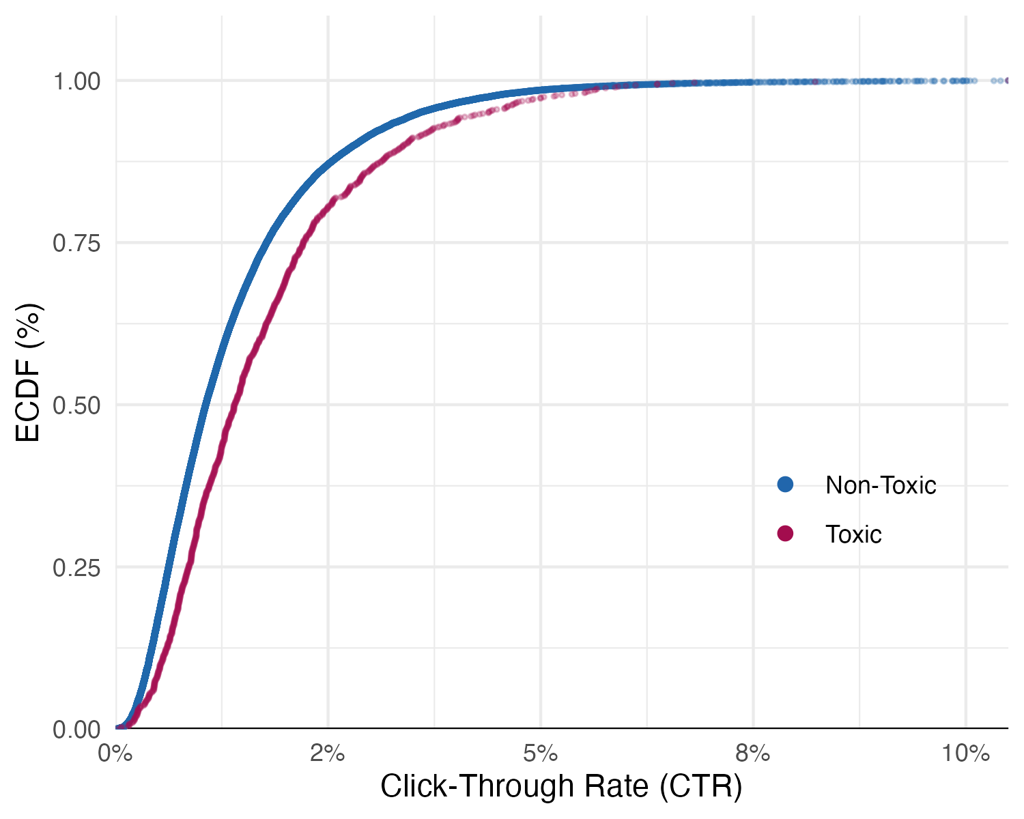
Figure 2: Empirical cumulative distribution functions of toxic vs. non-toxic headlines
Importantly, the presented field data comes with notable advantages over classic A/B testing discussed in marketing research (Braun et al. 2024): The A/B tests were designed by the platform itself, visitors were randomly assigned to headline variants, one experiment ran at a time, and commercial incentives likely ensured careful implementation. This kind of data is usually proprietary and therefore rare. Despite these favorable features of the data, two questions that are central to our research, remain unanswered. First, clicks measure interest in the toxic headline itself, not attention spillover to adjacent branded content. Whether elevated interest in toxic content extends to a co-located sponsored post cannot be assessed. Second, the data does not provide a brand outcome. As a consequence, the data does not allow us to derive any information on brand attitudes which would speak to H2 and H3.
Addressing these limitations with additional field data is difficult, if not impossible. In absence of proprietary data, marketing researchers often rely on social media data that is either scraped retrospectively or generated using social media platforms’ so-called A/B-testing functionalities. However, both of these data sources are affected by algorithmic interference: algorithms determine who sees what in ways that are unobservable to researchers and may lead to unbalanced samples. This complicates isolating the effect of toxicity (or any other variable) on the outcome of interest (Xu, Zhang, and Zhou 2020; Johnson 2023; Braun and Schwartz 2025; Boegershausen et al. 2025). More specific to our question, even absent algorithmic interference, it is usually not possible to manipulate or even observe the context surrounding a focal ad, which is required for measuring a feed’s toxicity and studying spillover effects that characterize brand safety in the domain of social media.

EXPERIMENTAL EVIDENCE
In our proposed study we therefore draw on recent methodological advances in consumer research to design an experiment that retains some of the field data’s ecological validity under controlled conditions. Specifically, we designed a Digital In-Context Experiment (Roggenkamp, Boegershausen, and Hildebrand 2025; Chen, Schonger, and Wickens 2016) that mimics the user interface of scrollable social media feeds. This allows us to embed a sponsored post (i.e., an ad) in a feed whose toxicity dose we manipulate exogenously and continuously in a between-subjects design. To increase both the ecological as well as the internal validity of our stimuli, we employed stimulus sampling and scope testing with AI-generated stimuli (STAGS) that we thoroughly validated (Simonsohn, Montealegre, and Evangelidis 2025; Tomaino et al. 2025). The remainder of this section describes these features of our proposed experiment in detail.

Design
Our Digital In-Context Experiment renders a social media feed in a responsive browser interface that mimics the visual structure of a microblogging platform (see Figure 3) and records granular behavioral data unobtrusively (i.e., without requiring any explicit response from participants). Each participant views a single feed consisting of 25 organic posts around the movie Avatar: Fire and Ash (2025) and one sponsored post advertising snacks from the well-known M&M’s brand. This design mirrors topic-related social media threads found on Reddit or X. We choose the movie context as it allows us to test a marketing-relevant topic that is not polarizing but familiar and potentially interesting to participants. At the same time, it is not unsafe or toxic per se and still enables toxicity doses and opinion valence to vary.
We operationalize a feed’s toxicity dose $d$ as the proportion of toxic organic posts (i.e., mimicked user generated content). It ranges from 0 (a fully civil feed) to 1 (a fully toxic feed) in increments of $\frac{1}{25}$. We then randomize $d$ between-subjects to create a continuous manipulation. This will allow us to estimate the full dose-response function and to test the functional forms predicted in H1-H3.

Stimuli

Generation
The continuous toxicity manipulation relies on adequate stimuli, i.e., a realistic pool of social media posts. To generate these stimuli, we combined stimulus sampling (Simonsohn, Montealegre, and Evangelidis 2025) and STAGS (Tomaino et al. 2025). Finally, we had human evaluators as well as a Large Language Model score the stimuli for validation.
Stimulus sampling treats stimuli the way experiments typically treat participants: just as findings based on a single participant would not generalize, findings based on a narrow set of stimuli may also reflect idiosyncratic features of this particular set (rather than the construct they are meant to operationalize). The approach addresses this by constructing a large corpus of social media posts and independently sampling from it for each participant, so that idiosyncratic post features are orthogonal to the dose manipulation. STAGS complements this by making large-scale corpus construction tractable. Specifically, we use generative AI to produce many social media posts across a range of toxicity levels while varying dimensions such as writing style, thematic focus, and post length that would be difficult to control systematically through manual construction or web scraping. While we do create posts that have idiosyncratic features, our dose-response estimates are unlikely to reflect these idiosyncrasies, because these features vary across the corpus. Taken together, STAGS supplies a diverse corpus spanning the full toxicity range, and stimulus sampling then draws independently from this corpus for each participant to implement the dose-response manipulation.
These approaches mitigate issues we see in extracting the toxicity stimuli (e.g., via web scraping) or manually constructing them via matched (non-)toxic pairs, which suffer from inevitable confounds, because toxicity often correlates with several latent content attributes. For example, a revision that removes the toxicity from a single toxic post to create a counterfactual may change other latent dimensions as well. Our approach, as well, hinges on the quality of the resulting corpus. We therefore proceed by first, describing the generation process in detail before we describe how we validated the stimuli in the subsequent section.
Our stimuli generation spanned four stages. In the first stage, we prompted the Grok-3 API (xAI) to generate topic-relevant posts across four broad toxicity levels (i.e., civil, mildly toxic, toxic, and highly toxic) while independently varying length, writing style, sentiment, and thematic focus (e.g., actors, studio, writing). Each post was then scored using the Google Perspective API. This API provides a continuous toxicity score on a $\left[0,1\right]$ scale and constitutes the industry standard for computational toxicity detection (Aridor et al. 2024). The ratings can be interpreted as the likelihood that a human reader would perceive the text as toxic.
This initial stimuli generation produced adequate coverage at the extremes of the distribution but left a gap in the moderate range (scores between approximately .15 and .65). The second stage targeted this gap. Posts were generated to match pre-specified toxicity targets and accepted only if their toxicity score (predicted with the Perspective API) fell within the target band, otherwise generation was repeated. The third stage comprised the rephrasing of posts, using another Grok-3 API call to eliminate repetitive phrasing. In the fourth stage, we manually checked the corpus and edited several individual tweets for evident flaws (e.g., due to remaining syntactic regularities, absence of typos and informal register markers, or implausibly coherent argumentation structure). The resulting corpus consists of 450 organic posts that span nearly the full toxicity range [.014, .939] (see Figure 3 for exemplary posts including annotated toxicity scores).
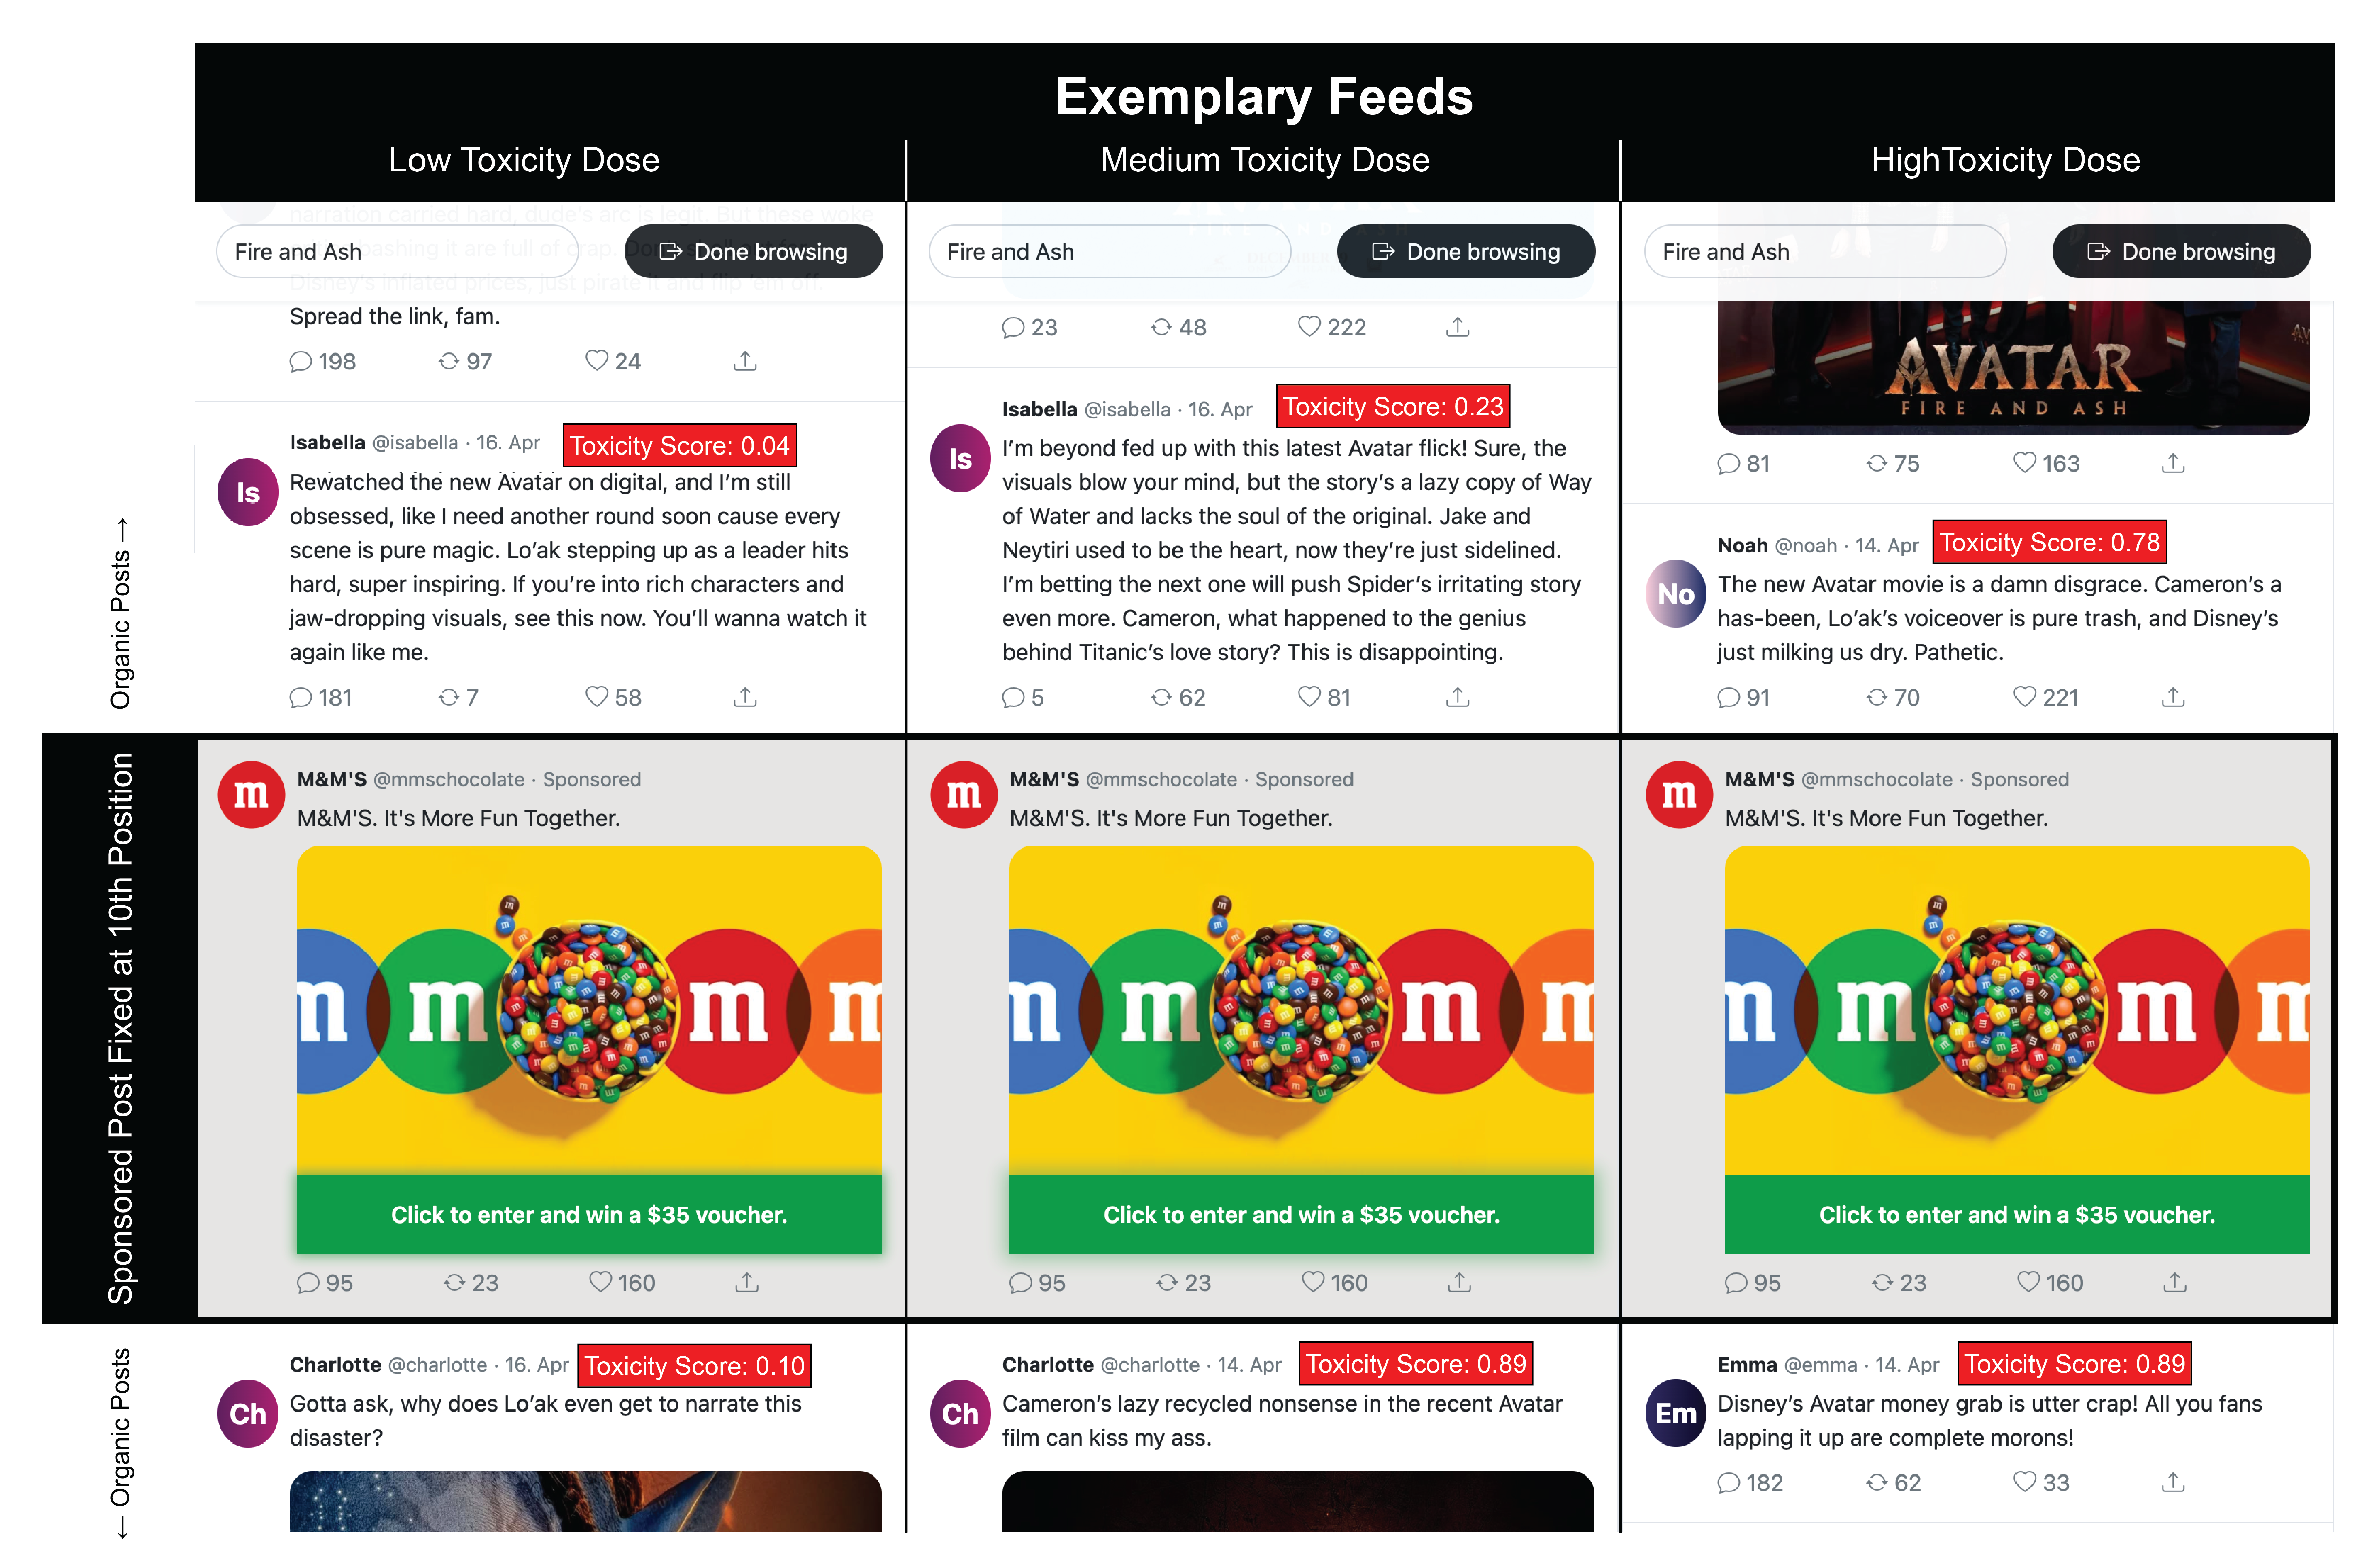
Figure 3: Exemplary DICE Feeds with Varying Toxicity Doses
Following the industry’s content moderation practices as well as prior academic work (Avalle et al. 2024), we then used a toxicity threshold of 60% to classify a post as toxic. This eventually yielded two pools to sample from: one toxic pool that would have been flagged and potentially moderated via the Perspective API and one non-toxic, or “civil”, pool. For a participant assigned dose $d$, the feed is assembled by sampling $d⋅25$ posts without replacement from the toxic pool and $\left(1-d\right)⋅25$ posts from the civil pool, then randomly shuffling the resulting 25 organic posts. Each participant draws an independent sample, so participants assigned the same dose see different posts in a different order.
In every feed, we further added one stimulus that mimicked a sponsored post by the M&M’s brand. The post included a call-to-action, inviting participants to enter an incentive-compatible prize lottery by clicking on it (see Figure 3). This lottery offered the opportunity to win a USD 35 voucher for an online platform delivering snacks (including M&M’s). The sponsored post is identical across all dose conditions and inserted at a fixed position (10th scroll position; see our “Pilot” section for reasoning behind position). The brand and product category were chosen to match the scenario framing: a snack brand is a contextually plausible advertiser in a feed about a movie.

Validation
We validated the resulting stimuli and their toxicity against two independent sources: 34 Prolific participants rated a stratified subset of the stimulus corpus, and GPT-4o-mini (version gpt-4o-mini-2024-07-18) scored every post in the full corpus using the same construct definition as the human raters.
For human validation, we drew 100 posts from the stimulus corpus stratified across ten Perspective score bins (10 per bin) and recruited participants on Prolific, restricting the sample to Canadian and US-American residents with a task-approval rate of at least 99% and self-reported English fluency. The study ran in oTree (Chen, Schonger, and Wickens 2016).
Before rating, participants read the toxicity definition below and then worked through three annotated calibration examples (one civil, one borderline, one clearly toxic) to anchor their judgments: “language that a reasonable person would find attacking, devaluing, or harmful – or that disrupts civil, constructive discourse.”
Each participant then rated a random selection of 36 posts spread across six pages on a continuous slider (0 = “Not at all toxic”, 100 = “Extremely toxic”). Two attention checks were interspersed at fixed positions (one unambiguously civil post and one unambiguously toxic post) and participants who rated the civil check above 40 or the toxic check below 60 were excluded.
For the analysis, we mirrored the Perspective API operationalization and for each post calculated the proportion of raters who assigned a score above 0.6 (on the 0-1 scale). We then compute three Pearson correlations: the Perspective API score against the mean human rating per post, the Perspective API score against the proportion of raters who exceeded 0.6, and the Perspective API score against the GPT-4o-mini toxicity score across the full corpus (see panels A, B, and C in Figure 4). The first two correlations describe criterion validity against human judgment via complementary aggregation schemes whereas the third provides a cross-check that requires no human data.
All three panels in Figure 4 support the decision to use the Perspective API score as a reliable measure of post-level toxicity. Mean human ratings tracked Perspective API scores closely (r = .888, 95% CI [.838, .924], t(98) = 19.15, p < .001), and agreement was essentially unchanged for the proportion-based operationalisation (r = .895, 95% CI [.847, .928], t(98) = 19.85, p < .001). Human raters and GPT-4o-mini also agreed within the validation subsample (r = .852, 95% CI [.784, .900], t(90) = 15.45, p < .001). Panel C extends this to the full corpus, where the two automated classifiers, which differ in architecture, training data, and scoring rubric, aligned tightly (r = .804, 95% CI [.765, .837], t(374) = 26.13, p < .001). The convergence of human raters, a purpose-built toxicity classifier, and a general-purpose language model on our generated posts provides evidence that a) they are criterion valid for toxicity and b) the Perspective API score is an adequate classifier capturing coherent, human-interpretable post toxicity at scale.
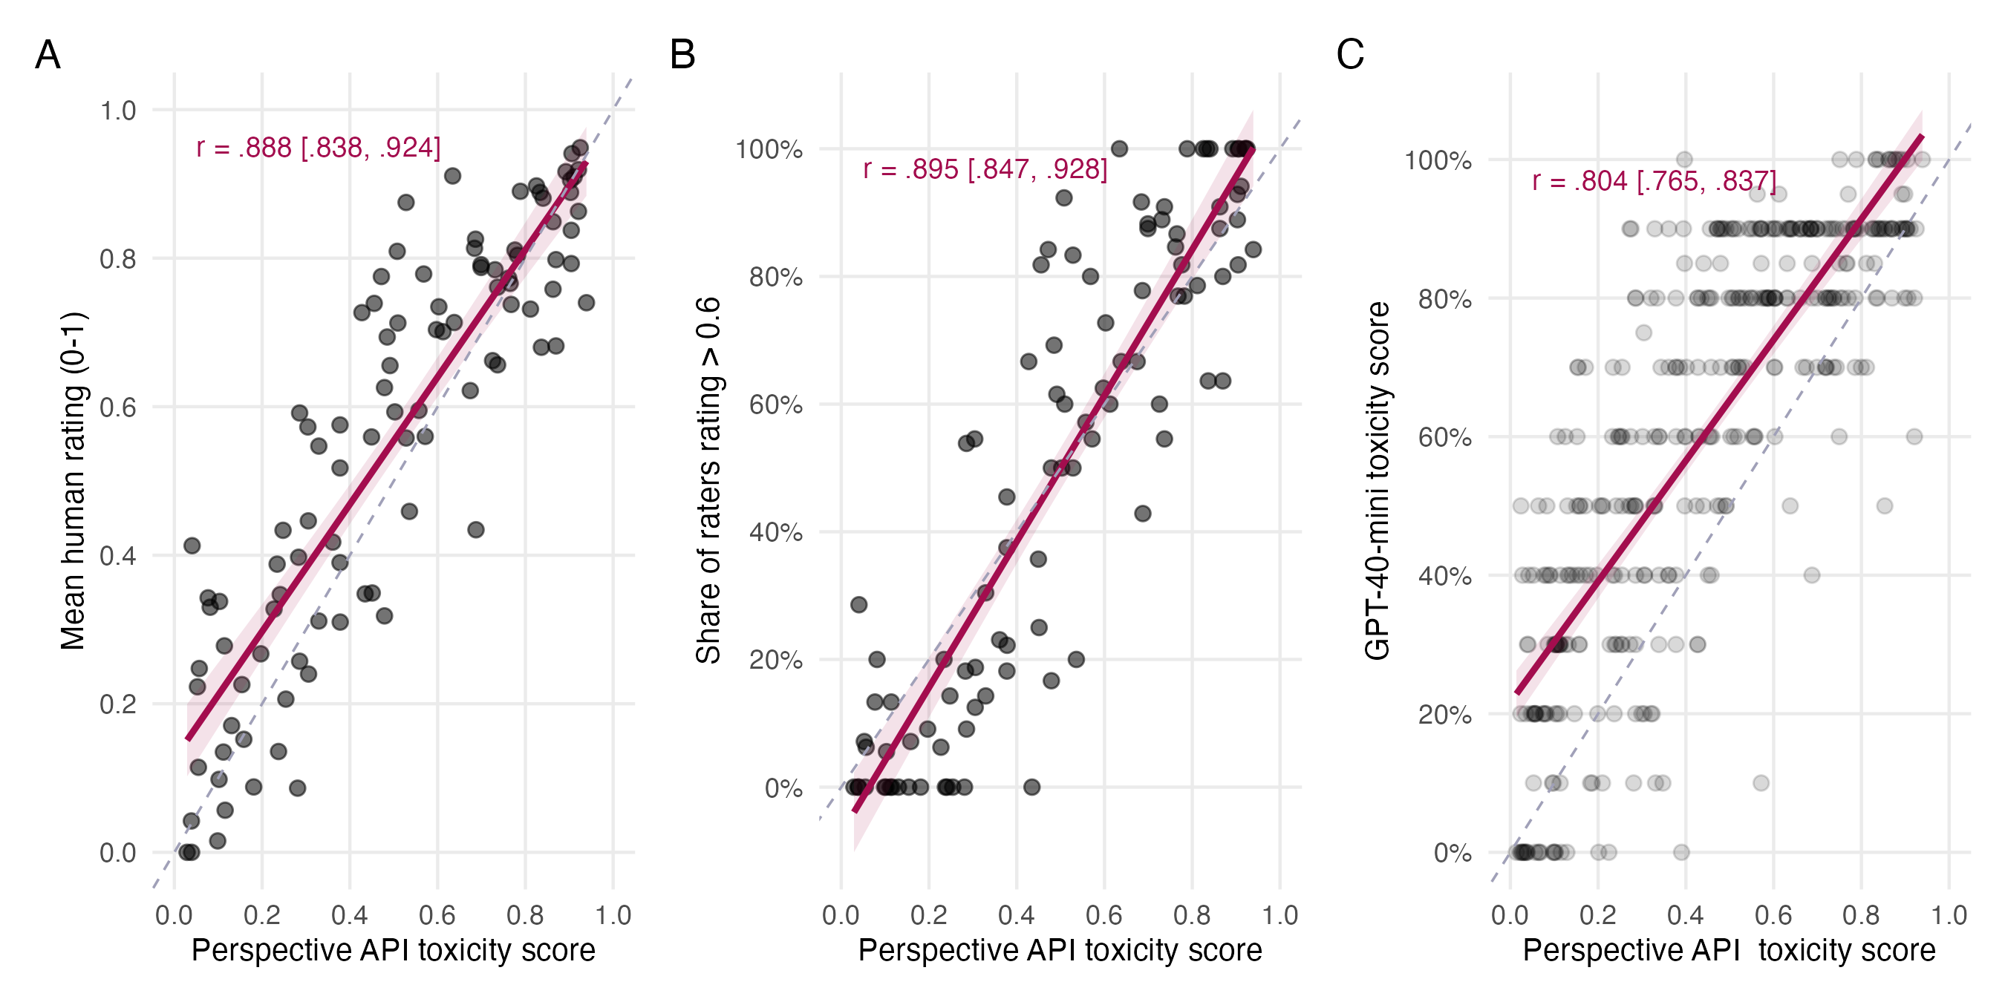
Figure 4: Convergent validity of automated toxicity measures. Panels A and B are based on the validation subsample (n = 100 posts, each rated by an average of 12 Prolific participants). Panel A shows the correlation between mean human ratings (0–1 scale) and the Perspective API score; Panel B shows the same Perspective API score against the share of raters who rated the post above 0.6. Panel C is based on the full synthetic corpus and shows the correlation between the Perspective API score and the GPT-4o-mini toxicity score.

Procedure
The experimental architecture is set up and fully functional (see https://forecastsurvey.herokuapp.com/demo) and proceeds as follows: after providing informed consent, participants first read a brief scenario contextualizing the task. They are informed that they had recently come across the Avatar: Fire and Ash movie and were opening a microblogging feed to learn about others’ opinions. Next, participants are instructed to browse the ensuing feed at whatever pace and depth feels natural to them. We add a “Done browsing” button (see the header depicted in Figure 3) for them to click whenever they wish to exit the feed. Afterwards, we redirected participants to a Qualtrics survey where they first provide demographic information as a filler task. After that, participants were tested for unaided and aided recall and asked for brand attitudes. We report these measures in more detail in the next section.

Measures
DICE enables us to combine survey responses with unobtrusive measures. More specifically, the participant behavior during feed exposure is recorded unobtrusively whereas the Qualtrics survey captures attitudes after exposure. URL parameters allow us to track and merge the IDs between both platforms.
Dwell time. Dwell time (on the sponsored post; measured in seconds; log-transformed) serves as the primary outcome variable measuring ad effectiveness. It represents a proxy to measure the attention allocated to the sponsored post and recorded continuously by the viewport tracker without requiring any active response from participants. Dwell time shows high concurrent validity with mobile eye-tracking measures ($r=.89$ with gaze duration) and accounts for 76% of the variance in brand recall in validation data (Bruns et al. 2025). The sample size is powered for this outcome and H1 is supported or rejected on the basis of this outcome alone.
Recall. Unaided recall (binary: recalled = 1; 0 otherwise) is a secondary outcome variable as prior work suggests that recall is not necessary for attitudinal effects to emerge (Shehu, Abou Nabout, and Clement 2021). Participants are asked to list any brands from which they recall having seen an ad in the feed. This captures whether exposure was sufficient to encode the brand into memory without a cue, and is stricter and less susceptible to guessing than aided recall (see also Campbell and Keller 2003; Shehu, Abou Nabout, and Clement 2021; Simonov, Valletti, and Veiga 2025). Aided recall is reported as a robustness check when unaided recall is sparse.
Brand Safety. Brand attitudes, calculated as average across the five statements drawn from Grewal, Vana, and Stephen (2025), is the primary outcome for brand safety. The measure covers the following items, which are all answered on a seven-point Likert scale (1 = Strongly disagree, 7 = Strongly agree): “I believe M&M’s is a quality brand;” “I would consider buying products from M&M’s;” “I would recommend products from M&M’s to someone else;” “I would like to be associated with M&M’s;” “I believe I would like M&M’s.” H2 and H3 are accepted or rejected on the basis of this outcome alone. To control for potential general spillovers not specific to the brand sponsoring the ad we include a second brand attitude composite measure for the brand Hershey’s. As a robustness check this measure will be deducted from the M&M’s average to achieve an attitudinal measure corrected for any unspecific spillover.
Additional Measures. We further measured additional variables informed by prior research on brand safety organized by their role in later exploratory analyses. The variables are summarized in the list below and full measures can be found in the appendix.
Dependent Variables
- Lottery signup
- Brand choice
- Purchase intention
- Brand trust
- Ad involvement
- Mood
Covariates
- Brand familiarity
- Movie exposure & liking
- Age & Gender

Pilot Data
To establish the feasibility of our methods, to determine the necessary sample size, and to provide a first proof of concept, we conducted a pilot study (see also https://osf.io/j6q3r/overview?view_only=502570a1d8c244389600e51181464b84 for all data, code, software, and materials).
We recruited 201 North American participants ($M_{\text{age}}$ = 36.7 years; 52.7% female) from Prolific for the pilot study. We designed the pilot following the descriptions above but deviated in three ways. First, we applied a different method to operationalize toxicity doses (we describe the rationale and our learning explaining the change in method below). Second, we updated the stimulus corpus after the pilot to increase realism. Third, we adjusted the position of the sponsored post after running the pilot, placing it in 10th position for the main study (instead of the 14th position we chose for the pilot). All the changes we plan to implement in the main study design are meant to improve the experiment’s rigor and are based on learnings from the pilot. We briefly report insights from the pilot data (see also Table 1) to motivate and ground the analysis plan as well as the power calculations.

Ad Exposure
The “Done Browsing” button allowed participants to leave the feed at any scroll depth which implies that not all participants were exposed to the sponsored post. Indeed, 137 of 201 participants (68.2%) scrolled far enough to reach the sponsored post and the median participant encountered 17 social media posts in total. While this feature causes data loss, we see its methodical merit. First, it prevents dwell time contamination from participants who only scroll to the end of the feed to finish the task, and second, it provides a natural measure of ad effectiveness and feed engagement. To keep exposure high overall and reduce a loss in statistical power, we decided to move the sponsored post up to the 10th position, which 81.6% of participants were exposed to (Figure 5, A).
One might further worry that if toxicity affects scroll depth, dwell time (observed only among exposed participants) would be subject to endogenous selection bias. However, toxicity dose did not predict scroll depth in the pilot r = -.009; CI = [-.148, .129].
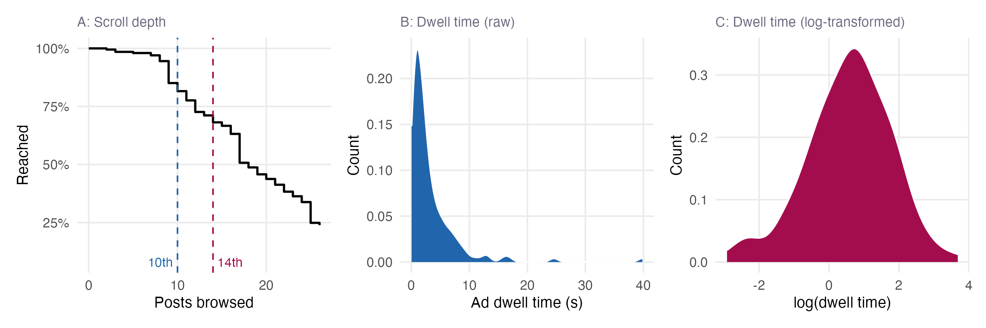
Figure 5: Pilot data descriptives. Panel A: proportion of participants who scrolled at least X posts; dashed lines mark the 10th and 14th feed positions. Panel B: raw ad dwell time distribution (exposed participants only). Panel C: log(dwell time) distribution.

Ad Effectiveness
Dwell time is heavily right-skewed (Figure 5, B), consistent with prior work (Roggenkamp, Boegershausen, and Hildebrand 2025). We therefore log-transform dwell time as log(seconds) for the primary analysis (Figure 5, C). The log-scale pilot mean is 0.564 (SD = 1.204). 71 (52.2%) recalled the M&M’s brand unaided, 94 (69.1%) aided. A logistic regression of recall on log-scale dwell time suggests that longer exposure predicts recall. Each additional unit of log(seconds) is associated with 1.58-fold higher odds of unaided recall (p = .004) and 1.62-fold higher odds of aided recall (p = 0.004). We report these results as a general validity check that mirrors prior research on dwell time and attention (Bruns et al. 2025; Simonov, Valletti, and Veiga 2025).
Table 1: Summary statistics: Pilot data
Variable | N | Min | Max | Median | Mean | Sd
Scroll depth | 201 | 1.00 | 26.00 | 17.00 | 17.58 | 7.03
Ad dwell time | 136 | 0.05 | 39.82 | 1.94 | 3.35 | 4.79
Brand attitude | 201 | 1.00 | 7.00 | 5.50 | 5.24 | 1.38
Recall unaided | 201 | 0.00 | 1.00 | 0.00 | 0.36 | 0.48
Recall aided | 201 | 0.00 | 1.00 | 0.00 | 0.47 | 0.50
Lottery signup | 201 | 0.00 | 1.00 | 0.00 | 0.03 | 0.17

Analysis Plan
Two of our hypotheses involve relationships that are non-monotonic. More specifically, H1 and H3 predict an (inverted) U-shape which translates to functional form with sign changes: for low values of toxicity, its effect on the dependent variable is negative, whereas for high values of toxicity, its effect on the dependent variable is positive (or vice versa). To capture this type of relationship, we will apply the two-lines approach suggested by Simonsohn (2018). Implementing his proposed analysis we will (1) fit a cubic spline for visual inspection, (2) apply the Robin Hood algorithm to determine a break, and (3) estimate a discontinuous regression with one slope below and one slope above that break point. An U-shape will then be supported by the data if the first estimated slope is negative, while the latter is positive.
We test all hypotheses with one-sided tests at $α=.05$ and target statistical power of 80% (see our Sample Size Justification). Age and gender are included as covariates in all analyses. For each hypothesis, the primary dependent variable is the basis for confirmatory inference.
To facilitate computational reproducibility, we follow a literate programming (Knuth 1984) approach: the Quarto source file that renders this manuscript simultaneously contains all data operations and analysis code. This means that the document deposited on OSF is both the manuscript and its own analysis script. Hence, rendering it with the raw data reproduces every number, table, and figure reported here.

H1: Toxicity Doses and Attention
We predict that the toxicity dose and the dependent variable follow an inverted U-shaped relationship. The primary dependent variable is ad dwell time (i.e., dwell time on the sponsored post) and the secondary dependent variable is unaided brand recall. Following the two-lines analysis (Simonsohn 2018), H1 is supported if both slopes (denoted $b_{1}$ and $b_{2}$) pass one-sided tests ($α=.05$) in the predicted directions: ${\hat{β}}_{below}>0$ below the break point and ${\hat{β}}_{above}<0$ above it (see Figure 6 for an illustration based on simulated data).
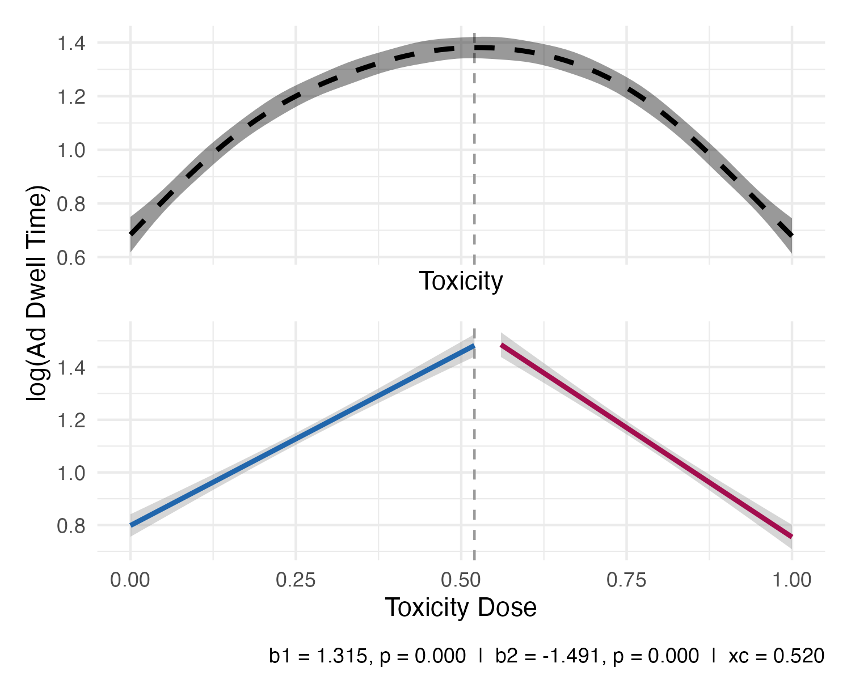
Figure 6: Two-lines test based on simulated data: toxicity doses and ad dwell time. Upper panel shows raw data with cubic regression spline smoother; lower panel shows the two fitted regression lines. Break point determined by the Robin Hood procedure (Simonsohn 2018).

H2: Toxicity Doses and Brand Attitudes (monotonic)
We predict a monotonically negative relationship between toxicity dose and brand attitudes. Accordingly, we estimate the slope via OLS regression:
$$Y_{i}=β_{0}+β_{1}⋅{\text{Toxicity}}_{i}+β_{2}⋅{\text{Age}}_{i}+β_{3}⋅{\text{Gender}}_{i}+ε_{i}$$
where $Y_{i}$ is the dependent variable for participant $i$ and $ε_{i}∼N\left(0,σ^{2}\right)$. The primary dependent variable is brand attitudes. H2 is supported if ${\hat{β}}_{1}<0$.

H3: Toxicity Doses and Brand Attitudes (non-monotonic)
We predict that the toxicity dose and the dependent variable follow an U-shaped relationship. We test the same dependent variable as in H2 (i.e., brand attitudes). Similar to our approach to H1, H3 is supported if both slopes pass one-sided tests ($α=.05$) in the predicted directions: ${\hat{β}}_{below}<0$ below the break point and ${\hat{β}}_{above}>0$ above it.

Exploratory analyses
In addition to the analyses described above, we will employ several analyses which we label as exploratory. Specifically, we will relax the statistical approach for our non-monotonic prediction and change the operationalization of the independent variable. Furthermore, we will specify alternative dependent variables as well as additional covariates. We describe each alteration in what follows.

Alternative Statistical Approach
Because the two-lines test requires a true sign reversal, a positive-then-flat trajectory (in which the dependent variable increases and then saturates without declining) would not satisfy the strict criterion but is still broadly consistent with our hypotheses. As an exploratory alternative, we therefore estimate a quadratic regression of the form:
$$Y_{i}=β_{0}+β_{1}⋅{\text{Toxicity}}_{i}+β_{2}⋅{\text{Toxicity}}_{i}^{2}+β_{3}⋅{\text{Age}}_{i}+β_{4}⋅{\text{Gender}}_{i}+ε_{i}$$
For H1, the hypothesized inverted U-shape is partially supported if ${\hat{β}}_{1}>0$ and ${\hat{β}}_{2}<0$. Likewise, the hypothesized U-shape for H3 is partially supported if ${\hat{β}}_{1}<0$ and ${\hat{β}}_{2}>0$.

Alternative Operationalization of the Independent Variable
Our main specification reported above models the toxicity dose as the fraction of toxic posts in a feed where a post is either classified as being toxic or not. This operationalization is rooted in the platform literature and moderation applications which require dichotomization of toxicity to hide or remove harmful content. Given that we classify posts based on a continuous prediction, one could also argue that a feed’s toxicity dose can be described as its average toxicity. Hence, we will also consider specifications in which we model the toxicity dose as the average of all the posts’ toxicity scores that were presented in a participant’s feed.
To better relate our results to the previous behavioral literature on brand safety (where sponsored content is usually paired with only one brand-safe or -unsafe organic post), we will also analyze the effect of adjacent toxicity. Specifically, we will rerun the analyses specified above by averaging the toxicity scores (as predicted by the Perspective API) of the organic post beneath and above the sponsored post. Even though we do not manipulate these two posts explicitly, we expect enough variation due to the stimulus sampling.

Alternative Specification of the Dependent Variables
Drawing from previous literature (Bernritter et al. 2025; Grewal, Vana, and Stephen 2025) we include alternative dependent variables to our Qualtrics Survey (see our Measures section). We will estimate how a feed’s toxicity dose affects these variables in line with the testing described above. Lottery signup (CTR), brand choice, and purchase intention have been discussed as financial brand safety metrics (Bernritter et al. 2025) and are thus tested against H2 and H3. Brand trust, commitment, attribution of toxicity, ad involvement, and mood are proposed as transmitting the effect of unsafe content on brand safety, we therefore explore them as upstream dependent variables as well.

Alternative specification of additional covariates
We will run the primary analyses while including brand familiarity and movie covariates.

Sample Size Justification
The two-lines test has no closed-form power formula, so we estimate power by simulation following Lakens (2022). For each sample size $N∈\left[200,400,...,4800,5000\right]$, we
- generate a dataset with two assumed inverted U-shaped data-generating processes representing for small and medium effect sizes,
- apply the two-lines test to the simulated data,
- flag a success when both slopes pass a one-sided test ($α=.05$; $b_{1}>0$ and $b_{2}<0$), and
- repeat the procedure 1,000 times.
Power is then estimated as one minus the proportion of inverted U-shaped simulations that the test failed to flag as successes, i.e., the false negative rate.
We report power for two effect sizes — small ($d=0.2$) and medium ($d=0.5$) — for each of the two primary outcomes (ad dwell time and brand attitudes). We express effect sizes as Cohen’s $d$, where $d$ is the expected uplift at peak toxicity (a 50% toxic feed) relative to the standard deviation of that outcome observed in the pilot.
Because dwell time is heavily right-skewed, we analyze it on the $log\left(\text{seconds}\right)$ scale, with $σ$ estimated from the pilot. The pilot baseline is 1.8 s (median dwell time at the tails, i.e., in a fully clean or fully toxic feed). The peak — a 50% toxic feed — raises median dwell time to 3.2 s under a medium effect ($d=0.5$), an absolute increase of 1.5 s. Under a small effect ($d=0.2$), the peak median is 2.2 s.
To calculate required sample size for the brand attitudes measure, we apply the same d = 0.5 / d = 0.2 convention. The pilot mean is 5.24 on a 1–7 scale (SD: 1.38). A medium effect raises peak-condition attitude by 0.69 points; a small effect by 0.28 points.
The power curves (Figure 7) indicate that detecting a small effect ($d=0.2$) with 80% power requires approximately 4,000 exposed observations. Because not all recruited participants scroll far enough to encounter the ad (18.4% of pilot participants did not reach position 10) we will recruit $(1+$ 0.18$)⋅4,000≈5,000$ participants in total to achieve the target exposed sample.
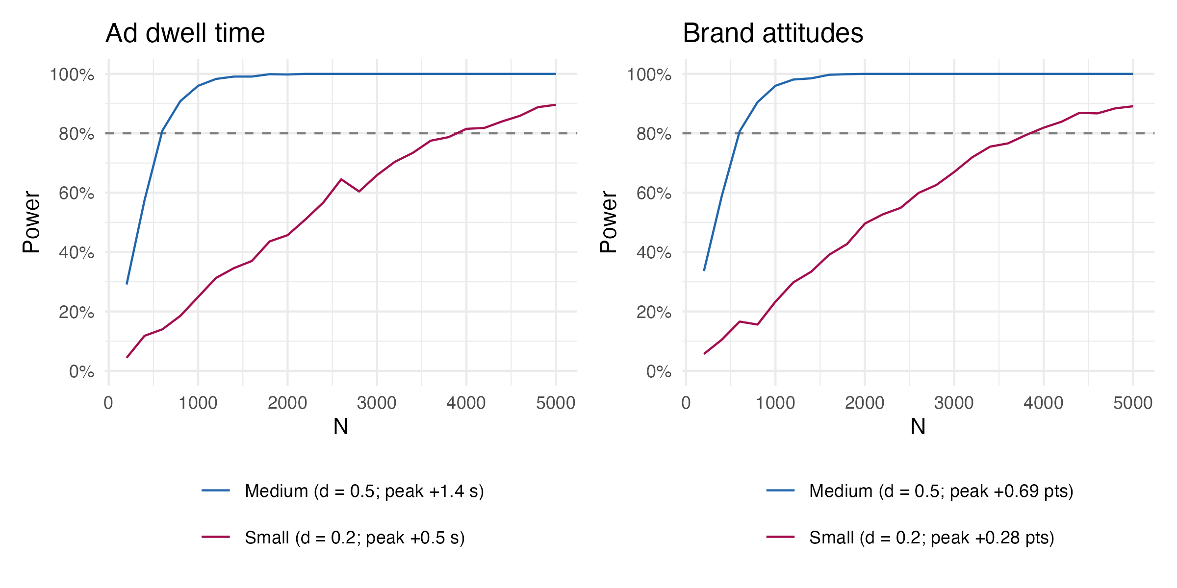
Figure 7: Power curves for the two-lines test on ad dwell time (left) and brand attitudes (right). Effect sizes are expressed as Cohen’s d at the inverted-U peak (d = peak uplift / pilot SD). Dashed line marks 80% power.

Recruitment
We recruit N participants via Prolific Academic, requiring a 99% approval rate, current country of residence in the US or Canada, and English as a first language.

Exclusion Criteria
We exclude participants who a) report technical difficulties via the survey interface or Prolific messaging feature or b) did not finish the survey.

Expected Timeline
Dependent on a successful Stage 1 decision and pending the suggested revisions, all infrastructure and stimuli material is deployable immediately. The timeline is thus only subject to a feasible and successful implementation of reviewer feedback.

DECLARATION OF GENERATIVE AI AND AI-ASSISTED TECHNOLOGIES IN THE MANUSCRIPT PREPARATION PROCESS
During the preparation of this work the authors used Anthropic’s Claude & Claude Code as well as X’s Grok in order to create stimuli, customize experimental software, and copyedit. After using these tools, the authors reviewed and edited the content as needed and take full responsibility for the content of the published article.

REFERENCES
Aridor, Guy, Rafael Jiménez-Durán, Ro’ee Levy, and Lena Song. 2024. “The Economics of Social Media.” Journal of Economic Literature 62 (4): 1422–74. https://doi.org/10.1257/jel.20241743.
Avalle, Michele, Niccolò Di Marco, Gabriele Etta, Emanuele Sangiorgio, Shayan Alipour, Anita Bonetti, Lorenzo Alvisi, et al. 2024. “Persistent Interaction Patterns Across Social Media Platforms and over Time.” Nature 628 (8008): 582–89. https://doi.org/10.1038/s41586-024-07229-y.
Banerjee, Shrabastee, Ishita Chakraborty, Hana Choi, Hannes Datta, Remi Daviet, Chiara Farronato, Minkyung Kim, et al. 2026. “Digital Platforms 2.0: Emerging Topics, Opportunities, and Challenges.” International Journal of Research in Marketing. https://doi.org/10.1016/j.ijresmar.2026.03.003.
Beknazar-Yuzbashev, George, Rafael Jiménez Durán, Jesse McCrosky, and Mateusz Stalinski. 2022. “Toxic Content and User Engagement on Social Media: Evidence from a Field Experiment.” Working Paper, November. https://doi.org/10.2139/ssrn.4307346.
Beknazar-Yuzbashev, George, Rafael Jiménez-Durán, and Mateusz Stalinski. 2024. “A Model of Harmful yet Engaging Content on Social Media.” AEA Papers and Proceedings 114 (May): 678–83. https://doi.org/10.1257/pandp.20241004.
Benjamin, Jack. 2024. “Half of Reach’s Euro 2024 Coverage Wrongly Identified by Brands as Unsafe.” The Media Leader. https://uk.themedialeader.com/half-of-reachs-euro-2024-coverage-wrongly-identified-by-brands-as-unsafe/.
Bernritter, Stefan F., Ilias Danatzis, Jana Möller-Herm, and Francesca Sotgiu. 2025. “Navigating Toxic Playgrounds: Managing Reputational and Financial Brand Safety in Multiplayer Video Games.” International Journal of Research in Marketing 42 (4, Part A): 936–56. https://doi.org/10.1016/j.ijresmar.2025.01.002.
Boegershausen, Johannes, Yann Cornil, Shangwen Yi, and David J. Hardisty. 2025. “On the Persistent Mischaracterization of Google and Facebook a/b Tests: How to Conduct and Report Online Platform Studies.” International Journal of Research in Marketing 42 (3, Part B): 886–903. https://doi.org/10.1016/j.ijresmar.2024.12.004.
Braun, Michael, Bart de Langhe, Stefano Puntoni, and Eric M Schwartz. 2024. “Leveraging Digital Advertising Platforms for Consumer Research.” Journal of Consumer Research 51 (1): 119–28. https://doi.org/10.1093/jcr/ucad058.
Braun, Michael, and Eric M. Schwartz. 2025. “Where a/b Testing Goes Wrong: How Divergent Delivery Affects What Online Experiments Cannot (and Can) Tell You about How Customers Respond to Advertising.” Journal of Marketing 89 (2): 71–95. https://doi.org/10.1177/00222429241275886.
Bruns, Daniel, Julian Felix Kopka, Lennart Borgmann, Steffen Prior, and Tobias Langner. 2025. “Measuring Gaining and Holding Attention to Social Media Ads with Viewport Logging: A Validation Study Using Mobile Eye-Tracking.” Journal of Advertising 54 (5): 655–72. https://doi.org/10.1080/00913367.2025.2524186.
Bushman, Brad J. 2005. “Violence and Sex in Television Programs Do Not Sell Products in Advertisements.” Psychological Science 16 (9): 702–8. https://doi.org/10.1111/j.1467-9280.2005.01599.x.
Campbell, Margaret C., and Kevin Lane Keller. 2003. “Brand Familiarity and Advertising Repetition Effects.” Journal of Consumer Research 30 (2): 292–304. https://doi.org/10.1086/376800.
Carlson, Caitlin. 2019. “Misogynistic Hate Speech and Its Chilling Effect on Women’s Free Expression During the 2016 U.S. Presidential Campaign.” Journal of Hate Studies 14 (1). https://doi.org/10.33972/jhs.126.
Chen, Daniel L., Martin Schonger, and Chris Wickens. 2016. “oTree—an Open-Source Platform for Laboratory, Online, and Field Experiments.” Journal of Behavioral and Experimental Finance 9: 88–97. https://doi.org/10.1016/j.jbef.2015.12.001.
“Content Exclusion Categories Brand Suitability Control.” n.d. Amazon Ads. Accessed April 10, 2026. https://advertising.amazon.com/resources/whats-new/content-exclusion-categories-brand-suitability-control.
De Pelsmacker, Patrick, Maggie Geuens, and Pascal Anckaert. 2002. “Media Context and Advertising Effectiveness: The Role of Context Appreciation and Context/Ad Similarity.” Journal of Advertising 31 (2): 49–61. https://doi.org/10.1080/00913367.2002.10673666.
Dempsey, Jemma. 2023. “Twitter Loses Nearly Half Advertising Revenue Since Elon Musk Takeover.” BBC News. BBC. https://www.bbc.com/news/business-66217641.
Easterbrook, J. A. 1959. “The Effect of Emotion on Cue Utilization and the Organization of Behavior.” Psychological Review 66 (3): 183–201. https://doi.org/10.1037/h0047707.
European Parliament, and Council of the European Union. 2022. “Regulation (EU) 2022/2065 of the European Parliament and of the Council of 19 October 2022 on a Single Market for Digital Services and Amending Directive 2000/31/EC (Digital Services Act).” Official Journal of the European Union. https://eur-lex.europa.eu/eli/reg/2022/2065/oj/eng.
Fossen, Beth L., Girish Mallapragada, and Anwesha De. 2020. “Impact of Political Television Advertisements on Viewers’ Response to Subsequent Advertisements.” Marketing Science 40 (2): 305–24. https://doi.org/10.1287/mksc.2020.1260.
GARM. 2026. “GARM - World Federation of Advertisers.” https://wfanet.org/leadership/garm.
Grewal, Lauren S., Prasad Vana, and Andrew T. Stephen. 2025. “Brands in Unsafe Places: Effects of Brand Safety Incidents on Brand Outcomes.” Journal of Marketing Research 62 (6): 981–1002. https://doi.org/10.1177/00222437251349522.
Hanscom, Rhett, Tamara Silbergleit Lehman, Qin Lv, and Shivakant Mishra. 2024. “The Toxicity Phenomenon Across Social Media.” arXiv. https://doi.org/10.48550/arXiv.2410.21589.
Harmon-Jones, Eddie, Philip A. Gable, and Tom F. Price. 2013. “Does Negative Affect Always Narrow and Positive Affect Always Broaden the Mind? Considering the Influence of Motivational Intensity on Cognitive Scope.” Current Directions in Psychological Science 22 (4): 301–7. https://doi.org/10.1177/0963721413481353.
Horta Ribeiro, Manoel, Justin Cheng, and Robert West. 2023. “Automated Content Moderation Increases Adherence to Community Guidelines.” In, 2666–76. WWW ’23. New York, NY, USA: Association for Computing Machinery. https://doi.org/10.1145/3543507.3583275.
Jhaver, Shagun, Iris Birman, Eric Gilbert, and Amy Bruckman. 2019. “Human-Machine Collaboration for Content Regulation: The Case of Reddit Automoderator.” ACM Trans. Comput.-Hum. Interact. 26 (5). https://doi.org/10.1145/3338243.
Johnson, Garrett A. 2023. “Inferno: A Guide to Field Experiments in Online Display Advertising.” Journal Article. Journal of Economics & Management Strategy 32 (3): 469–90. https://doi.org/10.1111/jems.12513.
Knuth, D. E. 1984. “Literate Programming.” The Computer Journal 27 (2): 97–111. https://doi.org/10.1093/comjnl/27.2.97.
Lakens, Daniël. 2022. “Improving Your Statistical Inferences.” Zenodo. https://doi.org/10.5281/zenodo.6409077.
Lee, Chunsik, Junga Kim, and Joon Soo Lim. 2021. “Spillover Effects of Brand Safety Violations in Social Media.” Journal of Current Issues & Research in Advertising 42 (4): 354–71. https://doi.org/10.1080/10641734.2021.1905572.
Lees, Alyssa, Vinh Q. Tran, Yi Tay, Jeffrey Sorensen, Jai Gupta, Donald Metzler, and Lucy Vasserman. 2022. “A New Generation of Perspective API: Efficient Multilingual Character-Level Transformers.” In Proceedings of the 28th ACM SIGKDD Conference on Knowledge Discovery and Data Mining, 3197–207. KDD ’22. New York, NY, USA: Association for Computing Machinery. https://doi.org/10.1145/3534678.3539147.
Lenhart, Amanda, Michele Ybarra, Kathryn Zickuhr, and Myeshia Price-Feeney. 2016. “Center for Innovative Public Health Research.”
Liu, Mingxuan, Jack Lipei Tang, and Dmitri Williams. 2025. “Sympathy for the Devil: Serial Mediation Models for Toxicity, Community, and Retention.” Media and Communication 13 (0). https://doi.org/10.17645/mac.8676.
Lyons, Emmet, and Joanne Stocker. 2024. “World Bank Halts Paid Advertising on X After CBS News Finds Its Promoted Ad Under Racist Content.” CBS News. https://www.cbsnews.com/news/world-bank-advertising-elon-musk-x-racism-pro-nazi-accounts/.
Madio, Leonardo, and Martin Quinn. 2024. “Content Moderation and Advertising in Social Media Platforms.” Journal of Economics & Management Strategy n/a (n/a): 1–28. https://doi.org/10.1111/jems.12602.
Matias, J. Nathan, Kevin Munger, Marianne Aubin Le Quere, and Charles Ebersole. 2021. “The Upworthy Research Archive, a Time Series of 32,487 Experiments in u.s. Media.” Scientific Data 8: 195. https://doi.org/10.1038/s41597-021-00934-7.
Müller, Karsten, and Carlo Schwarz. 2020. “Fanning the Flames of Hate: Social Media and Hate Crime.” Journal of the European Economic Association 19 (4): 2131–67. https://doi.org/10.1093/jeea/jvaa045.
Müller, Karsten, and Carlo Schwarz. 2023. “From Hashtag to Hate Crime: Twitter and Antiminority Sentiment.” American Economic Journal: Applied Economics 15 (3): 270–312. https://doi.org/10.1257/app.20210211.
Nian, Tingting, Yuheng Hu, and Cheng Chen. 2021. “Examining the Impact of Television-Program-Induced Emotions on Online Word-of-Mouth Toward Television Advertising.” Information Systems Research 32 (2): 605–32. https://doi.org/10.1287/isre.2020.0985.
Öhman, Arne, and Susan Mineka. 2001. “Fears, Phobias, and Preparedness: Toward an Evolved Module of Fear and Fear Learning.” Psychological Review 108 (3): 483–522. https://doi.org/10.1037/0033-295X.108.3.483.
Ordenes, Francisco Villarroel, Dhruv Grewal, Stephan Ludwig, Ko De Ruyter, Dominik Mahr, and Martin Wetzels. 2019. “Cutting Through Content Clutter: How Speech and Image Acts Drive Consumer Sharing of Social Media Brand Messages.” Journal of Consumer Research 45 (5): 988–1012. https://doi.org/10.1093/jcr/ucy032.
Pieters, Rik, Luk Warlop, and Michel Wedel. 2002. “Breaking Through the Clutter: Benefits of Advertisement Originality and Familiarity for Brand Attention and Memory.” Management Science 48 (6): 765–81. https://doi.org/10.1287/mnsc.48.6.765.192.
Pooley, Eric. 1989. “Grins, Gore and Videotape: The Trouble with Local TV News.” New York 22: 36–44.
Pratto, Felicia, and Oliver P. John. 1991. “Automatic Vigilance: The Attention-Grabbing Power of Negative Social Information.” Journal of Personality and Social Psychology 61 (3): 380–91. https://doi.org/10.1037/0022-3514.61.3.380.
Rathje, Steve, and Jay J. Van Bavel. 2025. “The Psychology of Virality.” Trends in Cognitive Sciences, August. https://doi.org/10.1016/j.tics.2025.06.014.
Recuero, Raquel. 2024. “The Platformization of Violence: Toward a Concept of Discursive Toxicity on Social Media.” Social Media + Society 10 (1): 20563051231224264. https://doi.org/10.1177/20563051231224264.
Reiss, Michael V., and Hauke Roggenkamp. 2025. “A Comment on "Negativity Drives Online News Consumption".” I4R Discussion Paper Series. Institute for Replication (I4R). https://hdl.handle.net/10419/311304.
Robertson, Claire E., Nicolas Pröllochs, Kaoru Schwarzenegger, Philip Pärnamets, Jay J. Van Bavel, and Stefan Feuerriegel. 2023. “Negativity Drives Online News Consumption.” Nature Human Behaviour 7: 812–22. https://doi.org/10.1038/s41562-023-01538-4.
Roggenkamp, Hauke, Johannes Boegershausen, and Christian Hildebrand. 2025. “DICE: Advancing Social Media Research Through Digital in-Context Experiments.” Journal of Marketing. https://doi.org/10.1177/00222429251371702.
Rozin, Paul, and Edward B. Royzman. 2001. “Negativity Bias, Negativity Dominance, and Contagion.” Personality and Social Psychology Review 5 (4): 296–320. https://doi.org/10.1207/S15327957PSPR0504\_2.
Salminen, Joni, Sercan Sengün, Juan Corporan, Soon-gyo Jung, and Bernard J. Jansen. 2020. “Topic-Driven Toxicity: Exploring the Relationship Between Online Toxicity and News Topics.” Edited by Pin-Yu Chen. PLOS ONE 15 (2): e0228723. https://doi.org/10.1371/journal.pone.0228723.
Saveski, Martin, Brandon Roy, and Deb Roy. 2021. “The Structure of Toxic Conversations on Twitter.” In Proceedings of the Web Conference 2021, 1086–97. Ljubljana Slovenia: ACM. https://doi.org/10.1145/3442381.3449861.
Shahi, Gautam Kishore, and Tim A. Majchrzak. 2025. “Defining, Understanding, and Detecting Online Toxicity: Challenges and Machine Learning Approaches.” arXiv. https://doi.org/10.48550/arXiv.2509.14264.
Shankar, Venkatesh, Dhruv Grewal, Sarang Sunder, Beth Fossen, Kay Peters, and Amit Agarwal. 2022. “Digital Marketing Communication in Global Marketplaces: A Review of Extant Research, Future Directions, and Potential Approaches.” International Journal of Research in Marketing 39 (2): 541–65. https://doi.org/10.1016/j.ijresmar.2021.09.005.
Shehu, Edlira, Nadia Abou Nabout, and Michel Clement. 2021. “The Risk of Programmatic Advertising: Effects of Website Quality on Advertising Effectiveness.” International Journal of Research in Marketing 38 (3): 663–77. https://doi.org/10.1016/j.ijresmar.2020.10.004.
Simonov, Andrey, Tommaso Valletti, and Andre Veiga. 2025. “Attention Spillovers from News to Ads: Evidence from an Eye-Tracking Experiment.” Journal of Marketing Research 62 (2): 294–315. https://doi.org/10.1177/00222437241256900.
Simonsohn, Uri. 2018. “Two Lines: A Valid Alternative to the Invalid Testing of u-Shaped Relationships with Quadratic Regressions.” Advances in Methods and Practices in Psychological Science 1 (4): 538–55. https://doi.org/10.1177/2515245918805755.
Simonsohn, Uri, Andres Montealegre, and Ioannis Evangelidis. 2025. “Stimulus Sampling Reimagined: Designing Experiments with Mix-and-Match, Analyzing Results with Stimulus Plots.” Journal of Personality and Social Psychology 129 (1): 71–90. https://doi.org/10.1037/pspa0000449.
Singhal, Mohit, Chen Ling, Pujan Paudel, Poojitha Thota, Nihal Kumarswamy, Gianluca Stringhini, and Shirin Nilizadeh. 2023. “SoK: Content Moderation in Social Media, from Guidelines to Enforcement, and Research to Practice.” In 2023 IEEE 8th European Symposium on Security and Privacy (EuroS&P), 868–95. Delft, Netherlands: IEEE. https://doi.org/10.1109/EuroSP57164.2023.00056.
Statista. 2026. “Social Media Advertising - Worldwide Market Forecast.” Statista. https://www.statista.com/outlook/amo/advertising/social-media-advertising/worldwide.
Tomaino, Geoff, Asaf Mazar, Ziv Carmon, and Klaus Wertenbroch. 2025. “A Simple Method for Improving Generalizability in Behavioral Science: Scope Testing with AI-Generated Stimuli (STAGS).” Consumer Psychology Review 8 (1): 87–97. https://doi.org/10.1002/arcp.1101.
Tufa, Wondimagegnhue Tsegaye, Ilia Markov, and Piek Vossen. 2024. “The Constant in HATE: Analyzing Toxicity in Reddit Across Topics and Languages.” arXiv. https://doi.org/10.48550/arXiv.2404.18726.
United Kingdom. 2023. “UK Online Safety Act 2023.” https://www.legislation.gov.uk/ukpga/2023/50.
Van Steenbergen, Henk, Guido P. H. Band, and Bernhard Hommel. 2011. “Threat But Not Arousal Narrows Attention: Evidence from Pupil Dilation and Saccade Control.” Frontiers in Psychology 2 (October). https://doi.org/10.3389/fpsyg.2011.00281.
WARC. 2026. “Global Ad Trends: Social Media Reaches New Peaks.” https://page.warc.com/global-ad-trends-social-media-reaches-new-peaks.html.
Wise, Kevin, Brian Hamman, and Kjerstin Thorson. 2006. “Moderation, Response Rate, and Message Interactivity: Features of Online Communities and Their Effects on Intent to Participate.” Journal of Computer-Mediated Communication 12 (1): 24–41. https://doi.org/10.1111/j.1083-6101.2006.00313.x.
Xu, Heng, Nan Zhang, and Le Zhou. 2020. “Validity Concerns in Research Using Organic Data.” Journal of Management 46 (7): 1257–74. https://doi.org/10.1177/0149206319862027.

APPENDIX
Here, we report the measures described above in more detail. Furthermore, we provide a detailed codebook on OSF.

Independent Variables
The following variables represent alternative operationalizations of the independent variable. They are generated by using different methods of calculating toxicity exposure but do not involve any experimenter intervention prior to or during the experiment.

Average Toxicity
Instead of classifying toxicity doeses based on the .6 threshold, we will also compute the average toxicity doses by summing the raw toxicity scores of all organic posts and dividing by 25.

Adjacent Toxicity
We calculate the average raw toxicity of the posts immediately preceding and succeeding the sponsored post.

Dependent Variables
The following dependent variables are derived as financial brand safety metrics from prior literature (Bernritter et al. 2025) or proposed as potential transmitting mechanisms of unsafe content on the brand (Grewal, Vana, and Stephen 2025). We included both in the survey and specify their analysis in the Analysis Plan.

Lottery Signup
Lottery signup is captured as click on the ad (binary: clicked = 1; 0 otherwise). Although it is behavioral in nature and has been discussed as an adequate approximation of financial brand safety (Bernritter et al. 2025), it is relatively sparse, which limits power. It is therefore reported for completeness.

Brand Choice
Participants select which snack brand they would choose (M&M’s, Skittles, Kit Kat Bites or Hershey’s (Bernritter et al. 2025).

Purchase Intention
Participants indicate how likely they are to purchase from M&M’s on a slider from 0 to 100 (Bernritter et al. 2025).
Note: The following measures describe transmitting mechanisms

Brand Trust
Participants indicate their agreement to a single item: “I believe M&M’s is trustworthy” (Grewal, Vana, and Stephen 2025).

Attribution
Participants answer the following question: “When you saw the ad next to the other content, who do you believe is responsible for this ad placement? The brand whose ad is visible is responsible for where its ad is placed; The website is responsible for the ad placement; Third party algorithms are responsible for ad placement” (Bernritter et al. 2025).

Ad Involvement
We measure ad involvement based on (Grewal, Vana, and Stephen 2025): How did you engage with the M&M’s brand ad you saw? not at all involved – very Involved ; skimmed it quickly – read it carefully; paid little attention – paid a lot of attention.

Mood
We measure mood as agreement to six mood states (happy, pleased, enthusiastic, sad, upset, and disappointed) (Grewal, Vana, and Stephen 2025).

Covariates
Besides demographics covariates age and gender, we measured the following set:

Brand Familiarity
We asked participants whether they knew the M&M’s brand before.

Movie Covariates
To control for potential effects of the feed’s topic (i.e., Avatar), we measure whether participants had seen the movie and if so, whether they liked it.

While the current implementation anchors around the movie-themed context, the STAGS approach allows us to extend the stimulus generation to other settings, as a new corpus for a different topic or product requires only minor changes to the underlying prompts in addition to a final validation step.
We retained the three feeds depicted in Figure 3. See : https://tinyurl.com/zj83m3vh, https://tinyurl.com/bdfwxr2a, and https://tinyurl.com/muan7r6a.
Note that this implies that our operationalization of the toxicity dose (i.e., the fraction of organic posts that is classified as toxic) allows us to estimate the Intention-to-Treat (ITT). The ITT describes the effect of assigning a treatment, regardless of compliance. Since not every participant scrolls to the end of their assigned social media feed, however, the assigned toxicity dose may differ from the received dose that would be used to estimate an Average Treatment Effect (ATE).

