**Analytics Engineer Assignment**

We are excited to see you applying for the role of Analytics Engineer at Spin Master! In this open-ended assignment we would like you to show us your skills in transforming and modelling data, as well as analyzing it and telling a visual story to a product team.

What we are trying to gauge here through an assignment is your command on Analytics Engineering skills through SQL and other languages/tools/frameworks, business prowess combined with a passion to analyze -> story tell through PowerBi and most importantly, to define ways to measure based on where the data leads you.

The best visual encompassing a cohesive story based on data points available and a robust data model to support the visual will be ranked higher.

**Analytics engineering task**

We have a wholesale business model where a fictious company called Pawt is selling toys to its customers like Walmart/Amazon etc and trying to assess performance of sales and impact of POS on future sales and strategies.

**Data Setup:**

* **Fin Data:** Financial records across brands and regions from 2019 to 2021 including record type (Actual, Budget, or Forecast), and the node column specifies the type of amount.
* **POS Data**: Weekly point-of-sale data reported by retailers (walmart, amazon etc) at brand level. Assume brand is a logical grouping of our toys. POS data is currently available only up to week 13.
* **Shipments Data**: Contains records of shipments sent to these retailers, including shipment type (FOB or DOM). Each shipment has a lead time for landing at the retailer based on its type:
* FOB shipments land after 8 weeks
* DOM shipments land after 4 weeks

**Your Task:**

**Task 1 – Build the Metrics**

1. Create a **POS view** that includes all data in POS and:

* A new column that shows the inventory units available at the end of each month.
* For weeks beyond the last POS week, project weekly inventory units based on a cumulative logic using previously available inventory and Shipments that land in that week.

⚠️ Hint: Assume that once a shipment "lands," it becomes available as inventory at the retailer. POS data might not yet be available for those weeks, but we still want to reflect how much inventory is on hand. You may use CTEs, window functions, or subqueries as needed.

1. Create a Finance view with the following:
   * Dimension columns:
     + Year,
     + Month
     + Type
     + Region
     + Brand
     + Node
   * Measure Columns
     + GPS Amount
     + NPS Amount (GPS – Allowance)
     + Revenue (NPS+ Other Revenue)
     + GM (Revenue - COGS)

**Task 2 – Build a Dashboard based on the story the data tells you**

1. Explore the datasets provided and uncover meaningful insights. Summarize your findings and create a dashboard to communicate your insights effectively.

**Task 3 –** **Build an Interactive Visual board**

1. Create the following interactive Power BI waterfall visual with Financial metrics. When clicking on each financial metric (NPS, Revenue, GM) and choosing the year, it will show the prev year value, delta values of the underlying nodes that contribute to that metric and current year value.

For eg., See the below image, Imagine there is a year slicer on the dashboard and 2021 is selected, when Revenue is clicked, since Revenue = GPS - Sales Allowance + Other Revenue, it should show

* + 2020 revenue (1.46 Billion)
  + change in value from 2020 to 2021 for Finance Metrics contributing to the selected Metric
    - delta GPS (-66.37 M)
    - delta Sales Allowance (19.56 M)
    - Other Revenue (7.01 M)
  + 2021 revenue (1.42 Billion).

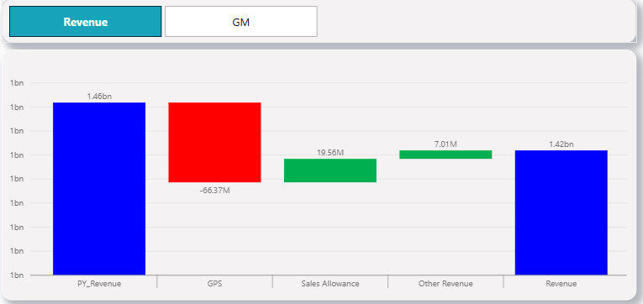

This is an example. But what would be scored higher is the ability to understand the data and showcase an intuitive dashboard with interactivity enabled.