

Lab Midterm

Design

Pattern

Submitted By:

* Hozefa Hassan Rizvi(FA20-BSE-019)

Lab Midterm

**GitHub Repository link:**

* [Design-Pattern/LabMidterm_Observor at main · HozefaRizvi/Design-Pattern (github.com)](https://github.com/HozefaRizvi/Design-Pattern/tree/main/LabMidterm_Observor)

**Class Diagram:**

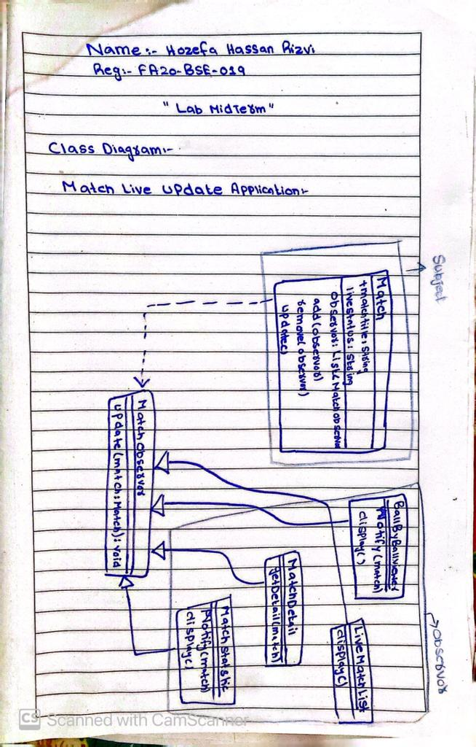

**Code Implementation Output:**

**Code Snippets:**

1. **Main Class :**

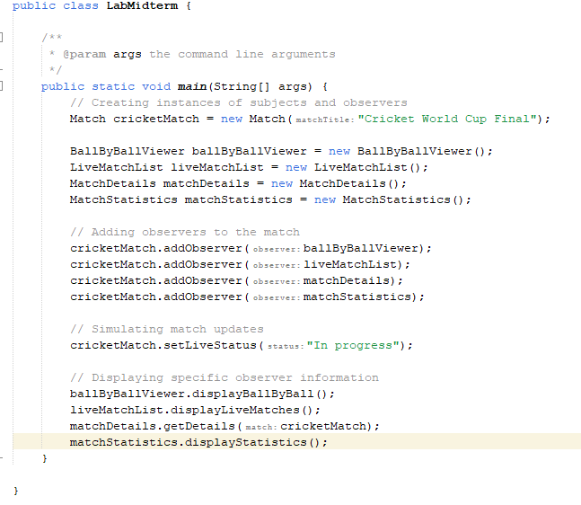

1. **MatchObservor interface:**

1. **BallbyBall(Observor class):**

1. **LiveMatchUpdate(Observor class):**

1. **MatchDetail(Observor class):**

1. **Match Stastics (Observor class):**

1. **Match(Subject Class):**



