|  |  |
| --- | --- |
|  | **Life INSURANCE**  We all have a future. Make sure it’s secure.  Made by:-Himesh Patel  INSURANCE BASE MANAGEMENT SYSTEM |

**LIFE** **INSURANCE BASE MANAGEMENT SYSTEM**

***Objective***:

The objective of insurance is to financially guard against unpredictable life occurrences.In short , when you buy an insurance policy,you make monthly payments,called premiums to purchase protection from monetary repercussions related to things like accidents,illness or even death.Insurance policies provides a lumpsum money to financially support your family.

**Table Structures;**

**CLIENT INFO**: This table contains the **information for the client** based on insurance branch.

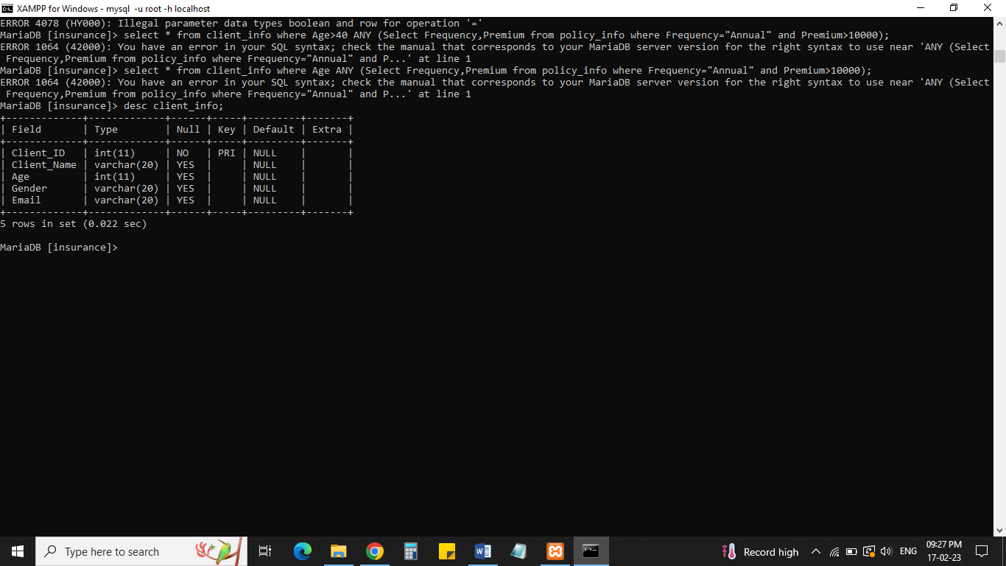

**POLICY INFO**: This table contains the information about Policy Details in branch.

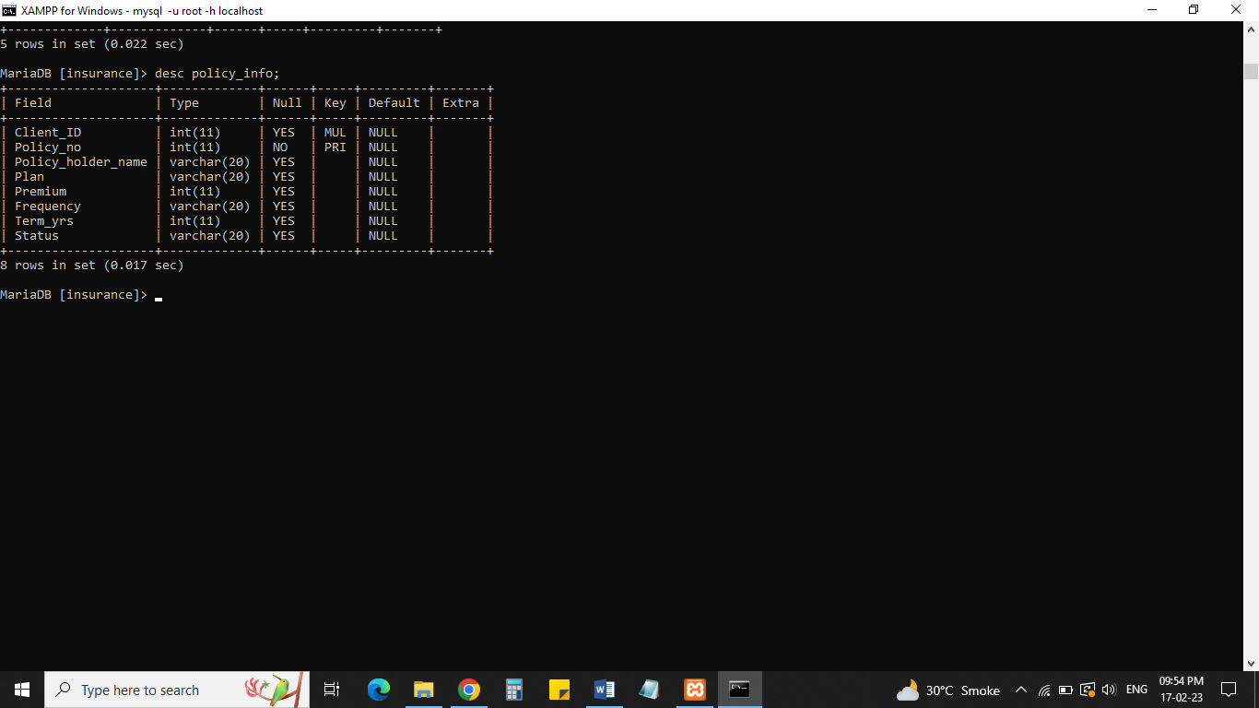

**EMP DETAILS**: This table contains the information of the Employee Details in respective departments.

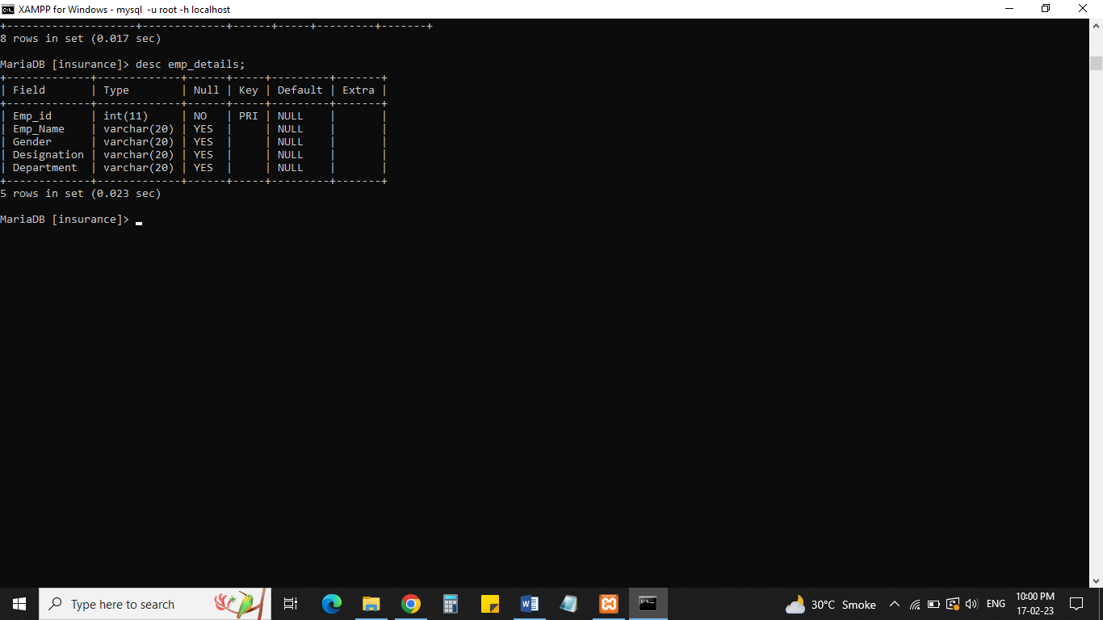

**POLICY SERVICES INFO** :This table contains the information about different Policy Services.

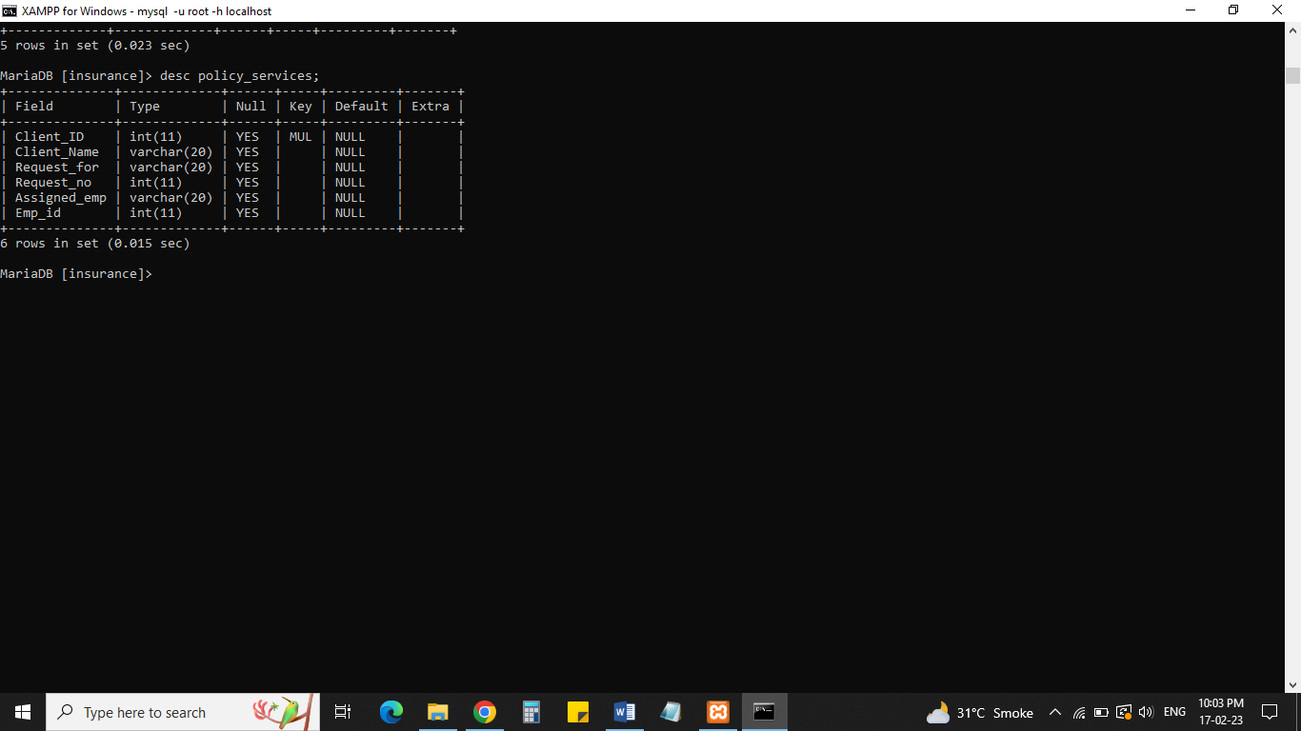

**DATA ENTRIES:**

**CLIENT INFO :**

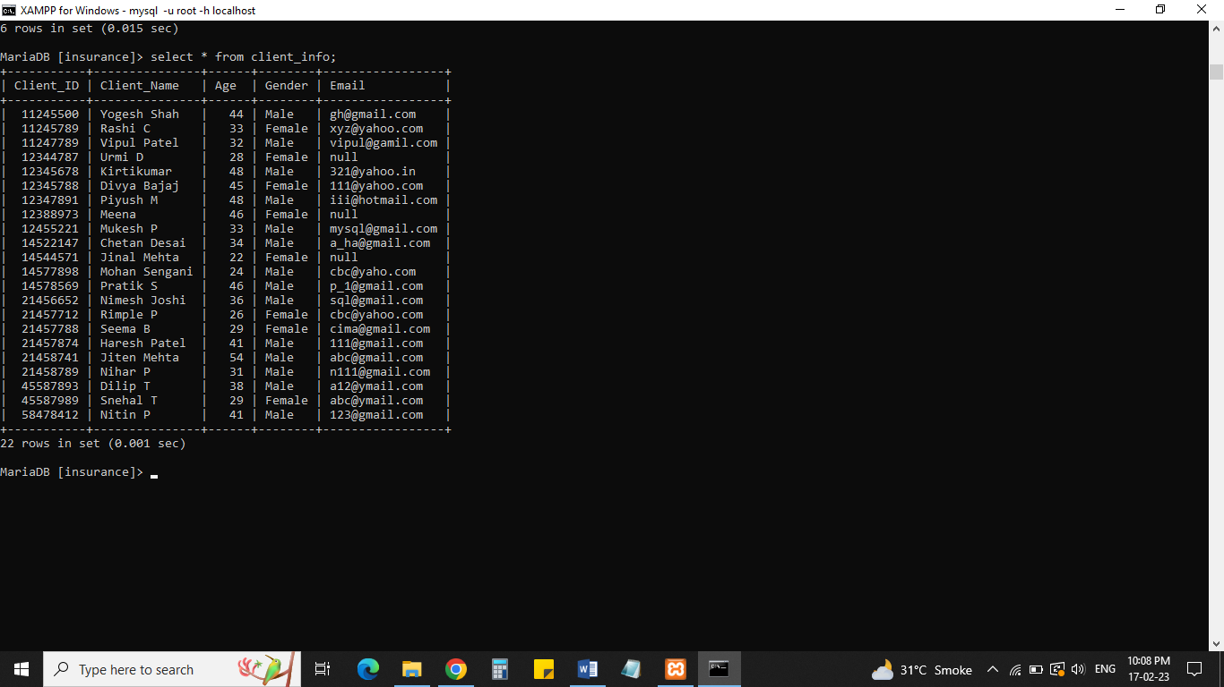

**EMP INFO :**

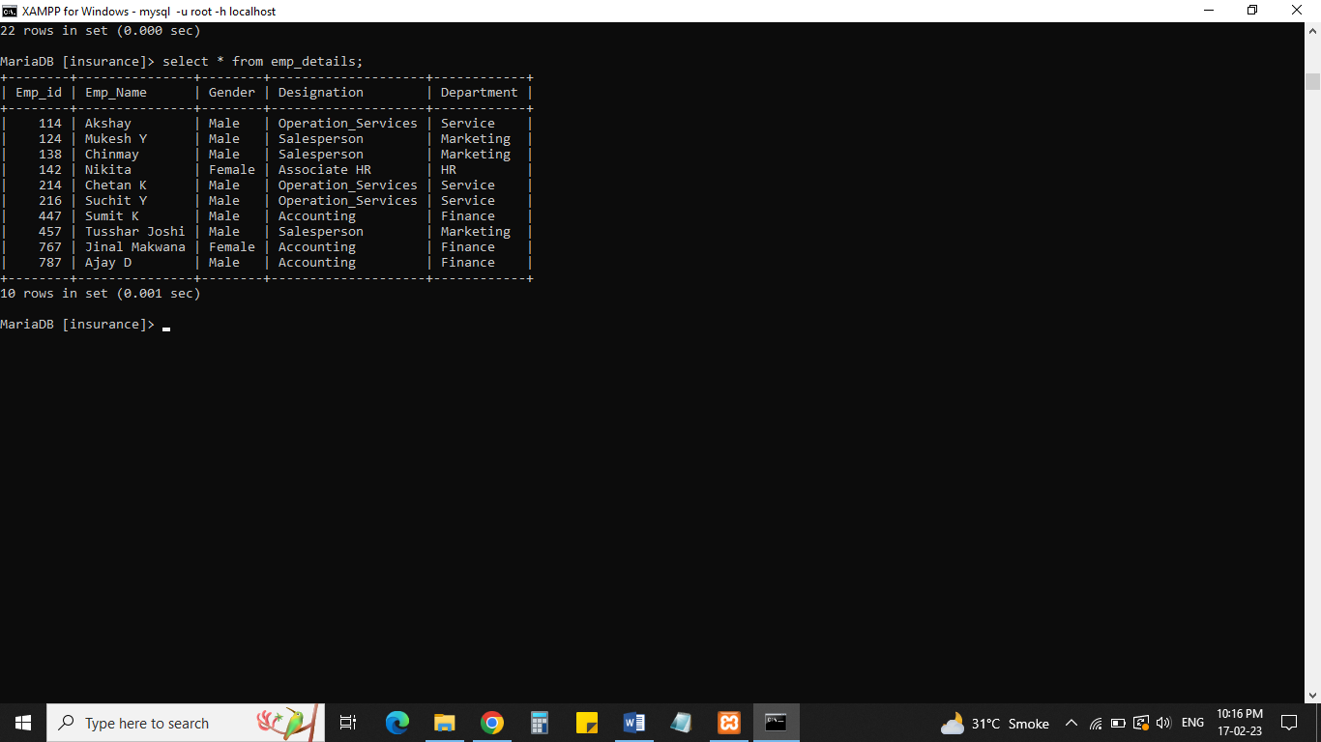

**POLICY INFO :**

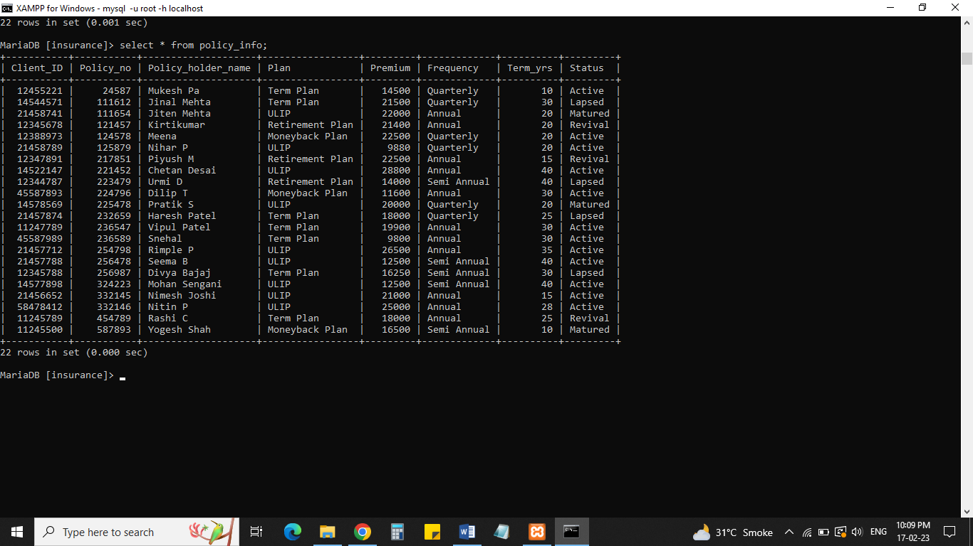

**POLICY SERVICES INFORMATION** :

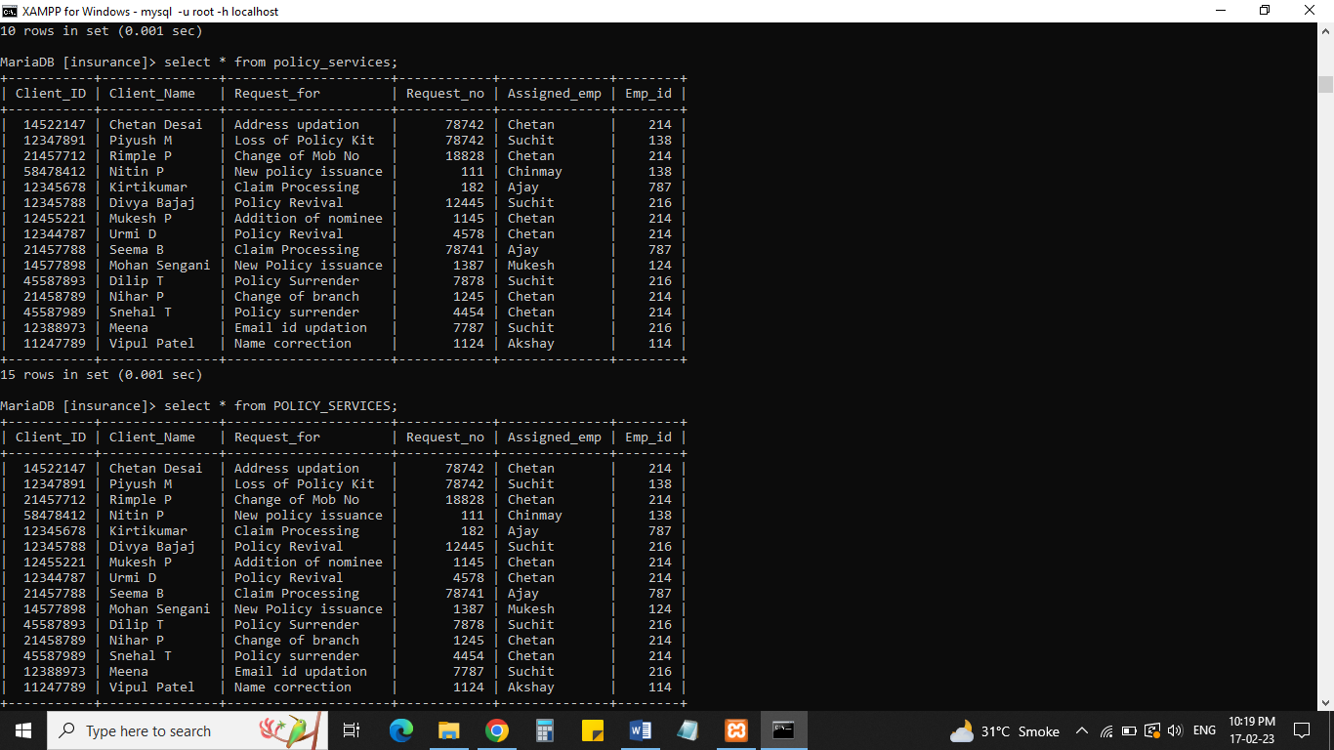

**SUBQUERY :**

1. **Find out Name, Plan and Status of Policy holder who’s Age is Greater than “40”?**

**Select Policy_holder_name,Plan,Status from Policy_info where Policy_holder_name IN (select client_name from Client_info where Age > 40);**

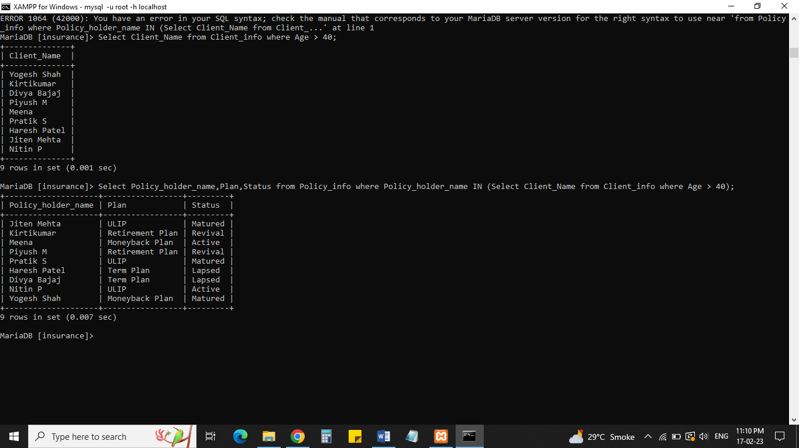

**2) Display all Client details who’s Request No’s are not showing in Policy Services Department?**

**Select * from Client_info where Client_Name NOT IN (Select Client_Name from policy_services);**

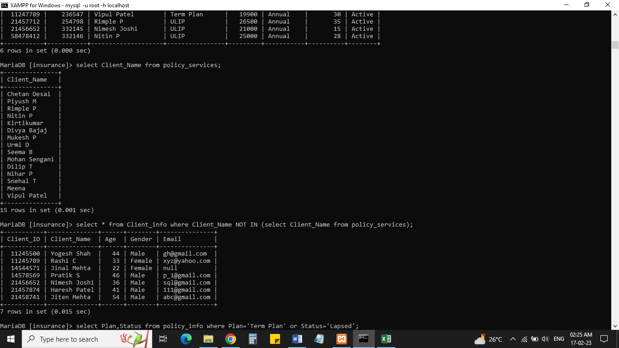

**3). Display all Policy holder details who’s premium amount is greater than policy holder “Urmi D”?**

**Select * from policy_info where Premium > (select Premium from policy_info where Policy_holder_name=”Urmi D”;**

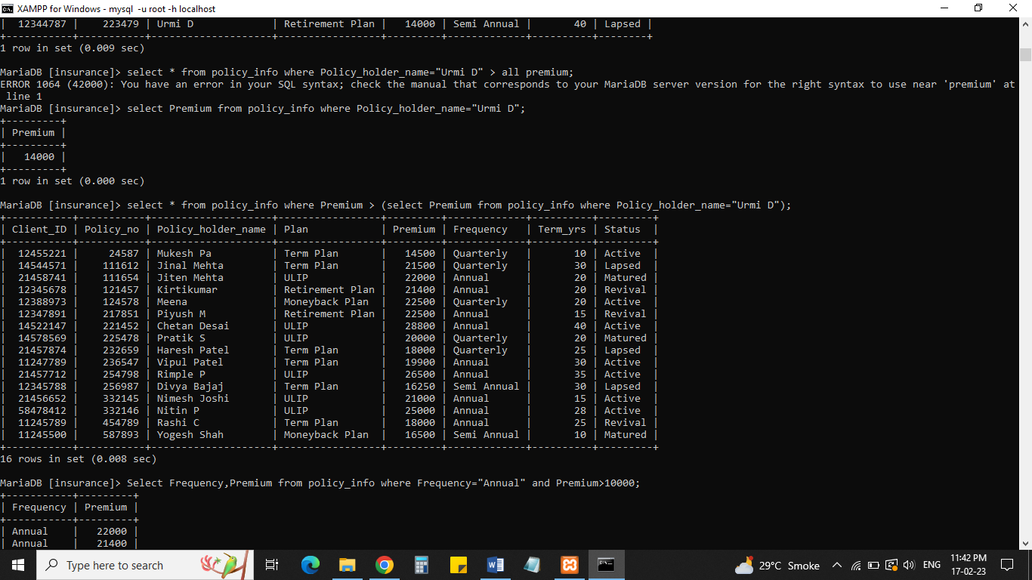

**JOINS**:

1. Display Client ID, Client Name, Policy No and Status using INNER JOIN:

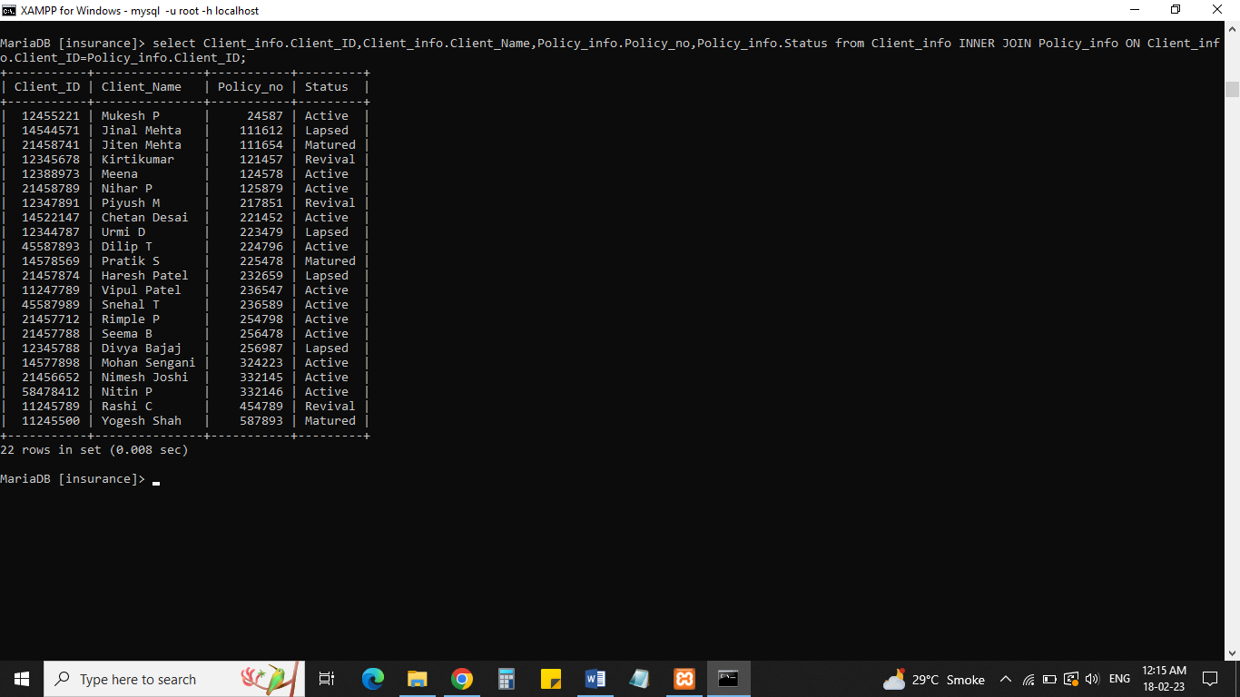

1. Display Client ID, Policy No , Policy holder name and request for using FULL JOIN:

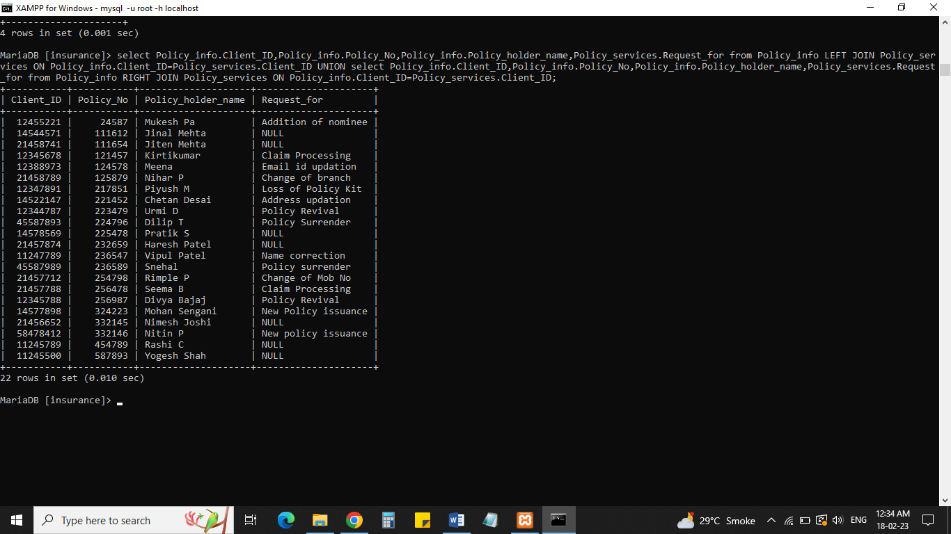

3)Display Client ID, Policy No , Policy holder name and request for using RIGHT JOIN:

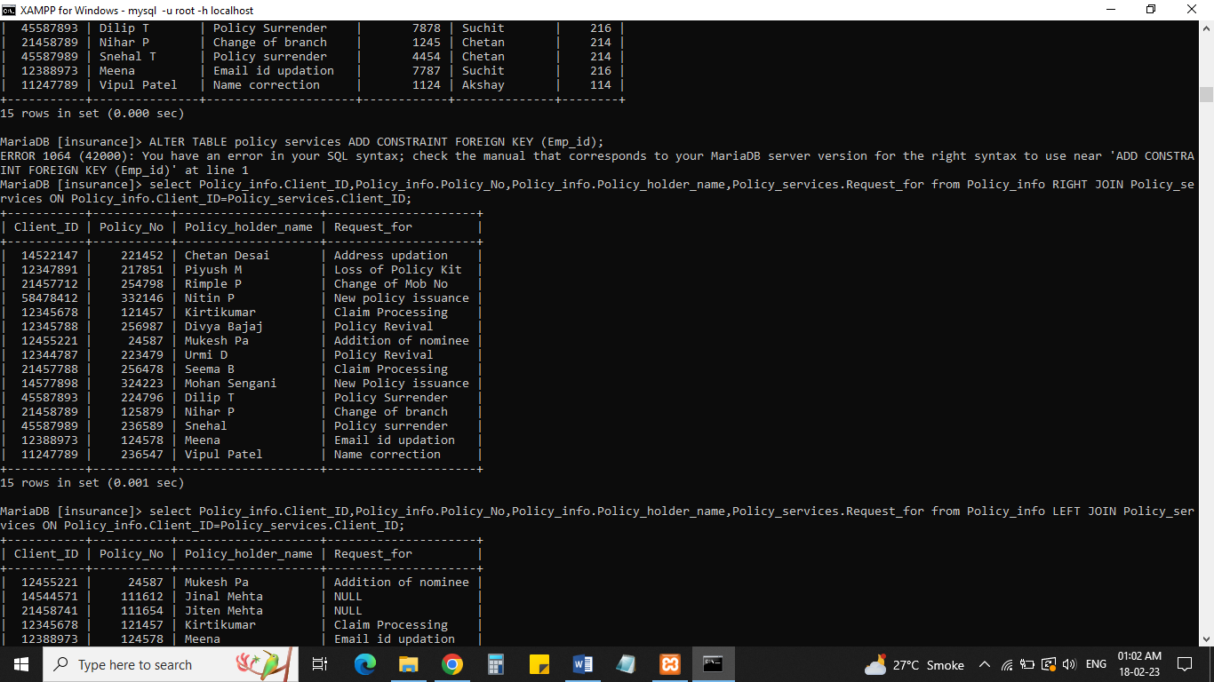

**VIEWS:**

1. Create View Table of Policy_Info_singleclick:

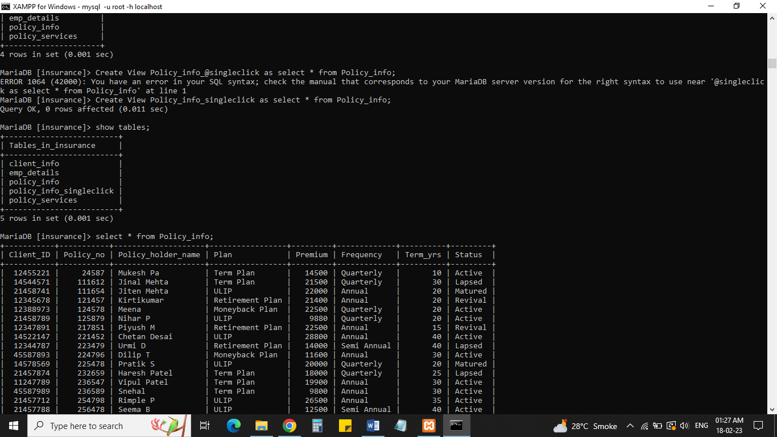

1. Update Frequency “Quarterly” to “Annual” in Client ID -14544571.

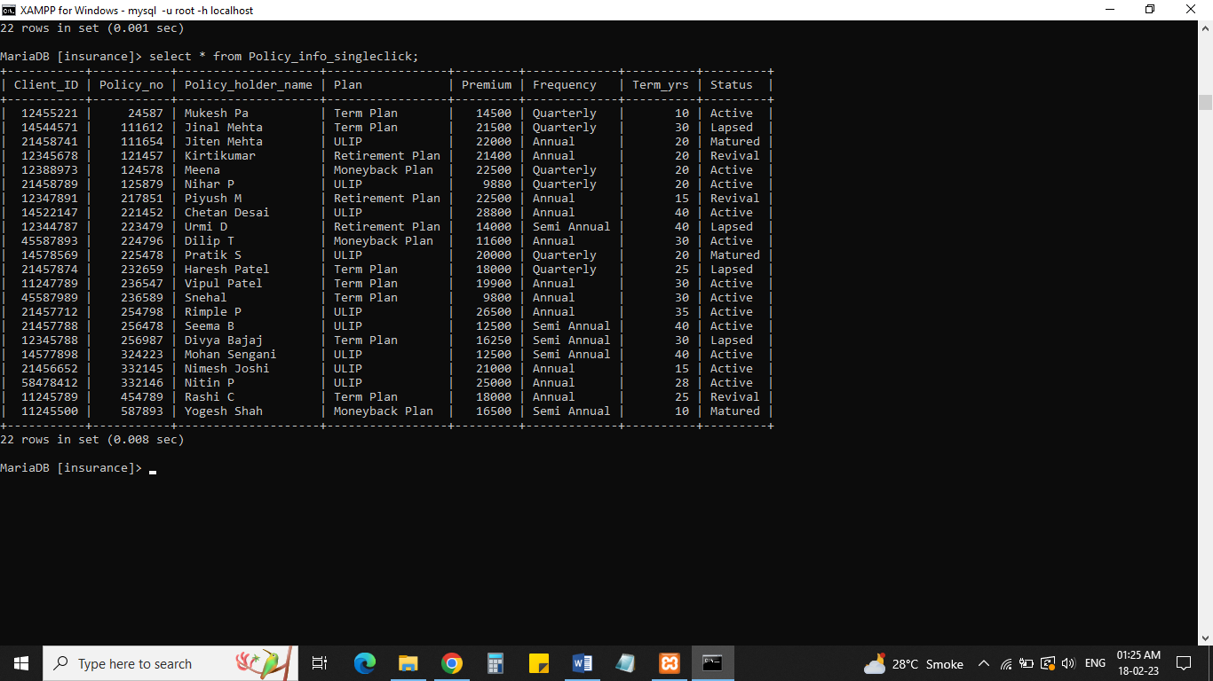

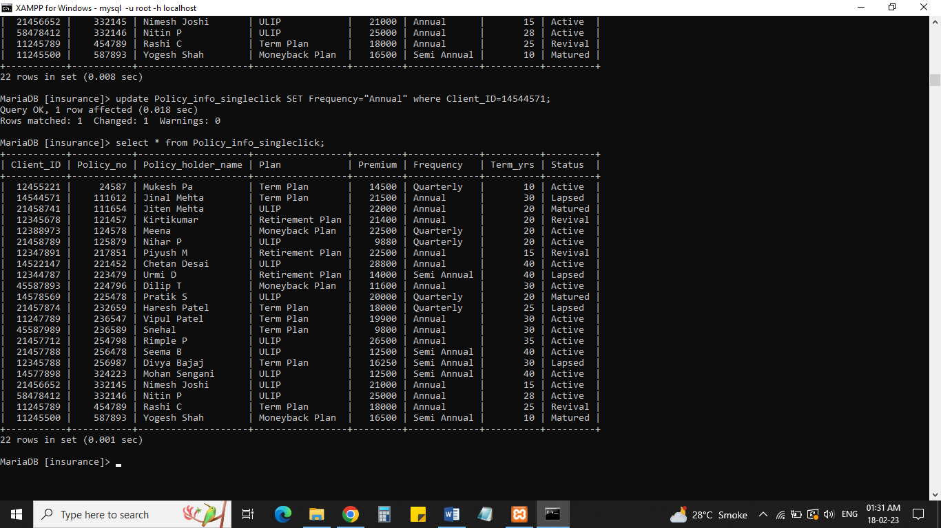

1. Drop the View Table Policy_info_singleclick.

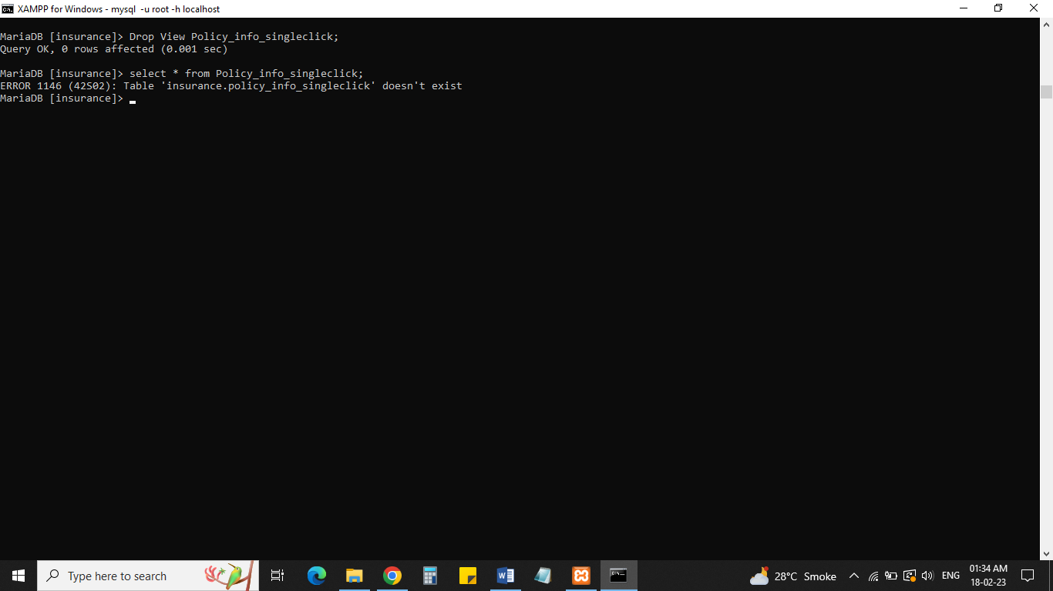

**THANK YOU**