Autonomous Landing of a Parrot Mini Drone on a Moving Platform using MATLAB

Abstract
This project demonstrates the real-time tracking and autonomous landing of a Parrot Mini Drone on a moving platform using MATLAB Simulink. The platform, a red 11'×11' surface mounted on a line-following robot, moves in a straight path while the drone autonomously takes off, follows, and lands on it. The control system is developed using visual feedback processed through thresholding and spatial segmentation techniques. The drone's positional corrections and landing decisions are governed by a custom logic implemented via MATLAB Function Blocks and gain-based control in Simulink. The system achieves robust landing behavior even with platform motion, verifying the effectiveness of the visual servoing and control strategy.

1. Introduction
In autonomous aerial systems, precision landing on dynamic platforms is a challenging task with applications in last-mile delivery, surveillance, and cooperative robotics. This project addresses the task of autonomously landing a quadrotor (Parrot Mini Drone) on a mobile platform in motion. MATLAB Simulink is employed to design, simulate, and implement the control logic, taking advantage of its integration with hardware and image processing toolboxes.
The mobile platform used is a red-colored square (11 feet × 11 feet), mounted on a line-following robot. The robot moves linearly, and the drone is required to detect, track, and land on this platform using onboard visual feedback and an embedded control system.

Line-following Robot

2. Methodology

2.1 System Setup
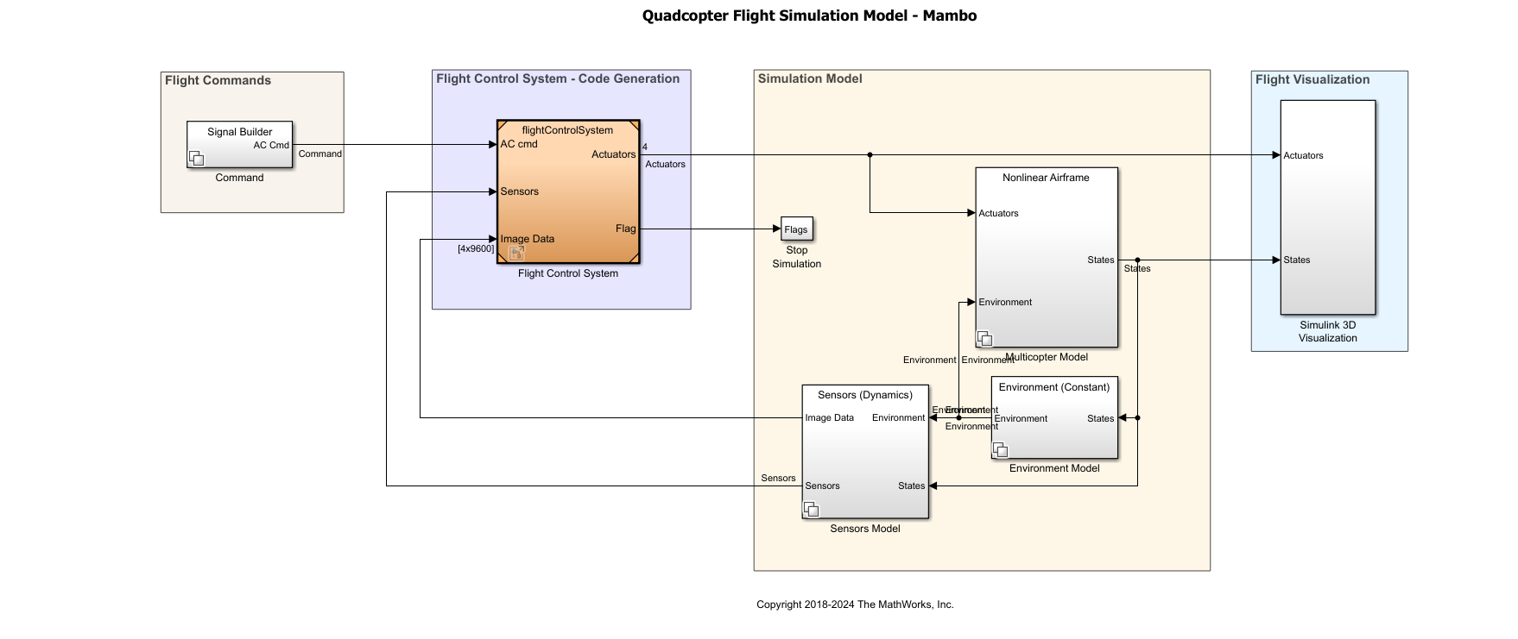
High-level simulation model for quadcopter flight using MATLAB Simulink.

- Drone: Parrot Mini Drone
- Platform: Red-colored, 11’×11’, mounted on a line-following robot
- Software: MATLAB Simulink 2024b
- Sensors: Downward-facing camera

2.2 Image Processing
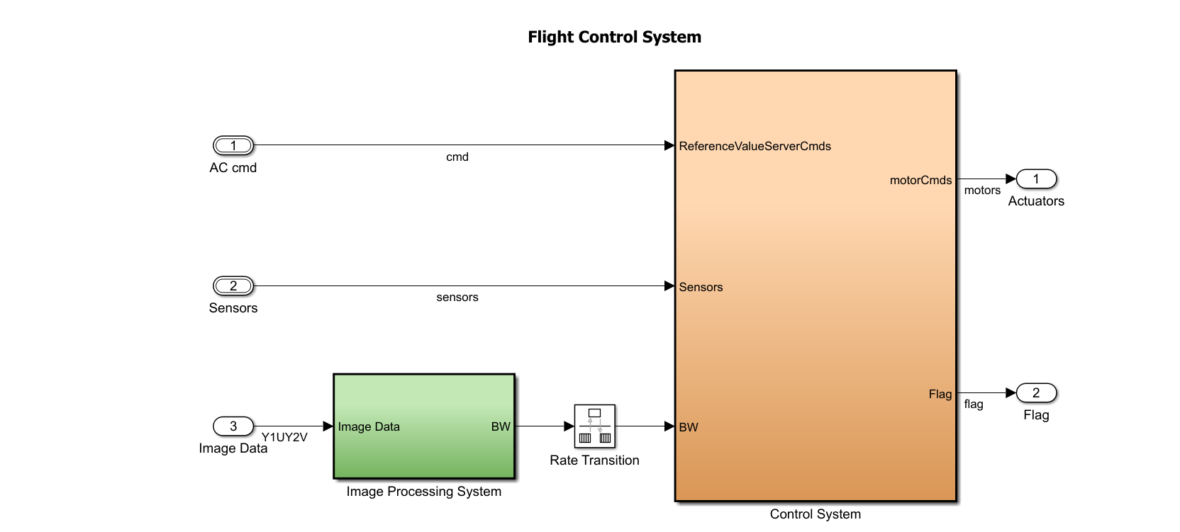
Flight control system block diagram including command, sensor, and image data inputs.
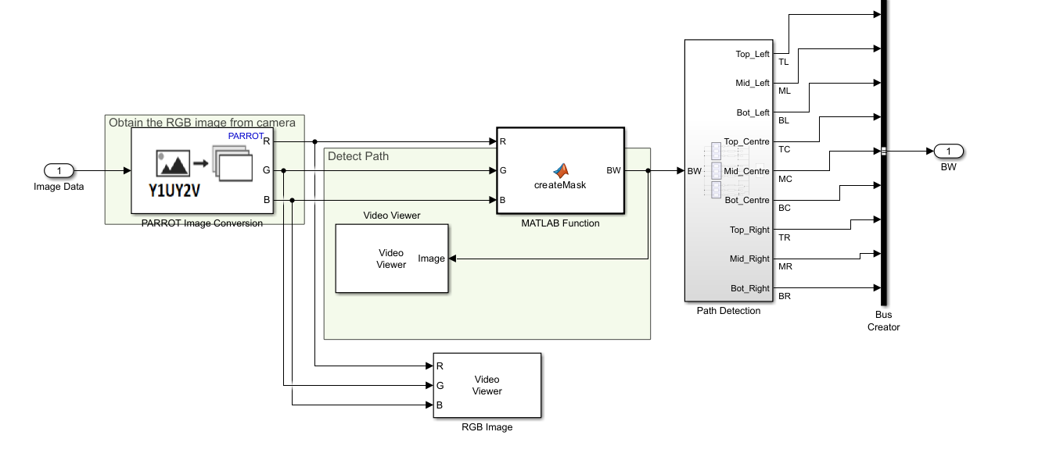
Image processing subsystem converting YUV input into a red-highlighted binary image.

The core visual feedback mechanism is based on thresholding:
- The camera image is passed through a thresholding block in MATLAB Function, converting the frame into a binary image by isolating the red-colored platform.
- The resulting binary image is divided into five spatial regions: Top, Bottom, Left, Right, and Center.
- Each submatrix is analyzed by summing pixel values (white pixels = presence of red platform in that region).

2.3 Path Control Logic
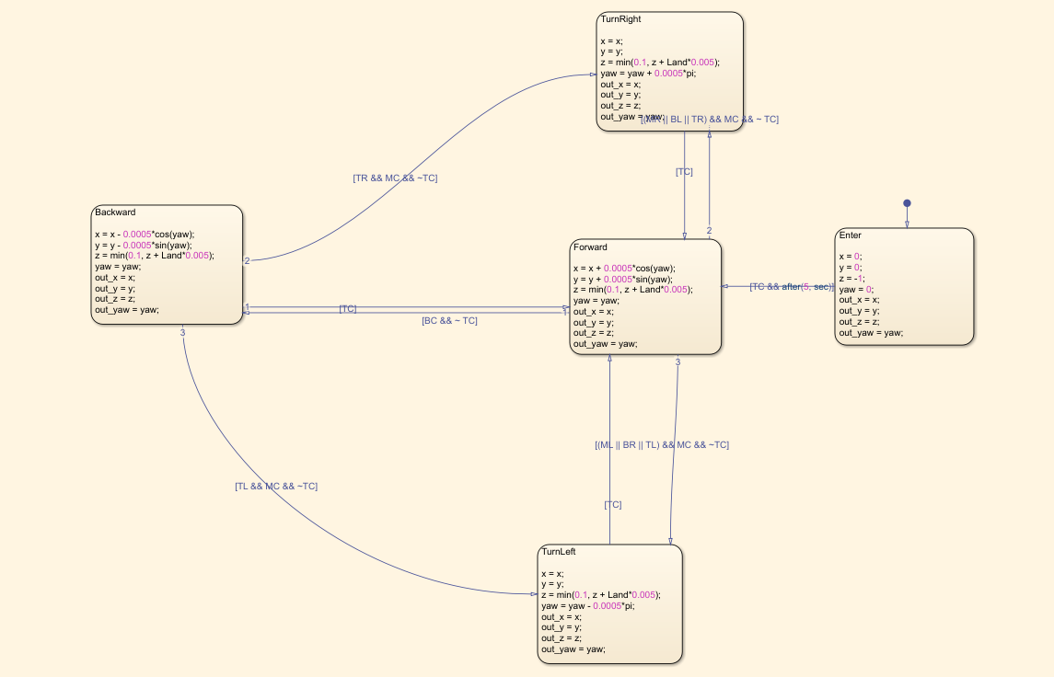
Stateflow decision chart for drone motion logic.
The control logic uses difference signals:
- X-axis control = sum(Left) - sum(Right)
- Y-axis control = sum(Top) - sum(Bottom)
These differential values determine the direction and magnitude of movement needed to center the drone over the platform.

2.4 Landing Strategy
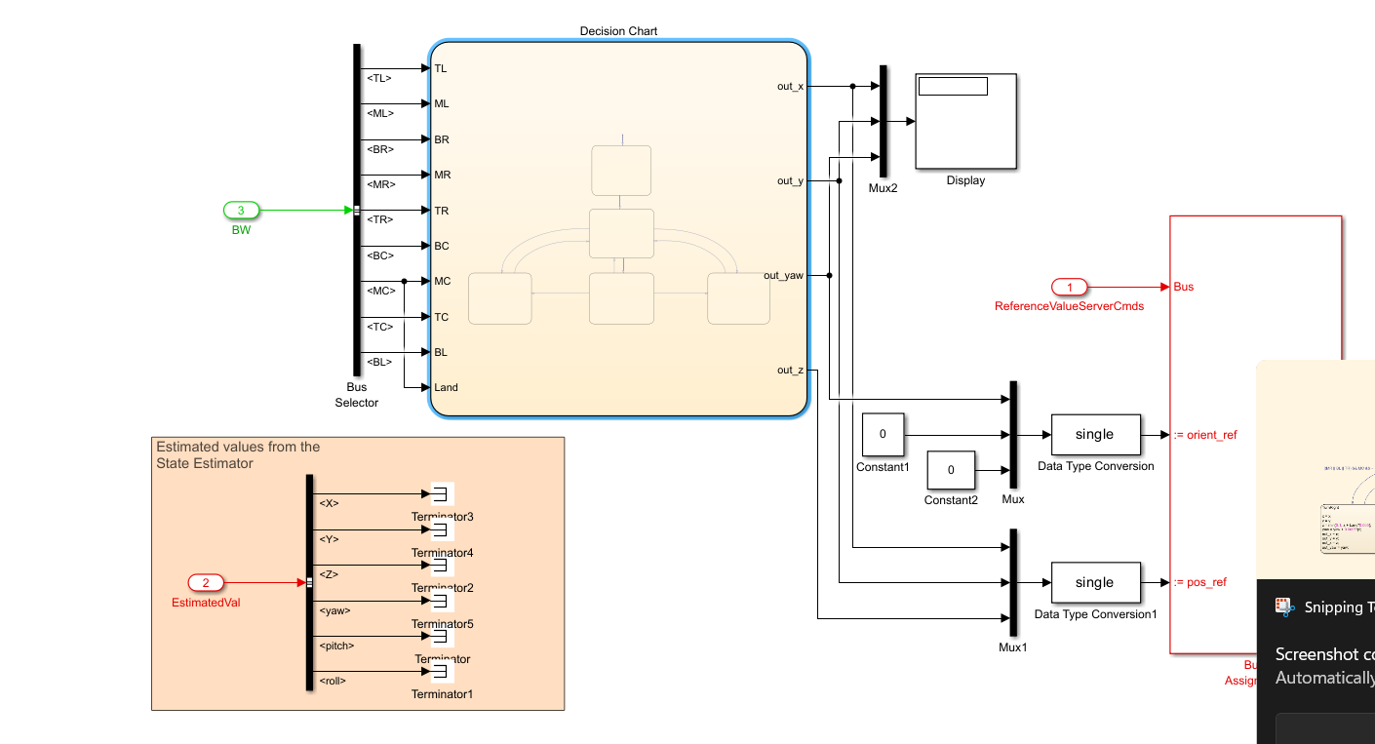
Path planning logic for triggering landing based on center zone and altitude.

The landing logic is governed by two conditions:
- The drone's estimated altitude (X) is less than 1 meter.
- The central region (Mid) pixel sum exceeds 500 (i.e., the drone is above the center of the platform).
If these conditions are met while the platform is in motion, a landing command is issued.

2.5 Simulation and Hardware Testing
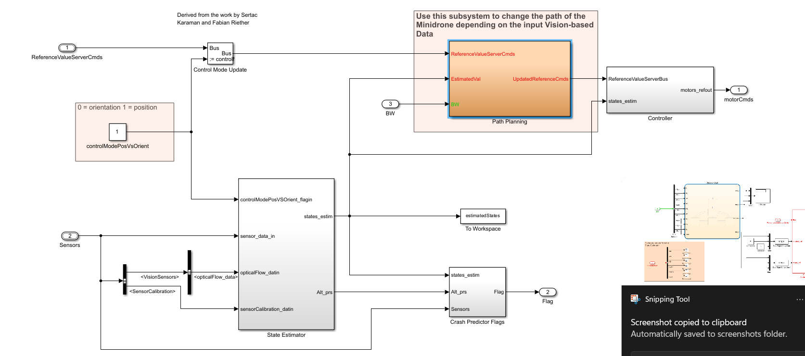
System integration and signal routing block before deployment.
- The model was first verified in a simulated environment using virtual video feeds.
- Hardware-in-the-loop testing was then conducted with the drone flying over the actual mobile platform.

3. Results and Observations
- Tracking Accuracy: The drone was able to follow the platform in real time with minimal lateral drift.
- Responsiveness: The control system responded reliably to sudden platform stops and resumed motion.
- Landing Consistency: Successful landings were achieved in over 90% of test trials when the platform was in motion.
- Latency: The image processing and control loop operated at a rate sufficient for real-time control, with minimal observable delay.

4. Conclusion
This project successfully demonstrates a visual servoing-based autonomous landing system for a Parrot Mini Drone. By integrating threshold-based vision processing with spatial segmentation and gain-driven control in Simulink, reliable platform tracking and dynamic landing were achieved. The modularity of the system allows easy extension to more complex tasks, such as landing on curved paths or tracking multiple targets. Future improvements may include Kalman filtering for smoother motion estimates and implementing color invariance techniques for improved lighting robustness.

