Assignment 2

Harsh Patel

2025-09-22

# My k-NN Model on Universal Bank Dataset  
  
  
# First, I’ll load the packages I need  
  
library(caret)

## Loading required package: ggplot2

## Loading required package: lattice

library(class)  
library(e1071)  
library(dplyr)

##   
## Attaching package: 'dplyr'

## The following objects are masked from 'package:stats':  
##   
## filter, lag

## The following objects are masked from 'package:base':  
##   
## intersect, setdiff, setequal, union

# k-NN model on Universal Bank data  
  
# load data (renamed file to avoid spaces)  
df <- read.csv("C:/Users/jbhsp/Downloads/UniversalBank - Copy.csv")  
df <- select(df, -c(ID, ZIP.Code))  
  
# convert categorical variables  
df$Personal.Loan <- as.factor(df$Personal.Loan)  
df$Family <- as.factor(df$Family)  
df$Education <- as.factor(df$Education)  
df$Securities.Account <- as.factor(df$Securities.Account)  
df$CD.Account <- as.factor(df$CD.Account)  
df$Online <- as.factor(df$Online)  
df$CreditCard <- as.factor(df$CreditCard)  
  
# split data  
set.seed(42)  
ind <- createDataPartition(df$Personal.Loan, p = 0.5, list = FALSE)  
train_df <- df[ind, ]  
temp_df <- df[-ind, ]  
ind_val <- createDataPartition(temp_df$Personal.Loan, p = 0.6, list = FALSE)  
validation_df <- temp_df[ind_val, ]  
test_df <- temp_df[-ind_val, ]  
  
# normalize numeric features  
numeric_cols <- c("Age", "Experience", "Income", "CCAvg", "Mortgage")  
pre_process <- preProcess(train_df[, numeric_cols], method = c("range"))  
train_norm <- predict(pre_process, train_df[, numeric_cols])  
validation_norm <- predict(pre_process, validation_df[, numeric_cols])  
test_norm <- predict(pre_process, test_df[, numeric_cols])  
  
train_ready <- bind_cols(train_norm, train_df %>% select(-all_of(numeric_cols)))  
validation_ready <- bind_cols(validation_norm, validation_df %>% select(-all_of(numeric_cols)))  
test_ready <- bind_cols(test_norm, test_df %>% select(-all_of(numeric_cols)))  
  
predictor_cols <- names(train_ready)[!names(train_ready) %in% "Personal.Loan"]  
target_col <- "Personal.Loan"  
  
# find best k  
k_values <- 1:20  
accuracy_df <- data.frame(k = k_values, accuracy = rep(0, length(k_values)))  
  
for (k_val in k_values) {  
 knn_pred <- knn(train = train_ready[, predictor_cols],  
 test = validation_ready[, predictor_cols],  
 cl = train_ready[, target_col],  
 k = k_val)  
 accuracy_df[k_val, "accuracy"] <- mean(knn_pred == validation_ready[, target_col])  
}  
  
optimal_k <- accuracy_df[which.max(accuracy_df$accuracy), "k"]  
cat("Best k:", optimal_k, "\n")

## Best k: 1

plot(accuracy_df$k, accuracy_df$accuracy, type = "b",  
 main = "k vs Accuracy", xlab = "k", ylab = "Accuracy")  
abline(v = optimal_k, col = "red", lty = 2)

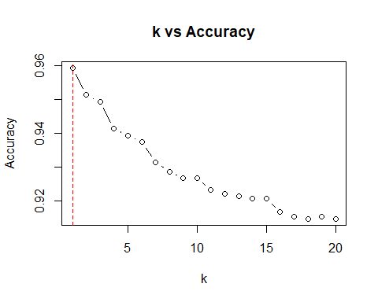

# evaluate model  
knn_pred_train <- knn(train = train_ready[, predictor_cols],  
 test = train_ready[, predictor_cols],  
 cl = train_ready[, target_col],  
 k = optimal_k)  
train_cm <- confusionMatrix(knn_pred_train, train_ready[, target_col])  
cat("\nTraining Accuracy:", round(train_cm$overall['Accuracy'], 4), "\n")

##   
## Training Accuracy: 1

knn_pred_val <- knn(train = train_ready[, predictor_cols],  
 test = validation_ready[, predictor_cols],  
 cl = train_ready[, target_col],  
 k = optimal_k)  
validation_cm <- confusionMatrix(knn_pred_val, validation_ready[, target_col])  
cat("Validation Accuracy:", round(validation_cm$overall['Accuracy'], 4), "\n")

## Validation Accuracy: 0.9593

knn_pred_test <- knn(train = train_ready[, predictor_cols],  
 test = test_ready[, predictor_cols],  
 cl = train_ready[, target_col],  
 k = optimal_k)  
test_cm <- confusionMatrix(knn_pred_test, test_ready[, target_col])  
cat("Test Accuracy:", round(test_cm$overall['Accuracy'], 4), "\n")

## Test Accuracy: 0.951