**Правительство Российской Федерации**

**Федеральное государственное автономное образовательное учреждение высшего профессионального образования   
"Национальный исследовательский университет   
"Высшая школа экономики"**

Московский институт электроники и математики Национального

исследовательского университета "Высшая школа экономики"

Департамент прикладной математики

**ОТЧЕТ**

**По лабораторной работе №1**

**По курсу «Алгоритмизация и программирование»**

|  |  |  |  |  |
| --- | --- | --- | --- | --- |
| |  |  | | --- | --- | |  | ФИО студента | | Номер группы | Дата |
| Колодин Матвей Алексеевич | БПМ213 | 21.10.22 |
|  |
|  |
|  |

**Москва – 2022 г.**

**Результаты**

1. Давайте сравним алгоритм find на следующих контейнерах: vector, deque и list. Данные будут типа char, а файлы, в которых хранятся данные, разных размеров.

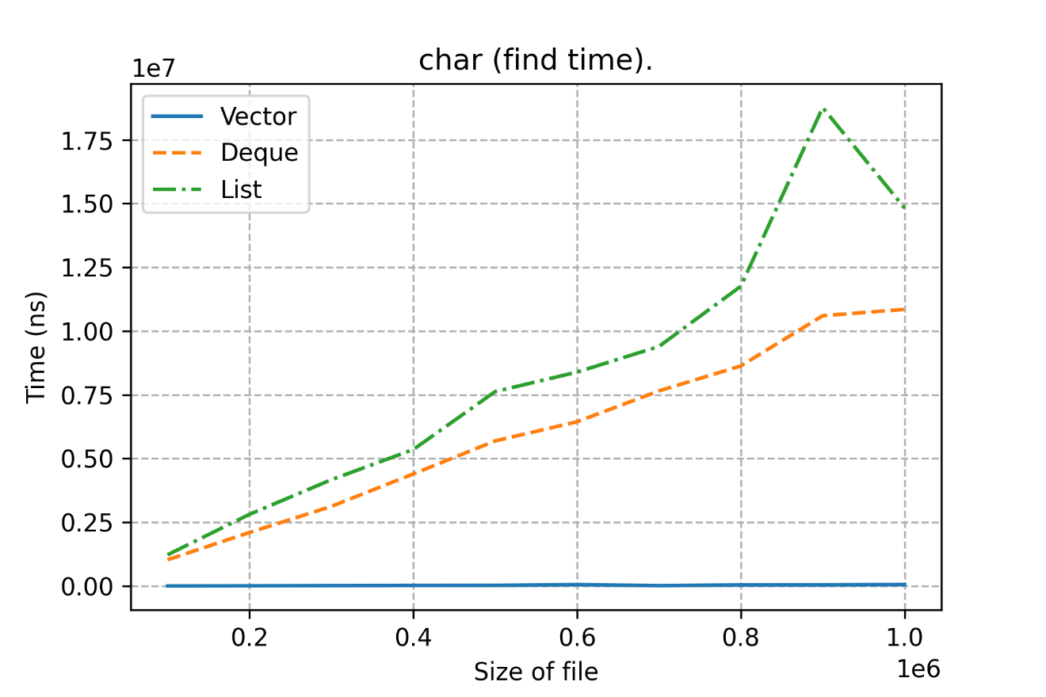

Можно видеть, что наилучшее время у vector, а худшее у list.

Объясняется это их хранением в памяти и тем, как ходят итераторы по их элементам.

Есть некоторая аномалия с листом (возможно какое-то провисание операционной системы)

1. Для int мы видим, что Deque и List очень близки по результату, а вот Vector сильно лучше их.

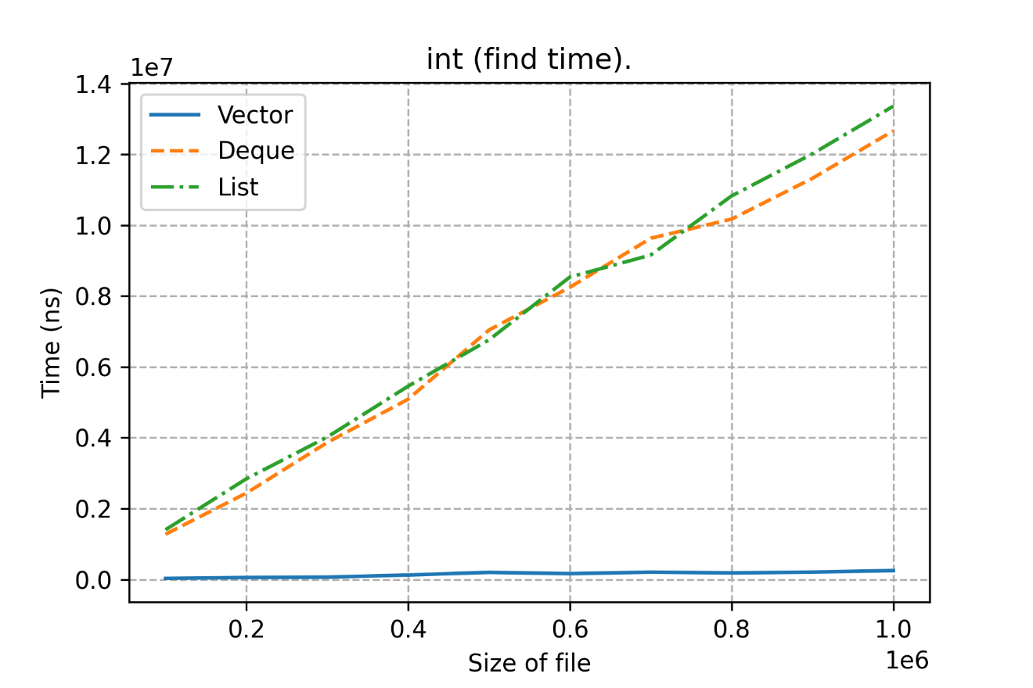

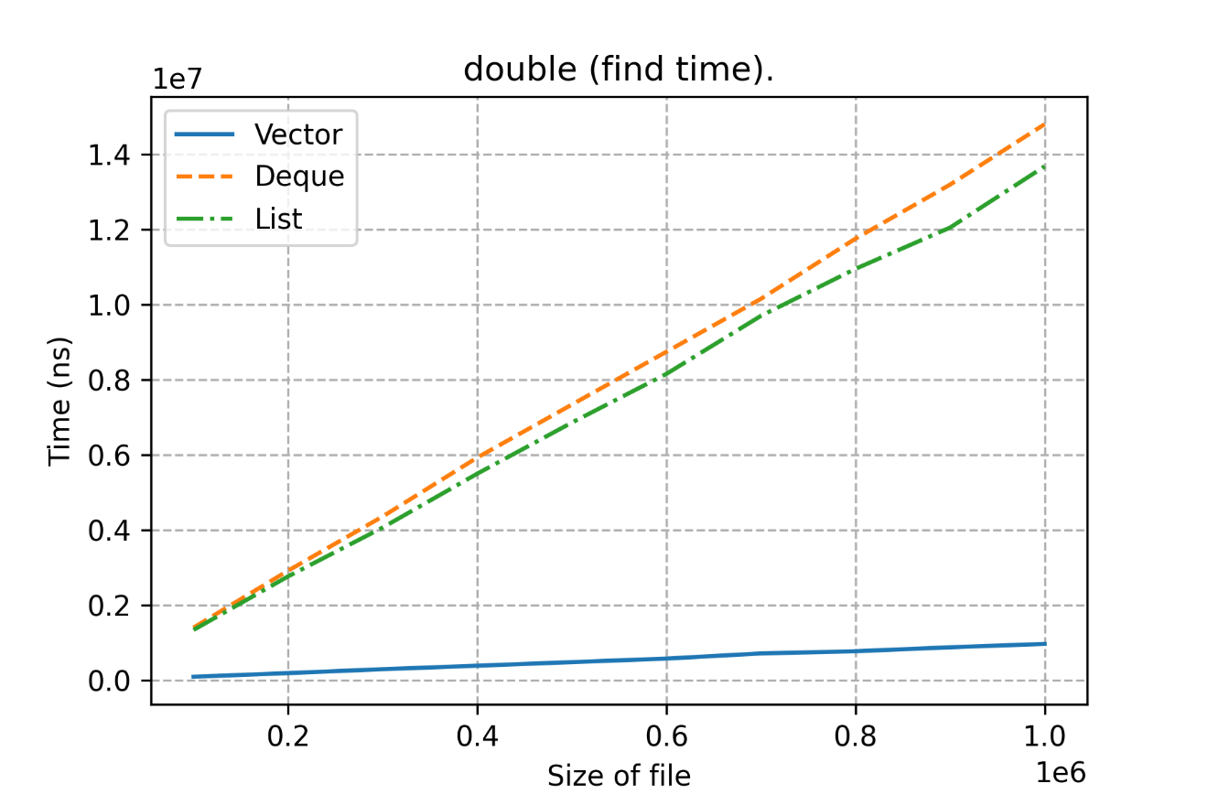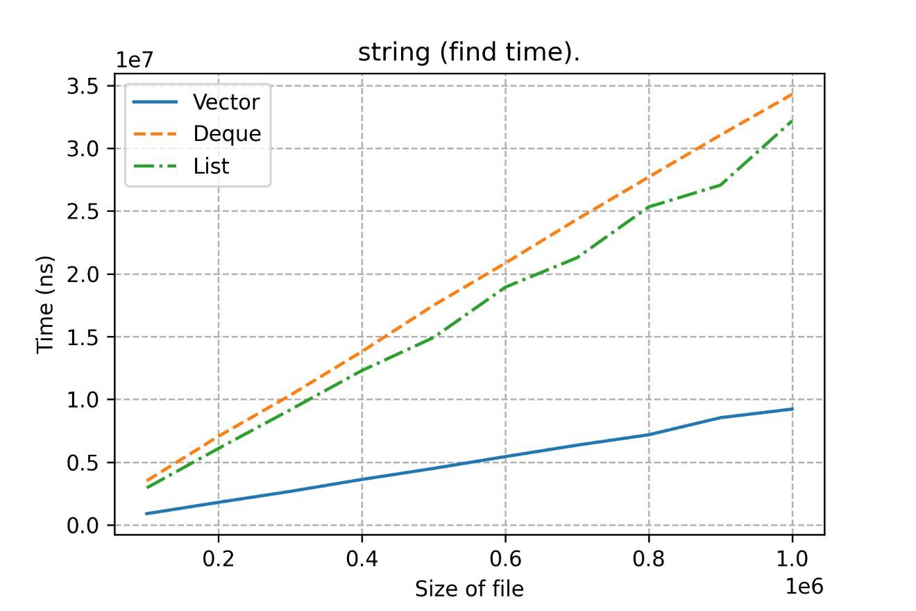

Для double ситуация схожая, а вот для string, Vector начинает тратить больше времени.

1. Переходим к sort – алгоритму.

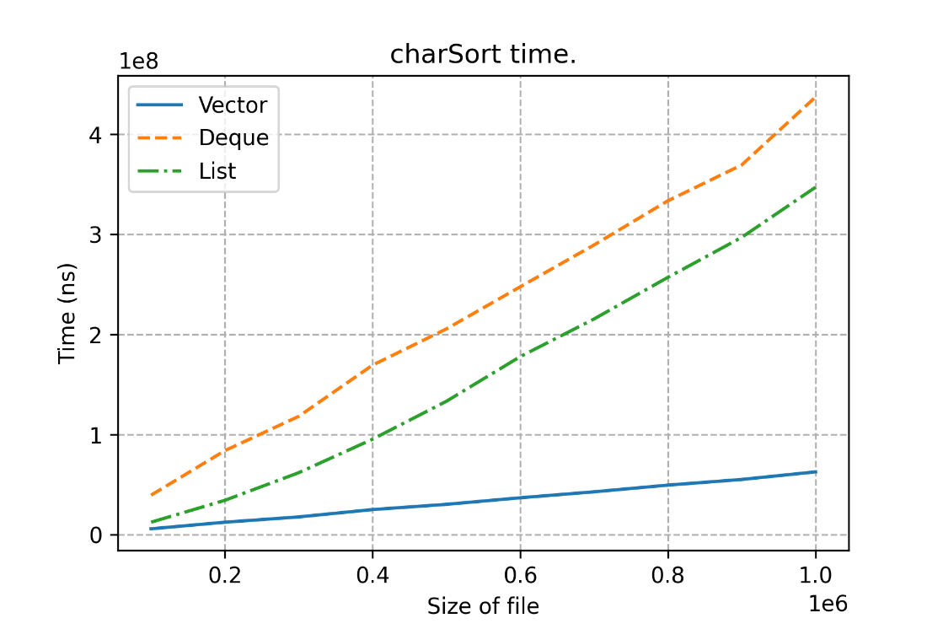

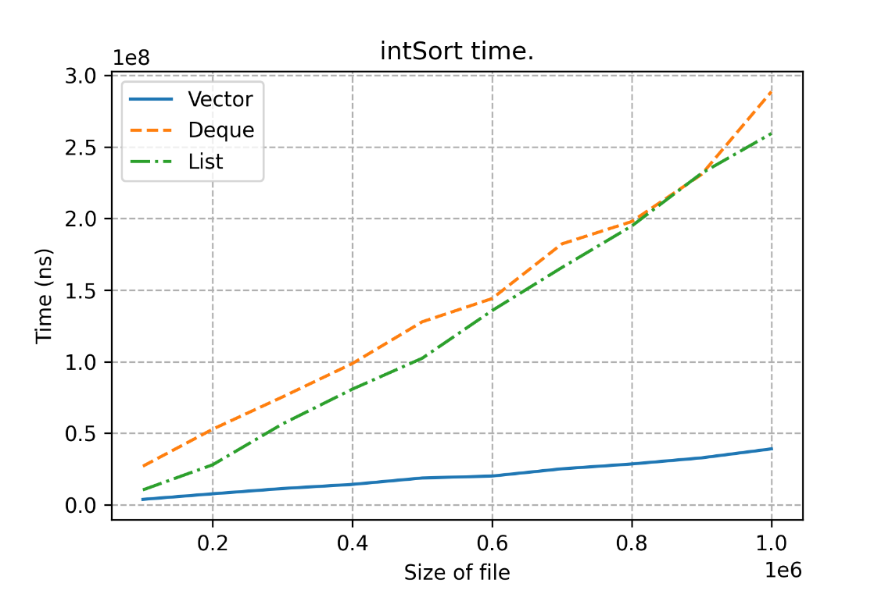

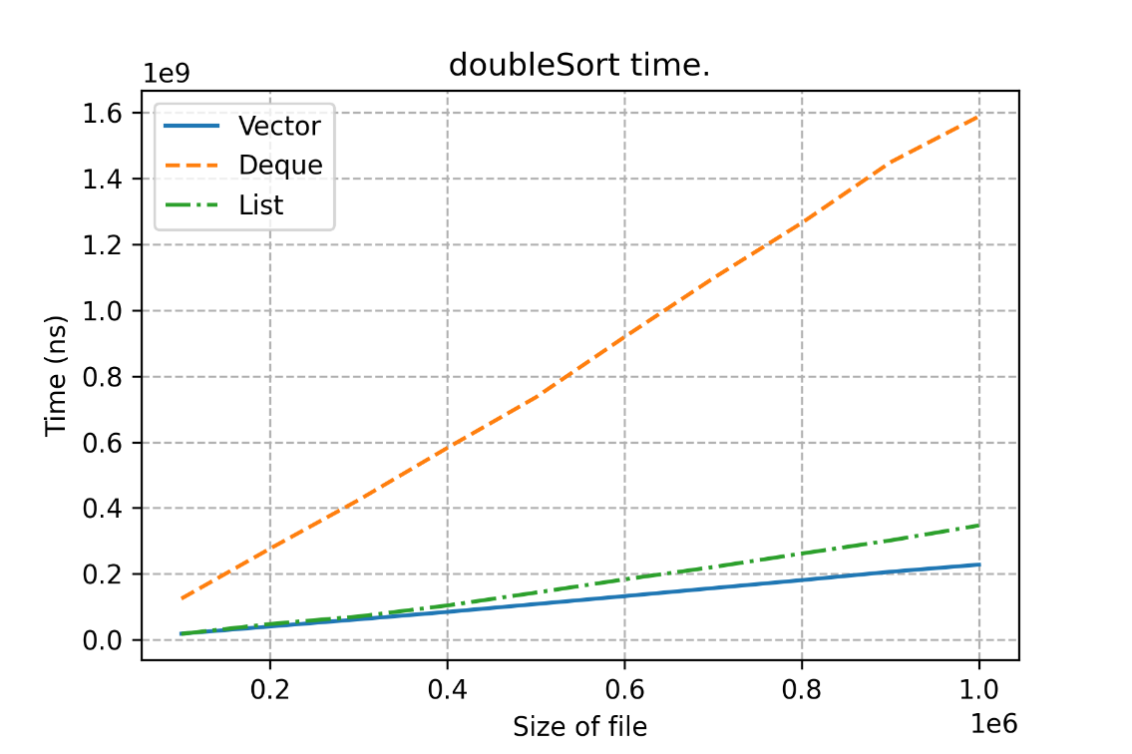

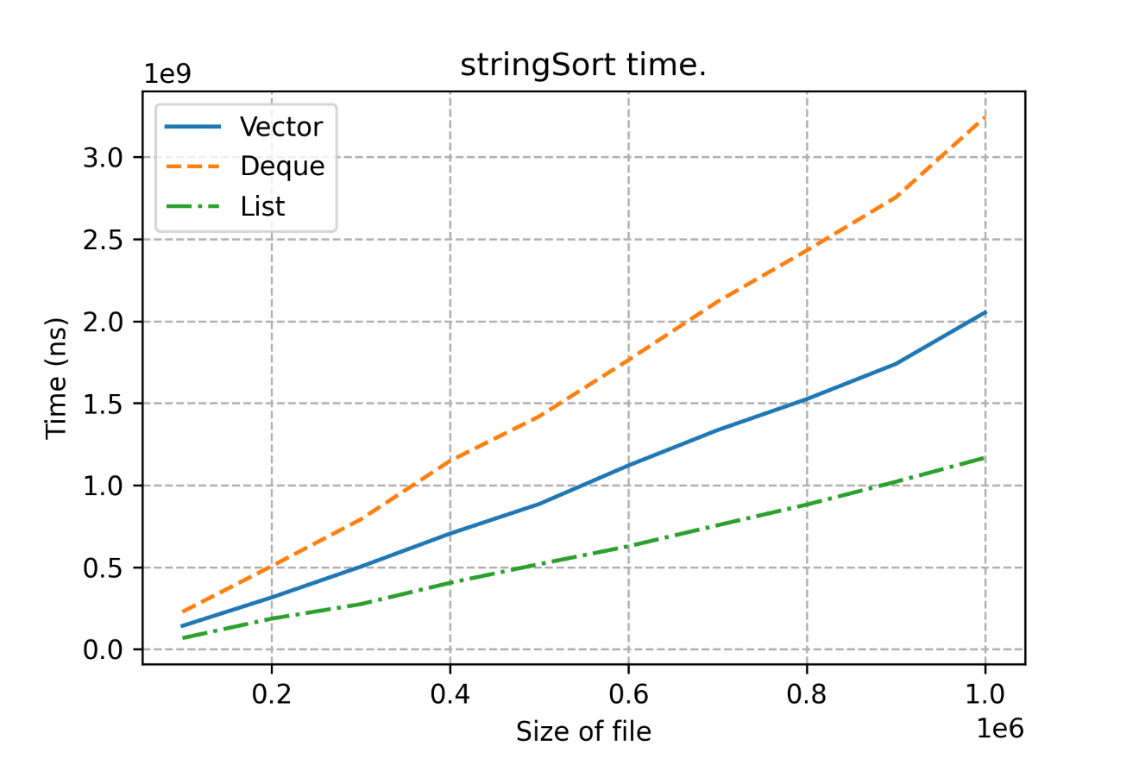

Ситуация, в целом, для char и int схожая, а вот в double к победителям по скорости присоединяется List, а для string и вовсе становится самым быстрым методом.

**У List свой метод сортировки, поскольку там не random-access итератор.**

1. Переходим к выкидыванию элементов! Pop_back

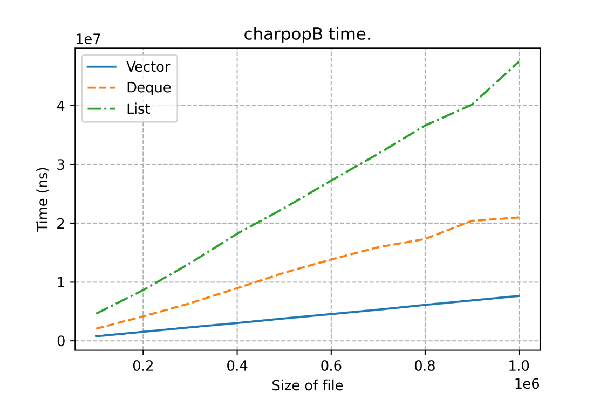

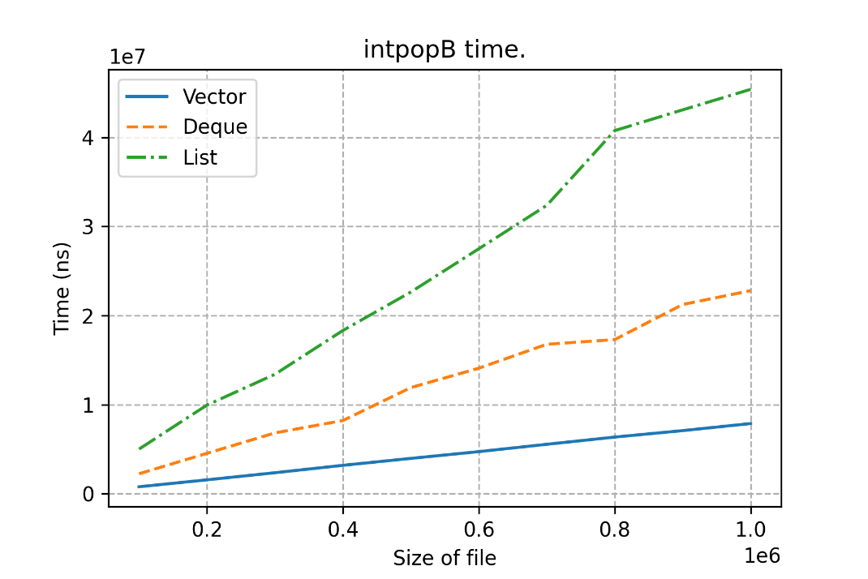

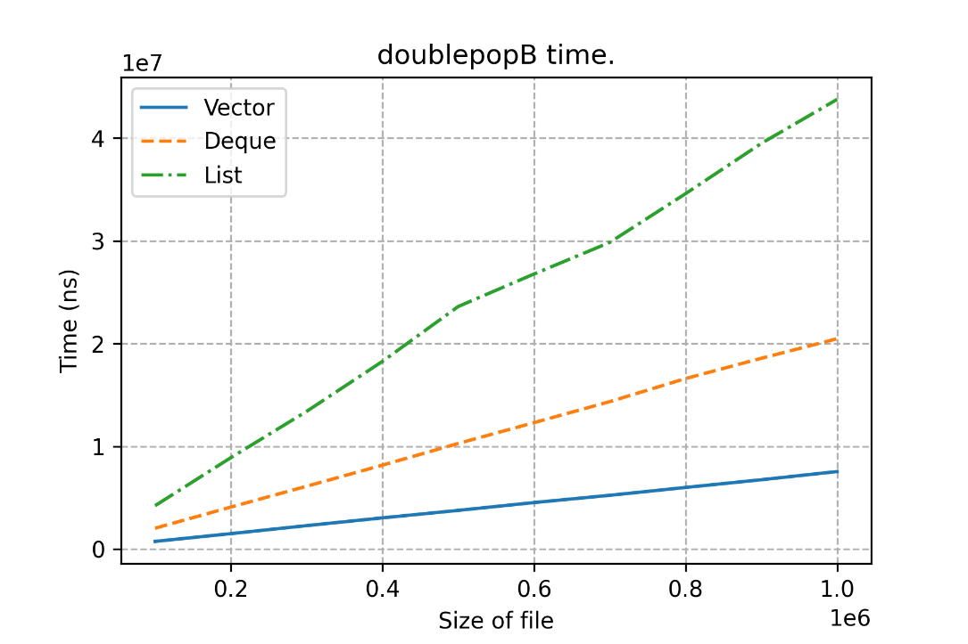

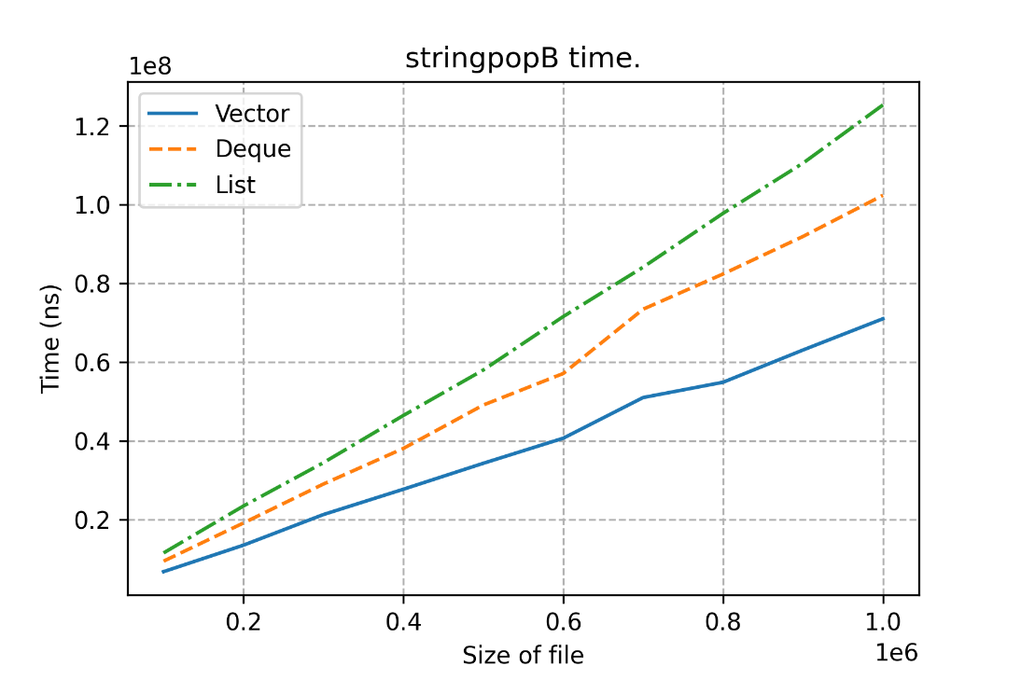

Тут для всех ситуаций тройка по скорости работы определяется однозначно.

1. Теперь pop_front!

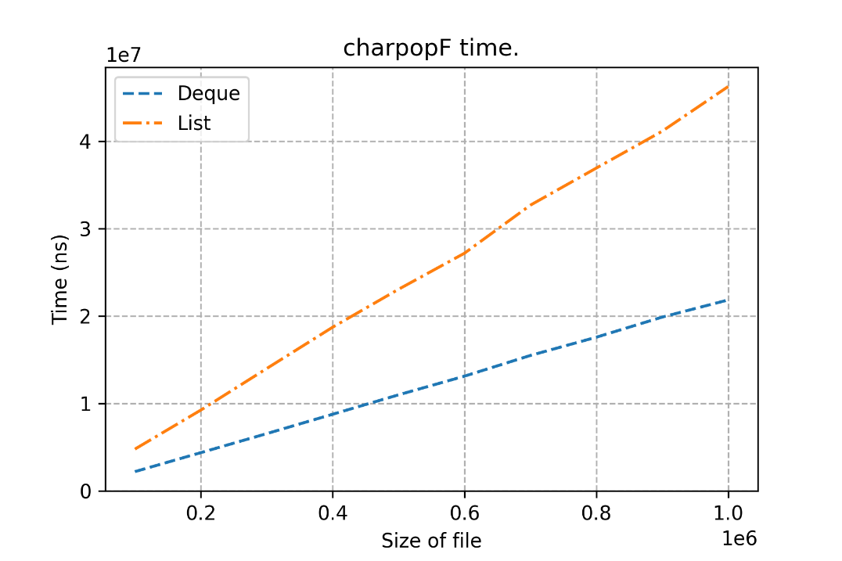

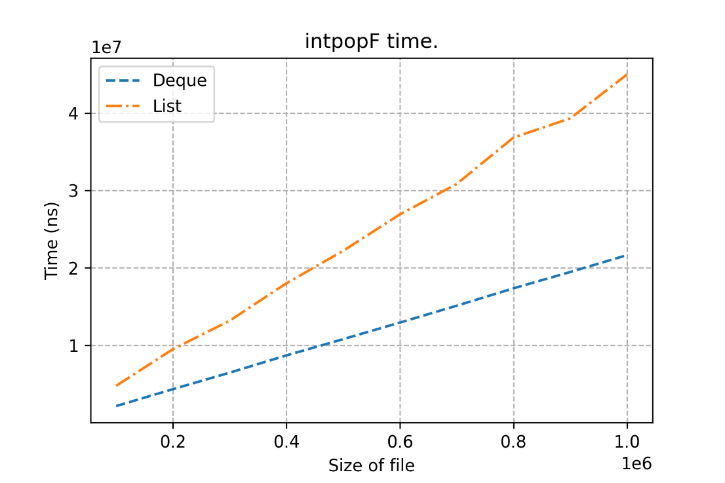

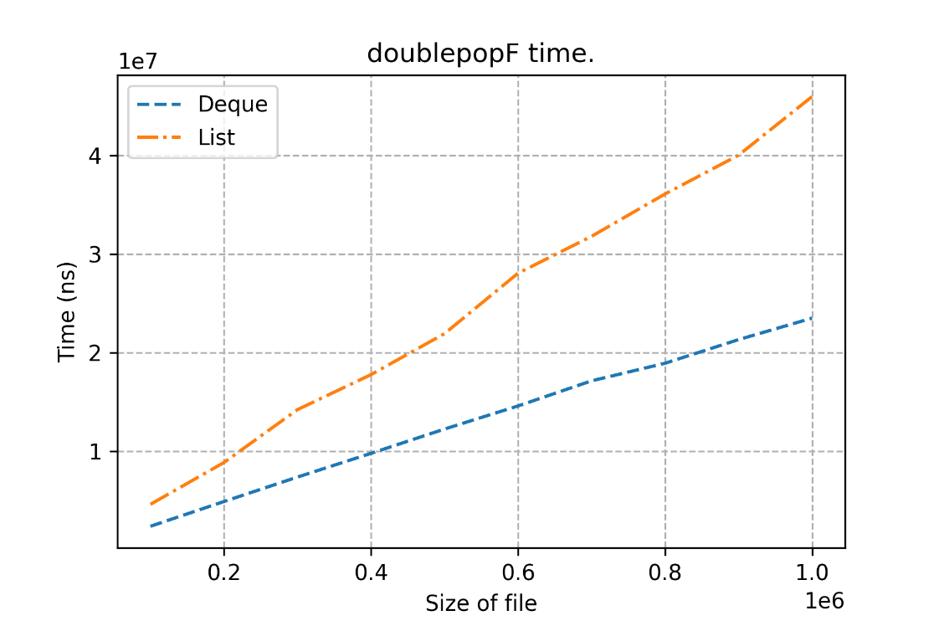

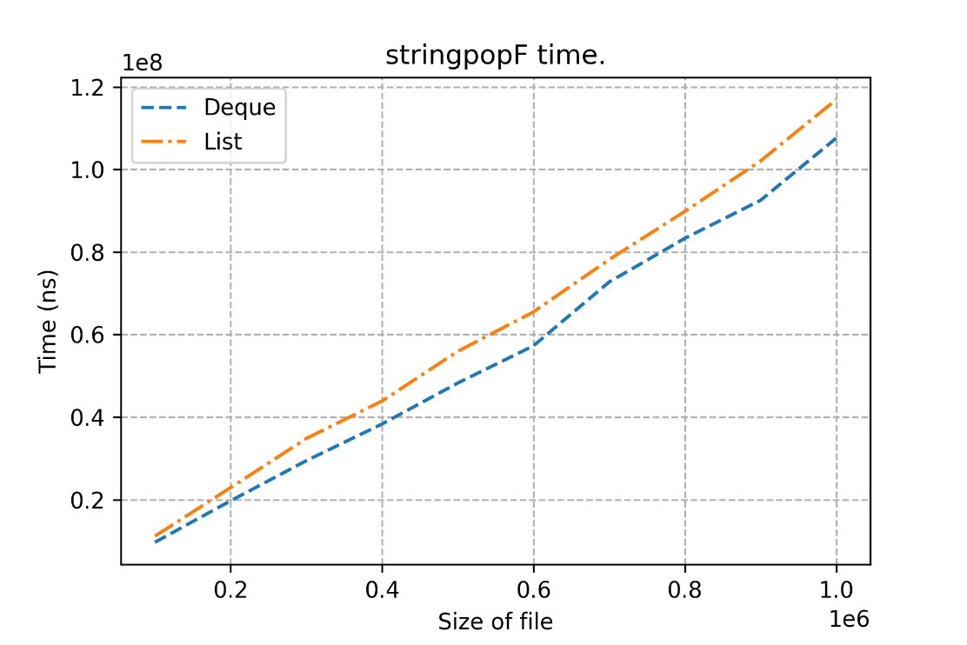

Контейнера vector нет, поскольку в нем не реализован метод pop_front (но костыльный вариант есть в коде). Работает долго(по расчетам около 6 часов уйдет)., смысла смотреть нет

Тут по скорости все также однозначно!

1. Переходим к последним функциям – push! На очереди pushB!

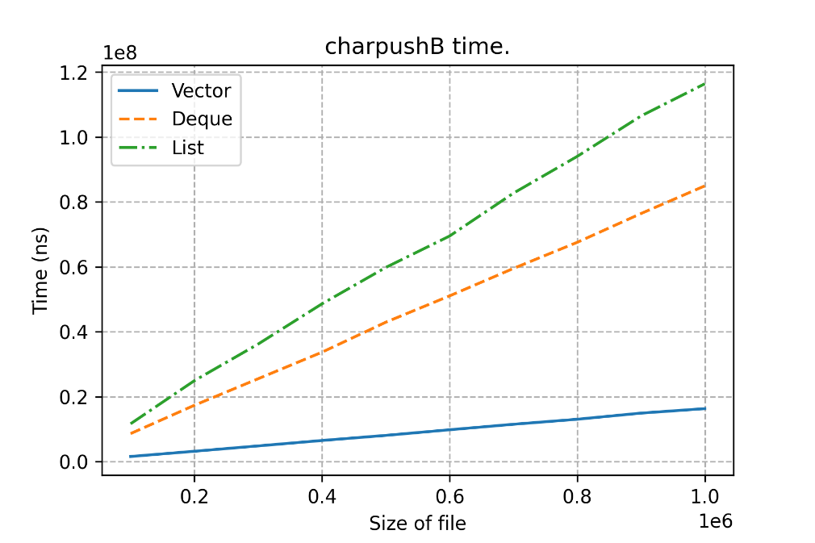

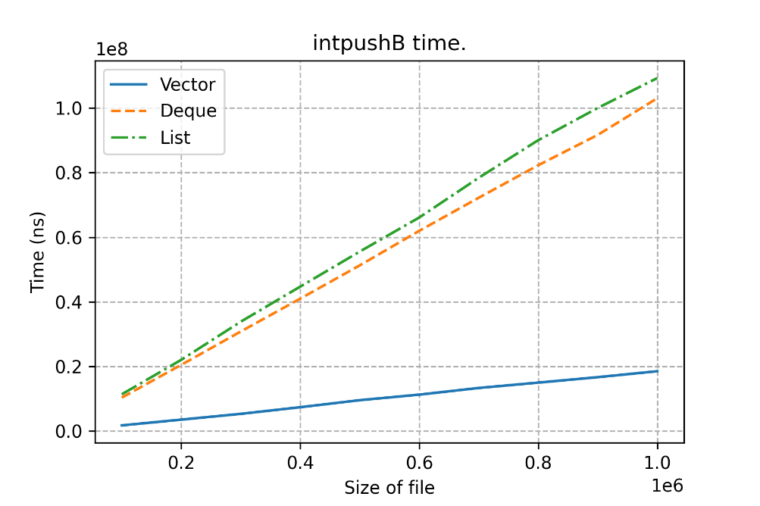

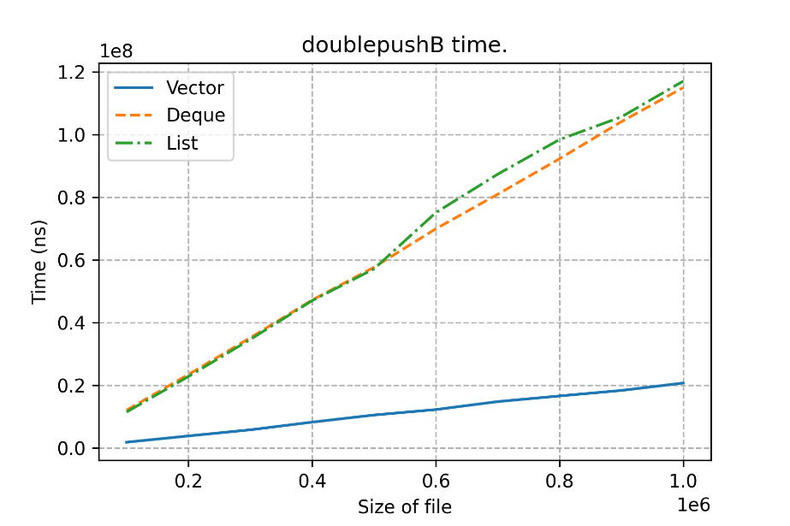

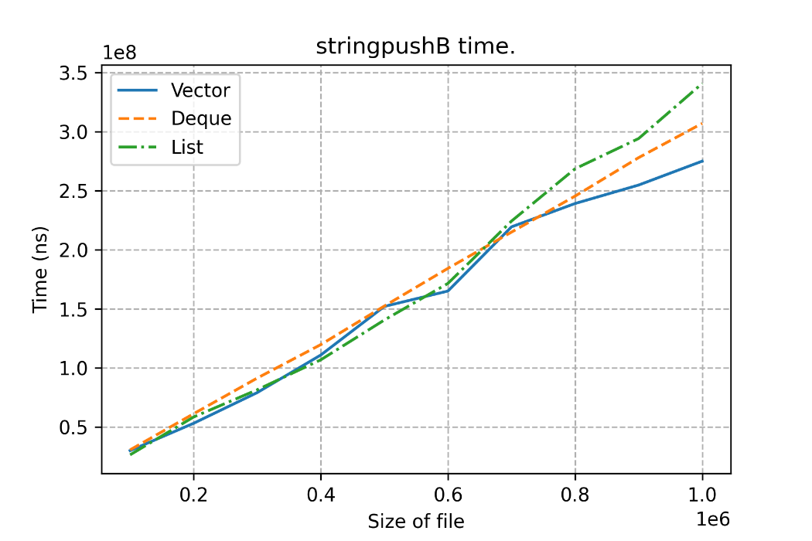

В целом, ситуации схожи! Только, в очередной раз, выделился случай со string – данными.

1. И последнее – pushF!

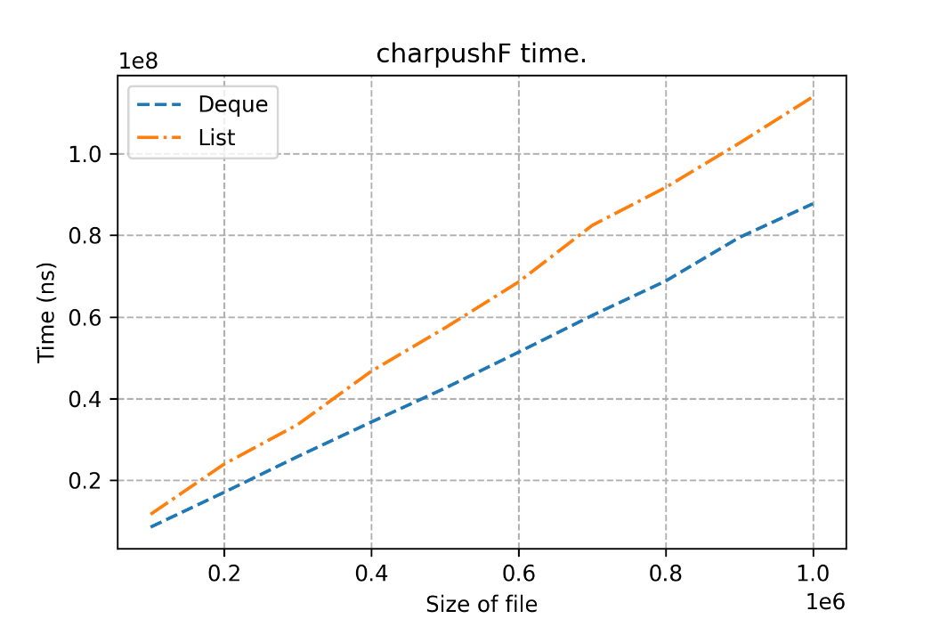

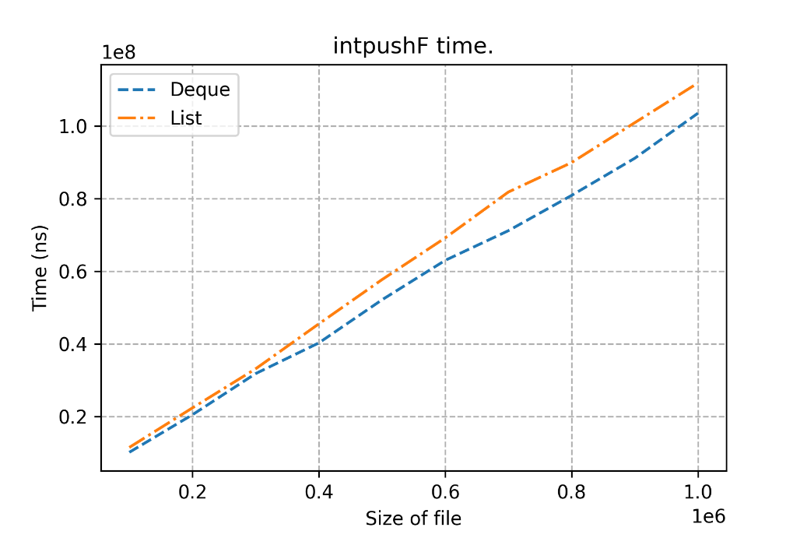

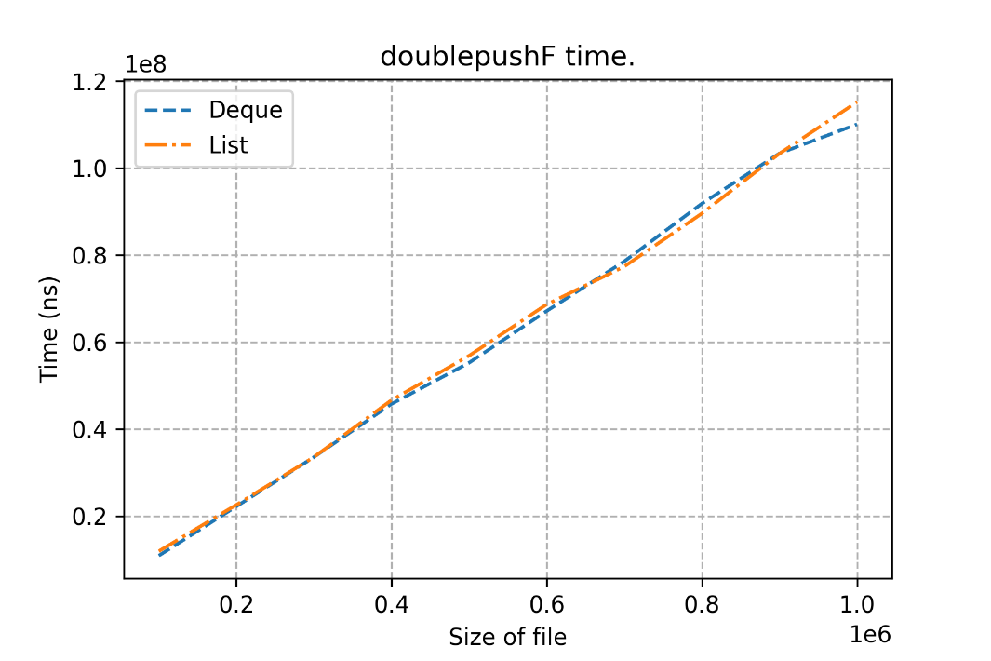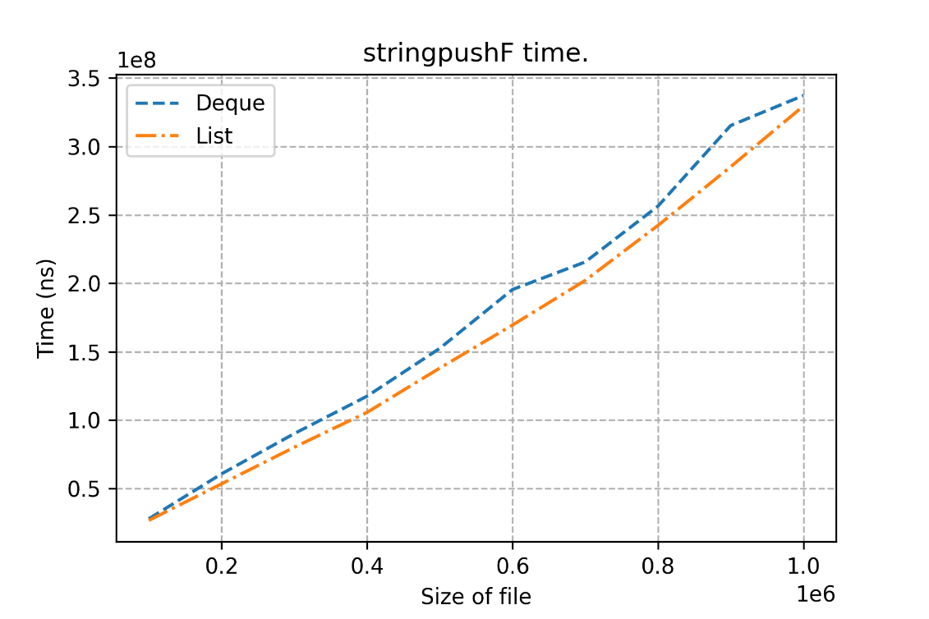

Результаты очень схожи! На string чуть лучше Deque, а на char и int – List.

Vector – контейнер опять отсутствует по причине того, что метод не реализован, а костыль работает долго

**Код**

Main.cpp

#include "TimeLogger.h"

#include "Load.h"

#include "Experiments.h"

int main() {

experiments::ex_all();

}

TimeLogger.h

#pragma once

#include <iostream>

#include <fstream>

#include <chrono>

#include <string>

namespace time_log {

class TimeLogger {

public:

TimeLogger(const std::string& path_to_out_file);

using clock = std::chrono::high_resolution_clock;

using time_point = std::chrono::time_point<clock>;

void reset_start();

void log_duration(int cont_size, const char* type, const char* opt_message);

void log_duration(int cont_size, const char* type);

private:

time_point m_start;

std::ofstream m_fout;

};

}

#pragma once

#include <vector>

#include <list>

#include <deque>

#include <string>

#include <iostream>

#include <fstream>

namespace data {

std::vector<char> load_vector_char(const std::string& path_file);

std::vector<int> load_vector_int(const std::string& path_file);

std::vector<double> load_vector_double(const std::string& path_file);

std::vector<std::string> load_vector_string(const std::string& path_file);

std::list<char> load_list_char(const std::string& path_file);

std::list<int> load_list_int(const std::string& path_file);

std::list<double> load_list_double(const std::string& path_file);

std::list<std::string> load_list_string(const std::string& path_file);

std::deque<char> load_deque_char(const std::string& path_file);

std::deque<int> load_deque_int(const std::string& path_file);

std::deque<double> load_deque_double(const std::string& path_file);

std::deque<std::string> load_deque_string(const std::string& path_file);

}

Load.h

#pragma once

#include <vector>

#include <list>

#include <deque>

#include <string>

#include <iostream>

#include <fstream>

namespace data {

std::vector<char> load_vector_char(const std::string& path_file);

std::vector<int> load_vector_int(const std::string& path_file);

std::vector<double> load_vector_double(const std::string& path_file);

std::vector<std::string> load_vector_string(const std::string& path_file);

std::list<char> load_list_char(const std::string& path_file);

std::list<int> load_list_int(const std::string& path_file);

std::list<double> load_list_double(const std::string& path_file);

std::list<std::string> load_list_string(const std::string& path_file);

std::deque<char> load_deque_char(const std::string& path_file);

std::deque<int> load_deque_int(const std::string& path_file);

std::deque<double> load_deque_double(const std::string& path_file);

std::deque<std::string> load_deque_string(const std::string& path_file);

}

Experiments.h

#pragma once

namespace experiments {

void ex_all();

void ex_find_test();

void ex_sort_test();

void ex_pop_bf_test();

void ex_push_bf_test();

void find_test_char();

void find_test_int();

void find_test_double();

void find_test_string();

void sort_test_char();

void sort_test_int();

void sort_test_double();

void sort_test_string();

void popB_test_char();

void popB_test_int();

void popB_test_double();

void popB_test_string();

void popF_test_char();

void popF_test_int();

void popF_test_double();

void popF_test_string();

void pushB_test_char();

void pushB_test_int();

void pushB_test_double();

void pushB_test_string();

void pushF_test_char();

void pushF_test_int();

void pushF_test_double();

void pushF_test_string();

}

TimeLogger.cpp

#include "TimeLogger.h"

time_log::TimeLogger::TimeLogger(const std::string& path_to_out_file)

: m_start(clock::now()), m_fout(path_to_out_file)

{

if (!m_fout.is_open()) {

std::cout << "The file can't be opened" << "\n";

std::cout << "Name of file is:" << path_to_out_file << "\n";

return;

}

m_fout << "sep=;\n";

m_fout << "Duration (ns); Size; Type; Message\n";

}

void time_log::TimeLogger::reset_start() {

m_start = clock::now();

}

void time_log::TimeLogger::log_duration(int cont_size, const char* type, const char* opt_message) {

std::chrono::nanoseconds duration = clock::now() - m_start;

m_fout << duration.count() << ';' << cont_size << ';' << type << ';' << opt_message << '\n';

}

void time_log::TimeLogger::log_duration(int cont_size, const char* type) {

std::chrono::nanoseconds duration = clock::now() - m_start;

m_fout << duration.count() << ';' << cont_size << ';' << type << ';' << '\n';

}

Load.cpp

#include "Load.h"

// Сначала выпишем блок для векторов.

std::vector<char> data::load_vector_char(const std::string& path_file) {

std::vector<char> vec;

std::ifstream fin(path_file);

if (!fin.is_open()) {

std::cout << "The file can't be opened" << "\n";

std::cout << "Name of file is:" << path_file << "\n";

return vec;

}

for (char el; !fin.eof();) {

if (fin >> el) {

vec.push_back(el);

}

}

fin.close();

return vec;

}

std::vector<int> data::load_vector_int(const std::string& path_file) {

std::vector<int> vec;

std::ifstream fin(path_file);

if (!fin.is_open()) {

std::cout << "The file can't be opened";

std::cout << "Name of file is:" << path_file << "\n";

return vec;

}

for (int el; !fin.eof();) {

if (fin >> el) {

vec.push_back(el);

}

}

fin.close();

return vec;

}

std::vector<double> data::load_vector_double(const std::string& path_file) {

std::vector<double> vec;

std::ifstream fin(path_file);

if (!fin.is_open()) {

std::cout << "The file can't be opened";

std::cout << "Name of file is:" << path_file << "\n";

return vec;

}

for (double el; !fin.eof();) {

if (fin >> el) {

vec.push_back(el);

}

}

fin.close();

return vec;

}

std::vector<std::string> data::load_vector_string(const std::string& path_file) {

std::vector<std::string> vec;

std::ifstream fin(path_file);

if (!fin.is_open()) {

std::cout << "The file can't be opened";

std::cout << "Name of file is:" << path_file << "\n";

return vec;

}

for (std::string el; !fin.eof();) {

if (fin >> el) {

vec.push_back(el);

}

}

fin.close();

return vec;

}

// Теперь определим функции для листа.

std::list<char> data::load_list_char(const std::string& path_file) {

std::list<char> lst;

std::ifstream fin(path_file);

if (!fin.is_open()) {

std::cout << "The file can't be opened";

std::cout << "Name of file is:" << path_file << "\n";

return lst;

}

for (char el; !fin.eof();) {

if (fin >> el) {

lst.push_back(el);

}

}

fin.close();

return lst;

}

std::list<int> data::load_list_int(const std::string& path_file) {

std::list<int> lst;

std::ifstream fin(path_file);

if (!fin.is_open()) {

std::cout << "The file can't be opened";

std::cout << "Name of file is:" << path_file << "\n";

return lst;

}

for (int el; !fin.eof();) {

if (fin >> el) {

lst.push_back(el);

}

}

fin.close();

return lst;

}

std::list<double> data::load_list_double(const std::string& path_file) {

std::list<double> lst;

std::ifstream fin(path_file);

if (!fin.is_open()) {

std::cout << "The file can't be opened";

std::cout << "Name of file is:" << path_file << "\n";

return lst;

}

for (double el; !fin.eof();) {

if (fin >> el) {

lst.push_back(el);

}

}

fin.close();

return lst;

}

std::list<std::string> data::load_list_string(const std::string& path_file) {

std::list<std::string> lst;

std::ifstream fin(path_file);

if (!fin.is_open()) {

std::cout << "The file can't be opened";

std::cout << "Name of file is:" << path_file << "\n";

return lst;

}

for (std::string el; !fin.eof();) {

if (fin >> el) {

lst.push_back(el);

}

}

fin.close();

return lst;

}

// И, наконец, напишем реализацию для deque.

std::deque<char> data::load_deque_char(const std::string& path_file) {

std::deque<char> deq;

std::ifstream fin(path_file);

if (!fin.is_open()) {

std::cout << "The file can't be opened";

std::cout << "Name of file is:" << path_file << "\n";

return deq;

}

for (char el; !fin.eof();) {

if (fin >> el) {

deq.push_back(el);

}

}

fin.close();

return deq;

}

std::deque<int> data::load_deque_int(const std::string& path_file) {

std::deque<int> deq;

std::ifstream fin(path_file);

if (!fin.is_open()) {

std::cout << "The file can't be opened";

std::cout << "Name of file is:" << path_file << "\n";

return deq;

}

for (int el; !fin.eof();) {

if (fin >> el) {

deq.push_back(el);

}

}

fin.close();

return deq;

}

std::deque<double> data::load_deque_double(const std::string& path_file) {

std::deque<double> deq;

std::ifstream fin(path_file);

if (!fin.is_open()) {

std::cout << "The file can't be opened";

std::cout << "Name of file is:" << path_file << "\n";

return deq;

}

for (double el; !fin.eof();) {

if (fin >> el) {

deq.push_back(el);

}

}

fin.close();

return deq;

}

std::deque<std::string> data::load_deque_string(const std::string& path_file) {

std::deque<std::string> deq;

std::ifstream fin(path_file);

if (!fin.is_open()) {

std::cout << "The file can't be opened";

std::cout << "Name of file is:" << path_file << "\n";

return deq;

}

for (std::string el; !fin.eof();) {

if (fin >> el) {

deq.push_back(el);

}

}

fin.close();

return deq;

}

Experiments.cpp

#include "Experiments.h"

#include "Load.h"

#include "TimeLogger.h"

#include <string>

#include <algorithm>

#include <iterator>

std::string data_path = "C:\\Users\\ender\\Desktop\\LP1\\Generator\\Data\\";

std::string reults_path = "C:\\Users\\ender\\Desktop\\LP1\\Results\\";

void experiments::ex_all() {

ex_find_test();

ex_sort_test();

ex_pop_bf_test();

ex_push_bf_test();

}

void experiments::ex_find_test() {

find_test_char();

find_test_int();

find_test_double();

find_test_string();

}

void experiments::ex_sort_test() {

sort_test_char();

sort_test_int();

sort_test_double();

sort_test_string();

}

void experiments::ex_pop_bf_test() {

popB_test_char();

popB_test_int();

popB_test_double();

popB_test_string();

popF_test_char();

popF_test_int();

popF_test_double();

popF_test_string();

}

void experiments::ex_push_bf_test() {

pushB_test_char();

pushB_test_int();

pushB_test_double();

pushB_test_string();

pushF_test_char();

pushF_test_int();

pushF_test_double();

pushF_test_string();

}

// 1 блок - поиск.

void experiments::find_test_char() {

time_log::TimeLogger timer = time_log::TimeLogger(reults_path + "find_test_char.csv");

std::string TD = "char_";

for (int i = 100000; i <= 1000000; i += 100000) {

std::string data_size = std::to_string(i);

std::vector<char> arr = data::load_vector_char(data_path + TD + data_size + ".txt");

timer.reset_start();

std::find(arr.begin(), arr.end(), '/');

timer.log_duration(i, "Vector");

}

for (int i = 100000; i <= 1000000; i += 100000) {

std::string data_size = std::to_string(i);

std::deque<char> arr = data::load_deque_char(data_path + TD + data_size + ".txt");

timer.reset_start();

std::find(arr.begin(), arr.end(), '/');

timer.log_duration(i, "Deque");

}

for (int i = 100000; i <= 1000000; i += 100000) {

std::string data_size = std::to_string(i);

std::list<char> arr = data::load_list_char(data_path + TD + data_size + ".txt");

timer.reset_start();

std::find(arr.begin(), arr.end(), '/');

timer.log_duration(i, "List");

}

}

void experiments::find_test_int() {

time_log::TimeLogger timer = time_log::TimeLogger(reults_path + "find_test_int.csv");

std::string TD = "int_";

for (int i = 100000; i <= 1000000; i += 100000) {

std::string data_size = std::to_string(i);

std::vector<int> arr = data::load_vector_int(data_path + TD + data_size + ".txt");

timer.reset_start();

std::find(arr.begin(), arr.end(), '/');

timer.log_duration(i, "Vector");

}

for (int i = 100000; i <= 1000000; i += 100000) {

std::string data_size = std::to_string(i);

std::deque<int> arr = data::load_deque_int(data_path + TD + data_size + ".txt");

timer.reset_start();

std::find(arr.begin(), arr.end(), '/');

timer.log_duration(i, "Deque");

}

for (int i = 100000; i <= 1000000; i += 100000) {

std::string data_size = std::to_string(i);

std::list<int> arr = data::load_list_int(data_path + TD + data_size + ".txt");

timer.reset_start();

std::find(arr.begin(), arr.end(), '/');

timer.log_duration(i, "List");

}

}

void experiments::find_test_double() {

time_log::TimeLogger timer = time_log::TimeLogger(reults_path + "find_test_double.csv");

std::string TD = "double_";

for (int i = 100000; i <= 1000000; i += 100000) {

std::string data_size = std::to_string(i);

std::vector<double> arr = data::load_vector_double(data_path + TD + data_size + ".txt");

timer.reset_start();

std::find(arr.begin(), arr.end(), '/');

timer.log_duration(i, "Vector");

}

for (int i = 100000; i <= 1000000; i += 100000) {

std::string data_size = std::to_string(i);

std::deque<double> arr = data::load_deque_double(data_path + TD + data_size + ".txt");

timer.reset_start();

std::find(arr.begin(), arr.end(), '/');

timer.log_duration(i, "Deque");

}

for (int i = 100000; i <= 1000000; i += 100000) {

std::string data_size = std::to_string(i);

std::list<double> arr = data::load_list_double(data_path + TD + data_size + ".txt");

timer.reset_start();

std::find(arr.begin(), arr.end(), '/');

timer.log_duration(i, "List");

}

}

void experiments::find_test_string() {

time_log::TimeLogger timer = time_log::TimeLogger(reults_path + "find_test_string.csv");

std::string TD = "string_";

for (int i = 100000; i <= 1000000; i += 100000) {

std::string data_size = std::to_string(i);

std::vector<std::string> arr = data::load_vector_string(data_path + TD + data_size + ".txt");

timer.reset_start();

std::find(arr.begin(), arr.end(), "/");

timer.log_duration(i, "Vector");

}

for (int i = 100000; i <= 1000000; i += 100000) {

std::string data_size = std::to_string(i);

std::deque<std::string> arr = data::load_deque_string(data_path + TD + data_size + ".txt");

timer.reset_start();

std::find(arr.begin(), arr.end(), "/");

timer.log_duration(i, "Deque");

}

for (int i = 100000; i <= 1000000; i += 100000) {

std::string data_size = std::to_string(i);

std::list<std::string> arr = data::load_list_string(data_path + TD + data_size + ".txt");

timer.reset_start();

std::find(arr.begin(), arr.end(), "/");

timer.log_duration(i, "List");

}

}

// 2 блок - сортировка.

void experiments::sort_test_char() {

time_log::TimeLogger timer = time_log::TimeLogger(reults_path + "sort_test_char.csv");

std::string TD = "char_";

for (int i = 100000; i <= 1000000; i += 100000) {

std::string data_size = std::to_string(i);

std::vector<char> arr = data::load_vector_char(data_path + TD + data_size + ".txt");

timer.reset_start();

std::sort(arr.begin(), arr.end());

timer.log_duration(i, "Vector");

}

for (int i = 100000; i <= 1000000; i += 100000) {

std::string data_size = std::to_string(i);

std::deque<char> arr = data::load_deque_char(data_path + TD + data_size + ".txt");

timer.reset_start();

std::sort(arr.begin(), arr.end());

timer.log_duration(i, "Deque");

}

for (int i = 100000; i <= 1000000; i += 100000) {

std::string data_size = std::to_string(i);

std::list<char> arr = data::load_list_char(data_path + TD + data_size + ".txt");

timer.reset_start();

arr.sort();

timer.log_duration(i, "List");

}

}

void experiments::sort_test_int() {

time_log::TimeLogger timer = time_log::TimeLogger(reults_path + "sort_test_int.csv");

std::string TD = "int_";

for (int i = 100000; i <= 1000000; i += 100000) {

std::string data_size = std::to_string(i);

std::vector<int> arr = data::load_vector_int(data_path + TD + data_size + ".txt");

timer.reset_start();

std::sort(arr.begin(), arr.end());

timer.log_duration(i, "Vector");

}

for (int i = 100000; i <= 1000000; i += 100000) {

std::string data_size = std::to_string(i);

std::deque<int> arr = data::load_deque_int(data_path + TD + data_size + ".txt");

timer.reset_start();

std::sort(arr.begin(), arr.end());

timer.log_duration(i, "Deque");

}

for (int i = 100000; i <= 1000000; i += 100000) {

std::string data_size = std::to_string(i);

std::list<int> arr = data::load_list_int(data_path + TD + data_size + ".txt");

timer.reset_start();

arr.sort();

timer.log_duration(i, "List");

}

}

void experiments::sort_test_double() {

time_log::TimeLogger timer = time_log::TimeLogger(reults_path + "sort_test_double.csv");

std::string TD = "double_";

for (int i = 100000; i <= 1000000; i += 100000) {

std::string data_size = std::to_string(i);

std::vector<double> arr = data::load_vector_double(data_path + TD + data_size + ".txt");

timer.reset_start();

std::sort(arr.begin(), arr.end());

timer.log_duration(i, "Vector");

}

for (int i = 100000; i <= 1000000; i += 100000) {

std::string data_size = std::to_string(i);

std::deque<double> arr = data::load_deque_double(data_path + TD + data_size + ".txt");

timer.reset_start();

std::sort(arr.begin(), arr.end());

timer.log_duration(i, "Deque");

}

for (int i = 100000; i <= 1000000; i += 100000) {

std::string data_size = std::to_string(i);

std::list<double> arr = data::load_list_double(data_path + TD + data_size + ".txt");

timer.reset_start();

arr.sort();

timer.log_duration(i, "List");

}

}

void experiments::sort_test_string() {

time_log::TimeLogger timer = time_log::TimeLogger(reults_path + "sort_test_string.csv");

std::string TD = "string_";

for (int i = 100000; i <= 1000000; i += 100000) {

std::string data_size = std::to_string(i);

std::vector<std::string> arr = data::load_vector_string(data_path + TD + data_size + ".txt");

timer.reset_start();

std::sort(arr.begin(), arr.end());

timer.log_duration(i, "Vector");

}

for (int i = 100000; i <= 1000000; i += 100000) {

std::string data_size = std::to_string(i);

std::deque<std::string> arr = data::load_deque_string(data_path + TD + data_size + ".txt");

timer.reset_start();

std::sort(arr.begin(), arr.end());

timer.log_duration(i, "Deque");

}

for (int i = 100000; i <= 1000000; i += 100000) {

std::string data_size = std::to_string(i);

std::list<std::string> arr = data::load_list_string(data_path + TD + data_size + ".txt");

timer.reset_start();

arr.sort();

timer.log_duration(i, "List");

}

}

// 3.1 блок - popB.

void experiments::popB_test_char() {

time_log::TimeLogger timer = time_log::TimeLogger(reults_path + "popB_test_char.csv");

std::string TD = "char_";

for (int i = 100000; i <= 1000000; i += 100000) {

std::string data_size = std::to_string(i);

std::vector<char> arr = data::load_vector_char(data_path + TD + data_size + ".txt");

timer.reset_start();

while (arr.size() > 0)

arr.pop_back();

timer.log_duration(i, "Vector");

}

for (int i = 100000; i <= 1000000; i += 100000) {

std::string data_size = std::to_string(i);

std::deque<char> arr = data::load_deque_char(data_path + TD + data_size + ".txt");

timer.reset_start();

while (arr.size() > 0)

arr.pop_back();

timer.log_duration(i, "Deque");

}

for (int i = 100000; i <= 1000000; i += 100000) {

std::string data_size = std::to_string(i);

std::list<char> arr = data::load_list_char(data_path + TD + data_size + ".txt");

timer.reset_start();

while (arr.size() > 0)

arr.pop_back();

timer.log_duration(i, "List");

}

}

void experiments::popB_test_int() {

time_log::TimeLogger timer = time_log::TimeLogger(reults_path + "popB_test_int.csv");

std::string TD = "int_";

for (int i = 100000; i <= 1000000; i += 100000) {

std::string data_size = std::to_string(i);

std::vector<int> arr = data::load_vector_int(data_path + TD + data_size + ".txt");

timer.reset_start();

while (arr.size() > 0)

arr.pop_back();

timer.log_duration(i, "Vector");

}

for (int i = 100000; i <= 1000000; i += 100000) {

std::string data_size = std::to_string(i);

std::deque<int> arr = data::load_deque_int(data_path + TD + data_size + ".txt");

timer.reset_start();

while (arr.size() > 0)

arr.pop_back();

timer.log_duration(i, "Deque");

}

for (int i = 100000; i <= 1000000; i += 100000) {

std::string data_size = std::to_string(i);

std::list<int> arr = data::load_list_int(data_path + TD + data_size + ".txt");

timer.reset_start();

while (arr.size() > 0)

arr.pop_back();

timer.log_duration(i, "List");

}

}

void experiments::popB_test_double() {

time_log::TimeLogger timer = time_log::TimeLogger(reults_path + "popB_test_double.csv");

std::string TD = "double_";

for (int i = 100000; i <= 1000000; i += 100000) {

std::string data_size = std::to_string(i);

std::vector<double> arr = data::load_vector_double(data_path + TD + data_size + ".txt");

timer.reset_start();

while (arr.size() > 0)

arr.pop_back();

timer.log_duration(i, "Vector");

}

for (int i = 100000; i <= 1000000; i += 100000) {

std::string data_size = std::to_string(i);

std::deque<double> arr = data::load_deque_double(data_path + TD + data_size + ".txt");

timer.reset_start();

while (arr.size() > 0)

arr.pop_back();

timer.log_duration(i, "Deque");

}

for (int i = 100000; i <= 1000000; i += 100000) {

std::string data_size = std::to_string(i);

std::list<double> arr = data::load_list_double(data_path + TD + data_size + ".txt");

timer.reset_start();

while (arr.size() > 0)

arr.pop_back();

timer.log_duration(i, "List");

}

}

void experiments::popB_test_string() {

time_log::TimeLogger timer = time_log::TimeLogger(reults_path + "popB_test_string.csv");

std::string TD = "string_";

for (int i = 100000; i <= 1000000; i += 100000) {

std::string data_size = std::to_string(i);

std::vector<std::string> arr = data::load_vector_string(data_path + TD + data_size + ".txt");

timer.reset_start();

while (arr.size() > 0)

arr.pop_back();

timer.log_duration(i, "Vector");

}

for (int i = 100000; i <= 1000000; i += 100000) {

std::string data_size = std::to_string(i);

std::deque<std::string> arr = data::load_deque_string(data_path + TD + data_size + ".txt");

timer.reset_start();

while (arr.size() > 0)

arr.pop_back();

timer.log_duration(i, "Deque");

}

for (int i = 100000; i <= 1000000; i += 100000) {

std::string data_size = std::to_string(i);

std::list<std::string> arr = data::load_list_string(data_path + TD + data_size + ".txt");

timer.reset_start();

while (arr.size() > 0)

arr.pop_back();

timer.log_duration(i, "List");

}

}

// 3.2 блок - popF;

void experiments::popF_test_char() {

time_log::TimeLogger timer = time_log::TimeLogger(reults_path + "popF_test_char.csv");

std::string TD = "char_";

/* Долго работает(!!!). Мне передали, что можно написать, но не использовать.

for (int i = 100000; i <= 1000000; i += 100000) {

std::string data_size = std::to_string(i);

std::vector<char> arr = data::load_vector_char(data_path + TD + data_size + ".txt");

timer.reset_start();

while (arr.size() > 0)

arr.erase(arr.begin());

timer.log_duration(i, "Vector");

}

*/

for (int i = 100000; i <= 1000000; i += 100000) {

std::string data_size = std::to_string(i);

std::deque<char> arr = data::load_deque_char(data_path + TD + data_size + ".txt");

timer.reset_start();

while (arr.size() > 0)

arr.pop_front();

timer.log_duration(i, "Deque");

}

for (int i = 100000; i <= 1000000; i += 100000) {

std::string data_size = std::to_string(i);

std::list<char> arr = data::load_list_char(data_path + TD + data_size + ".txt");

timer.reset_start();

while (arr.size() > 0)

arr.pop_front();

timer.log_duration(i, "List");

}

}

void experiments::popF_test_int() {

time_log::TimeLogger timer = time_log::TimeLogger(reults_path + "popF_test_int.csv");

std::string TD = "int_";

/* Долго работает(!!!). Мне передали, что можно написать, но не использовать.

for (int i = 100000; i <= 1000000; i += 100000) {

std::string data_size = std::to_string(i);

std::vector<int> arr = data::load_vector_int(data_path + TD + data_size + ".txt");

timer.reset_start();

while (arr.size() > 0)

arr.erase(arr.begin());

timer.log_duration(i, "Vector");

}

*/

for (int i = 100000; i <= 1000000; i += 100000) {

std::string data_size = std::to_string(i);

std::deque<int> arr = data::load_deque_int(data_path + TD + data_size + ".txt");

timer.reset_start();

while (arr.size() > 0)

arr.pop_front();

timer.log_duration(i, "Deque");

}

for (int i = 100000; i <= 1000000; i += 100000) {

std::string data_size = std::to_string(i);

std::list<int> arr = data::load_list_int(data_path + TD + data_size + ".txt");

timer.reset_start();

while (arr.size() > 0)

arr.pop_front();

timer.log_duration(i, "List");

}

}

void experiments::popF_test_double() {

time_log::TimeLogger timer = time_log::TimeLogger(reults_path + "popF_test_double.csv");

std::string TD = "double_";

/* Долго работает(!!!). Мне передали, что можно написать, но не использовать.

for (int i = 100000; i <= 1000000; i += 100000) {

std::string data_size = std::to_string(i);

std::vector<double> arr = data::load_vector_double(data_path + TD + data_size + ".txt");

timer.reset_start();

while (arr.size() > 0)

arr.erase(arr.begin());

timer.log_duration(i, "Vector");

}

*/

for (int i = 100000; i <= 1000000; i += 100000) {

std::string data_size = std::to_string(i);

std::deque<double> arr = data::load_deque_double(data_path + TD + data_size + ".txt");

timer.reset_start();

while (arr.size() > 0)

arr.pop_front();

timer.log_duration(i, "Deque");

}

for (int i = 100000; i <= 1000000; i += 100000) {

std::string data_size = std::to_string(i);

std::list<double> arr = data::load_list_double(data_path + TD + data_size + ".txt");

timer.reset_start();

while (arr.size() > 0)

arr.pop_front();

timer.log_duration(i, "List");

}

}

void experiments::popF_test_string() {

time_log::TimeLogger timer = time_log::TimeLogger(reults_path + "popF_test_string.csv");

std::string TD = "string_";

/* Долго работает(!!!). Мне передали, что можно написать, но не использовать.

for (int i = 100000; i <= 1000000; i += 100000) {

std::string data_size = std::to_string(i);

std::vector<std::string> arr = data::load_vector_string(data_path + TD + data_size + ".txt");

timer.reset_start();

while (arr.size() > 0)

arr.erase(arr.begin());

timer.log_duration(i, "Vector");

}

*/

for (int i = 100000; i <= 1000000; i += 100000) {

std::string data_size = std::to_string(i);

std::deque<std::string> arr = data::load_deque_string(data_path + TD + data_size + ".txt");

timer.reset_start();

while (arr.size() > 0)

arr.pop_front();

timer.log_duration(i, "Deque");

}

for (int i = 100000; i <= 1000000; i += 100000) {

std::string data_size = std::to_string(i);

std::list<std::string> arr = data::load_list_string(data_path + TD + data_size + ".txt");

timer.reset_start();

while (arr.size() > 0)

arr.pop_front();

timer.log_duration(i, "List");

}

}

// 4.1 блок - pushB.

void experiments::pushB_test_char() {

time_log::TimeLogger timer = time_log::TimeLogger(reults_path + "pushB_test_char.csv");

std::string TD = "char_";

for (int i = 100000; i <= 1000000; i += 100000) {

std::string data_size = std::to_string(i);

std::vector<char> arr = data::load_vector_char(data_path + TD + data_size + ".txt");

std::vector<char> tmp;

timer.reset_start();

for (int i = 0; i < arr.size(); ++i) {

tmp.push_back(arr[i]);

}

timer.log_duration(i, "Vector");

}

for (int i = 100000; i <= 1000000; i += 100000) {

std::string data_size = std::to_string(i);

std::deque<char> arr = data::load_deque_char(data_path + TD + data_size + ".txt");

std::deque<char> tmp;

timer.reset_start();

for (int i = 0; i < arr.size(); ++i) {

tmp.push_back(arr[i]);

}

timer.log_duration(i, "Deque");

}

for (int i = 100000; i <= 1000000; i += 100000) {

std::string data_size = std::to_string(i);

std::list<char> arr = data::load_list_char(data_path + TD + data_size + ".txt");

std::list<char> tmp;

std::list<char>::iterator it = arr.begin();

timer.reset_start();

while (it != arr.end()) {

tmp.push_back(*it);

++it;

}

timer.log_duration(i, "List");

}

}

void experiments::pushB_test_int() {

time_log::TimeLogger timer = time_log::TimeLogger(reults_path + "pushB_test_int.csv");

std::string TD = "int_";

for (int i = 100000; i <= 1000000; i += 100000) {

std::string data_size = std::to_string(i);

std::vector<int> arr = data::load_vector_int(data_path + TD + data_size + ".txt");

std::vector<int> tmp;

timer.reset_start();

for (int i = 0; i < arr.size(); ++i) {

tmp.push_back(arr[i]);

}

timer.log_duration(i, "Vector");

}

for (int i = 100000; i <= 1000000; i += 100000) {

std::string data_size = std::to_string(i);

std::deque<int> arr = data::load_deque_int(data_path + TD + data_size + ".txt");

std::deque<int> tmp;

timer.reset_start();

for (int i = 0; i < arr.size(); ++i) {

tmp.push_back(arr[i]);

}

timer.log_duration(i, "Deque");

}

for (int i = 100000; i <= 1000000; i += 100000) {

std::string data_size = std::to_string(i);

std::list<int> arr = data::load_list_int(data_path + TD + data_size + ".txt");

std::list<int> tmp;

std::list<int>::iterator it = arr.begin();

timer.reset_start();

while (it != arr.end()) {

tmp.push_back(*it);

++it;

}

timer.log_duration(i, "List");

}

}

void experiments::pushB_test_double() {

time_log::TimeLogger timer = time_log::TimeLogger(reults_path + "pushB_test_double.csv");

std::string TD = "double_";

for (int i = 100000; i <= 1000000; i += 100000) {

std::string data_size = std::to_string(i);

std::vector<double> arr = data::load_vector_double(data_path + TD + data_size + ".txt");

std::vector<double> tmp;

timer.reset_start();

for (int i = 0; i < arr.size(); ++i) {

tmp.push_back(arr[i]);

}

timer.log_duration(i, "Vector");

}

for (int i = 100000; i <= 1000000; i += 100000) {

std::string data_size = std::to_string(i);

std::deque<double> arr = data::load_deque_double(data_path + TD + data_size + ".txt");

std::deque<double> tmp;

timer.reset_start();

for (int i = 0; i < arr.size(); ++i) {

tmp.push_back(arr[i]);

}

timer.log_duration(i, "Deque");

}

for (int i = 100000; i <= 1000000; i += 100000) {

std::string data_size = std::to_string(i);

std::list<double> arr = data::load_list_double(data_path + TD + data_size + ".txt");

std::list<double> tmp;

std::list<double>::iterator it = arr.begin();

timer.reset_start();

while (it != arr.end()) {

tmp.push_back(*it);

++it;

}

timer.log_duration(i, "List");

}

}

void experiments::pushB_test_string() {

time_log::TimeLogger timer = time_log::TimeLogger(reults_path + "pushB_test_string.csv");

std::string TD = "string_";

for (int i = 100000; i <= 1000000; i += 100000) {

std::string data_size = std::to_string(i);

std::vector<std::string> arr = data::load_vector_string(data_path + TD + data_size + ".txt");

std::vector<std::string> tmp;

timer.reset_start();

for (int i = 0; i < arr.size(); ++i) {

tmp.push_back(arr[i]);

}

timer.log_duration(i, "Vector");

}

for (int i = 100000; i <= 1000000; i += 100000) {

std::string data_size = std::to_string(i);

std::deque<std::string> arr = data::load_deque_string(data_path + TD + data_size + ".txt");

std::deque<std::string> tmp;

timer.reset_start();

for (int i = 0; i < arr.size(); ++i) {

tmp.push_back(arr[i]);

}

timer.log_duration(i, "Deque");

}

for (int i = 100000; i <= 1000000; i += 100000) {

std::string data_size = std::to_string(i);

std::list<std::string> arr = data::load_list_string(data_path + TD + data_size + ".txt");

std::list<std::string> tmp;

std::list<std::string>::iterator it = arr.begin();

timer.reset_start();

while (it != arr.end()) {

tmp.push_back(*it);

++it;

}

timer.log_duration(i, "List");

}

}

// 4.2 блок - pushF.

void experiments::pushF_test_char() {

time_log::TimeLogger timer = time_log::TimeLogger(reults_path + "pushF_test_char.csv");

std::string TD = "char_";

/* Долго работает(!!!). Мне передали, что можно написать, но не использовать.

for (int i = 100000; i <= 1000000; i += 100000) {

std::string data_size = std::to_string(i);

std::vector<char> arr = data::load_vector_char(data_path + TD + data_size + ".txt");

std::vector<char> tmp;

timer.reset_start();

for (int i = 0; i < arr.size(); ++i) {

tmp.insert(tmp.begin(), arr[i]);

}

timer.log_duration(i, "Vector");

}

*/

for (int i = 100000; i <= 1000000; i += 100000) {

std::string data_size = std::to_string(i);

std::deque<char> arr = data::load_deque_char(data_path + TD + data_size + ".txt");

std::deque<char> tmp;

timer.reset_start();

for (int i = 0; i < arr.size(); ++i) {

tmp.push_front(arr[i]);

}

timer.log_duration(i, "Deque");

}

for (int i = 100000; i <= 1000000; i += 100000) {

std::string data_size = std::to_string(i);

std::list<char> arr = data::load_list_char(data_path + TD + data_size + ".txt");

std::list<char> tmp;

std::list<char>::iterator it = arr.begin();

timer.reset_start();

while (it != arr.end()) {

tmp.push_front(*it);

++it;

}

timer.log_duration(i, "List");

}

}

void experiments::pushF_test_int() {

time_log::TimeLogger timer = time_log::TimeLogger(reults_path + "pushF_test_int.csv");

std::string TD = "int_";

/* Долго работает(!!!). Мне передали, что можно написать, но не использовать.

for (int i = 100000; i <= 1000000; i += 100000) {

std::string data_size = std::to_string(i);

std::vector<int> arr = data::load_vector_int(data_path + TD + data_size + ".txt");

std::vector<int> tmp;

timer.reset_start();

for (int i = 0; i < arr.size(); ++i) {

tmp.insert(tmp.begin(), arr[i]);

}

timer.log_duration(i, "Vector");

}

*/

for (int i = 100000; i <= 1000000; i += 100000) {

std::string data_size = std::to_string(i);

std::deque<int> arr = data::load_deque_int(data_path + TD + data_size + ".txt");

std::deque<int> tmp;

timer.reset_start();

for (int i = 0; i < arr.size(); ++i) {

tmp.push_front(arr[i]);

}

timer.log_duration(i, "Deque");

}

for (int i = 100000; i <= 1000000; i += 100000) {

std::string data_size = std::to_string(i);

std::list<int> arr = data::load_list_int(data_path + TD + data_size + ".txt");

std::list<int> tmp;

std::list<int>::iterator it = arr.begin();

timer.reset_start();

while (it != arr.end()) {

tmp.push_front(*it);

++it;

}

timer.log_duration(i, "List");

}

}

void experiments::pushF_test_double() {

time_log::TimeLogger timer = time_log::TimeLogger(reults_path + "pushF_test_double.csv");

std::string TD = "double_";

/* Долго работает(!!!). Мне передали, что можно написать, но не использовать.

for (int i = 100000; i <= 1000000; i += 100000) {

std::string data_size = std::to_string(i);

std::vector<double> arr = data::load_vector_double(data_path + TD + data_size + ".txt");

std::vector<double> tmp;

timer.reset_start();

for (int i = 0; i < arr.size(); ++i) {

tmp.insert(tmp.begin(), arr[i]);

}

timer.log_duration(i, "Vector");

}

*/

for (int i = 100000; i <= 1000000; i += 100000) {

std::string data_size = std::to_string(i);

std::deque<double> arr = data::load_deque_double(data_path + TD + data_size + ".txt");

std::deque<double> tmp;

timer.reset_start();

for (int i = 0; i < arr.size(); ++i) {

tmp.push_front(arr[i]);

}

timer.log_duration(i, "Deque");

}

for (int i = 100000; i <= 1000000; i += 100000) {

std::string data_size = std::to_string(i);

std::list<double> arr = data::load_list_double(data_path + TD + data_size + ".txt");

std::list<double> tmp;

std::list<double>::iterator it = arr.begin();

timer.reset_start();

while (it != arr.end()) {

tmp.push_front(*it);

++it;

}

timer.log_duration(i, "List");

}

}

void experiments::pushF_test_string() {

time_log::TimeLogger timer = time_log::TimeLogger(reults_path + "pushF_test_string.csv");

std::string TD = "string_";

/* Долго работает(!!!). Мне передали, что можно написать, но не использовать.

for (int i = 100000; i <= 1000000; i += 100000) {

std::string data_size = std::to_string(i);

std::vector<std::string> arr = data::load_vector_string(data_path + TD + data_size + ".txt");

std::vector<std::string> tmp;

timer.reset_start();

for (int i = 0; i < arr.size(); ++i) {

tmp.insert(tmp.begin(), arr[i]);

}

timer.log_duration(i, "Vector");

}

*/

for (int i = 100000; i <= 1000000; i += 100000) {

std::string data_size = std::to_string(i);

std::deque<std::string> arr = data::load_deque_string(data_path + TD + data_size + ".txt");

std::deque<std::string> tmp;

timer.reset_start();

for (int i = 0; i < arr.size(); ++i) {

tmp.push_front(arr[i]);

}

timer.log_duration(i, "Deque");

}

for (int i = 100000; i <= 1000000; i += 100000) {

std::string data_size = std::to_string(i);

std::list<std::string> arr = data::load_list_string(data_path + TD + data_size + ".txt");

std::list<std::string> tmp;

std::list<std::string>::iterator it = arr.begin();

timer.reset_start();

while (it != arr.end()) {

tmp.push_front(*it);

++it;

}

timer.log_duration(i, "List");

}

}