Steps:

Configure connection users (AWS-github-Dockerhub)

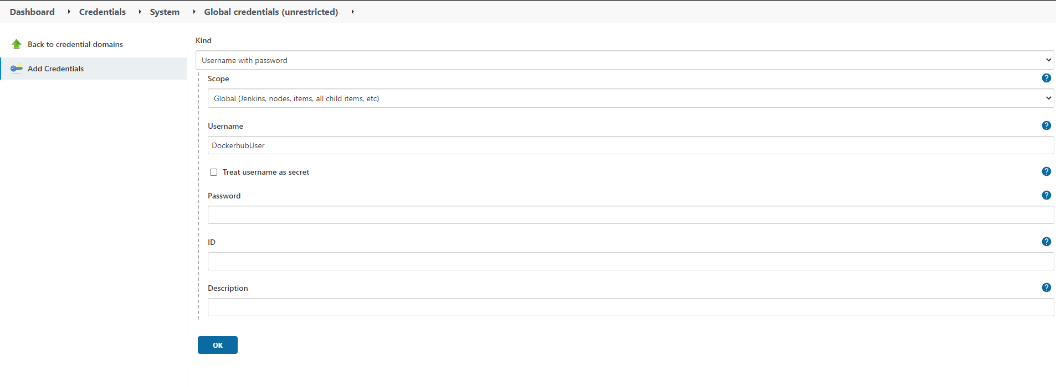

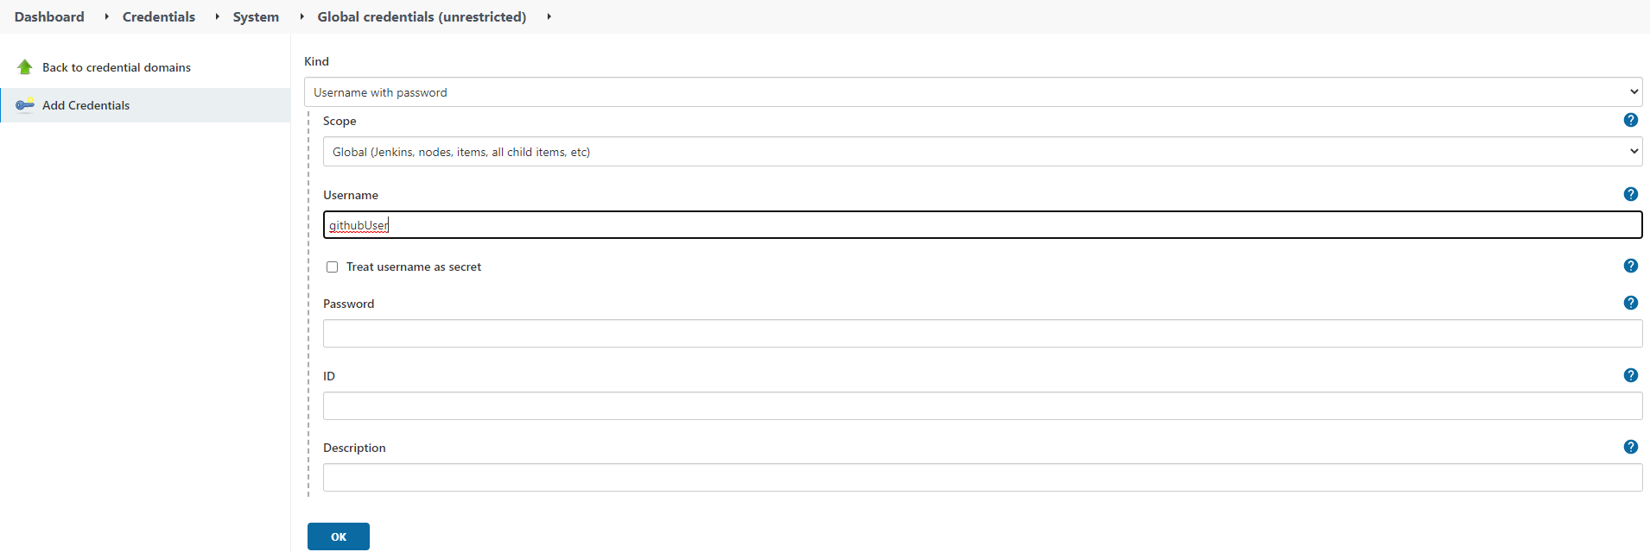

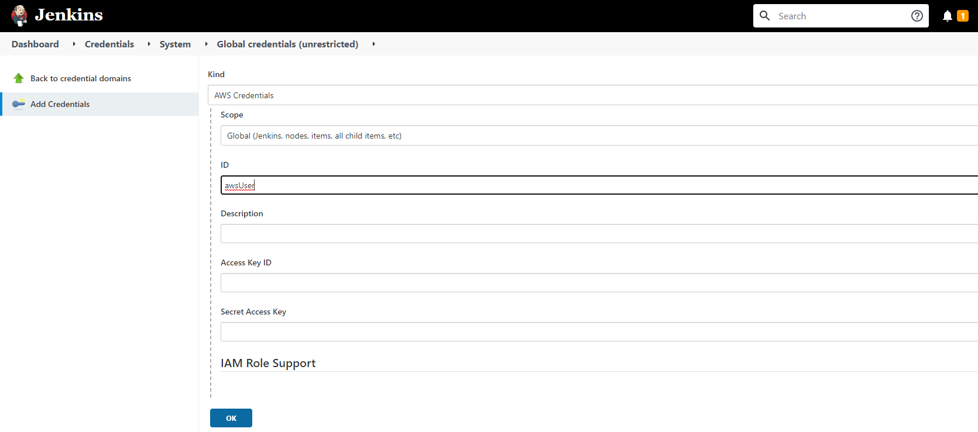

1. Create a new Job using the repo: https://github.globant.com/hugo-pena/devops-academy-jenkins-jobs.git

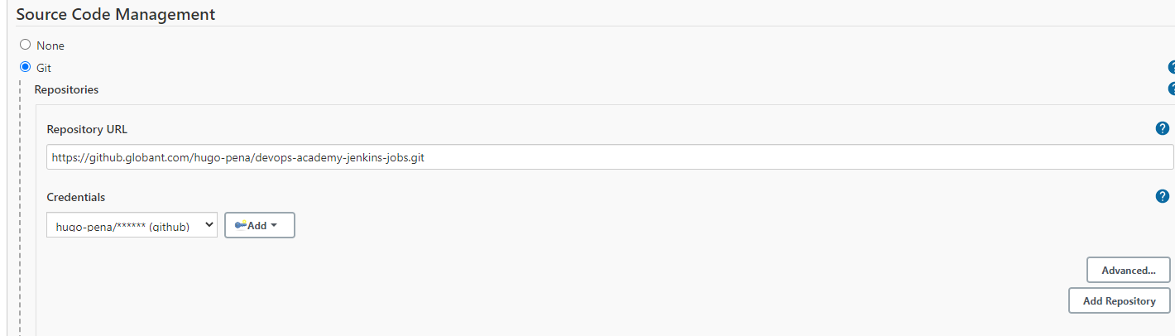

1. Save and run the new job

