Program 6
Multiview App/Files

In Program 6 you will be implementing an application that has multiple views and files.

Only one view (i.e., interface) can ever be shown at a time within the one Window object (e.g., JFrame).

Only one direct subclass of the Window class (e.g., JFrame) can be used when implementing Program6. Using multiple Window objects to create this program will not be acceptable.

Only one interface can be shown at a time. Applications that show more than one interface at a time within one Window object (e.g. JFrame) will not be acceptable.

The program must be stored in a package named program6 and the class that has the one main method (i.e., the Driver) must be named RadioTuner.

Two required files are included with this program – users.txt and stations.txt. users.txt is a file containing the username/password information while stations.txt is a file containing radio station information. users.txt initially contains only one record as shown below:

jsmith@uca.edu^hello1234

Where a ^ separates the username field from the password field. The password does not have to be encrypted for this application.

An example entry for the stations file is shown below:

AM^kabc^Los Angeles

Where a ^ separates the band, call letters , and city fields.

Note that the ^ is a delimiter separating username from the password. The password does not have to be encrypted for this application.

The following user interface is displayed when the main of RadioTuner is invoked from the bat file (.sh file) (This must be the only interface shown initially):

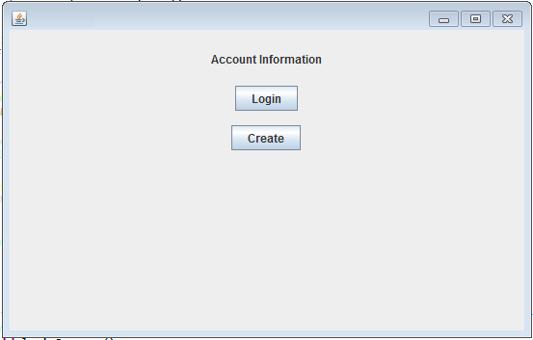

This interface will allow the user to either login using an existing account or create a new account.

If the user presses the “Login” button, a display will be presented that allows the user to enter a Username/Password combination. An example is illustrated below

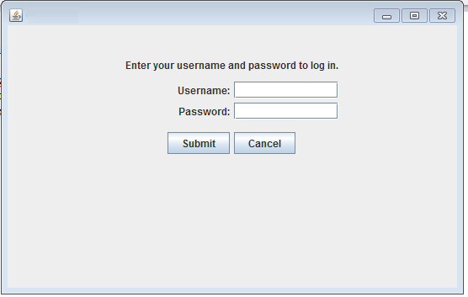
Pressing the “Cancel” button takes the User to the initial interface containing 2 buttons allowing to either Login using an existing account or to Create Account as before.

The user will then be allowed to enter a username/password combination. The username/password combination must be validated from the information that is stored in users.txt. If the user enters the incorrect username or password and presses “Submit”, an error message needs to be displayed as shown below:
Submit

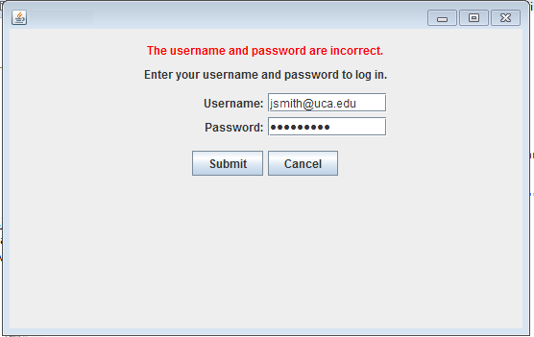

If the user enters the username/password correctly, a JPanel displaying all the AM Stations in a JScrollPane is displayed as described in the RadioTuner section.

If the user chooses to create a new account, the following example display is shown:

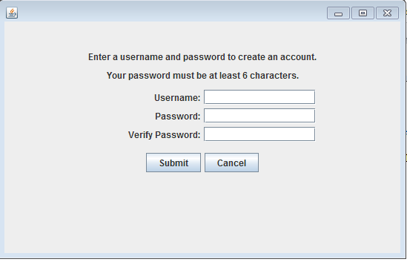

If the user selects a username that has already been used by another account, display an error message “Username has already been selected:

If the user does not enter a username or password with at least 6 characters, display an appropriate error message.

If the user does not re-enter the password correctly display an appropriate error message.

If the user does properly enter a new username/password correctly and presses “Submit”, the users.txt file must be updated to contain the new username/password combination. A JPanel is next shown displaying all the AM Stations in a JScrollPane as described in the RadioTuner section.

Radio Tuner Section

Upon successfully logging in, (or successfully creating a new account), the following interface displaying all AM channels in a JScrollPane should be shown:

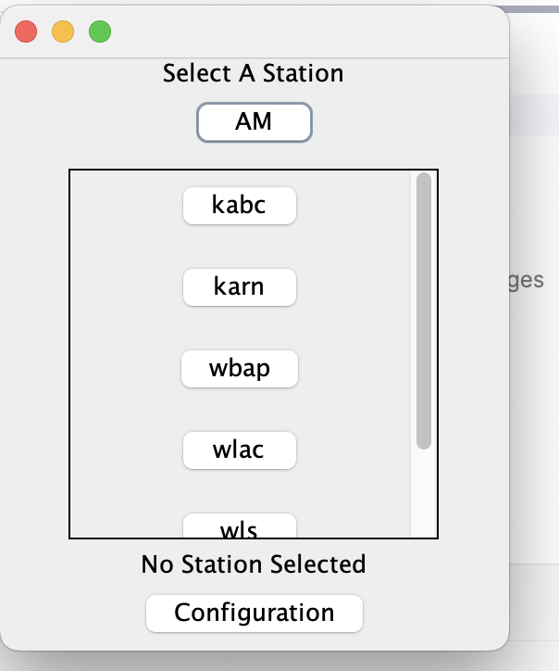
The buttons in the JScrollPane correspond be the initial AM channels input from the stations.txt file. The AM channels must be displayed in a JScrollPane with the scrollbars enabled properly. Scrolling down will display the remaining AM channels. Pressing any of the buttons corresponding to the AM channels will play the corresponding streaming audio associated with the call letters displayed on the buttons. The streaming audio for a given call letters and band can be played by using the following URL:

http://playerservices.streamtheworld.com/api/livestream-redirect/XXXXBB.mp3
Where XXXX are the call letters corresponding to each button and BB is the band (either AM or FM).

A class named JavaStreaming is provided to assist you in playing the streaming audio.
Invoke the play() method to start playing the desired streaming URL.

Invoke the close() method to stop the playing of the streaming URL.

Once a station has been selected, The JLabel under the JScrollPane should display the station that is currently playing as shown below:

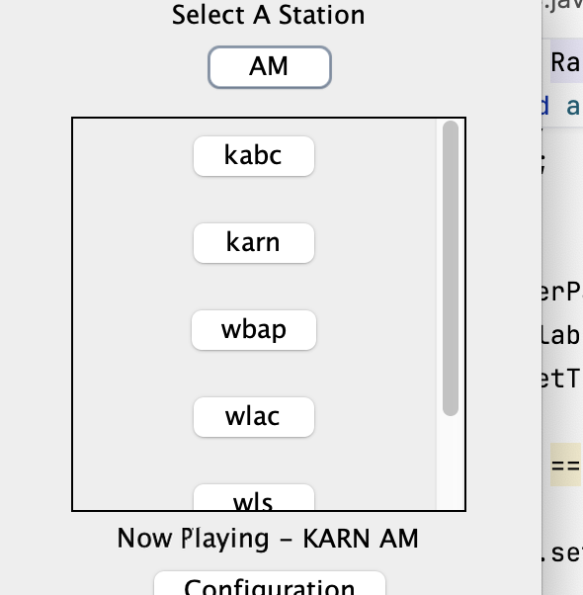

The example above is the result from pressing the “karn” button.

Pressing the band button will automatically toggle the text from “AM” to “FM” and display the FM channels that are stored in stations.txt. An example of the display after pressing this button the first time is shown below:

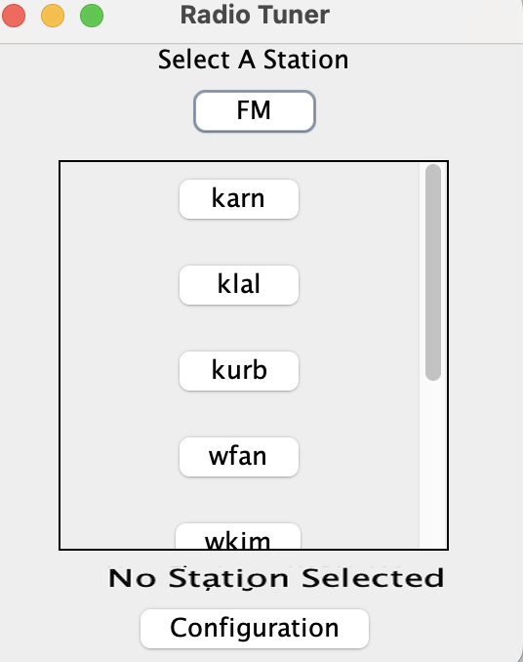

Upon pressing a corresponding FM channel button will result in the JLabel beneath the JScrollPane to display “Now Playing…” message as in the AM example.

Pressing Configuration will display a screen that will allow the user to add additional channels to the RadioTuner application. The following should be displayed once the Configuration button has been pressed:

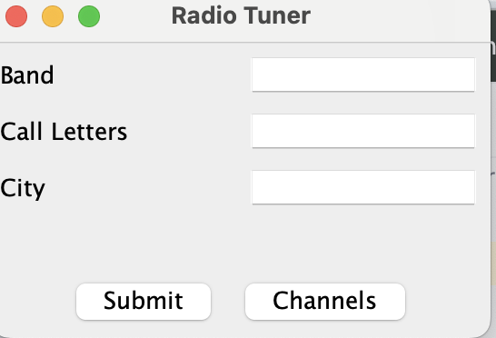
This interface will allow the user to add the Band, Call Letters and /City corresponding to a new Radio Station. For simplicity, assume all fields will be filled before pressing “Submit” and will correspond to a valid radio station. For testing, use the following station information:

FM kslx Phoenix

Upon entering all data and pressing the “Submit” button will result in stations.txt updated with the new station information.

An appropriate message should be displayed to the user indicating that the station was properly added to the file.

The Configuration interface should remain displayed after pressing “Submit” thus allowing the user the user to enter as many new channels as desired.

Pressing “Channels” will show the channels previously displayed to the user.

It is important that users.txt and stations.txt are updated with new user information and new station information.

Class and Package Requirements

You must name the public class that has your main method as RadioTuner and it must be stored in a Package named program6. You will be deducted points if you do not follow these naming requirements for the class and package.

There must be only one main method in your program6 package and it must be a member of the RadioTuner class.

You will need to create a jar file that contains all the .java, class and additional files within the program6 package.

You are free to name your jar file anything you like.

Running the bat (Windows ) or .sh (Mac)

The following files – prog6.bat or (prog6.sh for Mac) are provided to you for testing your work,

What you Submit
Submit your jar file containing all source (.java), class , and other required files to Blackboard.

