AI Clinical Consultation System
Architecture, Backend Implementation & Secure REST API Specification | GCMS | Version 1.2
Purpose: provide doctor-reviewed differential diagnosis suggestions using licensed SNOMED CT and medication candidates matched to the Singapore Drug Dictionary (SDD), without sending direct patient identifiers to the AI model.

1. Overall architecture
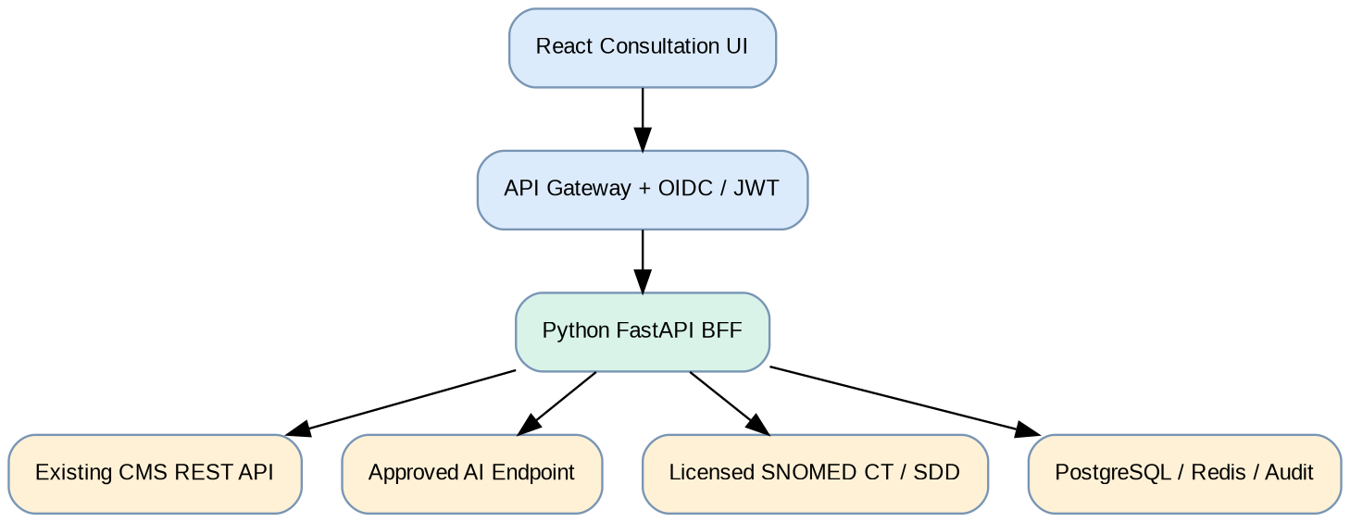
The React client uses the FastAPI backend-for-frontend (BFF) exclusively. Existing CMS REST APIs remain the system of record. Only the trusted Python service can call the model, terminology adapters and CMS integrations. Clinical approval is required before any write-back.

2. Detailed backend implementation
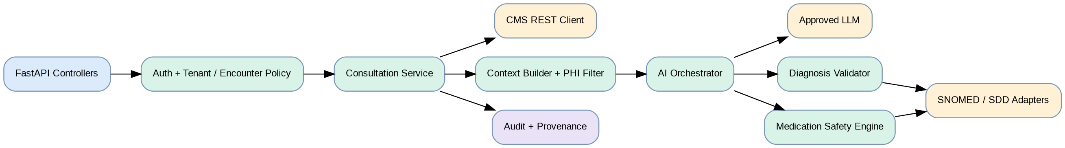
Module | Responsibility
api / auth | Pydantic validation, OIDC JWT verification, RBAC, tenant and encounter authorization
cms adapter | Typed REST client, timeout/retry, clinical context read, versioned write-back
privacy | Minimum-necessary context, direct/indirect identifier filtering, outbound policy enforcement
ai orchestrator | Approved model adapter, structured response parsing, model/prompt version tracking
terminology | Active SNOMED CT concept resolution and licensed SDD catalogue matching
clinical safety | Allergy, interaction, duplicate therapy, contraindication and missing-data checks
audit / workers | Redacted provenance, idempotency, async job handling and observability

3. End-to-end clinical processing
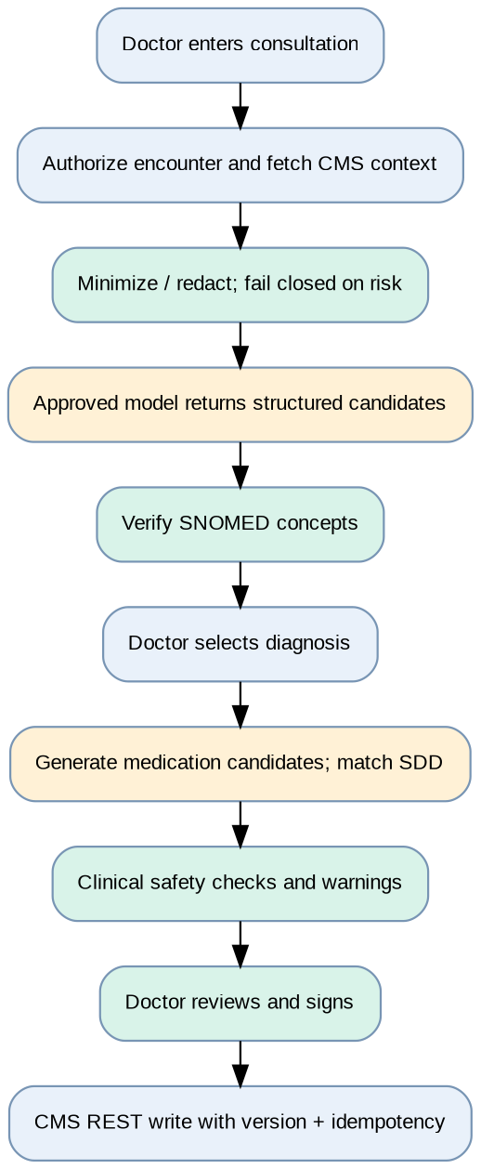
Diagnosis and medication recommendations are separate calls. Medication suggestions require a doctor-selected diagnosis; the model cannot finalize orders. If critical safety data or terminology validation is missing, the UI shows a blocked or unresolved state, not a silently accepted prescription.

4. REST API contracts
All paths are prefixed /api/v1. Authorization: Bearer OIDC access token; enforce tenant and encounter permissions server-side. JSON only, TLS required. These are proposed BFF contracts pending mapping to the existing CMS Swagger/OpenAPI.
Method / path | Request / behavior
GET /consultations/{id} | Read encounter, history, allergies and medications from CMS; return authorized view
PATCH /consultations/{id} | Save draft with If-Match version for optimistic concurrency
POST /ai/diagnoses/suggest | {consultation_id, max_suggestions}; returns verified/unresolved candidates
POST /ai/medications/suggest | {consultation_id, selected_diagnosis_concept_id}; returns SDD matches and safety flags
GET /terminology/snomed/search?q= | Search licensed SNOMED concepts; include edition/version and active status
GET /terminology/sdd/search?q= | Search licensed SDD medication entries and catalogue version
POST /medications/safety-check | Check selected order and relevant patient context
POST /consultations/{id}/finalize | Doctor sign-off; If-Match + Idempotency-Key; write via CMS adapter

Example request / response
POST /api/v1/ai/diagnoses/suggest
{"consultation_id":"enc-1029","max_suggestions":5}
{"request_id":"req-001","status":"review_required",
"suggestions":[{"candidate_id":"dx-01",
"display":"Acute respiratory infection",
"snomed_concept_id":null,"mapping_status":"pending",
"supporting_factors":["Cough","Fever"],
"missing_information":["Respiratory examination"]}]}
Error conventions: 400 invalid request; 401 unauthenticated; 403 unauthorized tenant/encounter; 404 absent resource; 409 encounter version conflict; 422 validation failure; 429 throttled; 502 upstream error; 503 AI/terminology unavailable. Return a request_id and machine-readable error code; never include PHI in error details.

5. Security and privacy design
Control | Technical implementation
Identity & access | OIDC/JWT signature, issuer/audience checks; clinician role and per-encounter authorization
Privacy boundary | Patient name, NRIC/FIN, contact details and internal mapping remain inside trusted CMS/BFF; screen free text for identifiers and indirect re-identification risk
AI data egress | Outbound allowlist, approved provider and region, minimized payload; do not transmit CMS credentials or pseudonymous encounter IDs
Encryption & isolation | TLS/mTLS as applicable; managed keys; per-tenant authorization and isolation for cache, jobs, logs and data
Audit & monitoring | Record request IDs, doctor decisions, terminology versions and model version; redact logs and restrict access
Safe write-back | No autonomous prescribing; doctor signature, optimistic concurrency and idempotent CMS transactions
Clinical governance | Validate clinical safety rules, monitor drift, test prompt injection and review HSA regulatory classification
Important: removal of NRIC and names produces de-identified or pseudonymized data, not guaranteed anonymity. Rare conditions, exact dates and narrative details can still identify patients. Treat clinical context as sensitive throughout processing.

6. Deployment and scalability
Start with a modular FastAPI monolith, stateless replicas behind a gateway, separate asynchronous AI workers, PostgreSQL for metadata/audit references, and Redis for job coordination and non-sensitive caches. Keep clinical records in the existing CMS. Deploy within an approved healthcare hosting boundary and enforce network egress restrictions.

7. Implementation prerequisites
Confirm: CMS Swagger/OpenAPI and authorization model; SNOMED CT and SDD endpoint contracts, licenses and versions; approved AI hosting/data processing terms; medication safety knowledge source; clinician sign-off and audit requirements. Clinical and regulatory validation must precede production use.

