Vehicle Management System (Apex VMS)

Executive Summary

Large-scale corporate enterprises face significant operational friction and financial leakage when managing distributed transportation fleets. In multi-facility organizations comprising Corporate Headquarters, Regional Distribution Hubs, Manufacturing Factories, and Remote Branches, ad-hoc vehicle requests over email, phone calls, or paper logbooks lead to:
- Asset Double-Booking & Scheduling Collisions: Inefficient vehicle and driver dispatching.
- Zero Fleet Visibility: Logistics managers have no real-time telemetry on where vehicles are, if passengers have arrived safely, or if journeys run on schedule.
- Pervasive Fuel Fraud & Leakage: Inflated fuel bills and unverified consumption rates without odometer-to-fuel correlation.
- Maintenance Neglect: Vehicles breaking down unpredictably due to lack of scheduled service tracking.
The Apex Vehicle Management System (VMS) is an end-to-end, digital fleet dispatch, tracking, and operational governance platform engineered to eliminate these inefficiencies through centralized requisition, real-time GPS telemetry, and automated anti-fraud analytics.

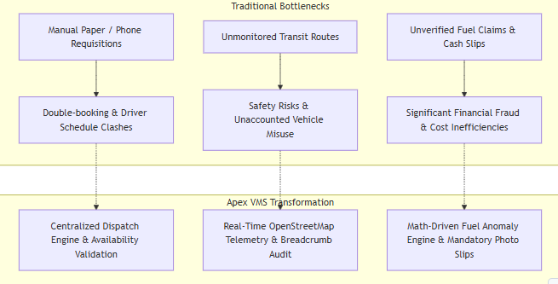
1. Problem Statement & Business Motivation

Key Business Goals:
- 100% Fleet Utilization Transparency: Ensure every vehicle and driver is accounted for (Available, In Transit, On Leave, In Maintenance).
- Fraud Prevention: Reduce fuel expenditure by cross-referencing actual odometer delta ($Δ\text{km}$) with manufacturer fuel efficiency ratings.
- Rapid Requisition Turnaround: Reduce approval-to-dispatch latency from hours to seconds.
- Duty of Care & Safety: Provide real-time location awareness for personnel traveling to remote manufacturing facilities and cross-country client sites.

2. Stakeholder Personas & High-Level Needs

Stakeholder / Persona | Primary Objective | Key Operational Pain Points | Platform Touchpoint
Fleet Administrator / Logistics Manager (Tanvir Hossain) | Oversee entire corporate fleet, approve/reject trips, assign drivers & vehicles without conflicts, monitor active routes, audit fuel costs. | Dealing with phone calls, manual whiteboards, blind spots regarding vehicle locations, fake fuel slips. | Web Admin Dashboard (React 18 + Leaflet + Tailwind)
Corporate Employee (e.g., John Doe, Sarah Smith) | Effortlessly requisition transportation for solo or team business trips across corporate offices, factories, and client sites. | Uncertainty over request status, delayed approvals, difficulty adding traveling colleagues to requisitions. | Employee Mobile App (React Native Expo)
Fleet Driver (e.g., Mohammad Rahim, Abdul Karim) | Receive clear route assignments, record odometer readings, stream live trip coordinates, submit verified fuel receipts, request leave. | Unclear trip details, disputes over fuel expenditure, paper receipt loss, manual route logging. | Driver Mobile App (Expo + GPS Geolocation + Camera)

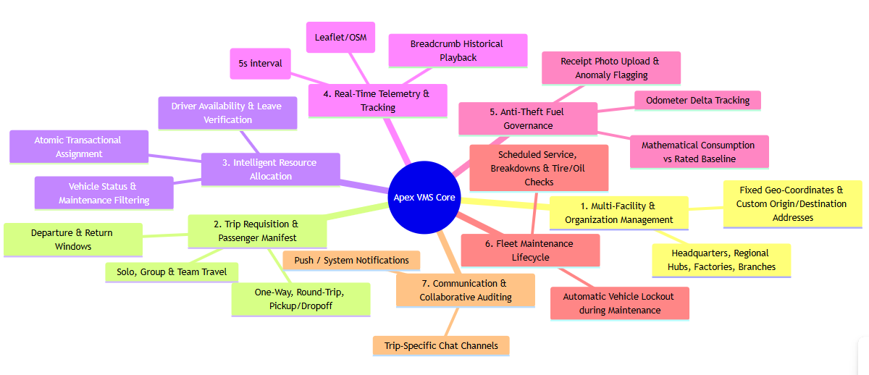
3. High-Level Functional Requirements (Grouped by Module)

Module 1: Organizational & Multi-Facility Hierarchy
- The system must model corporate organizations operating multiple facility types: Corporate Headquarters (HQ), Regional Logistics Hubs, Manufacturing Factories, and Regional Branches.
- Every facility contains geographical coordinates (latitude, longitude) enabling distance calculation and map rendering.

Module 2: Trip Requisition & Passenger Manifest Management
- Employees can requisition transport for:
  - Trip Types: One-Way, Round-Trip, or Pickup/Dropoff.
  - Routing: Office-to-Office, Office-to-Factory, Factory-to-Factory, or custom pickup/dropoff addresses.
  - Passenger Manifest: Solo journeys or group travel with searchable corporate colleagues (displaying Colleague Name, Employee ID, Department, Contact info).
- Requisition state follows a strict lifecycle: PENDING $→$APPROVED $→$IN_PROGRESS $→$COMPLETED (or REJECTED / CANCELLED).

Module 3: Conflict-Free Dispatch & Availability Validation
- The Admin can view verified lists of available assets filtered in real-time:
  - Drivers: Excludes drivers currently on active trips (ON_TRIP), on approved leave (ON_LEAVE), or inactive.
  - Vehicles: Excludes vehicles currently in transit (IN_USE), undergoing workshop service (IN_MAINTENANCE), or retired.
- Atomic Dispatch Guarantee: Assignment of vehicle + driver is executed in a single atomic database transaction to prevent double-booking race conditions when multiple dispatchers operate simultaneously.

Module 4: Real-Time Telemetry & Active Journey Tracking
- While a trip is IN_PROGRESS, the Driver's mobile device captures and streams high-accuracy GPS coordinates (latitude, longitude, speed, heading) via persistent WebSockets (Socket.io) every 5 seconds.
- The Admin Web Portal visualizes active vehicles on an interactive OpenStreetMap canvas with directional heading markers, live speed telemetry, and route breadcrumbs.
- Coordinates are persisted as TrackingPoint records for post-trip route verification and historical auditing.
Module 5: Anti-Fraud Fuel Audit & Anomaly Detection
- Drivers record fuel purchases at the pump: Odometer Reading, Liters Added, Fuel Price, Station Name, and mandatory Receipt Camera Photo.
- Automated Verification Engine: $\text{Actual Consumption (km/L)}=\frac{\text{Current Odometer}-\text{Previous Odometer}}{\text{Fuel Liters Added}}$
- If the calculated consumption deviates by $>25$from the manufacturer's rated efficiency (fuelEfficiency), the record is flagged as isAnomaly = true and an instant alert is triggered on the Admin Dashboard for financial investigation.

Module 6: Driver Leave & Fleet Maintenance Lifecycle
- Drivers can submit time-off requests (SICK, VACATION, PERSONAL, HOLIDAY) which, once approved by the Admin, automatically prevent trip assignments during that date range.
- Admins log preventive and corrective maintenance (SCHEDULED, BREAKDOWN, TIRE_CHANGE, OIL_CHANGE). Active maintenance automatically sets vehicle status to IN_MAINTENANCE, preventing dispatch.

Module 7: Collaboration & In-Trip Communication
- Every active trip automatically instantiates a dedicated communication channel (Conversation) where the Requester, Driver, and Admin can exchange real-time text updates, location pins, and incident reports without leaving the application.

5. System State Machine & Lifecycle Flow

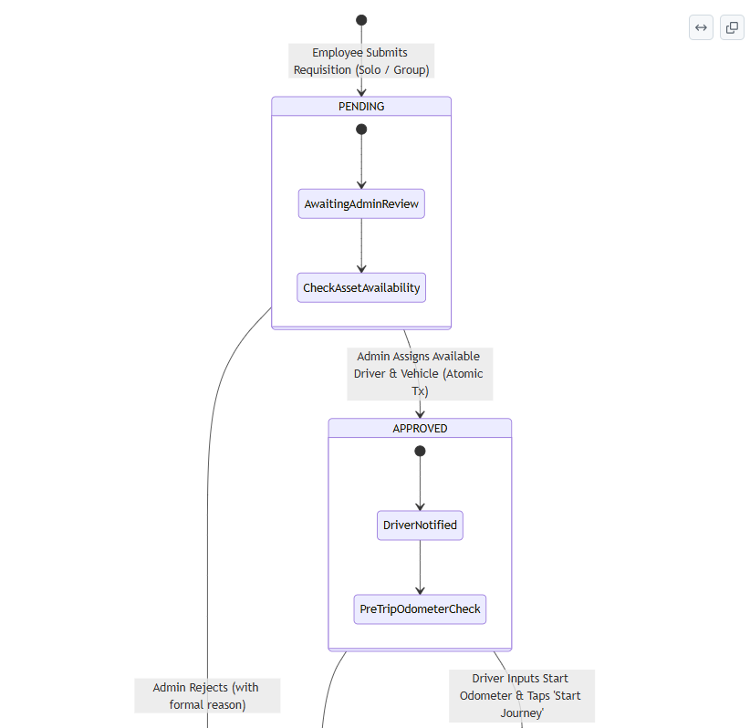

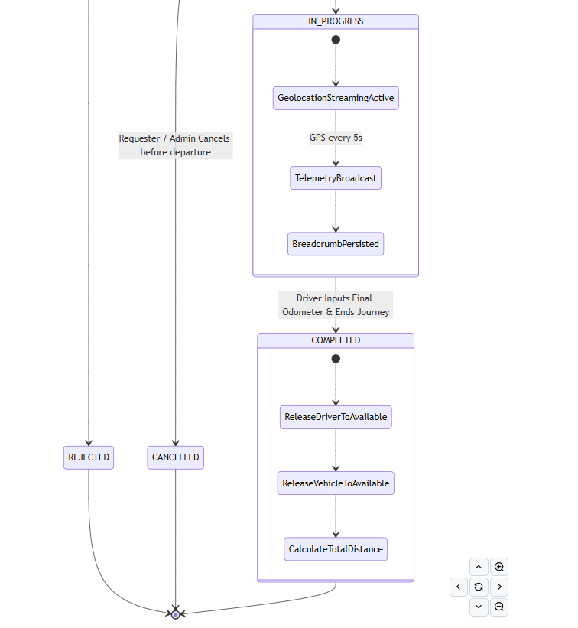

DATABASE DESIGN:

https://drive.google.com/file/d/1P1axvXyPk6yP87_5eHK3vOS3GWNPZo9T/view?usp=sharing

