Hybrid Natural Language & Semantic Search – Documentation

1. Project Overview
Objective:
This project demonstrates a hybrid search system that allows users to query a PostgreSQL database using either:
- Natural Language → SQL conversion (via Gemini AI)
- Semantic Vector Search (using product embeddings)
The system is built using Python, Streamlit, and PostgreSQL, with a focus on usability, safety, and modularity.
Key Features:
- Natural language queries automatically converted to SQL
- Semantic search for unstructured or loosely defined product queries
- Optional filters (e.g., price)
- Safe execution: only SELECT queries allowed
- Interactive results displayed in a DataFrame UI
2. Technology Stack
- Programming Language: Python
- Frontend: Streamlit
- Database: PostgreSQL
- Vector Extension: pgvector
- LLM: Google Gemini (for NL → SQL)
- Embedding Model: all-MiniLM-L6-v2 (Sentence Transformers)

3. Database Schema
Table Name | Columns | Description
employees | id, name, department_id, email, salary | Employee details
departments | id, name | Department information
orders | id, customer_name, employee_id, order_total, order_date | Customer orders
products | id, name, price, embedding | Product information with embeddings

Relationships:
- employees.department_id → departments.id
- orders.employee_id → employees.id

4. System Architecture
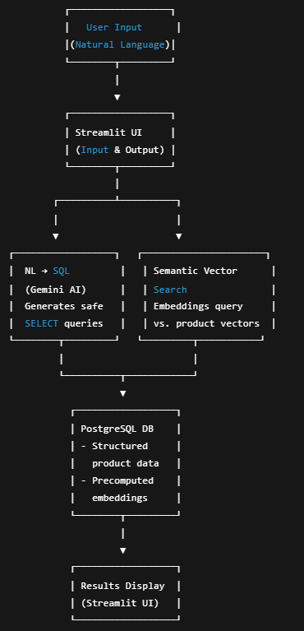
Description
- The user submits a natural language query via the Streamlit interface.
- The system determines whether the query is:
  - Structured (e.g., employees, orders) → NL → SQL path
  - Semantic/Fuzzy (e.g., products, affordability) → Vector search path
- Results are safely executed and displayed in tabular format.

5.Natural Language to SQL
- Prompting Gemini: The system sends a prompt to Gemini AI containing the database schema and the user question.
- Rules enforced:
  - Only SELECT queries are allowed
  - No explanations or comments in SQL
- Safety Check: Queries are checked to ensure they start with SELECT before execution.
- Example Query:
- User Input: Show all employees in the Sales department
- Generated SQL:

SELECT id, name, department_id, email, salary
FROM employees
WHERE department_id = (SELECT id FROM departments WHERE name='Sales');
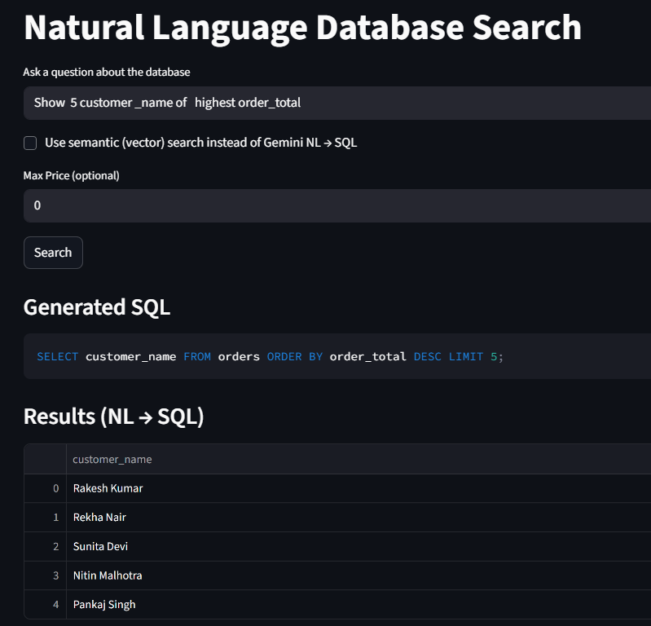
6. Semantic Vector Search
- Embedding Model: all-MiniLM-L6-v2 from Sentence Transformers
- Process:
  - Convert user query into a vector embedding
  - Compare with product embeddings stored in PostgreSQL using the <-> operator
  - Rank products by similarity
- Optional Filter: Users can filter results by price
- Example Query: Affordable laptops and smartphones under 15000
- Result: Top-k most relevant products within the price limit
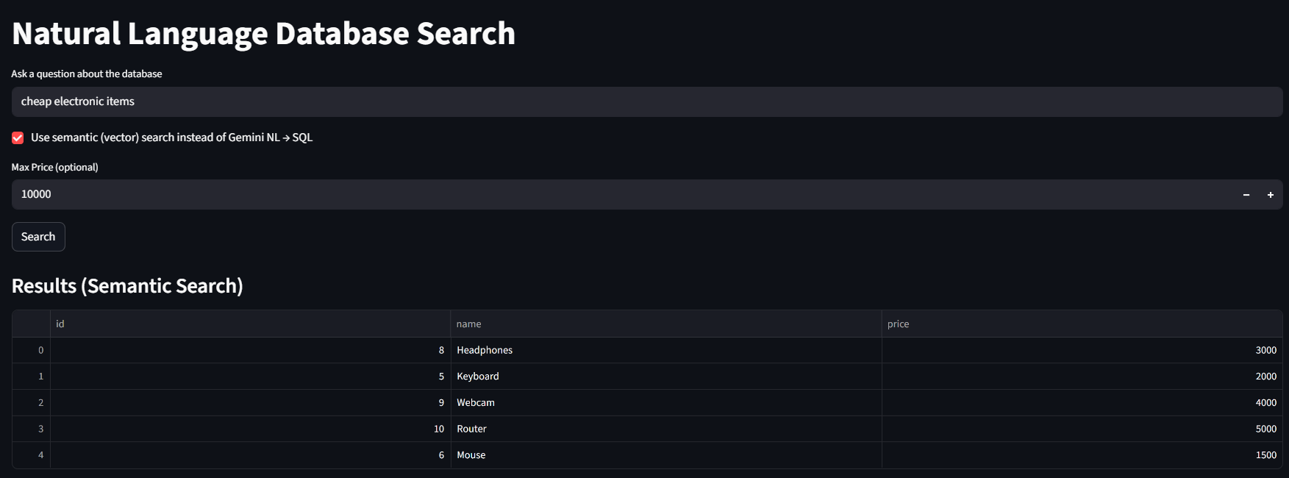

7. Limitations
- NL → SQL accuracy depends on LLM response quality
- Product embeddings must be regenerated when product data changes
- Large datasets may require ANN indexing for better performance
- Complex multi-table semantic queries are not yet supported

8. Suggestions for Improving System Effectiveness

Performance Optimizations:
- Cache embeddings to avoid recalculating for repeated queries
Automatic Query classification :
- Implement a system that classifies the user query and automatically decides whether to use NL → SQL or semantic vector search.

9. Conclusion
The Hybrid Natural Language & Semantic Search system is a robust, user-friendly solution for querying structured and unstructured data. By combining Gemini AI for NL→SQL conversion and semantic vector search for product retrieval, users can obtain fast and relevant results safely and efficiently.

