# BoardLight

# INFORMATION GATHERING

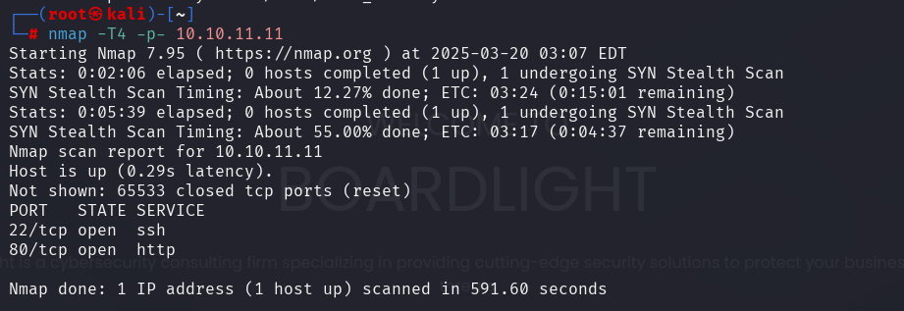

# EXPLOIT