# Code

# INFORMATION GATHERING

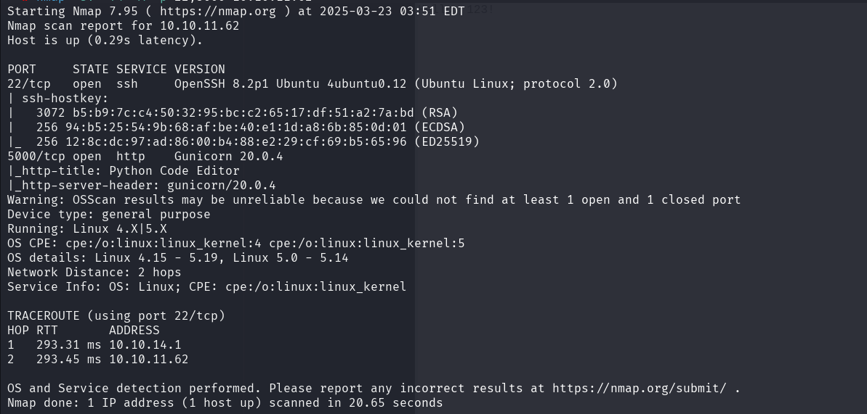

# EXPLOIT