# SwagShop

# INFORMATION GATHERING

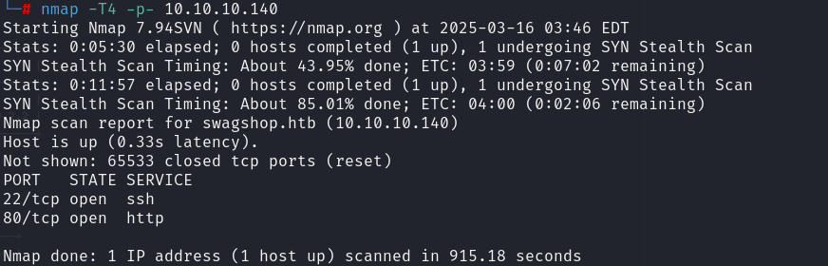

# EXPLOIT

