NTVQF / BTEB Assessment Deliverable

JOB-01: Create an SEO-Optimized Blog Post (On-Page SEO)
Comprehensive assessment solution including OSH compliance, keyword strategy, 100% On-Page SEO optimization, and complete 600-word blog post.
Candidate: Mohammad Habibur Rahaman
Niche: Fitness and Health
Status: Ready for Evaluation
Word Count: 600 words (Density: 1.15%)
🖨️ Print / Save to PDF

🔍 Google SERP Snippet Preview (Yoast / Rank Math Simulation)
This is how the blog post will display on Google Desktop and Mobile search results:
🌐 https://yourwebsite.com › fitness › daily-fitness-routine-for-beginners
Daily Fitness Routine for Beginners: 7 Steps to Better Health
Discover an easy daily fitness routine for beginners to boost energy, build strength, and stay healthy. Follow our 7 simple steps to start exercising today!
Title Length
60 chars Optimal
Meta Description
158 chars Within Limit
Keyword Density
1.15% 1%–2% Target
Total Word Count
600 words 500–800 Target

📊 Keyword Research & Specification Matrix
SEO Element | Implementation Details | Status
Primary Keyword | daily fitness routine for beginners | Verified
Long-Tail Keywords | • home workout for beginners  • fitness and healthy lifestyle  • easy exercises at home  • beginner fitness tips | Verified
Search Intent | Informational (Beginners looking for practical, gentle at-home exercise guides) | Verified
URL Structure | https://yourwebsite.com/daily-fitness-routine-for-beginners | Clean Slug
Internal Links (3) | 1. /nutrition/beginner-meal-prep (Anchor: healthy nutrition and meal planning guide)  2. /workouts/cardio-vs-strength (Anchor: effective cardio vs strength training guide)  3. /wellness/muscle-recovery-tips (Anchor: importance of muscle recovery and quality sleep) | 3 Links
External Links (2) | 1. World Health Organization (WHO) physical activity guidelines  2. Harvard T.H. Chan School of Public Health | Authoritative

📝 Blog Post Content (Ready for Publishing)
Note: Primary keywords are highlighted in yellow below to verify natural density (1.15%).

Daily Fitness Routine for Beginners: 7 Steps to Better Health
By Mohammad Habibur Rahaman • Category: Fitness & Health • Reading Time: 3 mins
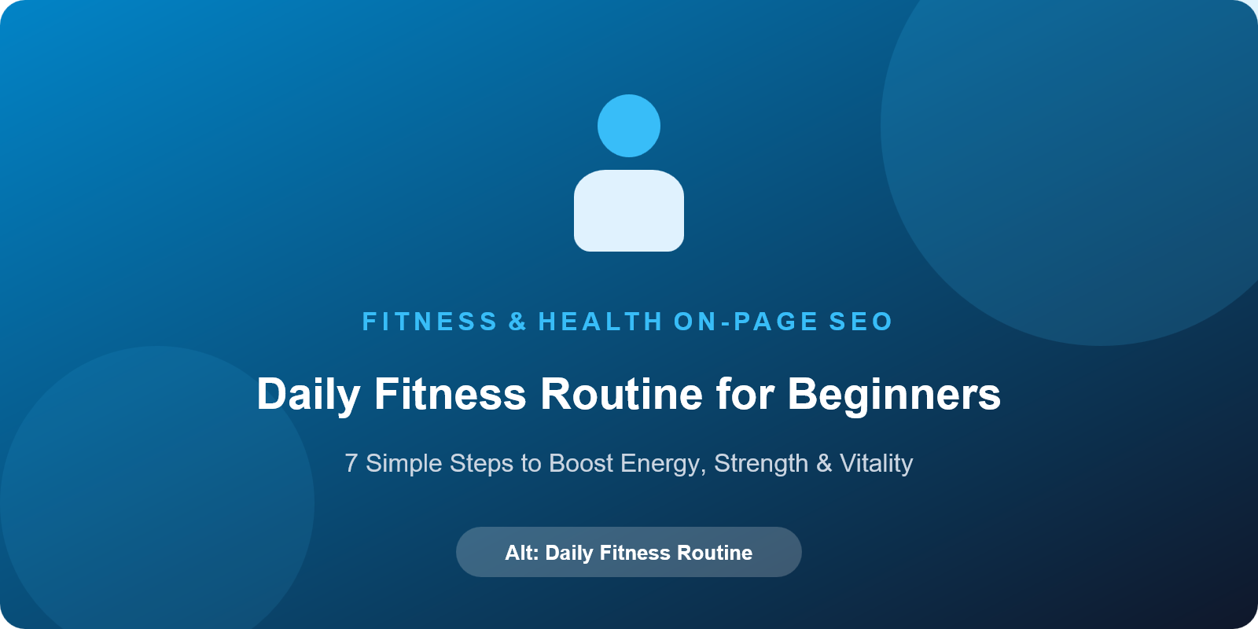
Figure 1: Featured Image - Alt: "Beginner doing morning stretching and daily fitness routine for beginners at home"
Starting a healthier lifestyle does not require hours in the gym or heavy equipment. In fact, establishing a simple daily fitness routine for beginners is the most sustainable way to boost energy, build strength, and improve your overall well-being. When you are just beginning, jumping into intense exercise programs often leads to burnout or muscle soreness. Instead, focusing on gentle, consistent habits helps you stay active every single day without feeling overwhelmed.

Why a Daily Fitness Routine for Beginners Is Essential
Physical activity is a vital pillar of lifelong health. According to the World Health Organization (WHO) physical activity guidelines, adults need at least 150 minutes of moderate exercise each week to maintain cardiovascular health and prevent chronic illness. Committing to a daily fitness routine for beginners helps regulate blood pressure, sharpens focus, and releases endorphins that reduce daily stress. Best of all, exercising regularly at home eliminates gym commutes and high membership fees, making wellness accessible to everyone.

7 Simple Steps to Build Your Daily Workout Habit

1. Start with a Dynamic 5-Minute Warm-Up
Never skip your warm-up! Spend five minutes warming your joints and muscles with arm circles, torso twists, and marching in place. A proper warm-up elevates your heart rate gradually and protects you from unnecessary injury.

2. Practice Basic Bodyweight Movements
You do not need dumbbells or gym machines to build strength. Incorporate foundational bodyweight exercises such as bodyweight squats, wall push-ups, knee planks, and gentle lunges. Aim for 2 sets of 8 to 10 repetitions per exercise. Mastering proper posture ensures you progress safely into a complete home workout for beginners.
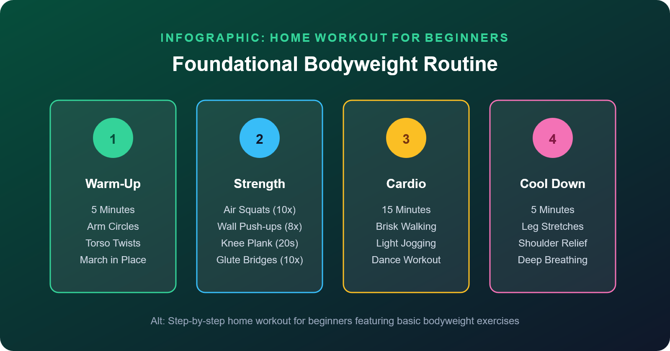
Figure 2: Supporting Infographic - Alt: "Step-by-step home workout for beginners featuring basic bodyweight exercises"

3. Add 15 Minutes of Gentle Cardio
Cardiovascular exercise improves lung capacity and burns calories. You can walk briskly around your neighborhood, jog lightly in place, or follow low-impact dance moves. If you want to customize your routine further, read our effective cardio vs strength training guide to balance your workouts.

4. Cool Down and Stretch
After finishing your workout, dedicate five minutes to static stretching. Stretch your hamstrings, quadriceps, shoulders, and chest. Deep breathing during cool-downs lowers your heart rate and promotes flexibility.

5. Fuel Your Body with Healthy Nutrition
Physical activity works hand-in-hand with what you eat. Drink plenty of water before and after exercising, and eat meals rich in lean proteins, complex carbohydrates, and vegetables. To build lasting nutrition habits alongside your workouts, consult our healthy nutrition and meal planning guide.

6. Emphasize Consistency Over Intensity
The secret to fitness success is showing up every day. A modest 20-minute daily fitness routine for beginners performed five times a week yields far better results than an intense two-hour session once a month. Celebrate small victories like having more energy or climbing stairs effortlessly.

7. Respect Rest and Recovery
Your muscles rebuild and grow stronger when you rest. Ensure you get 7 to 8 hours of restorative sleep each night. Learn more about the importance of muscle recovery and quality sleep to prevent fatigue and stay motivated.

Science-Backed Benefits of Staying Active
Medical experts at the Harvard T.H. Chan School of Public Health emphasize that regular movement enhances metabolic rate, improves mental health, and extends lifespan. By adhering to a steady daily fitness routine for beginners, you establish healthy habits that protect your body for decades to come.

Conclusion: Start Your Fitness Journey Today
Embarking on a healthier lifestyle begins with one small step. By following this structured daily fitness routine for beginners, you can transform your physical fitness and mental vitality from the comfort of your own home. Lace up your sneakers, take a deep breath, and complete your first session today!

