Text-Informed Nutritional Prioritization and
Food Ranking in West Africa
Irene Huang, Stony Brook University

West Africa is undergoing a nutrition crisis, where an estimated 110 million people are not receiving adequate nutrition for their needs, and over 58 million people are classified as underweight [1]. At the same time, developing effective nutritional guidance in resource-constrained settings is complex because dietary deficiencies, food systems, and nutrient needs can vary substantially across regions and populations, where essential goods and services are already limited [2]. This understanding makes region-specific approaches especially important when evaluating nutritional priorities.
Additionally, many existing nutrient-density rankings treat all nutrients as equally important, even though some deficiencies may be more pressing than others in a specific public health context. In West Africa, for example, deficiencies in iron, vitamin A, and other micronutrients are frequently discussed in biomedical and public health literature, suggesting that some nutrients may warrant greater emphasis than others when evaluating foods for nutritional prioritization.
This project investigates whether food composition data and biomedical literature signals can be integrated into a unified framework to inform nutritional prioritization. Using nutrient composition data from the West Africa Food Composition Table (WAFCT) [3] and deficiency-related signals extracted from PubMed abstracts, the project builds a reproducible pipeline that ranks foods according to alignment with region-relevant nutritional concerns.
The goal is not to produce a definitive dietary recommendation or policy guideline. Instead, the project is designed to serve as an evidence-informed prioritization tool to identify foods that may warrant further attention, expert review, or communication. Just as importantly, the pipeline is fully inspectable from input data through final ranking so that each modeling decision can be reviewed, revised, or traced.

Project Snapshot
Component | Current Default Run
Input food composition source | FAO/INFOODS WAFCT
Literature source | Cached PubMed title and abstract dataset
Missingness threshold | 10%
WAFCT entries screened | 1,028
WAFCT entries excluded before ranking | 26 excluded by eligibility rules and 2 flagged for manual review
Foods ranked | 834
Nutrients used in scoring | 17
Ranking method | TOPSIS multi-criteria decision analysis
Interpretive layer | Post-hoc Reference Daily Intake coverage analysis

A Pipeline Built Around Two Questions
The project is organized around two linked questions. First, which WAFCT foods can be responsibly considered as candidate foods for ranking? Second, among those foods, which ones best align with nutrients that appear most often in deficiency-related West African biomedical literature?
The first question is addressed through WAFCT cleaning, food eligibility screening, and missing data filtering. The second is addressed through PubMed text mining, literature-derived nutrient weights, nutrient directionality, and Technique for Order of Preference by Similarity to Ideal Solution (TOPSIS) scoring.
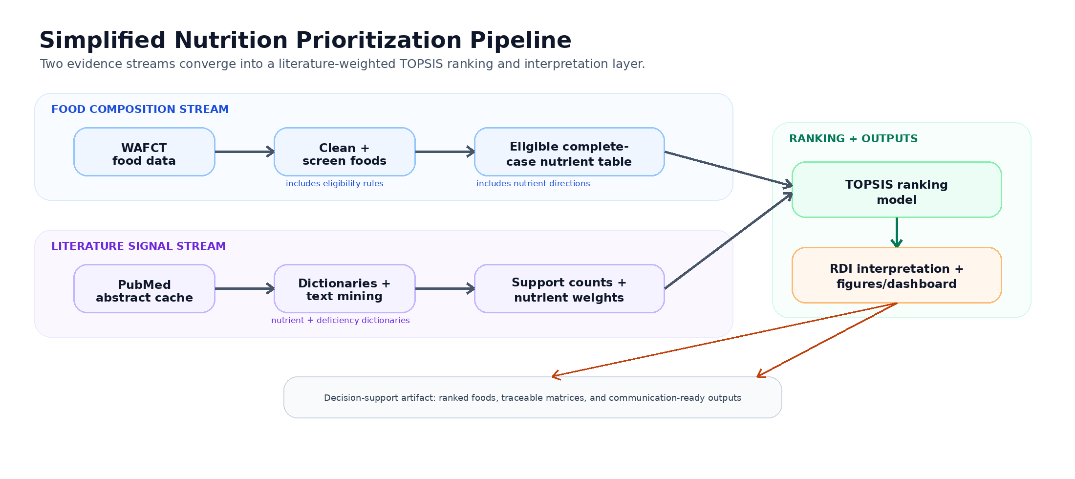
Fig. 1. Simplified workflow connecting WAFCT food composition data, PubMed literature signals, TOPSIS ranking, and interpretation outputs.

From Food Composition Data to Candidate Foods
The WAFCT is a food composition reference, not a curated list of recommended foods. In addition to standalone foods, it contains ingredients, condiments, additives, recipe-calculation items, and other entries that are useful for nutrient analysis but not for direct food recommendations.
Therefore, the project begins with a cleaning and screening stage to refine the dataset into a more meaningful set of candidate foods. Core food identifiers are preserved while non-modeling fields, redundant nutrient forms, and irrelevant metadata are removed. One important preprocessing decision is the replacement of total carbohydrate with net carbohydrate, calculated as total carbohydrate minus fiber. This step avoids fiber from artificially inflating an undesirable carbohydrate measure while retaining a more interpretable carbohydrate variable for later analysis.
The pipeline then applies eligibility screening to remove entries that are unlikely to function as meaningful standalone recommendations. Examples include caustic compounds, seasoning additives, minor-use condiments, and other recipe-support ingredients.
After screening, the dataset is evaluated for nutrient completeness. In the default run, nutrients are retained only if data missingness is less than or equal to 10%, and foods with missing retained nutrient values are removed through complete-case filtering. The project intentionally avoids imputing missing nutrient values before ranking because doing so could introduce artificial nutrient profiles into the decision model.

Translating Biomedical Literature into Nutrient Priorities
After refining the food dataset, the project turns to a second source of evidence: deficiency-related biomedical literature from PubMed.
The literature component is structured as a reproducible scan rather than a systematic review. Its purpose is not to establish causality or summarize all nutrition research in West Africa. Instead, it provides a transparent signal about which nutrients appear most frequently in discussions of malnutrition, deficiency, undernutrition, anemia, and related public health concerns.
Using a cached dataset of PubMed titles and abstracts, the project searches for co-occurrences between nutrient terms and deficiency-related language. Nutrients that repeatedly appear in these contexts are interpreted as stronger signals within the literature corpus. These signals are then converted into nutrient weights for the ranking model. This distinction is important since the model does not assume that all nutrients should contribute equally to nutritional prioritization.
At the same time, nutrient importance and nutrient desirability are treated separately. Vitamins, minerals, protein, fiber, and essential unsaturated fatty acids are generally more desirable in diets, while nutrients such as sodium and saturated fat are more desirable in lower values. This distinction informs the ranking system to reward foods that contribute positively to nutritional adequacy while penalizing less desirable nutrient profiles.

Ranking Foods with TOPSIS
Once nutrient composition data, literature-derived weights, and nutrient directionality are aligned, the project applies TOPSIS, a multi-criteria decision analysis method commonly used for comparative ranking problems.
TOPSIS evaluates each food relative to two hypothetical reference profiles: an ideal profile containing the most favorable nutrient values, and a worst-case profile containing the least favorable values.
Foods are ranked according to how close they are to the ideal profile and how far they are from the worst-case profile after weighting and normalization are applied.
Importantly, a TOPSIS score should be interpreted comparatively rather than absolutely. A high score does not mean that a food is universally “optimal,” sufficient on its own, or appropriate for every dietary context. Instead, it indicates that the food more closely aligns with the weighted nutrient priorities defined within this specific model.

Interpreting Rankings Through Nutritional Contribution
Because TOPSIS produces relative rankings, the project also analyzes Reference Daily Intake (RDI) values for each nutrient to yield a more meaningful interpretation of the rankings.
For top-ranked foods, nutrient values per 100 g are compared against general daily value benchmarks to estimate how strongly foods contribute to specific nutrients. This layer does not affect the TOPSIS score itself. Instead, it provides additional context for understanding what high-ranking foods actually contribute nutritionally.
For example, a food may perform well because it maintains a balanced nutrient profile across many weighted criteria, while another food may provide exceptionally strong coverage for one or two specific nutrients. Viewing RDI coverage alongside TOPSIS scores helps distinguish between these patterns and prevents rankings from being interpreted too simplistically.
To support communication and transparency, the project also generates figures and includes a dashboard prototype that allows users to interactively inspect rankings, nutrient weights, and RDI coverage. This communication layer is important because the project is intended not only as a modeling exercise, but also as a decision-support demonstration.

Current Results Snapshot
In the latest verified default run, 1,028 WAFCT entries were screened. The eligibility filter excluded 26 entries, while 2 additional foods were flagged for manual review. This left 1,000 foods eligible before nutrient completeness filtering. After applying the 10% missingness threshold, 166 foods were removed for missing retained nutrient data, leaving 834 foods ranked across 17 nutrients.
The PubMed support count figure shows that the literature-derived signal is not evenly distributed across nutrients. Iron receives the strongest support by a wide margin, followed by protein, vitamin A, zinc, and folate. This suggests that the final model is influenced heavily by nutrients that appear most in deficiency-related West African biomedical literature. Lower-count nutrients remain in the model if they meet the support and data requirements, but they exert less influence after normalization.
The top 20 TOPSIS ranking shows a small group of foods with substantially higher scores than the rest of the ranked set. The highest-ranked foods include carrot, onion, jute mallow, benniseed, cowpea leaves, fonio, shrimp, turnip, and several liver entries. This mix is useful because it shows that the model is not simply selecting one type of food. Instead, high-ranking foods include vegetables, leafy greens, grains, seeds, seafood, and animal-source foods.
Similarly, the RDI coverage heatmap displays that foods can appear to provide particularly strong coverage for selected micronutrients or show moderate contributions across a wider range of nutrients. This distinction underscores that two foods can receive high TOPSIS scores for different nutritional reasons.
The TOPSIS score distribution further shows that the ranking is highly skewed. Most foods cluster at relatively low scores, while a small number of foods achieve much higher values. The figure reports a mean TOPSIS score of 0.089 and a median of 0.071, with a P90–P10 ranking spread of 0.068. This indicates that most foods are relatively far from the constructed ideal profile, while only a limited number of foods stand out under the selected criteria, weights, and directionality assumptions. Therefore, the ranking should be interpreted as a prioritization tool that highlights relatively strong candidates, not as a claim that most foods are nutritionally poor or that the highest-ranked foods are universally optimal.

What This Project Contributes
The main contribution of this project is methodological rather than prescriptive; instead of applying a generic nutrient-density formula, the framework combines food composition data with literature-derived deficiency signals to create a context-aware ranking system.
The project also emphasizes traceability. Each stage of the pipeline—from food screening to literature weighting to ranking—can be inspected and modified. This makes the framework more useful as a research and decision-support tool than as a static scoring system.
More broadly, the project demonstrates how computational methods, public health framing, and interpretable modeling can intersect within nutrition research. It combines reproducible pipeline design, text mining, multi-criteria decision analysis, visualization, and communication into a single workflow intended for exploration and refinement rather than definitive recommendation-making.

Limitations and Future Work
Several limitations shape how the results should be interpreted. Firstly, the PubMed component captures patterns in indexed abstracts, but it does not evaluate study quality, effect sizes, or causal relationships. Likewise, the text-mining approach identifies co-occurrence patterns rather than directly proving deficiency prevalence or nutritional importance.
The ranking model also operates on nutrient values per 100 g and does not yet incorporate serving size, affordability, seasonality, preparation loss, food safety, bioavailability, or cultural dietary patterns. These factors are essential for translating computational rankings into practical dietary guidance.
Future work could extend the framework through expert nutrition review, sensitivity analyses across missingness thresholds, integration of food cost and availability data, and validation against dietary intake datasets. The dashboard prototype could also be connected directly to live pipeline outputs, allowing users to explore rankings interactively and inspect why specific foods score highly under different assumptions.
Ultimately, the project is best understood as an evolving computational framework for transparent nutritional prioritization rather than a finalized recommendation system.

AI Usage Disclosure
Generative AI tools were used to assist with code drafting, methodology refinement, and editing. All outputs were reviewed by the author, and final methodological decisions were based on the implemented pipeline and documented project files.

References
[1] Sahel and West Africa Club Secretariat/OECD, "Food System Transformations in the Sahel and West Africa: Implications for People and Policies," Maps & Facts, no. 4, Apr. 2021. [Online]. Available: https://www.oecd.org/content/dam/oecd/en/blogs/2021/04/maps-and-facts/food-systems-sahel-west-africa-2021-en.pdf. [Accessed: May 24, 2026].
[2] U.S. Department of Health and Human Services, Office of Disease Prevention and Health Promotion, Food Is Medicine Landscape Summary, Washington, DC, USA, Sep. 2024. [Online]. Available: https://odphp.health.gov/sites/default/files/2024-09/Food%20Is%20Medicine%20Landscape%20Summary%20FINAL%20508.pdf. [Accessed: May 24, 2026].
[3] A. Vincent et al., FAO/INFOODS Food Composition Table for Western Africa (WAFCT 2019). Rome, Italy: Food and Agriculture Organization of the United Nations, 2020. [Online]. Available: https://www.fao.org/fileadmin/user_upload/faoweb/2020/WAFCT_2019.xlsx. [Accessed: May 24, 2026].

Appendix A: Supplemental Figures
The following figures provide additional context for the literature signals, TOPSIS results, and post-hoc RDI interpretation used in the project.
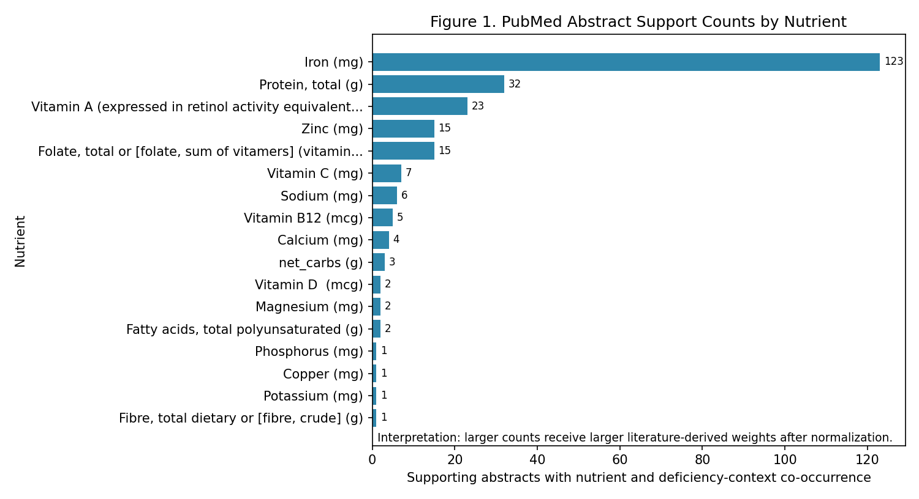
Fig. A1. PubMed abstract support counts by nutrient.
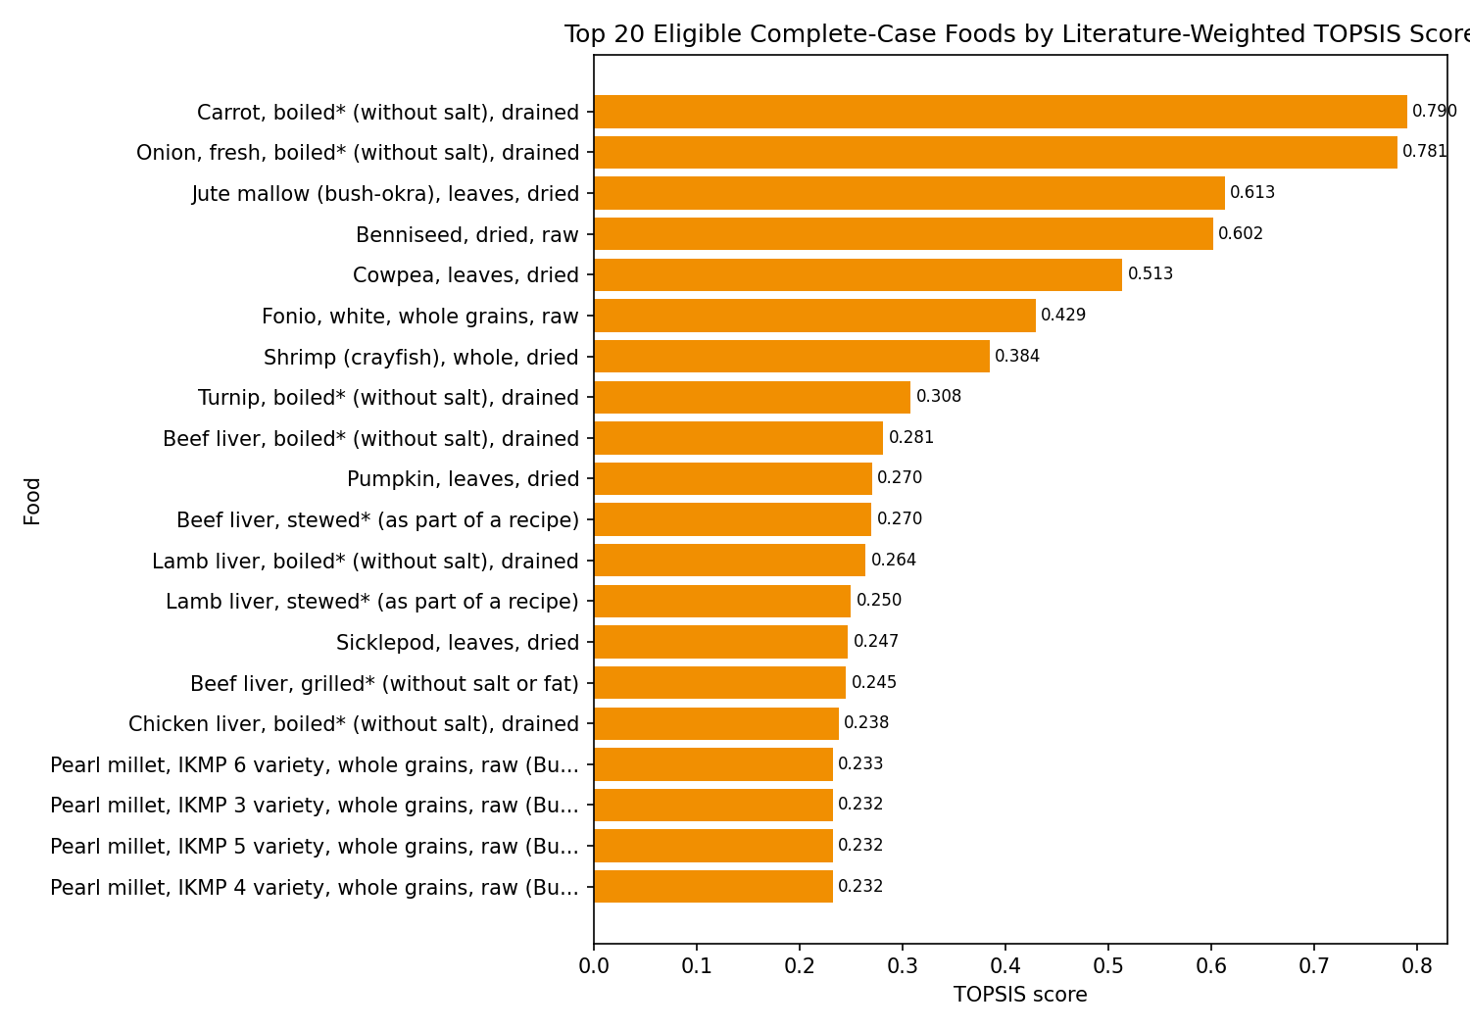
Fig. A2. Top 20 eligible complete-case foods by literature-weighted TOPSIS score.
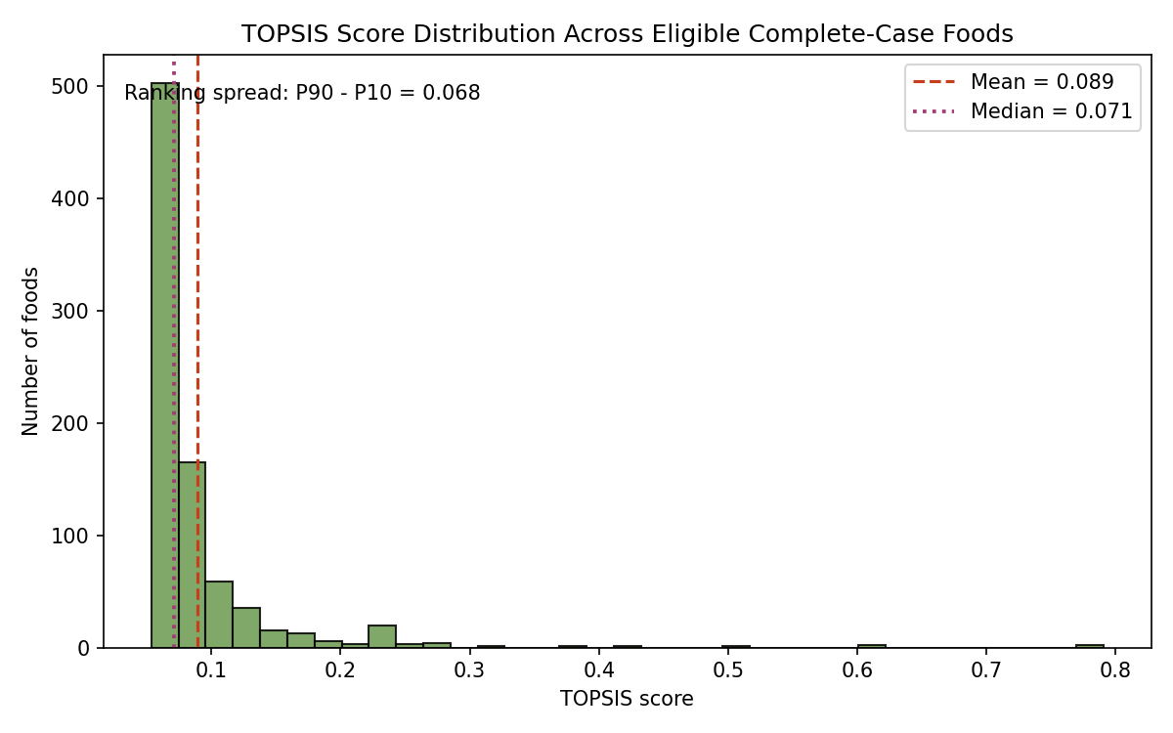
Fig. A3. Distribution of TOPSIS scores across eligible complete-case foods.
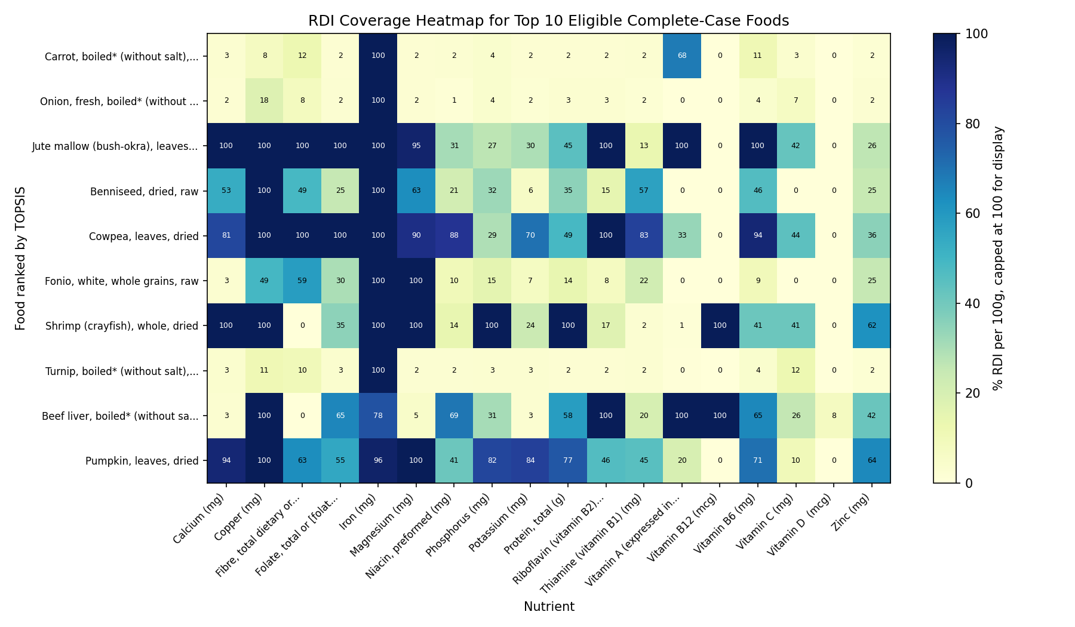
Fig. A4. RDI coverage heatmap for top 10 eligible complete-case foods.

