**Visual Studio Code Installation:**

Step 1:

Open Below Link:

<https://code.visualstudio.com/download>

Step 2:

Click on WINDOWS to download Visual Studio Code.

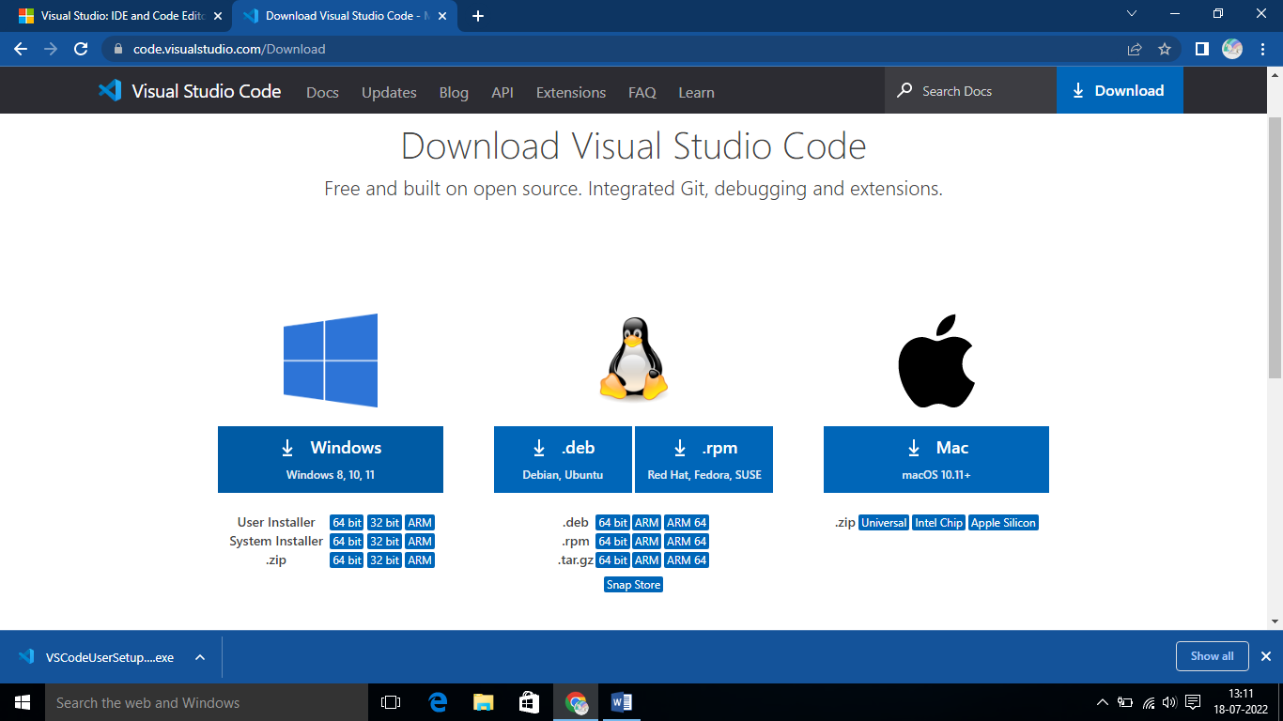

Example:

VSCodeUserSetup-x64-1.69.1.exe

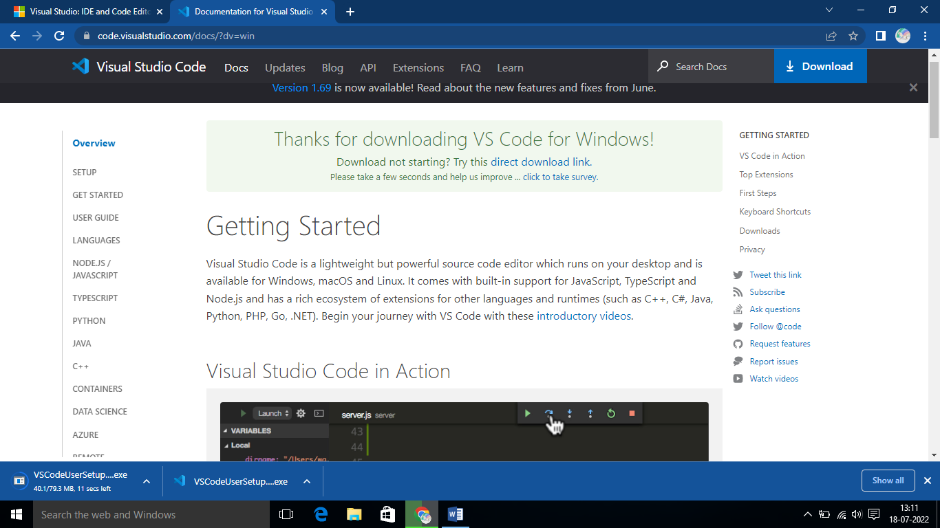

**Wait till user setup download.**

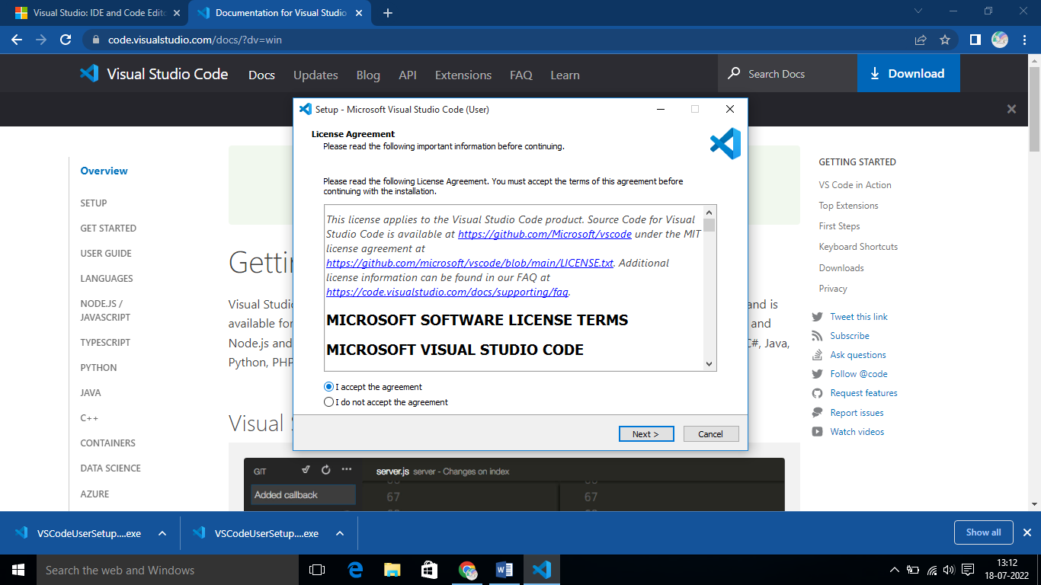

**Once downloaded, customize your VSC on device.**

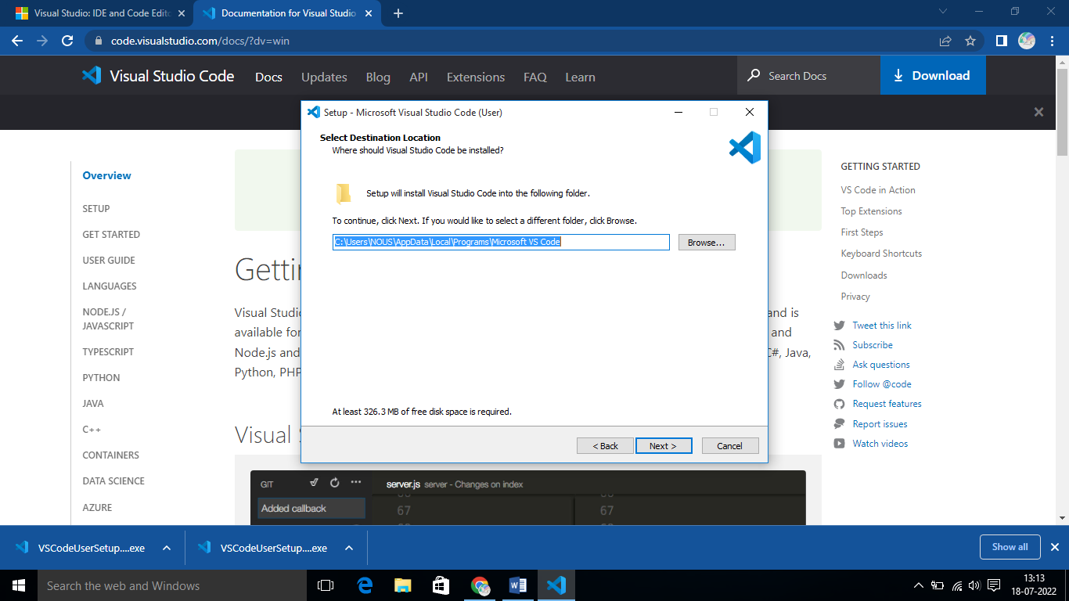

By default, VS Code is installed under:

**C:\Users\{Username}\AppData\Local\Programs\Microsoft VS Code.**

MAKE INSTALLATION SUCCESSFUL WITH FOLLOWING:

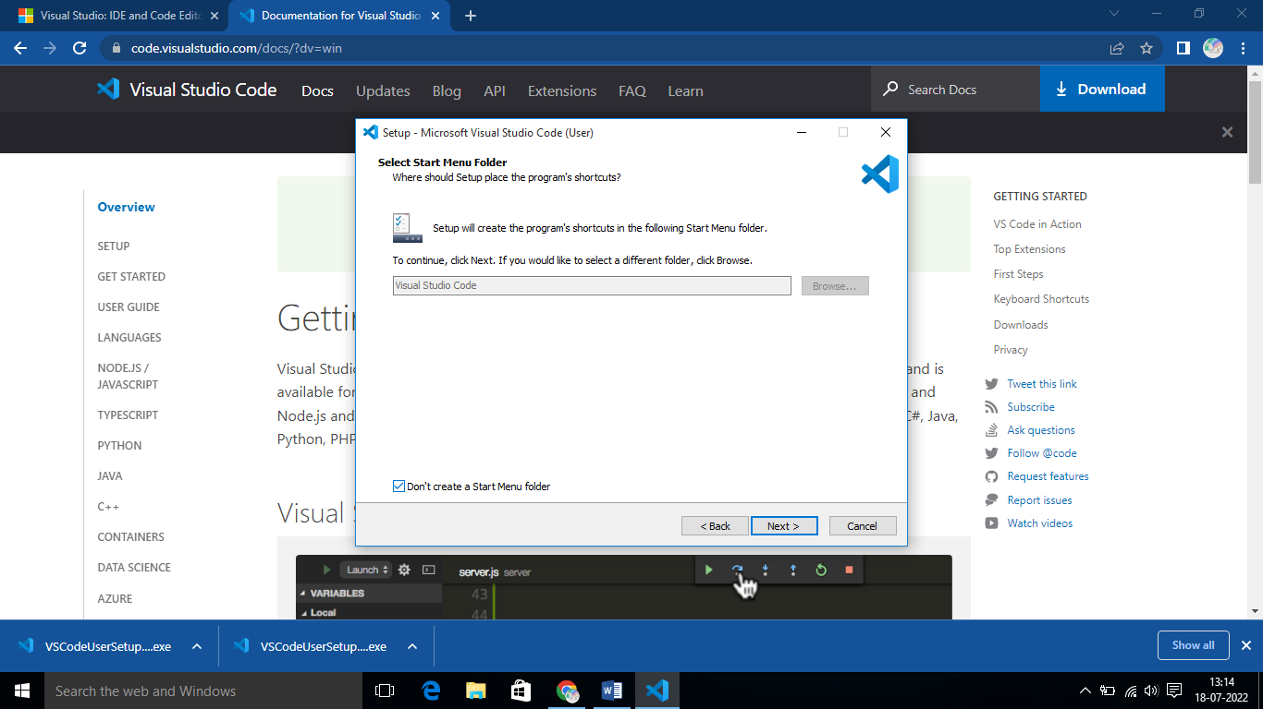

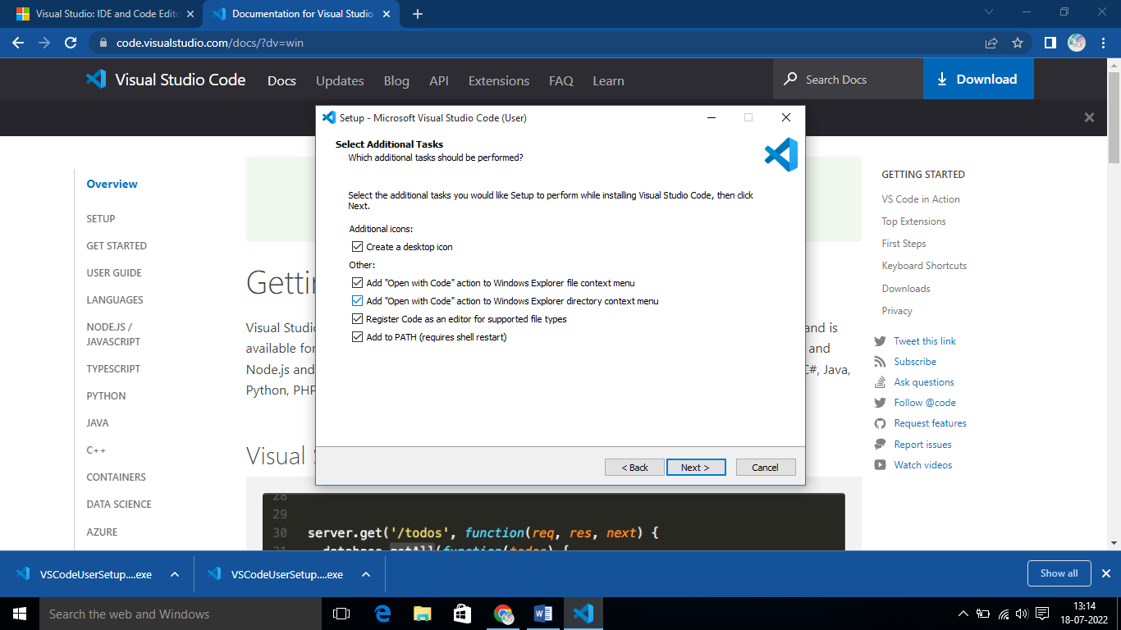

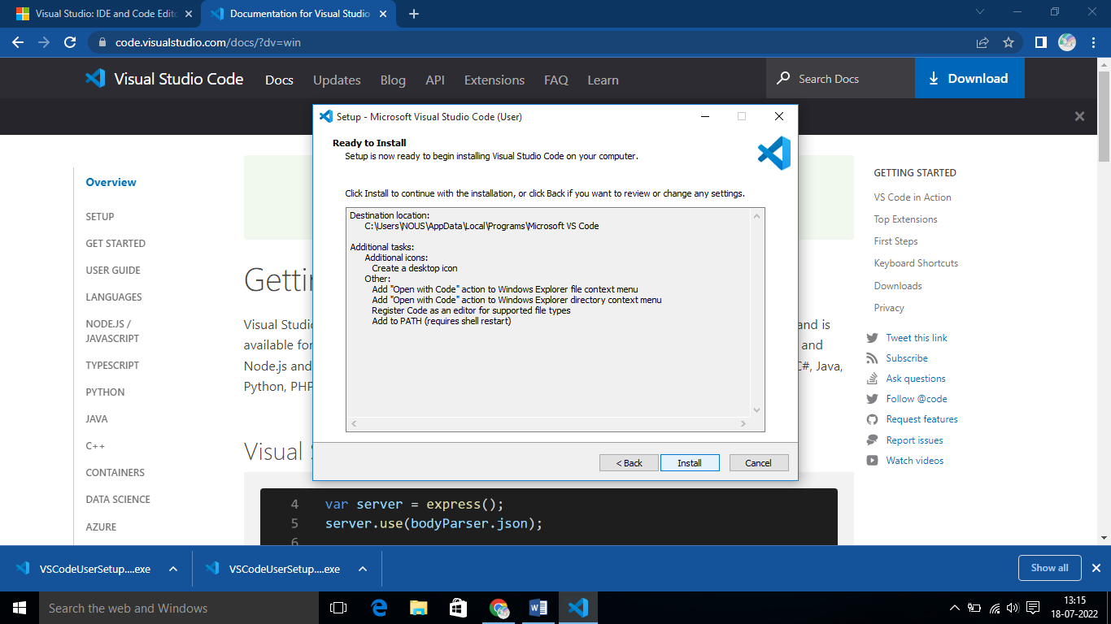

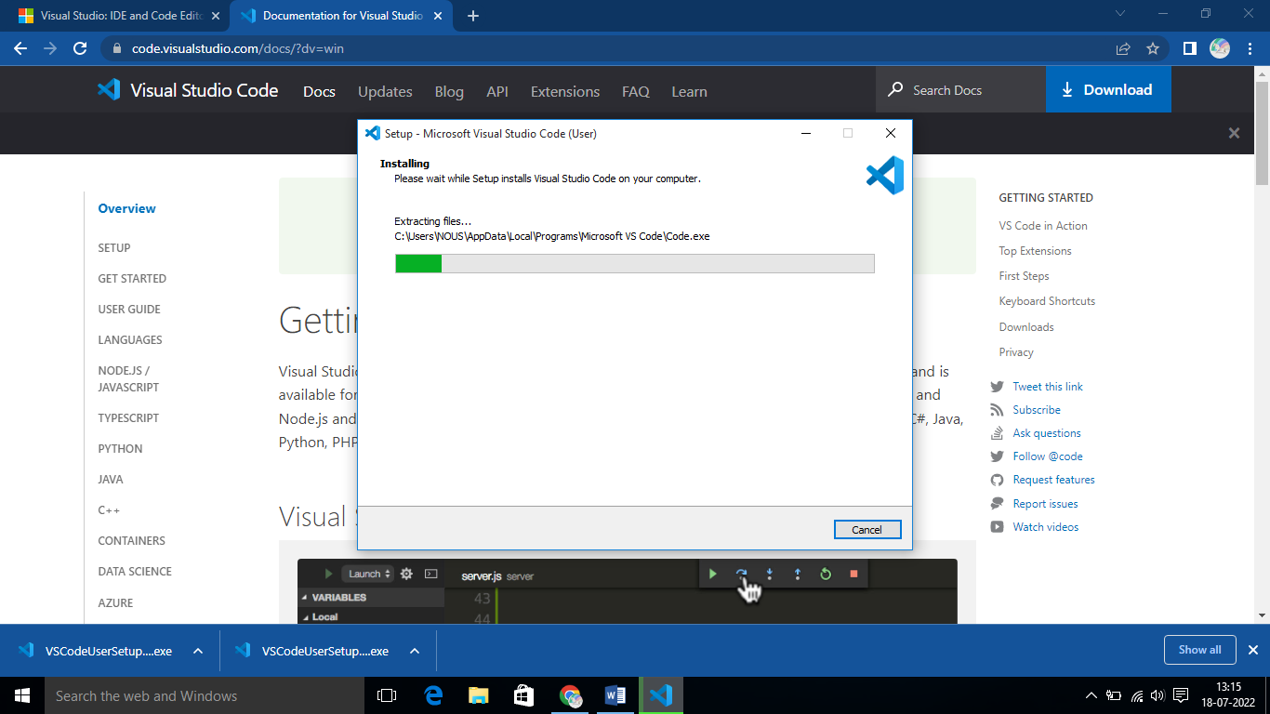

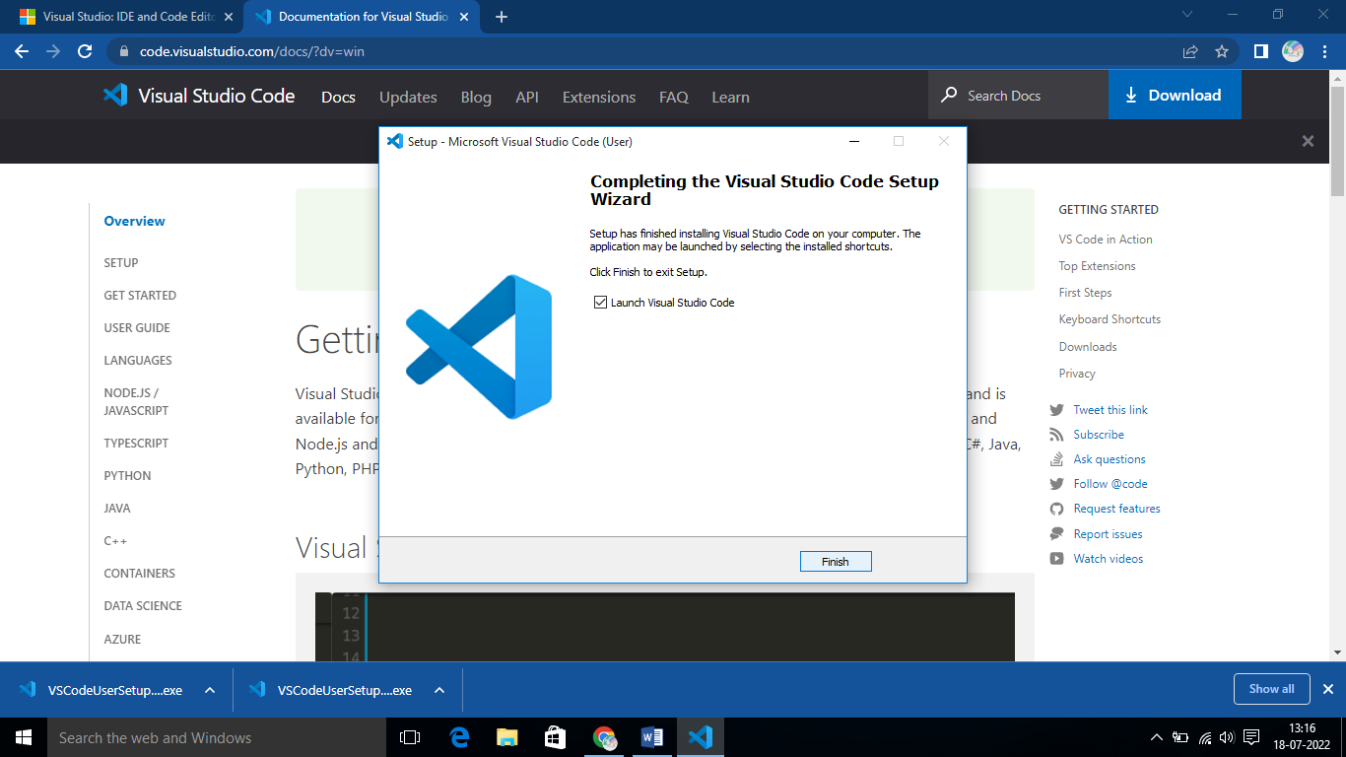

After this final process your VSC is getting started on your desktop.

**Step 3**

**Getting Started:**

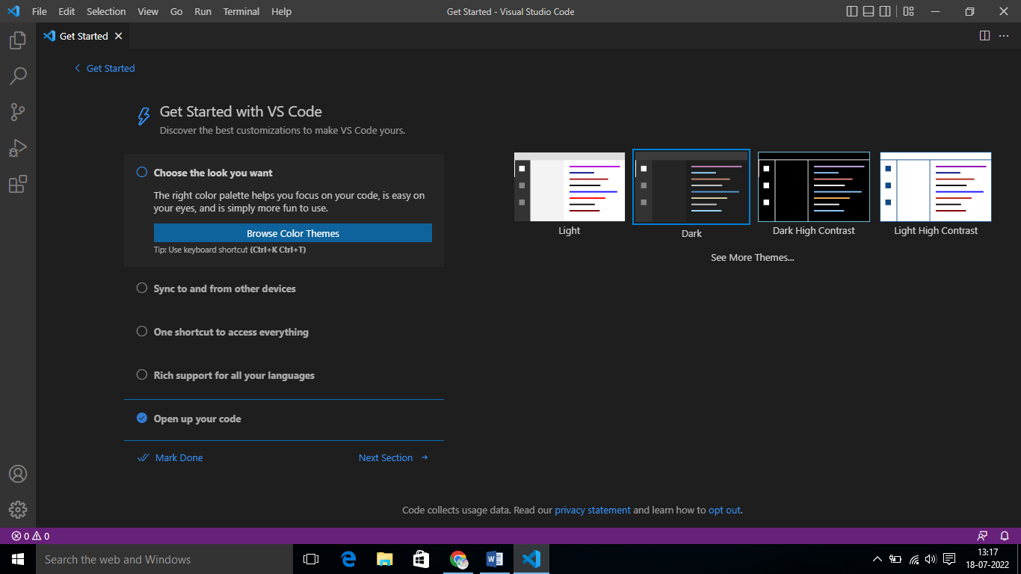

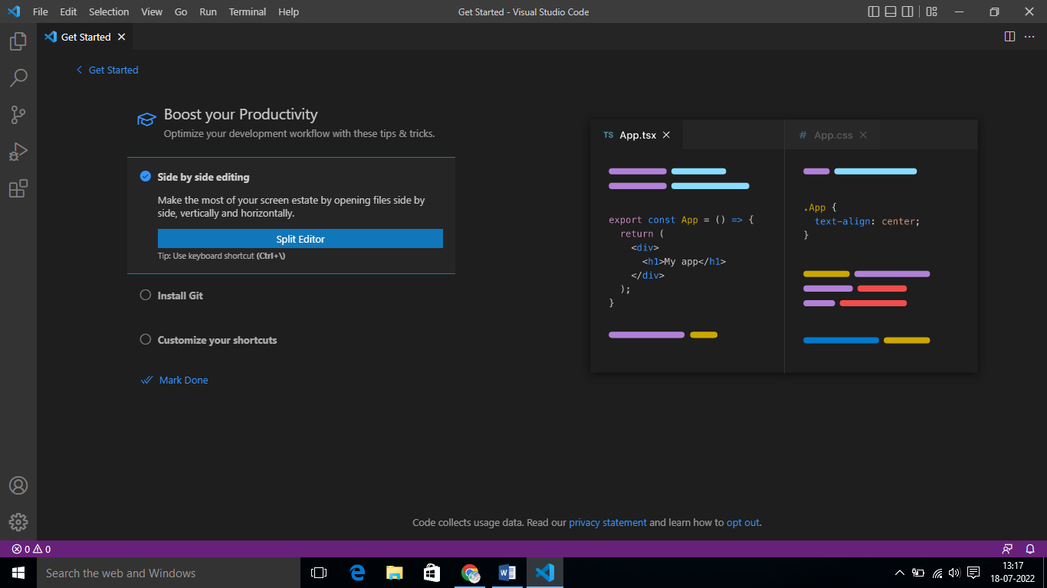

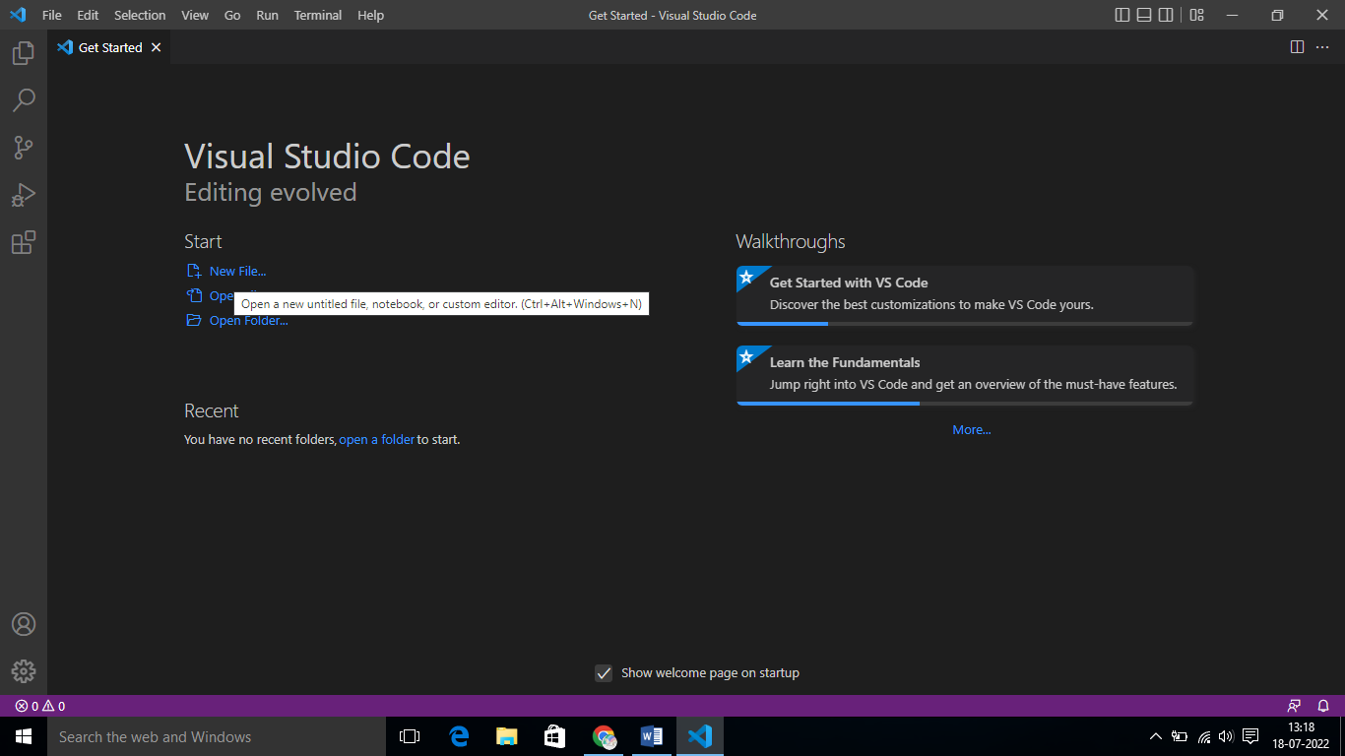

Once done , work with VSC.

**Choose a directory**

**User Interface:** Basic Layout

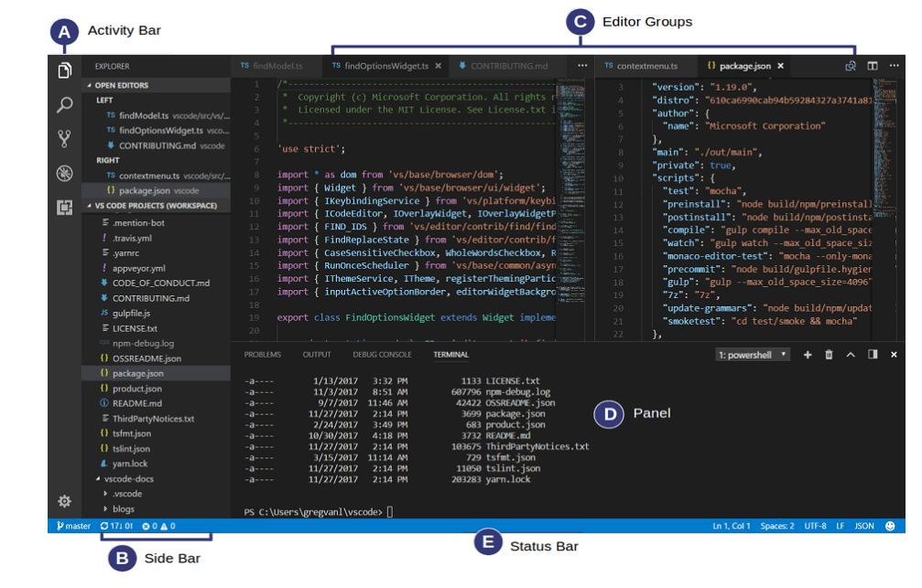

**The UI is divided into five areas:**

* **Editor** - The main area to edit your files. You can open as many editors as you like side by side vertically and horizontally.
* **Side Bar** - Contains different views like the Explorer to assist you while working on your project.
* **Status Bar** - Information about the opened project and the files you edit.
* **Activity Bar** - Located on the far left-hand side, this lets you switch between views and gives you additional context-specific indicators, like the number of outgoing changes when Git is enabled.
* **Panels** - You can display different panels below the editor region for output or debug information, errors and warnings, or an integrated terminal. Panel can also be moved to the right for more vertical space.

**Extensions:**

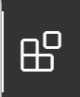

On Activity you can able to see Extension symbol, which helps you to download different extensions.

**HTML CSS Support**

**HTML Snippets**

**HTMLHint**

**Auto Rename Tag**

**Rainbow Brackets**

**Live Server**