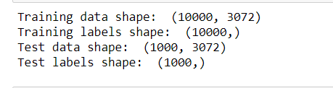



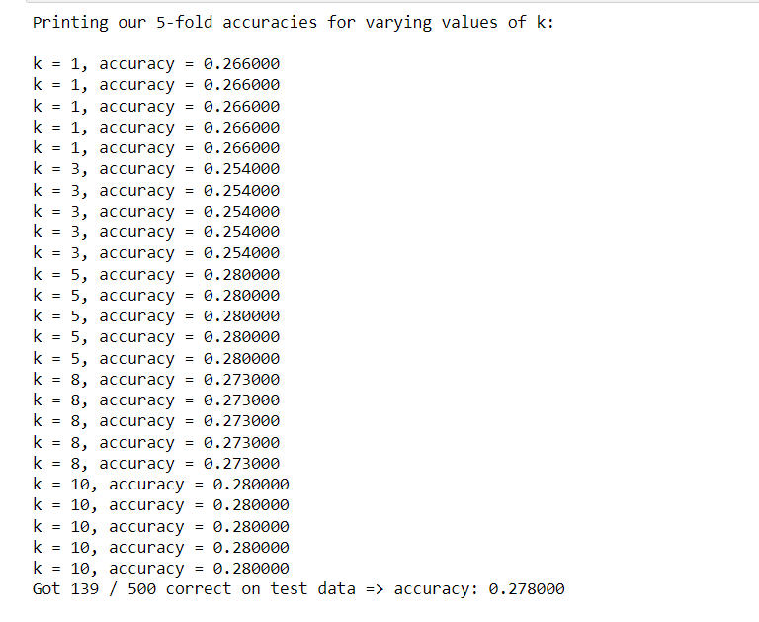

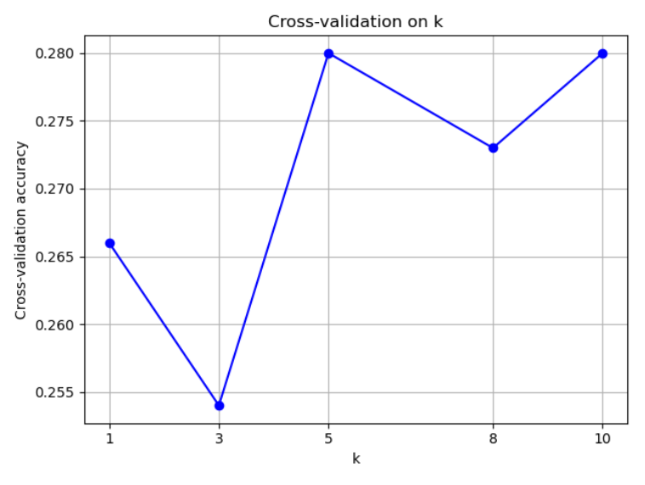

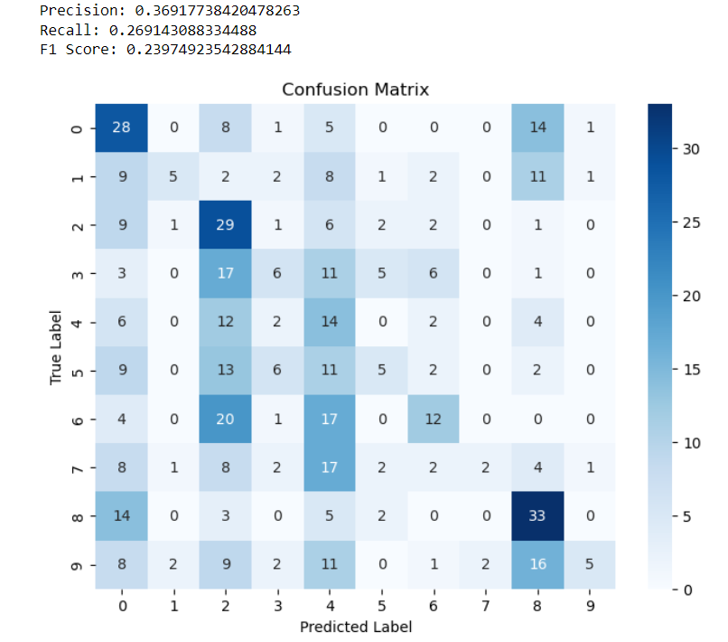

Overview:

The results obtained from running the K-nearest neighbour (KNN) classifier on the CIFAR-10 dataset show that the model achieved an accuracy of approximately 29% when using the Euclidean distance metric and 31% when using the Manhattan distance metric. These accuracies were computed on a test set comprising 500 samples, with the training set consisting of 5000 samples.

Performing cross-validation to find the optimal value of k is essential as it helps in selecting a hyperparameter that generalizes well to unseen data. By iteratively evaluating the model on different subsets of the training data, cross-validation provides a more reliable estimate of the model's performance and helps prevent overfitting.

Despite its simplicity, the KNN classifier's performance on the CIFAR-10 dataset is relatively modest compared to more sophisticated models such as neural networks (NN) or convolutional neural networks (CNNs). These models can learn complex patterns and representations directly from the raw pixel data, leading to significantly higher accuracies on image classification tasks like CIFAR-10. However, it's worth noting that KNN serves as a baseline model and can be useful in certain scenarios, particularly when interpretability and simplicity are prioritized over performance.