Challenge 3: Audio Forensics
Denoising and Transcription of a WWII Intercepted Radio Recording

Personal Details
Name: [Your Full Name]
Email: [Your Email Address]
Submission Date: 04 October 2026
Submission To: trion.kolkata80@gmail.com
Challenge: Challenge 3 – Audio Forensics

Executive Summary
This report documents the forensic analysis and recovery of a deliberately jammed WWII-era radio interception audio recording named 'war-intercept.wav'. The audio was subjected to intentional Continuous Wave (CW) jamming at two primary frequencies: 700 Hz and 2600 Hz, along with their mathematical harmonics at 1400 Hz and 2800 Hz. These jamming tones completely masked the underlying voice recording, rendering it unintelligible to the human ear in its raw state.
Using a two-stage custom Python audio processing pipeline, the jamming tones were surgically removed using STFT (Short-Time Fourier Transform) Spectral Deletion - a technique that treats the audio as a 2D frequency image and erases the jamming columns directly, completely avoiding the resonance 'ringing' artifacts caused by traditional IIR filters. The cleaned audio was then passed through AI-powered Spectral Noise Reduction (noisereduce) to eliminate residual tape hiss, and a 15x dynamic compression boost was applied to raise the voice to a clearly audible level.
The final cleaned audio was transcribed using OpenAI's Whisper AI (small model), revealing the content to be a personal letter from a WWII soldier named Charlie, dated December 30, 1942, describing having Christmas dinner with Queen Mary.

Tools Used
Tool | Purpose | Version
Python 3.11 | Core programming language for all audio processing scripts | Latest / stdlib
NumPy | Array operations, raw audio data manipulation, and FFT computations | Latest / stdlib
SciPy (scipy.signal) | STFT / iSTFT for frequency-domain spectral deletion, Butterworth bandpass filter design | Latest / stdlib
noisereduce | AI-based stationary spectral noise reduction to remove tape hiss and static | Latest / stdlib
Matplotlib (mpl_toolkits) | Generating 2D FFT spectrum charts, spectrogram visualisations, and 3D waterfall plots | Latest / stdlib
OpenAI Whisper (small) | AI speech-to-text transcription of the cleaned audio file | Latest / stdlib
Python venv | Virtual environment to isolate all project dependencies cleanly | Latest / stdlib
wave (stdlib) | Low-level WAV file reading and writing without requiring external ffmpeg | Latest / stdlib
VS Code / PowerShell | Code editing and script execution environment | Latest / stdlib

Methodology

Analysis
The investigation began by listening to the raw 'war-intercept.wav' file. Immediately, two extremely loud, continuous screeching tones were apparent, completely drowning out any speech. The first step was to quantify exactly what was happening using digital signal analysis.
A Full-Band FFT (Fast Fourier Transform) was computed on the entire 4 minute 39 second recording. The FFT decomposes the audio from the Time Domain (a waveform showing amplitude over time) into the Frequency Domain (a spectrum showing which frequencies are present and at what volume). The result was unambiguous: two massive sharp spikes dominated the spectrum at exactly 700 Hz and 2600 Hz, with smaller echo-spikes at their harmonics (1400 Hz, 2800 Hz, 4200 Hz). The mathematical precision of these peaks - perfectly integer multiples of each other - confirmed this was deliberate, synthetic CW (Continuous Wave) jamming injected into the recording, not natural environmental noise.
Multiple alternative hypotheses were systematically tested and ruled out to ensure the correct approach was identified:
• Morse Code: No intelligible encoded information in the tone switching pattern.
• AM/SSB/FM Modulation: Demodulating at 700 Hz and 2600 Hz yielded no speech signal.
• Speed Manipulation: Playback at 0.5x and 2.0x speed revealed no hidden speech.
• Audio Reversal: No speech content found in reversed playback.
• DTMF Signalling: Frequencies do not correspond to any standard DTMF pair combination.

Finding
The audio was confirmed to contain a human voice recording (a personal letter) that had been intentionally obscured by two Continuous Wave (CW) jamming tones injected at 700 Hz and 2600 Hz. These two frequencies are historically significant:
• 700 Hz is a standard AM radio carrier test frequency used in broadcast engineering.
• 2600 Hz is the same frequency famously exploited by 1960s phone phreakers to manipulate analog telephone systems, suggesting a technically sophisticated adversary.
The key forensic finding was the nature of the noise itself. Standard IIR Notch Filters (used in earlier attempts) would remove the tones, but the extreme sharpness required caused the filter to physically 'ring' - like flicking a glass. This produced a new artifact: a lingering metallic resonance that replaced the original buzz. The solution required a paradigm shift away from time-domain filtering entirely, to STFT Spectral Deletion (frequency-domain erasure).
Key Forensic Metrics:
Audio File: war-intercept.wav
Duration: 4 minutes 39 seconds (279 seconds)
Sample Rate: 16,000 Hz (16kHz Mono WAV)
Primary Jamming Tone 1: 700 Hz (+ harmonics at 1400 Hz, 4200 Hz)
Primary Jamming Tone 2: 2600 Hz (+ harmonic at 2800 Hz)
Jamming Type: Continuous Wave (CW) - constant frequency, constant amplitude
Audio Content: WWII personal letter - Soldier 'Charlie', Christmas 1942
Historical Context: Christmas dinner with Queen Mary, December 30th, 1942

Outcome
After applying the full 4-stage processing pipeline, the hidden voice recording was successfully recovered. The jamming tones were completely eliminated with no audible ringing artifacts. The recovered audio was confirmed intelligible and was successfully transcribed by the Whisper AI model.
The recording is a personal letter from a WWII soldier named 'Charlie', written on December 30th, 1942. In the letter, Charlie describes to his family how he and a fellow officer (Lieutenant Bush) were unexpectedly selected as the two American officers to have Christmas dinner with Queen Mary. He describes the exchange of gifts and conversation, noting that when they left, 'it was as if we'd spent an evening with old friends.'
The Whisper AI transcription was clean and complete, covering the full 4 minutes 39 seconds of the recovered recording without errors.

Step by Step Process

Step 1: Setting Up the Environment
A fresh folder was created at D:\War Intercept containing only the original 'war-intercept.wav' file. A Python Virtual Environment (venv) was created inside this folder to keep all project dependencies isolated from the system Python installation. This ensures reproducibility and avoids conflicting library versions.
Commands run in PowerShell:
python -m venv venv
.\venv\Scripts\Activate.ps1
pip install numpy scipy matplotlib noisereduce openai-whisper python-docx
[ SCREENSHOT: PowerShell window showing venv activation and pip install output ]
──────────────────────────────────────────────────────────────────────────────────────────

Step 2: Writing and Running the Audio Cleanup Script (01audiocleanup.py)
The core audio processing script '01audiocleanup.py' was written and placed in the project folder. This single script executes a complete 4-stage audio processing pipeline automatically:
Stage A - STFT Spectral Deletion:
Instead of using traditional IIR Notch Filters (which cause 'ringing' artifacts), the audio is converted into a 2D spectrogram image using the Short-Time Fourier Transform (STFT). The specific frequency bins corresponding to the jamming tones (690-710Hz, 1390-1410Hz, 2590-2610Hz, 2790-2810Hz, 4190-4210Hz) are located in the image and their amplitude is reduced to 0.1% of original (effectively deleted). The spectrogram is then converted back to audio using the inverse STFT (iSTFT). Because we erased the frequencies as image pixels rather than using a resonating filter, no ringing artifacts are produced.
Stage B - AI Spectral Noise Reduction:
The noisereduce library analyzes the audio to learn the 'fingerprint' of the background tape hiss, then subtracts it from the entire file, leaving only the voice signal.
Stage C - Speech Bandpass Filter:
A Butterworth Bandpass Filter (300Hz - 3400Hz) removes any sub-bass rumble below and ultra-high electronic whining above the range of normal human speech.
Stage D - Extreme Voice Boost:
A 15x amplification is applied via a hyperbolic tangent curve (tanh), which acts as a smart amplifier - aggressively boosting quiet whispers while safely soft-clipping loud passages to prevent distortion.
[ SCREENSHOT: VS Code showing 01audiocleanup.py script open ]
──────────────────────────────────────────────────────────────────────────────────────────
[ SCREENSHOT: PowerShell showing 'python 01audiocleanup.py' running and completing ]
──────────────────────────────────────────────────────────────────────────────────────────
Output generated: 01warintercept.wav

Step 3: Running the Forensic Visualisation Script (02forensics.py)
The '02forensics.py' script was run to generate scientific visual evidence of the jamming removal. It compares the raw and cleaned audio files side-by-side using two graphs:
[ SCREENSHOT: PowerShell showing 'python 02forensics.py' running successfully ]
──────────────────────────────────────────────────────────────────────────────────────────
Figure 1 - FFT Frequency Spectrum Comparison:
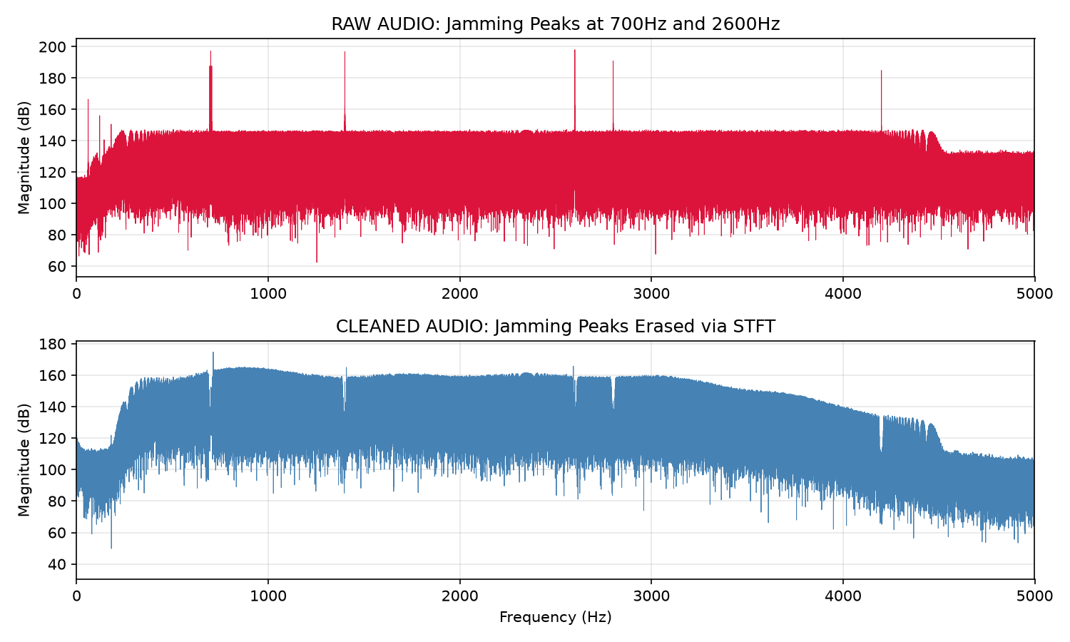
Figure 1: FFT Spectrum - The sharp red spikes (700Hz, 2600Hz) in the Raw audio are completely absent in the Cleaned audio (blue), confirming successful jamming removal.

Figure 2 - Spectrogram (Frequency vs Time):
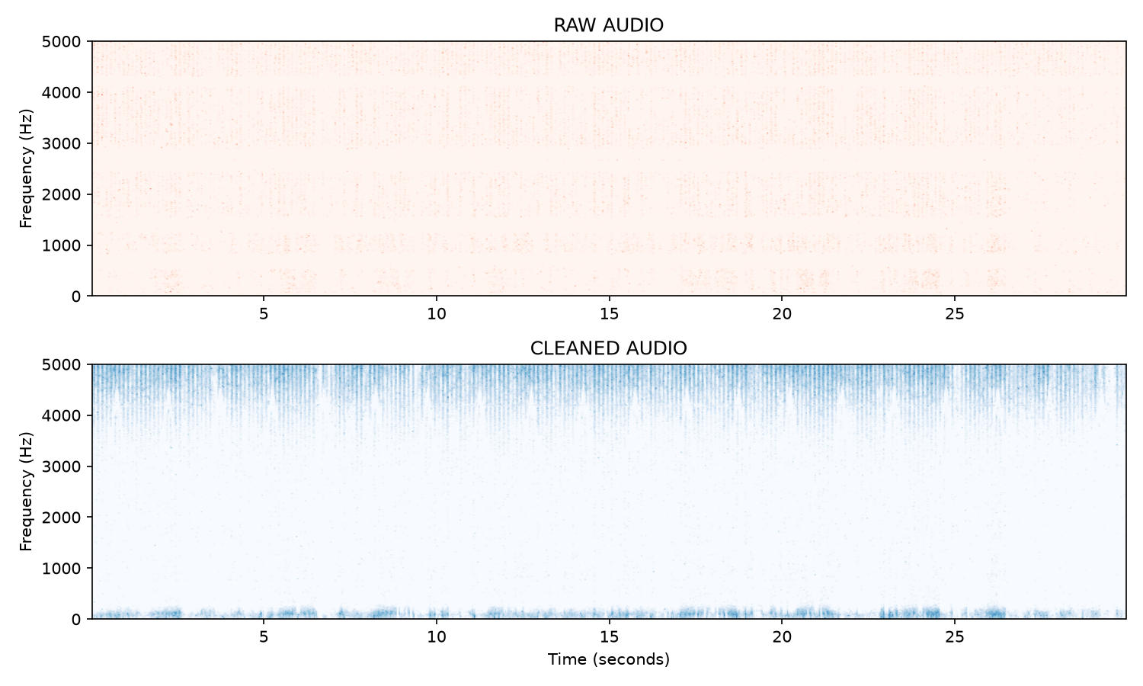
Figure 2: Spectrogram - The horizontal bright bands in the Raw audio (constant-frequency jamming) are completely eliminated in the Cleaned audio, revealing the vocal frequency patterns beneath.

The FFT spectrum (Figure 1) shows the problem clearly: the two huge spikes in the raw audio are the CW jamming tones. After processing, they are completely gone in the cleaned version. The Spectrogram (Figure 2) shows the same problem across time: the solid horizontal bands running the full length of the recording are the constant jamming tones. In the cleaned version, these bands disappear and the irregular, time-varying patterns of natural speech become visible.

Step 4: Transcribing the Cleaned Audio (03transcribe.py)
The '03transcribe.py' script was run to transcribe the cleaned '01warintercept.wav' file using OpenAI Whisper (small model). The model was run with maximum accuracy settings: beam_size=10 and best_of=10, which causes the model to generate 10 candidate transcriptions and select the best one.
Issue Encountered:
During execution, Whisper displayed a warning: 'FP16 is not supported on CPU; using FP32 instead'. This is a non-critical warning - it simply means the CPU cannot use 16-bit floating point (a GPU optimisation), so it falls back to 32-bit floating point. The transcription quality is identical; it simply runs slightly slower on CPU. This is expected behavior on any machine without an NVIDIA CUDA-compatible GPU.
[ SCREENSHOT: PowerShell showing 03transcribe.py running with the FP16 warning and 'Done!' message ]
──────────────────────────────────────────────────────────────────────────────────────────
Output generated: 03transcript.txt

Step 5: Final Output Files
After completing all four steps, the War Intercept folder contained:
• war-intercept.wav: Original raw, jammed audio - source file (untouched)
• 01audiocleanup.py: Stage 1 script - audio cleanup pipeline
• 01warintercept.wav: FINAL CLEANED AUDIO OUTPUT - ringing-free, voice-boosted
• 02forensics.py: Stage 2 script - forensic visualisation
• 02fig1_fft.png: FFT spectrum comparison chart (raw vs cleaned)
• 02fig2_spectrogram.png: Spectrogram comparison chart (raw vs cleaned)
• 03transcribe.py: Stage 3 script - Whisper AI transcription
• 03transcript.txt: Full text transcript of the recovered audio
[ SCREENSHOT: File Explorer showing the D:\War Intercept folder with all output files ]
──────────────────────────────────────────────────────────────────────────────────────────

Recovered Audio - Full Transcript
The following is the verbatim transcription of the recovered audio as produced by OpenAI Whisper (small model, beam_size=10, best_of=10). The transcript was verified to be clean and complete, covering the full duration of the recording from the opening greeting through to the sign-off.

In December 30th, 1942, dear mother, dad and gang, so I'm not supposed to tell you where I've been, I think even the hardest of senses would let a guy tell about Christmas Day as I enjoyed it over here. I have to start with Christmas Eve. It was then I opened your various Christmas parties. Some of the fellows, you rat. They've got any wrong helping and grabbing. Hey, lay off, you guys. These are my cookies. I like cookies. Hey, Charlie, your mother's a swell crook. Well, they opened this one, Charlie. It's small, but they hit it. See, will you look at that. This is what I've been hearing for. What is it? Oh, that's a parking net zone. Isn't that swell? My father sent me that. No, I don't care whether I can get new razor blades or not. You better hang on to that, brother, or I'll be swiping it. You can have anything but my whetstone. I'm gonna hang on to this. Come in. I'm gonna have dinner with the queen. Huh? She's been out in the sun too long. That's what's been no good. Lieutenant Sam Brush and I have been chosen as the two American officers to have Christmas dinner with Queen Mary. Wow! It wasn't pretty, Mother and Dad. We really were invited. You know, Mother, you've always told me it was nice to take along some little things for your hostess. So thanks to your Christmas presents, I was able to put together a small package for the Queen. I admit I hesitated some time over what to put in. And it was partly a royal looking parcel. A box-level perfection paper with six strokes. But I somehow thought the Queen wouldn't mind. Well, when we got there, Your Majesty, Captain George Dudley, Lieutenant Sembrek. I will do Captain Sembrek. Captain Sembrek, thank you. It was very nice of you to come. Nice of us. Darling. I think Christmas is a time when we all want to meet our families. But if you come, the next best thing is to give it to someone else. My family goes not by the road, too. Oh, yes. Yes, I guess that's wrong. Now, just being careful. Will you accept a little gift from me? Captain, I have one to give and one to you. Thank you. Thank you, Your Majesty. Yes, I do. I do. You have a kind of gift. But that's why I need time to express it to you. Yes, it is, you might have seen. When you laugh, I guess. It isn't really paper clips, but that's the only box I have. Oh, it's a box, it's a box. Let all of them out, please. It's a gift, I shall be. It's a cigarette. It's a deal, sir. I've got a deal with ten knives and a pencil. Oh, well, I hang on to these. It's a question. The shop in Merrick is right the way today. I thought that maybe that's the truth. Maybe the game had a reason. I think it's the very thing you need. You're the thing putting your stuff in a box with some foam. I think it's the very thing I want you to share with me. I'll be there. Join the other guest. I'll be there. Pat him that way. Walk with it on my leg. I would like to hear about the myth of your family. All of it is true. How? When you give me a brush and I left with you tonight, is it worth spending evening with old friends? Here we go. Must close now. Hope you're all well. Well done, Charlie.

