This project is made in accordance to the project guidelines as per GGSIPU syllabus

The source code can be accessed at: [https://github.com/Hriday31/CProject](https://github.com/Hriday31/CProject%20)

Code:

***//Header files***

***#include <stdio.h>***

***#include <string.h>***

***#include <stdlib.h>***

***//Declaring global variables***

***int d,size,w=0,r,q=0,marks=0,k,newdob,columns=120,p;***

***FILE *f;***

***char newname[30],subject_code,*name2;***

***//Initialising Functions***

***void pr();***

***void gotoxy();***

***void welcome();***

***void paper();***

***void debug();***

***void displayrecord();***

***struct student{***

***int roll_no;***

***int dob;***

***char name[30];***

***int score_pe;***

***int score_phy;***

***int score_chem;***

***int score_polsci;***

***int score_psy;***

***};***

***//Main Function body***

***int main()***

***{***

***printf ( "\033[2J");***

***system("cls");***

***struct student s1[100]={{14801,31122003,"Hriday Aggarwal",10,9,9,0,7},{14802,21032005,"Anandita",10,10,9,8,0},{14803,14122007,"Sabhyata",10,10,9,0,8},};***

***size=sizeof(s1)/sizeof(s1[0]);***

***int l=3;***

***p1:{welcome();}***

***for (int i=0;i<(size);i++){***

***if(r==s1[i].roll_no)***

***{   w=1;***

***if(d==s1[i].dob){***

***p2:{printf ( "\033[2J");}***

***gotoxy(0,0);***

***pr("","~");***

***pr("Welcome Back"," ");***

***pr(s1[i].name," ");***

***pr("","~");***

***gotoxy(27,0);***

***pr("","~");***

***gotoxy(10,10);***

***printf("Your Previous Scores are\n\n\tPhysical Education : %d\n\tPhysics : %d\n\tChemistry : %d\n\tPolitical Science : %d\n\tPsychology : %d\n",s1[i].score_pe,s1[i].score_phy,s1[i].score_chem,s1[i].score_polsci,s1[i].score_psy);***

***p3 : { gotoxy(20,10);***

***printf("Enter Subject code:\n\tA. Physical Education\n\tB. Physics\n\tC. Chemistry\n\tD. Political Science\n\tE. Psychology\n ");***

***debug();***

***gotoxy(20,35);***

***scanf("%s", &subject_code);}***

***printf ( "\033[2J");***

***gotoxy(0,0);***

***FILE *f;***

***switch(subject_code)***

***{***

***case 'A' : f=fopen("PE.txt","r");***

***paper(f);***

***s1[i].score_pe=marks;***

***break;***

***case 'B' : f=fopen("physics.txt","r");***

***paper(f);***

***s1[i].score_phy=marks;***

***break;***

***case 'C' : f=fopen("chem.txt","r");***

***paper(f);***

***s1[i].score_chem=marks;***

***break;***

***case 'D' : f=fopen("polsci.txt","r");***

***paper(f);***

***s1[i].score_polsci=marks;***

***break;***

***case 'E' : f=fopen("psych.txt","r");***

***paper(f);***

***s1[i].score_polsci=marks;***

***break;***

***default:***

***{printf ( "\033[2J");***

***pr("","~");***

***pr("This is an invalid subject code."," ");***

***pr("","~");***

***gotoxy(27,0);***

***pr("","~");***

***goto p3;}***

***}***

***if(q==0){scanf("%d",&q);***

***printf("%d",q);***

***printf ( "\033[2J");***

***goto p4;}***

***}***

***if(d!=s1[i].dob){***

***printf ( "\033[2J");***

***gotoxy(20,10);***

***printf("Hello %s \n",s1[i].name);***

***gotoxy(21,10);***

***printf("You entered the wrong date of birth please try again");***

***goto p1;***

***}***

***printf ( "\033[2J");***

***p4:{gotoxy(0,0);***

***pr("","~");***

***pr("Test Submitted Successfully"," ");***

***pr("","~");***

***gotoxy(27,0);***

***pr("","~");}***

***gotoxy(8,0);***

***pr(" Your updated score is: "," ");***

***gotoxy(10,10);***

***printf("Physical Education \t\t%d\n",s1[i].score_pe);***

***gotoxy(11,10);***

***printf("Physics \t\t\t%d\n",s1[i].score_phy);***

***gotoxy(12,10);***

***printf("Chemistry \t\t\t%d\n",s1[i].score_chem);***

***gotoxy(13,10);***

***printf("Political Science\t\t%d\n",s1[i].score_polsci);***

***gotoxy(14,10);***

***printf("Psychology\t\t\t%d\n",s1[i].score_psy);***

***gotoxy(25,10);***

***printf("If you want to :");***

***gotoxy(26,10);***

***printf("Go back to tests page enter 1");***

***gotoxy(27,10);***

***printf("Exit enter 2:\t\t\t");***

***scanf("%d",&k);***

***switch(k)***

***{***

***case 1: {***

***printf ( "\033[2J");***

***goto p2;***

***break;}***

***case 2:{***

***exit(0);***

***break;}***

***default:***

***printf("\nINVALID CHOICE...\n");***

***goto p4;***

***}***

***}***

***}if(w==0)***

***{   printf ( "\033[2J");***

***gotoxy(0,0);***

***pr("","~");***

***pr("Sorry your Record does not exist"," ");***

***pr("","~");***

***gotoxy(10,10);***

***printf("If you want to :");***

***gotoxy(11,10);***

***printf("return to the previous page enter 1");***

***gotoxy(12,10);***

***printf( "sign up as new student enter 2: ");***

***gotoxy(27,0);***

***pr("","~");***

***gotoxy(12,45);***

***scanf("%d",&p);***

***switch(p)***

***{***

***case 1: {***

***printf ( "\033[2J");***

***goto p1;***

***break;}***

***case 2: {gotoxy(8,10);***

***printf("Enter name : ");***

***gotoxy(8,40);***

***scanf("%s",&newname);***

***gotoxy(9,10);***

***printf("Enter you DOB : ");***

***gotoxy(9,40);***

***scanf("%d",&newdob);***

***s1[l].roll_no=14801+l;***

***s1[l].dob=newdob;***

***strcpy(s1[l].name , newname);***

***s1[l].score_pe=0;***

***s1[l].score_phy=0;***

***s1[l].score_chem=0;***

***s1[l].score_polsci=0;***

***s1[l].score_psy=0;***

***printf ( "\033[2J");***

***gotoxy(20,10);***

***printf("Welcome New User: %s", s1[l].name);***

***gotoxy(21,10);***

***printf("Your roll number is :%d", s1[l].roll_no);***

***l=l+1;***

***goto p1;***

***break;}***

***default: goto p1;***

***}***

***}***

***while(1){}***

***}***

***//Function definations***

***void paper(FILE *f)***

***{***

***char a,o,end;***

***pr("","~");***

***pr("TEST STARTS"," ");***

***pr("","~");***

***while(a!='|')***

***{***

***a=getc(f);***

***if (a=='~')***

***{   debug();***

***a=getc(f);***

***printf("\nEnter option : ");***

***scanf("%c",&o);***

***if (a==o)***

***{   marks++;***

***continue;***

***}***

***continue;***

***}***

***else if(a=='|'){break;}***

***else{***

***printf("%c",a);***

***}***

***continue;***

***}***

***pr("TEST ENDS","*");***

***pr("Enter 1 to go to results","-");***

***}***

***void gotoxy(int row,int col)***

***{***

***printf ( "\033[%d;%dH",row,col);***

***}***

***void welcome()//Page 1***

***{   gotoxy(0,0);***

***pr(" Welcome to Online Examination System ","~");***

***pr(" Please Login using your Credentials "," ");***

***gotoxy(27,0);***

***pr("","~");***

***gotoxy(10,10);***

***printf("Enter Your Roll Number -");***

***gotoxy(15,10);***

***printf("Enter Your DOB(ddmmyyyy) -");***

***gotoxy(10,50);***

***scanf("%d",&r);***

***gotoxy(15,50);***

***scanf("%d",&d);***

***}***

***void debug()***

***{char t;***

***scanf("%c",&t);***

***}***

***void pr(char a[100],char b[1])//Function to print text in centre of screen***

***{***

***int n;***

***n=strlen(a);***

***printf("\n");***

***for (int x=0;x<((columns-n)/2);x++)***

***printf("%s",b);***

***printf("%s",a);***

***for (int x=0;x<((columns-n)/2);x++)***

***printf("%s",b);***

***printf("\n");***

***}***

PROJECT RUN THROUGH :

WELCOME PAGE:

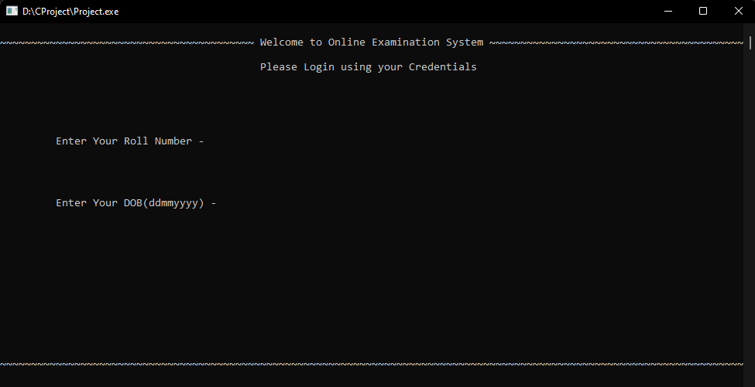

If the user fails to enter correct credentials-

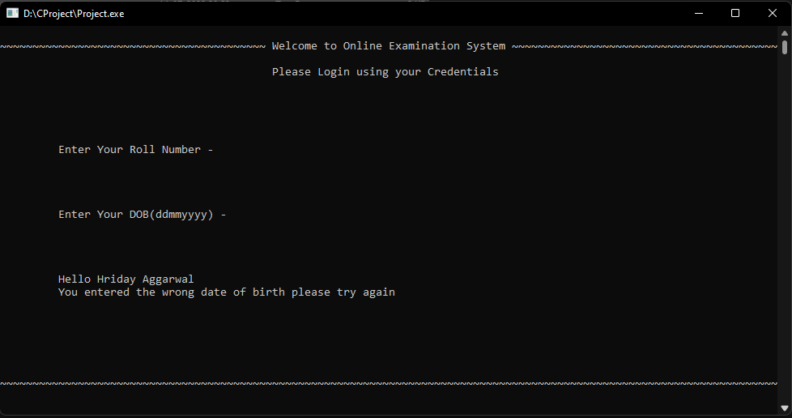

If the entered credentials do not exit-

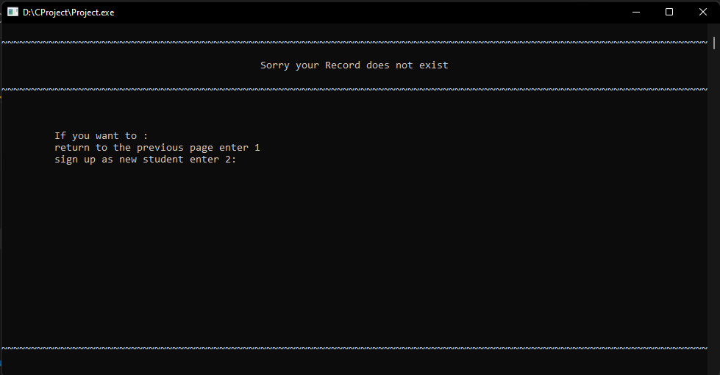

Registration of New User-

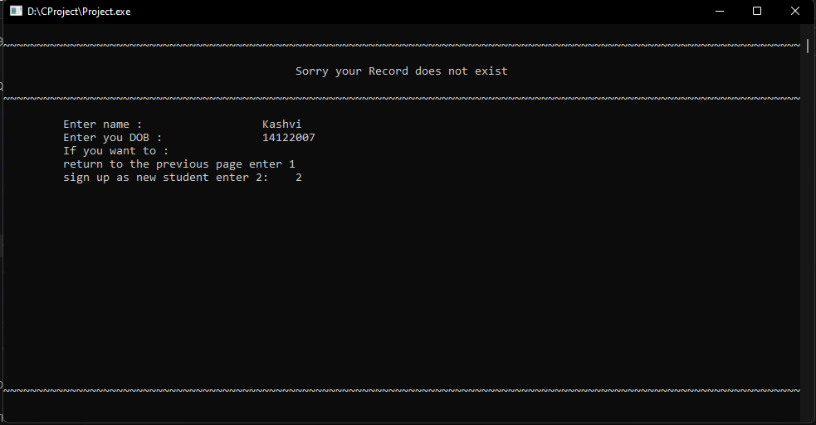

Logging in through new credentials-

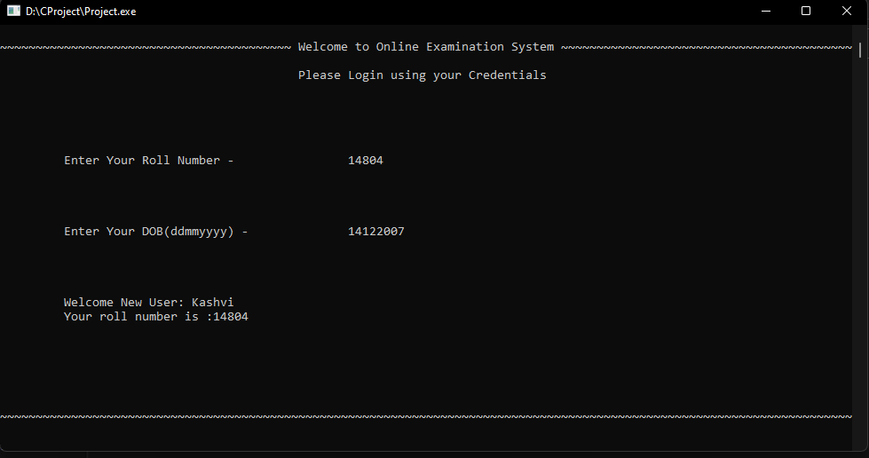

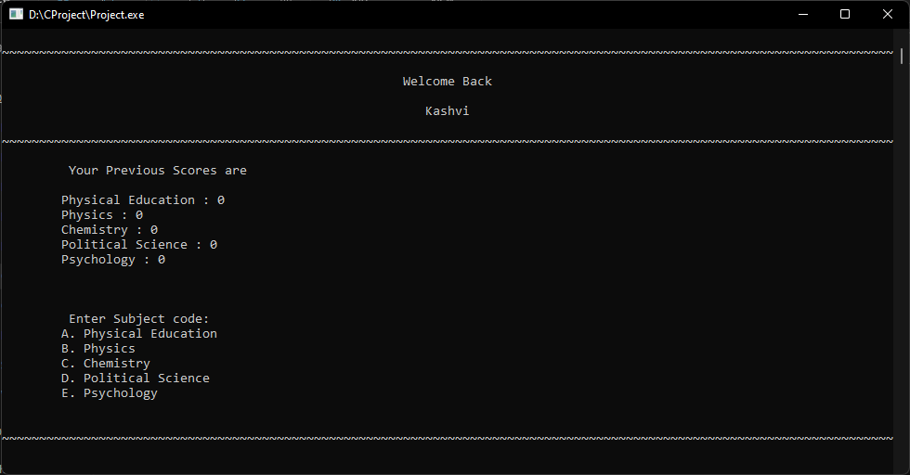TEST SELECTION PAGE:

If wrong paper code is given:

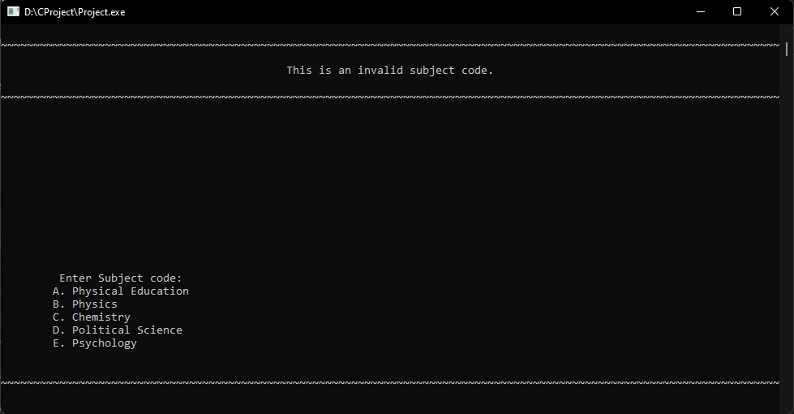

TEST PAGE:

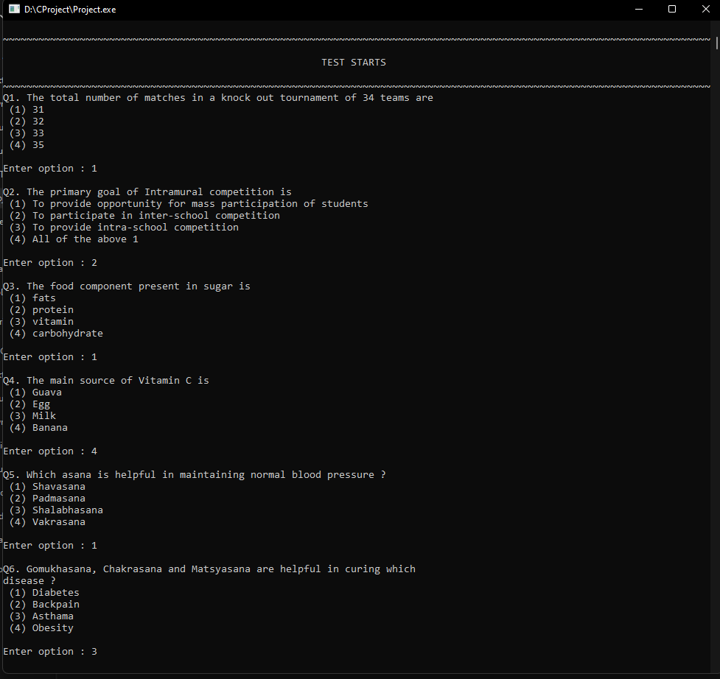

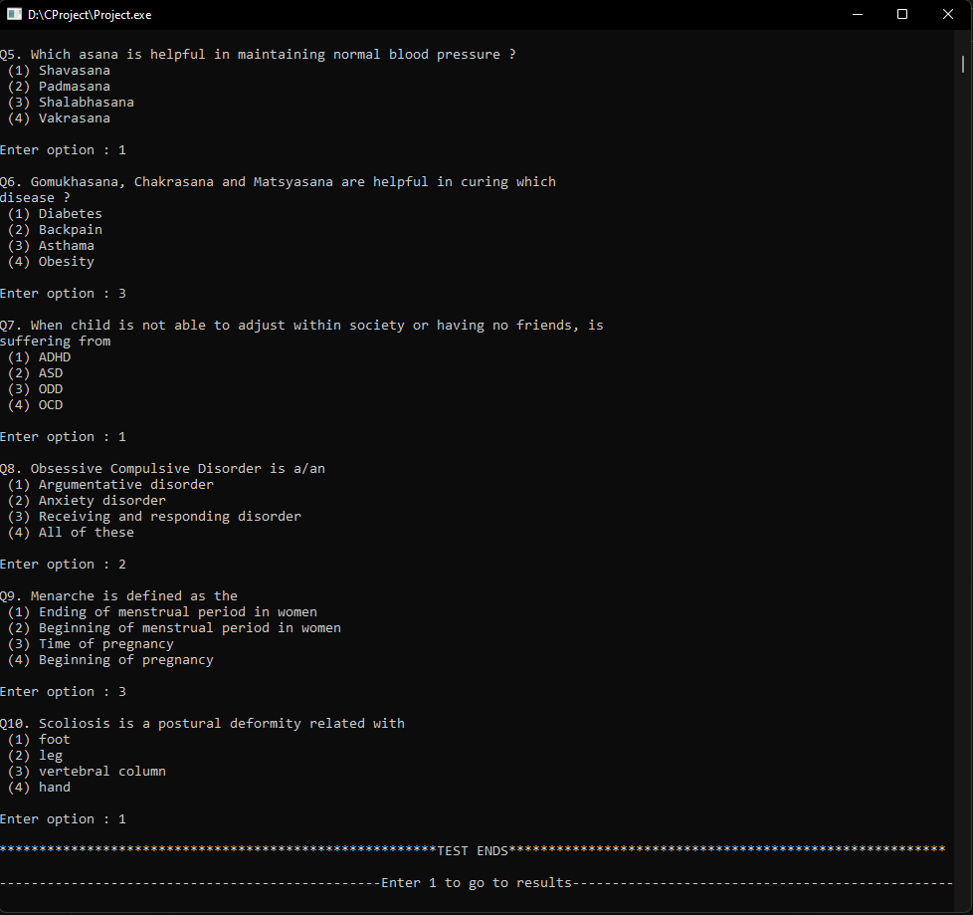

RESULTS PAGE:

