SIT315 Week 4 — M1 Report
QP1: PIR polling system | QP2: PIR interrupt and ultrasonic distance system
Item Details
Student name Hriday Bhadouria.

Student ID S224768021

Unit SIT315

Assessment Week 4 M1 — QP1 and QP2

What is this report about?
This report explains the two Week 4 practical systems using the supplied task-sheet requirements, final code files, screenshots and physical-setup photographs. It uses plain language and only describes results shown in the supplied evidence or in the final code.

What evidence was supplied?
- Final QP1 code: TaskM1.cpp.
- Final QP2 code: TaskM2.cpp.
- Two Arduino IDE / Serial Monitor screenshots for QP2.
- Five physical photographs of the breadboard prototype, sensors and LED.

What is not treated as a Week 4 requirement?
A reflection report is included here because it is useful for the student, but QP4-only requirements are not described as mandatory for Week 4. The Week 4 submission evidence remains the code, circuit evidence, Serial Monitor evidence and demonstration described by the task sheet.

QP1 — What did the system do?
QP1 is a basic motion-activated light or security simulation. The PIR sensor provides a digital input. The Arduino reads that input repeatedly, which is called polling. A polling program checks the sensor in the normal loop instead of using an interrupt.
When the PIR reports motion, the program turns the LED on. When it reports no motion, the program turns the LED off. The result is printed to Serial Monitor.

How was QP1 wired?
Part Connection
PIR sensor VCC → 5V; GND → GND; OUT → D2

LED D6 → resistor → LED positive leg; LED negative leg → GND

How did QP1 use Sense–Think–Act?
Stage Simple explanation
Sense The program reads the PIR state from D2 using digitalRead(). Think The if statement checks whether the PIR reading is HIGH.
Act The program writes HIGH or LOW to D6 and prints the result to Serial Monitor.

What does the final QP1 code do?
int motion = digitalRead(pirPin);

if (motion == HIGH) { digitalWrite(ledPin, HIGH);
Serial.println("Motion detected - LED ON");
} else {
digitalWrite(ledPin, LOW); Serial.println("No motion - LED OFF");
}
The final QP1 code uses a 500 ms delay between checks. It contains no attachInterrupt() call or ISR, which keeps it appropriate for the polling-based QP1 task.

QP1 — What physical evidence was supplied?
The following photos show the supplied breadboard prototype with the Arduino Nano 33 IoT, LED, PIR module and connecting wires. The captions only identify what is visible; exact pin connections are documented above from the final code and wiring plan.
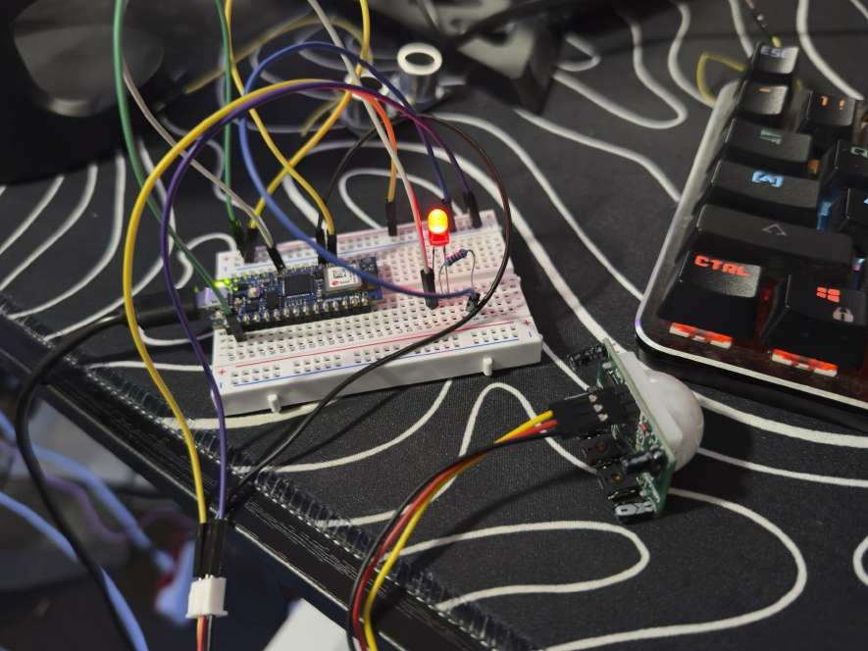
Physical breadboard prototype. The red LED is visibly illuminated; the PIR module is shown beside the breadboard.

QP1 — Additional physical evidence
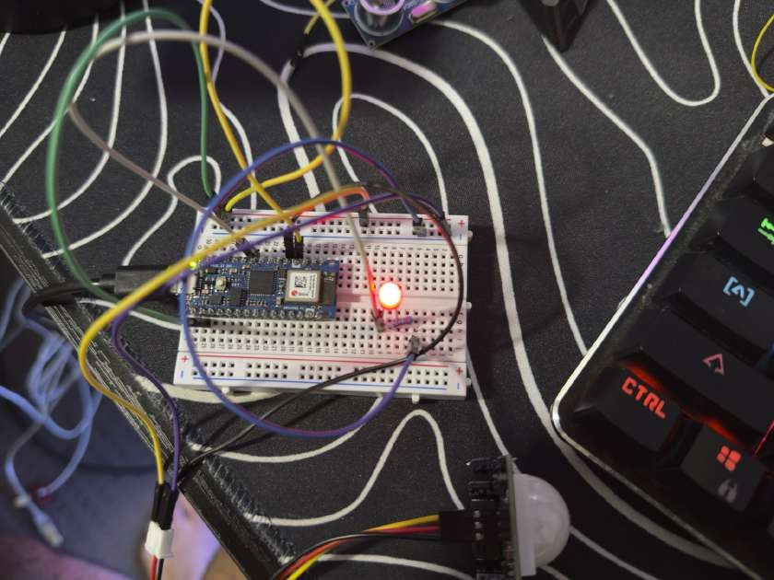
Close view of the Arduino board, breadboard wiring and illuminated red LED.

QP1 — What does the Serial Monitor evidence show?
The screenshot shows the final QP1 code and Serial Monitor output at 9600 baud. The program repeatedly displays “Motion detected - LED ON”. This matches the code: when the PIR sensor reading is HIGH, the Arduino turns the LED on and prints the same message to Serial Monitor.

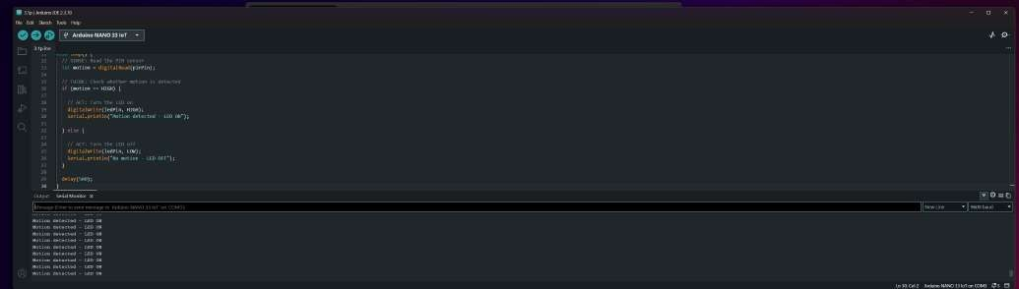
QP1 Arduino IDE and Serial Monitor showing motion detected and the LED-ON response.

QP2 — What did the system do?
QP2 is a two-input system. It uses the PIR sensor for motion and an ultrasonic sensor for distance. The LED turns on only when motion is present and the measured distance is more than 0 cm and less than 30 cm.

What is an interrupt?
An interrupt is a signal that tells the Arduino to run a small function immediately when an event occurs. In this project, the PIR is connected to D2 and is registered with attachInterrupt(). The small interrupt function is called an interrupt service routine, or ISR.
The ISR does not measure distance, print Serial messages or delay. It only changes a flag. The main loop then reads the sensors and controls the LED. This keeps the interrupt routine short and simple.

How was QP2 wired?
Part Connection
PIR sensor VCC → 5V; GND → GND; OUT → D2

Ultrasonic sensor VCC → 5V; GND → GND; TRIG → D3; ECHO → D4

LED D6 → resistor → LED positive leg; LED negative leg → GND

How does the QP2 decision work?

PIR state | Distance | LED result
HIGH | 1–29 cm | ON
HIGH | 0 cm or 30 cm and above | OFF
LOW | Any distance | OFF

QP2 — How did the final code work?
The supplied TaskM2.cpp uses four pins: D2 for PIR, D3 for ultrasonic TRIG, D4 for ultrasonic ECHO and D6 for the LED.

How was the interrupt written?
volatile bool pirChanged = false;

void pirISR() { pirChanged = true;
}

attachInterrupt(digitalPinToInterrupt(pirPin), pirISR, CHANGE);
The keyword volatile tells the program that pirChanged can be changed by the ISR. The ISR sets the flag to true whenever the PIR changes state. The main loop checks the flag, resets it and prints “PIR interrupt detected”.

How was distance measured?
The ultrasonic sensor sends a short trigger pulse. The program measures the return time of the echo pulse and converts this time to distance in centimetres. The code uses a timeout, so it does not wait forever if an echo is not received.
long duration = pulseIn(echoPin, HIGH, 30000); int distance = duration * 0.034 / 2;

What condition turns the LED on?
if (pirState == HIGH && distance > 0 && distance < 30) { digitalWrite(ledPin, HIGH);
Serial.println("Motion + Object close - LED ON");
} else {
digitalWrite(ledPin, LOW); Serial.println("Conditions not met - LED OFF");
}
The final loop ends with delay(2000), which gives a two-second pause between normal sensor readings. The delay is in the main loop, not in the ISR.

QP2 — What does the Serial Monitor evidence show?
The first screenshot shows the final LED decision code and Serial Monitor output. The output includes 95 cm, 96 cm and 0 cm readings. For those readings, the displayed result is “Conditions not met - LED OFF”, which matches the program condition.
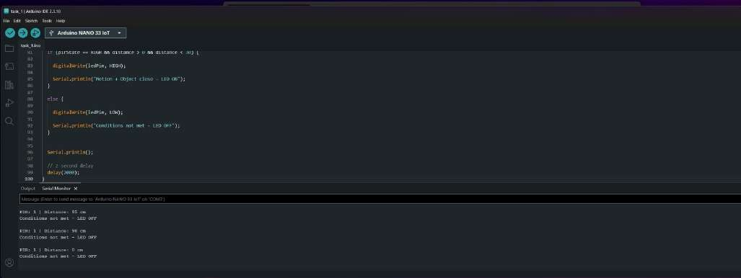
QP2 Arduino IDE and Serial Monitor: examples of readings outside the valid 1–29 cm range, with the LED result shown as OFF.
The second screenshot shows the same condition with a 4 cm distance reading. The Serial Monitor displays “Motion + Object close - LED ON”, matching the final condition in TaskM2.cpp.
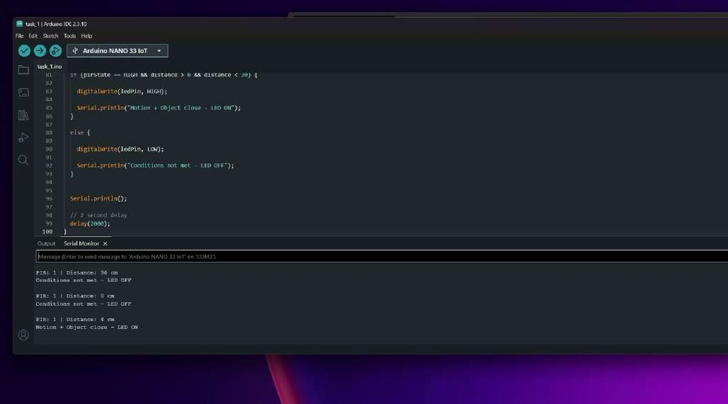
. QP2 Arduino IDE and Serial Monitor: a 4 cm reading with PIR state 1 and the resulting LED-ON message.

QP2 — What physical evidence was supplied?
These supplied photos show the physical QP2 prototype. They show the Arduino board, LED, sensors and breadboard wiring. The photos are supporting physical evidence; the exact final logic is confirmed by TaskM2.cpp and the Serial Monitor screenshots.
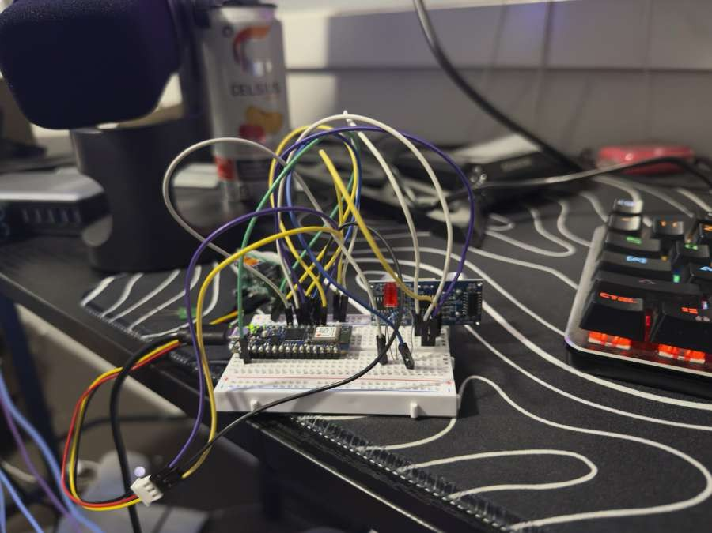
. Physical prototype with Arduino board, breadboard, LED and connected sensor modules.

QP2 — Additional physical evidence
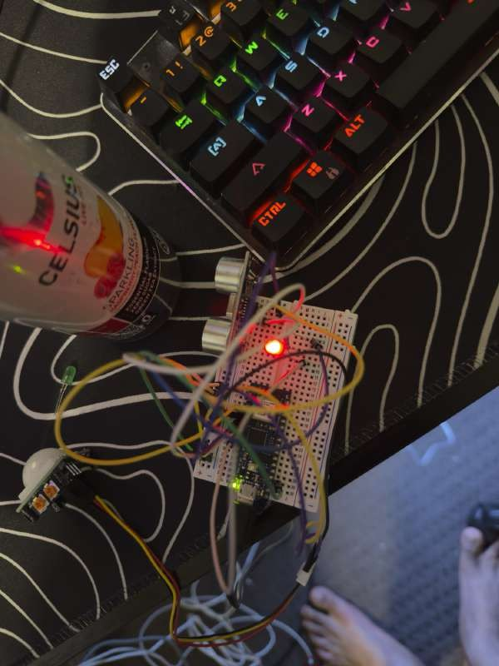
. Overhead physical-prototype view showing the ultrasonic sensor, PIR module, breadboard wiring and illuminated LED.

QP2 — Final physical-evidence photo
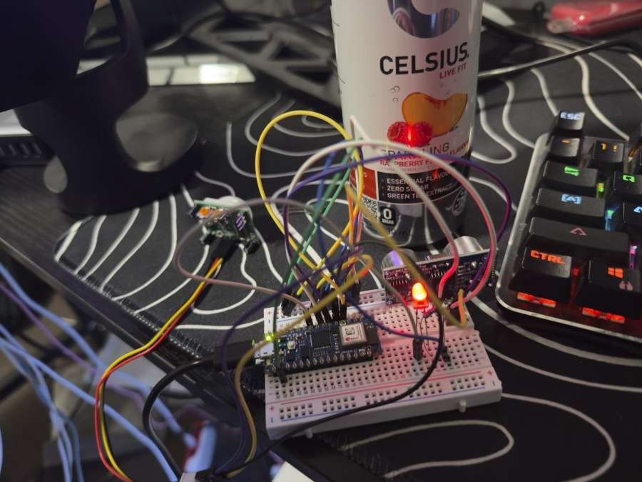
Figure 7. Physical prototype view showing the Arduino board, sensor wiring and illuminated LED.

What development tests were included in the ZIP?
The ZIP also contains two earlier Arduino sketches. They are useful as development evidence, but they are not presented as the final Week 4 submission code.
File Purpose shown by the code
1.1p.ino A switch-controlled two-LED timing test. It uses a slide switch and two LEDs with 30-second delays.

1_1p_copy_20260411192932. ino
An LDR light-sensor test. It reads A0, prints the light value and reports when a threshold is crossed.

TaskM1.cpp Final QP1 code: PIR polling and LED response.

TaskM2.cpp Final QP2 code: PIR interrupt, ultrasonic distance and LED response.

What challenges were identified?

The following challenges are based on the recorded development discussion and the final code. They can be kept in the report only if they match the student’s own experience and explanation.
Challenge How it was handled

PIR stayed HIGH for a period
The original approach relied too heavily on a new RISING event. The final program still uses the PIR interrupt, but it uses the current PIR state for the LED decision. The interrupt separately sets a change flag.

Sound-sensor output was not reliable

LED did not turn on in the first combined test
The sound sensor was tested but did not give a reliable response for the planned two-input system. The ultrasonic sensor was used as the second input because it provided a measurable distance condition.

A close object alone was not enough because the earlier logic required a new PIR interrupt event. The final condition checks both the current PIR state and distance below 30 cm.

Ultrasonic reading could be 0 cm The final decision includes distance > 0. This prevents an invalid 0
cm reading from turning the LED on.

Avoiding work inside the interrupt The ISR only sets a flag. Serial output, distance measurement and
the two-second delay stay in the main loop.

What did I learn?
I learned the difference between polling and an interrupt. In QP1, the Arduino repeatedly reads the PIR in the loop. In QP2, the PIR can trigger a short ISR, while the main loop performs the remaining work. I also

learned that using two sensor conditions makes an LED response more specific: motion must be present and the object must be close enough.

What are the key findings?
- QP1 demonstrates a simple Sense–Think–Act system using a PIR sensor and LED.
- QP2 demonstrates a two-input decision using PIR motion and ultrasonic distance.
- The supplied Serial Monitor screenshot shows an LED-OFF example at 96 cm and an LED-ON example at 4 cm with PIR state 1.
- A short ISR plus a flag lets the main loop safely complete the longer tasks.

Current working system update
The QP1 and QP2 report above is kept as my original work and evidence. This section only adds my current working Arduino setup, circuit diagram, code summary and links.

Current circuit
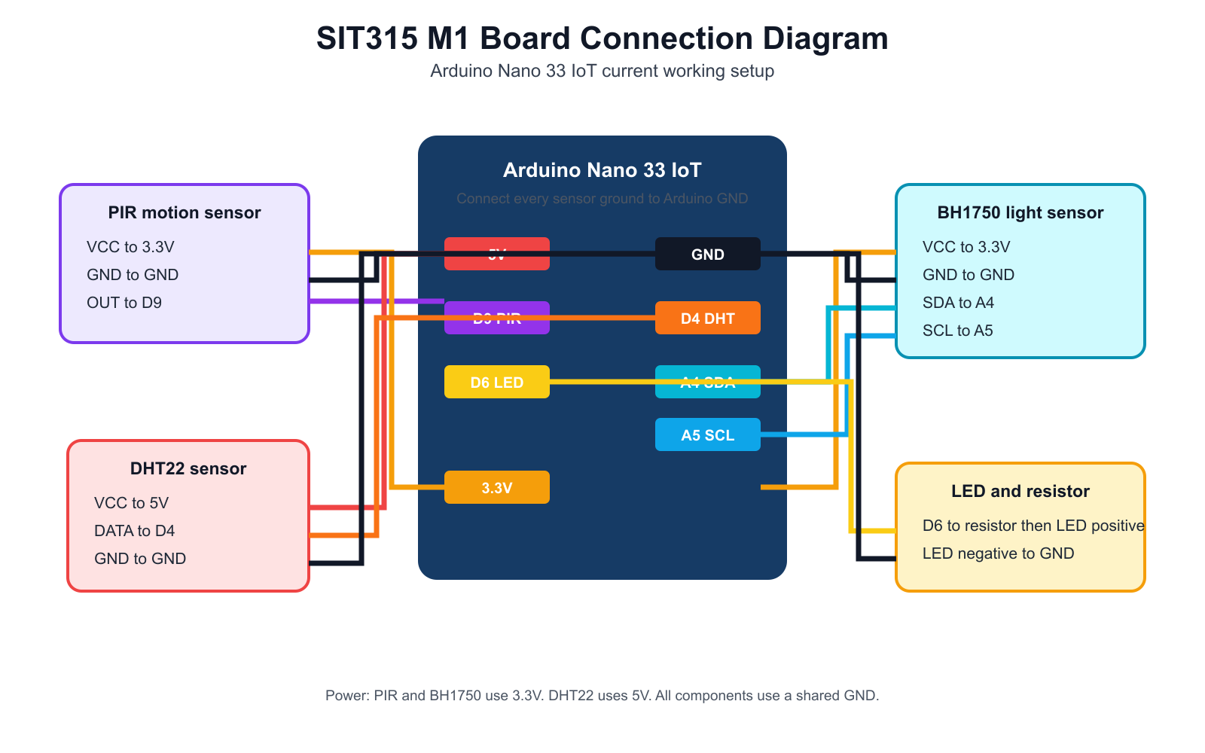
Figure 8. My current Arduino Nano 33 IoT circuit diagram.
Part | Current connection | What it does
PIR sensor | OUT to D9, 3.3V and GND | Detects motion.
DHT22 | DATA to D4, 5V and GND | Reads temperature and humidity.
BH1750 | SDA to A4, SCL to A5, 3.3V and GND | Reads the light level.
LED and resistor | D6 to resistor then LED, LED to GND | Shows the output.

How my current code works
My current TaskM1.cpp code uses D9 for the PIR sensor, D4 for the DHT22 sensor and D6 for the LED. The BH1750 light sensor uses the I2C pins A4 and A5. I use the Wire library for the light sensor and the DHT library for the DHT22 sensor.
Code part | Simple explanation
Lines 5 to 8 | I set the pins and the light-sensor address.
Lines 24 to 26 | My PIR interrupt function only sets a flag.
Line 58 | I attach the PIR interrupt to D9.
Lines 84 to 90 | I turn the LED on only when there is motion and it is dark or hot.
Lines 93 to 112 | I print PIR, light, temperature, humidity and LED values to Serial Monitor.

The current update uses one PIR interrupt. It is a working extension of my project, but I do not describe it as a replacement for the original QP1 and QP2 work above or as a multi-input pin-change-interrupt implementation.

Current links
Video demonstration: Open my Panopto video
GitHub repository: https://github.com/HridayBhadouria/SIT315-Task
Tutor access if required: ________________________________

Current reflection
I first tried to use an HC-SR04 ultrasonic sensor in the updated setup, but it did not give reliable readings. I then tested the PIR, light and DHT22 sensors one at a time. This helped me check the power connection, shared ground, data pin and library for each sensor. I learned to keep the interrupt function short and let the main loop read the sensors and control the LED.

