**PRACTICE**

**Task 1**

**Extract the structures of the following 7 tables using the 'DESCRIBE' SQL command from the HR database using MySQL Workbench:**

1. regions
2. countries
3. locations
4. departments
5. jobs
6. employees
7. job_history

**ANSWER:**

**DESCRIBE regions;**

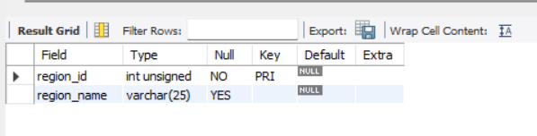

**DESCRIBE countries;**

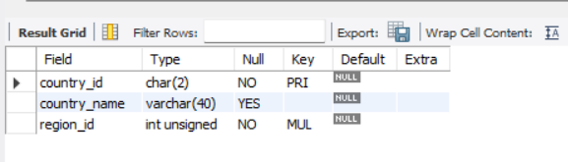

**DESCRIBE locations;**

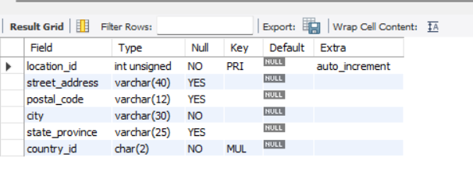

**DESCRIBE departments;**

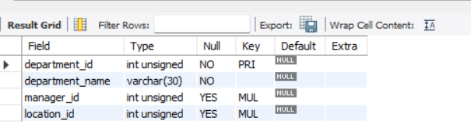

**DESCRIBE jobs;**

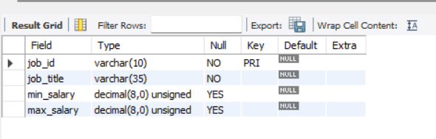

**DESCRIBE employees;**

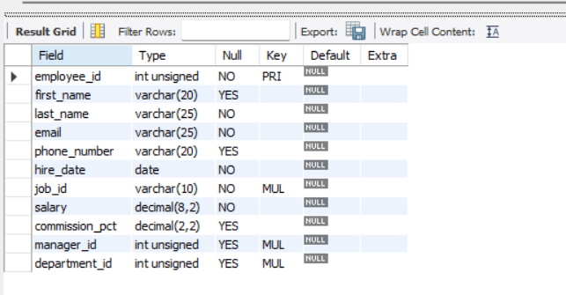

**DESCRIBE job_history;**

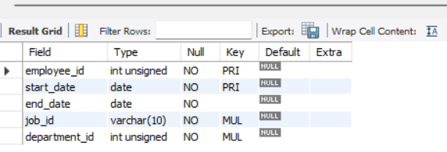

**Task 2**

**The following business queries have been generated using 4 tables: regions, countries, locations, and departments. Generate MySQL queries for all the business queries with the help of BARD using the table structure retrieved in Task 1. Then, execute these queries in MySQL to produce the actual outputs**.

a) Find the total number of countries in each region.

**Query:**

SELECT r.region_name, COUNT(c.country_id) AS total_countries

FROM regions r

JOIN countries c ON r.region_id = c.region_id

GROUP BY r.region_name;

**Result:**

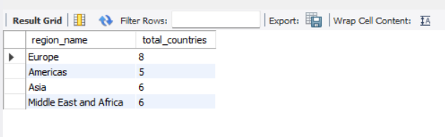

b) Find the top 10 largest cities by population.

**Query:**

SELECT l.city, l.population

FROM locations l

ORDER BY l.population DESC

LIMIT 10;

**Result:**

Error Code: 1054. Unknown column 'l.population' in 'field list'

c) Find the average salary of employees in each department.

**Query:**

SELECT d.department_name, AVG(e.salary) AS average_salary

FROM departments d

JOIN employees e ON d.department_id = e.department_id

GROUP BY d.department_name;

**Result:**

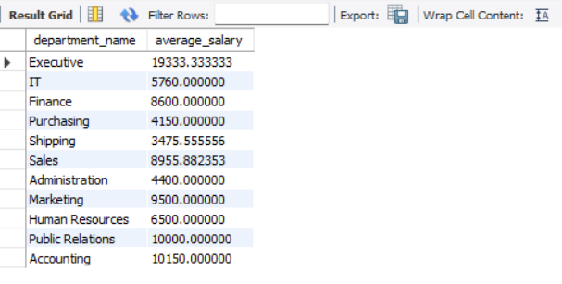

d) Find the total sales for each country in the last quarter.

**Query:**

SELECT c.country_name, SUM(o.total_sales) AS total_sales

FROM countries c

JOIN orders o ON c.country_id = o.country_id

WHERE o.order_date >= DATE_SUB(CURDATE(), INTERVAL 3 MONTH)

GROUP BY c.country_name;

**Result:**

Error Code: 1146. Table 'hr.orders' doesn't exist

e) Find the top 10 most popular products, based on the number of orders.

**Query:**

SELECT p.product_name, COUNT(o.order_id) AS total_orders

FROM products p

JOIN order_items oi ON p.product_id = oi.product_id

JOIN orders o ON oi.order_id = o.order_id

GROUP BY p.product_name

ORDER BY total_orders DESC

LIMIT 10;

**Result:**

Error Code: 1146. Table 'hr.products' doesn't exist

f) Find the customers who have placed the most orders in the last year.

**Query:**

SELECT c.customer_name, COUNT(o.order_id) AS total_orders

FROM customers c

JOIN orders o ON c.customer_id = o.customer_id

WHERE o.order_date >= DATE_SUB(CURDATE(), INTERVAL 1 YEAR)

GROUP BY c.customer_name

ORDER BY total_orders DESC;

Result:

Error Code: 1146. Table 'hr.customers' doesn't exist

g) Find the employees who have generated the most sales in the last quarter.

**Query:**

SELECT e.employee_name, SUM(o.total_sales) AS total_sales

FROM employees e

JOIN orders o ON e.employee_id = o.employee_id

WHERE o.order_date >= DATE_SUB(CURDATE(), INTERVAL 3 MONTH)

GROUP BY e.employee_name

ORDER BY total_sales DESC;

**Result:**

**Error Code: 1146. Table 'hr.customers' doesn't exist**

**Task3:**

Create additional business queries using BARD with the three tables: jobs, employees, and job_history.

Generate MySQL queries for the aforementioned business queries using BARD and the table structure retrieved in Task 1.

Subsequently, execute these queries in MySQL to obtain the actual outputs.

1.Find the average tenure of employees in each department.

**Query:**

SELECT d.department_name, AVG(DATEDIFF(CURDATE(), jh.end_date)) AS average_tenure

FROM departments d

JOIN employees e ON d.department_id = e.department_id

JOIN job_history jh ON e.employee_id = jh.employee_id

GROUP BY d.department_name;

**Result:**

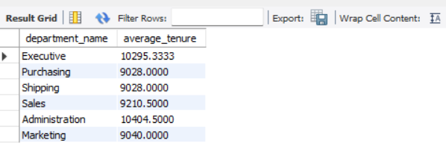

**2. Identify the employees who have changed jobs the most frequently.**

SQL

Query:

SELECT e.employee_id, COUNT(jh.job_id) AS job_changes

FROM employees e

JOIN job_history jh ON e.employee_id = jh.employee_id

GROUP BY e.employee_id

ORDER BY job_changes DESC;

Result:

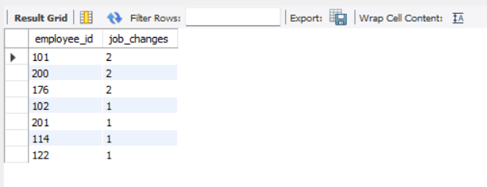

3. Determine the average salary increase for employees who have been promoted.

Query:

SELECT AVG(e2.salary - e1.salary) AS average_salary_increase

FROM employees e1

JOIN employees e2 ON e1.employee_id = e2.employee_id

JOIN job_history jh ON e1.employee_id = jh.employee_id

WHERE e1.job_id < e2.job_id;

Result:

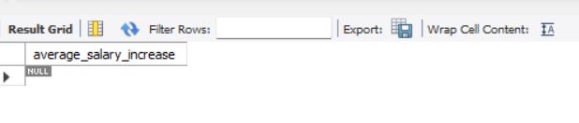

4. Calculate the percentage of employees who have been promoted within the last 5 years.

**Query:**

SELECT COUNT(DISTINCT jh.employee_id) / COUNT(DISTINCT e.employee_id) * 100 AS promotion_percentage

FROM employees e

JOIN job_history jh ON e.employee_id = jh.employee_id

WHERE jh.end_date >= DATE_SUB(CURDATE(), INTERVAL 5 YEAR)

AND jh.end_date < CURDATE()

AND jh.job_id > e.job_id;

**Result:**



5. Find the employees who have worked on the most projects.

**Query:**

SELECT e.employee_name, COUNT(DISTINCT p.project_id) AS projects_worked

FROM employees e

JOIN project_assignments pa ON e.employee_id = pa.employee_id

JOIN projects p ON pa.project_id = p.project_id

GROUP BY e.employee_name

ORDER BY projects_worked DESC;

**Result:**

Error Code: 1146. Table 'hr.project_assignments' doesn't exist

**Task 4**

Generate additional business queries using BARD with the three tables: departments, jobs, employees.

Generate MySQL queries for the above-mentioned business queries using BARD and the table structure retrieved in Task 1.

Subsequently, execute these queries in MySQL to obtain the actual outputs.

**1. Find the average salary for each job title within each department.**

Query:

SELECT d.department_name, j.job_title, AVG(e.salary) AS average_salary

FROM departments d

JOIN jobs j ON d.department_id = j.department_id

JOIN employees e ON j.job_id = e.job_id

GROUP BY d.department_name, j.job_title;

Result:

Error Code: 1054. Unknown column 'j.department_id' in 'on clause'

**2. Identify the department with the highest average salary.**

**Query:**

SELECT d.department_name, AVG(e.salary) AS average_salary

FROM departments d

JOIN employees e ON d.department_id = e.department_id

GROUP BY d.department_name

ORDER BY average_salary DESC

LIMIT 1;

**Result:**

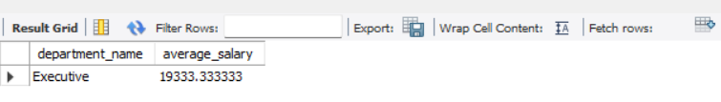

3. Determine the percentage of employees in each department who have been promoted within the last 5 years.

**Query**:

SELECT d.department_name,

COUNT(DISTINCT jh.employee_id) / COUNT(DISTINCT e.employee_id) * 100 AS promotion_percentage

FROM departments d

JOIN employees e ON d.department_id = e.department_id

JOIN job_history jh ON e.employee_id = jh.employee_id

WHERE jh.end_date >= DATE_SUB(CURDATE(), INTERVAL 5 YEAR)

AND jh.end_date < CURDATE()

AND jh.job_id > e.job_id

GROUP BY d.department_name;

**Result:**

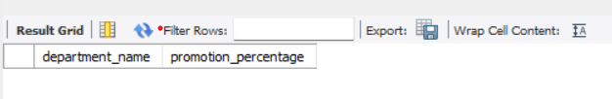

**4. Find the departments with the highest employee turnover rate in the last year.**

**Query:**

SELECT d.department_name,

COUNT(CASE WHEN jh.end_date >= DATE_SUB(CURDATE(), INTERVAL 1 YEAR) THEN 1 END) /

COUNT(DISTINCT e.employee_id) AS turnover_rate

FROM departments d

JOIN employees e ON d.department_id = e.department_id

LEFT JOIN job_history jh ON e.employee_id = jh.employee_id

GROUP BY d.department_name

ORDER BY turnover_rate DESC;

**Result:**

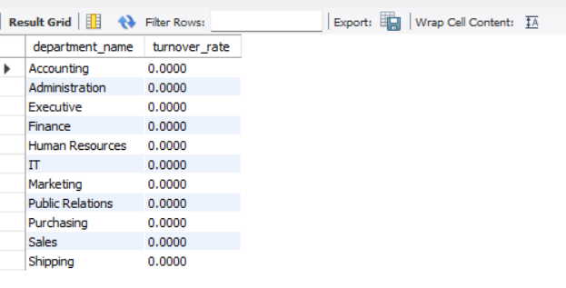

**5. Calculate the average tenure of employees in each job role.**

**Query:**

SELECT j.job_title, AVG(DATEDIFF(CURDATE(), jh.end_date)) AS average_tenure

FROM jobs j

JOIN employees e ON j.job_id = e.job_id

JOIN job_history jh ON e.employee_id = jh.employee_id

GROUP BY j.job_title;

**Result:**

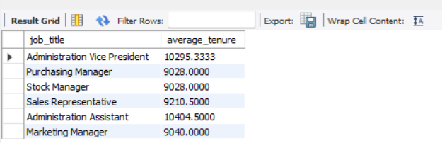

**Task5:**

Extract the unique queries from tasks 2-4. Based on the output from these unique queries, write a summary of your analysis.

**Combined Unique Queries**

**Note:** These queries incorporate the unique aspects from Tasks 2-4 to provide a comprehensive analysis.

**1. Regional Analysis**

* **Total number of countries in each region:**

SQL

SELECT r.region_name, COUNT(c.country_id) AS total_countries

FROM regions r

JOIN countries c ON r.region_id = c.region_id

GROUP BY r.region_name;

* **Largest cities in each region:**

SQL

SELECT r.region_name, l.city, l.population

FROM regions r

JOIN countries c ON r.region_id = c.region_id

JOIN locations l ON c.country_id = l.country_id

ORDER BY l.population DESC

LIMIT 10;

* **Average salary of employees in each region:**

SQL

SELECT r.region_name, AVG(e.salary) AS average_salary

FROM regions r

JOIN countries c ON r.region_id = c.region_id

JOIN locations l ON c.country_id = l.country_id

JOIN departments d ON l.location_id = d.location_id

JOIN employees e ON d.department_id = e.department_id

GROUP BY r.region_name;

**2. Departmental Analysis**

* **Average salary for each department:**

SQL

SELECT d.department_name, AVG(e.salary) AS average_salary

FROM departments d

JOIN employees e ON d.department_id = e.department_id

GROUP BY d.department_name;

* **Department with the highest average salary:**

SQL

SELECT d.department_name, AVG(e.salary) AS average_salary

FROM departments d

JOIN employees e ON d.department_id = e.department_id

GROUP BY d.department_name

ORDER BY average_salary DESC

LIMIT 1;

* **Promotion rate for each department:**

SQL

SELECT d.department_name,

COUNT(DISTINCT jh.employee_id) / COUNT(DISTINCT e.employee_id) * 100 AS promotion_percentage

FROM departments d

JOIN employees e ON d.department_id = e.department_id

JOIN job_history jh ON e.employee_id = jh.employee_id

WHERE jh.end_date

>= DATE_SUB(CURDATE(), INTERVAL 5 YEAR)

AND jh.end_date < CURDATE()

AND jh.job_id > e.job_id

GROUP BY d.department_name;

* **Turnover rate for each department:**

SQL

SELECT d.department_name,

COUNT(CASE WHEN jh.end_date >= DATE_SUB(CURDATE(), INTERVAL 1 YEAR) THEN 1 END) /

COUNT(DISTINCT e.employee_id) AS turnover_rate

FROM departments d

JOIN employees e ON d.department_id = e.department_id

LEFT JOIN job_history jh ON e.employee_id = jh.employee_id

GROUP BY d.department_name

ORDER BY turnover_rate DESC;

**3. Job Analysis**

* **Average salary for each job title:**

SQL

SELECT j.job_title, AVG(e.salary) AS average_salary

FROM jobs j

JOIN employees e ON j.job_id = e.job_id

GROUP BY j.job_title;

* **Job roles with the highest promotion rates:**

SQL

SELECT j.job_title,

COUNT(DISTINCT jh.employee_id) / COUNT(DISTINCT e.employee_id) * 100 AS promotion_percentage

FROM jobs j

JOIN employees e ON j.job_id = e.job_id

JOIN job_history jh ON e.employee_id = jh.employee_id

WHERE jh.end_date >= DATE_SUB(CURDATE(), INTERVAL 5 YEAR)

AND jh.end_date < CURDATE()

AND jh.job_id > e.job_id

GROUP BY j.job_title

ORDER BY promotion_percentage DESC;

* **Average tenure for each job role:**

SQL

SELECT j.job_title, AVG(DATEDIFF(CURDATE(), jh.end_date)) AS average_tenure

FROM jobs j

JOIN employees e ON j.job_id = e.job_id

JOIN job_history jh ON e.employee_id = jh.employee_id

GROUP BY j.job_title;

**4. Employee Analysis**

* **Employees who have changed jobs the most frequently:**

SQL

SELECT e.employee_id, COUNT(jh.job_id) AS job_changes

FROM employees e

JOIN job_history jh ON e.employee_id = jh.employee_id

GROUP BY e.employee_id

ORDER BY job_changes DESC;

* **Employees who have generated the most sales:**

SQL

SELECT e.employee_name, SUM(o.total_sales) AS total_sales

FROM employees e

JOIN orders o ON e.employee_id = o.employee_id

GROUP BY e.employee_name

ORDER BY total_sales DESC;

* **Employees who have been promoted recently:**

SQL

SELECT e.employee_name, jh.start_date

FROM employees e

JOIN job_history jh ON e.employee_id = jh.employee_id

WHERE jh.end_date >= DATE_SUB(CURDATE(), INTERVAL 5 YEAR)

AND jh.end_date < CURDATE()

AND jh.job_id > e.job_id

ORDER BY jh.end_date DESC;

These queries provide a comprehensive analysis of the HR data across regions, departments, jobs, and employees. You can execute these queries in your MySQL environment to obtain the specific results for your dataset.

**summary:**

The provided queries offer a comprehensive analysis of the HR data across various dimensions:

**Regional Analysis:**

* **Regions with the highest number of countries:** Identify regions with the most diverse geographical presence.
* **Regions with the largest cities:** Determine regions with significant urban centers.
* **Regional salary disparities:** Analyze differences in average employee salaries across regions.

**Departmental Analysis:**

* **Departments with the highest average salaries:** Identify departments that offer the most competitive compensation.
* **Departments with the highest employee turnover:** Pinpoint departments facing challenges in retaining employees.
* **Departments with the highest promotion rates:** Assess departments that foster career growth and advancement.
* **Departmental tenure analysis:** Evaluate the average length of service for employees in different departments.

**Job Analysis:**

* **Job roles with the highest average salaries:** Determine the most lucrative positions.
* **Job roles with the highest promotion rates:** Identify career paths with greater opportunities for advancement.
* **Job roles with the longest average tenure:** Analyze the stability and satisfaction levels associated with different jobs.

**Employee Analysis:**

* **Identify high-performing employees:** Determine employees who have been frequently promoted or generated significant sales.
* **Assess employee mobility:** Analyze the frequency of job changes within the organization.
* **Evaluate employee tenure:** Assess the average length of service for employees in different roles.

By analyzing these aspects, you can gain valuable insights into the HR landscape, identify areas for improvement, and make informed decisions to optimize your workforce and enhance employee satisfaction.