1st run output:
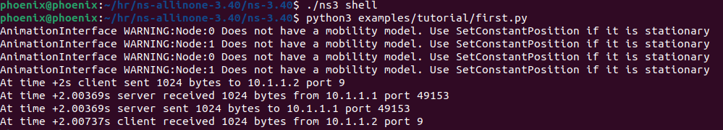

Outputs for different data sizes

1. Changed 1024 to 128 data output:
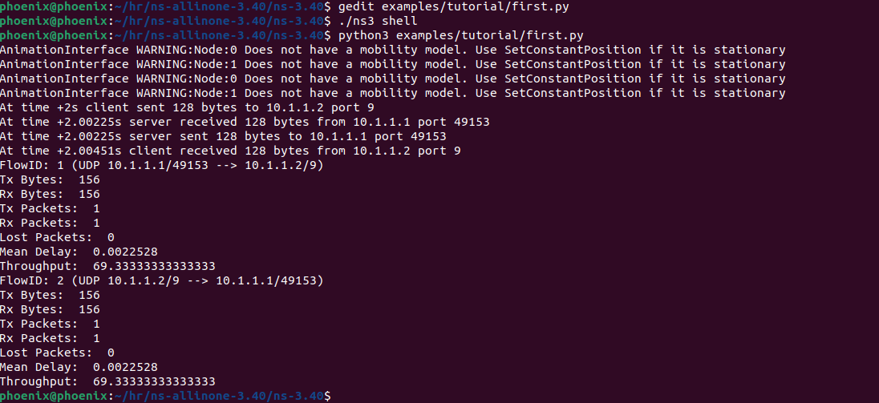

2. Changed 128 to 256 data output:

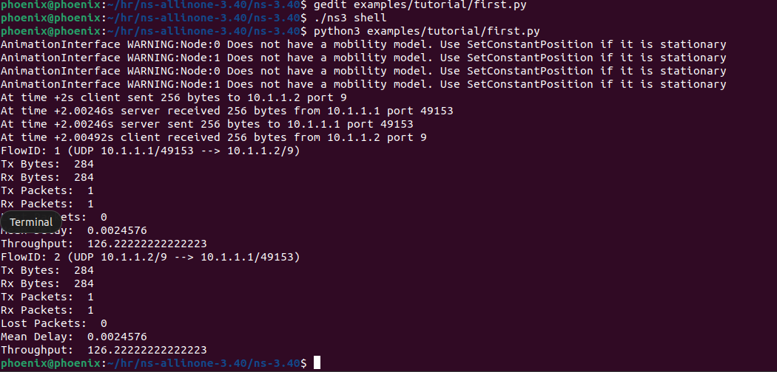
3. Changed 256 to 512 data output:
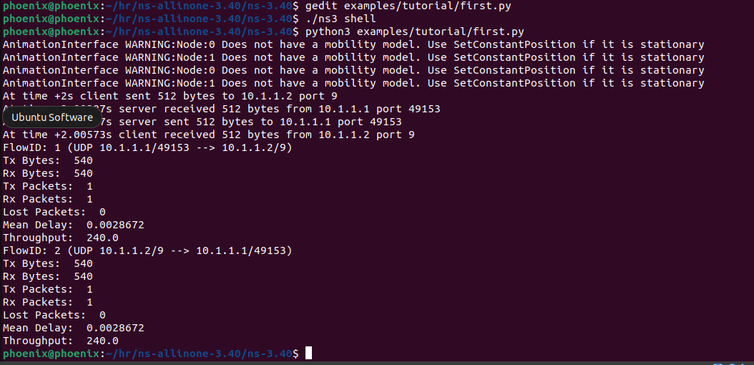

4. Changed 512 to 1024 data output:
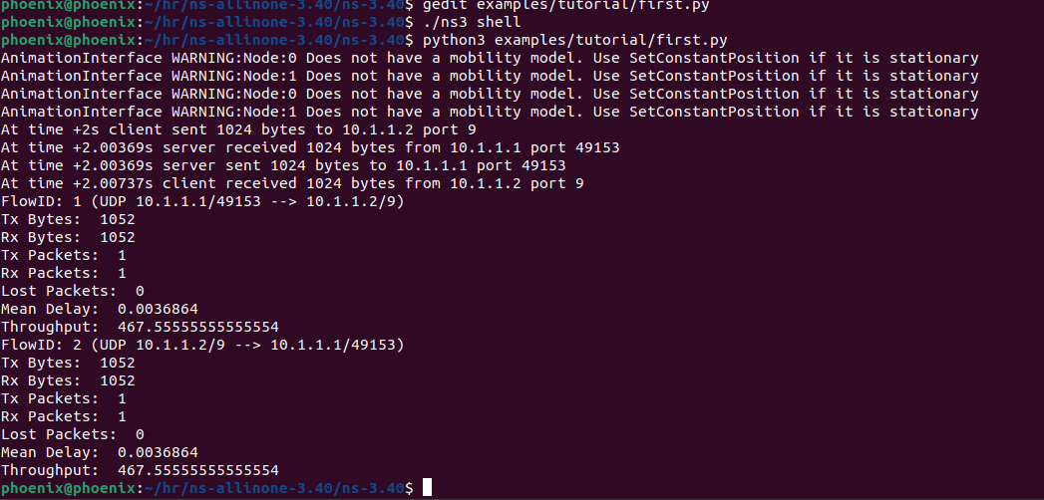

5. Changed 1024 to 2048 data output:
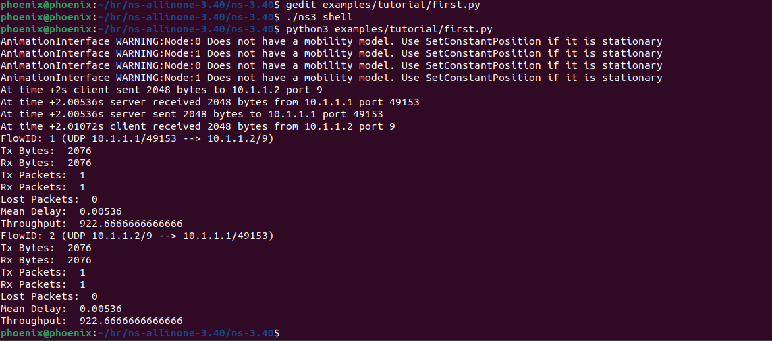

Throughput vs data size graph:
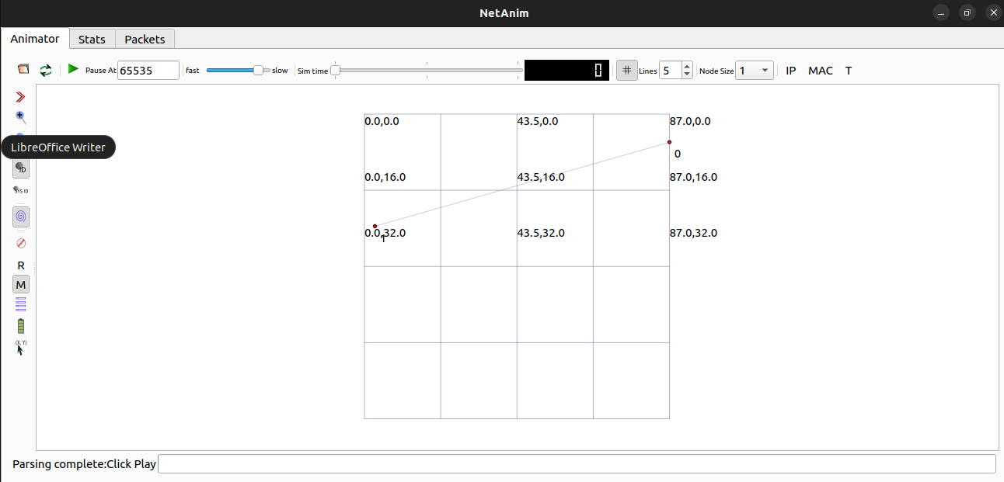

Data Size (bytes) | Throughput (bps)
128 | 69.33
256 | 126.22
512 | 240.0
1024 | 467.56
2048 | 922.67

Description of the graph:
The graph clearly shows a strong, positive, and near-linear correlation: as the packet's data size increases, the measured throughput also increases. This trend is caused by network overhead. Every packet sent includes fixed-size headers (like IP and UDP headers) in addition to the data. We can see this in the output:

- For the 128-byte packet, the total bytes sent: 156. So, (156 - 128 = 28 bytes of overhead).

- For the 2048-byte packet, the total bytes sent: 2076. So, (2076 - 2048 = 28 bytes of overhead).

This 28-byte overhead is constant. When the packet size is small, this overhead makes up a large percentage of the total transmission, making it inefficient. As the packet size gets larger, the 28-byte overhead becomes a tiny fraction of the total, meaning more of the network's time is spent sending useful data. This increased efficiency results in a higher measured throughput.

