WireShirk:
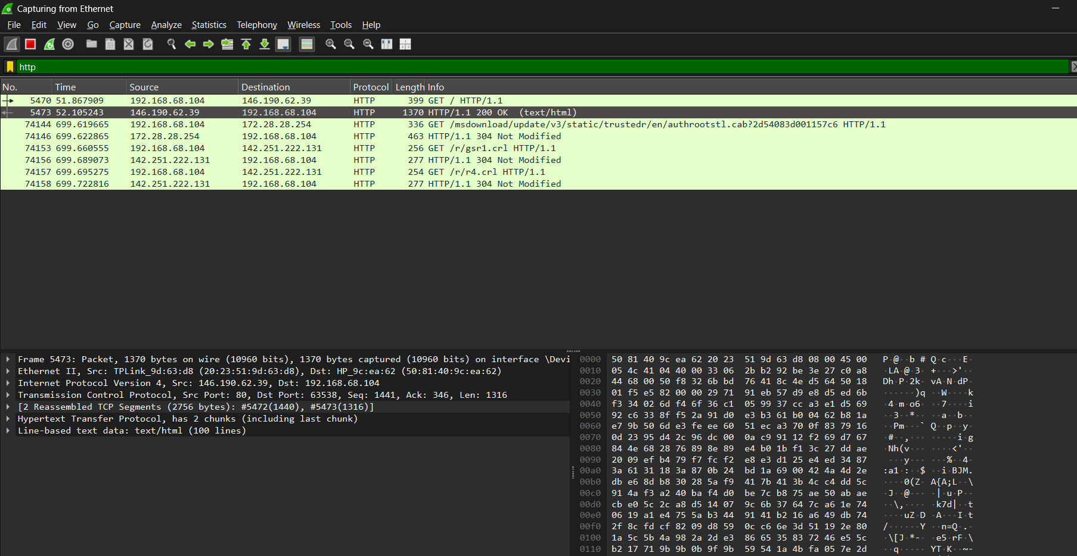

Layer 1: Frame:
Frame is under the data link layer. Here, it indicates the frame information of this layer.
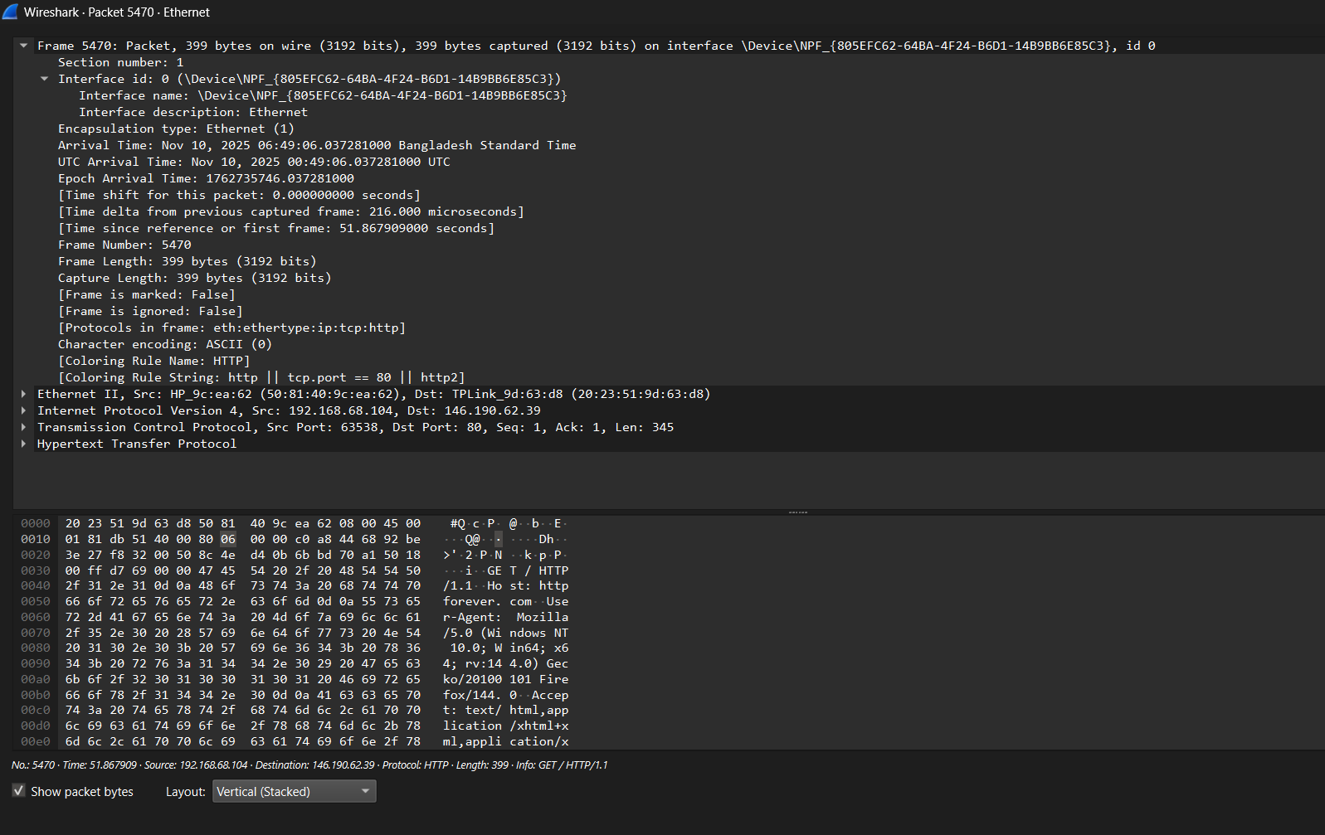

Layer 2: Ethernet II:
Ethernet2 under the datalink layer. This layer handles local network addressing. The source indicates the device's MAC address that will receive the frame (HP_9c:ea:62), which is my device. This is shown in human readable format (hex) and Destination TPLink_9d:63:d8 (The MAC address of the next device, my router).
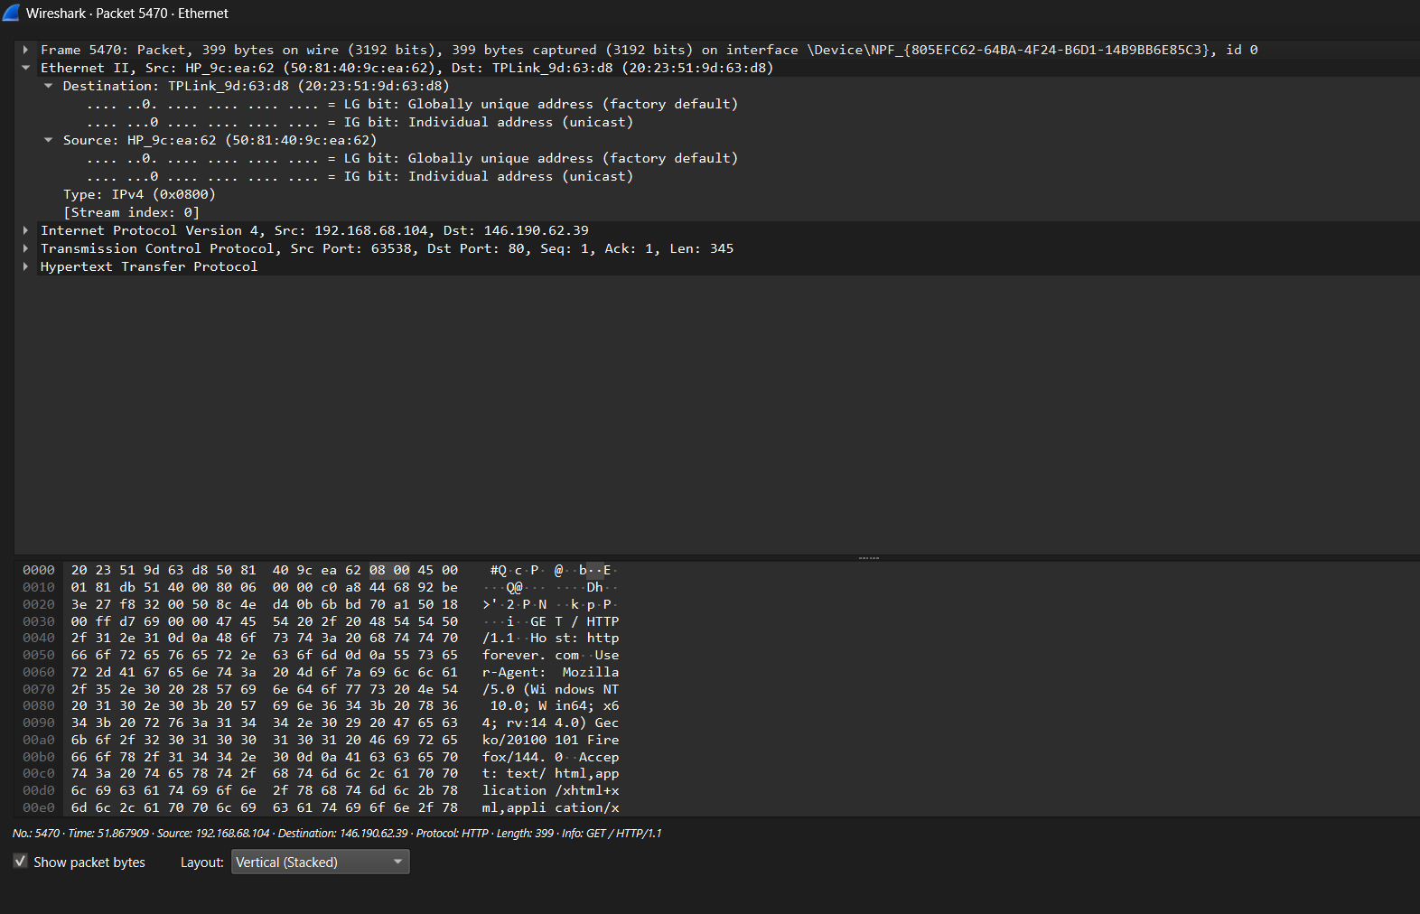

Layer 3: Internet Protocol Version 4:
This layer handles global routing. It’s the network layer. Here, IPV4 means internet protocol version 4 is used. Source IP address is: 192.168.68.104 and Destination IP: 146.190.62.39 , The public IP address of the web server. Also, Header length is 20 bytes. Fragmentation was off. TTL is 64. There are 6 TCP protocols. Header checksum number is 0x0000 . Here, checksum status is unverified and validation disabled.
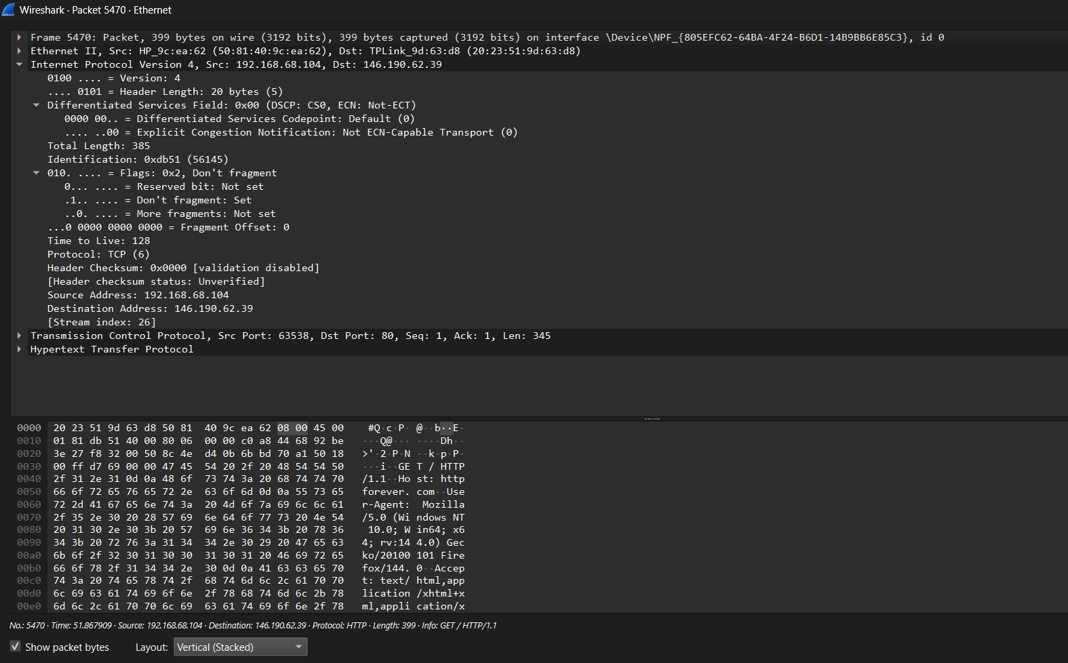

Layer 4: Transmission Control Protocol:
This layer manages the end-to-end connection. Here, Source port is 63538. This indicates which sending device port started the conversation. Destination port is 80. This indicates which port on the receiving device the data is meant to be sent. It means that the conversation is probably a part of an online browsing session. The push flag is set. Also ACK flag is set. Checksum value is 0xd769. The sender computes the checksum, and the recipient confirms it. The status is unverified.
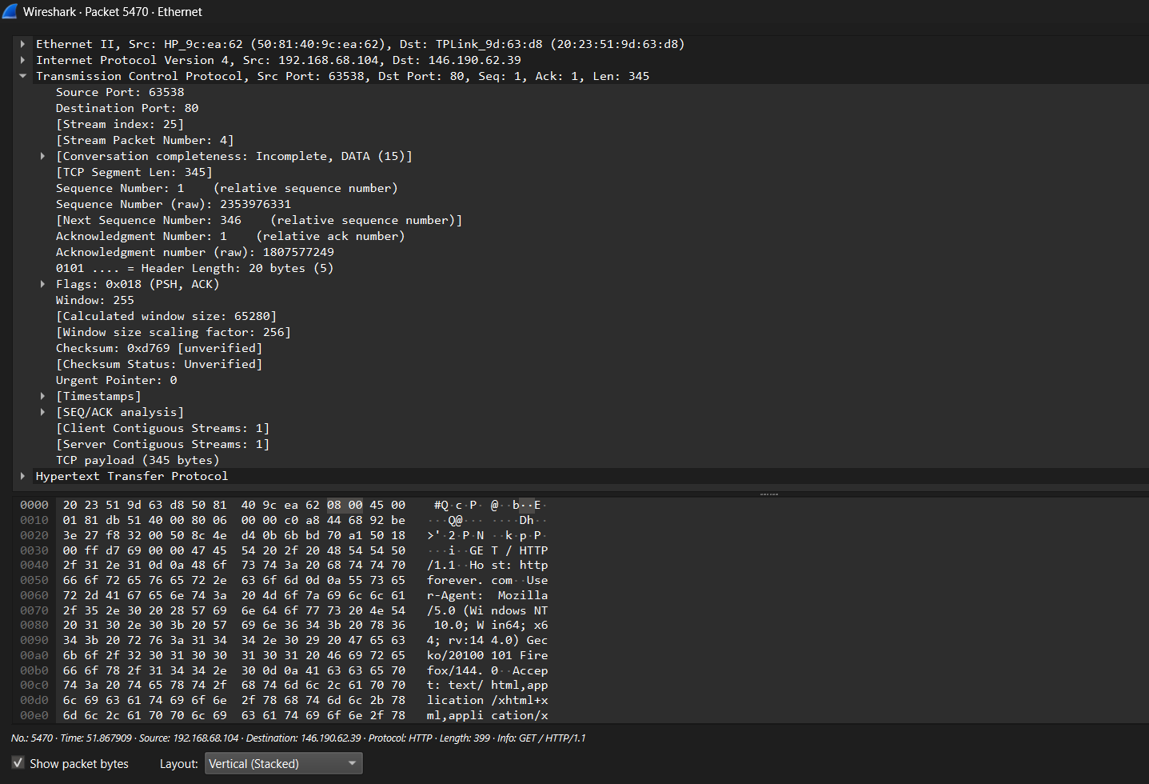

Layer 5: Hypertext Transfer Protocol
This is the application layer, containing the actual request message. Here, The browser is fetching information, as indicated by the "GET" method. Host: httpforever.com , User-Agent: Mozilla/5.0

