**Distance Measuring Using Arduino**

**Jahidul Alam   
ID: 16215588042  
North South UniversityDhaka, Bangladesh  
jahidul.alam@northsouth.edu**

*Abstract*— We are going to build a project in which we measure the distance. We will be using the ultrasonic sensor HC SR-04.

Keywords—component, formatting, style, styling, insert (key words)

# Introduction

The HC-SRO4 ultrasonic uses sonar to determine distance to an object. IT offers an excellent non-contact range detection with high accuracy and stable readings in an easy-to-use package. It comes with ultrasonic transmitter and receiver modules.

# Features

## Here is a list of some of the HC-SR04 ultrasonic sensor features and specs:

* Power Supply: +5V DC.
* Quiscent Current: <2mA .
* Working Current: 15 mA
* Effectual Angle: <15°
* Ranging Distance : 2cm – 400 cm/1″ – 13ft
* Resolution : 0.3 cm
* Measuring Angle: 30 degree
* Trigger Input Pulse width: 10uS
* Dimension: 45mm x 20mm x 15mm.

# How it works

The sensor emits an ultrasound at 40,000 Hz which travels through the air and if there is an object or obstacle on its path it will bounce back to the module.

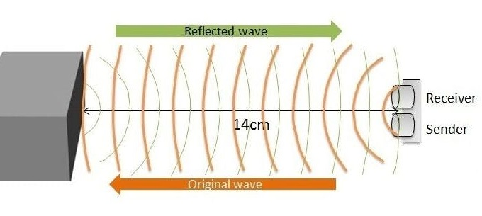

The HC-SR04 Ultrasonic Module has 4 pins, Ground, VCC, Trig and Echo. The Ground and the VCC pins of the module needs to be connected to the Ground and the 5 volts pins on the Arduino Board respectively and the trig and echo pins to any Digital I/O pin on the Arduino Board.

In order to generate the ultrasound you need to set the Trig on a High State for 10 µs. That will send out an 8 cycle sonic burst which will travel at the speed sound and it will be received in the Echo pin. The Echo pin will output the time in microseconds the sound wave traveled.

For example, if the object is 10 cm away from the sensor, and the speed of the sound is 340 m/s or 0.034 cm/µs the sound wave will need to travel about 294 u seconds. But what you will get from the Echo pin will be double that number because the sound wave needs to travel forward and bounce backward.  So in order to get the distance in cm we need to multiply the received travel time value from the echo pin by 0.034 and divide it by 2.

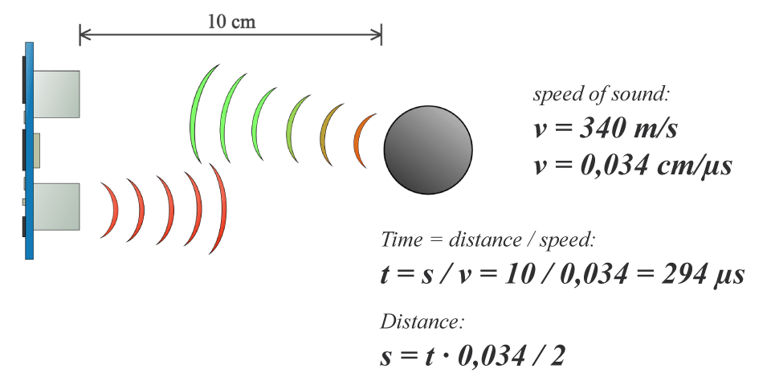

# Source code

First you have to define the Trig and Echo pins. In this case they are the pins number 9 and 10 on the Arduino Board and they are named trigPin and echoPin. Then you need a Long variable, named “duration” for the travel time that you will get from the sensor and an integer variable for the distance.

In the setup you have to define the trigPin as an output and the echoPin as an Input and also start the serial communication for showing the results on the serial monitor.

In the loop first you have to make sure that the trigPin is clear so you have to set that pin on a LOW State for just 2 µs. Now for generating the Ultra sound wave we have to set the trigPin on HIGH State for 10 µs. Using the ***pulseIn()***function you have to read the travel time and put that value into the variable “duration”. This function has 2 parameters, the first one is the name of the echo pin and for the second one you can write either HIGH or LOW. In this case, HIGH means that the ***pulseIn()*** function will wait for the pin to go HIGH caused by the bounced sound wave and it will start timing, then it will wait for the pin to go LOW when the sound wave will end which will stop the timing. At the end the function will return the length of the pulse in microseconds. For getting the distance we will multiply the duration by 0.034 and divide it by 2 as we explained this equation previously.  At the end we will print the value of the distance on the Serial Monitor.

Source code

// defines pins numbers

const int trigPin = 9;

const int echoPin = 10;

// defines variables

long duration;

int distance;

void setup() {

pinMode(trigPin, OUTPUT); // Sets the trigPin as an Output

pinMode(echoPin, INPUT); // Sets the echoPin as an Input

Serial.begin(9600); // Starts the serial communication

}

void loop() {

// Clears the trigPin

digitalWrite(trigPin, LOW);

delayMicroseconds(2);

// Sets the trigPin on HIGH state for 10 micro seconds

digitalWrite(trigPin, HIGH);

delayMicroseconds(10);

digitalWrite(trigPin, LOW);

// Reads the echoPin, returns the sound wave travel time in microseconds

duration = pulseIn(echoPin, HIGH);

// Calculating the distance

distance= duration*0.034/2;

// Prints the distance on the Serial Monitor

Serial.print("Distance: ");

Serial.println(distance);

}

 Display the results from the HC-SR04 Ultrasonic Sensor on an [LCD](https://howtomechatronics.com/tutorials/arduino/lcd-tutorial/)  following source code:

#include <LiquidCrystal.h> // includes the LiquidCrystal Library

LiquidCrystal lcd(1, 2, 4, 5, 6, 7); // Creates an LCD object. Parameters: (rs, enable, d4, d5, d6, d7)

const int trigPin = 9;

const int echoPin = 10;

long duration;

int distanceCm, distanceInch;

**void** setup() {

lcd.begin(16,2); // Initializes the interface to the LCD screen, and specifies the dimensions (width and height) of the display

pinMode(trigPin, OUTPUT);

pinMode(echoPin, INPUT);

}

**void** loop() {

digitalWrite(trigPin, LOW);

delayMicroseconds(2);

digitalWrite(trigPin, HIGH);

delayMicroseconds(10);

digitalWrite(trigPin, LOW);

duration = pulseIn(echoPin, HIGH);

distanceCm= duration*0.034/2;

distanceInch = duration*0.0133/2;

lcd.setCursor(0,0); // Sets the location at which subsequent text written to the LCD will be displayed

lcd.print("Distance: "); // Prints string "Distance" on the LCD

lcd.print(distanceCm); // Prints the distance value from the sensor

lcd.print(" cm");

delay(10);

lcd.setCursor(0,1);//bootom left

lcd.print("Distance: ");

lcd.print(distanceInch);

lcd.print(" inch");

delay(10);

}

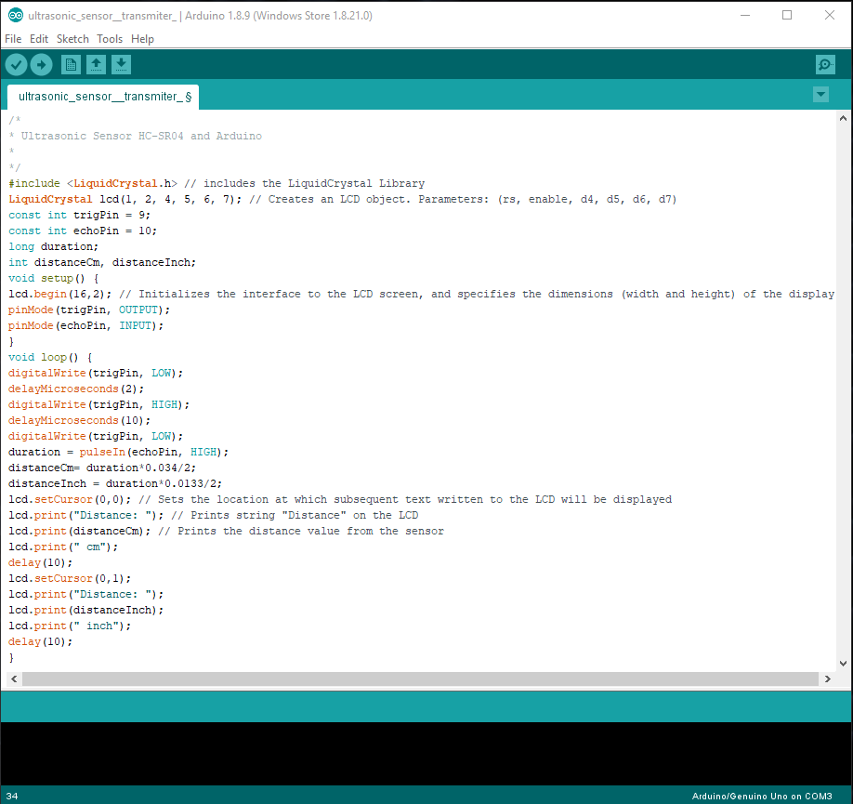

##### References

1. <https://www.arduino.cc/reference/en/language/functions/time/delay/>
2. <https://howtomechatronics.com/tutorials/arduino/ultrasonic-sensor-hc-sr04/?fbclid=IwAR0vPnB4fdw1pJDmdyh433JlJSVyzP6RAcj0Kbi1jKRAQu-41_IxHthJpFg>

Conclusion

**Ultrasonic sensor** HC-SR04 is used here to**measure**

**distance** in range of 2cm-400cm with accuracy of 3mm.

The **sensor** module consists of**ultrasonic** transmitter,

receiver and the control circuit. The working principle of

**ultrasonic sensor** is as follows: High level signal is sent

for 10us **using**Trigger .This can be used for different purpose

like if a blind person know distance from a object ,he will walk

more easily .There are lot’s application exist ,where distance

measuring is very important .