**Department of Electrical and Electronic**



**Engineering (EEE) Faculty of**

**Engineering (FE)**

**American International University- Bangladesh (AIUB)**

**Experiment 10**

**Engineering Shop**

**Section: F** **Semester: Summer 2020-21**

Experiment Title: Design and implementation of an electronic circuit PCB layout.

Date of Experiment: 28.07.2021 Date of Report Submission: 29.07.2021

|  |  |  |  |
| --- | --- | --- | --- |
| **Group No.** |  | **Group Members (**only for group report submission**)** | |
|  |  |
|  | **Sl.** | **NAME** | **ID** |
| 08 | 01. | Suhas Iftekhar | 18-36059-1 |
| 02. | MD.Ashraful Alam Shah | 18-36063-1 |
|  | 03. | Hridoy Chandra Deb | 18-36333-1 |
|  | 04. | Mahmud,Abdullah Al | 17-33676-1 |
|  | 05 | Shafiul Muznebin | 17-33638-1 |

**School/College Quiz Buzzer Circuit using 555 Timer IC**

**Purpose:**

Quiz is an important activity for testing the knowledge of participants in any institution. In order to increase the difficulty, the spontaneity of the participants was also tested, which is also considered as the reaction time of the participants. Those who are ready to answer the question must press a button. When the contestants ran to answer the question, it was difficult for the referee or organizer to determine the first person to press the call button. We added a feature that if someone presses the call button first, all calls from the remaining party will be called. Disabled, the buzzer will only sound again when the reset button is pressed.

**Equipment:**

1. 555 timer IC – 3Nos

2. Tactile switch – 4Nos

3. BC547 – 1No.

4. Buzzer – 1No.

5. LED – 6Nos

6. Diode – 3Nos

7. Breadboard

8. Resistors (10kὨ - 4Nos; 1kὨ - 7Nos)

9. Connecting wires

**Procedure:**

For hardware implementation we used to follow this process but because of this pandemic situation (COVID-19) we could not collect the components. But if we can do the hardware implementation, we will do it like the following steps.

STEP 1: First, we make a printed copy of the PCB design. For this, we need to use a laser printer and A4 photo / glossy paper to print PCB designs. We need to consider the following points. : The printing must be mirrored. Then we choose black output in the settings of PCB layout program and printer driver and we must ensure that we print on the glossy side of the paper.

STEP 2: Then we will cut the Copper Plate for the Circuit Board according to the size of the layout using a hacksaw or a cutter. Next, we will rub the copper side of the PCB using steel wool or abrasive sponge scrubs. This removes the top oxide layer of copper as well as the photo resist layer. Sanded surfaces also allow the image from the paper to stick better.

STEP 3: After that we used to transfer the PCB Print onto the Copper Plate. For that first we will transfer the printed image (taken from a laser printer) from the photo paper to the board. We must make sure to flip top layer horizontally. Then we have to put the copper surface of the board on the printed layout. We have to ensure that the board is aligned correctly along the borders of the printed layout and we use tape to hold the board and the printed paper in the correct position.

STEP 4: Next ironing the Circuit from the Paper onto the PCB Plate. After printingon glossy paper, we have to iron it image side down to the copper side, then heat up the electric iron to the maximum temperature. We put the board and photo paper arrangement on a clean wooden table (covered with a table cloth) with the back of the photo paper facing us. Using pliers or a spatula, have to hold we need to apply pressure and do the ironing slowly. Doing a long hard press seems to work better than moving the iron around. The heat from the iron transfers the ink printed on the glossy paper to the copper plate.

STEP 5: Next Etching the Plate. We need to be really careful while performing this step. First, we have to put on rubber or plastic gloves. Then we need to place some newspaper on the bottom so the etching solution does not spoil our floor. We need to take a plastic box and fill it up with some water. We have to dissolve 2-3 teaspoons of ferric chloride power in the water. After that we have to dip the PCB into the etching solution (Ferric chloride solution, FeCl3) for approximately 30 mins. The FeCl3 reacts with the unmasked copper and removes the unwanted copper from the PCB. This process is called Etching. We need to use pliers to take out the PCB and check if the entire unmasked area has been etched or not. In case it is not etched, leave it in the solution for some more time.

### Circuit Diagram

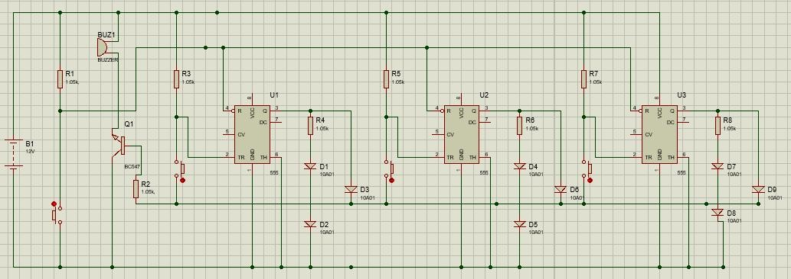

Fig-2: [School/College](https://circuitdigest.com/electronic-circuits/quiz-buzzer-circuit-using-555-timer) [Quiz](https://circuitdigest.com/electronic-circuits/quiz-buzzer-circuit-using-555-timer) [Buzzer](https://circuitdigest.com/electronic-circuits/quiz-buzzer-circuit-using-555-timer) [Circuit](https://circuitdigest.com/electronic-circuits/quiz-buzzer-circuit-using-555-timer) [using](https://circuitdigest.com/electronic-circuits/quiz-buzzer-circuit-using-555-timer) [555](https://circuitdigest.com/electronic-circuits/quiz-buzzer-circuit-using-555-timer) [Timer](https://circuitdigest.com/electronic-circuits/quiz-buzzer-circuit-using-555-timer) [IC](https://circuitdigest.com/electronic-circuits/quiz-buzzer-circuit-using-555-timer) (**Schematic**)

### PCB Layout

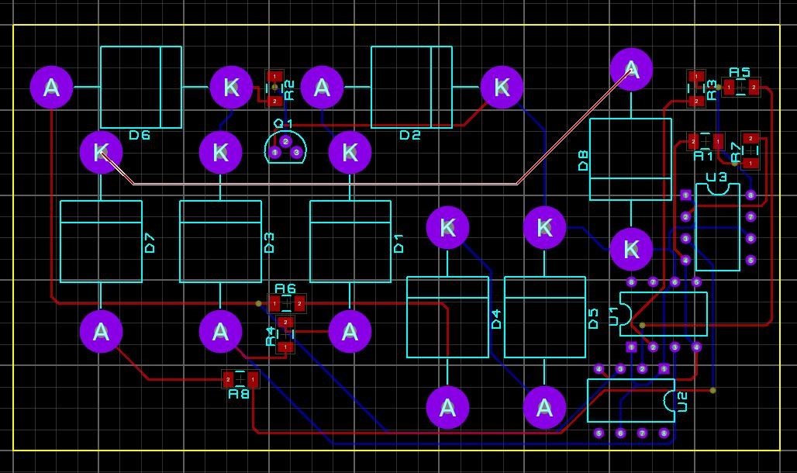

Fig-3: [School/College](https://circuitdigest.com/electronic-circuits/quiz-buzzer-circuit-using-555-timer) [Quiz](https://circuitdigest.com/electronic-circuits/quiz-buzzer-circuit-using-555-timer) [Buzzer](https://circuitdigest.com/electronic-circuits/quiz-buzzer-circuit-using-555-timer) [Circuit](https://circuitdigest.com/electronic-circuits/quiz-buzzer-circuit-using-555-timer) [using](https://circuitdigest.com/electronic-circuits/quiz-buzzer-circuit-using-555-timer) [555](https://circuitdigest.com/electronic-circuits/quiz-buzzer-circuit-using-555-timer) [Timer](https://circuitdigest.com/electronic-circuits/quiz-buzzer-circuit-using-555-timer) [IC](https://circuitdigest.com/electronic-circuits/quiz-buzzer-circuit-using-555-timer) (**PCB**)

### 3D Layout (FRONT)

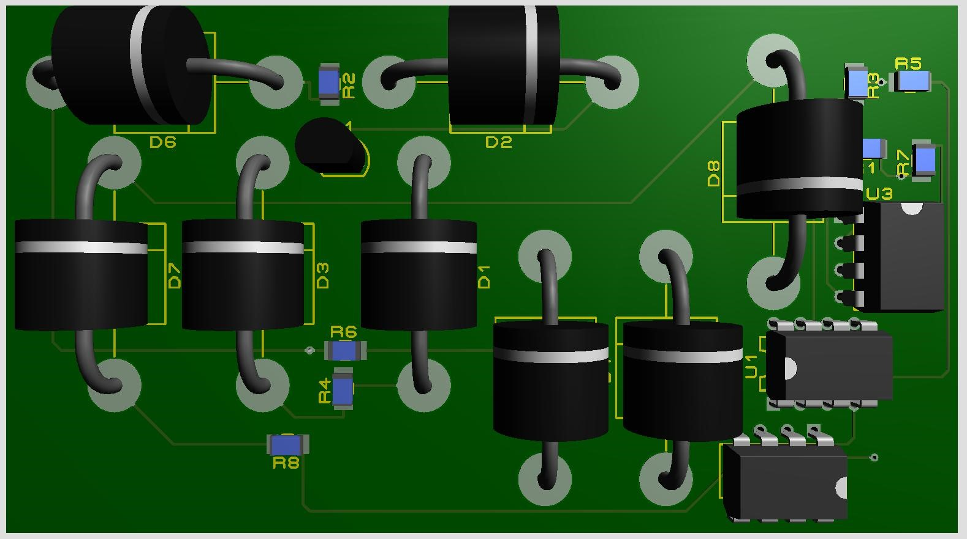

Fig-4: [School/College](https://circuitdigest.com/electronic-circuits/quiz-buzzer-circuit-using-555-timer) [Quiz](https://circuitdigest.com/electronic-circuits/quiz-buzzer-circuit-using-555-timer) [Buzzer](https://circuitdigest.com/electronic-circuits/quiz-buzzer-circuit-using-555-timer) [Circuit](https://circuitdigest.com/electronic-circuits/quiz-buzzer-circuit-using-555-timer) [using](https://circuitdigest.com/electronic-circuits/quiz-buzzer-circuit-using-555-timer) [555](https://circuitdigest.com/electronic-circuits/quiz-buzzer-circuit-using-555-timer) [Timer](https://circuitdigest.com/electronic-circuits/quiz-buzzer-circuit-using-555-timer) [IC](https://circuitdigest.com/electronic-circuits/quiz-buzzer-circuit-using-555-timer) (**3D Layout Front**)

### 3D Layout (BACK)

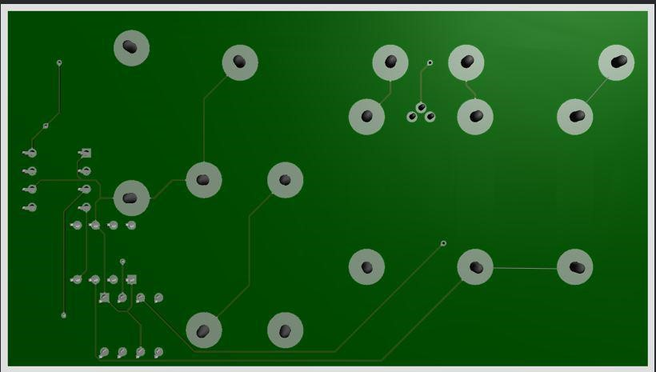

Fig-5: [School/College](https://circuitdigest.com/electronic-circuits/quiz-buzzer-circuit-using-555-timer) [Quiz](https://circuitdigest.com/electronic-circuits/quiz-buzzer-circuit-using-555-timer) [Buzzer](https://circuitdigest.com/electronic-circuits/quiz-buzzer-circuit-using-555-timer) [Circuit](https://circuitdigest.com/electronic-circuits/quiz-buzzer-circuit-using-555-timer) [using](https://circuitdigest.com/electronic-circuits/quiz-buzzer-circuit-using-555-timer) [555](https://circuitdigest.com/electronic-circuits/quiz-buzzer-circuit-using-555-timer) [Timer](https://circuitdigest.com/electronic-circuits/quiz-buzzer-circuit-using-555-timer) [IC](https://circuitdigest.com/electronic-circuits/quiz-buzzer-circuit-using-555-timer) (**3D Layout Back)**

**Cost analysis:**

|  |  |  |  |
| --- | --- | --- | --- |
| **Serial** | **Product Name** | **Quantity** | **Price(BDT)** |
| **1** | **555 timer IC** | **3** | **15*1=45** |
| **2** | **Tactile switch** | **4** | **5*4=20** |
| **3** | **BC547** | **1** | **10*1=10** |
| **4** | **Buzzer** | **1** | **15*1=15** |
| **5** | **LED** | **3** | **2*3=6** |
| **6** | **Breadboard** | **1** | **50*1=50** |
| **7** | **Resistors (10kὨ - 4Nos; 1kὨ - 7Nos)** | **7** | **2*7= 14** |
|  |  | **Total= 20** | **Total Cost= 160/-** |

**Discussion and Conclusions:**

In this project, we tried to design a system that will make fire alarms simple and convenient. The idea came to us fromsome in-depth searching that convinced us that there is need for such a system. we saw potential in such a system that can really push the fire alarm concept forward. While we have made significant progress from our initial design, we still have some limitations such as, Very High temperature may damage the circuit. The thermistor sensing part must be set outside of the circuit board for better sensing. With limitation this circuit has some advantages too, low cost but highly efficient. Small circuit and portable. Easy to construct the circuit Since we are dealing with a pandemic, currently we couldn’t implement the circuit. Our desire apparatus we are having a cost estimate which is around **160BDT**. We come know and learn a lot of new electronics from this course and this project. For present circumstance we were not allowed to create a live project demo but we simulate different layouts, watches a lot of videos, read resources to make our project in the supervision of our instructor. We use our knowledge from this course into this project.

**Questions:**

1. How many layers have you used in your PCB design? What was your limitation in designing multi-layer PCB?

2. What do you mean by PCB fabrication process?

3. How are PCBs constructed with more than two copper layers?

4. What is a typical minimum width for a copper track and minimum gap between tracks on a commercial PCB?

**Ans:**

1. Our PCB design uses two layers only in terms of thickness. Insulating layers cannot be madeany thinner than 5 thou (0.005"), and perhaps 3 thou at the thinnest. Copper foil must be similarly thin, or else the resin will be unable to flow into the gaps between the traces. Resin is also a factor in why heavy copper printed circuit boards have laxer design rules. That, and the dexterity required to etch and plate such thick layers in the first place. The positional error of an edge is approximately equal to the height of the foil. Thus, while 2oz copper is sufficient for the majority of applications (including ICs with a pitch of 0.5mm),heavier copper (3oz, 4oz, heavy) requires coarser design rules and components.
2. PCB fabrication is the process or procedure that transforms a circuit board design into a physical structure based upon the specifications provided in the design package. The manufacturing of a printed circuit board is a complex process that begins with a product concept and ends with a fully functional PCB assembly. Along the way a schematic is created to capture the net connectivity, the physical circuitry is laid out in a PCB design, and electronic components are ordered. After soldering the components onto the board and completing assembly testing and verification, the circuit board will be integrated into the full system.
3. To make multilayer printed circuit boards, a hydraulic press is used to laminate alternating layers of epoxy-impregnated fiberglass boards (called prepregs) and conductive core materials under high temperature and pressure. Rust or brown rust (depending on the process) is the chemical treatment of the inner layer of the multilayer circuit board before lamination. The purpose is to increase the roughness of the copper-clad and improve the bonding strength of the laminate. This process helps prevent delamination. After the manufacturing process is completed, the delamination or separation between one layer of the substrate or between the laminate and the conductive foil.
4. Most manufacturers can make rails that are at least 0.006 inches wide. (Many can leave tracks that are 0.004 inches wide.) These smallest tracks are sufficient for most digital and analog signals. The manufacturer of each part recommends a "fingerprint", that is, the copper pattern of the part to be soldered to the circuit board. The minimum track width and spacing of the FR4 circuit board depends on the thickness of the copper. For 35 microns, the typical value is 0.1 mm for standard and 0.05 mm for advanced manufacturing.

**Reference:**

1. https://circuitdigest.com/electronic-circuits/quiz-buzzer-circuit-using-555-timers
2. https://circuits-diy.com/school-college-quiz-buzzer-circuit-electronics-projects/

3.https://www.google.com/search?rlz=1C1CHBF_enBD855BD855&sxsrf=ALeKk02vPYsf6 PoN8afUMzTQL5jWBc3Q_w%3A1596880568315&ei=uHYuX7TyEoSGmgfA9q7ACg&q= why+555+timer+use+in+a+fire+alarm&oq=why+&gs_lcp=CgZwc3ktYWIQAxgAMgQIIxA nMgQIIxAnMgQIIxAnMgQIABBDMgIIADICCC4yAggAMgIhttps://www.google.com/sear ch?

4.<https://www.instructables.com/Quiz-Buzzer-Using-555-Timer-IC/>

5.[https://www.google.com/search?q=School%2FCollege%20Quiz%20Buzzer%20Circuit%20](https://www.google.com/search?q=School%2FCollege%20Quiz%20Buzzer%20Circuit%20using&ie=utf-8) using&ie=utf-8

6. https://www.edrawmax.com/templates/1000466/college-quiz-buzzer