
American International University – Bangladesh
Faculty of Engineering
Department of Electrical & Electronic Engineering

DLD PROJECT Report

SEMESTER OF REGISTRATION: Spring2020-2021
GROUP#:03

*PROJECT TITLE: Control your home lighting with ANDROID via Bluetooth.
Attach PROGRESS REPORT with given TEMPLATE:
- Title of Project
- Goals and Potential Benefits of the Project | 1 Page
- Model/Experimental Design (Block diagram) | 1 Page
- Experimental/Simulation Results | 1 Page
- Project Pictures | 1 Page
- References | 1 Page

Group Members
S/l | Name | ID
1 | Suhas Iftakhar | 18-36059-1
2 | Hridoy Chandra Deb | 18-36333-1
3 | MD. Ashraful Alam Shah | 18-36063-1
4 | SHEIKH, MD. SHAZIB | 18-36278-1
5

Project Title: Control your home lighting with ANDROID via Bluetooth.

Goals and Potential:

This device not only provide safety and security while user are away, The main objective to help user monitor energy usage and help cut costs on him/her lighting bills. By connecting the products with user’s mobile app, he/she can control the lighting system from user’s mobile device with a few simple taps. It truly provides peace of mind, while protecting user’s home at the same time. It is an easy way to modernized user’s home.
The sequence of usage in the system will be like this:
- a. The user clicks a button in the smartphone engaging a Bluetooth command.
- b. The Bluetooth module receives it and sends that command to the Arduino.
- c. The Arduino will then process that command and send a signal to the relay to turn it ON or OFF.
- d. The Arduino then sends a successful message to the Bluetooth module, where the Bluetooth module sends this message back to the smartphone.
Component List:
Hardware:

- 1. Arduino UNO
- 2. Relay Module
- 3. Bluetooth Module
- 4. Smartphone
- 5. Bulb
- 6. Cable
- 7. Plug
- 8. Fitting Lamp

Software

- 1. Arduino IDE
- 2. Bluetooth Controller
. Block diagram:
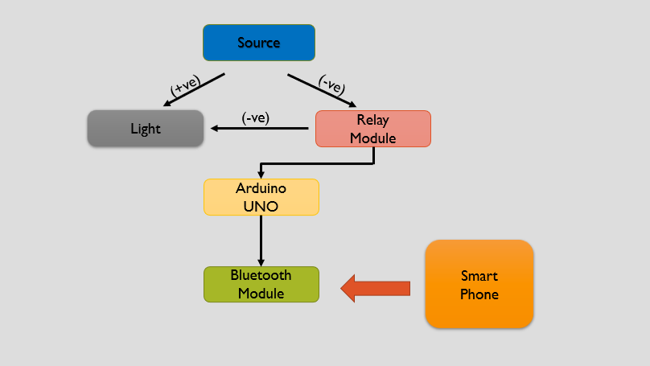

Experimental Design:
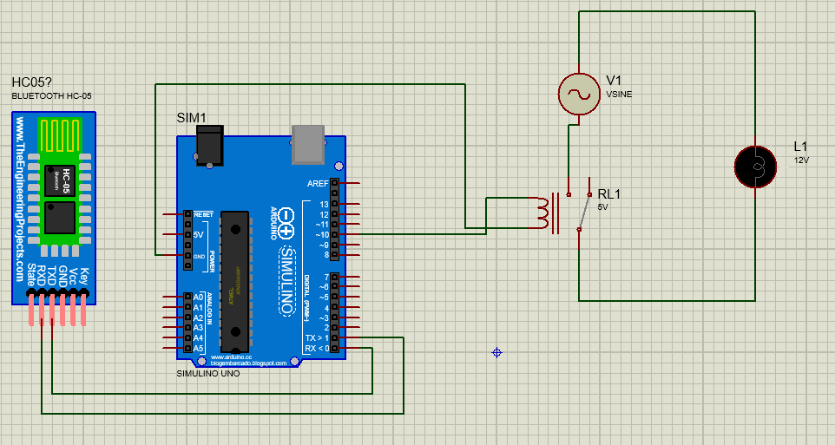
Simulation Results:

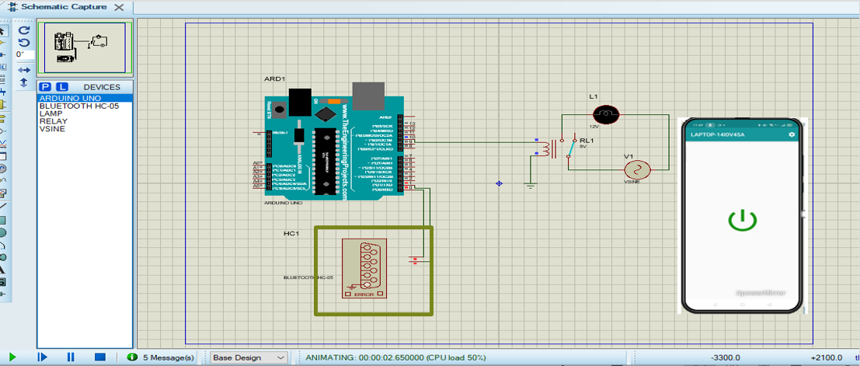

Code:
#include <arduino.h>
int state;
int flag=0;
int stateStop=0;
void setup() {
pinMode(10, OUTPUT);
Serial.begin(9600);
}
void loop() {
if(Serial.available() > 0)
{
state = Serial.read();
flag=0; if (state == 'A')
{
digitalWrite(10, LOW);
}
if (state == '1')
{
digitalWrite(10, HIGH);
}
if (state == '2')
{
digitalWrite(10, LOW);
}
}
}

Project Pictures:
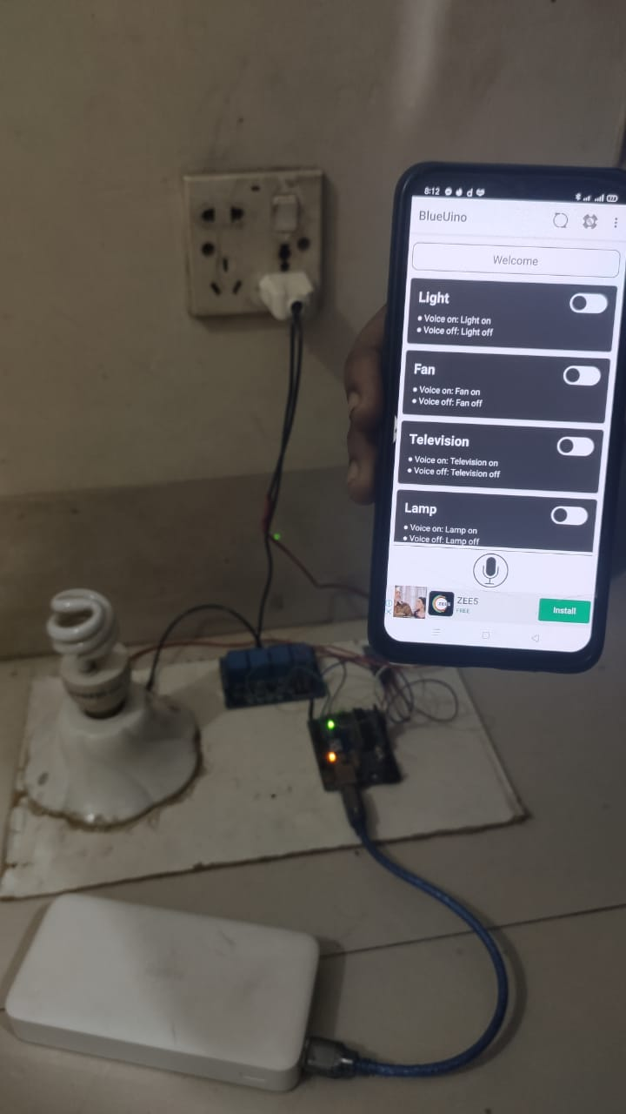
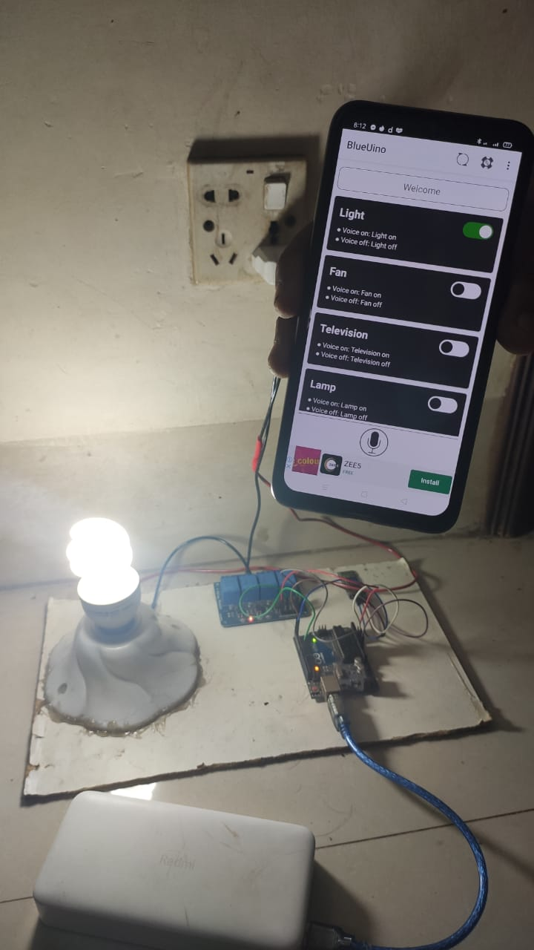
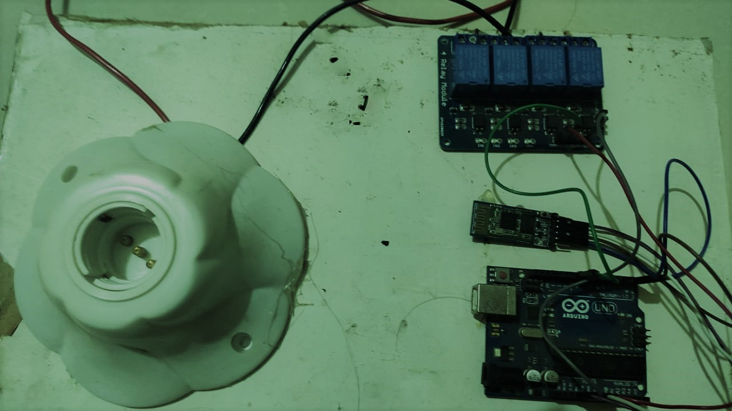

References:

[1]. https://www.instructables.com/id/CONTROL-YOUR-HOME-LIGHTING-WITH-ANDROID/?fbclid=IwAR0Fc8xA0OFaSXh6XSuusfS28XFMZ491BqrO04wJR9oDp69UE9PmceFFyxc
Last access: 20.4.2021 10:56 AM
[2]. Guide for Relay Module with Arduino | Random Nerd Tutorials
Last access: 15.4.2021 11:02 AM
[3]. https://www.techshopbd.com/
Last access: 25.3.2021 11:44 AM

